INVESTIGATIVE ARTICLE AND EXHIBITS

Who Owns the Apartments Around Campus?
  - The captive economics of student housing around the University of Texas at Austin
Property-level investigation and financial model
Primary record: two completed evidence memoranda, underlying source ledger, and a six-property normalized cash-flow model. As of July 2026.
July 2026

Article map
01 A lease that is not quite monthly rent
02 Six buildings, 4,805 beds and several kinds of capital
03 What the student buys
04 The property statement
05 SkyLoft and the capital stack
06 2400 Nueces and the public control
07 Waterloo and residual land value
08 The Standard, Callaway and 26 West
09 The West Campus premium
10 Guarantors and preleasing
11 What breaks
12 Loss allocation
13 Source and assumption notes

Model scope
Six properties, 4,805 beds. Article body: 5,109 words. Reported figures are separated from modeled assumptions throughout. SkyLoft debt is actual at 2019 origination; current debt for the other five properties is illustrative unless stated otherwise.

A lease that is not quite monthly rent
At The Callaway House, $1,959 is not quite a monthly rent. It is an installment on a school-year obligation. The current entry rate is quoted per person, the typical occupancy period is about nine and a half months, and the total rent is generally divided into ten equal payments due from August through May. Callaway’s own explanation says those payments do not represent monthly rent. Furniture, a meal plan, utilities, internet, housekeeping and building amenities sit inside the bundle. Parking and required liability coverage sit outside it. Unless a student can show income greater than three times the installment, a guarantor is required. At the entry rate, the housing obligation is $19,590 before parking and insurance. A parent often signs behind the same number. [EP-OP-001; S03; S20]
That contract can be scaled directly into a property statement. Callaway contains 753 beds. At the entry rate, a fully invoiced year would produce about $14.75 million before premium rooms and ancillary charges. The property model uses a higher weighted average face installment of $2,450 to account for its broad room ladder. That produces $18.45 million of gross potential residential rent. After vacancy, unleased inventory, bad debt and concessions, the model records $17.36 million of net residential revenue and $17.74 million of effective gross income. The difference between a student’s payment and an owner’s return begins there, not at the website price. [S12; Model]
Callaway is also the first warning against a simple profit claim. It buys food, housekeeping, utilities, staff and contracted services that ordinary apartments do not. The model assigns $9.58 million of annual operating expense before replacement reserves and produces $8.15 million of net operating income, a 46.0% margin. Five other modeled properties range from 58.4% to 61.5%. Callaway can charge the highest student-facing price in the sample and still convert a smaller share of revenue into property NOI. A burdensome contract and an unusually high investment return are different questions. [Model]
The investigation therefore tests a narrower definition of captivity. Before signing, students have alternatives: university housing, cooperatives, older apartments, shared bedrooms and commute-based choices. Those options differ in location, privacy, furnishings and service. After signing, the market changes. A student may face a parental guaranty, a controlled relet process, early cancellation deadlines and an obligation that survives non-occupancy. The evidence supports substantial post-signing lock-in. It supports a location and service premium before signing. It does not establish that every owner has monopoly pricing or that every tower earns excess returns. [EP-OP-001; S01; S03; S06; S23]

Six buildings, 4,805 beds and several kinds of capital
The six-property sample was selected for evidence quality rather than visibility. SkyLoft exposes a complete 2019 securitized loan file, including the borrower, whole loan, preferred equity and cash-management rules. 2400 Nueces records a private ground-lease development followed by a university purchase. Waterloo connects a 0.45-acre site, a density bonus, a 796-bed tower and a sale to Global Student Accommodation. The Standard shows construction debt followed by a recapitalization with Landmark retaining ownership. Callaway provides a service-heavy private-dorm product. 26 West supplies an older property with an actual 2011 acquisition price. [EP-OWN-001]
Together the six properties contain 4,805 beds. The average is 801 beds and the median is 775. Every building was delivered after the University Neighborhood Overlay was adopted in 2004, but that is a sample fact, not a market-wide share. The wider roster still contains unresolved bed counts, parcel entities and internal ownership transfers. A concentration ratio built on that incomplete denominator would look precise and say little. The defensible finding is platform concentration: American Campus Communities, now owned by Blackstone, controls multiple West Campus properties; Landmark owns and operates a cluster; GSA owns Waterloo through its platform; UT owns 2400 Nueces; and SkyLoft’s consumer-facing brand sits over a separate borrower, master tenant, subordinate lender and preferred investor. [EP-OWN-001; S12]
This distinction matters to a student following a rent payment. The manager collecting it may not own the real estate. The fee owner may sit in a single-purpose entity. The mortgage may be split among pari passu and subordinate notes. A preferred investor can sit between the lender and common sponsor capital while holding control rights that resemble debt remedies. The brand on the leasing office is only the first name in the chain. [S04]
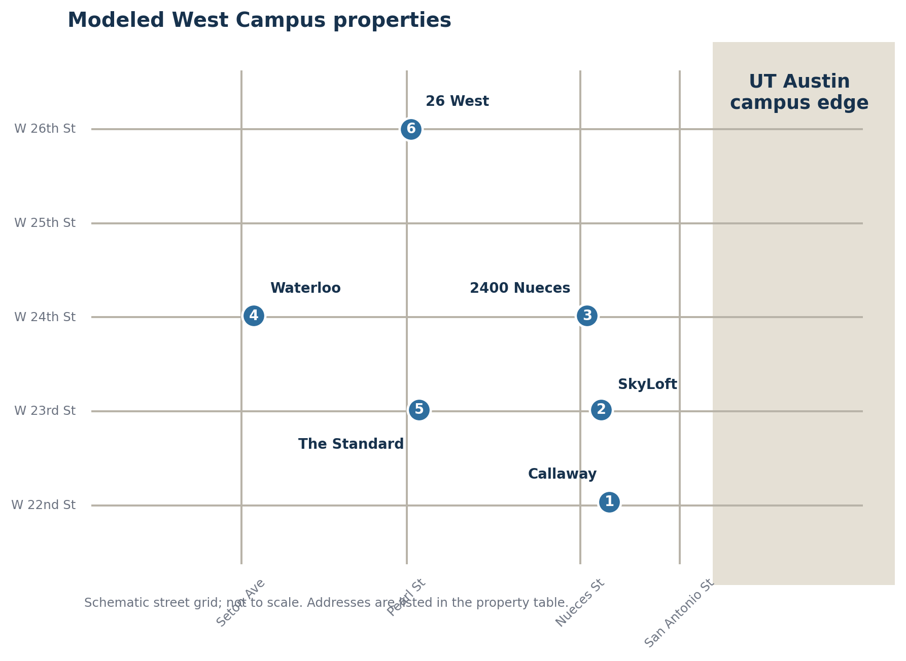
Exhibit 1. Modeled properties in West Campus Source: Property addresses in EP-OWN-001; map is schematic, not a parcel survey.
Exhibit 2. Ownership and manager table Source: EP-OWN-001 and property source IDs in Exhibit 13.
Property | Units | Beds | Owner / sponsor | Manager / operating brand | Evidence status
SkyLoft | 212 | 674 | NP Skyloft, DST at 2019 origination; current control unresolved | SkyLoft brand; master tenant NP Skyloft Leaseco, LLC at origination | High for 2019; current status incomplete
2400 Nueces | 304 | 622 | Board of Regents of The University of Texas System | UT University Housing and Dining | High for purchase structure; low for allocated balance
Waterloo | 241 | 796 | Global Student Accommodation | Yugo Austin Waterloo | High owner/sale chronology; low debt/basis precision
The Standard | 287 | 934 | Landmark Properties (retained ownership in 2023 recap) | Landmark Properties | High sponsor/2018 loan; low current balance/maturity
Callaway | 219 | 753 | American Campus Communities / Blackstone platform | American Campus Communities | High sponsor/revenue; low basis/current debt
26 West | 367 | 1,026 | American Campus Communities / Blackstone platform | American Campus Communities | High sponsor/acquisition; low current debt

What the student buys
The standard West Campus product is a separately monetized bedroom. Individual leasing limits a resident’s liability for a roommate’s unpaid rent, which is a real consumer benefit. It also lets the owner price each bedroom, bathroom arrangement, view and floor premium as its own revenue unit. SkyLoft’s current 2026–27 page ranges from roughly $1,200 for selected shared-bath bedrooms to about $2,000 for studios and above $2,200 for one-bedrooms. 2400 Nueces publishes per-person rates from $1,141 for a 12-month 4x4 to $1,495 for a studio. Callaway begins around $1,959 per installment and moves materially higher for premium layouts. [EP-OP-001; S06; S20; S21]
Installment language changes how those figures should be compared. A 12-month 4x4 at 2400 Nueces costs $13,692 in published installments, versus $10,989 for the nine-month version. Adding the $100 application fee used in the student-cost model brings the contractual totals to $13,792 and $11,089. The twelve-month option has the lower sticker at $1,141, but it costs $2,703 more in total and about $1,532 per academic-use month if the student values nine months near campus. The nine-month version is about $1,232 per academic-use month. The installment is accurate; the intuition it invites can be wrong. [S06; Model]
Fees produce a second gap. SkyLoft’s representative 4x2 rate of $1,209 becomes $1,232 per contracted month after modeled mandatory one-time charges. Parking at $195 takes the occupied-month cost to about $1,427. Torre’s $1,460 rate becomes $17,729 for the contract after $209 of required administrative, application and utility-administration charges. The Standard adds a current mandatory monthly fee in the model. Rise has advertised the inverse structure: a large rent discount, gift card and waived fees on selected inventory. Headline rent anchors the shopper; fees and concessions settle the economic price. [EP-OP-001; S01; S02; S19; S21]
Reletting rules make the obligation harder to unwind. Torre’s archived lease requires full-term rent whether the unit is occupied or not and imposes a reletting fee. Callaway’s release rules put the replacement burden on the resident after defined deadlines. A guarantor or prepayment requirement makes the obligation more collectible. It does not create demand for an empty bed. That difference becomes central when a building misses its lease-up target. [S01; S03]
Exhibit 4. Rent per bed and effective student cost Source: S03, S06, S14, S19-S23 and Model. Rates are representative asks, not executed leases.
Property | Representative plan | Advertised installment | No. | Contract total | Effective / contracted month | Per academic-use month | Parking-inclusive / month
SkyLoft | 4x2 Stubb's B | $1,209 | 12 | $14,783 | $1,232 | $1,643 | $1,427
2400 Nueces | 4x4, 12-month | $1,141 | 12 | $13,792 | $1,149 | $1,532 | $1,149
2400 Nueces | 4x4, 9-month | $1,221 | 9 | $11,089 | $1,232 | $1,232 | $1,232
Waterloo | Representative 4-6BR bed | $1,349 | 12 | $16,188 | $1,349 | $1,799 | $1,349
The Standard | 4x4 representative | $1,385 | 12 | $16,889 | $1,407 | $1,877 | $1,407
Callaway | Entry private-dorm rate | $1,959 | 10 | $19,590 | $1,959 | $2,062 | $1,959
26 West | Current lower-end offer | $1,244 | 12 | $14,928 | $1,244 | $1,659 | $1,394
College Houses | Private room co-op | $955 | 9 | $8,595 | $955 | $955 | $955
ICC Austin | Private room incl. food | $1,175 | 9 | $10,575 | $1,175 | $1,175 | $1,175
North University | Half of average 2BR unit | $787 | 12 | $9,444 | $787 | $1,049 | $787

Exhibit 5. Fee and concession comparison Source: EP-OP-001; S01-S03; S06; S14; S19-S21.
Property | Mandatory recurring | Mandatory one-time | Parking | Major inclusions | Concession evidence
SkyLoft | $0 modeled mandatory monthly | $275 modeled one-time | $195/mo | Furniture; internet varies by listing | No sampled concession
2400 Nueces | $0 | $100 application | $0 modeled | Utilities and internet | 9- and 12-month choice
The Standard | $22.45/mo | $0 modeled | Not quantified | Furnished student product | Modeled 0.5 month recurring + $300/bed one-time
Callaway | $0 in posted bundle | Not quantified | Extra; amount unresolved | Meal plan, utilities, internet, housekeeping | Modeled 0.1 month + $100/bed
26 West | $0 modeled | $0 modeled | $150/mo sample | Furnished student product | Modeled 0.1 month + $50/bed
Torre | $0 modeled | $209 required | Not quantified | Property-specific | Historical fee waivers
Rise | Underlying fee schedule unresolved | Fees advertised waived on select units | Not quantified | Property-specific | $175/mo + $1,000 gift card on selected inventory

The property statement: rent, fees, expenses and NOI
SkyLoft provides the cleanest reported bridge from a rent roll to NOI. Its 2019 securitization file showed $9.06 million of gross potential rent, $732,312 of other income, $453,131 of vacancy and concessions, $9.34 million of effective gross income, $3.17 million of operating expense and $6.17 million of NOI. Other income included application, late, administrative and pet fees. At about $1,087 per bed, it represented 7.8% of effective gross income. The reported NOI was $9,160 per bed. [S04]
The six current property models use that disclosure as an anchor, then change the inputs to match each asset’s contract and service mix. They are normalized statements, not reported collections. Face rent is reduced for structural vacancy, unleased beds, bad debt and concessions. Fees, parking, reimbursements, retail and recurring administrative income are added. Property taxes, insurance, payroll, repairs, utilities, security, cleaning, turnover, marketing, management and reserves are deducted. Each assumption is visible in the workbook. [Model]
The modeled margins cluster in a way that is economically plausible. 2400 Nueces produces $5.54 million of NOI on $9.48 million of effective gross income, a 58.4% margin, with no property-tax expense under university ownership. SkyLoft produces $6.12 million on $10.35 million, a 59.1% margin. Waterloo, The Standard and 26 West produce margins near 61%. Callaway falls to 46% because meals, housekeeping, utilities, payroll and contracted services cost far more per bed. Expense per bed is roughly $12,725 at Callaway versus about $6,300 to $6,800 at the other five. [Model]
Break-even occupancy is low in the arithmetic and higher in practice. The model calculates about 32% to 40% for five apartment properties when other income is credited against expenses, and 51% for Callaway. Those figures do not mean a tower can operate normally at those occupancies. They exclude many ownership-level obligations, leasing disruption, lender controls and the capital cost of maintaining an amenity-heavy high-rise. They say only that high per-bed revenue leaves a large gross margin before capital structure. [Model]
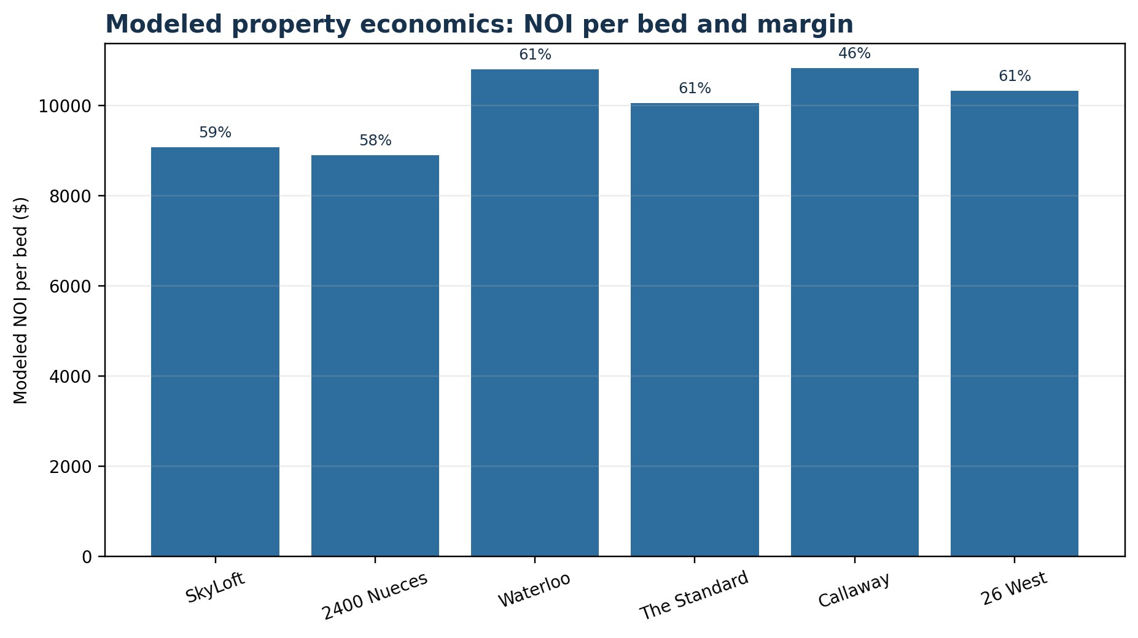
Exhibit 8. Normalized NOI and margin comparison Source: Model. Only SkyLoft 2019 operating data are directly reported; the six current cases are normalized.

SkyLoft: a strong building statement and a weak common-equity position
SkyLoft is the clearest answer to the assignment’s central question because it exposes both sides. The property statement looked strong in 2019. The capital stack was much less forgiving. NP Skyloft, DST acquired the 212-unit, 674-bed tower for $119.55 million. Total disclosed uses, including reserves and closing costs, were about $124.37 million. The property carried a $66.125 million whole loan: $36 million of senior notes and a $30.125 million subordinate companion note. Above common equity sat $35 million of preferred equity. [S04]
The preferred security was not ordinary sponsor capital. It earned a 14% return, with 8% current pay and 6% accruing. It also held change-of-control and loan-purchase rights under a recognition agreement. At origination, the remaining common sponsor check implied by disclosed uses was about $23.24 million. On paper the mortgage looked conservative: 55.2% whole-loan LTV, 2.03x DSCR and a 9.3% debt yield. Those ratios did not include the preferred claim as property debt. [S04; Model]
The normalized current model shows why that omission matters. At $6.12 million of NOI, whole-loan interest is about $2.94 million. Preferred current pay is $2.8 million. Replacement reserves are about $202,000. The cash left for common equity is approximately $171,000, before ownership-level costs and taxes. A building with a 59% NOI margin can therefore produce almost no common cash yield when its capital is layered. [Model]
Value creates the same result. Capitalizing normalized NOI across a 6.5% to 8.0% range produces a value range of about $76.4 million to $94.1 million, with a central value of $87.4 million. The whole mortgage remains covered at the central value, but mortgage plus stated preferred principal totals $101.1 million. Common equity is out of the money and the preferred position is impaired by about $13.8 million before considering accrued return. The model’s ten-year common-equity IRR at the central all-in basis is negative 10.3%; the low- and high-basis cases are negative 7.6% and negative 12.5%. These are model outputs, not realized investor statements. They show the burden of the disclosed stack. [Model]
Later surveillance confirms that strong underwriting was not permanent. Fitch reported that the loan transferred to special servicing in March 2024 and that occupancy was 42% as of March 2025. The current property site still markets 2026–27 leases, but a limited search did not locate a later public surveillance report establishing a cure, payoff or change of control. The latest located credit evidence and the current leasing page can coexist: the building may operate while the capital structure remains unresolved. [S05; S21]
SkyLoft therefore cuts against two easy stories. Parental guarantees did not make the asset recession-proof. Nor did the original 2.03x DSCR make the common sponsor safe. Empty or heavily discounted inventory first reduced property cash flow. Common equity then lost its residual value. Preferred capital had contractual rights to intervene before suffering a full economic loss. If value fell below the $66.125 million mortgage, the subordinate note would be exposed before the senior notes. The legal documents, not the consumer brand, determine that sequence. [S04; S05; Model]
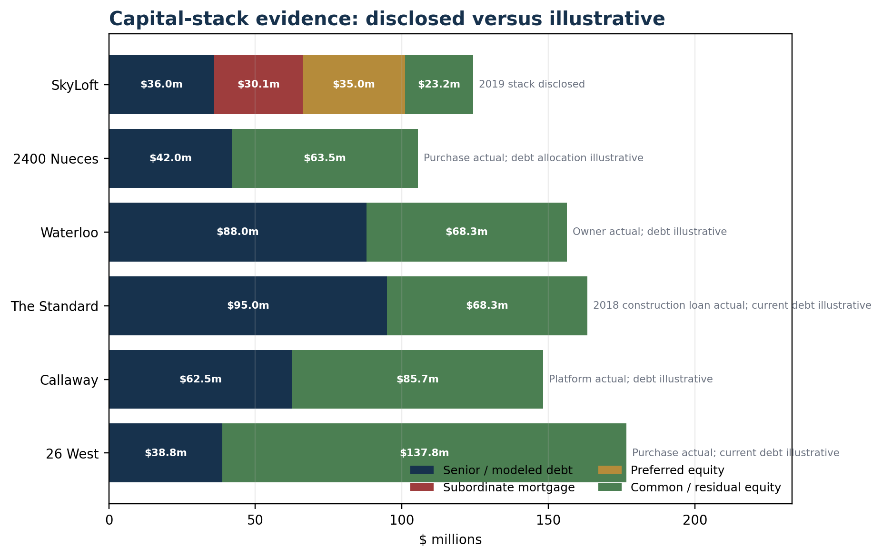
Exhibit 3. Capital-stack evidence: disclosed versus illustrative Source: S04, S07, S11-S12 and Model. Non-SkyLoft current debt is illustrative.
Exhibit 9. Debt, maturity and refinance evidence Source: S04, S07, S11-S12 and Model. Only SkyLoft balance/rate/maturity are actual current-loan terms from the disclosed origination.
Property | Balance | Rate | Amortization | Maturity | Status | DSCR | LTV
SkyLoft | $66.1m | 4.45% | Interest-only | 2029-03-06 | Actual 2019 whole loan; 120-month interest-only | 2.08x | 75.7%
2400 Nueces | $42.0m | 4.25% | 30 years | Not disclosed | Illustrative current RFS-bond allocation; actual project balance not public | 2.23x | 39.8%
Waterloo | $88.0m | 6.75% | 30 years | Not disclosed | Illustrative current leverage; actual GSA debt not public | 1.26x | 56.3%
The Standard | $95.0m | 6.75% | 30 years | Not disclosed | Illustrative current recap balance; 2018 construction loan was $101.1m | 1.27x | 58.2%
Callaway | $62.5m | 6.25% | 30 years | Not disclosed | Illustrative asset leverage; ACC/Blackstone property-level debt not public | 1.77x | 42.2%
26 West | $38.8m | 6.25% | 30 years | Not disclosed | Illustrative asset leverage; current ACC/Blackstone debt not public | 3.70x | 22.0%

2400 Nueces: the lower-rate control with different economics
2400 Nueces is not a clean private-market comparable, which is exactly why it is useful. Education Realty Trust developed the building on a ground-lease structure. In 2018, the UT System Board of Regents approved a $74.759 million purchase of the leasehold estate and improvements under an option in the ground lease. The board materials describe more than 300 units, about 600 beds, 20,560 square feet of commercial space and structured parking for more than 560 vehicles. The model uses the earlier 304-unit, 622-bedroom count. [S07; EP-OWN-001]
University ownership changes the statement. Published rates include utilities and internet, students can choose nine- or twelve-month contracts, and the guarantor requirement applies only to applicants under 18. The model assumes no property tax, consistent with public ownership. That omission alone makes the asset a poor measure of what a taxable private owner could earn at the same rent. It is better used to test the student-facing premium and the value of lease flexibility. [S06; S08; Model]
The normalized model produces $9.48 million of effective gross income, $5.54 million of NOI and an economic value of about $105.5 million at a 5.25% capitalization rate. The value is an operating benchmark, not a forecast that UT would sell. An illustrative $42 million RFS-bond allocation produces 2.23x DSCR. The ten-year levered IRR is 17.6% at the actual 2018 purchase basis, but that result depends on a modeled debt allocation that is not disclosed at the asset level. The public purchase price is established; the asset-level capital structure is not. [S07; Model]
For students, 2400 Nueces shows that proximity does not require a private-tower contract. A 12-month 4x4 still creates unused-summer cost for a nine-month user, but the nine-month alternative lets the student pay more per installment and less in total. The private market often sells only the annual product. That flexibility is a real control for the lock-in analysis. [S06]

Waterloo: converting entitlement into beds
Waterloo turns the zoning question into a property calculation. LV Collective acquired a 0.45-acre site in 2019, broke ground in 2020 and delivered a 30-story, 796-bed tower in 2022. The developer says a November 2019 density-bonus amendment enabled the 300-foot height in exchange for two floors, or 20% of units, as affordable housing. The project was fully leased at delivery and sold to Global Student Accommodation in August 2022. A transaction report states that UMB Bank provided a $76.3 million construction loan. [S09; S10; S25]
The sale price and full development budget were not disclosed. The model reconstructs a range rather than inventing one point. Its central cost is $155 million: $15 million of land, $95 million of hard cost, $19 million of soft cost, $8 million of financing cost, a $4 million interest reserve, a $6 million developer fee, $5 million of furniture and equipment and $3 million of lease-up cost. That is about $194,700 per bed. The $76.3 million reported construction loan is recorded as financing evidence, not added to cost and not treated as current debt. [S25; Model]
At $9.5 million of stabilized NOI, the central yield on cost is 6.13%. A 5.50% market capitalization rate implies $172.7 million of value, a development spread of 63 basis points and $17.7 million of profit before sponsor-level taxes and financing differences. The spread is positive, but it is thin relative to construction risk. A 10% hard-cost overrun cuts modeled profit to $8.2 million. A 50-basis-point exit-cap increase cuts it to $3.3 million. One month of effective concessions pushes profit slightly negative. A combined cost, lease-up and exit shock produces a modeled loss of $43.6 million. [Model]
The current operating model is deliberately separate from the development model. It uses $1,500 face rent, 96% physical occupancy, a quarter-month of recurring concessions and a $100 one-time concession per bed. The result is $13.99 million of effective gross income, $8.60 million of NOI and a 61.5% margin. At a 5.50% cap rate, value is $156.3 million. An illustrative $88 million current debt balance produces 1.26x DSCR and requires about $18.0 million of paydown in the model’s refinancing test. GSA’s actual current loan is not public. [Model]
The residual-land model estimates how much of the site’s value could be associated with entitlement. A 225-foot acquisition-date proxy supports 600 beds and $7.5 million of residual land value. The 300-foot density-bonus case supports 796 beds and $17.2 million. The modeled increment is $9.7 million, or roughly $9,100 more residual land value per entitled bed. That is not an appraisal of the actual parcel. It holds too much constant. Rent growth, Austin land values, construction inflation, interest rates and the affordable set-aside all affect the result. The calculation shows why an entitlement can create value; it does not assign all appreciation to zoning. [S09; S24; Model]
Exhibit 7. Waterloo development cost per bed Source: S09, S25 and Model. Cost lines are reconstructed; the loan is reported and not added to total cost.
Component | Central amount | Per bed
Land basis | $15.0m | $18,844
Hard cost | $95.0m | $119,347
Soft cost | $19.0m | $23,869
Financing cost | $8.0m | $10,050
Interest reserve | $4.0m | $5,025
Developer fee | $6.0m | $7,538
Furniture and equipment | $5.0m | $6,281
Lease-up cost | $3.0m | $3,769
Total development cost | $155.0m | $194,724
Reported 2020 construction loan (memo only) | $76.3m | $95,854

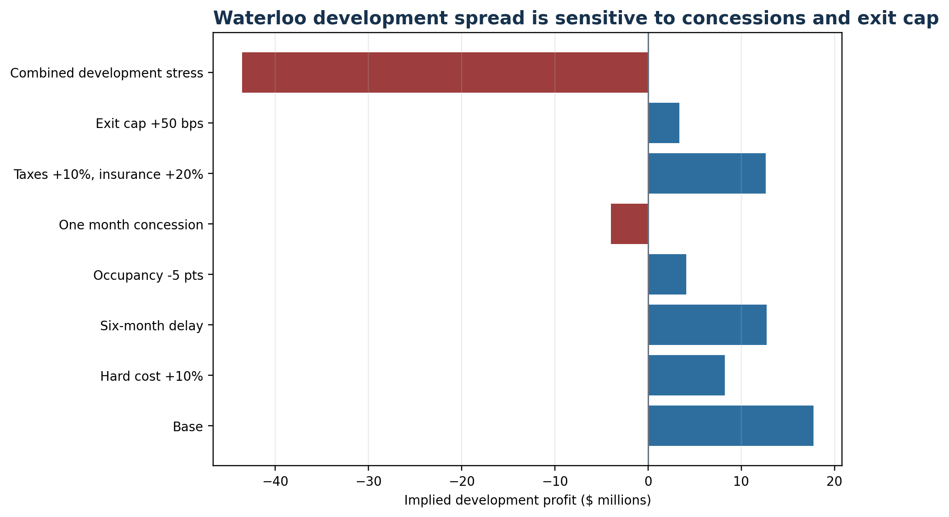
Exhibit 7. Waterloo development spread under stress Source: Model. Companion to the cost-per-bed table; exhibit number repeated as one development exhibit.
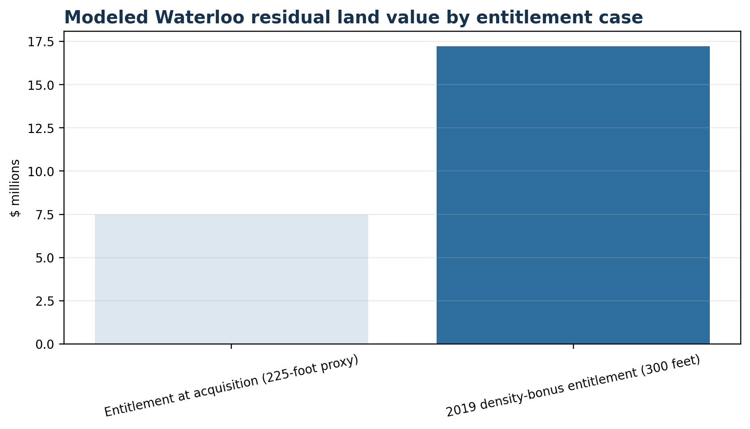
Exhibit 11. Waterloo residual-land analysis under two entitlement cases Source: S09, S24 and Model. The 225-foot case is a proxy, not an appraisal.

The Standard, Callaway and 26 West: debt, services and basis
The Standard at Austin shows how a high-margin tower can still sit close to a financing threshold. Landmark completed the 934-bed property in 2021 after a reported $101.1 million construction loan. It recapitalized the property in 2023 and retained ownership, but the recap debt amount, rate and maturity were not disclosed. The model therefore uses a $95 million illustrative current balance rather than presenting the old construction loan as current. [S11; EP-OWN-001]
Current asking rates and concessions support a $1,525 average face-rent assumption, 92% physical occupancy, half a month of recurring concessions and a $300 one-time concession per bed. The model produces $15.44 million of effective gross income and $9.39 million of NOI. At a 5.75% cap rate, value is $163.3 million. The illustrative debt produces 1.27x DSCR. A refinancing rate 200 basis points higher, constrained to 55% LTV and 1.30x DSCR, produces about $76.5 million of proceeds and an $18.5 million equity requirement. The conclusion is about sensitivity, not Landmark’s actual loan. [S19; Model]
Callaway reaches a similar NOI with very different inputs. Its $17.74 million of effective gross income is the highest in the six-property model, but $9.58 million of operating expense leaves $8.15 million of NOI. The central value is $148.2 million at a 5.50% cap rate. The basis is not public; the $110 million to $145 million range is triangulated from reported physical and revenue data, modeled NOI and price-per-bed controls. With illustrative 50% leverage, the central ten-year common IRR is 13.0%. A student may dislike the guaranty and relet terms while the owner earns an ordinary return for a service-heavy asset. Both can be true. [S03; S12; Model]
26 West is the opposite case. American Campus Communities bought the 1,026-bed property for $86.2 million in December 2011. The model’s current statement produces $17.24 million of effective gross income, $10.60 million of NOI and a 61.4% margin. At a 6.0% cap rate, central value is $176.6 million. The low acquisition basis drives a 25.5% modeled levered IRR with illustrative 45% leverage. This is the strongest above-market return in the sample, but it is not a realized sponsor return. Current property debt, major renovations, capital calls and historical distributions are unresolved. [S12; S14; EP-OWN-001; Model]
These three assets make basis the main divider. The Standard may be operationally profitable and still refinance poorly if recapitalization debt is high. Callaway may charge more and retain less because services consume revenue. 26 West may charge less and earn more because it was bought at a much lower price per bed. Rent practices alone do not rank investment returns. [Model]

How much of the West Campus price is a captive premium?
There is a persistent price difference between premium West Campus beds and lower-cost controls. The most direct comparison is not Austin’s citywide one-bedroom average. It is a set of imperfect substitutes. College Houses posts a private room around $955 for the academic term with utilities and internet. ICC Austin posts a private room around $1,175 including food, utilities and internet. Splitting the average North University two-bedroom gives about $787 per person before utilities. UT’s 2400 Nueces posts $1,141 for a 12-month 4x4 and $1,221 for a nine-month 4x4. Premium private towers commonly move into the $1,200 to $1,500 range for shared apartments, with studios and one-bedrooms much higher. [S06; S21; S23]
The price bridge in the model begins with an $850 central conventional split-housing control. It assigns about $375 to walk-to-campus location, $225 to furniture, internet and individual liability, $250 to new construction and amenities, $175 to room and bathroom privacy, and zero net for fees less concessions in the central case. That leaves about $100 per month unexplained. The ranges are broad. They are not a hedonic regression and do not prove that the residual is market power. [Model]
Several observed facts support a real location premium. UT enrolled 55,000 students in fall 2025, while university beds cover only a fraction of that population. West Campus lets residents walk to class and avoid a commute. Roommate matching and individual liability reduce coordination costs. Furnished units avoid move-in purchases. Private bathrooms and studios are different products from a split conventional unit. Those features have value even in a competitive market. [S15; EP-OP-001]
Several facts also support reduced student bargaining power. The leasing cycle begins in the fall before the next academic year. Families face search costs, roommate coordination, financial-aid timing and fear of losing a preferred layout. After execution, guaranties and relet rules make exit costly. Operators advertise dwindling inventory and short deadlines. Yet late-cycle concessions at Rise, Rambler and The Standard show that owners sometimes lack the leverage implied by early scarcity messages. The evidence is stronger for post-signing lock-in than for pre-signing monopoly. [EP-OP-001; S19]
The better description is a segmented market with high switching costs. Some students pay for true scarcity near campus. Some pay for privacy and services. Some pay because the individual-bed contract solves a roommate problem. Some overpay relative to their likely academic use because the product is billed across twelve installments. The remaining premium cannot be assigned to market power without executed lease data, inventory histories and a property-level rent regression. [Model]

Guarantors and preleasing: stronger collection, not guaranteed occupancy
Parental guarantees change credit risk. Callaway requires a guarantor unless the resident can self-qualify at three times the installment. Torre permits a guarantor or deferred-rent prepayment. Those structures move collection exposure from a student with little income to a family balance sheet or prepaid cash. They may reduce bad debt, support lower deposits and make lenders more comfortable with future rent rolls. The documents establish the mechanism. The sample does not contain cross-property bad-debt data proving the size of the effect. [S01; S03]
The same structure can exclude students without qualifying family support. It can also make a signed obligation harder to escape. A guarantor who has promised the full term gives the operator an additional collection target during a dispute or relet. That is contractual leverage, not the same thing as pricing power before the contract. [EP-OP-001]
Preleasing works in a similar way. It converts next year’s demand into signed paper months before move-in. ACC reported Callaway at 97.7% leased for 2015–16 roughly four months before move-in and 26 West at 99.8%. Waterloo was fully leased at delivery. SkyLoft’s January 2019 underwritten rent roll was 100% leased roughly seven months before the next fall. These observations come from different academic years and cannot be connected into one market curve. [S04; S09; S13]
Their value lies in the contrast. SkyLoft was 100% leased in the 2019 file and 42% occupied in March 2025 surveillance. An early rent roll reduced lease-up uncertainty for one year. It did not protect the property from later demand, management, reputation or capital problems. A guarantee improves recoverability on signed leases. It cannot make an unsigned bed pay rent. [S04; S05]
Public marketing data are too thin to decide whether early scarcity is real or staged. Rise has advertised limited spaces, short signing windows and large discounts at the same time. Torre has paired deadline language with fee waivers and immediate-move-in rates. Those pages show sales pressure, not inventory truth. A valid prelease test needs weekly leased-bed counts, remaining units by floor plan, executed rent and concessions within one academic year. [EP-OP-001]
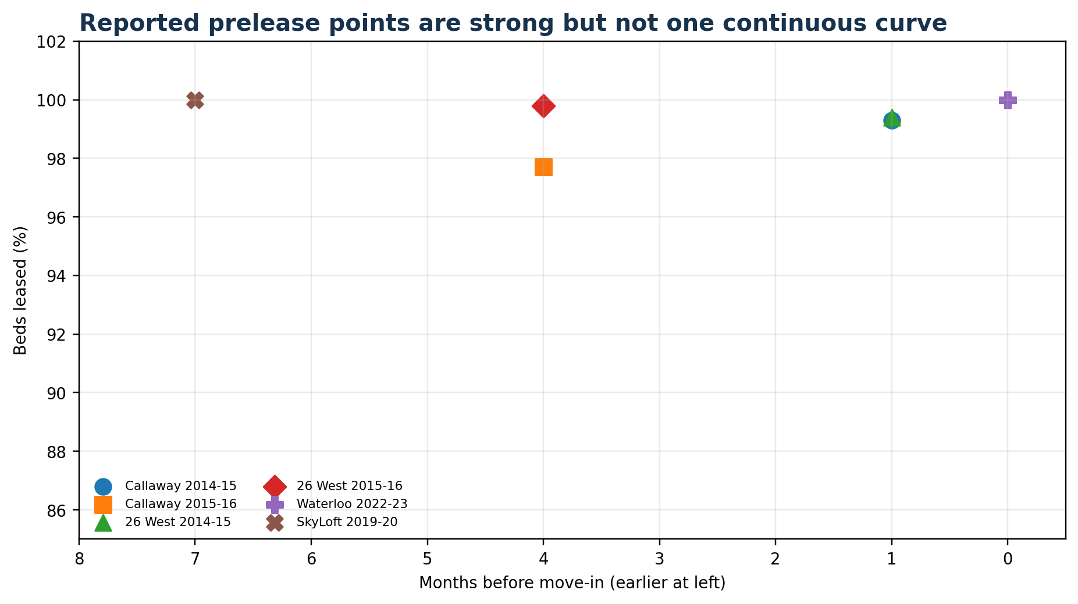
Exhibit 6. Prelease observations by property and academic year Source: S04, S09 and S13. Points from different years are not a single continuous curve.

What breaks
The standardized scenarios separate operating stress from financing stress. A 500-bed supply case applies a half-percent rent cut, one percentage point of occupancy loss and a tenth of a month of added concessions. The 1,500-bed case applies a 2% rent cut, three points of occupancy loss, half a month of added concessions and a 25-basis-point cap-rate increase. The 3,000-bed case applies a 4% rent cut, six points of occupancy loss, one added concession month and a 50-basis-point cap-rate increase. These are imposed shocks, not forecasts of how the West Campus market will react. [Model]
A combined stress applies a 4% rent cut, seven points of occupancy loss, one month of extra concessions, 10% higher taxes, 20% higher insurance, 8% higher payroll and repairs, $500 per bed of major replacement spending, a 75-basis-point cap-rate increase and refinancing at 200 basis points above the base rate. It is intentionally severe but internally consistent: weaker leasing reduces NOI while a wider cap rate reduces value and a higher debt constant reduces refinance proceeds. [Model]
SkyLoft enters that case with the least common-equity protection. NOI falls from $6.12 million to $3.94 million. Cash flow to common becomes negative $1.51 million after mortgage interest, preferred current pay and replacement spending. Implied value falls to $50.9 million, below the $66.125 million whole mortgage. Common and preferred capital are wiped in the model, and the subordinate mortgage becomes the first debt layer impaired. A refinancing sized to the model’s constraints produces only $28.0 million, implying a $38.1 million paydown against the existing whole loan. [Model]
The Standard’s NOI falls from $9.39 million to $5.97 million and value from $163.3 million to $91.9 million. The model still shows positive operating cash after resized debt, but the existing illustrative $95 million balance cannot be refinanced without roughly $46.3 million of equity. Waterloo requires about $41.6 million. Callaway requires about $26.3 million. 2400 Nueces requires about $7.8 million under the illustrative bond allocation. 26 West requires no paydown because its modeled current leverage begins much lower. [Model]
The refinancing result can be worse than the property-income result. Waterloo’s combined-stress NOI still covers newly sized debt at 1.30x, but the loan that can meet that covenant is only $46.4 million against an illustrative $88 million existing balance. An owner with enough equity can survive. An owner without it may sell, bring in preferred capital, negotiate an extension or hand control to a lender. The property can remain occupied and cash-flow positive while common ownership changes. [Model]
Supply and concessions hit the newest towers hardest because their basis leaves less room. One month of concessions reduces SkyLoft NOI by about $870,000 and pushes common cash flow negative. It reduces Waterloo NOI by about $1.14 million. In the Waterloo development model, the same one-month concession moves profit from positive $17.7 million to negative $4.0 million. 26 West also loses NOI, but its much lower acquisition basis preserves a larger equity cushion. [Model]
Enrollment is the slower-moving risk. UT reported record fall 2025 enrollment, so the base case does not assume contraction. The university’s Whitis Avenue project is expected to deliver 1,000 gross beds and about 800 net new beds for fall 2027. Icon delivered 555 beds for 2025–26. The current pipeline evidence is incomplete, and a 3,000-bed shock should not be reported as a forecast. It is a test of how quickly concessions, value and refinance proceeds can move when several pressures arrive together. [S15; S16; EP-OP-001]
Exhibit 10. Base returns and combined-stress equity outcomes Source: Model. Non-SkyLoft leverage and debt terms are illustrative; one-year stress values are not IRRs.
Property | Unlev. IRR | Lev. common IRR | Base value | Combined value | Combined equity | Refi paydown | First loss
SkyLoft | 4.5% | -10.3% | $87.4m | $50.9m | $-12.1m | $38.1m | Property cash flow, then common equity
2400 Nueces | 11.8% | 17.6% | $105.5m | $62.3m | $28.0m | $7.8m | Project rental-income cushion, then UT System support
Waterloo | 7.5% | 8.3% | $156.3m | $91.1m | $44.7m | $41.6m | Property cash flow, then common equity
The Standard | 8.7% | 10.6% | $163.3m | $91.9m | $43.2m | $46.3m | Property cash flow, then common equity
Callaway | 10.2% | 13.0% | $148.2m | $67.9m | $31.7m | $26.3m | Property cash flow, then common equity
26 West | 18.9% | 25.5% | $176.6m | $104.7m | $47.1m | $0.0 | Property cash flow, then common equity

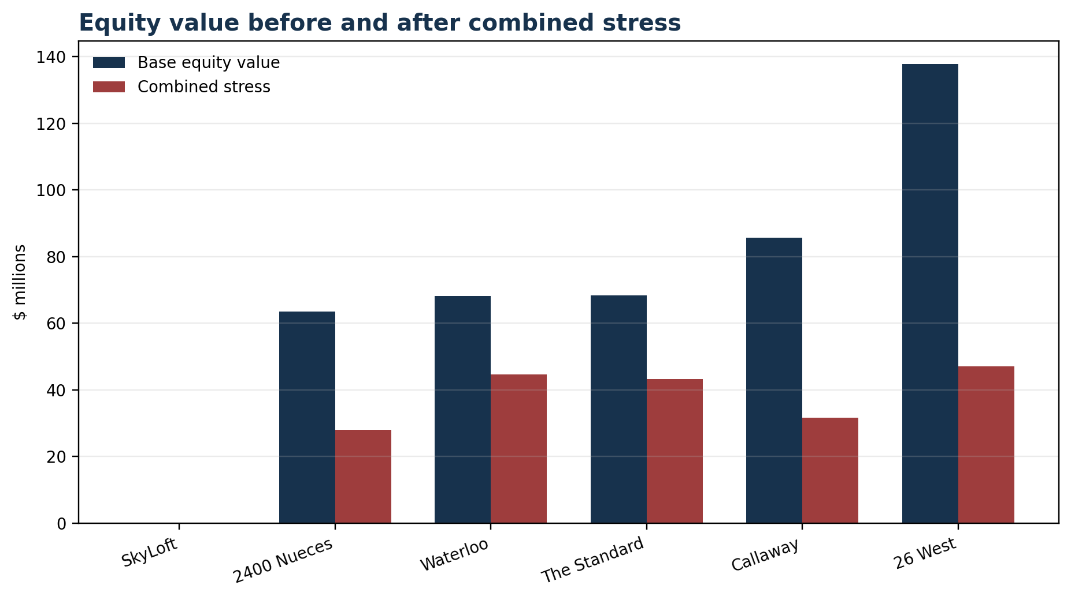
Exhibit 10. Equity value in the base and combined-stress cases Source: Model. Companion to the returns table.

Who absorbs the first loss
The generic waterfall needs one correction at the top. A tenant or guarantor absorbs only a signed obligation. They do not cover speculative vacancy elsewhere in the building. Unleased beds first reduce property cash flow. That loss reaches common sponsor equity through lower distributions and lower value. Preferred equity follows economically, although its control rights may activate before its capital is fully lost. Mezzanine debt and subordinate mortgage debt follow according to their contracts. Senior mortgage debt is last. [S01; S03; S04]
SkyLoft makes the sequence visible. At the central modeled value of $87.4 million, the $66.125 million whole mortgage is covered, common equity is zero and the $35 million preferred principal is partly impaired. At the $50.9 million combined-stress value, the common and preferred layers are gone and about $15.2 million of the subordinate mortgage lacks value coverage, while the $36 million senior balance remains covered. Legal enforcement costs, reserves and claim timing would change recoveries, but the economic order is clear. [Model]
Control can move before final loss. SkyLoft’s preferred investor held loan-purchase and change-of-control rights. A senior lender can sweep cash after covenant triggers. A manager may continue leasing while a special servicer controls major decisions. The party suffering the first dollar of economic loss and the party holding the first intervention right are not always the same. [S04]
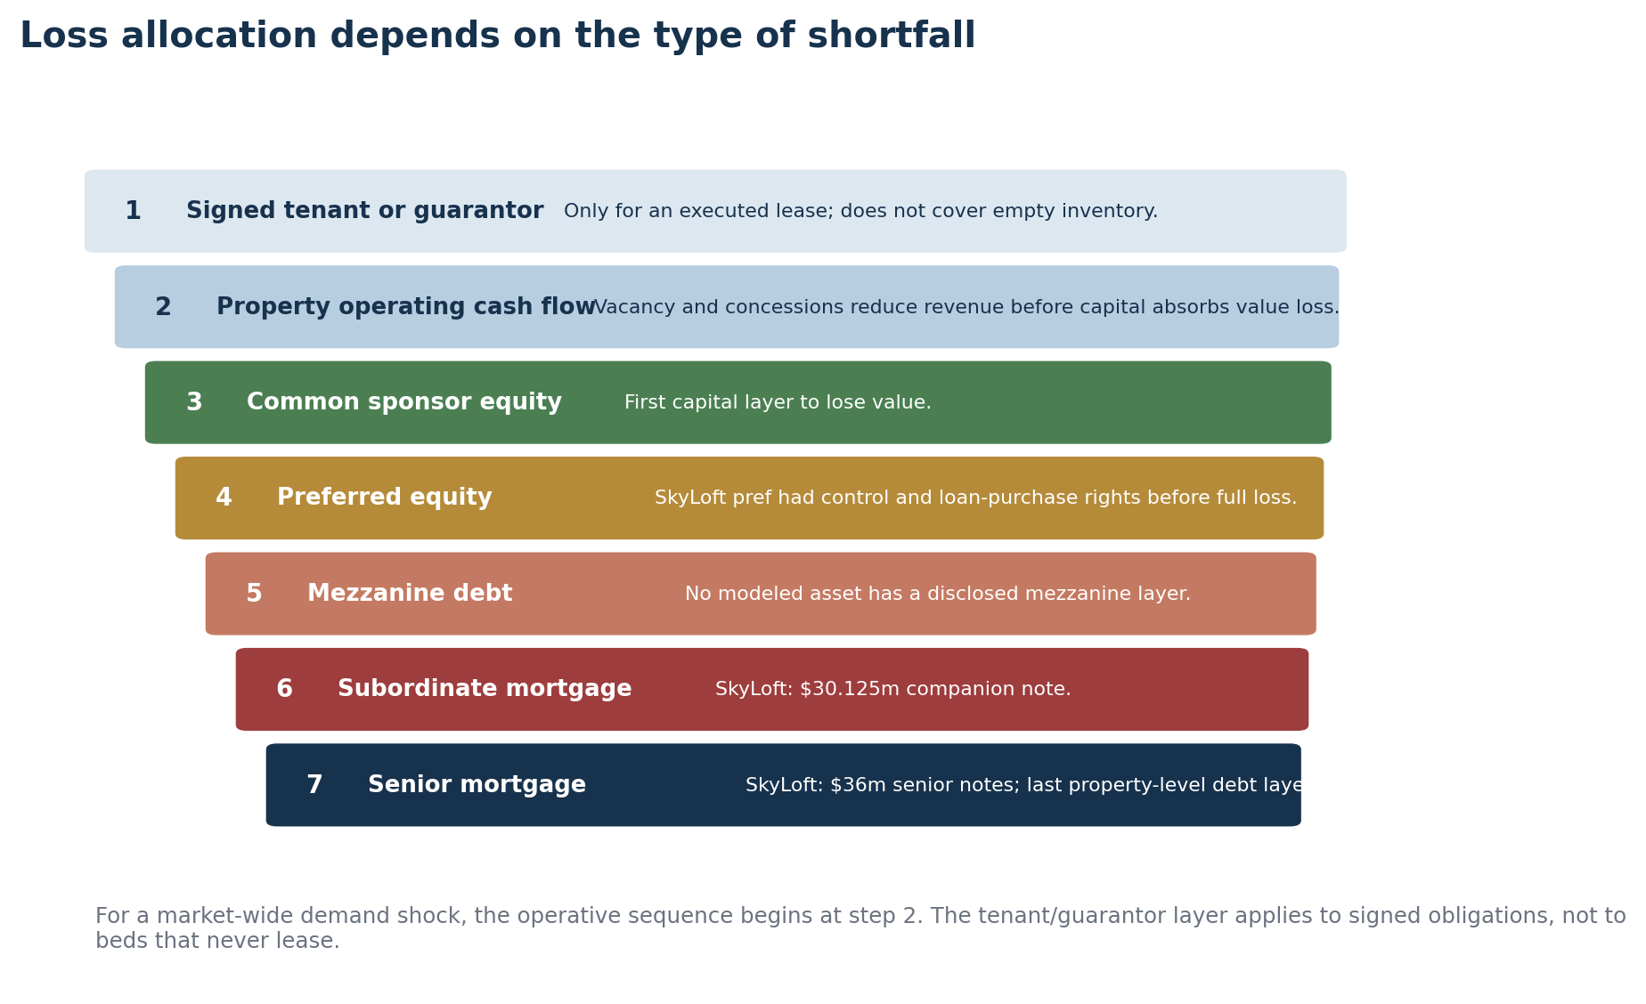
Exhibit 12. Loss waterfall and control rights Source: Lease sources, S04 and Model.

Following one payment to the end
Return to the $1,959 Callaway installment. In the student contract it buys a furnished place, meals, utilities, internet, housekeeping and proximity. It also binds the resident and, usually, a guarantor to a defined school-year amount. In the building model, each revenue dollar first pays the service-heavy operating statement. About 54 cents goes to property operations and management, leaving 46 cents of NOI. Under the illustrative capital structure, roughly 26 cents of revenue goes to debt service and about 19 cents remains as current common cash flow before ownership-level taxes and nonrecurring capital. [Model]
The same rent dollar behaves differently at 26 West. The operating margin is about 61 cents, the modeled debt burden is lower, and the old $86.2 million acquisition basis leaves a large equity cushion. At SkyLoft, the property margin is also about 59 cents, but whole-loan interest and preferred current pay consume nearly all cash available to common equity. The contract can be equally collectible in each building while the sponsor outcome diverges. [Model]
The evidence supports a location premium, individual-bed monetization, early contractual lock-in and stronger collections through guarantors. It supports unusually good stabilized property margins at several towers. It does not support one return claim for all owners. The highest modeled return belongs to the older asset bought cheaply. The weakest belongs to the tower with the most disclosed capital layers. When demand or financing weakens, the loss does not travel backward to every student. It moves through the property statement and then through common equity, preferred capital, subordinate debt and senior debt in the order set by the contracts. [Model; S04]

Source and assumption notes
Exhibit 13. Source and assumption notes Source: Full source ledger and claims matrix are in the supporting appendix.
Property | Rent / operations | Acquisition-basis evidence | Debt evidence | Cap range | Source IDs
SkyLoft | Reported | Actual purchase price $119.55m; central basis includes disclosed reserves and closing costs. | Actual 2019 whole loan; 120-month interest-only | 6.50%-8.00% | EP-OP-001; EP-OWN-001; S04; S05; S21
2400 Nueces | Modeled from current asks | Actual 2018 UT System purchase price; original 2013 development cost reported at $63.9m. | Illustrative current RFS-bond allocation; actual project balance not public | 4.75%-5.75% | EP-OP-001; EP-OWN-001; S06; S07; S08
Waterloo | Modeled from current asks | Sale price not disclosed; range triangulates cap-rate, price-per-bed and development-cost methods. | Illustrative current leverage; actual GSA debt not public | 5.00%-6.00% | EP-OWN-001; S09; S10; S22; S24
The Standard | Modeled from current asks | Range implied by $101.1m construction loan at 60%-70% LTC; current recap amount not disclosed. | Illustrative current recap balance; 2018 construction loan was $101.1m | 5.25%-6.25% | EP-OWN-001; S11; S19
Callaway | Modeled from current asks | Basis not public; range triangulates disclosed revenue, modeled NOI and price-per-bed controls. | Illustrative asset leverage; ACC/Blackstone property-level debt not public | 5.00%-6.00% | EP-OP-001; EP-OWN-001; S03; S12; S13; S20
26 West | Modeled from current asks | Actual December 2011 purchase price was $86.2m; range allows transaction/initial-capex uncertainty. | Illustrative asset leverage; current ACC/Blackstone debt not public | 5.50%-6.50% | EP-OWN-001; S12; S13; S14

Reported means the cited source states the figure directly. Modeled means the workbook combines public physical data, current asking rates, concessions and documented expense controls. Tax appraisal is not used as acquisition price. Preferred equity is shown separately from common sponsor equity.
The article should be read with the workbook. Every hard-coded property assumption, formula, basis range, scenario and source ID appears there. Current asset debt is unresolved for five properties; those capital structures are presented as illustrative cases, not facts.
Source IDs correspond to the ledger in West_Campus_Dossiers_Methodology_Claims.docx and the Sources tab in West_Campus_Property_Models.xlsx.

