SOURCE-GROUNDED INVESTIGATION AND UNIT-ECONOMIC MODEL

Where Your Online Return Actually Goes
  - The reverse-logistics tax on online shopping
A product-level investigation of what survives after the refund: transportation, inspection, repair, liquidation, resale, fraud, ownership and environmental disposition.

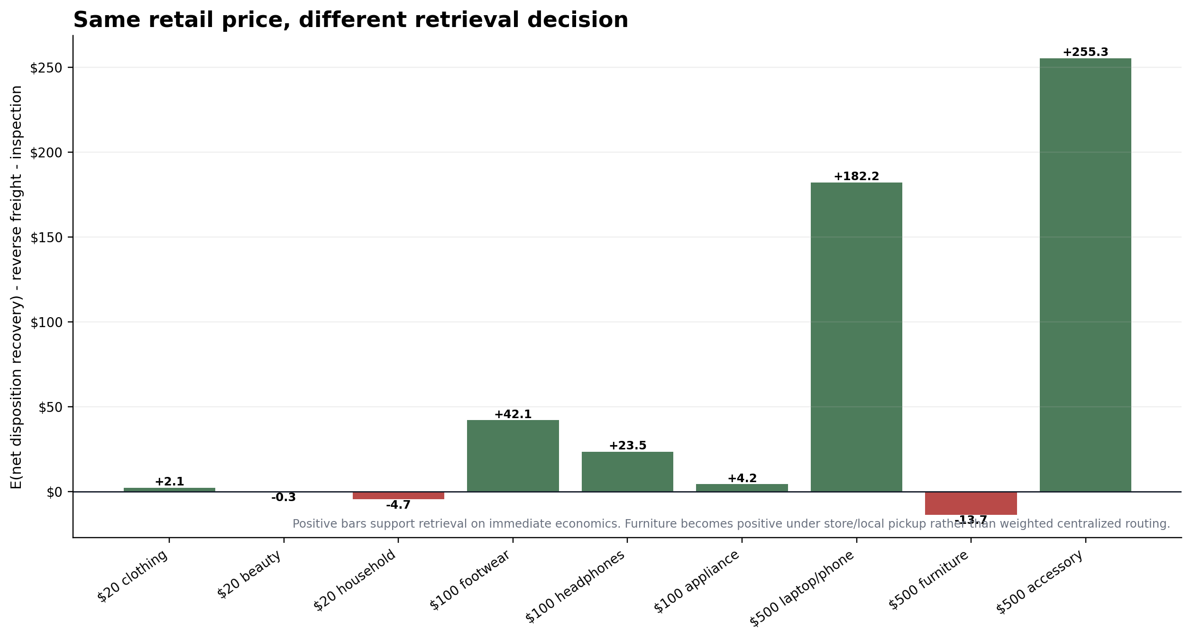
Prepared from the two supplied evidence documents and their cited source records. No new external research was added.
Model date: July 22, 2026 | Base currency: U.S. dollars | Retail prices modeled: $20, $100 and $500

Contents
Executive analytical memo
Investigative article
1. The refund does not tell you where the product went
2. The return decision engine
3. Inside the return center
4. Six products, six different routes
5. The market after the retailer
6. How much value survives
7. The $20, $100 and $500 return
8. Fraud changes the decision
9. Sustainability claims meet disposition economics
Detailed methodology
Unit-economic model and sensitivity
Auction analysis
Category and operating-model comparison
Calculation appendix
Assumption register
Research limitations
Fact-check checklist
Source ledger
Reading the figures
All percentages labeled “modeled” are scenario outputs, not company disclosures. Source IDs in brackets map to the Source Ledger. The spreadsheet deliverable contains the full 1,701-row disposition engine and editable assumptions.

Executive analytical memo
Decision statement. The economic value of a return is set by the cost of learning what the item is, the cost of moving it, and the set of resale channels still legally and commercially available. Retail price matters, but value density, condition, time, fraud and contract structure often matter more.
The model’s original contribution is visible inside each price tier. At $20, the clothing item produces $2.11 of incremental retrieval value, while the beauty item is $-0.28 and the small household item is $-4.68. At $100, the same metric ranges from $4.22 for the appliance to $42.06 for footwear. At $500, the laptop/phone and premium accessory support recovery, but the weighted centralized furniture route is negative by $13.74; a local pickup route turns it positive. These are model results, not disclosed company averages.

Exhibit A. Same retail price, different retrieval decision Source: Model; assumptions in Appendix B
Product | Price | E(net recovery) | Reverse freight | Inspection | Retrieve value | Return tax / return | Expected tax / order | Base action
Basic clothing ($20) | $20 | $6.90 | $3.62 | $1.17 | $2.11 | $17.97 | $4.49 | Retrieve through store/drop-off; returnless for long parcel
Cosmetic/personal-care ($20) | $20 | $3.64 | $3.23 | $0.70 | $-0.28 | $20.31 | $2.03 | Returnless for parcel; retrieve via store return
Small household ($20) | $20 | $3.42 | $7.16 | $0.93 | $-4.68 | $24.71 | $2.97 | Returnless for parcel; retrieve via store return
Footwear/premium apparel ($100) | $100 | $49.07 | $5.14 | $1.87 | $42.06 | $58.30 | $17.49 | Retrieve
Headphones/small electronics ($100) | $100 | $33.37 | $5.91 | $4.00 | $23.46 | $77.44 | $9.29 | Retrieve
Small appliance ($100) | $100 | $22.34 | $13.12 | $5.00 | $4.22 | $96.23 | $14.44 | Retrieve
Laptop/phone premium electronics ($500) | $500 | $200.58 | $8.20 | $10.20 | $182.18 | $322.72 | $32.27 | Retrieve
Furniture ($500) | $500 | $95.16 | $98.90 | $10.00 | $-13.74 | $514.04 | $92.53 | Route locally (store/local pickup); avoid long-haul/oversize
Premium apparel/accessory ($500) | $500 | $269.18 | $7.90 | $6.00 | $255.28 | $248.57 | $49.71 | Retrieve

Table 1. Base-case unit economics for nine product archetypes Source: Model. Price and product definitions are assignment inputs; remaining values use the Assumption Register.
What the model says about margin
Under the required definition, product cost C, original fulfillment Fo and original payment cost P cancel from the dollar return tax because both the kept-sale and returned-sale cases bear them. They still determine post-return loss and the percentage of kept-sale contribution consumed by the return. A lower-margin product therefore experiences the same incremental dollar tax but a much larger percentage hit.

Eight findings
- A refund and a physical return are separate events. Amazon reports a refund liability and a distinct recovery asset; marketplace policies allow cash settlement before final physical disposition. [S01, S02, S05]
- Returnless refunds are economically rational when expected recovery does not cover reverse freight and inspection. In the base model, mailed beauty and low-value household returns fail that test; store return can still work because the logistics cost collapses. [S02, S07; Model]
- Value density explains the furniture result. The modeled $500 furniture item carries only about $3.60 of retail value per billable pound, versus more than $71 for the $500 laptop/phone. A weighted reverse-freight burden of $98.90 exceeds the furniture item’s maximum economical freight of $85.16. [S17, S21-S24; Model]
- Inspection is an investment in information. The $100 headphones can support roughly 55 minutes of inspection at the modeled labor rate before retrieval turns negative; the $20 household item cannot support the two-minute base inspection under its weighted parcel route. [Model]
- Liquidation recovery and consumer resale price are different layers. The two public lots produce inferred bids of 14.6% and 19.6% of stated retail; consumer-facing refurbished electronics can sell far higher because a downstream operator has absorbed freight, testing, repair, warranty, listing and failed-unit risk. [S32, S33, S35-S37, P02]
- Buyer delivered cost is not retailer recovery. With explicit assumptions for buyer premium and freight, the two observed lots rise to 26.7% and 49.4% of stated retail at the buyer’s dock, while estimated retailer net recovery after seller-side fees and prep falls near 10%-12%. [S36, S37, S49; Model]
- Fraud control clears a higher hurdle on premium goods. In the illustrative control scenario, extra inspection and false-positive costs are not justified for $100 footwear or headphones, but they are positive for the $500 electronics and accessory because loss given substitution is much larger. [S31; Model assumption]
- Sustainability claims are usually numerators without the denominator needed to calculate a customer-return disposition rate. Liquidation proves title transfer, not reuse; 'proper disposal' proves a policy outcome, not landfill, recycling or energy-recovery shares. [S04, S08, S30, P01, P02]

Investigative article
OPENING
A $100 pair of headphones is dropped at a nearby return counter. The customer’s refund can post before the product reaches a return center. The item is consolidated with other returns, moved to a facility, opened, matched to a serial number and tested. That sequence is not clerical overhead. It is a bet: spend roughly $5.91 on reverse movement and $4.00 on intake and inspection in the base model, then decide whether the item can support open-box or refurbished proceeds.
The expected net disposition recovery is $33.37. Retrieval therefore adds $23.46 before the model’s separate fraud-administration cost. But the original sale would have generated $46.20 of contribution; after the refund and recovery chain, the returned order lands at $-31.24. The return tax is $77.44. A successful recovery does not make the return profitable. It makes the loss smaller.
The same price does not produce the same decision. A $100 small appliance has only $4.22 of retrieval headroom because its package and testing costs are heavier. A $100 footwear return has $42.06, because it can move cheaply and often re-enter a controlled restock or outlet channel. Price is one input. The route is the outcome of a chain.

1. The refund does not tell you where the product went
The consumer sees money move. The merchandise can remain still. Walmart sellers can establish Keep It rules when return shipping is uneconomic. Amazon seller programs include returnless resolutions. eBay can require or enforce a refund through seller settlement while the seller remains the economic owner. These programs make the separation explicit: a platform can settle the customer claim without creating a recoverable product asset. [S02, S05, S07]
The accounting makes the split visible. Amazon reports return-allowance liabilities and a separate asset for rights to recover products from customers. Nike reports a sales-returns reserve separately from its inventory reserve. The refund obligation and the expected value of returned goods do not move one-for-one. [S01, S20]
Four measures that cannot be substituted for one another
Customer refund is R-K. Retailer exposure is the returned-order contribution after all original and reverse costs. Physical recovery describes whether usable product or material comes back. Environmental disposition describes resale, transfer, donation, recycling or disposal. A full refund can coexist with high physical recovery, low financial recovery, or an unknown final environmental endpoint.

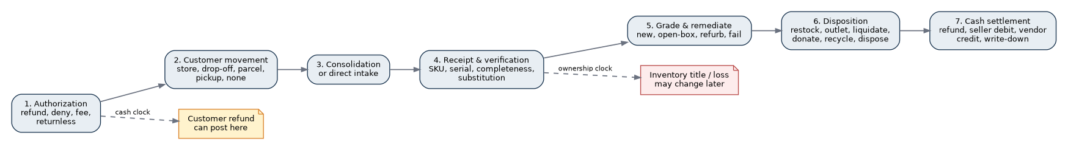
Exhibit 1. End-to-end return flow Source: P01; S02-S07; S21

2. The return decision engine
The retrieval decision is an expected-value calculation. The retailer does not need the product’s full future value. It needs the probability-weighted, time-adjusted recovery after cleaning, testing, storage, selling fees, secondary transport and disposal to exceed reverse freight and the cost of learning the item’s condition. The simplified rule is:
Immediate retrieval rule
E(Recovery if retrieved) - F_r - H > 0
Strategic value can override the immediate result: fraud deterrence, serial control, safety, evidence, vendor reimbursement, warranty and customer-account policy.

The condition probability matters twice. First, it changes expected proceeds. Second, it changes which route is eligible. An unopened product can support primary restock. A lightly used device may justify refurbishment. An opened cosmetic can retain physical material while losing commercial resale eligibility. A substituted laptop can have almost no legitimate recovery but high evidentiary value. [S08, S11, S16, S29; Model]
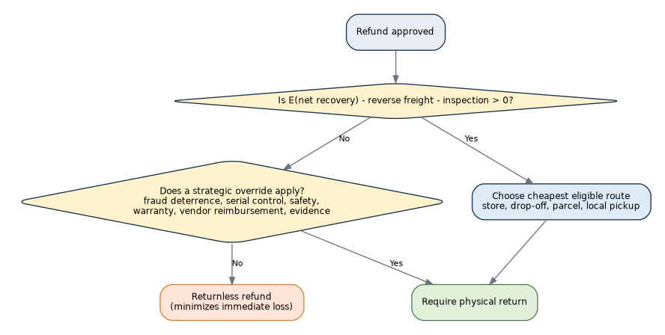
Exhibit 3. Returnless-refund decision tree Source: S02; S07; P01; Model
The model’s break-even thresholds expose why retail price is not enough. The $20 clothing item needs about $9.18 of gross recovery conditional on receiving the correct item. The $20 household product needs $12.49, more than 62% of retail, because its parcel cost is so high. The $500 laptop/phone needs only about 11% of retail on the same measure. [Model]

3. Inside the return center
A return center manufactures information. Consolidation reduces transportation and per-unit receiving cost, but it can delay resale. Happy Returns markets five-day arrival and faster restocking, though those figures are vendor claims. Target’s reverse-logistics role lists central return centers, donation, salvage, electronics recycling, vendor credits and inventory removals. Those materials prove the tasks and routes exist; they do not reveal throughput or route shares. [S04, S27]
Inspection is not one uniform step. Apparel can require tags, odor, wear, size and season checks. Electronics add serial identity, activation, battery health, function, accessories and data risk. Furniture adds structural condition, missing hardware, assembly state and packaging damage. Beauty turns on seal and integrity. The labor can be shorter than the transport, yet still exceed the product’s net recovery on low-value goods. [S08, S11, S12, S16, P01]
The disposition decision is another expected-value problem. After safety and identity filters, the inventory owner compares only eligible routes and chooses the highest present-value net proceeds. Brand rules, channel capacity, contractual restrictions and labor queues can remove the apparent top option. [S06-S08, S11, S29; Model]
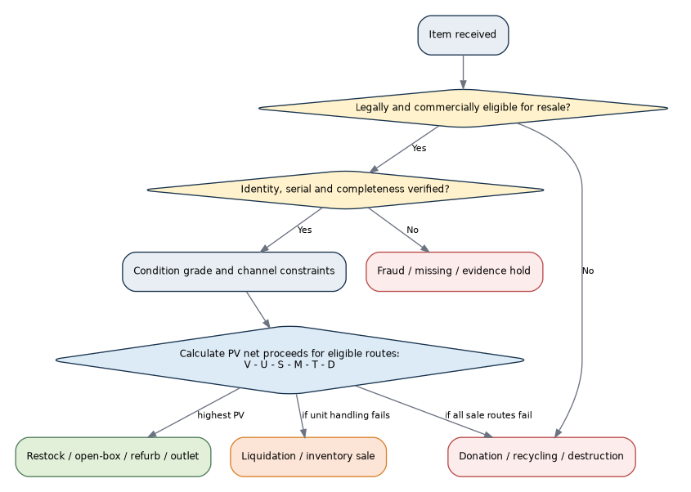
Exhibit 4. Disposition decision tree Source: S06-S08; S11; S16; S29; Model

4. Six products, six different routes

$20 clothing: cheap to ship, costly to sort
The modeled clothing item can be recovered when it comes back through a store or consolidated drop-off. Its base expected recovery is $6.90, against $3.62 of weighted reverse freight and $1.17 of inspection. The same item is barely uneconomic through a short parcel and clearly uneconomic through a long parcel. The model sends unopened and clean opened units back to stock, lightly used units to outlet, and damaged units to liquidation. Apparel auction evidence in the package sits in the low-to-mid teens of retail, while store return networks can preserve more value by avoiding parcel freight and delay. [S15, S18, S32; Model]
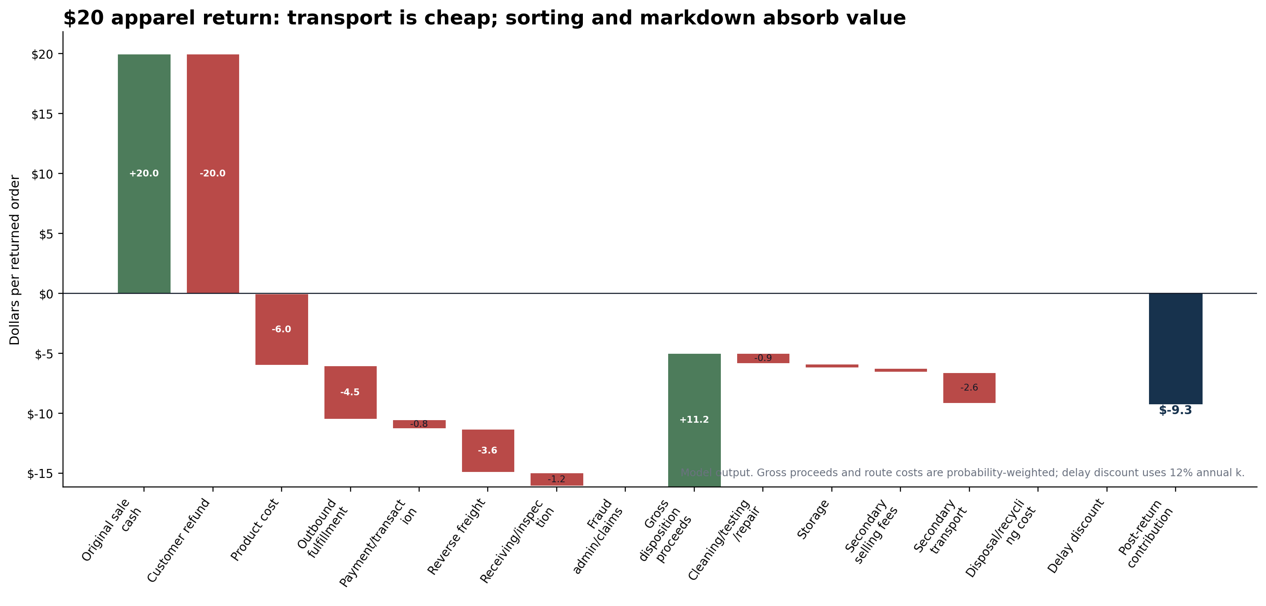
Apparel value waterfall Source: S15; S18; S32; Model

$20 beauty: physical value without commercial value
An opened cosmetic can still contain almost all of the original material. That does not mean a retailer can sell it. Ulta states that used, damaged or expired returned products are not resold and are disposed of. FDA rules set a safety and labeling floor, but a retailer can adopt a stricter commercial standard. In the base model, only the 32% unopened share returns to stock; the balance is disposed or lost to a fraud/missing outcome. [S08, S16, S41; Model]
Under the weighted return route, retrieval value is $-0.28. Store intake remains positive, but a parcel return does not. The immediate economic answer is a returnless refund unless safety, evidence or abuse controls require possession. The environmental answer is not known from the phrase 'properly disposed.'

$100 headphones: testing buys a higher-value channel
Electronics justify a deeper look because the resale spread is larger. The modeled headphones allocate 47% of units to open-box resale, 13% to refurbishment and 12% to recycling, with 5% assigned to substitution or missing-return risk. A damaged but repairable unit supports up to $18.20 of refurbishment cost before liquidation becomes preferable; the model uses $12. [S11, S39; Model]
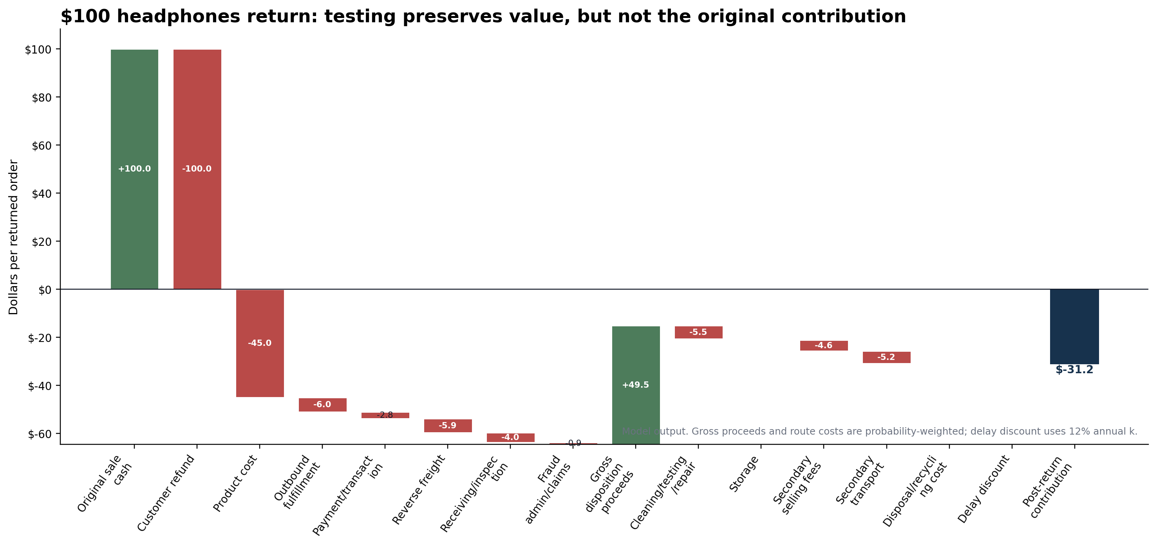
Exhibit 6. $100 headphones recovery waterfall Source: S11; S39; Model

$100 small appliance: a narrow retrieval margin
The appliance is the fragile case inside the $100 tier. Its expected net recovery is $22.34, but weighted reverse freight and inspection consume $18.12. Retrieval remains positive by only $4.22. In the low-recovery scenario it turns negative. The damaged-condition repair budget is lower than the modeled repair cost, so liquidation wins even when every eligible route produces a weak result. The public microwave lot reinforces the low-recovery channel: its inferred winning bid was 14.6% of stated retail before buyer fees and freight. [S37; Model]

$500 laptop or phone: high value density funds control
The premium device is expensive to lose and cheap to move relative to its value. The model produces $182.18 of retrieval value after reverse freight and inspection. Damaged units route to refurbishment; the maximum economical refurbishment cost is $102.70, versus a $45 model input. Delay matters because the model depreciates premium electronics at 3.5% per month. The same economics make serial checks and fraud controls more defensible. [S11, S33, S35, S39; Model]
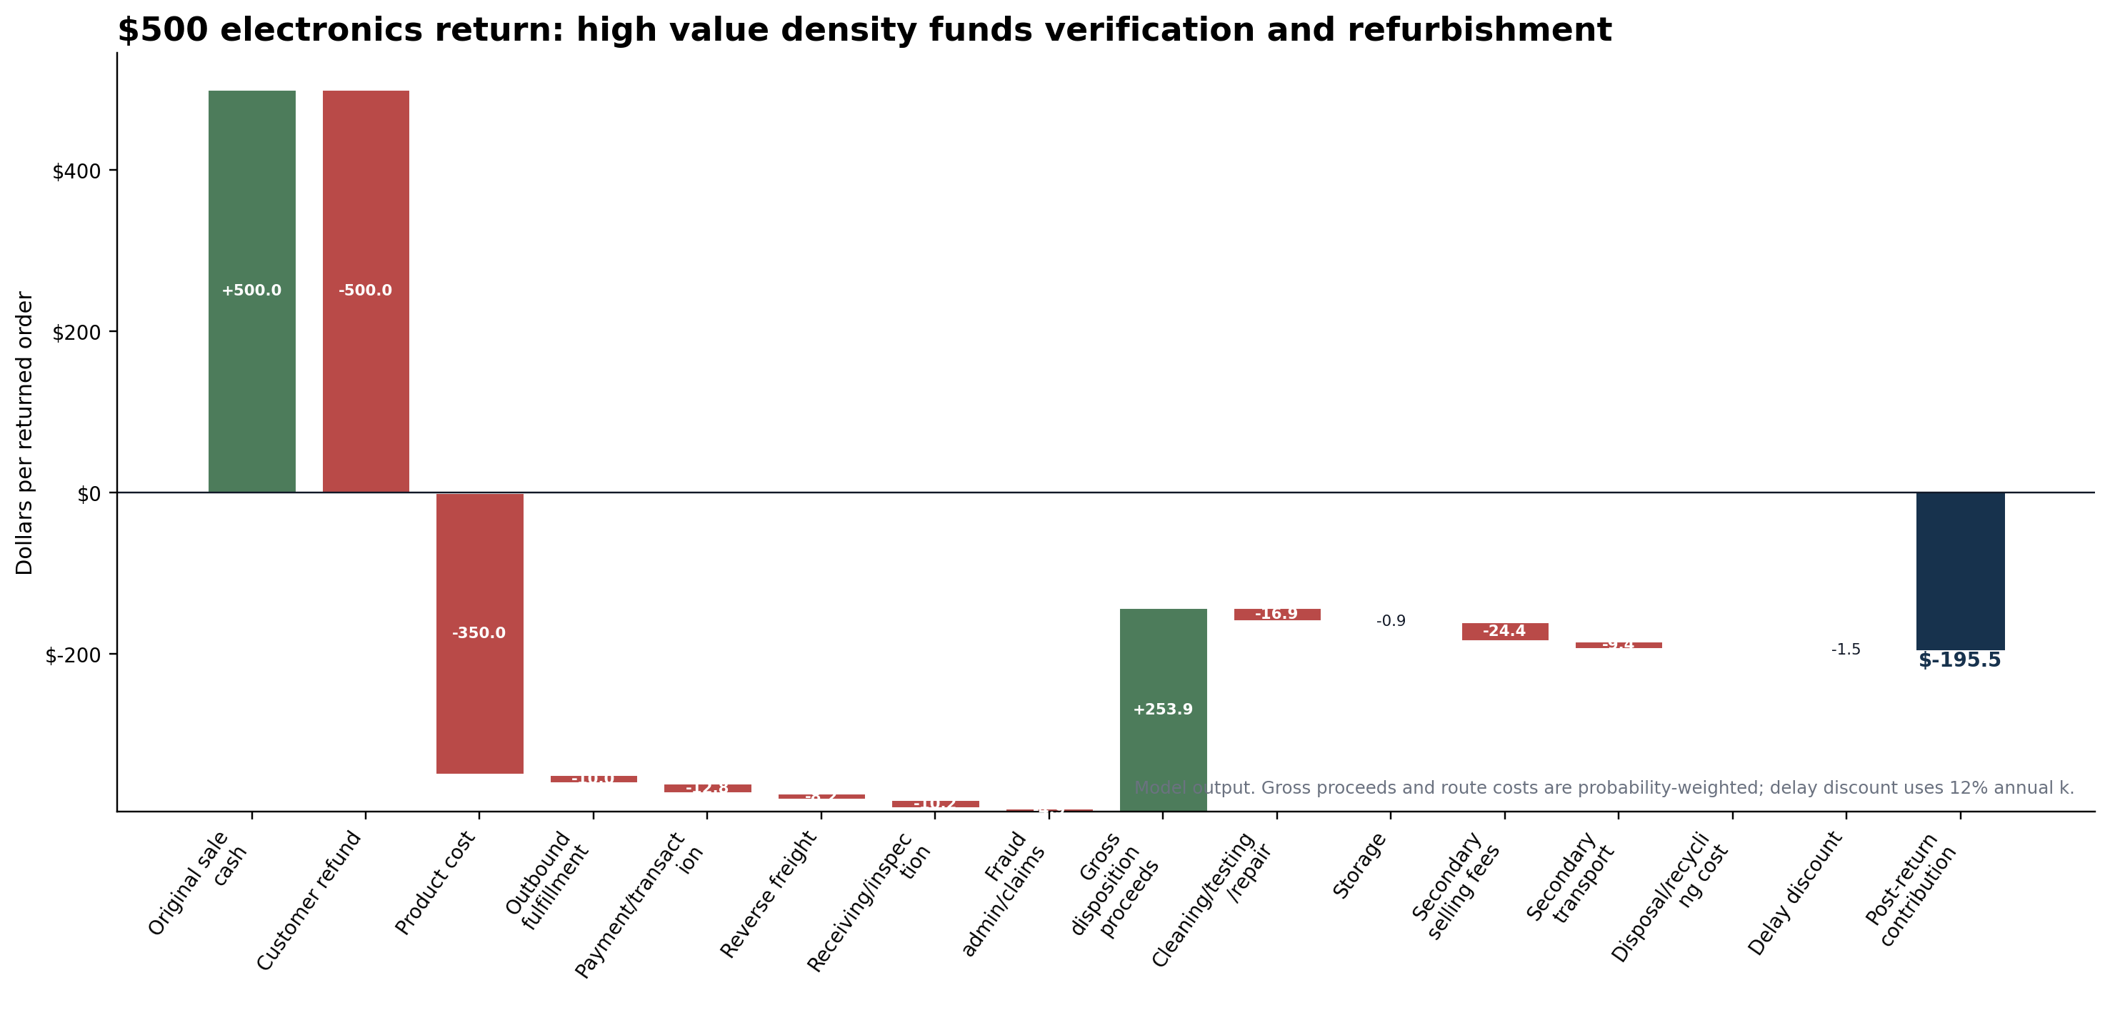
Premium electronics value waterfall Source: S11; S33; S35; S39; Model

$500 furniture: consumer value, negative centralized recovery value
Furniture demonstrates why ticket price can mislead. Wayfair discloses that many products need special handling and can be damaged in transit. WFS lists a big-and-bulky return-processing fee of $155 plus $0.80 per pound over 90 pounds, while UPS and FedEx tariffs expose additional-handling and large-package surcharges. The model’s 48 x 20 x 20 inch package has a 138-pound DIM weight before rounding. [S12, S17, S21-S24]
The weighted reverse-freight assumption is $98.90, above the $85.16 maximum economical freight. The result is $-13.74. Store intake, short-distance routing and local pickup remain positive; long-distance parcel and oversize routes do not. Under a $25 fixed plus $1.25 per-mile local-routing proxy, the break-even distance is about 48 miles. [Model]
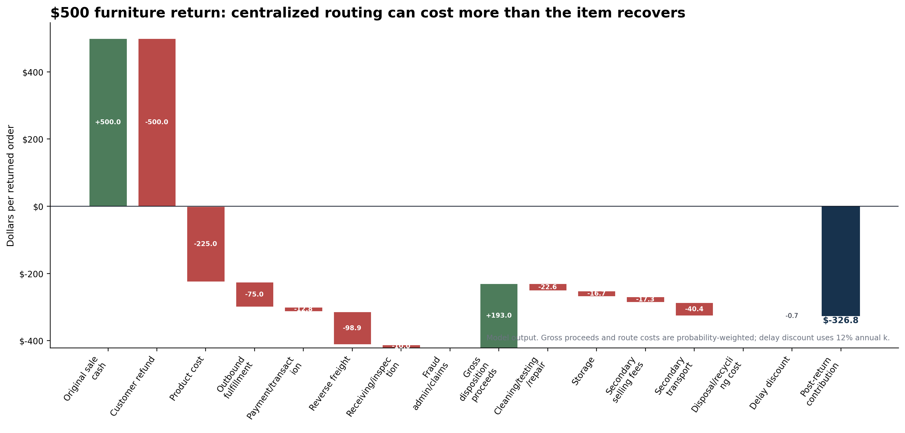
Exhibit 7. $500 furniture recovery waterfall Source: S12; S17; S21-S24; S40; Model

5. The market after the retailer
Liquidation is not one final market. National auction platforms sell pallets and truckloads. Regional wholesalers, bin stores, local auctions, repair shops, eBay sellers, social-commerce sellers, exporters, parts harvesters and scrap buyers take the next steps. B-Stock says it runs programs for major retailers; Liquidation.com combines returns with overstock, shelf pulls, salvage and other conditions. The inventory labels are not standardized enough to assume every lot is a pure customer-return sample. [S19, S28, S38, S42]
The downstream spread is payment for work and risk. The winning bid is not the buyer’s cost. Buyer premium, freight, liftgate, residential delivery, unloading, inspection, repair, storage, failed units and resale-channel fees sit between the auction and the final consumer sale. Liquidation.com terms compress the window for description disputes, transferring manifest and quality risk to the buyer. B-Stock reseller case studies show that skilled operators can rebuild value, but they are survivor stories, not a random sample of buyer returns. [S44, S45, S47, S49]
Exhibit 2. Ownership and loss allocation Source: P01; S01-S07; S21; S45

6. How much value survives
The public auction sample is too small to carry a market claim. It contains two completed Walmart/B-Stock lots. The microwave lot shows $7,004 of stated retail value, 102 units and an inferred final bid near $1,020, or 14.6%. The eBike lot shows $3,058 of stated retail value, 12 units and an inferred final bid near $600, or 19.6%. The exact conditions, buyer premium, seller settlement and freight were not public. [S36, S37]
The broader anchors are directionally consistent but not interchangeable. An apparel field study covering 11,879 auctions found 13.11% recovery for private label and 16.339% for national brands. Amazon’s FBA Liquidations guidance says sellers typically recover 5%-10% of average selling price within that program. An industry review places mixed customer returns around 10%-30% of MSRP. Each denominator and inventory population differs. [S32, S35, S42]
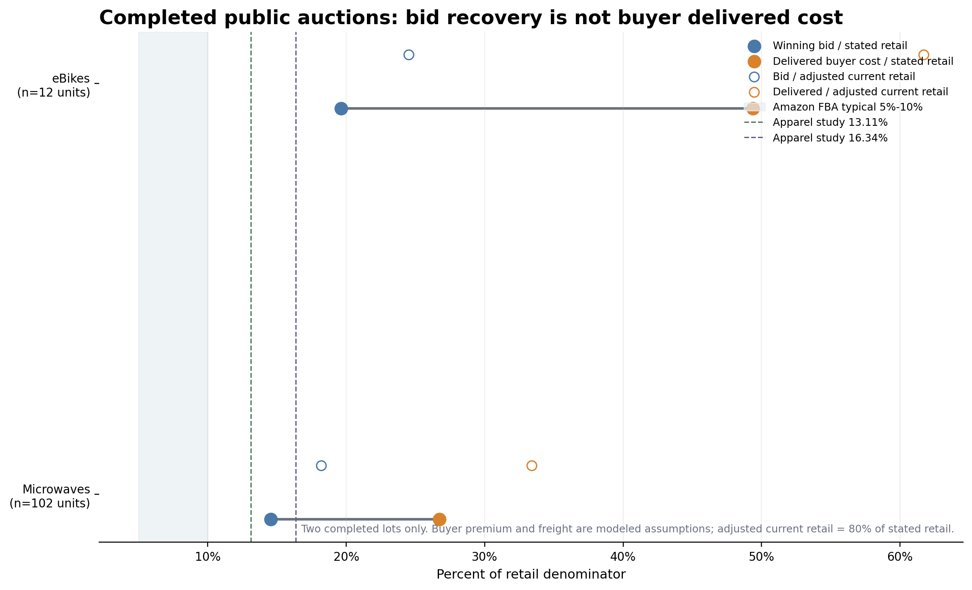
Exhibit 9. Auction recovery distribution Source: S32; S35-S37; S42; model assumptions for delivered cost
The buyer-cost adjustment is large. With a 10% buyer-premium assumption and modeled freight, the microwave lot’s delivered cost is 26.7% of stated retail; the eBike lot reaches 49.4%. On an adjusted current-retail denominator equal to 80% of stated retail, the figures rise to 33.4% and 61.7%. Those are acquisition costs, not retailer recovery or reseller profit.
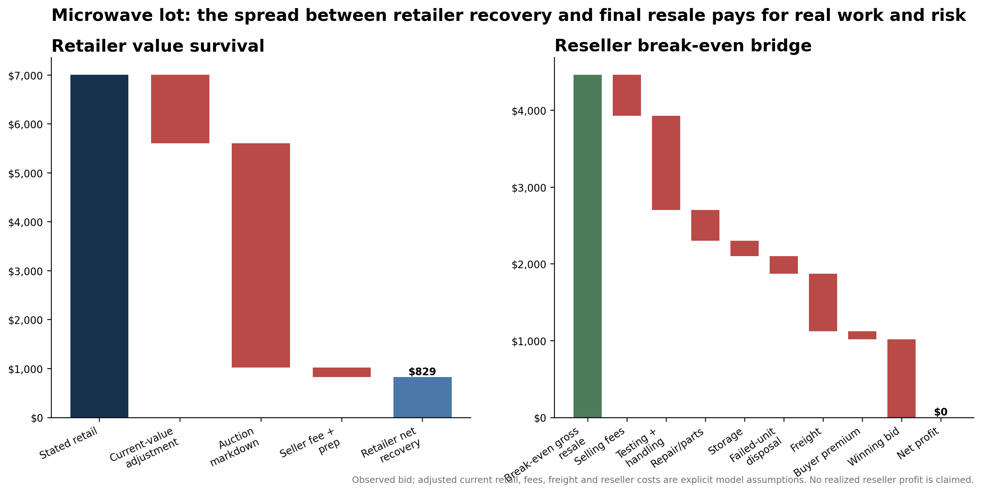
Exhibit 11. Retailer-to-reseller value waterfall Source: S37; S45; S49; model assumptions

7. The $20, $100 and $500 return
The nine-product grid isolates price from recoverability. Within each price tier, logistics, condition and channel change the retrieval decision more than price. The table reports the return tax as dollars per returned order and the expected tax across all orders using the modeled return rate.
Price | Product | Kept-sale contribution | Post-return contribution | Return tax / returned order | % of retail | % of kept contribution | Return rate | Expected tax / order | bps of sales
$20 | Basic clothing item ($20) | $8.70 | $-9.27 | $17.97 | 89.9% | 206.6% | 25.0% | $4.49 | 2,246 bps
$20 | Cosmetic/personal-care item ($20) | $10.20 | $-10.11 | $20.31 | 101.6% | 199.1% | 10.0% | $2.03 | 1,016 bps
$20 | Small household product ($20) | $6.70 | $-18.01 | $24.71 | 123.6% | 368.8% | 12.0% | $2.97 | 1,483 bps
$100 | Footwear/premium apparel ($100) | $55.20 | $-3.10 | $58.30 | 58.3% | 105.6% | 30.0% | $17.49 | 1,749 bps
$100 | Headphones/small electronics ($100) | $46.20 | $-31.24 | $77.44 | 77.4% | 167.6% | 12.0% | $9.29 | 929 bps
$100 | Small appliance ($100) | $45.20 | $-51.03 | $96.23 | 96.2% | 212.9% | 15.0% | $14.44 | 1,444 bps
$500 | Laptop/phone premium electronics ($500) | $127.20 | $-195.52 | $322.72 | 64.5% | 253.7% | 10.0% | $32.27 | 645 bps
$500 | Furniture product ($500) | $187.20 | $-326.84 | $514.04 | 102.8% | 274.6% | 18.0% | $92.53 | 1,851 bps
$500 | Premium apparel/accessory ($500) | $325.20 | $76.63 | $248.57 | 49.7% | 76.4% | 20.0% | $49.71 | 994 bps

Table 2. Return tax by product archetype Source: Model. Contribution margin is not GAAP gross margin.
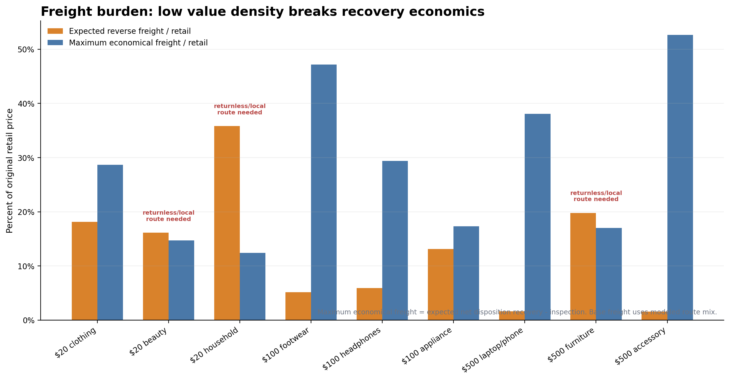
Exhibit 10. Freight burden by product type Source: S17; S21-S26; Model
The product-gross-margin sensitivity has a deliberately unusual result. Changing C does not change the dollar return tax under the required formula. It changes the kept-sale contribution denominator. For the $500 laptop/phone, the base return tax is 254% of kept-sale contribution; adding ten percentage points of product cost raises that ratio to roughly 418% without moving the dollar tax. The model therefore reports both dollars and percentages.
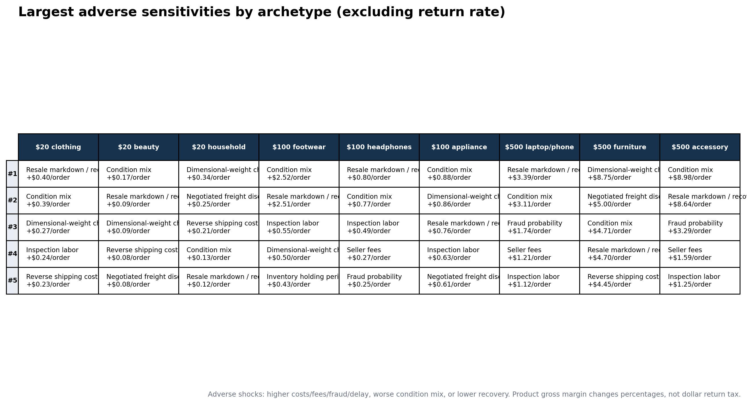
Top adverse operational sensitivities by product Source: Model

8. Fraud changes the decision
Public fraud estimates are not clean inputs. The evidence package cites industry reports with different populations and definitions, including fraud, abuse and claims. The model therefore uses narrower confirmed substitution/counterfeit probabilities by product and labels them assumptions. It does not treat broad industry percentages as exact category rates. [S31, P01]
The fraud calculation separates lost recovery from incremental administration. A fraudulent or substituted condition receives zero legitimate disposition recovery, so the lost recovery already enters through Qj. The variable A contains only investigation, claims and related administration. This avoids charging the same missing product value twice.
Expected total fraud loss
p_f x (lost recovery versus correct item + fraud administration)
In the main post-return formula, lost recovery is inside Qj; only the administration component is subtracted as A.

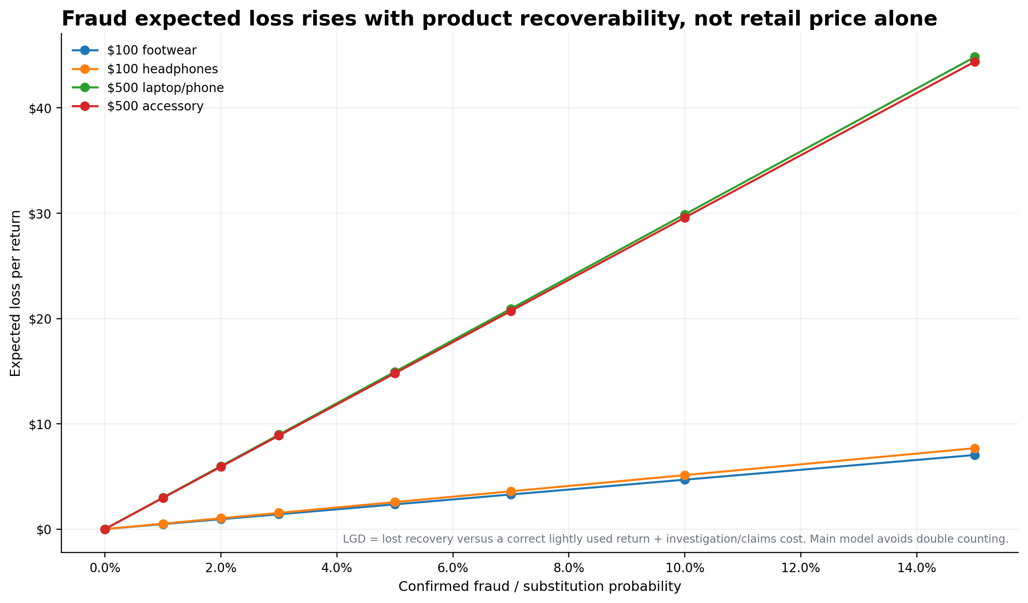
Exhibit 12. Fraud expected-loss sensitivity Source: S31; Model assumptions
Controls can cost more than they save. The illustrative control case adds inspection time, false-positive service cost and delayed-refund cost. It is negative for $100 footwear and headphones but positive for the $500 device and premium accessory. That is not a universal recommendation; it shows why the same fraud system should not be applied without product-level loss severity and customer-service costs.

9. Sustainability claims meet disposition economics
Financial recovery and environmental recovery can point in different directions. Opened beauty can retain material but lose resale eligibility. Furniture can retain consumer utility while becoming uneconomic to transport to a central facility. Liquidation can be the best financial route while leaving the final physical endpoint unobserved. Recycling can recover material while producing no positive net recovery to the inventory owner.
The public claims need denominator tests. Amazon reports nearly 391 million items resold or donated through seller services in 2024, but the cited disclosure does not isolate customer returns or provide a denominator. Ulta clearly states a no-resale and disposal policy for used, damaged or expired returns, but it does not provide the endpoint split. Target operational materials name donation, recycling and salvage without route volumes. [S04, S08, S30]
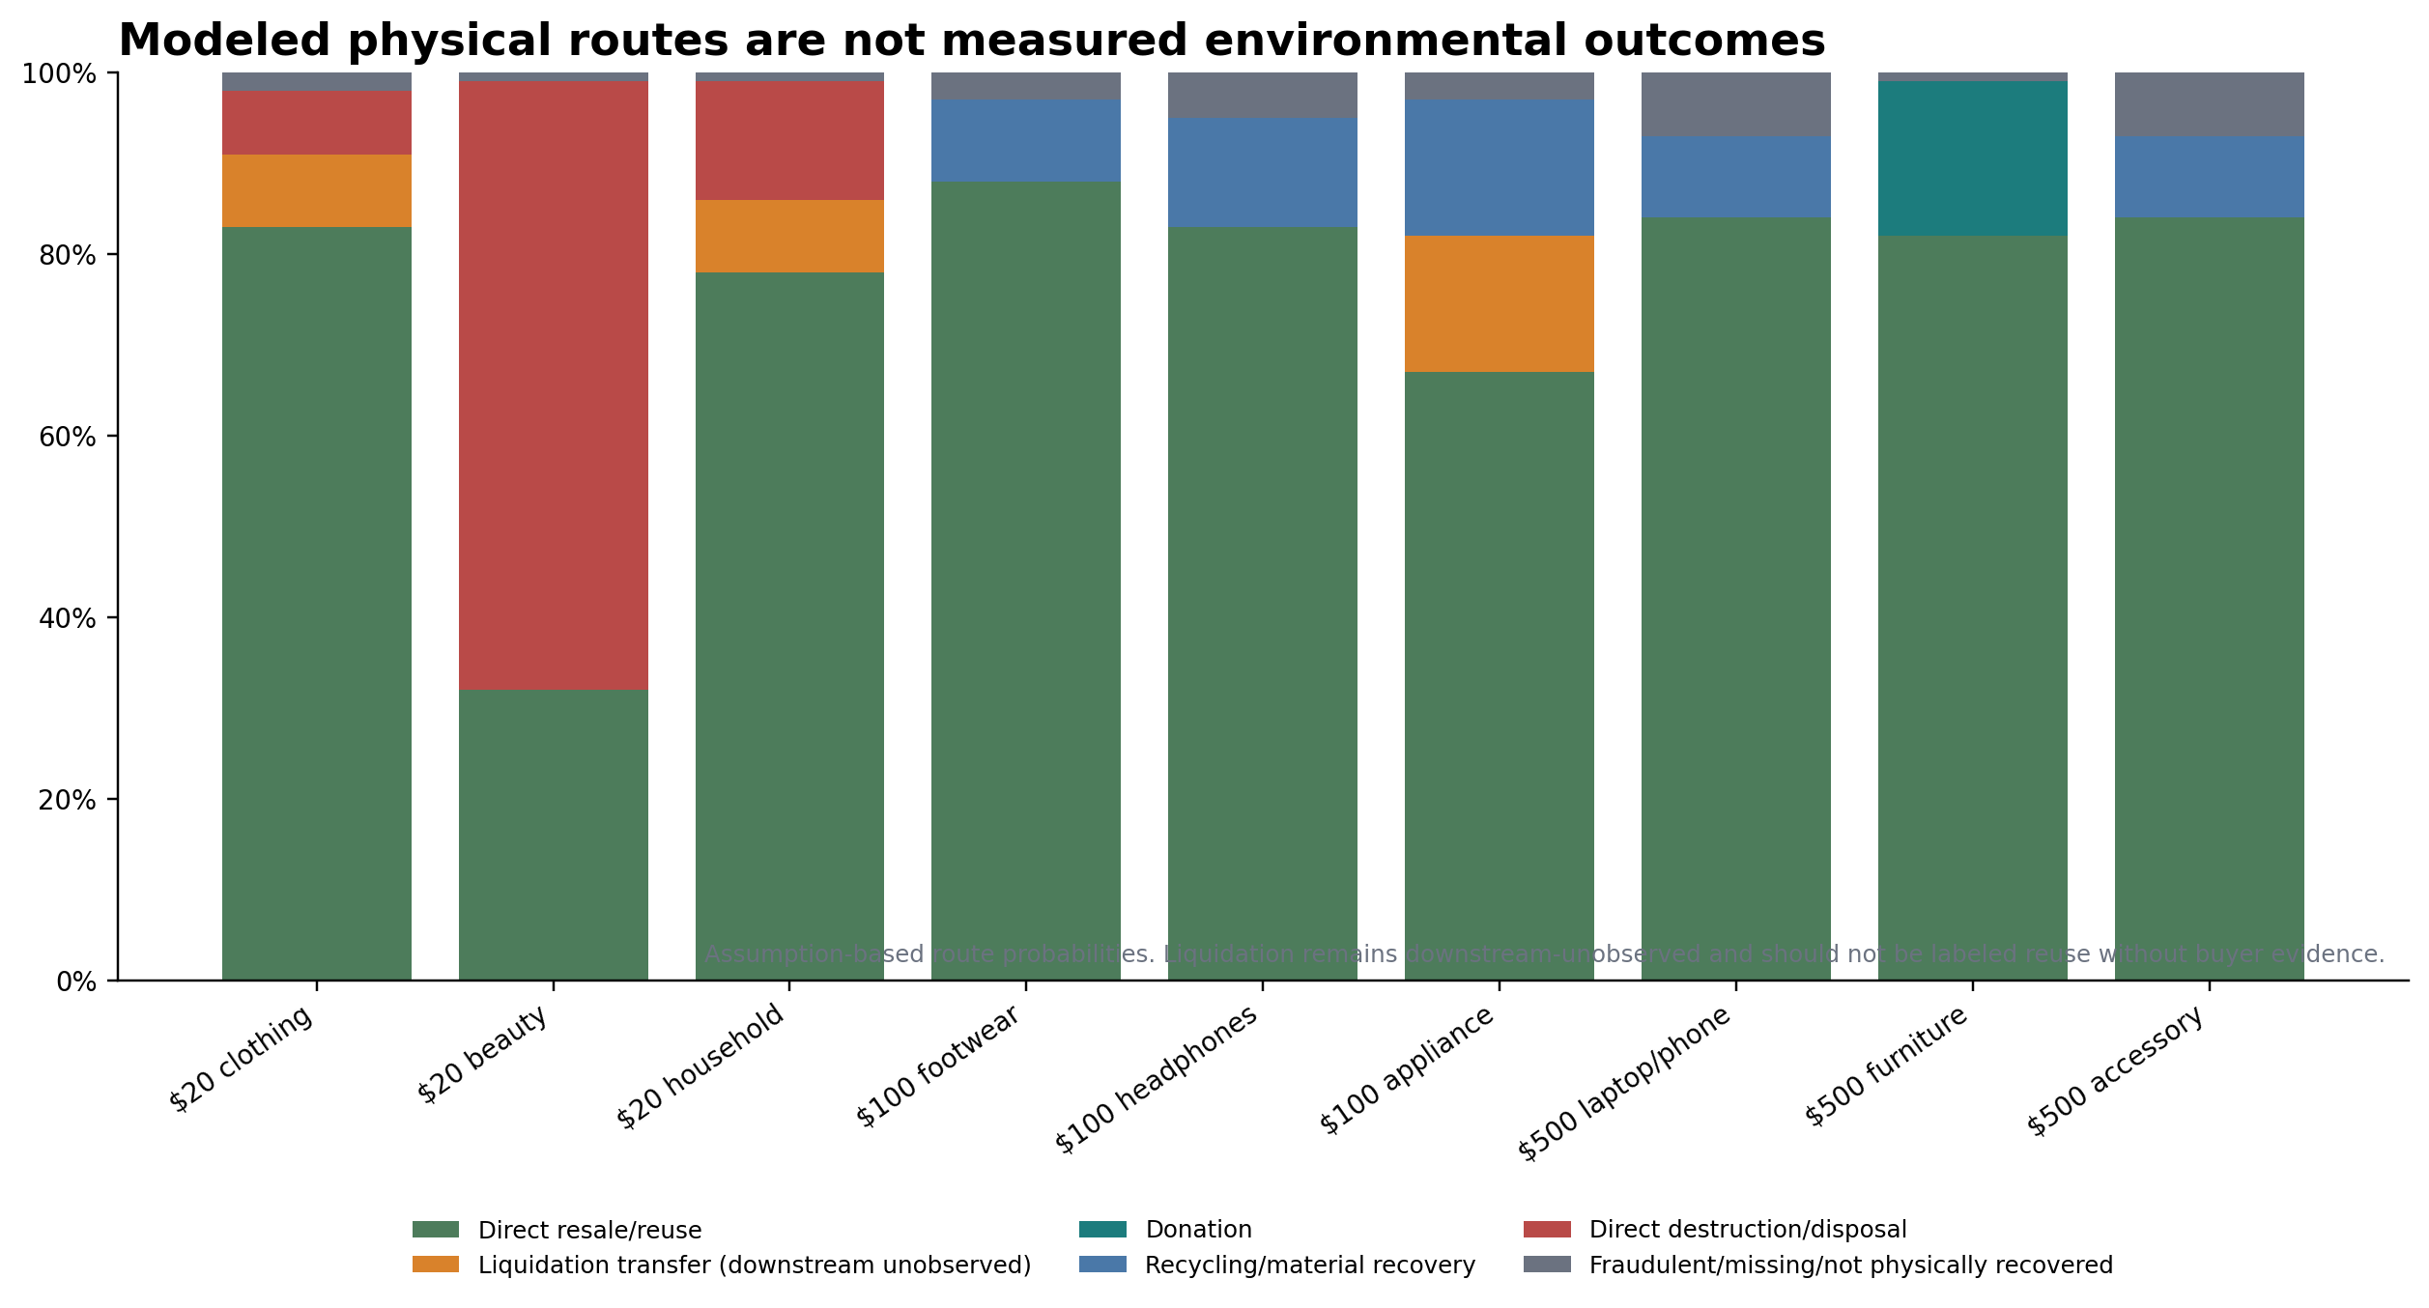
Modeled physical routes are not measured environmental outcomes Source: Model; route shares are assumptions

Exhibit 13. Sustainability claims audit
Company/program | Claim/observation | Denominator? | Returns separated? | Final endpoint? | Audit finding | Confidence
Amazon seller recovery programs | Nearly 391 million items were resold or donated in the U.S. and Europe in 2024 through seller services including Grade & Resell and donation. | No | No | Not fully | Large numerator proves program scale, not a customer-return resale rate or net economic recovery rate. | High for the numerator; low for disposition-rate inference
Ulta Beauty returned merchandise | Used, damaged, or expired returned products are not resold and are properly disposed of. | No | The statement is return-specific, but no volume is given | No | Strong evidence of commercial-value loss after integrity breaks; insufficient to distinguish recycling, hazardous handling, incineration, or landfill. | High for no-resale policy; low for environmental endpoint
Target reverse-logistics operations | Operational materials reference donations, central return centers, electronics recycling, salvage, environmentally sensitive items, vendor credits, and inventory removals. | No | No | No | Confirms multiple routes exist, but job-task evidence cannot establish route shares or diversion performance. | Medium for route existence; low for quantities
B-Stock and liquidation transfers | Retailer programs move customer returns and other inventory through B2B auctions; case studies report recovery-rate improvements. | Usually no program-wide denominator in cited pages | Often mixed by lot or marketplace | Often no after auction sale | Financial transfer to a buyer is observable; final environmental disposition is usually not. Liquidation should not automatically be counted as reuse. | Medium for auction transfer; low for final endpoint
Modeled product archetypes | The model separates direct resale, liquidation transfer, donation, recycling, disposal, and missing/fraud outcomes. | Model denominator is one returned order | Yes by construction | Liquidation downstream remains unobserved | Useful for decision economics, not a measured corporate diversion rate. | Model-dependent

Exhibit 13. Sustainability claims audit Source: S04; S08; S30; P01; P02

ENDING
The headphones from the opening are economically recoverable. The model’s most likely route is open-box resale, with refurbishment for damaged-but-repairable units and recycling for the unsellable share. The retailer still loses most of the contribution the original sale would have produced. The customer’s refund closes one transaction; the product remains inside another market where freight, testing, time and risk determine how much value survives, and who gets to keep it.

Detailed methodology

Evidence protocol
The two supplied documents were treated as the primary record. No new external research was added. The source ledger consolidates the original URLs cited in the package. Where a needed model input was not disclosed, the model uses an explicit proxy or assumption with low, base and high cases. No interview-derived numeric input was used.
- Directly disclosed: filings, policy language, fee schedules and stated company metrics.
- Calculated from disclosed data: DIM weights, auction bid percentages and accounting comparisons.
- Market observation: public closed-auction fields and observed resale channels.
- Proxy: public fees or market bands used to approximate an undisclosed product-level cost.
- Assumption: condition mix, labor minutes, cost of goods, route shares, repair success and specific fraud probabilities.
- Interview-derived: none in the current model.

Definitions and formulas
Kept-sale contribution
R-C-F_o-P

Net recovery_j
V_j-U_j-S_j-M_j-T_j-D_j

PV recovery_j
Net recovery_j/(1+k)^(L_j/365)

Expected recovery
sum_j Q_j*PV recovery_j

Post-return contribution
K-C-F_o-P-F_r-H-A+E(Recovery)

Return tax per returned order
Kept-sale contribution - Post-return contribution

Expected return tax per order
p_r * Return tax per returned order

Retrieve rule
Retrieve when E(Recovery)-F_r-H > 0 before strategic overrides

Disposition rule
Choose eligible d maximizing PV net recovery

Model architecture
The model contains nine archetypes, seven conditions, seven logistics routes, nine dispositions and three composite recovery scenarios. For each product-condition pair, it calculates gross proceeds, repair/repack cost, storage, seller fees, secondary transport, disposal cost and delay. It selects the eligible route with the highest present-value net recovery. Condition probabilities then create Qj and expected recovery. The spreadsheet preserves all eligible and ineligible route rows so the selected path can be audited.
- Low recovery: worse condition mix, 12% lower gross recovery, 25% higher reverse freight, 20% higher labor, 50% longer holding, higher fees and depreciation, lower repair success.
- Base: category-calibrated assumptions anchored to the evidence package.
- High recovery: better condition mix, 8% higher gross recovery, 20% lower reverse freight, lower labor/fees, shorter holding, slower depreciation and higher repair success.

Cost treatment and double-counting controls
- Product cost C is subtracted once in post-return contribution and never inside recovery proceeds.
- Original outbound fulfillment Fo and original payment cost P are not subtracted inside disposition recovery. Secondary selling and shipping costs are M and T.
- Counterfeit/missing condition reduces E(Recovery) through Qj. A contains only incremental fraud administration/claims cost, not the lost recovery already captured by Qj.
- Storage S is physical storage/space cost. Capital delay is handled separately through PV discounting.
- Retailer recovery is not buyer delivered cost, and buyer delivered cost is not reseller profit.

Included costs
- Product cost; original fulfillment/shipping; original payment/transaction; reverse freight; receiving/inspection; cleaning/testing/repair/repack; physical storage; secondary selling fees; secondary transport; disposal/recycling cost; incremental fraud admin/claims; time discount.

Excluded costs
- Fixed corporate overhead; customer acquisition marketing; sales tax/VAT; income-tax effects; donation tax benefits; vendor allowances unless explicitly modeled; insurance/chargeback recoveries; customer lifetime-value effects; public-relations cost; environmental externalities; unobserved post-liquidation outcomes.

Returnless-refund and disposition thresholds
The break-even gross recovery conditional on receiving the correct product is calculated as total retrieval and fixed processing costs divided by the correct-item probability and one minus the effective selling-fee rate. The model also solves for maximum reverse freight, maximum inspection minutes, maximum refurbishment cost versus the next-best route, minimum correct-item probability and the retail price at which retrieval becomes economic for the same product form.

Unit-economic model and sensitivity

Low, base and high recovery cases
Product | Scenario | E recovery | Fr | H | Retrieve value | Return tax / return | Expected tax / order | bps
Basic clothing item ($20) | Low recovery | $3.11 | $4.53 | $1.40 | $-2.83 | $22.91 | $5.73 | 2,863 bps
Basic clothing item ($20) | Base | $6.90 | $3.62 | $1.17 | $2.11 | $17.97 | $4.49 | 2,246 bps
Basic clothing item ($20) | High recovery | $10.07 | $2.90 | $0.99 | $6.17 | $13.91 | $3.48 | 1,738 bps
Cosmetic/personal-care item ($20) | Low recovery | $0.96 | $4.03 | $0.84 | $-3.91 | $23.94 | $2.39 | 1,197 bps
Cosmetic/personal-care item ($20) | Base | $3.64 | $3.23 | $0.70 | $-0.28 | $20.31 | $2.03 | 1,016 bps
Cosmetic/personal-care item ($20) | High recovery | $6.09 | $2.58 | $0.60 | $2.92 | $17.11 | $1.71 | 856 bps
Small household product ($20) | Low recovery | $0.73 | $8.95 | $1.12 | $-9.34 | $29.38 | $3.53 | 1,763 bps
Small household product ($20) | Base | $3.42 | $7.16 | $0.93 | $-4.68 | $24.71 | $2.97 | 1,483 bps
Small household product ($20) | High recovery | $6.15 | $5.73 | $0.79 | $-0.38 | $20.41 | $2.45 | 1,225 bps
Footwear/premium apparel ($100) | Low recovery | $31.48 | $6.42 | $2.24 | $22.82 | $77.54 | $23.26 | 2,326 bps
Footwear/premium apparel ($100) | Base | $49.07 | $5.14 | $1.87 | $42.06 | $58.30 | $17.49 | 1,749 bps
Footwear/premium apparel ($100) | High recovery | $63.70 | $4.11 | $1.59 | $58.00 | $42.36 | $12.71 | 1,271 bps
Headphones/small electronics ($100) | Low recovery | $18.07 | $7.39 | $4.80 | $5.88 | $95.02 | $11.40 | 1,140 bps
Headphones/small electronics ($100) | Base | $33.37 | $5.91 | $4.00 | $23.46 | $77.44 | $9.29 | 929 bps
Headphones/small electronics ($100) | High recovery | $48.25 | $4.73 | $3.40 | $40.12 | $60.78 | $7.29 | 729 bps
Small appliance ($100) | Low recovery | $9.67 | $16.41 | $6.00 | $-12.74 | $113.19 | $16.98 | 1,698 bps
Small appliance ($100) | Base | $22.34 | $13.12 | $5.00 | $4.22 | $96.23 | $14.44 | 1,444 bps
Small appliance ($100) | High recovery | $36.06 | $10.50 | $4.25 | $21.31 | $79.14 | $11.87 | 1,187 bps
Laptop/phone premium electronics ($500) | Low recovery | $123.07 | $10.25 | $12.24 | $100.58 | $404.32 | $40.43 | 809 bps
Laptop/phone premium electronics ($500) | Base | $200.58 | $8.20 | $10.20 | $182.18 | $322.72 | $32.27 | 645 bps
Laptop/phone premium electronics ($500) | High recovery | $275.85 | $6.56 | $8.67 | $260.62 | $244.28 | $24.43 | 489 bps
Furniture product ($500) | Low recovery | $25.90 | $123.62 | $12.00 | $-109.72 | $610.02 | $109.80 | 2,196 bps
Furniture product ($500) | Base | $95.16 | $98.90 | $10.00 | $-13.74 | $514.04 | $92.53 | 1,851 bps
Furniture product ($500) | High recovery | $163.28 | $79.12 | $8.50 | $75.66 | $424.64 | $76.44 | 1,529 bps
Premium apparel/accessory ($500) | Low recovery | $181.83 | $9.88 | $7.20 | $164.76 | $339.09 | $67.82 | 1,356 bps
Premium apparel/accessory ($500) | Base | $269.18 | $7.90 | $6.00 | $255.28 | $248.57 | $49.71 | 994 bps
Premium apparel/accessory ($500) | High recovery | $345.70 | $6.32 | $5.10 | $334.28 | $169.57 | $33.91 | 678 bps

Table 3. Scenario results Source: Model

Returnless-refund comparison
Product | Retrieved tax | Returnless tax | Retrieval advantage | Immediate rule | Strategic factors
Basic clothing item ($20) | $17.97 | $20.00 | $2.03 | Retrieve | Account history, vendor credit, customer service
Cosmetic/personal-care item ($20) | $20.31 | $20.00 | $-0.31 | Returnless | Safety/integrity and abuse controls
Small household product ($20) | $24.71 | $20.00 | $-4.71 | Returnless | Account history, vendor credit, customer service
Footwear/premium apparel ($100) | $58.30 | $100.00 | $41.70 | Retrieve | Serial/authentication and fraud deterrence
Headphones/small electronics ($100) | $77.44 | $100.00 | $22.56 | Retrieve | Serial/authentication and fraud deterrence
Small appliance ($100) | $96.23 | $100.00 | $3.77 | Retrieve | Account history, vendor credit, customer service
Laptop/phone premium electronics ($500) | $322.72 | $500.00 | $177.28 | Retrieve | Serial/authentication and fraud deterrence
Furniture product ($500) | $514.04 | $500.00 | $-14.04 | Returnless | Local routing and damage evidence
Premium apparel/accessory ($500) | $248.57 | $500.00 | $251.43 | Retrieve | Serial/authentication and fraud deterrence

Table 4. Retrieved versus returnless refund Source: Returnless tax excludes strategic abuse, safety, customer-service and public-relations effects.

Break-even thresholds
Product | Required gross recovery | Required % retail | Min correct-item probability | Modeled correct-item probability | Max inspection minutes | Max reverse freight | Price threshold | Max refurb cost
Basic clothing item ($20) | $9.18 | 45.9% | 78.7% | 98.0% | 7.0 | $5.73 | $16.08 | -
Cosmetic/personal-care item ($20) | $6.71 | 33.6% | 103.3% | 99.0% | 0.9 | $2.94 | $20.91 | -
Small household product ($20) | $12.49 | 62.4% | 163.0% | 99.0% | 0.0 | $2.49 | $31.52 | $-3.68
Footwear/premium apparel ($100) | $14.77 | 14.8% | 23.9% | 97.0% | 94.1 | $47.20 | $24.25 | $2.24
Headphones/small electronics ($100) | $24.68 | 24.7% | 45.0% | 95.0% | 54.9 | $29.37 | $43.27 | $18.20
Small appliance ($100) | $36.79 | 36.8% | 85.6% | 97.0% | 18.4 | $17.34 | $87.63 | $10.91
Laptop/phone premium electronics ($500) | $54.51 | 10.9% | 18.6% | 93.0% | 339.5 | $190.38 | $81.49 | $102.70
Furniture product ($500) | $209.34 | 41.9% | 106.3% | 99.0% | 0.0 | $85.16 | $539.45 | $-1.37
Premium apparel/accessory ($500) | $38.13 | 7.6% | 10.7% | 93.0% | 435.5 | $263.18 | $46.42 | $30.71

Table 5. Retrieval and processing thresholds Source: Model. Values above 100% probability indicate retrieval cannot break even under the current condition/recovery structure.

Sensitivity findings
Return rate is the largest driver of expected tax per order because it scales the per-return tax directly. Operational rankings differ by category. Recovery markdown and condition mix dominate apparel and electronics. DIM charges and freight discount dominate low-value household goods and furniture. Fraud probability matters most for premium electronics and accessories. Seller fees matter where consumer-facing resale remains viable. Product gross margin changes percentage severity, not dollar return tax.
Product | #1 | #2 | #3 | #4
Basic clothing item ($20) | Resale markdown / recovery (+$0.40) | Condition mix (+$0.39) | Dimensional-weight charges (+$0.27) | Inspection labor (+$0.24)
Cosmetic/personal-care item ($20) | Condition mix (+$0.17) | Resale markdown / recovery (+$0.09) | Dimensional-weight charges (+$0.09) | Reverse shipping cost (+$0.08)
Small household product ($20) | Dimensional-weight charges (+$0.34) | Negotiated freight discount (+$0.25) | Reverse shipping cost (+$0.21) | Condition mix (+$0.13)
Footwear/premium apparel ($100) | Condition mix (+$2.52) | Resale markdown / recovery (+$2.51) | Inspection labor (+$0.55) | Dimensional-weight charges (+$0.50)
Headphones/small electronics ($100) | Resale markdown / recovery (+$0.80) | Condition mix (+$0.77) | Inspection labor (+$0.49) | Seller fees (+$0.27)
Small appliance ($100) | Condition mix (+$0.88) | Dimensional-weight charges (+$0.86) | Resale markdown / recovery (+$0.76) | Inspection labor (+$0.63)
Laptop/phone premium electronics ($500) | Resale markdown / recovery (+$3.39) | Condition mix (+$3.11) | Fraud probability (+$1.74) | Seller fees (+$1.21)
Furniture product ($500) | Dimensional-weight charges (+$8.75) | Negotiated freight discount (+$5.00) | Condition mix (+$4.71) | Resale markdown / recovery (+$4.70)
Premium apparel/accessory ($500) | Condition mix (+$8.98) | Resale markdown / recovery (+$8.64) | Fraud probability (+$3.29) | Seller fees (+$1.59)

Table 6. Largest adverse sensitivities, excluding return rate Source: Dollar change in expected return tax per order under the defined adverse shock.

Auction analysis
Completed-auction sample size: two. No open-auction observation was supplied or used. The package explicitly could not verify a broad unrestricted master file; the report therefore preserves lot-level fields, reports distribution statistics and avoids population claims.
Auction ID | Category | Status | Stated retail | Adjusted current retail | Winning bid | Buyer premium | Freight | Delivered cost | Units | Condition | Manifest
WMT-150184 | Microwaves | Completed | $7,004 | $5,603 | $1,020 | $102 | $750 | $1,872 | 102 | Detailed condition not public; liquidation lot in customer-return channel | Partial public listing; full details login-gated
WMT-150245 | eBikes | Completed | $3,058 | $2,446 | $600 | $60 | $850 | $1,510 | 12 | Detailed condition not public; liquidation lot in customer-return channel | Partial public listing; full details login-gated

Table 7. Completed auction master sample Source: S36, S37. Adjusted current retail, buyer premium and freight are assumptions.

Metric | n | Min | P25 | Median | Mean | P75 | Max | Range
Auction bid % stated retail | 2 | 14.6% | 15.8% | 17.1% | 17.1% | 18.4% | 19.6% | 5.1%
Delivered cost % stated retail | 2 | 26.7% | 32.4% | 38.1% | 38.1% | 43.7% | 49.4% | 22.7%
Auction bid % adjusted current retail | 2 | 18.2% | 19.8% | 21.4% | 21.4% | 22.9% | 24.5% | 6.3%
Delivered cost % adjusted current retail | 2 | 33.4% | 40.5% | 47.6% | 47.6% | 54.6% | 61.7% | 28.3%
Retailer recovery after fees % stated retail | 2 | 10.5% | 10.8% | 11.2% | 11.2% | 11.5% | 11.8% | 1.4%
Reseller break-even % stated retail | 2 | 63.7% | 72.2% | 80.8% | 80.8% | 89.3% | 97.9% | 34.2%

Table 8. Distribution and dispersion Source: n=2; quartiles are interpolated and should not be read as stable distribution estimates.
Benchmark | Sample/status | Recovery measure | Denominator | Generalizability | Sources
Apparel field study - private label | 11,879 completed auctions across study; segment result | 13.11% of retail | Original retail | Apparel/end-of-life only | S32
Apparel field study - national brands | 11,879 completed auctions across study; segment result | 16.339% of retail | Original retail | Apparel/end-of-life only | S32
Amazon FBA Liquidations typical range | Program guidance, not auction sample | 5%-10% of average selling price | Average selling price | FBA Liquidations only | S35
AuctionMethod mixed customer-return range | Industry review | 10%-30% of MSRP | MSRP | Secondary source; mixed conditions | S42
Observed microwave lot | 1 completed public lot | 14.6% bid / stated retail | Stated retail | Single lot | S37
Observed eBike lot | 1 completed public lot | 19.6% bid / stated retail | Stated retail | Single lot | S36

Table 9. Auction and liquidation benchmarks Source: S32; S35-S37; S42

Category and operating-model comparison

Exhibit 8. Category comparison
Category | Return drivers | Return-rate evidence | Value density | Inspection | Safety | Fraud | Depreciation | Common disposition | Gross recovery | Net recovery | Returnless | Major uncertainty
Clothing and footwear | Fit, size, style, seasonality, wardrobing, missing tags or accessories | Broad online returns are high; ASOS policy tightens high-return behavior; Nordstrom says most returns flow through stores. Model: 20%-30%. | High for premium goods; moderate for low-price basics | Low-to-moderate per unit, but sorting, steaming, sizing and retagging are labor-heavy at scale | Low except hygiene-specific items | Moderate; wardrobing and counterfeit risk rise with price/brand | Moderate; season and fashion cycle matter | Restock, outlet/off-price, liquidation; donation for saleable but noncommercial units | 56%-62% | 34%-54% | Conditional for $20 parcel returns; uncommon for premium items | Condition mix, route shares, actual remarketing labor
Consumer electronics | Compatibility, buyer remorse, defects, activation, missing accessories, battery or data issues | No clean category population rate in package; model: 10%-12%. | High | High: serial, function, activation, battery, accessories, data sanitization | Recalled products, battery handling, data security | High for substitution and serial-controlled goods | High; model uses 3.0%-3.5% monthly | Open-box, refurbishment, outlet, recycling | 50%-51% | 33%-40% | Rare except very low-value accessories or account-specific exceptions | Diagnostic time, repair success, warranty cost, actual device age
Furniture and bulky home | Damage, color/fit mismatch, assembly issues, missing hardware, carrier damage | Vendor case material cites roughly 30% online furniture returns; model uses 18% for the selected item. | Low per cubic foot and per billable pound | Moderate, but space and handling are expensive | Structural integrity, recalls, sanitation for some categories | Low-to-moderate | Low-to-moderate, but dwell and damage compound | Local open-box/outlet, local pickup, liquidation, donation/salvage | 39%-39% | 19%-19% | High when only long-haul or oversize retrieval is available | Actual local routing, carrier discount, damage and assembly state
Cosmetics and personal care | Shade preference, reaction, damaged packaging, expiration or seal concerns | No clean category population rate in package; model uses 10%. | High physically, but commercial value can collapse on opening | Low time, high assurance burden | Integrity, contamination, labeling and retailer policy | Low-to-moderate | Moderate through shelf life and obsolescence | Restock only when sealed and trusted; otherwise disposal | 32%-32% | 18%-18% | Frequent on immediate economics for mailed returns, subject to abuse/safety controls | Definition and endpoint of 'properly disposed'
Small household goods | Fit/utility mismatch, low perceived quality, damage, missing parts | No category population rate in package; model: 12%-15%. | Often low, especially light-but-bulky goods | Low per unit, but often larger than liquidation value | Product-specific; electrical items need testing | Low-to-moderate | Low for basics; moderate for small appliances | Outlet, liquidation, donation/recycling, returnless refund | 38%-40% | 17%-22% | Likely for low-value parcel returns; less likely for appliances near stores | DIM-weight billing, actual consolidation cost, unit-level saleability
Third-party marketplace goods | Same product drivers as above, plus seller-policy mismatch and platform-enforced refunds | Contract- and category-specific; no defensible single rate | Product-specific | Platform or seller may inspect; economic owner may never touch the unit | Product-specific plus marketplace eligibility rules | Seller may bear fraud or dispute losses despite platform-controlled intake | Product-specific; settlement delay adds exposure | Platform restock, Grade & Resell, liquidation, returnless resolution, return to seller | Not modeled as one category | Contract-dependent | Seller-program election or platform rule | Title, fee, fault and recovery allocation in private contracts

Exhibit 8. Category comparison Source: P01; P02; Model

Company and platform comparison
Company/platform | Merchandise | Policy anchor | Network/inspection | Disposition | Loss allocation
Amazon retail and FBA | General merchandise; mixes Amazon-owned and third-party inventory | FBA outsources returns to Amazon. Seller programs include Returnless Resolutions, Liquidations, and Grade & Resell. Seller-fulfilled refunds now give four calendar days from return-delivery scan before automated refunds. | Amazon says FBA stores, picks, packs, ships, and processes returns across hundreds of fulfillment centers. | Primary restock; Grade & Resell used-condition relisting; FBA Liquidations; donation/resell claims in sustainability report; auction visibility through Amazon Liquidation Auctions on B-Stock. | Amazon retail carries return liabilities and recovery assets on its own books; FBA programs imply sellers remain economically exposed for their own inventory and fees.
Walmart and WFS | General merchandise, marketplace, grocery-adjacent, bulky categories | Most Walmart-owned items: 90 days. Marketplace seller items: generally 30 days, with electronics and major-appliance exceptions. | WFS sends return labels to Walmart fulfillment centers for inspection and handling. Sellers can set Keep It rules. | Primary restock where feasible; WFS inspection; seller-directed keep-it; visible liquidation channel through Walmart Liquidation Auctions on B-Stock. | Walmart covers return shipping only for Walmart-at-fault WFS returns; sellers pay return processing otherwise. Big & bulky return fees are explicit.
Target and Target Plus | Large omnichannel retailer with store-heavy network plus partner marketplace | Most unopened Target items in new condition: 90 days. Target Plus partner items: mostly 30 days, returned to Target in store or by mail. | Store reverse-logistics role references Central Return Center, donations, electronics recycling, transfers, salvage, inventory removals, vendor credits, and ESIM logs. | Restock, CRC routing, donation, electronics recycling, salvage, vendor credit, inventory removals. | Platform experience is consumer-facing, but vendor credits and partner differences matter behind the scenes. Partner items physically come back to Target, but contractual loss-sharing is more fragmented than for owned inventory.
Best Buy and marketplace partners | Electronics-heavy retailer with open-box and partner marketplace features | Standard window is short; some categories are nonreturnable once opened, including bodily-fluid-interacting goods and many marketplace entertainment goods. | Policy differentiates Best Buy inventory and Marketplace Seller inventory; marketplace restrictions and packaging requirements are explicit. | New restock, open-box, refurbished, pre-owned, recycling, and marketplace-partner-specific flows. | Short windows and opened-item restrictions reduce recoverability risk. Vendor allowances are economically important in inventory and cost of sales.
Wayfair | Furniture and bulky home goods, high ship-cost and damage exposure | Wayfair public help pages are less transparent in scraped text, but its SEC disclosures emphasize customer returns risk and large-item special handling. | SEC filing says many products are large, need special handling, and can be damaged in transit; logistics footprint includes warehouses, consolidation centers, cross-docks, and last-mile facilities. | Restock where undamaged; open-box and closeout paths exist commercially, but public contract-level disclosure is thin; liquidation likely on bulky/problem inventory. | Freight and transit-damage economics dominate; resale delays are especially costly in large home categories.
IKEA | Furniture and home goods with high flat-pack share plus mattresses | Unopened products: 365 days. Open products: 180 days. Mattresses: one exchange within 90 days. | Heavy store network changes reverse economics versus pure e-commerce furniture. | Re-entry to stock for unopened or fit-for-sale goods; exchange program for mattresses; secondary or disposal routes still needed for damaged/opened goods. | Flat-pack format improves recoverability versus assembled furniture, but mattress flows are separate and replacement-heavy.
Ulta Beauty | Beauty, cosmetics, personal care | Returned-merchandise policy is blunt: used, damaged, or expired products are not resold and are disposed of. | Store-centric network reduces mail handling for many returns, but the key issue is not routing, it is resale eligibility. | Limited primary restock for unused compliant goods; nonstandard beauty returns go to disposal, not resale. | Here the loss is often the product cost plus handling, with little secondary recovery once product integrity is uncertain.
Nike | DTC apparel and footwear with brand control | 60-day return or exchange window with proof of purchase; some products must remain sealed or cannot be returned. | Brand-controlled DTC network improves authorization and fraud checks. | Restock as new when condition passes; likely factory/outlet or recommerce for other items, though Nike does not publicly publish a full return-disposition ladder. | Nike carries both a sales-related reserve and a separate inventory reserve, showing both refund and inventory-value exposure.
ASOS | Apparel-heavy e-commerce with high return incidence | Original-condition rule, typically 28 days. Fair-use policy applies, and some high-return customers face a £3.95 deduction. | Centralized parcel returns; customer feedback box in return flow; brand-partner items can have separate processing times. | New-condition restock where possible; markdown, outlet, partner return, or disposal where not. | ASOS has been explicit that tighter return economics improved profitability and order quality, especially in high-return segments.
eBay | Marketplace, mostly seller-owned inventory | Sellers can automate returns and immediate refunds. After inspection, seller completes refund; if a dispute goes against seller, eBay can deduct seller funds. | No platform-owned reverse network in the Amazon/WFS sense; routing depends on listing and program. | Return to seller, relist, payment-dispute refund without physical recovery in some cases; eBay Refurbished provides a distinct resale channel. | Seller usually funds the loss unless seller protections apply. eBay can seek reimbursement from seller payouts or on-file payment methods.

Table 10. Company and platform operating evidence Source: P01 company dossiers; source IDs in Source Ledger

Ownership and loss allocation by operating model
Operating model | Inventory owner | Refund payer | Freight payer | Processing payer | Disposition controller | Recovery recipient | Fraud-loss bearer | Write-down bearer | Environmental reporting entity | Confidence
Vertically integrated retailer | Retailer | Retailer | Retailer or customer under policy | Retailer | Retailer | Retailer | Retailer | Retailer | Retailer; downstream processors may report their own operations | High
Brand selling direct to consumer | Brand | Brand | Brand or customer by policy | Brand or contracted 3PL | Brand within contract/SLA | Brand | Brand | Brand | Brand for product claims; logistics vendor for operational footprint | High-medium
Marketplace first-party retail | Platform retailer | Platform retailer | Platform retailer, customer, or vendor allowance depending fault/policy | Platform retailer | Platform retailer | Platform retailer; vendor credits may offset loss | Platform retailer, subject to carrier/vendor recovery | Platform retailer | Platform retailer for owned inventory | High
Marketplace third-party fulfillment | Third-party seller | Platform-facing process, economically seller in many cases | Seller for non-platform-fault returns; platform for protected/fault cases | Seller through program fees or platform under exceptions | Platform operationally; seller elects program options | Seller net of fees | Seller unless protection or platform-at-fault rule applies | Seller | Ambiguous: seller owns inventory, platform operates facility and may make program claims | Medium-high
Merchant-fulfilled marketplace sale | Seller | Seller, sometimes enforced/debited by platform | Seller/customer under listing and platform rules | Seller | Seller | Seller | Seller unless marketplace protection applies | Seller | Seller; platform may report only limited program data | High
Vendor-supported retailer | Usually retailer after purchase; title may vary | Retailer to customer | Retailer initially; vendor may reimburse defect/fault costs | Retailer or vendor under allowance/return-to-vendor terms | Retailer, vendor, or shared by contract | Retailer unless vendor credit or return-to-vendor transfers economics | Usually retailer for customer fraud; vendor for validated defect obligations | Retailer net of vendor allowances/credits | Depends on title and contractual responsibility | Medium
Consignment | Consignor until sale or contractual title transfer | Retailer/platform to customer, then settled with consignor under contract | Contract-specific | Contract-specific; often retailer charges consignor | Consignor or retailer within agreed rules | Consignor net of commission/fees | Contract-specific; often consignor for merchandise, retailer for process failure | Consignor before title transfer | Owner/consignor for product outcome; processor for operations | Low-medium
Reverse-logistics service contract | Client retailer/brand/seller | Client or platform | Client, passed through or bundled | Client pays service fee | 3PL within SLA; client retains policy authority | Client, net of service and channel fees | Client unless service-level guarantee shifts defined losses | Client | Client for product claims; 3PL may report handling/diversion metrics | Medium-low
Inventory-purchase arrangement | Retailer until bulk sale; liquidator after title transfer | Retailer/seller before inventory sale | Negotiated: seller-delivered, buyer pickup, or embedded in price | Liquidator after purchase; retailer may pay prep | Liquidator after title transfer | Retailer gets fixed sale proceeds; liquidator keeps downstream upside | Retailer before title transfer; liquidator bears manifest/sell-through risk after purchase subject to claims rights | Retailer through discounted sale, then liquidator on purchased inventory | Ambiguous after title transfer; retailer may count transfer without observing endpoint | Medium
Auction agency model | Retailer/seller until auction sale closes | Retailer/seller | Upstream owner to sale point or buyer after sale, per terms | Owner and/or agent fee | Agent runs auction; owner sets program constraints; buyer controls after title transfer | Owner receives bid proceeds net of seller-side fees; agent receives fees | Owner until title transfer; buyer takes manifest and resale risk subject to narrow dispute rights | Owner until sale; buyer thereafter | Owner may report liquidation transfer; final endpoint rests with buyer and is often unobserved | Medium

Table 11. Ownership and loss-allocation ledger Source: P01; contractual archetypes labeled by confidence

Fraud analysis detail
Product | Base p_f | Lost recovery | Admin/claims | LGD | Expected total fraud loss | Inside Qj | Separate A
Footwear/premium apparel ($100) | 3.0% | $34.90 | $12.00 | $46.90 | $1.41 | $1.05 | $0.36
Headphones/small electronics ($100) | 5.0% | $33.22 | $18.00 | $51.22 | $2.56 | $1.66 | $0.90
Laptop/phone premium electronics ($500) | 7.0% | $228.93 | $70.00 | $298.93 | $20.93 | $16.03 | $4.90
Premium apparel/accessory ($500) | 7.0% | $240.92 | $55.00 | $295.92 | $20.71 | $16.86 | $3.85

Table 12. Expected fraud loss and double-counting control Source: S31; Model assumptions
Product | Base p_f | Controlled p_f | Avoided loss | Inspection cost | False-positive cost | Delay/service cost | Total control cost | Net benefit
Footwear/premium apparel ($100) | 3.0% | 1.5% | $0.70 | $0.93 | $0.20 | $0.75 | $1.88 | $-1.18
Headphones/small electronics ($100) | 5.0% | 2.5% | $1.28 | $2.00 | $0.38 | $1.00 | $3.38 | $-2.09
Laptop/phone premium electronics ($500) | 7.0% | 3.0% | $11.96 | $3.40 | $0.75 | $1.50 | $5.65 | $6.31
Premium apparel/accessory ($500) | 7.0% | 3.0% | $11.84 | $3.00 | $0.75 | $1.25 | $5.00 | $6.84

Table 13. Illustrative aggressive-control economics Source: All control parameters are assumptions, not disclosures.

Calculation appendix

Product inputs
Product | R | C | C/R | Fo | P | DIM lb | Billable lb | Value/billable lb | Inspect min | Labor/hr | Return rate | Depreciation/mo | Fraud p
Basic clothing item ($20) | $20 | $6.00 | 30.0% | $4.50 | $0.80 | 1.2 | 2 | $10.00 | 2.5 | $28 | 25.0% | 2.0% | 2.0%
Cosmetic/personal-care item ($20) | $20 | $5.00 | 25.0% | $4.00 | $0.80 | 1.0 | 2 | $10.00 | 1.5 | $28 | 10.0% | 1.5% | 1.0%
Small household product ($20) | $20 | $7.00 | 35.0% | $5.50 | $0.80 | 27.6 | 28 | $0.71 | 2.0 | $28 | 12.0% | 0.5% | 1.0%
Footwear/premium apparel ($100) | $100 | $35.00 | 35.0% | $7.00 | $2.80 | 6.0 | 7 | $14.29 | 4.0 | $28 | 30.0% | 2.0% | 3.0%
Headphones/small electronics ($100) | $100 | $45.00 | 45.0% | $6.00 | $2.80 | 2.9 | 3 | $33.33 | 8.0 | $30 | 12.0% | 3.0% | 5.0%
Small appliance ($100) | $100 | $42.00 | 42.0% | $10.00 | $2.80 | 21.8 | 22 | $4.55 | 10.0 | $30 | 15.0% | 1.0% | 3.0%
Laptop/phone premium electronics ($500) | $500 | $350.00 | 70.0% | $10.00 | $12.80 | 6.7 | 7 | $71.43 | 18.0 | $34 | 10.0% | 3.5% | 7.0%
Furniture product ($500) | $500 | $225.00 | 45.0% | $75.00 | $12.80 | 138.1 | 139 | $3.60 | 20.0 | $30 | 18.0% | 0.7% | 1.0%
Premium apparel/accessory ($500) | $500 | $150.00 | 30.0% | $12.00 | $12.80 | 8.3 | 9 | $55.56 | 10.0 | $36 | 20.0% | 1.5% | 7.0%

Appendix Table A1. Product inputs Source: R fixed by assignment. Other inputs are assumptions/proxies unless noted.

Base condition-to-disposition selections
Product | Condition | Q | Selected disposition | Gross proceeds | U | S | M | T | D | Days | PV recovery | Q x PV
Basic clothing item ($20) | Unopened | 20.0% | Restock as new | $19.87 | $0.32 | $0.15 | $0.56 | $4.50 | $0.00 | 10 | $14.30 | $2.86
Basic clothing item ($20) | Opened but unused | 28.0% | Restock as new | $18.87 | $0.64 | $0.15 | $0.53 | $4.50 | $0.00 | 10 | $13.01 | $3.64
Basic clothing item ($20) | Lightly used | 28.0% | Outlet/off-price | $5.71 | $1.65 | $0.53 | $0.29 | $1.12 | $0.00 | 35 | $2.11 | $0.59
Basic clothing item ($20) | Damaged but repairable | 8.0% | Liquidation | $0.88 | $0.54 | $0.75 | $0.13 | $0.75 | $0.00 | 50 | $-1.27 | $-0.10
Basic clothing item ($20) | Incomplete | 7.0% | Outlet/off-price | $3.96 | $2.25 | $0.53 | $0.20 | $1.12 | $0.00 | 35 | $-0.14 | $-0.01
Basic clothing item ($20) | Counterfeit or substituted | 2.0% | Fraudulent/missing | $0.00 | $0.00 | $0.30 | $0.00 | $0.00 | $0.00 | 20 | $-0.30 | $-0.01
Basic clothing item ($20) | Unsellable | 7.0% | Destruction/landfill | $0.00 | $0.10 | $0.22 | $0.00 | $0.00 | $0.75 | 15 | $-1.07 | $-0.07
Cosmetic/personal-care item ($20) | Unopened | 32.0% | Restock as new | $19.90 | $0.16 | $0.10 | $0.56 | $4.00 | $0.00 | 10 | $15.04 | $4.81
Cosmetic/personal-care item ($20) | Opened but unused | 14.0% | Destruction/landfill | $0.00 | $0.32 | $0.15 | $0.00 | $0.00 | $1.25 | 15 | $-1.71 | $-0.24
Cosmetic/personal-care item ($20) | Lightly used | 18.0% | Destruction/landfill | $0.00 | $0.44 | $0.15 | $0.00 | $0.00 | $1.25 | 15 | $-1.83 | $-0.33
Cosmetic/personal-care item ($20) | Damaged but repairable | 5.0% | Destruction/landfill | $0.00 | $0.72 | $0.15 | $0.00 | $0.00 | $1.25 | 15 | $-2.11 | $-0.11
Cosmetic/personal-care item ($20) | Incomplete | 3.0% | Destruction/landfill | $0.00 | $0.60 | $0.15 | $0.00 | $0.00 | $1.25 | 15 | $-1.99 | $-0.06
Cosmetic/personal-care item ($20) | Counterfeit or substituted | 1.0% | Fraudulent/missing | $0.00 | $0.00 | $0.20 | $0.00 | $0.00 | $0.00 | 20 | $-0.20 | $-0.00
Cosmetic/personal-care item ($20) | Unsellable | 27.0% | Destruction/landfill | $0.00 | $0.20 | $0.15 | $0.00 | $0.00 | $1.25 | 15 | $-1.59 | $-0.43
Small household product ($20) | Unopened | 18.0% | Restock as new | $19.97 | $0.32 | $0.20 | $0.56 | $5.50 | $0.00 | 10 | $13.35 | $2.40
Small household product ($20) | Opened but unused | 25.0% | Outlet/off-price | $7.56 | $1.20 | $0.70 | $0.38 | $1.50 | $0.00 | 35 | $3.74 | $0.93
Small household product ($20) | Lightly used | 25.0% | Outlet/off-price | $6.36 | $1.65 | $0.70 | $0.32 | $1.50 | $0.00 | 35 | $2.17 | $0.54
Small household product ($20) | Damaged but repairable | 10.0% | Outlet/off-price | $3.58 | $2.70 | $0.70 | $0.18 | $1.50 | $0.00 | 35 | $-1.48 | $-0.15
Small household product ($20) | Incomplete | 8.0% | Liquidation | $0.97 | $0.60 | $1.00 | $0.15 | $1.00 | $0.00 | 50 | $-1.75 | $-0.14
Small household product ($20) | Counterfeit or substituted | 1.0% | Fraudulent/missing | $0.00 | $0.00 | $0.40 | $0.00 | $0.00 | $0.00 | 20 | $-0.40 | $-0.00
Small household product ($20) | Unsellable | 13.0% | Destruction/landfill | $0.00 | $0.25 | $0.30 | $0.00 | $0.00 | $0.75 | 15 | $-1.29 | $-0.17
Footwear/premium apparel ($100) | Unopened | 18.0% | Restock as new | $99.33 | $0.60 | $0.25 | $2.78 | $7.00 | $0.00 | 10 | $88.42 | $15.92
Footwear/premium apparel ($100) | Opened but unused | 26.0% | Restock as new | $94.36 | $1.20 | $0.25 | $2.64 | $7.00 | $0.00 | 10 | $83.01 | $21.58
Footwear/premium apparel ($100) | Lightly used | 28.0% | Outlet/off-price | $42.98 | $3.30 | $0.88 | $2.15 | $1.88 | $0.00 | 35 | $34.40 | $9.63
Footwear/premium apparel ($100) | Damaged but repairable | 9.0% | Outlet/off-price | $24.17 | $5.40 | $0.88 | $1.21 | $1.88 | $0.00 | 35 | $14.65 | $1.32
Footwear/premium apparel ($100) | Incomplete | 7.0% | Outlet/off-price | $18.80 | $4.50 | $0.88 | $0.94 | $1.88 | $0.00 | 35 | $10.50 | $0.73
Footwear/premium apparel ($100) | Counterfeit or substituted | 3.0% | Fraudulent/missing | $0.00 | $0.00 | $0.50 | $0.00 | $0.00 | $0.00 | 20 | $-0.50 | $-0.01
Footwear/premium apparel ($100) | Unsellable | 9.0% | Recycling/scrap | $1.95 | $0.25 | $0.88 | $0.00 | $1.50 | $0.50 | 35 | $-1.16 | $-0.10
Headphones/small electronics ($100) | Unopened | 14.0% | Restock as new | $98.99 | $0.80 | $0.20 | $2.77 | $6.00 | $0.00 | 10 | $88.94 | $12.45
Headphones/small electronics ($100) | Opened but unused | 21.0% | Open-box resale | $70.20 | $5.60 | $0.50 | $8.42 | $6.60 | $0.00 | 25 | $48.69 | $10.23
Headphones/small electronics ($100) | Lightly used | 26.0% | Open-box resale | $54.75 | $8.00 | $0.50 | $6.57 | $6.60 | $0.00 | 25 | $32.83 | $8.53
Headphones/small electronics ($100) | Damaged but repairable | 13.0% | Refurbished resale | $37.36 | $12.00 | $0.90 | $4.86 | $7.60 | $0.00 | 45 | $11.83 | $1.54
Headphones/small electronics ($100) | Incomplete | 9.0% | Outlet/off-price | $13.90 | $6.00 | $0.70 | $0.69 | $1.50 | $0.00 | 35 | $4.95 | $0.45
Headphones/small electronics ($100) | Counterfeit or substituted | 5.0% | Fraudulent/missing | $0.00 | $0.00 | $0.40 | $0.00 | $0.00 | $0.00 | 20 | $-0.40 | $-0.02
Headphones/small electronics ($100) | Unsellable | 12.0% | Recycling/scrap | $4.83 | $0.50 | $0.70 | $0.00 | $1.20 | $0.75 | 35 | $1.66 | $0.20
Small appliance ($100) | Unopened | 12.0% | Restock as new | $99.67 | $1.20 | $0.50 | $2.79 | $10.00 | $0.00 | 10 | $84.91 | $10.19
Small appliance ($100) | Opened but unused | 20.0% | Open-box resale | $64.46 | $7.00 | $1.25 | $7.73 | $11.00 | $0.00 | 25 | $37.18 | $7.44
Small appliance ($100) | Lightly used | 25.0% | Open-box resale | $50.28 | $10.00 | $1.25 | $6.03 | $11.00 | $0.00 | 25 | $21.82 | $5.46
Small appliance ($100) | Damaged but repairable | 15.0% | Liquidation | $7.38 | $1.80 | $2.50 | $1.11 | $2.50 | $0.00 | 50 | $-0.52 | $-0.08
Small appliance ($100) | Incomplete | 10.0% | Outlet/off-price | $13.34 | $9.00 | $1.75 | $0.67 | $3.75 | $0.00 | 35 | $-1.80 | $-0.18
Small appliance ($100) | Counterfeit or substituted | 3.0% | Fraudulent/missing | $0.00 | $0.00 | $1.00 | $0.00 | $0.00 | $0.00 | 20 | $-0.99 | $-0.03
Small appliance ($100) | Unsellable | 15.0% | Recycling/scrap | $3.95 | $1.00 | $1.75 | $0.00 | $3.00 | $1.25 | 35 | $-3.01 | $-0.45
Laptop/phone premium electronics ($500) | Unopened | 12.0% | Restock as new | $494.10 | $1.60 | $0.30 | $13.83 | $10.00 | $0.00 | 10 | $466.91 | $56.03
Laptop/phone premium electronics ($500) | Opened but unused | 18.0% | Open-box resale | $378.59 | $12.60 | $0.75 | $45.43 | $11.00 | $0.00 | 25 | $306.42 | $55.16
Laptop/phone premium electronics ($500) | Lightly used | 26.0% | Open-box resale | $295.30 | $18.00 | $0.75 | $35.44 | $11.00 | $0.00 | 25 | $228.34 | $59.37
Laptop/phone premium electronics ($500) | Damaged but repairable | 18.0% | Refurbished resale | $210.46 | $45.00 | $1.55 | $27.36 | $16.00 | $0.00 | 52 | $118.63 | $21.35
Laptop/phone premium electronics ($500) | Incomplete | 10.0% | Outlet/off-price | $83.46 | $15.00 | $1.05 | $4.17 | $3.00 | $0.00 | 35 | $59.58 | $5.96
Laptop/phone premium electronics ($500) | Counterfeit or substituted | 7.0% | Fraudulent/missing | $0.00 | $0.00 | $0.60 | $0.00 | $0.00 | $0.00 | 20 | $-0.60 | $-0.04
Laptop/phone premium electronics ($500) | Unsellable | 9.0% | Recycling/scrap | $38.37 | $2.00 | $1.05 | $0.00 | $2.40 | $2.00 | 35 | $30.59 | $2.75
Furniture product ($500) | Unopened | 8.0% | Restock as new | $498.83 | $4.00 | $5.00 | $13.97 | $60.00 | $0.00 | 10 | $414.57 | $33.17
Furniture product ($500) | Opened but unused | 18.0% | Open-box resale | $337.52 | $21.00 | $15.62 | $40.50 | $55.00 | $0.00 | 31 | $203.41 | $36.61
Furniture product ($500) | Lightly used | 22.0% | Open-box resale | $276.77 | $30.00 | $15.62 | $33.21 | $55.00 | $0.00 | 31 | $141.55 | $31.14
Furniture product ($500) | Damaged but repairable | 22.0% | Outlet/off-price | $100.22 | $36.00 | $21.88 | $5.01 | $25.00 | $0.00 | 44 | $12.17 | $2.68
Furniture product ($500) | Incomplete | 12.0% | Outlet/off-price | $77.95 | $30.00 | $21.88 | $3.90 | $25.00 | $0.00 | 44 | $-2.79 | $-0.33
Furniture product ($500) | Counterfeit or substituted | 1.0% | Fraudulent/missing | $0.00 | $0.00 | $10.00 | $0.00 | $0.00 | $0.00 | 20 | $-9.94 | $-0.10
Furniture product ($500) | Unsellable | 17.0% | Donation | $0.00 | $2.50 | $15.00 | $0.00 | $30.00 | $0.00 | 30 | $-47.06 | $-8.00
Premium apparel/accessory ($500) | Unopened | 18.0% | Restock as new | $497.49 | $2.00 | $0.25 | $13.93 | $12.00 | $0.00 | 10 | $467.85 | $84.21
Premium apparel/accessory ($500) | Opened but unused | 24.0% | Restock as new | $472.61 | $4.00 | $0.25 | $13.23 | $12.00 | $0.00 | 10 | $441.76 | $106.02
Premium apparel/accessory ($500) | Lightly used | 26.0% | Open-box resale | $308.10 | $15.00 | $0.62 | $36.97 | $13.20 | $0.00 | 25 | $240.43 | $62.51
Premium apparel/accessory ($500) | Damaged but repairable | 8.0% | Refurbished resale | $190.02 | $25.00 | $1.12 | $24.70 | $21.20 | $0.00 | 45 | $116.36 | $9.31
Premium apparel/accessory ($500) | Incomplete | 8.0% | Outlet/off-price | $106.60 | $12.00 | $0.88 | $5.33 | $3.00 | $0.00 | 35 | $84.48 | $6.76
Premium apparel/accessory ($500) | Counterfeit or substituted | 7.0% | Fraudulent/missing | $0.00 | $0.00 | $0.50 | $0.00 | $0.00 | $0.00 | 20 | $-0.50 | $-0.03
Premium apparel/accessory ($500) | Unsellable | 9.0% | Recycling/scrap | $9.83 | $1.00 | $0.88 | $0.00 | $2.40 | $1.00 | 35 | $4.50 | $0.41

Appendix Table A2. Base condition engine Source: Full eligible-route matrix for low/base/high scenarios is in the spreadsheet.

Logistics scenarios
Product | Logistics scenario | Reverse freight | E recovery | Inspection | Retrieve value | Return tax | Retrieve?
Basic clothing item ($20) | Store return | $1.25 | $6.90 | $1.17 | $4.48 | $15.60 | Yes
Basic clothing item ($20) | Nearby drop-off + consolidation | $3.00 | $6.90 | $1.17 | $2.73 | $17.35 | Yes
Basic clothing item ($20) | Short-distance parcel | $5.75 | $6.90 | $1.17 | $-0.02 | $20.10 | No
Basic clothing item ($20) | Long-distance parcel | $8.50 | $6.90 | $1.17 | $-2.77 | $22.85 | No
Basic clothing item ($20) | Oversize shipment | $30.00 | $6.90 | $1.17 | $-24.27 | $44.35 | No
Basic clothing item ($20) | Local pickup | $25.00 | $6.90 | $1.17 | $-19.27 | $39.35 | No
Basic clothing item ($20) | Pallet liquidation | $0.75 | $6.90 | $1.17 | $4.98 | $15.10 | Yes
Cosmetic/personal-care item ($20) | Store return | $1.00 | $3.64 | $0.70 | $1.94 | $18.09 | Yes
Cosmetic/personal-care item ($20) | Nearby drop-off + consolidation | $2.75 | $3.64 | $0.70 | $0.19 | $19.84 | Yes
Cosmetic/personal-care item ($20) | Short-distance parcel | $5.25 | $3.64 | $0.70 | $-2.31 | $22.34 | No
Cosmetic/personal-care item ($20) | Long-distance parcel | $7.75 | $3.64 | $0.70 | $-4.81 | $24.84 | No
Cosmetic/personal-care item ($20) | Oversize shipment | $25.00 | $3.64 | $0.70 | $-22.06 | $42.09 | No
Cosmetic/personal-care item ($20) | Local pickup | $20.00 | $3.64 | $0.70 | $-17.06 | $37.09 | No
Cosmetic/personal-care item ($20) | Pallet liquidation | $0.50 | $3.64 | $0.70 | $2.44 | $17.59 | Yes
Small household product ($20) | Store return | $1.50 | $3.42 | $0.93 | $0.99 | $19.05 | Yes
Small household product ($20) | Nearby drop-off + consolidation | $3.50 | $3.42 | $0.93 | $-1.01 | $21.05 | No
Small household product ($20) | Short-distance parcel | $7.25 | $3.42 | $0.93 | $-4.76 | $24.80 | No
Small household product ($20) | Long-distance parcel | $11.50 | $3.42 | $0.93 | $-9.01 | $29.05 | No
Small household product ($20) | Oversize shipment | $32.00 | $3.42 | $0.93 | $-29.51 | $49.55 | No
Small household product ($20) | Local pickup | $30.00 | $3.42 | $0.93 | $-27.51 | $47.55 | No
Small household product ($20) | Pallet liquidation | $1.00 | $3.42 | $0.93 | $1.49 | $18.55 | Yes
Footwear/premium apparel ($100) | Store return | $1.75 | $49.07 | $1.87 | $45.45 | $54.91 | Yes
Footwear/premium apparel ($100) | Nearby drop-off + consolidation | $4.00 | $49.07 | $1.87 | $43.20 | $57.16 | Yes
Footwear/premium apparel ($100) | Short-distance parcel | $7.50 | $49.07 | $1.87 | $39.70 | $60.66 | Yes
Footwear/premium apparel ($100) | Long-distance parcel | $11.00 | $49.07 | $1.87 | $36.20 | $64.16 | Yes
Footwear/premium apparel ($100) | Oversize shipment | $35.00 | $49.07 | $1.87 | $12.20 | $88.16 | Yes
Footwear/premium apparel ($100) | Local pickup | $30.00 | $49.07 | $1.87 | $17.20 | $83.16 | Yes
Footwear/premium apparel ($100) | Pallet liquidation | $1.25 | $49.07 | $1.87 | $45.95 | $54.41 | Yes
Headphones/small electronics ($100) | Store return | $1.75 | $33.37 | $4.00 | $27.62 | $73.28 | Yes
Headphones/small electronics ($100) | Nearby drop-off + consolidation | $4.25 | $33.37 | $4.00 | $25.12 | $75.78 | Yes
Headphones/small electronics ($100) | Short-distance parcel | $7.25 | $33.37 | $4.00 | $22.12 | $78.78 | Yes
Headphones/small electronics ($100) | Long-distance parcel | $10.50 | $33.37 | $4.00 | $18.87 | $82.03 | Yes
Headphones/small electronics ($100) | Oversize shipment | $30.00 | $33.37 | $4.00 | $-0.63 | $101.53 | No
Headphones/small electronics ($100) | Local pickup | $25.00 | $33.37 | $4.00 | $4.37 | $96.53 | Yes
Headphones/small electronics ($100) | Pallet liquidation | $1.00 | $33.37 | $4.00 | $28.37 | $72.53 | Yes
Small appliance ($100) | Store return | $2.25 | $22.34 | $5.00 | $15.09 | $85.36 | Yes
Small appliance ($100) | Nearby drop-off + consolidation | $5.50 | $22.34 | $5.00 | $11.84 | $88.61 | Yes
Small appliance ($100) | Short-distance parcel | $10.50 | $22.34 | $5.00 | $6.84 | $93.61 | Yes
Small appliance ($100) | Long-distance parcel | $17.00 | $22.34 | $5.00 | $0.34 | $100.11 | Yes
Small appliance ($100) | Oversize shipment | $38.00 | $22.34 | $5.00 | $-20.66 | $121.11 | No
Small appliance ($100) | Local pickup | $35.00 | $22.34 | $5.00 | $-17.66 | $118.11 | No
Small appliance ($100) | Pallet liquidation | $2.50 | $22.34 | $5.00 | $14.84 | $85.61 | Yes
Laptop/phone premium electronics ($500) | Store return | $2.25 | $200.58 | $10.20 | $188.13 | $316.77 | Yes
Laptop/phone premium electronics ($500) | Nearby drop-off + consolidation | $5.00 | $200.58 | $10.20 | $185.38 | $319.52 | Yes
Laptop/phone premium electronics ($500) | Short-distance parcel | $9.50 | $200.58 | $10.20 | $180.88 | $324.02 | Yes
Laptop/phone premium electronics ($500) | Long-distance parcel | $14.50 | $200.58 | $10.20 | $175.88 | $329.02 | Yes
Laptop/phone premium electronics ($500) | Oversize shipment | $40.00 | $200.58 | $10.20 | $150.38 | $354.52 | Yes
Laptop/phone premium electronics ($500) | Local pickup | $35.00 | $200.58 | $10.20 | $155.38 | $349.52 | Yes
Laptop/phone premium electronics ($500) | Pallet liquidation | $2.00 | $200.58 | $10.20 | $188.38 | $316.52 | Yes
Furniture product ($500) | Store return | $8.00 | $95.16 | $10.00 | $77.16 | $423.14 | Yes
Furniture product ($500) | Nearby drop-off + consolidation | $25.00 | $95.16 | $10.00 | $60.16 | $440.14 | Yes
Furniture product ($500) | Short-distance parcel | $60.00 | $95.16 | $10.00 | $25.16 | $475.14 | Yes
Furniture product ($500) | Long-distance parcel | $110.00 | $95.16 | $10.00 | $-24.84 | $525.14 | No
Furniture product ($500) | Oversize shipment | $180.00 | $95.16 | $10.00 | $-94.84 | $595.14 | No
Furniture product ($500) | Local pickup | $65.00 | $95.16 | $10.00 | $20.16 | $480.14 | Yes
Furniture product ($500) | Pallet liquidation | $25.00 | $95.16 | $10.00 | $60.16 | $440.14 | Yes
Premium apparel/accessory ($500) | Store return | $2.50 | $269.18 | $6.00 | $260.68 | $243.17 | Yes
Premium apparel/accessory ($500) | Nearby drop-off + consolidation | $5.25 | $269.18 | $6.00 | $257.93 | $245.92 | Yes
Premium apparel/accessory ($500) | Short-distance parcel | $9.75 | $269.18 | $6.00 | $253.43 | $250.42 | Yes
Premium apparel/accessory ($500) | Long-distance parcel | $15.00 | $269.18 | $6.00 | $248.18 | $255.67 | Yes
Premium apparel/accessory ($500) | Oversize shipment | $42.00 | $269.18 | $6.00 | $221.18 | $282.67 | Yes
Premium apparel/accessory ($500) | Local pickup | $40.00 | $269.18 | $6.00 | $223.18 | $280.67 | Yes
Premium apparel/accessory ($500) | Pallet liquidation | $2.00 | $269.18 | $6.00 | $261.18 | $242.67 | Yes

Appendix Table A3. Logistics scenarios Source: Pallet liquidation is a secondary transfer-cost scenario, not a customer return method.

Exhibits and chart specifications
# | Title | Format | Core fields | Analytical point | Primary sources
1 | End-to-end return flow | Process diagram | Authorization; movement; consolidation; verification; grading; disposition; settlement | Refund timing and product ownership move on different clocks. | P01; S02-S07; S21
2 | Ownership and loss-allocation diagram | Swimlane diagram | Customer; retailer/platform; seller/vendor; carrier/3PL; liquidator/reseller; waste handler | Physical handler, inventory owner, refund payer, and loss bearer often differ. | P01; S01-S07; S21; S45
3 | Returnless-refund decision tree | Decision tree | Expected net recovery; reverse freight; inspection; correct-item probability; strategic overrides | Returnless refunds minimize immediate loss when retrieval value is negative, but policy can override. | S02; S07; P01; model
4 | Disposition decision tree | Decision tree | Safety; identity; condition; eligible channels; maximum PV net proceeds | No universal recovery rate; route is an argmax subject to constraints. | S06-S08; S11; S16; S29; model
5 | $20 product recovery waterfall | Waterfall | Small household returned order vs returnless alternative | DIM freight and handling can make a physically useful item uneconomic to retrieve. | S17; S21-S26; P02; model
6 | $100 product recovery waterfall | Waterfall | Headphones: refund, reverse costs, testing, open-box/refurb proceeds | Testing preserves enough value to justify retrieval, but most original contribution is lost. | S11; S39; model
7 | $500 product recovery waterfall | Waterfall | Furniture under weighted centralized route; local-route comparison | High ticket price does not protect recovery when value density is low. | S12; S21-S24; S40; model
8 | Category comparison | Table | Drivers; rates; value density; inspection; safety; fraud; depreciation; route; recovery; uncertainty | Category constraints, not price alone, determine value survival. | P01; P02; model
9 | Auction recovery distribution | Dot/interval plot | Bid/stated; bid/adjusted; delivered/stated; delivered/adjusted; benchmark bands | Retailer recovery and buyer delivered cost are different; n=2 lot sample remains nonrepresentative. | S32; S35-S37; S42; model assumptions
10 | Freight burden by product type | Scatter/bar chart | Billable weight; value per billable lb; reverse freight % retail; max economical freight | Value density explains more than sticker price for parcel and bulky goods. | S17; S21-S26; model
11 | Retailer-to-reseller value waterfall | Two-stage bridge | Stated retail; adjusted current retail; retailer net recovery; buyer delivered cost; reseller processing; break-even proceeds | Downstream spread pays for freight, labor, risk, and selling costs; it is not pure profit. | S36; S37; S45; S49; model assumptions
12 | Fraud expected-loss sensitivity | Line chart / table | p_f; LGD; lost recovery; admin cost; false-positive/control scenario | Aggressive controls clear the hurdle on premium goods more readily than on $100 apparel or headphones. | S31; P01; model assumptions
13 | Sustainability claims audit | Audit matrix | Claim; denominator; returns-only?; third-party?; recycling definition; destruction; endpoint observability | Program numerators do not establish customer-return diversion rates. | S04; S08; S30; P01; P02
14 | Evidence-confidence table | Heat-mapped table | Claim/input; evidence type; directness; confidence; model use; limitation | Strong evidence covers policies and fees; weak evidence covers route shares and labor. | Source ledger

Exhibit 14. Evidence-confidence table
Claim/input | Evidence type | Directness | Confidence | Model use | Main limitation | Sources
Amazon return liability and return asset are separate accounting balances | SEC filing | Direct disclosure | High | Supports separation of refund obligation and recovery asset | Company-wide balance, not unit route share | S01
Nike sales-return reserve is distinct from inventory reserve | SEC filing | Direct disclosure | High | Supports refund vs inventory-value distinction | Not category-unit economics | S20
WFS standard and big-and-bulky return fees | Official fee schedule | Direct disclosure | High | Reverse handling/freight anchors | Program-specific and may change | S21
UPS/FedEx/USPS list-price surcharges and DIM mechanics | Official tariff/guidance | Direct disclosure | High for tariff; medium for realized cost | Freight proxy and dimensional-weight sensitivity | Large merchants negotiate discounts | S17; S22-S26
Amazon FBA Liquidations typical 5%-10% recovery | Official seller communication | Direct program claim | High within program | Liquidation downside anchor | Not representative of all retailers/categories | S35
Apparel online-auction recovery of 13.11%-16.339% | Academic field study | Observed sample of 11,879 auctions | Medium-high | Apparel liquidation recovery anchor | Older, end-of-life inventory, category-specific | S32
Public microwave and eBike auction bid recovery | Closed auction pages | Observed/inferred from next bid increment | Medium-high for arithmetic | Two lot-level checks | n=2; final fee/freight/condition hidden | S36; S37
Open-box/refurbished consumer resale can retain 57%-85% of retail | Observed storefronts summarized in package | Market observation | Medium | Final consumer-facing recovery ceilings | Not retailer first-sale recovery; selection of clean units | S33; P02
Condition mix by product archetype | Model assumption | Not disclosed | Low-medium | Primary probability weights Qj | Needs interviews or retailer data | P01; P02
Inspection and refurbishment minutes/costs | Model assumption/proxy | Not disclosed | Low | H and U | Named evidence gap; category operators needed | P01
Category-specific confirmed fraud probabilities | Model assumption calibrated below broad industry estimates | Not disclosed | Low-medium | Counterfeit/missing Qj and fraud sensitivity | Public reports mix fraud, abuse, claims and error | S31; P01
Customer-return environmental route shares | Corporate claims and operational clues | Mostly numerator/program existence | Low | Qualitative audit only | Missing denominators and final downstream endpoint | S04; S08; S30; P01
Marketplace title and exact loss allocation at each processing stage | Policies and program rules | Partly inferential | Medium-low | Ownership/loss-allocation table | Private contracts and settlement rules not supplied | S02; S05-S07; S21; P01

Exhibit 14. Evidence-confidence table Source: Source Ledger

Assumption register
All entries below are model inputs, not company disclosures, unless the classification says otherwise. Low and high mean favorable and adverse bounds only where the row’s direction is obvious; percentage discounts use the literal low/base/high value shown.
Assumption | Scope | Low | Base | High | Units | Classification | Justification | Effect | Sources
Annual cost of capital (k) | All products | 8.0% | 12.0% | 18.0% | % per year | Assumption | Discount delayed recovery; public package does not disclose product-level hurdle rates. | Higher k reduces long-dated recovery, especially refurbishment and furniture. | P01
Negotiated freight discount vs list/proxy | Discountable parcel/oversize routes | 20.0% | 40.0% | 60.0% | % discount | Assumption/proxy | Carrier list rates are public but large-merchant realized rates are not. | Higher discount lowers reverse freight; effect is largest for low-value bulky goods. | S21-S26; P01
Payment/transaction cost | Original sale | 2.2% + $0.20 | 2.5% + $0.30 rounded | 3.2% + $0.30 | $/order | Assumption | Evidence package does not provide merchant-specific payment economics. | Changes kept and post-return contribution equally; cancels from return-tax dollars under the specified formula. | P01
Secondary-market seller fee | Open-box/refurbished resale | 8.0% | 12.0% | 18.0% | % of proceeds | Proxy | Varies by marketplace and channel; liquidation fee anchored at 15% in Amazon program. | Reduces recovery, more material for high-value electronics and accessories. | S35; P02
Liquidation fee | Liquidation route | 10.0% | 15.0% | 20.0% | % of proceeds | Proxy | Amazon FBA Liquidations discloses 15%; other contracts vary. | Lowers retailer recovery but does not equal buyer premium. | S35
Adjusted current retail factor for public lots | Auction analysis | 65.0% | 80.0% | 90.0% | % of stated retail | Assumption | Stated retail/MSRP can be stale or inflated; no line-item manifest available. | Lower adjusted value raises bid and delivered-cost percentages on the economically relevant denominator. | P02; S48
Buyer premium | Auction analysis | 5.0% | 10.0% | 15.0% | % of winning bid | Assumption | Public pages confirm a buyer fee but do not expose the exact rate for the observed lots. | Raises buyer delivered cost; does not necessarily reduce retailer proceeds. | P02; S49
Seller-side auction/agency fee | Auction analysis | 0.0% | 5.0% | 10.0% | % of winning bid | Assumption | Retailer-specific agent settlement is not public. | Reduces estimated retailer net recovery. | P02
Return-center labor mix | Disposition processing | 0.75 | 1.00 | 1.50 | x base cost | Assumption | Public filings do not disclose inspection or diagnostic minutes. | Matters most where item-level testing is intensive or retail value is low. | P01
Holding-period multiplier | All disposition routes | 0.50 | 1.00 | 2.00 | x base days | Assumption | Actual dwell time and queueing are undisclosed. | Raises physical storage cost and compounds depreciation/discounting. | P01; S27
Refurbishment success | Refurbishable products | 50.0% | 65%-85% by category | 90.0% | % successful | Assumption/proxy | Public channels prove refurbishment exists but do not disclose success rates. | Changes whether repair beats outlet or liquidation. | S11; S33; S39; P02
Restocking fee or non-refundable charge (K) | Base cases | 0.00 | 0.00 | 15% of R sensitivity | $/order | Assumption | Base model does not assume a retained fee without product-specific evidence. | Reduces customer refund and dollar return tax one-for-one. | P01
Landed product cost (C) | Basic clothing item ($20) | $4.00 | $6.00 | $8.00 | $ | Assumption | No product-level COGS supplied; calibrated to category margin structure. | Does not change return-tax dollars under the specified incremental formula, but changes post-return loss and tax as % of kept contribution. | P01; P02
Outbound fulfillment and shipping (Fo) | Basic clothing item ($20) | $3.38 | $4.50 | $6.08 | $ | Proxy | Calibrated to package size and public carrier/WFS anchors; actual negotiated rates unknown. | Changes kept and post-return contribution equally; does not change incremental return-tax dollars unless used again as secondary transport. | S17; S21-S26
Return rate (p_r) | Basic clothing item ($20) | 18.8% | 25.0% | 31.2% | % of orders | Assumption/proxy | Category-specific population rates are not consistently disclosed; broad online and furniture anchors used. | Scales expected return tax per order linearly. | S34; S40; P01
Inspection minutes | Basic clothing item ($20) | 1.88 | 2.50 | 3.75 | minutes | Assumption | Labor minutes are a named research gap. | Can flip retrieval decisions for low-value items. | P01
Monthly product depreciation | Basic clothing item ($20) | 1.0% | 2.0% | 4.0% | % per month | Proxy/assumption | Electronics market evidence supports faster depreciation; other categories use lower proxies. | Penalizes slow resale and refurbishment. | S39; P02
Confirmed substitution/counterfeit probability | Basic clothing item ($20) | 0.0% | 2.0% | 4.0% | % of returns | Assumption | Industry estimates combine fraud, abuse, and claims and are not category-specific; model uses narrower confirmed-event probabilities. | Reduces expected recovery and can justify serial/authentication controls. | S31; P01
Landed product cost (C) | Cosmetic/personal-care item ($20) | $3.00 | $5.00 | $7.00 | $ | Assumption | No product-level COGS supplied; calibrated to category margin structure. | Does not change return-tax dollars under the specified incremental formula, but changes post-return loss and tax as % of kept contribution. | P01; P02
Outbound fulfillment and shipping (Fo) | Cosmetic/personal-care item ($20) | $3.00 | $4.00 | $5.40 | $ | Proxy | Calibrated to package size and public carrier/WFS anchors; actual negotiated rates unknown. | Changes kept and post-return contribution equally; does not change incremental return-tax dollars unless used again as secondary transport. | S17; S21-S26
Return rate (p_r) | Cosmetic/personal-care item ($20) | 7.5% | 10.0% | 12.5% | % of orders | Assumption/proxy | Category-specific population rates are not consistently disclosed; broad online and furniture anchors used. | Scales expected return tax per order linearly. | S34; S40; P01
Inspection minutes | Cosmetic/personal-care item ($20) | 1.12 | 1.50 | 2.25 | minutes | Assumption | Labor minutes are a named research gap. | Can flip retrieval decisions for low-value items. | P01
Monthly product depreciation | Cosmetic/personal-care item ($20) | 0.8% | 1.5% | 3.0% | % per month | Proxy/assumption | Electronics market evidence supports faster depreciation; other categories use lower proxies. | Penalizes slow resale and refurbishment. | S39; P02
Confirmed substitution/counterfeit probability | Cosmetic/personal-care item ($20) | 0.0% | 1.0% | 2.0% | % of returns | Assumption | Industry estimates combine fraud, abuse, and claims and are not category-specific; model uses narrower confirmed-event probabilities. | Reduces expected recovery and can justify serial/authentication controls. | S31; P01
Landed product cost (C) | Small household product ($20) | $5.00 | $7.00 | $9.00 | $ | Assumption | No product-level COGS supplied; calibrated to category margin structure. | Does not change return-tax dollars under the specified incremental formula, but changes post-return loss and tax as % of kept contribution. | P01; P02
Outbound fulfillment and shipping (Fo) | Small household product ($20) | $4.12 | $5.50 | $7.43 | $ | Proxy | Calibrated to package size and public carrier/WFS anchors; actual negotiated rates unknown. | Changes kept and post-return contribution equally; does not change incremental return-tax dollars unless used again as secondary transport. | S17; S21-S26
Return rate (p_r) | Small household product ($20) | 9.0% | 12.0% | 15.0% | % of orders | Assumption/proxy | Category-specific population rates are not consistently disclosed; broad online and furniture anchors used. | Scales expected return tax per order linearly. | S34; S40; P01
Inspection minutes | Small household product ($20) | 1.50 | 2.00 | 3.00 | minutes | Assumption | Labor minutes are a named research gap. | Can flip retrieval decisions for low-value items. | P01
Monthly product depreciation | Small household product ($20) | 0.2% | 0.5% | 1.0% | % per month | Proxy/assumption | Electronics market evidence supports faster depreciation; other categories use lower proxies. | Penalizes slow resale and refurbishment. | S39; P02
Confirmed substitution/counterfeit probability | Small household product ($20) | 0.0% | 1.0% | 2.0% | % of returns | Assumption | Industry estimates combine fraud, abuse, and claims and are not category-specific; model uses narrower confirmed-event probabilities. | Reduces expected recovery and can justify serial/authentication controls. | S31; P01
Landed product cost (C) | Footwear/premium apparel ($100) | $25.00 | $35.00 | $45.00 | $ | Assumption | No product-level COGS supplied; calibrated to category margin structure. | Does not change return-tax dollars under the specified incremental formula, but changes post-return loss and tax as % of kept contribution. | P01; P02
Outbound fulfillment and shipping (Fo) | Footwear/premium apparel ($100) | $5.25 | $7.00 | $9.45 | $ | Proxy | Calibrated to package size and public carrier/WFS anchors; actual negotiated rates unknown. | Changes kept and post-return contribution equally; does not change incremental return-tax dollars unless used again as secondary transport. | S17; S21-S26
Return rate (p_r) | Footwear/premium apparel ($100) | 22.5% | 30.0% | 37.5% | % of orders | Assumption/proxy | Category-specific population rates are not consistently disclosed; broad online and furniture anchors used. | Scales expected return tax per order linearly. | S34; S40; P01
Inspection minutes | Footwear/premium apparel ($100) | 3.00 | 4.00 | 6.00 | minutes | Assumption | Labor minutes are a named research gap. | Can flip retrieval decisions for low-value items. | P01
Monthly product depreciation | Footwear/premium apparel ($100) | 1.0% | 2.0% | 4.0% | % per month | Proxy/assumption | Electronics market evidence supports faster depreciation; other categories use lower proxies. | Penalizes slow resale and refurbishment. | S39; P02
Confirmed substitution/counterfeit probability | Footwear/premium apparel ($100) | 0.0% | 3.0% | 6.0% | % of returns | Assumption | Industry estimates combine fraud, abuse, and claims and are not category-specific; model uses narrower confirmed-event probabilities. | Reduces expected recovery and can justify serial/authentication controls. | S31; P01
Landed product cost (C) | Headphones/small electronics ($100) | $35.00 | $45.00 | $55.00 | $ | Assumption | No product-level COGS supplied; calibrated to category margin structure. | Does not change return-tax dollars under the specified incremental formula, but changes post-return loss and tax as % of kept contribution. | P01; P02
Outbound fulfillment and shipping (Fo) | Headphones/small electronics ($100) | $4.50 | $6.00 | $8.10 | $ | Proxy | Calibrated to package size and public carrier/WFS anchors; actual negotiated rates unknown. | Changes kept and post-return contribution equally; does not change incremental return-tax dollars unless used again as secondary transport. | S17; S21-S26
Return rate (p_r) | Headphones/small electronics ($100) | 9.0% | 12.0% | 15.0% | % of orders | Assumption/proxy | Category-specific population rates are not consistently disclosed; broad online and furniture anchors used. | Scales expected return tax per order linearly. | S34; S40; P01
Inspection minutes | Headphones/small electronics ($100) | 6.00 | 8.00 | 12.00 | minutes | Assumption | Labor minutes are a named research gap. | Can flip retrieval decisions for low-value items. | P01
Monthly product depreciation | Headphones/small electronics ($100) | 1.5% | 3.0% | 6.0% | % per month | Proxy/assumption | Electronics market evidence supports faster depreciation; other categories use lower proxies. | Penalizes slow resale and refurbishment. | S39; P02
Confirmed substitution/counterfeit probability | Headphones/small electronics ($100) | 0.0% | 5.0% | 10.0% | % of returns | Assumption | Industry estimates combine fraud, abuse, and claims and are not category-specific; model uses narrower confirmed-event probabilities. | Reduces expected recovery and can justify serial/authentication controls. | S31; P01
Landed product cost (C) | Small appliance ($100) | $32.00 | $42.00 | $52.00 | $ | Assumption | No product-level COGS supplied; calibrated to category margin structure. | Does not change return-tax dollars under the specified incremental formula, but changes post-return loss and tax as % of kept contribution. | P01; P02
Outbound fulfillment and shipping (Fo) | Small appliance ($100) | $7.50 | $10.00 | $13.50 | $ | Proxy | Calibrated to package size and public carrier/WFS anchors; actual negotiated rates unknown. | Changes kept and post-return contribution equally; does not change incremental return-tax dollars unless used again as secondary transport. | S17; S21-S26
Return rate (p_r) | Small appliance ($100) | 11.2% | 15.0% | 18.8% | % of orders | Assumption/proxy | Category-specific population rates are not consistently disclosed; broad online and furniture anchors used. | Scales expected return tax per order linearly. | S34; S40; P01
Inspection minutes | Small appliance ($100) | 7.50 | 10.00 | 15.00 | minutes | Assumption | Labor minutes are a named research gap. | Can flip retrieval decisions for low-value items. | P01
Monthly product depreciation | Small appliance ($100) | 0.5% | 1.0% | 2.0% | % per month | Proxy/assumption | Electronics market evidence supports faster depreciation; other categories use lower proxies. | Penalizes slow resale and refurbishment. | S39; P02
Confirmed substitution/counterfeit probability | Small appliance ($100) | 0.0% | 3.0% | 6.0% | % of returns | Assumption | Industry estimates combine fraud, abuse, and claims and are not category-specific; model uses narrower confirmed-event probabilities. | Reduces expected recovery and can justify serial/authentication controls. | S31; P01
Landed product cost (C) | Laptop/phone premium electronics ($500) | $300.00 | $350.00 | $400.00 | $ | Assumption | No product-level COGS supplied; calibrated to category margin structure. | Does not change return-tax dollars under the specified incremental formula, but changes post-return loss and tax as % of kept contribution. | P01; P02
Outbound fulfillment and shipping (Fo) | Laptop/phone premium electronics ($500) | $7.50 | $10.00 | $13.50 | $ | Proxy | Calibrated to package size and public carrier/WFS anchors; actual negotiated rates unknown. | Changes kept and post-return contribution equally; does not change incremental return-tax dollars unless used again as secondary transport. | S17; S21-S26
Return rate (p_r) | Laptop/phone premium electronics ($500) | 7.5% | 10.0% | 12.5% | % of orders | Assumption/proxy | Category-specific population rates are not consistently disclosed; broad online and furniture anchors used. | Scales expected return tax per order linearly. | S34; S40; P01
Inspection minutes | Laptop/phone premium electronics ($500) | 13.50 | 18.00 | 27.00 | minutes | Assumption | Labor minutes are a named research gap. | Can flip retrieval decisions for low-value items. | P01
Monthly product depreciation | Laptop/phone premium electronics ($500) | 1.8% | 3.5% | 7.0% | % per month | Proxy/assumption | Electronics market evidence supports faster depreciation; other categories use lower proxies. | Penalizes slow resale and refurbishment. | S39; P02
Confirmed substitution/counterfeit probability | Laptop/phone premium electronics ($500) | 0.0% | 7.0% | 14.0% | % of returns | Assumption | Industry estimates combine fraud, abuse, and claims and are not category-specific; model uses narrower confirmed-event probabilities. | Reduces expected recovery and can justify serial/authentication controls. | S31; P01
Landed product cost (C) | Furniture product ($500) | $175.00 | $225.00 | $275.00 | $ | Assumption | No product-level COGS supplied; calibrated to category margin structure. | Does not change return-tax dollars under the specified incremental formula, but changes post-return loss and tax as % of kept contribution. | P01; P02
Outbound fulfillment and shipping (Fo) | Furniture product ($500) | $56.25 | $75.00 | $101.25 | $ | Proxy | Calibrated to package size and public carrier/WFS anchors; actual negotiated rates unknown. | Changes kept and post-return contribution equally; does not change incremental return-tax dollars unless used again as secondary transport. | S17; S21-S26
Return rate (p_r) | Furniture product ($500) | 13.5% | 18.0% | 22.5% | % of orders | Assumption/proxy | Category-specific population rates are not consistently disclosed; broad online and furniture anchors used. | Scales expected return tax per order linearly. | S34; S40; P01
Inspection minutes | Furniture product ($500) | 15.00 | 20.00 | 30.00 | minutes | Assumption | Labor minutes are a named research gap. | Can flip retrieval decisions for low-value items. | P01
Monthly product depreciation | Furniture product ($500) | 0.4% | 0.7% | 1.4% | % per month | Proxy/assumption | Electronics market evidence supports faster depreciation; other categories use lower proxies. | Penalizes slow resale and refurbishment. | S39; P02
Confirmed substitution/counterfeit probability | Furniture product ($500) | 0.0% | 1.0% | 2.0% | % of returns | Assumption | Industry estimates combine fraud, abuse, and claims and are not category-specific; model uses narrower confirmed-event probabilities. | Reduces expected recovery and can justify serial/authentication controls. | S31; P01
Landed product cost (C) | Premium apparel/accessory ($500) | $100.00 | $150.00 | $200.00 | $ | Assumption | No product-level COGS supplied; calibrated to category margin structure. | Does not change return-tax dollars under the specified incremental formula, but changes post-return loss and tax as % of kept contribution. | P01; P02
Outbound fulfillment and shipping (Fo) | Premium apparel/accessory ($500) | $9.00 | $12.00 | $16.20 | $ | Proxy | Calibrated to package size and public carrier/WFS anchors; actual negotiated rates unknown. | Changes kept and post-return contribution equally; does not change incremental return-tax dollars unless used again as secondary transport. | S17; S21-S26
Return rate (p_r) | Premium apparel/accessory ($500) | 15.0% | 20.0% | 25.0% | % of orders | Assumption/proxy | Category-specific population rates are not consistently disclosed; broad online and furniture anchors used. | Scales expected return tax per order linearly. | S34; S40; P01
Inspection minutes | Premium apparel/accessory ($500) | 7.50 | 10.00 | 15.00 | minutes | Assumption | Labor minutes are a named research gap. | Can flip retrieval decisions for low-value items. | P01
Monthly product depreciation | Premium apparel/accessory ($500) | 0.8% | 1.5% | 3.0% | % per month | Proxy/assumption | Electronics market evidence supports faster depreciation; other categories use lower proxies. | Penalizes slow resale and refurbishment. | S39; P02
Confirmed substitution/counterfeit probability | Premium apparel/accessory ($500) | 0.0% | 7.0% | 14.0% | % of returns | Assumption | Industry estimates combine fraud, abuse, and claims and are not category-specific; model uses narrower confirmed-event probabilities. | Reduces expected recovery and can justify serial/authentication controls. | S31; P01

Appendix Table B1. Assumption register Source: Model

Research limitations
- Public route shares by category are not disclosed. The model's condition and disposition probabilities are assumptions, not measured retailer outcomes.
- Inspection time, testing time, cleaning/repack labor, repair success, and physical storage cost are not disclosed in the package. They are explicit proxies with low/base/high cases.
- Carrier list prices and WFS fees are visible; large-retailer negotiated freight rates are not. Freight results should be read as scenario economics, not invoices.
- The completed-auction sample contains two public lots. It is adequate for arithmetic examples, not category medians or population inference.
- Winning bids on the two B-Stock pages are inferred from the next required bid increment. Buyer premium, seller-side fees, and freight are not public for those exact transactions.
- Stated retail value can exceed current realizable retail. The auction model applies an 80% base adjustment and reports both denominators.
- Liquidation is a transfer of title, not proof of reuse. Final sale, export, parts harvesting, recycling, and disposal after auction are generally unobserved.
- Fraud benchmarks in public reports combine different definitions. The model uses narrower category-specific assumptions and does not present them as industry disclosures.
- The model treats A as incremental fraud administration/claims cost. Lost recovery from a counterfeit or missing return enters through the fraud condition probability, preventing double counting.
- Fixed corporate overhead, marketing acquisition cost, tax effects, vendor allowances, insurance recoveries, customer lifetime-value changes, and environmental externalities are excluded unless separately stated.
- Return tax is a contribution concept, not GAAP gross margin. C, Fo, and P cancel from dollar return tax under the user's specified formula but still affect post-return contribution and denominator-based metrics.
- No new external research was added. All factual evidence and market observations come from the two supplied evidence files and their cited source lists.

Fact-check checklist
Check | Status | Owner | Notes
Every material factual claim has a source ID | Complete in draft; publication editor should re-run | Fact checker | Bracket citations map to Source Ledger.
All modeled inputs labeled disclosed/calculated/market observation/interview/proxy/assumption | Complete | Model reviewer | No interview-derived numeric input was used.
Retail price, MSRP/stated retail, current retail, retailer recovery, reseller revenue and profit remain separate | Complete | Model reviewer | Auction sheets preserve both stated and adjusted current retail denominators.
Product cost is not subtracted twice | Complete | Model reviewer | C appears once in post-return contribution and not inside recovery proceeds.
Customer refund is separated from retailer accounting exposure | Complete | Article editor | Refund = R-K; post-return contribution includes cost and recovery.
Physical recovery is separated from environmental disposition | Complete | Sustainability reviewer | Liquidation transfer remains an unobserved downstream outcome.
Open auctions excluded from completed-auction statistics | Complete | Data reviewer | No open-auction rows were supplied; open sheet is explicitly empty.
Observed auction final bids verified behind login | Open item | Data reporter | Public page supports inferred final bid from next required increment; obtain authenticated confirmation before publication.
Buyer premium and seller-side auction fee verified for each observed lot | Open item | Data reporter | Current model uses 10% buyer premium and 5% seller-side fee assumptions.
Auction freight quotes replaced with origin-destination quotes | Open item | Logistics reporter | Base freight is an explicit assumption with low/high sensitivity.
ASOS, Amazon seller-refund, Walmart/WFS and carrier policies rechecked immediately before publication | Open item | Policy fact checker | Policies and fees can change after the evidence package date.
NIST media-sanitization and USPS damaged-battery original links added | Open item | Regulatory fact checker | The package cites the rules in synthesis but does not include the original URLs in its source list.
Ulta disposal endpoint defined | Open item | Sustainability reporter | Policy establishes no resale and disposal, not landfill/recycling split.
Marketplace contracts obtained for title, fee and recovery allocation | Open item | Contracts reporter | Public policies are not enough for legal ownership at every stage.
Inspection minutes and refurbishment success validated with operators | Open item | Interviews lead | Highest-impact model gap for electronics and low-value goods.
Route shares by category obtained or uncertainty kept visible | Complete in model as assumptions | Editor | Do not relabel model route shares as company disclosures.
Return-rate benchmark methodologies kept non-comparable | Complete | Fact checker | Avoid combining Appriss and NRF fraud/return figures.
All calculations independently recalculated | Pending final workbook QA | Model reviewer | Check formulas, signs, basis points and percentage denominators.

Appendix Table C1. Fact-check checklist Source: Open items should be resolved before external publication.

Source ledger
No new external sources were added. The ledger unifies the two supplied documents and their cited originals. URLs are printed for source verification; model assumptions cite source IDs rather than implying disclosure.
ID | Title | URL | Source type | Primary? | Use | Confidence | New research?
P01 | Where Your Online Return Actually Goes - Executive evidence package | Local uploaded file | Evidence package / synthesis | No - synthesis of cited originals | Policies, operating models, cost anchors, ownership, regulation, sustainability, fraud | High as package record; varies by underlying source | No
P02 | The Market After the Refund | Local uploaded file | Evidence package / synthesis | No - synthesis of cited originals | Liquidation recovery, auction observations, reseller economics, archetype ranges | High as package record; limited sample for auctions | No
S01 | Amazon 2025 Form 10-K | https://www.sec.gov/Archives/edgar/data/1018724/000101872426000004/amzn-20251231.htm | SEC filing | Yes | Return liability and recovery asset; Amazon retail accounting | High | No
S02 | Walmart Marketplace Learn - Add a Keep It Rule | https://marketplacelearn.walmart.com/guides/Order%20management/Returns%20%26%20refunds/Add-a-Keep-It-Rule | Official seller policy | Yes | Returnless-refund rules and seller control | High | No
S03 | Target returns help | https://www.target.com/help/articles/returns-exchanges/returns | Official consumer policy | Yes | Target and Target Plus customer return routing | High | No
S04 | Target Reverse Logistics Expert role | https://corporate.target.com/jobs/w43/09/reverse-logistics-expert | Official job posting | Yes | CRC, donation, salvage, electronics recycling, vendor credits; tasks only, not throughput | Medium-high | No
S05 | eBay - Refunding buyers | https://www.ebay.com/help/selling/managing-returns-refunds/refunding-buyers?id=5182 | Official marketplace policy | Yes | Inspection/refund sequence and seller fund deductions | High | No
S06 | Amazon FBA Grade & Resell announcement | https://sellercentral.amazon.com/seller-forums/discussions/t/e53f277f-a59a-4b86-aceb-df824793e2a3 | Official seller communication | Yes | Used-condition grading channel and seller of record | High for program existence | No
S07 | Amazon FBA Liquidations help | https://sellercentral.amazon.com/help/hub/reference/external/GYVCG5Q3BEJ6MLMF | Official seller program | Yes | Liquidation disposition channel | High | No
S08 | Ulta Beauty guest services - returns | https://www.ulta.com/guestservices/all | Official consumer policy | Yes | No resale of used, damaged, or expired returned products; disposal | High | No
S09 | Amazon FBA overview | https://sell.amazon.com/fulfillment-by-amazon | Official seller program | Yes | Platform processing of seller returns | High | No
S10 | Walmart standard return policy | https://www.walmart.com/help/article/walmart-standard-return-policy/adc0dfb692954e67a4de206fb8d9e03a | Official consumer policy | Yes | Return windows and marketplace exceptions | High | No
S11 | Best Buy return and exchange policy | https://www.bestbuy.com/site/help-topics/return-exchange-policy/pcmcat260800050014.c?id=pcmcat260800050014 | Official consumer policy | Yes | Opened-item restrictions and condition channels | High | No
S12 | Wayfair 2025 Form 10-K | https://www.sec.gov/Archives/edgar/data/1616707/000161670726000027/w-20251231.htm | SEC filing | Yes | Bulky-product handling, transit damage, network footprint | High | No
S13 | IKEA U.S. return policies | https://www.ikea.com/us/en/customer-service/returns-claims/ | Official consumer policy | Yes | Open/unopened return windows and store-network counterexample | High | No
S14 | Nike return policy | https://www.nike.com/help/a/returns-policy | Official consumer policy | Yes | DTC apparel return rules | High | No
S15 | ASOS return policy | https://www.asos.com/customer-care/returns-refunds/what-is-your-returns-policy/ | Official consumer policy | Yes | Fair-use policy and high-return-customer fee | High | No
S16 | FDA - Cosmetics and U.S. law | https://www.fda.gov/cosmetics/cosmetics-laws-regulations/cosmetics-us-law | Regulator guidance | Yes | Cosmetics safety and labeling legal floor | High | No
S17 | UPS shipping dimensions and weight | https://www.ups.com/us/en/support/shipping-support/shipping-dimensions-weight | Official carrier guidance | Yes | DIM divisor and dimensional-weight mechanics | High | No
S18 | Nordstrom 2024 Form 10-K | https://www.sec.gov/Archives/edgar/data/72333/000007233325000039/jwn-20250201.htm | SEC filing | Yes | Majority of returns through stores | High | No
S19 | Amazon Liquidation Auctions on B-Stock | https://bstock.com/auctions/amazon/ | Liquidation marketplace | Market observation | Channel existence | Medium | No
S20 | Nike 2025 Form 10-K | https://www.sec.gov/Archives/edgar/data/320187/000032018725000047/nke-20250531.htm | SEC filing | Yes | Sales returns reserve and inventory reserve | High | No
S21 | Walmart Fulfillment Services fees | https://marketplacelearn.walmart.com/guides/Walmart%20Fulfillment%20Services%20%28WFS%29/WFS%20basics/WFS-fees | Official seller fee schedule | Yes | Standard and big-and-bulky return-processing cost anchors | High | No
S22 | UPS 2026 daily rates | https://assets.ups.com/adobe/assets/urn%3Aaaid%3Aaem%3A356d938a-4f0a-4c71-b50e-bdd890f50b47/original/as/daily-rates-us-en.pdf | Official carrier tariff | Yes | Residential, additional-handling, and large-package surcharge anchors | High for list rates; medium for realized merchant cost | No
S23 | FedEx 2026 Service Guide | https://www.fedex.com/content/dam/fedex/us-united-states/services/Service_Guide_2026.pdf | Official carrier guide | Yes | Residential surcharge anchor | High for list rates | No
S24 | FedEx 2026 surcharge and fee changes | https://www.fedex.com/content/dam/fedex/us-united-states/services/surcharge_and_fee_changes_2026.pdf | Official carrier tariff | Yes | Packaging-based additional handling | High for list rates | No
S25 | USPS Notice 123 | https://pe.usps.com/text/dmm300/notice123.htm | Official postal price schedule | Yes | Flat-rate reverse-shipping anchors | High | No
S26 | USPS 2026 temporary transportation-related price change | https://about.usps.com/newsroom/national-releases/2026/0325-usps-announces-transportation-related-time-limited-price-change.htm | Official postal announcement | Yes | Current temporary price uplift | High | No
S27 | Happy Returns product claims | https://happyreturns.com/ | Vendor marketing | Vendor claim | Consolidation speed and restocking-time claim | Low-medium | No
S28 | Walmart Liquidation Auctions on B-Stock | https://bstock.com/auctions/walmart/ | Liquidation marketplace | Market observation | Channel existence and public listings | Medium | No
S29 | CPSC - Stop online sale of recalled products | https://www.cpsc.gov/Business--Manufacturing/Business-Education/ResaleThrift-Stores-Information-Center/Stop-Online-Sale-of-Recalled-Products | Regulator guidance | Yes | Recalled goods cannot be offered for sale | High | No
S30 | Amazon 2024 Sustainability Report | https://sustainability.aboutamazon.com/2024-amazon-sustainability-report.pdf | Company sustainability report | Yes for company claim | 391 million items resold or donated claim and denominator audit | High for claim; limited comparability | No
S31 | Appriss Retail 2024 Consumer Returns report | https://apprissretail.com/resources/2024-consumer-returns-report/ | Sponsor-generated industry report | Survey/report | Fraud and return-rate headline benchmarks | Medium-low due definitions and sponsorship | No
S32 | Online auction field study of end-of-life apparel inventory | https://www.researchgate.net/publication/222881906_Can_retailers_get_higher_prices_for_end-of-life_inventory_through_online_auctions | Academic field study | Yes for study sample | 11,879 auctions; 13.11% private-label and 16.339% national-brand recovery | Medium-high; category- and period-specific | No
S33 | Apple Certified Refurbished store | https://www.apple.com/shop/refurbished | Official resale storefront | Market observation | Final consumer-facing refurbished price up to roughly 85% of new | High for observed channel; not retailer liquidation recovery | No
S34 | NRF and Happy Returns 2024 retail returns release | https://nrf.com/media-center/press-releases/nrf-and-happy-returns-report-2024-retail-returns-total-890-billion | Industry association / vendor report | Survey estimate | 2024 return volume and rate context | Medium | No
S35 | Amazon seller communication - FBA Liquidations typical recovery | https://sellercentral.amazon.com/seller-forums/discussions/t/7baf9138523e2e98ec8eb5f91875dd80 | Official seller communication | Yes for program claim | Typical 5%-10% of average selling price and fee structure | High within program; low generalizability | No
S36 | B-Stock Walmart eBikes lot 150245 | https://walmart.bstock.com/auction/auction/view/id/150245/ | Completed auction observation | Market observation | 12 units, $3,058 stated retail, inferred ~$600 bid | Medium-high for visible fields; freight/fees hidden | No
S37 | B-Stock Walmart microwaves lot 150184 | https://walmart.bstock.com/auction/auction/view/id/150184/ | Completed auction observation | Market observation | 102 units, $7,004 stated retail, inferred ~$1,020 bid | Medium-high for visible fields; freight/fees hidden | No
S38 | Liquidation.com marketplace | https://www.liquidation.com/ | Liquidation marketplace | Market observation | Mixed condition taxonomy and market structure | Medium | No
S39 | B-Stock - State of B2B Recommerce recap | https://bstock.com/blog/the-state-of-b2b-recommerce-a-recap/ | Marketplace analysis | Vendor analysis | Electronics recovery ranking and depreciation observations | Medium | No
S40 | B-Stock - Furniture e-commerce returns | https://bstock.com/blog/bigger-buys-bigger-returns-bigger-challenges-for-furniture-e-commerce/ | Marketplace analysis / case study | Vendor analysis | Furniture return-rate claim and recovery improvement case study | Medium-low for population inference | No
S41 | Sephora returns and exchanges | https://www.sephora.com/beauty/returns-exchanges | Official consumer policy | Yes | Beauty returns including gently used products | High | No
S42 | AuctionMethod retail liquidation industry report | https://www.auctionmethod.com/hubfs/blog-files/Comprehensive%20Report%20on%20the%20Retail%20Liquidation%20Auction%20Industry.pdf | Industry review | No | 10%-30% mixed-return range and bin-store operating observations | Low-medium | No
S43 | B-Stock Austin liquidation auctions | https://bstock.com/auctions/united-states/texas/austin-tx/ | Liquidation marketplace | Market observation | Buyer-market/channel visibility | Medium | No
S44 | B-Stock reseller case study - Jim Rowe | https://bstock.com/blog/how-jim-rowe-filled-a-shopping-desert-with-costco-returns/ | Vendor case study | Interview/case | Downstream reseller labor and channel creation | Low-medium; survivor bias | No
S45 | Liquidation.com terms and conditions | https://www.liquidation.com/c/terms.html | Marketplace contract terms | Yes | Manifest-dispute timing and buyer risk transfer | High for terms | No
S46 | B-Stock / JCPenney centralized returns case | https://www.linkedin.com/posts/bstocksolutions_case-study-how-jcpenney-scaled-its-b2b-resale-activity-7480644364512169984-7ZdR | Vendor case-study promotion | Company claim | Recovery pricing improvement and buyer competition | Low-medium | No
S47 | B-Stock reseller case study - Shannon Jean | https://bstock.com/blog/an-uncommon-life-in-reselling-meet-shannon-jean/ | Vendor case study | Interview/case | Reseller scale, repair and resale economics | Low-medium; survivor bias | No
S48 | B-Stock listing factors and recovery modeling | https://bstock.com/blog/what-factors-make-or-break-your-listings-b-stock-uses-data-predictive-modeling-to-find-out/ | Marketplace analysis | Vendor analysis | Manifest/information and current-value denominator cautions | Medium | No
S49 | Amazon U.S. Liquidation Auctions shipping | https://bstock.com/amazon/shipping/ | Marketplace shipping terms | Yes for marketplace rules | Liftgate, residential, unloading, and freight accessorials | High for stated terms | No

Appendix Table D1. Unified source ledger Source: P01 and P02 are the supplied evidence documents; S01-S49 are their cited originals.

Publication note
The model is designed to be edited, not treated as a black box. The accompanying spreadsheet contains the product inputs, condition mixes, logistics costs, disposition economics, route selections, returnless comparison, sensitivities, auction calculations, fraud controls, ownership ledger, source ledger and fact-check register. Any publication should preserve the distinction between observed facts, market examples and modeled assumptions.

