**Sulbha Aggarwal**

**Student Id: 4419**

**Class: CSCI 331 Database Systems**

**Submission date: 03/06/2020**

**Project 1**

**UML to Relations:**

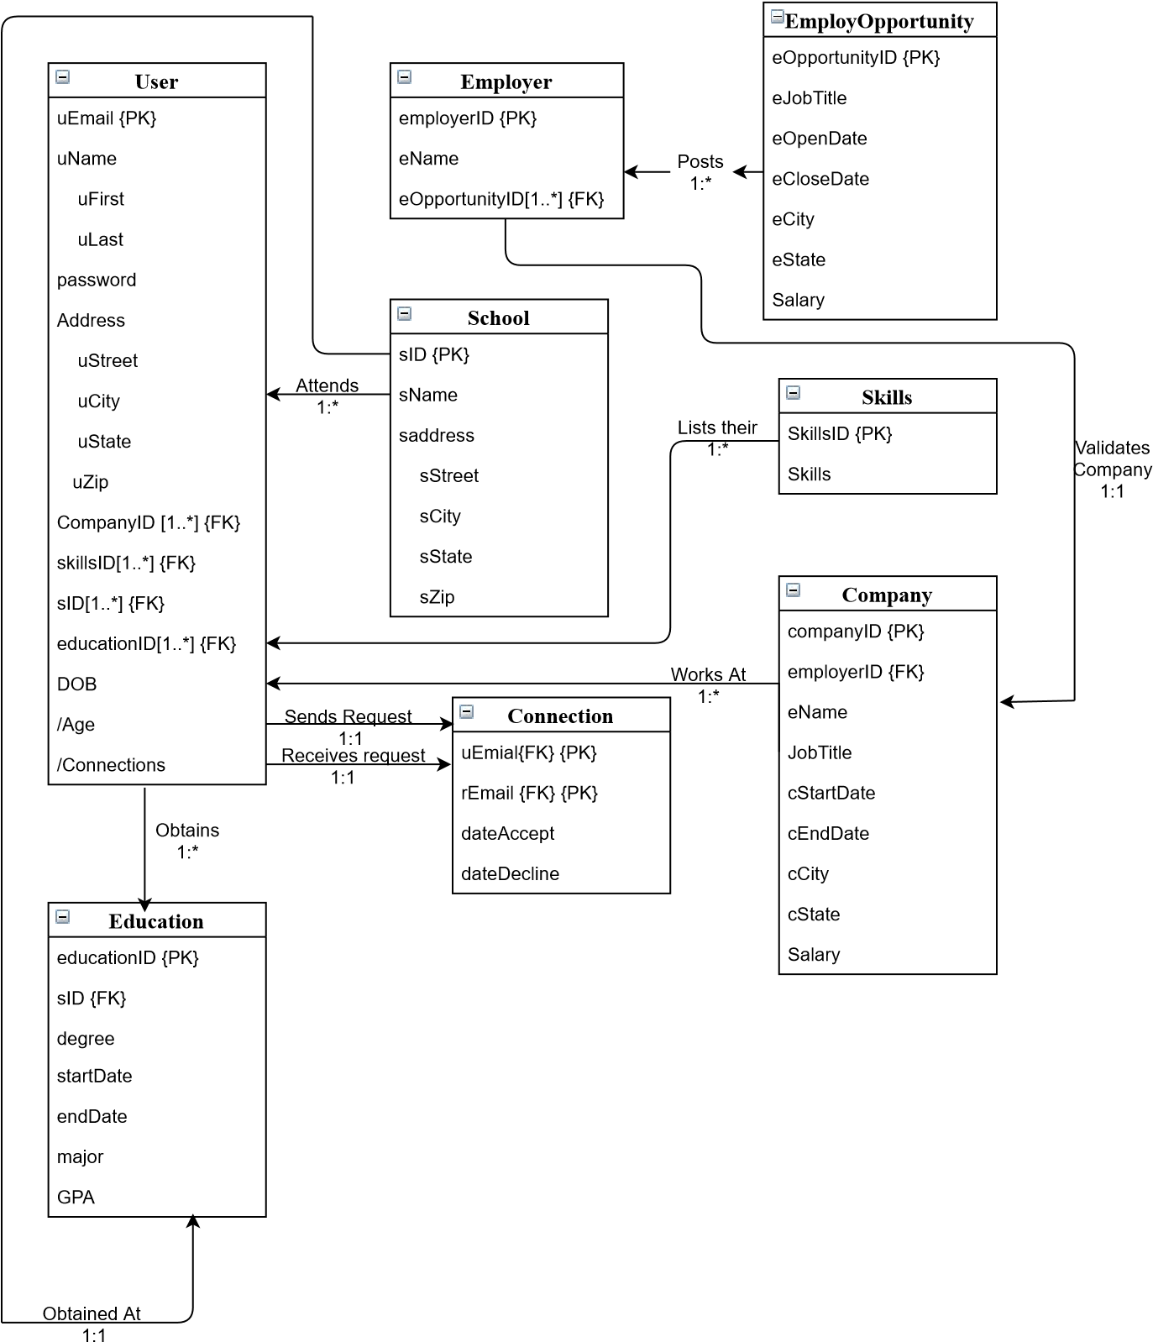

**Convert UML to Relations:**

User (uEmail, Password, uFirst, uLast, uStreet, uCity, uState, uZip, DOB, Age, connections)

Employer (employerID, eName)

EmployOpportunity (eOpportunityID, eJobTitle, eOpenDate, eCloseDate, eCity, eState, eCity)

School (sID, sName, sStreet, sCity, sState, sZip)

Company (companyID, eName, employerID, cJobTitle, cStartDate, cEndDate, salary, cCity, cState)

Education (educationID, sID, startDate, endDate, degree, major)

Connection (uEmail, rEmail, dateAccept, dateDecline)

Skills (skillsID, skills)

Note: All the primary keys are of Purple-blue color

(New relations to keep track of **multivalues**)

UserCompany (companyID, uEmail)

UserSkills (uEmail, skillsID)

UserSchool (sID, uEmail)

EmployerOpportunties (employerID, eOpportunityID)

UserEducation (uemail, educationID)

**Degree of Relations:**

Note: d(something) means Degree of something

d(User): 11

d(Employer): 2

d(EmployOpportunity): 7

d(School): 6

d(Company): 9

d(Education): 6

d(Connections): 4

d(Skills): 2

(**Multivalue**)

d(UserCompany): 2

d(UserSkills): 2

d(UserSchool): 2

d(EmployerOpportunties): 2

d(UserEducation): 2

Domains for Attributes:

uEmail: letters and numbers (for Example: sa12@gmail.com)

uFirst: Sulbha, Daniel, Krish

uLast: Aggarwal, McDonald, Gracia

uCity: Queens Village, Flushing, Corona Park

uState: New York, Michigan, California, Texas

eName: Facebook, Amazon, Oscar Health, IBM (could be number, letters and special characters)

jobTitle: Software Engineer I, Data Scientist, Team Member, Cleaner

salary: Number with two decimal values

skills: Java, C++, Detail-oriented, Microsoft Excel

sName: Queens College, Harvard University, University of Chicago (numbers and letters)

major: Computer Science, Mathematics, Phycology, Nursing (letters)

dateAccepted/dateDecline: MM-DD-YYYY

degree: BA, BS, Masters, PhD (letters)

**Relational Algebra:**

**1. Identify LinkedIn users who graduated from Queens College with a Computer Science degree in the last five years. Display the user name, email and date graduated.**

CSLast5Years ← $δ_{endDate ≥ "\text{03-04-2015"} ᶺ major ="Computer Science"} (∏_{sID, endDate,email}\left(Education\right) )$

QC ← $δ_{CSLast5years.uEmail = UserSchool.uEmail}( CSLast5Years X userSchool )$

QueensCollege ← $δ_{School.sID=QC.sID}( School X QC)$

A ← $δ_{User.uEmail=QueensCollege.uEmail}( User X QueensCollege)$

**Answer** ← $∏_{uFirst , uLast, uEmail, endDate }(A)$

**2. Identify employers with employment opportunities for Java Developers in New York City now. Display the employer, job title and location.**

A ← $δ_{eCity= \text{"New York City"} ᶺ eJobTitle ="\text{Java Developer" ᶺ eCloseDate ≥ "}03-04-2020" }(∏_{eJobTitle, eCity, eState}\left(EmployOpportuntity\right) )$

B ← $δ_{EmployerOpportunities.eOpportunittyID = \text{A.eOpportunityID} }(EmplyerOppoertunities X A )$

Answer ← $∏_{eName, eJobTitle, eCity, eState}(∏_{eJobTitle, eCity}\left(EmployOpportuntity\right) )$

**3. Identify LinkedIn users with an undergraduate Computer Science degree from the City University of New York with Java, security and database skills who live in New York City. Display the user name, email, employers and skills.**

A ← $δ_{(degree = \text{"BA" V degree = "BS" ) ᶺ endDate ≤ "03-04-2020"} }(EmplyerOpportunities X A )$

B ← $δ_{\text{A.educationID = UserEducation.educationID} }( A X userEducation )$

C ← $δ_{B.uEmail = \text{UserSchool.uEmail} }(B X UserSchool )$

D ← $δ_{sName= \text{"City University of New York"} }(δ_{School.sID= \text{C.sID} }\left(School X C \right))$

E ← $δ_{Skills.skillsID = \text{D.skillsID} }(Skills X \left(δ_{UserSkills.uEmail = \text{D.uEmail} }\left(UserSkills X D \right)\right) )$

F ← $δ_{Skills ="Java" }(E)$

G ← $δ_{Skills ="security" }(E)$

H ← $δ_{Skills ="database" }(E)$

K ← $δ_{f.uEmail =G.uEmail ᶺ G.uEmail=j.uEmail }(F X G X J)$

NYC ← $δ_{uCity ="New York City" }(δ_{User.uEmail =K.uEmail }(User X K))$

L ← $δ_{NYC.uEmail = UserCompany.uEmail }(NYC X UserCompany )$

**Answer** ← $∏_{uFirst, uLast, uEmail, cName, skills }$ ($δ_{L.ComapnyID =Company.companyID }(∏_{cName}$ (Company) X L))

**4. Identify LinkedIn users connected to the user Bo Li. Display the user name and email.**

A ← $δ_{uFirst=\text{Bo}ᶺ uLast="Li" }(∏_{iFirst, uLast, uEmail }$ (User))

B ← $δ_{dateAccept = "03-04-2020" }(δ_{A.uEmail = Connection.uEmail }(A X Connection$))

**Answer ← $∏_{iFirst, uLast, uEmail }(δ_{B.rEmail = User.uEmail }(User X B$** ))

**5. Identify employers without current job postings. Display the employer name.**

A ← $δ_{eCloseDate < "03-04-2020" }(EmployOpportunity)$

B ← $δ_{A.eOppoertunityId = EmployerOpportunties.eOpportunityID }\left(A X EmployerOpportunties \right)$

C ← $δ_{B.employerID = Employer.employerID }(B X Employer)$

D ← $δ_{EmployerOpportunities.eOpportunityID = EmployOpportunity.eOpportunityID }(EmployerOpportunities X$

$EmployOpportunity$)

E ← $δ_{Employer.employerID = D.employerID }(Employer X D)$

F ← $∏_{employerID }(Employer) -$ $∏_{employerID}(E)$

**Answer** ← $∏_{eName}(C) ∨ ∏_{eName}(D)$

**6. Identify LinkedIn users not currently employed who live in New York City. Display the LinkedIn user name.**

A ← $δ_{uCity="New York City"}(∏_{uFirst, uLast}(User))$

B ← $δ_{A.uEmail = UserCompany. uEmail}\left(A X UserCompany\right)$

C ← $δ_{B.CompanyID = Company. CompanyID }\left(B X Company\right)$

D ← $δ_{eEndDate < "03-04-2020" }(C)$

E ← $∏_{companyID}(C) - ∏_{companyID}(D)$

**Answer** ← $∏_{companyID}(Company) - ∏_{companyID}(E)$

**7. Identify LinkedIn users without a college degree and skills. Display the user and email.**

A ← $δ_{endDate ≤ "03-04-2020" }(Education)$

B ← $δ_{UserSkills.skillsID = Skills.skillsID}(UserSkills X Skills )$

D ← $δ_{UserEducation.educationID = A.educationID}(UserEducation X A)$

NoEducation ← $∏_{educationID}(UserEducation) - ∏_{educationID}(D)$

NoSkills ← $∏_{skillsID}(UserSkills) - ∏_{skillsID}(Skills)$

**Answer** ← ${∏_{uFirst, uLast, uEmail}(δ}_{NoEducation.uEmail = NoSkills.uEmail}(NoEducation X NoSkills ))$

**8. Identify employers who have never hired Computer Science graduates from the University of Chicago. Display the employer name.**

A ← $δ_{sName =”University of Chicago” ᶺ endDate ≤ “03-04-2020” ᶺ major = “Computer Science” }(δ_{UserEducation.uEmail = UserSchool.uEmail}$

$(UserEducation X UserSchool))$

B ← $δ_{UserCompany.uEmail = A.uEmail}(UserCompany X A )$

C ← $δ_{Company.companyID = C.companyID }(Company X B )$

**Answer** ← $∏_{eName}(∏_{employerID}(Employer) -∏_{employerID}(C))$

**9. Identify the number of users by skill. Display two columns: skill name and number of users. Display one row for each distinct skill. Use an aggregate function and grouping operation to answer this question.**

A ← $δ_{User.uEmail = UserSkills.uEmail}(User X UserSkills )$

$P_{answer}{(Skill Name, Number of Users)}_{skills}{}_{count uEmail}$ ($δ_{Skills.skillsID = A.skillsID}(Skills X A )$)

**10.Identify the number of users who graduated in the last five years from New York colleges. Display two columns: college name and number of users. Display one row for each distinct college name. Use an aggregate function and grouping operation to answer this question.**

Last5Years ← $δ_{endDate > "03-04-2015" }(Education)$

B ← $δ_{UserEducation.educationID = Last5Years.educationID}(UserEducation X Last5Years)$

C ← $δ_{UserSchool.uEmail = B.uEmail}((∏_{email}(B)) X UserSchool)$

D ← $∏_{sState="New York" , sName , uEmail}(δ_{School.SID = C.sID}(School X C)$)

$P_{answer}{(College Name, Number of Users)}_{sName}{}_{count uEmail}$ ($D$)

**11.Identify current job postings by employer in New York City. Display two columns: employer name and number of job postings. Display one row for each distinct employer name. Use an aggregate function and grouping operation to answer this question.**

A ← $δ_{eCity="New York city" ᶺ eCloseDate ≥ "03-04-2020"}(∏_{eJobTitle, eOpportunityID}(EmployOpportunity))$

B ← $δ_{EmployerOpportunities.eOpportunityID =A.eOpportunityID }(EmployerOpportunities X A)$

C ← $∏_{eName, eJobTitle}$ ($δ_{Employer.employerID =B.employerID }(Employer X B)$)

$P_{answer}{(Employer Name, Number of Job Postings)}_{eName}{}_{count eJobTitle}$ ($C$)