Q3: 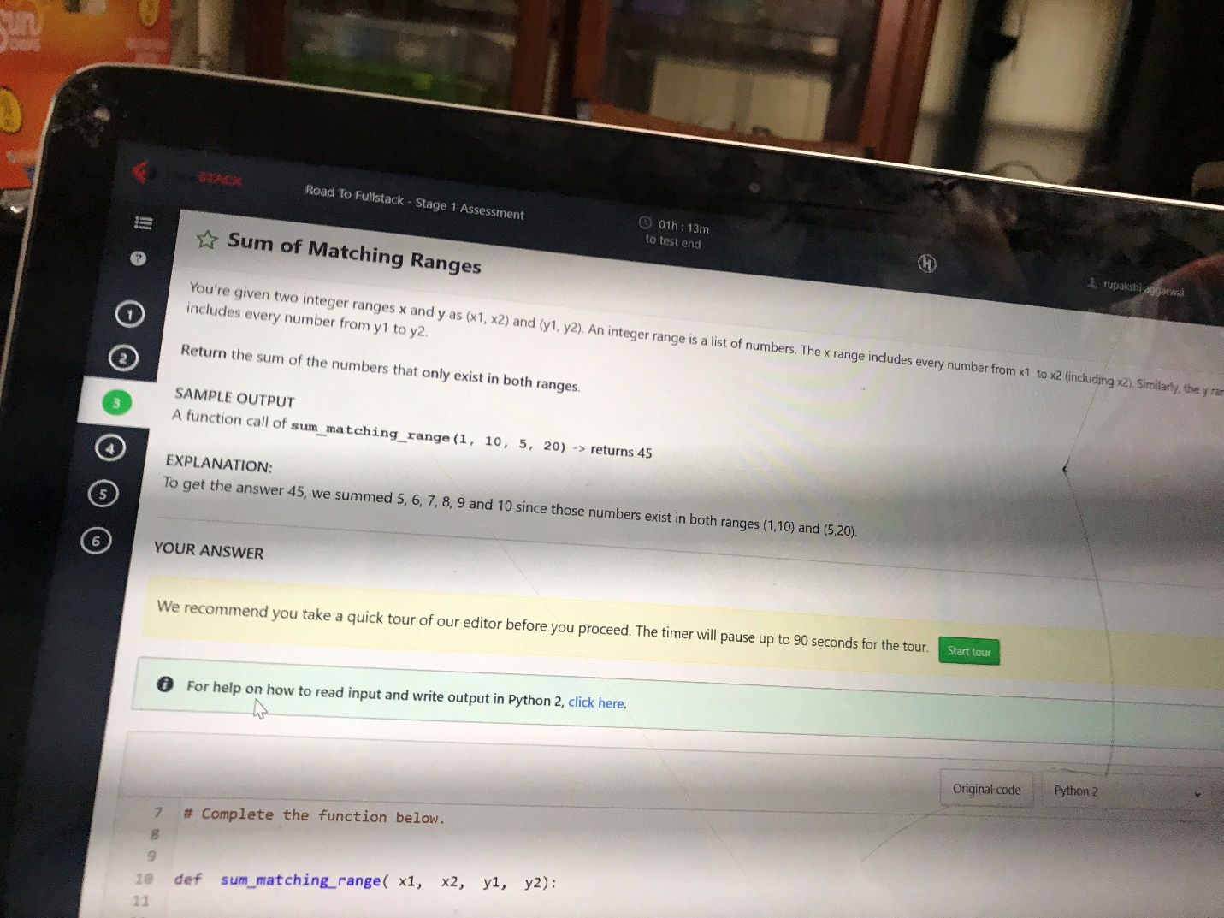

Solution3:

Def sum_matching_range( x1 , x2 , y1 , y2 )

if x1 < y1 :

x1 = y1

if x2 > y2:

x2 = y2

sum = 0

if x1 < x2:

for i in range( x1 , x2+1):

sum += i

return sum