Q4:

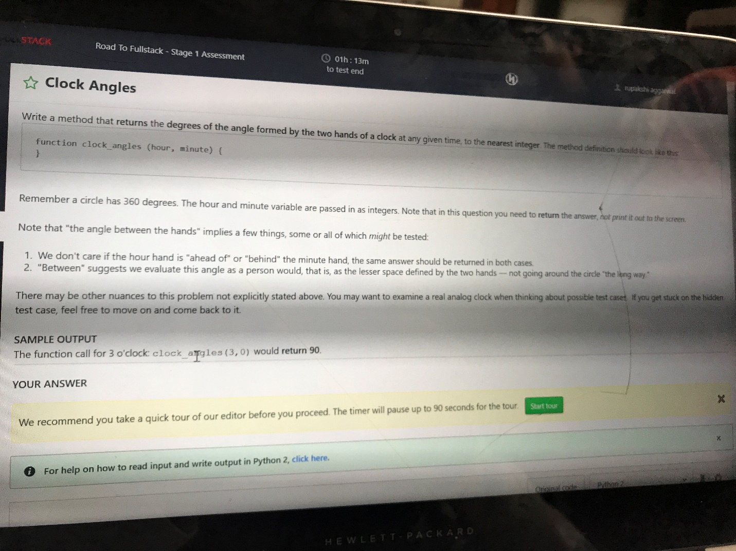

def calcAngle(hour ,minute ):

# validate the input

if (hour < 0 or minute < 0 or hour > 12 or minute > 60):

print('Wrong input')

if (hour == 12):

h = 0

if (minute == 60):

minute = 0

# Calculate the angles moved by

# hour and minute hands with

# reference to 12:00

hour_angle = 0.5 * (hour * 60 + minute )

minute_angle = 6 * minute

# Find the difference between two angles

angle = abs(hour_angle - minute_angle)

# Return the smaller angle of two

# possible angles

angle = min(360 - angle, angle)

return angle