Question5:

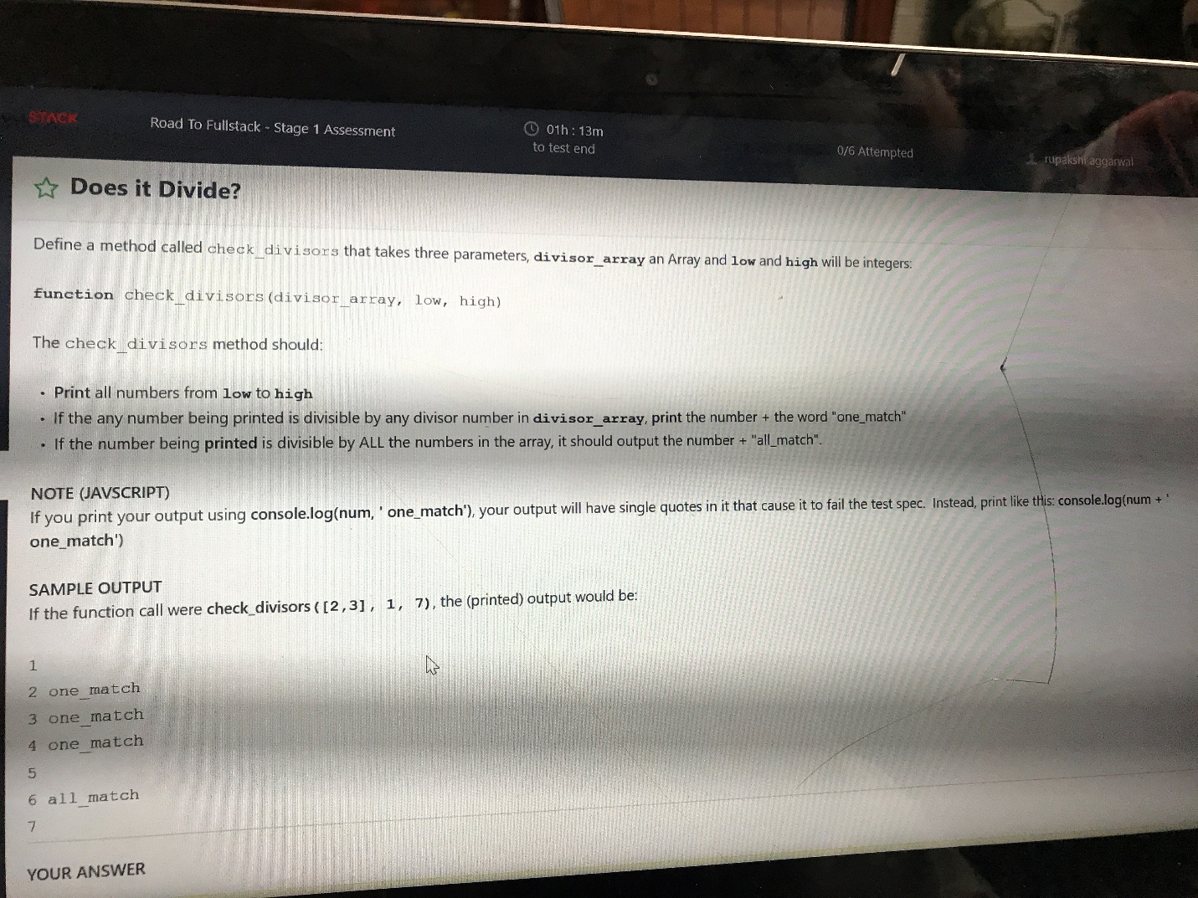

Def check_divisors( divisor_array, low , high):

for i in range(low,high+1):

output = []

for x in divisor_array:

if i % x == 0:

output.append(True)

else:

output.append(False)

if False not in output:

print( i , "all_match" )

elif True in output:

print( i , "one_match" )

else:

print(i)