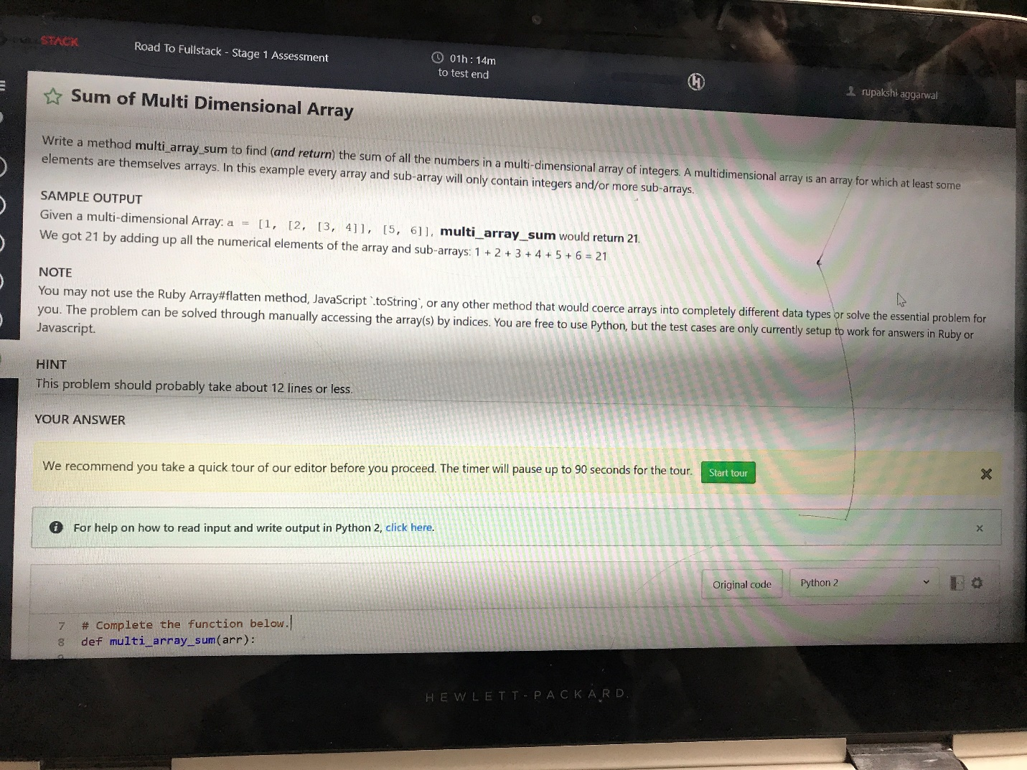

Solution6:

def multi_array_sum(arr):

sum = 0

for i in range(len(arr)):

if isinstance(arr[i],list) == False:

sum += arr[i]

else:

sum += multi_array_sum(arr[i])

return sum