library(tidyverse)

## ── Attaching packages ─────────────────────────────────────── tidyverse 1.3.2 ──  
## ✔ ggplot2 3.3.6 ✔ purrr 0.3.4  
## ✔ tibble 3.1.8 ✔ dplyr 1.0.9  
## ✔ tidyr 1.2.0 ✔ stringr 1.4.1  
## ✔ readr 2.1.2 ✔ forcats 0.5.2  
## ── Conflicts ────────────────────────────────────────── tidyverse_conflicts() ──  
## ✖ dplyr::filter() masks stats::filter()  
## ✖ dplyr::lag() masks stats::lag()

library(tidymodels)

## ── Attaching packages ────────────────────────────────────── tidymodels 1.0.0 ──  
## ✔ broom 1.0.1 ✔ rsample 1.1.0  
## ✔ dials 1.0.0 ✔ tune 1.0.0  
## ✔ infer 1.0.3 ✔ workflows 1.0.0  
## ✔ modeldata 1.0.1 ✔ workflowsets 1.0.0  
## ✔ parsnip 1.0.1 ✔ yardstick 1.0.0  
## ✔ recipes 1.0.1   
## ── Conflicts ───────────────────────────────────────── tidymodels_conflicts() ──  
## ✖ scales::discard() masks purrr::discard()  
## ✖ dplyr::filter() masks stats::filter()  
## ✖ recipes::fixed() masks stringr::fixed()  
## ✖ dplyr::lag() masks stats::lag()  
## ✖ yardstick::spec() masks readr::spec()  
## ✖ recipes::step() masks stats::step()  
## • Use suppressPackageStartupMessages() to eliminate package startup messages

library(esquisse)  
library(GGally)

## Registered S3 method overwritten by 'GGally':  
## method from   
## +.gg ggplot2

library(ggcorrplot)  
library(gridExtra) #I may need to put plots in a grid for easier viewing

##   
## Attaching package: 'gridExtra'  
##   
## The following object is masked from 'package:dplyr':  
##   
## combine

library(leaps)  
library(skimr)

#Read in the dataset

ames_homesales <- read_csv("ames_homesales.csv")

## Rows: 2053 Columns: 81  
## ── Column specification ────────────────────────────────────────────────────────  
## Delimiter: ","  
## chr (47): MS_SubClass, MS_Zoning, Street, Alley, Lot_Shape, Land_Contour, Ut...  
## dbl (34): Lot_Frontage, Lot_Area, Year_Built, Year_Remod_Add, Mas_Vnr_Area, ...  
##   
## ℹ Use `spec()` to retrieve the full column specification for this data.  
## ℹ Specify the column types or set `show_col_types = FALSE` to quiet this message.

#skim(ames_homesales) #Good news, no missing data  
#summary(ames_homesales)

ames_homesales[sapply(ames_homesales, is.character)] <- lapply(ames_homesales[sapply(ames_homesales, is.character)],   
 as.factor)  
  
#Response Variable, Above_Median, is a character vector. Also, let's convert all the variables that are characters to factors

str(ames_homesales)

## spec_tbl_df [2,053 × 81] (S3: spec_tbl_df/tbl_df/tbl/data.frame)  
## $ MS_SubClass : Factor w/ 16 levels "Duplex_All_Styles_and_Ages",..: 6 6 6 6 15 15 7 7 6 6 ...  
## $ MS_Zoning : Factor w/ 7 levels "A_agr","C_all",..: 6 5 6 6 6 6 6 6 6 6 ...  
## $ Lot_Frontage : num [1:2053] 141 80 81 93 74 78 43 39 0 85 ...  
## $ Lot_Area : num [1:2053] 31770 11622 14267 11160 13830 ...  
## $ Street : Factor w/ 2 levels "Grvl","Pave": 2 2 2 2 2 2 2 2 2 2 ...  
## $ Alley : Factor w/ 3 levels "Gravel","No_Alley_Access",..: 2 2 2 2 2 2 2 2 2 2 ...  
## $ Lot_Shape : Factor w/ 4 levels "Irregular","Moderately_Irregular",..: 4 3 4 3 4 4 4 4 4 3 ...  
## $ Land_Contour : Factor w/ 4 levels "Bnk","HLS","Low",..: 4 4 4 4 4 4 2 4 4 4 ...  
## $ Utilities : Factor w/ 2 levels "AllPub","NoSewr": 1 1 1 1 1 1 1 1 1 1 ...  
## $ Lot_Config : Factor w/ 5 levels "Corner","CulDSac",..: 1 5 1 1 5 5 5 5 5 5 ...  
## $ Land_Slope : Factor w/ 3 levels "Gtl","Mod","Sev": 1 1 1 1 1 1 1 1 1 1 ...  
## $ Neighborhood : Factor w/ 28 levels "Bloomington_Heights",..: 16 16 16 16 9 9 26 26 9 9 ...  
## $ Condition_1 : Factor w/ 9 levels "Artery","Feedr",..: 3 2 3 3 3 3 3 3 3 3 ...  
## $ Condition_2 : Factor w/ 8 levels "Artery","Feedr",..: 3 3 3 3 3 3 3 3 3 3 ...  
## $ Bldg_Type : Factor w/ 5 levels "Duplex","OneFam",..: 2 2 2 2 2 2 4 4 2 2 ...  
## $ House_Style : Factor w/ 8 levels "One_and_Half_Fin",..: 3 3 3 3 8 8 3 3 3 3 ...  
## $ Overall_Qual : Factor w/ 10 levels "Above_Average",..: 1 2 1 6 2 1 9 9 1 6 ...  
## $ Overall_Cond : Factor w/ 9 levels "Above_Average",..: 2 1 1 2 2 1 2 2 6 2 ...  
## $ Year_Built : num [1:2053] 1960 1961 1958 1968 1997 ...  
## $ Year_Remod_Add : num [1:2053] 1960 1961 1958 1968 1998 ...  
## $ Roof_Style : Factor w/ 6 levels "Flat","Gable",..: 4 2 4 4 2 2 2 2 2 2 ...  
## $ Roof_Matl : Factor w/ 6 levels "CompShg","Metal",..: 1 1 1 1 1 1 1 1 1 1 ...  
## $ Exterior_1st : Factor w/ 16 levels "AsbShng","AsphShn",..: 4 14 15 4 14 14 7 6 7 7 ...  
## $ Exterior_2nd : Factor w/ 17 levels "AsbShng","AsphShn",..: 11 15 16 4 15 15 7 6 7 7 ...  
## $ Mas_Vnr_Type : Factor w/ 5 levels "BrkCmn","BrkFace",..: 5 4 2 4 4 2 4 4 4 4 ...  
## $ Mas_Vnr_Area : num [1:2053] 112 0 108 0 0 20 0 0 0 0 ...  
## $ Exter_Qual : Factor w/ 4 levels "Excellent","Fair",..: 4 4 4 3 4 4 3 3 4 4 ...  
## $ Exter_Cond : Factor w/ 5 levels "Excellent","Fair",..: 5 5 5 5 5 5 5 5 3 5 ...  
## $ Foundation : Factor w/ 6 levels "BrkTil","CBlock",..: 2 2 2 2 3 3 3 3 3 3 ...  
## $ Bsmt_Qual : Factor w/ 6 levels "Excellent","Fair",..: 6 6 6 6 3 6 3 3 3 3 ...  
## $ Bsmt_Cond : Factor w/ 6 levels "Excellent","Fair",..: 3 6 6 6 6 6 6 6 6 6 ...  
## $ Bsmt_Exposure : Factor w/ 5 levels "Av","Gd","Mn",..: 2 4 4 4 4 4 4 4 4 2 ...  
## $ BsmtFin_Type_1 : Factor w/ 7 levels "ALQ","BLQ","GLQ",..: 2 6 1 1 3 3 1 3 1 3 ...  
## $ BsmtFin_SF_1 : num [1:2053] 2 6 1 1 3 3 1 3 1 3 ...  
## $ BsmtFin_Type_2 : Factor w/ 7 levels "ALQ","BLQ","GLQ",..: 7 4 7 7 7 7 7 7 7 7 ...  
## $ BsmtFin_SF_2 : num [1:2053] 0 144 0 0 0 0 0 0 0 0 ...  
## $ Bsmt_Unf_SF : num [1:2053] 441 270 406 1045 137 ...  
## $ Total_Bsmt_SF : num [1:2053] 1080 882 1329 2110 928 ...  
## $ Heating : Factor w/ 6 levels "Floor","GasA",..: 2 2 2 2 2 2 2 2 2 2 ...  
## $ Heating_QC : Factor w/ 5 levels "Excellent","Fair",..: 2 5 5 1 3 1 1 1 1 3 ...  
## $ Central_Air : Factor w/ 2 levels "N","Y": 2 2 2 2 2 2 2 2 2 2 ...  
## $ Electrical : Factor w/ 5 levels "FuseA","FuseF",..: 4 4 4 4 4 4 4 4 4 4 ...  
## $ First_Flr_SF : num [1:2053] 1656 896 1329 2110 928 ...  
## $ Second_Flr_SF : num [1:2053] 0 0 0 0 701 678 0 0 0 0 ...  
## $ Low_Qual_Fin_SF : num [1:2053] 0 0 0 0 0 0 0 0 0 0 ...  
## $ Gr_Liv_Area : num [1:2053] 1656 896 1329 2110 1629 ...  
## $ Bsmt_Full_Bath : num [1:2053] 1 0 0 1 0 0 0 1 1 1 ...  
## $ Bsmt_Half_Bath : num [1:2053] 0 0 0 0 0 0 0 0 0 0 ...  
## $ Full_Bath : num [1:2053] 1 1 1 2 2 2 2 2 2 1 ...  
## $ Half_Bath : num [1:2053] 0 0 1 1 1 1 0 0 0 1 ...  
## $ Bedroom_AbvGr : num [1:2053] 3 2 3 3 3 3 2 2 3 2 ...  
## $ Kitchen_AbvGr : num [1:2053] 1 1 1 1 1 1 1 1 1 1 ...  
## $ Kitchen_Qual : Factor w/ 5 levels "Excellent","Fair",..: 5 5 3 1 5 3 3 3 5 3 ...  
## $ TotRms_AbvGrd : num [1:2053] 7 5 6 8 6 7 5 5 6 5 ...  
## $ Functional : Factor w/ 8 levels "Maj1","Maj2",..: 8 8 8 8 8 8 8 8 8 8 ...  
## $ Fireplaces : num [1:2053] 2 0 0 2 1 1 0 1 0 1 ...  
## $ Fireplace_Qu : Factor w/ 6 levels "Excellent","Fair",..: 3 4 4 6 6 3 4 6 4 5 ...  
## $ Garage_Type : Factor w/ 7 levels "Attchd","Basment",..: 1 1 1 1 1 1 1 1 1 1 ...  
## $ Garage_Finish : Factor w/ 4 levels "Fin","No_Garage",..: 1 4 4 1 1 1 3 3 1 4 ...  
## $ Garage_Cars : num [1:2053] 2 1 1 2 2 2 2 2 2 2 ...  
## $ Garage_Area : num [1:2053] 528 730 312 522 482 470 506 608 420 506 ...  
## $ Garage_Qual : Factor w/ 6 levels "Excellent","Fair",..: 6 6 6 6 6 6 6 6 6 6 ...  
## $ Garage_Cond : Factor w/ 6 levels "Excellent","Fair",..: 6 6 6 6 6 6 6 6 6 6 ...  
## $ Paved_Drive : Factor w/ 3 levels "Dirt_Gravel",..: 2 3 3 3 3 3 3 3 3 3 ...  
## $ Wood_Deck_SF : num [1:2053] 210 140 393 0 212 360 0 237 483 192 ...  
## $ Open_Porch_SF : num [1:2053] 62 0 36 0 34 36 82 152 21 0 ...  
## $ Enclosed_Porch : num [1:2053] 0 0 0 0 0 0 0 0 0 0 ...  
## $ Three_season_porch: num [1:2053] 0 0 0 0 0 0 0 0 0 0 ...  
## $ Screen_Porch : num [1:2053] 0 120 0 0 0 0 144 0 0 0 ...  
## $ Pool_Area : num [1:2053] 0 0 0 0 0 0 0 0 0 0 ...  
## $ Pool_QC : Factor w/ 5 levels "Excellent","Fair",..: 4 4 4 4 4 4 4 4 4 4 ...  
## $ Fence : Factor w/ 5 levels "Good_Privacy",..: 5 3 5 5 3 5 5 5 1 5 ...  
## $ Misc_Feature : Factor w/ 5 levels "Elev","Gar2",..: 3 3 2 3 3 3 3 3 5 3 ...  
## $ Misc_Val : num [1:2053] 0 0 12500 0 0 0 0 0 500 0 ...  
## $ Mo_Sold : num [1:2053] 5 6 6 4 3 6 1 3 3 2 ...  
## $ Year_Sold : num [1:2053] 2010 2010 2010 2010 2010 2010 2010 2010 2010 2010 ...  
## $ Sale_Type : Factor w/ 10 levels "COD","Con","ConLD",..: 10 10 10 10 10 10 10 10 10 10 ...  
## $ Sale_Condition : Factor w/ 6 levels "Abnorml","AdjLand",..: 5 5 5 5 5 5 5 5 5 5 ...  
## $ Longitude : num [1:2053] -93.6 -93.6 -93.6 -93.6 -93.6 ...  
## $ Latitude : num [1:2053] 42.1 42.1 42.1 42.1 42.1 ...  
## $ Above_Median : Factor w/ 2 levels "No","Yes": 2 1 2 2 2 2 2 2 2 2 ...  
## - attr(*, "spec")=  
## .. cols(  
## .. MS_SubClass = col_character(),  
## .. MS_Zoning = col_character(),  
## .. Lot_Frontage = col_double(),  
## .. Lot_Area = col_double(),  
## .. Street = col_character(),  
## .. Alley = col_character(),  
## .. Lot_Shape = col_character(),  
## .. Land_Contour = col_character(),  
## .. Utilities = col_character(),  
## .. Lot_Config = col_character(),  
## .. Land_Slope = col_character(),  
## .. Neighborhood = col_character(),  
## .. Condition_1 = col_character(),  
## .. Condition_2 = col_character(),  
## .. Bldg_Type = col_character(),  
## .. House_Style = col_character(),  
## .. Overall_Qual = col_character(),  
## .. Overall_Cond = col_character(),  
## .. Year_Built = col_double(),  
## .. Year_Remod_Add = col_double(),  
## .. Roof_Style = col_character(),  
## .. Roof_Matl = col_character(),  
## .. Exterior_1st = col_character(),  
## .. Exterior_2nd = col_character(),  
## .. Mas_Vnr_Type = col_character(),  
## .. Mas_Vnr_Area = col_double(),  
## .. Exter_Qual = col_character(),  
## .. Exter_Cond = col_character(),  
## .. Foundation = col_character(),  
## .. Bsmt_Qual = col_character(),  
## .. Bsmt_Cond = col_character(),  
## .. Bsmt_Exposure = col_character(),  
## .. BsmtFin_Type_1 = col_character(),  
## .. BsmtFin_SF_1 = col_double(),  
## .. BsmtFin_Type_2 = col_character(),  
## .. BsmtFin_SF_2 = col_double(),  
## .. Bsmt_Unf_SF = col_double(),  
## .. Total_Bsmt_SF = col_double(),  
## .. Heating = col_character(),  
## .. Heating_QC = col_character(),  
## .. Central_Air = col_character(),  
## .. Electrical = col_character(),  
## .. First_Flr_SF = col_double(),  
## .. Second_Flr_SF = col_double(),  
## .. Low_Qual_Fin_SF = col_double(),  
## .. Gr_Liv_Area = col_double(),  
## .. Bsmt_Full_Bath = col_double(),  
## .. Bsmt_Half_Bath = col_double(),  
## .. Full_Bath = col_double(),  
## .. Half_Bath = col_double(),  
## .. Bedroom_AbvGr = col_double(),  
## .. Kitchen_AbvGr = col_double(),  
## .. Kitchen_Qual = col_character(),  
## .. TotRms_AbvGrd = col_double(),  
## .. Functional = col_character(),  
## .. Fireplaces = col_double(),  
## .. Fireplace_Qu = col_character(),  
## .. Garage_Type = col_character(),  
## .. Garage_Finish = col_character(),  
## .. Garage_Cars = col_double(),  
## .. Garage_Area = col_double(),  
## .. Garage_Qual = col_character(),  
## .. Garage_Cond = col_character(),  
## .. Paved_Drive = col_character(),  
## .. Wood_Deck_SF = col_double(),  
## .. Open_Porch_SF = col_double(),  
## .. Enclosed_Porch = col_double(),  
## .. Three_season_porch = col_double(),  
## .. Screen_Porch = col_double(),  
## .. Pool_Area = col_double(),  
## .. Pool_QC = col_character(),  
## .. Fence = col_character(),  
## .. Misc_Feature = col_character(),  
## .. Misc_Val = col_double(),  
## .. Mo_Sold = col_double(),  
## .. Year_Sold = col_double(),  
## .. Sale_Type = col_character(),  
## .. Sale_Condition = col_character(),  
## .. Longitude = col_double(),  
## .. Latitude = col_double(),  
## .. Above_Median = col_character()  
## .. )  
## - attr(*, "problems")=<externalptr>

ames <- ames_homesales %>%  
select(c(1:78,81))  
#Removing columns 79 & 80 (Longitude and Latitude) to reduce the complexity since these are variables that don't add to our predictions.

table(ames$Above_Median) #1010 properties not above median, 1043 above median

##   
## No Yes   
## 1010 1043

#this is the response variable and the dataset appears balanced with only slightly more than half of the properties selling above median

t1 = table(ames$Above_Median, ames$Year_Sold) #create a table object  
prop.table(t1, margin = 2 ) #crosstab with proportions

##   
## 2006 2007 2008 2009 2010  
## No 0.4909502 0.4669339 0.4966292 0.5043860 0.5165877  
## Yes 0.5090498 0.5330661 0.5033708 0.4956140 0.4834123

#Proportion of homes selling above (or below) median (response variable) by year sold

t2 = table(ames$Above_Median, ames$Lot_Config)  
prop.table(t2, margin = 2)

##   
## Corner CulDSac FR2 FR3 Inside  
## No 0.5320334 0.2518519 0.4821429 0.3750000 0.5050167  
## Yes 0.4679666 0.7481481 0.5178571 0.6250000 0.4949833

#Proportion of properties selling above median by lot config. CulDeSacs are selling above median, as are FR3.

ggplot(ames) +  
 aes(x = Lot_Config, fill = Above_Median) +  
 geom_bar() +  
 scale_fill_hue(direction = 1) +  
 labs(title = " Cul-de-sacs are more valuable and corner lots are slightly less valuable") +  
 theme_minimal() +  
 theme(legend.position = "top", plot.title = element_text(size = 15L, face = "bold",   
 hjust = 0.5), plot.subtitle = element_text(size = 12L, hjust = 0.5))

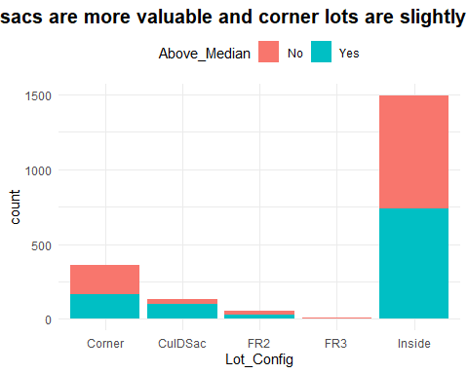

#How many properties sold each year?  
ggplot(ames) +  
 aes(x = Year_Sold, fill = Above_Median) +  
 geom_histogram(bins = 30L) +  
 scale_fill_hue(direction = 1) +  
 labs(title = "Home Sales by Year Sold") +  
 theme_minimal()

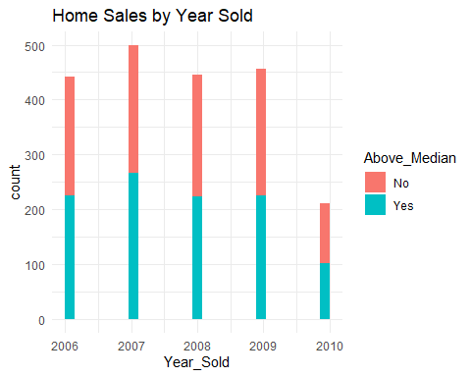

#We learn that sales dropped in 2010 but as we already knew from the table, proportion of above and below median was uniform across the years.

#esquisser  
  
  
ggplot(ames) +  
 aes(x = MS_SubClass) +  
 geom_bar(fill = "#112446") +  
 labs(x = "Number of properties sold",   
 title = "What floorplans and age of homes were selling?") +  
 coord_flip() +  
 theme_minimal() +  
 theme(plot.title = element_text(size = 15L,   
 face = "bold", hjust = 0.5), plot.subtitle = element_text(size = 12L, hjust = 0.5)) +  
 facet_wrap(vars(Above_Median))

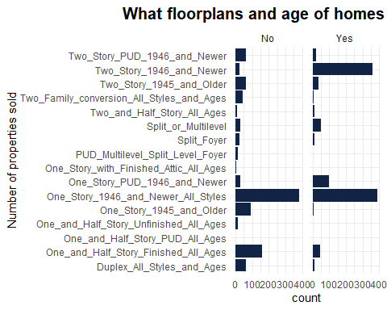

ggplot(ames) +  
 aes(x = MS_SubClass, fill = Above_Median) +  
 geom_bar() +  
 scale_fill_hue(direction = 1) +  
 coord_flip() +  
 theme_minimal() +  
 theme(legend.position = "top", plot.title = element_text(size = 15L,   
 face = "bold", hjust = 0.5), plot.subtitle = element_text(size = 12L, hjust = 0.5))

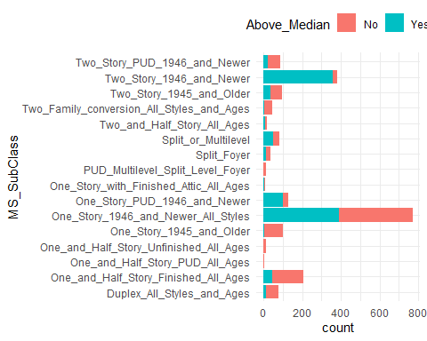

ggplot(ames) +  
 aes(x = Neighborhood, fill = Above_Median) +  
 geom_bar() +  
 scale_fill_hue(direction = 1) +  
 labs(title = "Some Neighborhoods Appear to be Hot Sellers") +  
 coord_flip() +  
 theme_minimal() +  
 theme(legend.position = "top",   
 plot.title = element_text(size = 15L, face = "bold", hjust = 0.5), plot.subtitle = element_text(size = 12L,   
 hjust = 0.5))

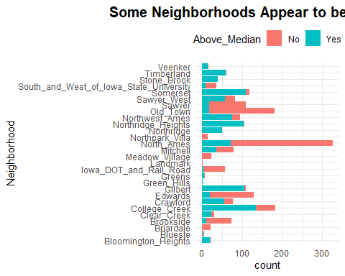

table(ames$Street) #Only 7 properties in this category are in "gravel" category, all others are "street"

##   
## Grvl Pave   
## 7 2046

table(ames$Utilities) #Only 1 property is "no sewr" all other are "public"

##   
## AllPub NoSewr   
## 2052 1

table(ames$Lot_Shape)

##   
## Irregular Moderately_Irregular Regular   
## 11 53 1275   
## Slightly_Irregular   
## 714

table(ames$Half_Bath) #1300 have no half bath, 736 have 1 half bath and 17 have 2 half baths

##   
## 0 1 2   
## 1300 736 17

ggplot(ames) +  
 aes(x = Garage_Cond, fill = Above_Median) +  
 geom_bar() +  
 scale_fill_hue(direction = 1) +  
 labs(title = "Condition of Garage, If Property has Garage") +  
 theme_minimal()

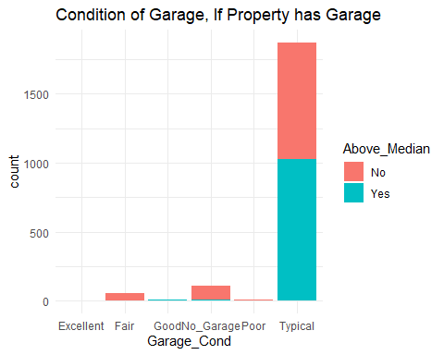

ggplot(ames) +  
 aes(x = Garage_Type, fill = Above_Median) +  
 geom_bar() +  
 scale_fill_hue(direction = 1) +  
 labs(title = "Style of Garage, If Property has Garage") +  
 theme(axis.text.x = element_text(angle = 90,vjust = .5))

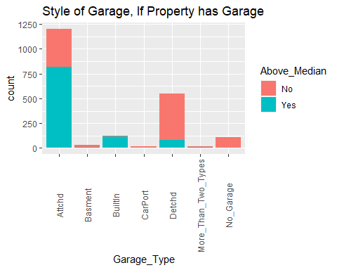

ggplot(ames) +  
 aes(x = Paved_Drive, fill = Above_Median) +  
 geom_bar() +  
 scale_fill_hue(direction = 1) +  
 labs(title = "Dirt Driveways Sell for Below Median in Many Cases") +  
 theme_minimal()

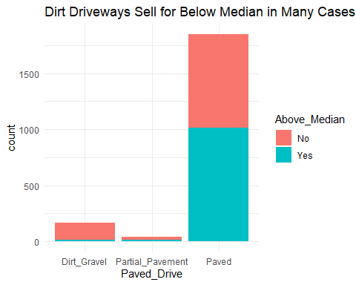

ggplot(ames) +  
 aes(x = Garage_Finish, fill = Above_Median) +  
 geom_bar() +  
 scale_fill_hue(direction = 1) +  
 labs(title = "Finished Vs Unfirished Garages") +  
 theme_minimal()

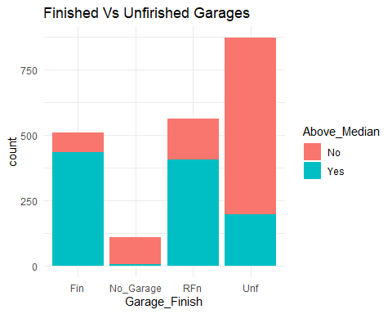

ggplot(ames) +  
 aes(x = Fireplace_Qu, fill = Above_Median) +  
 geom_bar() +  
 scale_fill_hue(direction = 1) +  
 labs(title = "Condition of Fireplace") +  
 theme_minimal()

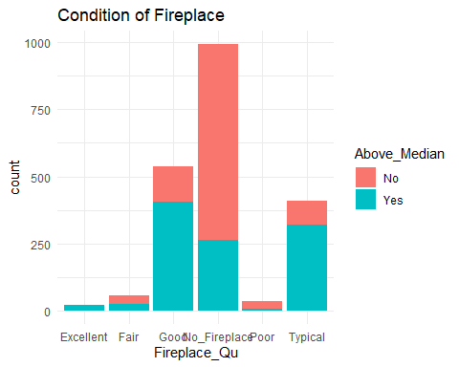

ggplot(ames) +  
 aes(x = Kitchen_Qual, fill = Above_Median) +  
 geom_bar() +  
 scale_fill_hue(direction = 1) +  
 labs(title = "Condition of Kitchen") +  
 theme_minimal()

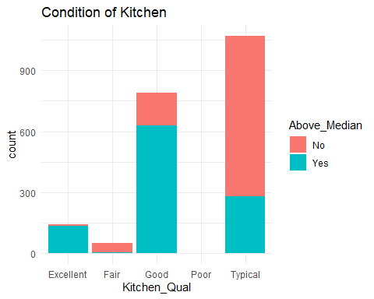

ggplot(ames) +  
 aes(x = Central_Air, fill = Above_Median) +  
 geom_bar() +  
 scale_fill_hue(direction = 1) +  
 labs(title = "Is there a Good Month to Sell if you don't have AC?") +  
 theme_minimal() +  
 facet_wrap(vars(Mo_Sold))

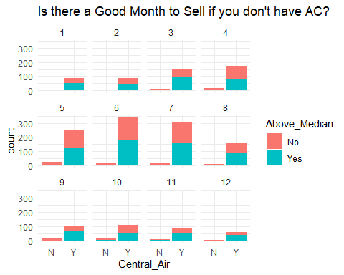

ggplot(ames) +  
 aes(x = House_Style, fill = Above_Median) +  
 geom_bar() +  
 scale_fill_hue(direction = 1) +  
 labs(title = "House Style") +  
 theme(axis.text.x = element_text(angle = 90,vjust = .5))

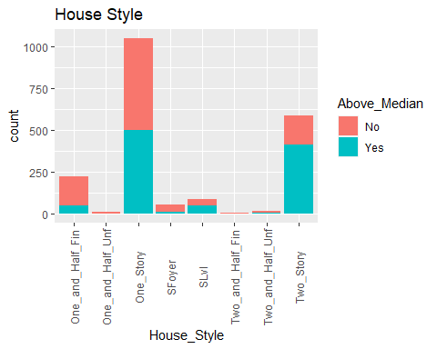

ggplot(ames) +  
 aes(x = Overall_Qual, fill = Above_Median) +  
 geom_bar() +  
 scale_fill_hue(direction = 1) +  
 labs(title = "Overall Quality of Property") +  
 theme(axis.text.x = element_text(angle = 90,vjust = .5))

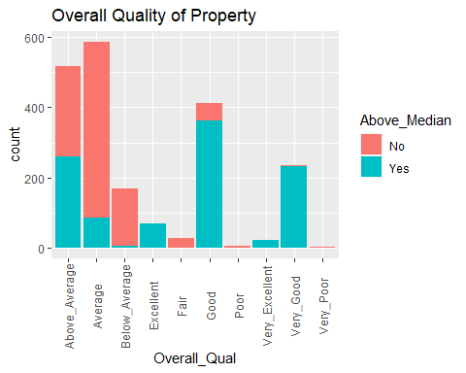

ggplot(ames) +  
 aes(x = Overall_Cond, fill = Above_Median) +  
 geom_bar() +  
 scale_fill_hue(direction = 1) +  
 labs(title = "Overall Condition of Property") +  
 theme(axis.text.x = element_text(angle = 90,vjust = .5))

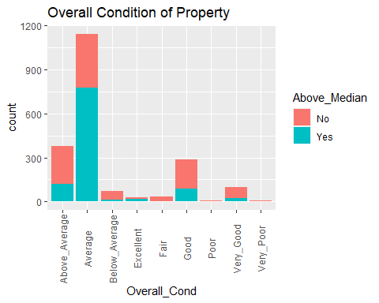

ggplot(ames) +  
 aes(x = Exterior_1st, fill = Above_Median) +  
 geom_bar() +  
 scale_fill_hue(direction = 1) +  
 labs(title = "Exterior First Floor with Vinly Siding being a good seller") +  
 theme_minimal()

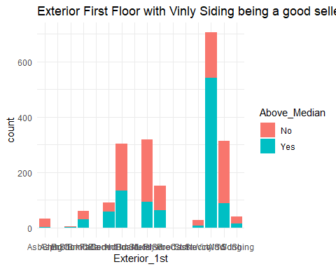

ggplot(ames) +  
 aes(x = Exterior_2nd, fill = Above_Median) +  
 geom_bar() +  
 scale_fill_hue(direction = 1) +  
 labs(title = "Exterior Second Floor (similiar to data for exterior first floor)") +  
 theme(axis.text.x = element_text(angle = 90,vjust = .5))

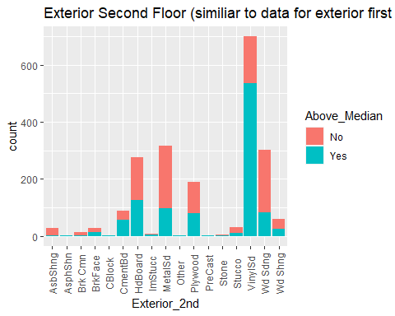

ggplot(ames) +  
 aes(x = Exter_Qual, fill = Above_Median) +  
 geom_bar() +  
 scale_fill_hue(direction = 1) +  
 labs(title = "Exterior Quality") +  
 theme_minimal()

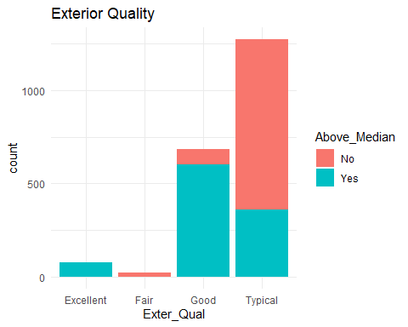

ggplot(ames) +  
 aes(x = Foundation, fill = Above_Median) +  
 geom_bar() +  
 scale_fill_hue(direction = 1) +  
 labs(title = "Foundation Construction") +  
 theme_minimal()

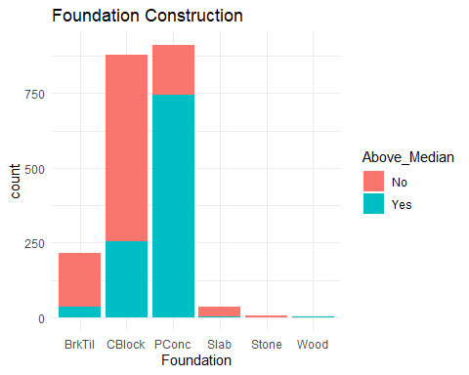

ggplot(ames) +  
 aes(x = Bsmt_Qual, fill = Above_Median) +  
 geom_bar() +  
 scale_fill_hue(direction = 1) +  
 labs(title = "Basement Quality") +  
 theme_minimal()

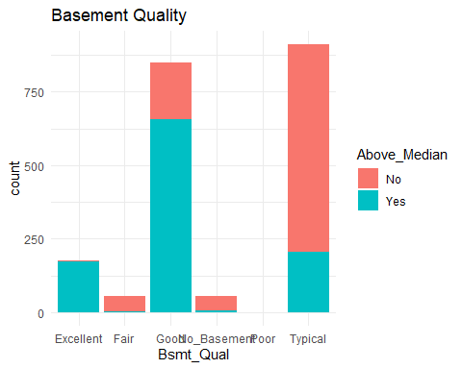

ggplot(ames) +  
 aes(x = Heating_QC, fill = Above_Median) +  
 geom_bar() +  
 scale_fill_hue(direction = 1) +  
 labs(title = "Heating QC") +  
 theme_minimal()

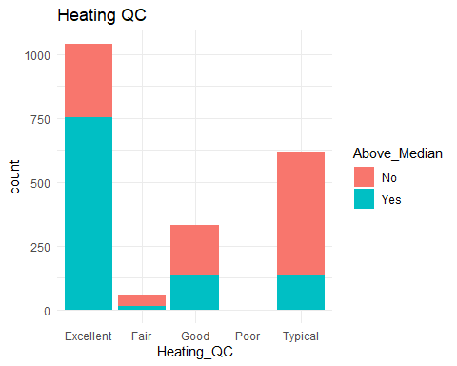

ggplot(ames) +  
 aes(x = Kitchen_Qual, fill = Above_Median) +  
 geom_bar() +  
 scale_fill_hue(direction = 1) +  
 labs(title = "Kitchen Quality") +  
 theme_minimal()

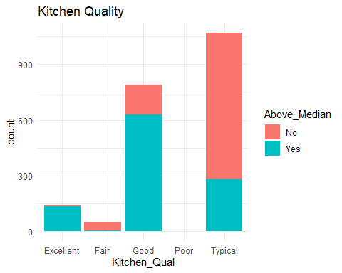

ggplot(ames) +  
 aes(x = Year_Remod_Add, fill = Above_Median) +  
 geom_histogram(bins = 30L) +  
 scale_fill_hue(direction = 1) +  
 labs(title = "Recent Remodeling likely to land the property above median") +  
 theme_minimal()

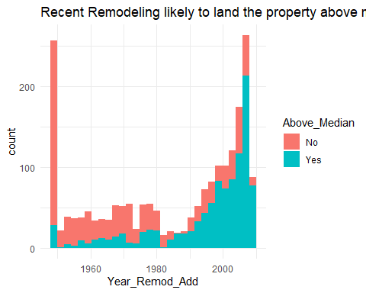

ggplot(ames) +  
 aes(x = Three_season_porch, fill = Above_Median) +  
 geom_histogram(bins = 30L) +  
 scale_fill_hue(direction = 1) +  
 labs(title = "Three Season Porch") +  
 theme_minimal()

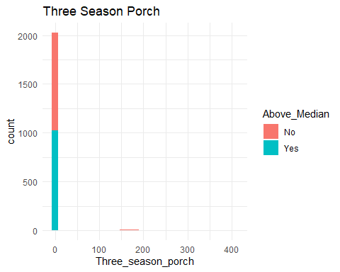

ggplot(ames) +  
 aes(x = Enclosed_Porch, fill = Above_Median) +  
 geom_histogram(bins = 30L) +  
 scale_fill_hue(direction = 1) +  
 labs(title = "Enclosed Porch") +  
 theme_minimal()

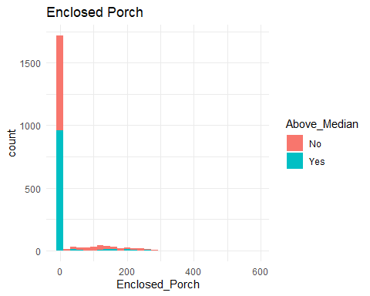

ames %>%  
 filter(Wood_Deck_SF >= 0L & Wood_Deck_SF <= 302L) %>%  
 ggplot() +  
 aes(x = Wood_Deck_SF, fill = Above_Median) +  
 geom_histogram(bins = 30L) +  
 scale_fill_hue(direction = 1) +  
 labs(title = "Wood Deck SF") +  
 theme_minimal()

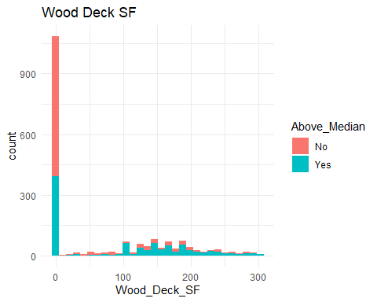

ames %>%  
 filter(Lot_Area >= 1300L & Lot_Area <= 28280L) %>%  
 filter(Wood_Deck_SF >= 0L & Wood_Deck_SF <=   
 302L) %>%  
 ggplot() +  
 aes(x = "", y = Lot_Area, fill = Above_Median) +  
 geom_boxplot() +  
 scale_fill_hue(direction = 1) +  
 labs(title = "Lot Area") +  
 theme_minimal()

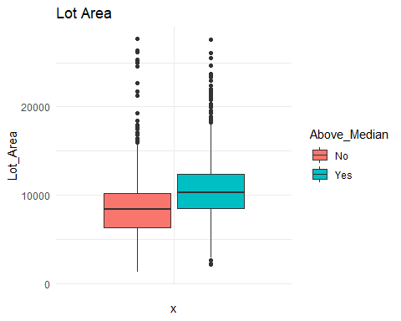

ames %>%  
 filter(Lot_Area >= 1300L & Lot_Area <= 28280L) %>%  
 filter(Wood_Deck_SF >= 0L & Wood_Deck_SF <=   
 302L) %>%  
 ggplot() +  
 aes(x = "", y = Year_Built, fill = Above_Median) +  
 geom_boxplot() +  
 scale_fill_hue(direction = 1) +  
 labs(title = "Newer Houses Have higher Selling Prices") +  
 theme_minimal()

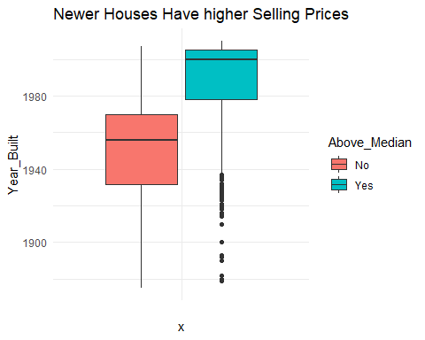

ames %>%  
 filter(Lot_Area >= 1300L & Lot_Area <= 28280L) %>%  
 filter(Wood_Deck_SF >= 0L & Wood_Deck_SF <=   
 302L) %>%  
 ggplot() +  
 aes(x = Wood_Deck_SF, fill = Above_Median) +  
 geom_histogram(bins = 30L) +  
 scale_fill_hue(direction = 1) +  
 labs(title = "Wood Decks from 100 - 300 square feet are good selling points") +  
 theme_minimal()

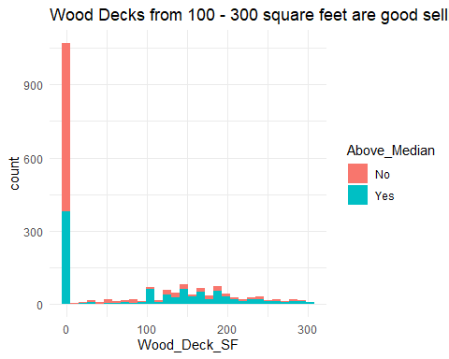

ames %>%  
 filter(Lot_Area >= 1300L & Lot_Area <= 28280L) %>%  
 filter(Wood_Deck_SF >= 0L & Wood_Deck_SF <=   
 302L) %>%  
 ggplot() +  
 aes(x = "", y = First_Flr_SF, fill = Above_Median) +  
 geom_boxplot() +  
 scale_fill_hue(direction = 1) +  
 labs(title = "First Floor Sf") +  
 theme_minimal()

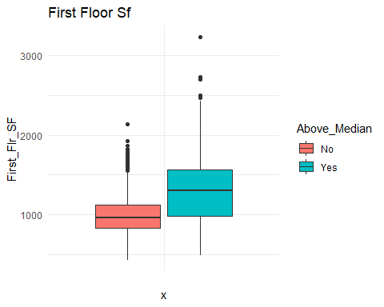

ames %>%  
 filter(Lot_Area >= 1300L & Lot_Area <= 28280L) %>%  
 filter(Mas_Vnr_Area >= 0L & Mas_Vnr_Area <=   
 502L) %>%  
 filter(Wood_Deck_SF >= 0L & Wood_Deck_SF <= 302L) %>%  
 ggplot() +  
 aes(x = Full_Bath, fill = Above_Median) +  
 geom_histogram(bins = 30L) +  
 scale_fill_hue(direction = 1) +  
 labs(title = "Two Full Bathrooms is a predictor for above median value") +  
 theme_minimal()

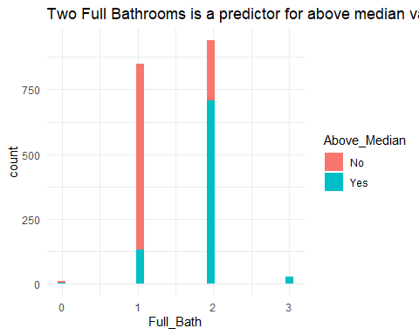

ames %>%  
 filter(Lot_Area >= 1300L & Lot_Area <= 28280L) %>%  
 filter(Mas_Vnr_Area >= 0L & Mas_Vnr_Area <=   
 502L) %>%  
 filter(Wood_Deck_SF >= 0L & Wood_Deck_SF <= 302L) %>%  
 ggplot() +  
 aes(x = Full_Bath, fill = Above_Median) +  
 geom_histogram(bins = 30L) +  
 scale_fill_hue(direction = 1) +  
 labs(title = "Two Full Bathrooms is a predictor for above median value") +  
 theme_minimal()



t9 = table(ames$Above_Median, ames$Full_Bath)  
prop.table(t9, margin = 2)

##   
## 0 1 2 3 4  
## No 0.70000000 0.82500000 0.22500000 0.02439024 0.00000000  
## Yes 0.30000000 0.17500000 0.77500000 0.97560976 1.00000000

#ggcorr(ames) #Correlation is not calculated for non-quantitative variables #ggcorr ignores non-numeric variables #Heat map indicates: Garage Cars, Bedroom AbvGr, Gr_Liv_Area, Total Bsmt SF, Year Built, Bsmt fin Sq Ft 1 and Bsmt Unfin are all correlated with each other however, our response variable isn’t even in this equation because it is a categorical variable. So, basically no predictive response ntoed.

ggplot(ames, aes(x=Gr_Liv_Area, y=Above_Median)) + geom_point() + theme_bw()

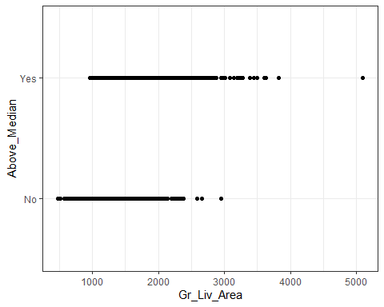

#Some outliers are homes with large square footage, above 3000 sq feet

Ames_MS_SubClass <- ames_homesales %>%  
 group_by(MS_SubClass) %>%  
 summarize(freq = n()) %>%  
 arrange(desc(freq))  
  
Ames_MS_SubClass

## # A tibble: 16 × 2  
## MS_SubClass freq  
## <fct> <int>  
## 1 One_Story_1946_and_Newer_All_Styles 772  
## 2 Two_Story_1946_and_Newer 383  
## 3 One_and_Half_Story_Finished_All_Ages 204  
## 4 One_Story_PUD_1946_and_Newer 129  
## 5 One_Story_1945_and_Older 98  
## 6 Two_Story_1945_and_Older 95  
## 7 Two_Story_PUD_1946_and_Newer 85  
## 8 Split_or_Multilevel 82  
## 9 Duplex_All_Styles_and_Ages 76  
## 10 Two_Family_conversion_All_Styles_and_Ages 46  
## 11 Split_Foyer 34  
## 12 Two_and_Half_Story_All_Ages 17  
## 13 One_and_Half_Story_Unfinished_All_Ages 13  
## 14 PUD_Multilevel_Split_Level_Foyer 12  
## 15 One_Story_with_Finished_Attic_All_Ages 6  
## 16 One_and_Half_Story_PUD_All_Ages 1

t3 = table(ames$Above_Median, ames$MS_SubClass) #create a table object  
t3

##   
## Duplex_All_Styles_and_Ages One_and_Half_Story_Finished_All_Ages  
## No 63 159  
## Yes 13 45  
##   
## One_and_Half_Story_PUD_All_Ages One_and_Half_Story_Unfinished_All_Ages  
## No 1 13  
## Yes 0 0  
##   
## One_Story_1945_and_Older One_Story_1946_and_Newer_All_Styles  
## No 94 383  
## Yes 4 389  
##   
## One_Story_PUD_1946_and_Newer One_Story_with_Finished_Attic_All_Ages  
## No 29 5  
## Yes 100 1  
##   
## PUD_Multilevel_Split_Level_Foyer Split_Foyer Split_or_Multilevel  
## No 12 23 31  
## Yes 0 11 51  
##   
## Two_and_Half_Story_All_Ages Two_Family_conversion_All_Styles_and_Ages  
## No 8 41  
## Yes 9 5  
##   
## Two_Story_1945_and_Older Two_Story_1946_and_Newer  
## No 62 23  
## Yes 33 360  
##   
## Two_Story_PUD_1946_and_Newer  
## No 63  
## Yes 22

#28 Neighborhoods are represented. Some neighborhoods have very few (only 1) home sale while others have many (327)  
Ames_gp_neighborhoods <- ames_homesales %>%  
 group_by(Neighborhood) %>%  
 summarize(freq = n()) %>%  
 arrange(desc(freq))  
  
Ames_gp_neighborhoods

## # A tibble: 28 × 2  
## Neighborhood freq  
## <fct> <int>  
## 1 North_Ames 327  
## 2 College_Creek 183  
## 3 Old_Town 181  
## 4 Edwards 129  
## 5 Somerset 119  
## 6 Gilbert 109  
## 7 Sawyer 109  
## 8 Northridge_Heights 105  
## 9 Northwest_Ames 95  
## 10 Sawyer_West 82  
## # … with 18 more rows

t8 = table(ames$Above_Median, ames$Neighborhood) #create a table object  
prop.table(t8, margin = 2)

##   
## Bloomington_Heights Blueste Briardale Brookside Clear_Creek  
## No 0.09523810 0.80000000 1.00000000 0.86486486 0.22580645  
## Yes 0.90476190 0.20000000 0.00000000 0.13513514 0.77419355  
##   
## College_Creek Crawford Edwards Gilbert Green_Hills Greens  
## No 0.26775956 0.27272727 0.84496124 0.02752294 0.00000000 0.14285714  
## Yes 0.73224044 0.72727273 0.15503876 0.97247706 1.00000000 0.85714286  
##   
## Iowa_DOT_and_Rail_Road Landmark Meadow_Village Mitchell North_Ames  
## No 0.92982456 1.00000000 1.00000000 0.54430380 0.77981651  
## Yes 0.07017544 0.00000000 0.00000000 0.45569620 0.22018349  
##   
## Northpark_Villa Northridge Northridge_Heights Northwest_Ames Old_Town  
## No 1.00000000 0.00000000 0.00952381 0.20000000 0.90055249  
## Yes 0.00000000 1.00000000 0.99047619 0.80000000 0.09944751  
##   
## Sawyer Sawyer_West Somerset South_and_West_of_Iowa_State_University  
## No 0.84403670 0.30487805 0.07563025 0.74285714  
## Yes 0.15596330 0.69512195 0.92436975 0.25714286  
##   
## Stone_Brook Timberland Veenker  
## No 0.00000000 0.01666667 0.06250000  
## Yes 1.00000000 0.98333333 0.93750000

#crosstab with proportions  
  
#Proportion of homes selling above (or below) median by neighborhood

Ames_Overall_Qual <- ames_homesales %>%  
 group_by(Overall_Qual) %>%  
 summarize(freq = n()) %>%  
 arrange(desc(freq))  
  
Ames_Overall_Qual

## # A tibble: 10 × 2  
## Overall_Qual freq  
## <fct> <int>  
## 1 Average 587  
## 2 Above_Average 518  
## 3 Good 411  
## 4 Very_Good 237  
## 5 Below_Average 169  
## 6 Excellent 70  
## 7 Fair 28  
## 8 Very_Excellent 24  
## 9 Poor 6  
## 10 Very_Poor 3

ggplot(ames_homesales, aes(Overall_Qual))+  
 geom_bar() +  
 theme(axis.text.x = element_text(angle = 90, vjust = .5, size = 15))

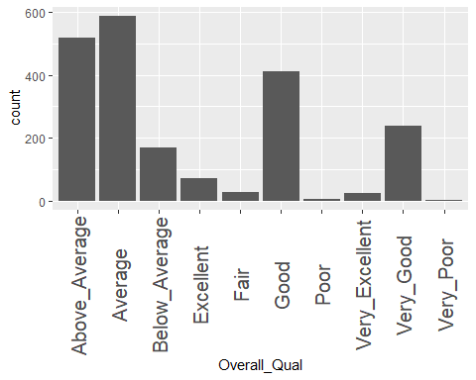

#Looks like some of these conditions are outliers

ggplot(ames) +  
 aes(x = Mo_Sold) +  
 geom_histogram(bins = 30L, fill = "#B22222") +  
 labs(title = "Summer is the Season with the Most Sales") +   
 theme_bw() +  
 theme(axis.title.x = element_text(size = 12L))

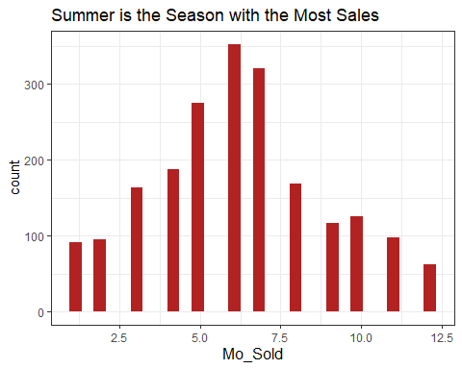

#Let's group the neighborhoods with

ggplot(ames, aes(x = Lot_Area, y = Gr_Liv_Area, color = Neighborhood))+ geom_point()+   
 labs(title = "City Home Value Comparison", ) +   
 theme(axis.text.x = element_text(angle = 90, vjust = .5, size = 5))+ scale_y_continuous(name = "Living Area Square Footage", labels = scales::comma)

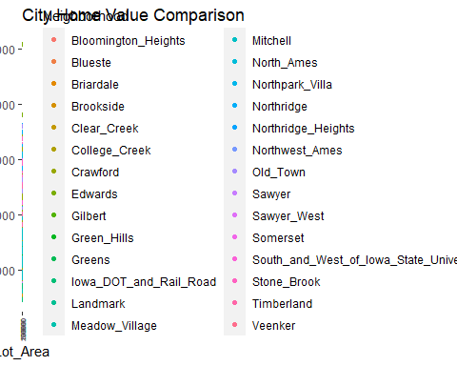

ggplot(ames, aes(Gr_Liv_Area))+   
 geom_boxplot()

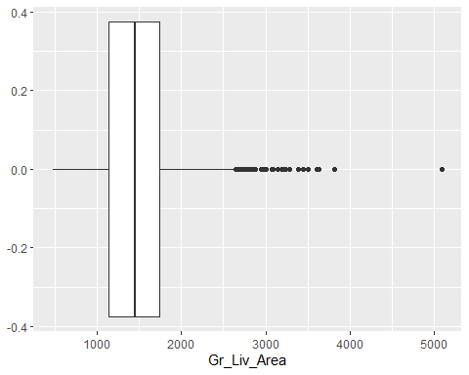

table(ames$Gr_Liv_Area > 3000) #Sixteen properties are outliers, they are large properties with more than 3000 square feet

##   
## FALSE TRUE   
## 2037 16

#Outliers in living area with 16 of the homes being over 3000 sq feet. Let's remove these 16 observations, which is .77% of the total dataset.  
  
ames <-ames %>%  
 filter(Gr_Liv_Area<3000)

t1 <-table(ames$Lot_Shape)  
  
t2 <- table(ames$MS_Zoning)  
  
t3 <- table(ames$Bldg_Type)  
t4 <- table(ames$Roof_Style)  
t5 <- table(ames$Sale_Type)  
t6 <- table(ames$Foundation)  
t7 <- table(ames$Land_Slope)  
  
t1

##   
## Irregular Moderately_Irregular Regular   
## 11 51 1270   
## Slightly_Irregular   
## 705

t2

##   
## A_agr C_all   
## 2 17   
## Floating_Village_Residential I_all   
## 86 1   
## Residential_High_Density Residential_Low_Density   
## 20 1586   
## Residential_Medium_Density   
## 325

#Some neighborhoods have very few (only 1) home sale while others have many (327)

Ames_gp_neighborhoods <- ames %>%  
 group_by(Neighborhood) %>%  
 summarize(freq = n()) %>%  
 arrange(desc(freq))

Ames_gp_neighborhoods

## # A tibble: 28 × 2  
## Neighborhood freq  
## <fct> <int>  
## 1 North_Ames 326  
## 2 College_Creek 183  
## 3 Old_Town 180  
## 4 Edwards 127  
## 5 Somerset 118  
## 6 Gilbert 109  
## 7 Sawyer 109  
## 8 Northridge_Heights 104  
## 9 Northwest_Ames 95  
## 10 Sawyer_West 82  
## # … with 18 more rows

#Year Sold is an integer variable, but we want to examine each year as it’s own category. Therefore, we convert Year_Sold into a factor.

ames_yr_as_factor <- ames %>%  
 mutate(Year_Sold = as_factor(Year_Sold))

ggplot(ames) +  
 aes(x = Lot_Area, y = Neighborhood) +  
 geom_boxplot(fill = "#112446") +  
 theme_minimal()

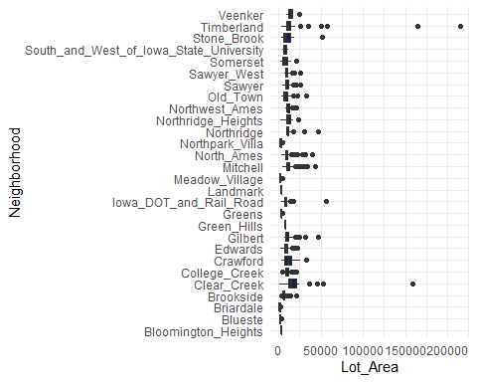

ggplot(ames, aes(x=Lot_Area, y=Above_Median))+  
 geom_point(alpha=.1)

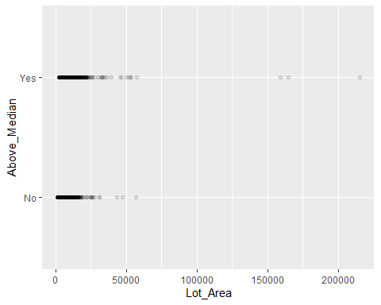

ames <- ames %>%  
select(c(1:4,6:8,10:79))  
#Removing columns 5 & 9 (Street and Utilities) as these variables that don't add to our predictions.

#Remove Alley, Land_Slope, Condition_1, Condition_2, Sale_Condition, Sale_type, Basement_Type_2_Misc_features as all have no predictive value