1. Create a report that shows the ContactName, CompanyName, ContactTitle and Phone number from the customers table sorted by Phone

SELECT ContactName, CompanyName, ContactTitle, Phone  
FROM customers  
ORDER BY Phone;

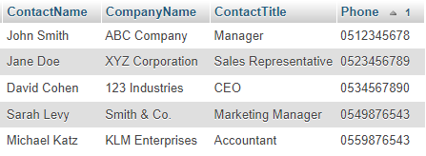

1. Create a report that shows the top 10 OrderlD, OrderDate, Shipped Date, CustomerlD, Freight from the orders table sorted by Freight in descending order

SELECT id, OrderDate, ShippedDate, CustomerID, Freight  
FROM Orders  
ORDER BY Freight DESC  
LIMIT 10;

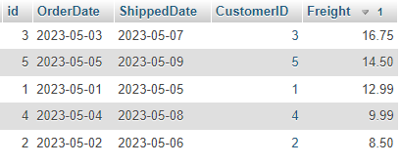

1. Create a report that shows the City, CompanyName, ContactName of customers from cities that has letter L in the name sorted by ContactName

* Solution where L is not case sensitive:  
  SELECT City, CompanyName, ContactName  
  FROM customers  
  WHERE City LIKE '%L%'  
  ORDER BY ContactName;

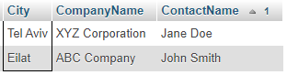

* Solution where L is case sensitive:

SELECT City, CompanyName, ContactName  
FROM customers  
WHERE City LIKE '%L%'  
 AND City REGEXP BINARY '^[A-Z].*L.*$'  
ORDER BY ContactName;

1. Create a report showing OrderlD, total number of Order ID as NumberofOrders from the orderdetails table grouped by OrderlD and sorted by NumberofOrders in descending order

SELECT OrderID, COUNT(*) AS NumberofOrders  
FROM order_details  
GROUP BY OrderID  
ORDER BY NumberofOrders DESC;

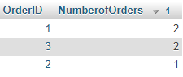

1. Create a report that shows the ShipPostalCode, OrderlD, OrderDate, RequiredDate, Shipped Date, ShipAddress of all orders with ShipPostalCode beginning with "98124"

SELECT ShipPostalCode, id, OrderDate, RequiredDate, ShippedDate, ShipAddress  
FROM Orders  
WHERE ShipPostalCode LIKE '98124%'

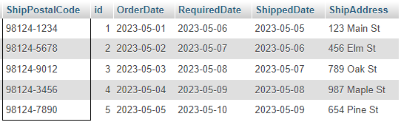

1. Create a report that shows the LastName, FirstName, City of employees in cities other "Seattle"

SELECT LastName, FirstName, City  
FROM employees  
WHERE City <> 'Seattle'

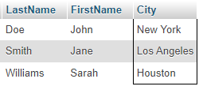

1. Create a report that shows the average UnitPrice rounded to the next whole number, total price of UnitslnStock and maximum number of orders from the products table. All saved as AveragePrice, TotalStock and MaxOrder respectively

SELECT   
 CEILING(AVG(UnitPrice)) AS AveragePrice,  
 SUM(UnitPrice * UnitsInStock) AS TotalStock,  
 MAX(UnitsOnOrder) AS MaxOrder  
FROM products;



1. Create a report that shows the SupplierlD, ProductName, CompanyName from all product Supplied by "Exotic Liquids", "Specialty Biscuits, Ltd.", "Escargots Nouveaux", sorted by the supplier ID

SELECT p.SupplierID, p.ProductName, s.CompanyName  
FROM Products p  
JOIN Suppliers s ON p.SupplierID = s.id  
WHERE s.CompanyName IN ('Exotic Liquids', 'Specialty Biscuits, Ltd', 'Escargots Nouveaux')  
ORDER BY p.SupplierID;

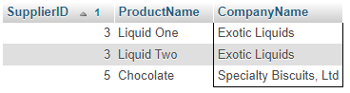

1. Create a report that shows the SupplierlD, CompanyName, CategoryName, ProductName and UnitPrice from the products, suppliers and categories table

SELECT p.SupplierID, s.CompanyName, c.CategoryName, p.ProductName, p.UnitPrice  
FROM products p  
JOIN suppliers s ON p.SupplierID = s.id  
JOIN categories c ON p.CategoryID = c.id;

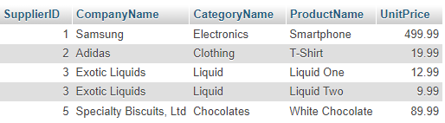

1. Create a report that shows the OrderlD ContactName, UnitPrice, Quantity, Discount from the order details, orders and customers table with discount given on every purchase

SELECT o.id AS OrderID, c.ContactName, od.UnitPrice, od.Quantity, od.Discount  
FROM order_details od  
JOIN orders o ON od.OrderID = o.id  
JOIN customers c ON o.CustomerID = c.id;

