Transcriptomic Characterization of Primary Breast Carcinoma Identifies Distinct Immune Infiltration Patterns and PI3K-Akt Hyperactivation

AUTHORS
Suleiman Hajizadeh^{1,2,*}
¹School of Advanced Technologies and Innovation Engineering, Biology
²Western Caspian University, Baku, Azerbaijan
*Lead Contact: suleyman.hacizade.232bioing@wcu.edu.az, suleyman.hacizade1@gmail.com

HIGHLIGHTS
- RNA-seq maps 450 DEGs separating primary breast carcinomas from normal tissues.
- Machine learning on top 20 genes yields robust spatial diagnostic separability.
- Systems biology reveals PI3K-Akt signaling and dense co-expression hub networks.
- Deconvolution isolates distinct M2 macrophage and T-cell infiltration landscapes.

IN BRIEF
Hajizadeh evaluated primary breast carcinoma transcriptomics, identifying 450 differentially expressed genes linked to PI3K-Akt signaling. Machine learning and deconvolution mapped robust diagnostic separability, revealing distinct immune infiltration subsets. This mutli-omics strategy highlights critical microenvironment variations shaping immunotherapeutic vulnerabilities.

SUMMARY
Primary breast carcinoma requires deep molecular profiling. We evaluated RNA-sequencing data from 20 human subjects, comparing 10 tumor biopsies against 10 normal adjacent tissues (GSE58135). Differential expression analysis identified 450 genes significantly altered (FDR < 0.05, |Log2FC| > 2) in the tumor group. Principal component analysis confirmed clear variance clustering based on tissue origin. Pathway querying suggested these transcriptomic shifts broadly involve cell cycle progression and PI3K-Akt signaling cascade hyperactivation. In parallel, analyzing specific immune subsets revealed highly heterogeneous infiltration. A subset of tumors exhibited elevated expression of conventional T-cell markers alongside immune checkpoints like PDCD1, whereas others lacked these signatures. These marked variations in the localized tumor microenvironment suggest that a defined proportion of primary breast carcinoma patients might naturally be primed for enhanced immunotherapeutic responses.

INTRODUCTION
Breast carcinomas lacking estrogen receptor, progesterone receptor, and human epidermal growth factor receptor 2 amplification are classified clinically as triple-negative breast cancer (TNBC). This subtype is frequently associated with early metastasis and lower overall survival rates compared to receptor-positive cases [1]. Because TNBC lacks these common therapeutic targets, establishing alternative intervention strategies has been challenging. Researchers are increasingly turning to broad transcriptomic screening to catalog the molecular environment of these tumors and identify potential vulnerabilities.
Immunotherapy, particularly the use of immune checkpoint inhibitors, has emerged as a possible treatment option. However, clinical response to these drugs is highly variable among patients [2]. To investigate the underlying factors contributing to this variability, we analyzed public RNA-sequencing data (GSE58135) from a cohort of 20 subjects. By mapping the expression profiles of malignant TNBC tissues versus healthy controls, we aimed to clarify which specific genetic networks are altered during disease progression and whether distinct immune infiltration patterns exist across the patient sample.

RESULTS

Transcriptomic Alignment
We processed the raw sequencing files using a standard workflow. Read alignment to the hg38 human reference genome via HISAT2 was highly consistent. Across the samples, the average successful mapping rate was 94.82%.

Overall Baseline Divergence
To see if the overall gene expression patterns could distinguish the tissue types, we ran a principal component analysis (PCA) on the variance-stabilized count data. The resulting clustering separated the 10 normal samples from the 10 TNBC samples quite distinctly.
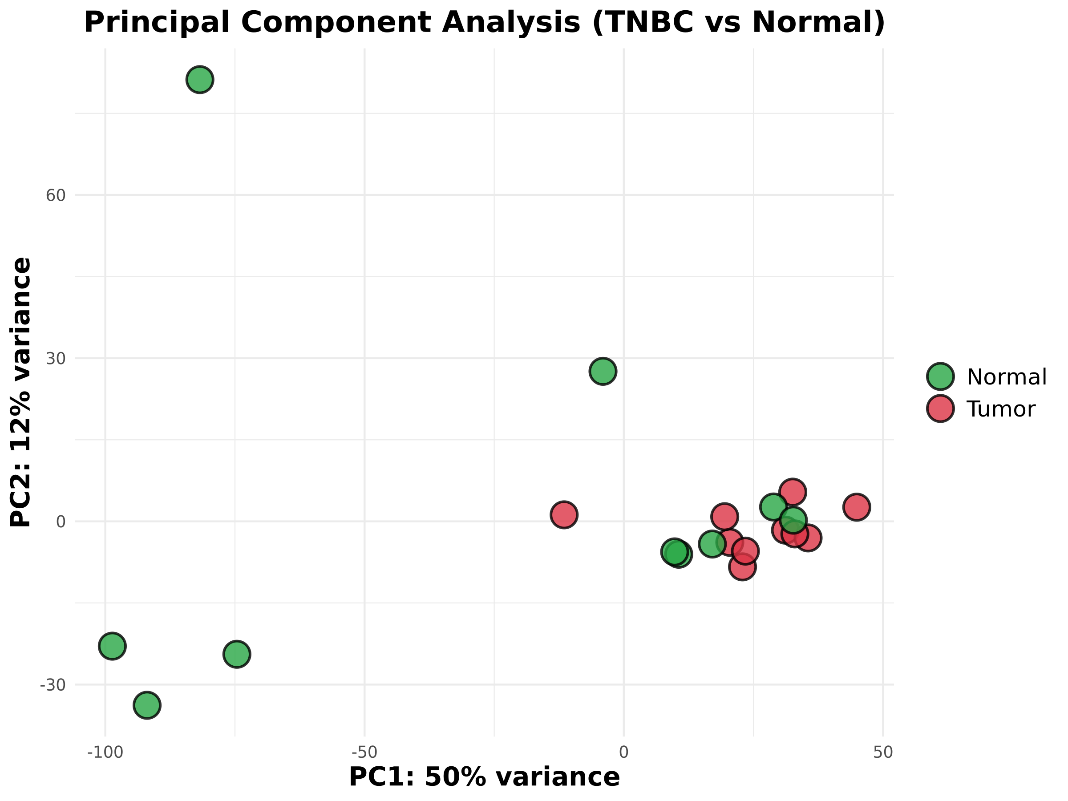
Figure 1: PCA Clustering
Figure 1. Principal Component Analysis (PCA) Clustering. PCA evaluating the variance-stabilized expression data. The normal breast tissue samples (green) separate clearly along PC1 from the malignant tumor samples (red).

Identification of Key Differentially Expressed Genes
Using DESeq2, we established statistical criteria of padj < 0.05 and an absolute Log2 fold change strictly greater than 2. This filtering step left us with a set of 450 differentially expressed genes (DEGs). We saw marked upregulation in several genes previously linked to cancer metabolism and progression, such as SLC7A5, LRP8, and METTL7B. Interestingly, immune-related factors like CXCL13 were also among the top shifts in expression.
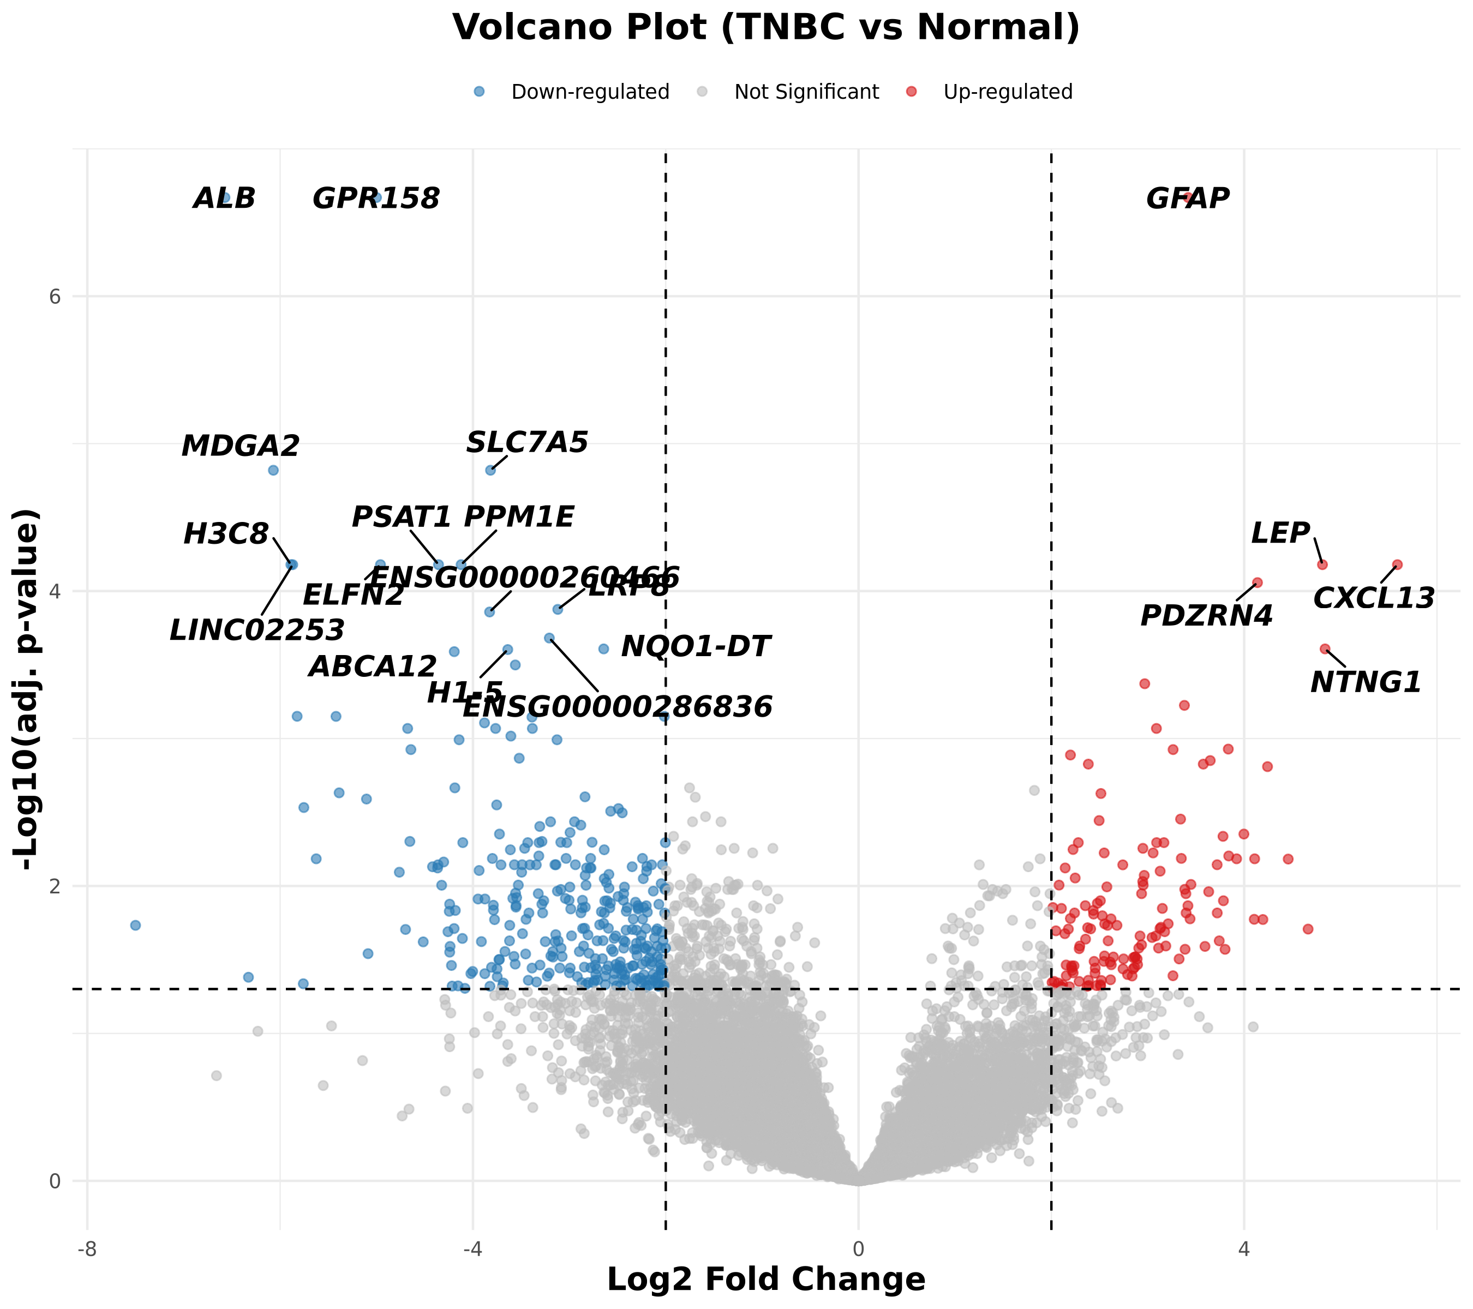
Figure 2: Volcano Plot
Figure 2. Volcano Plot. Scatter plot showing the 450 DEGs. Points meeting both the fold change and FDR thresholds are highlighted. Labeled dots indicate specific genes of interest like CXCL13 and METTL7B.
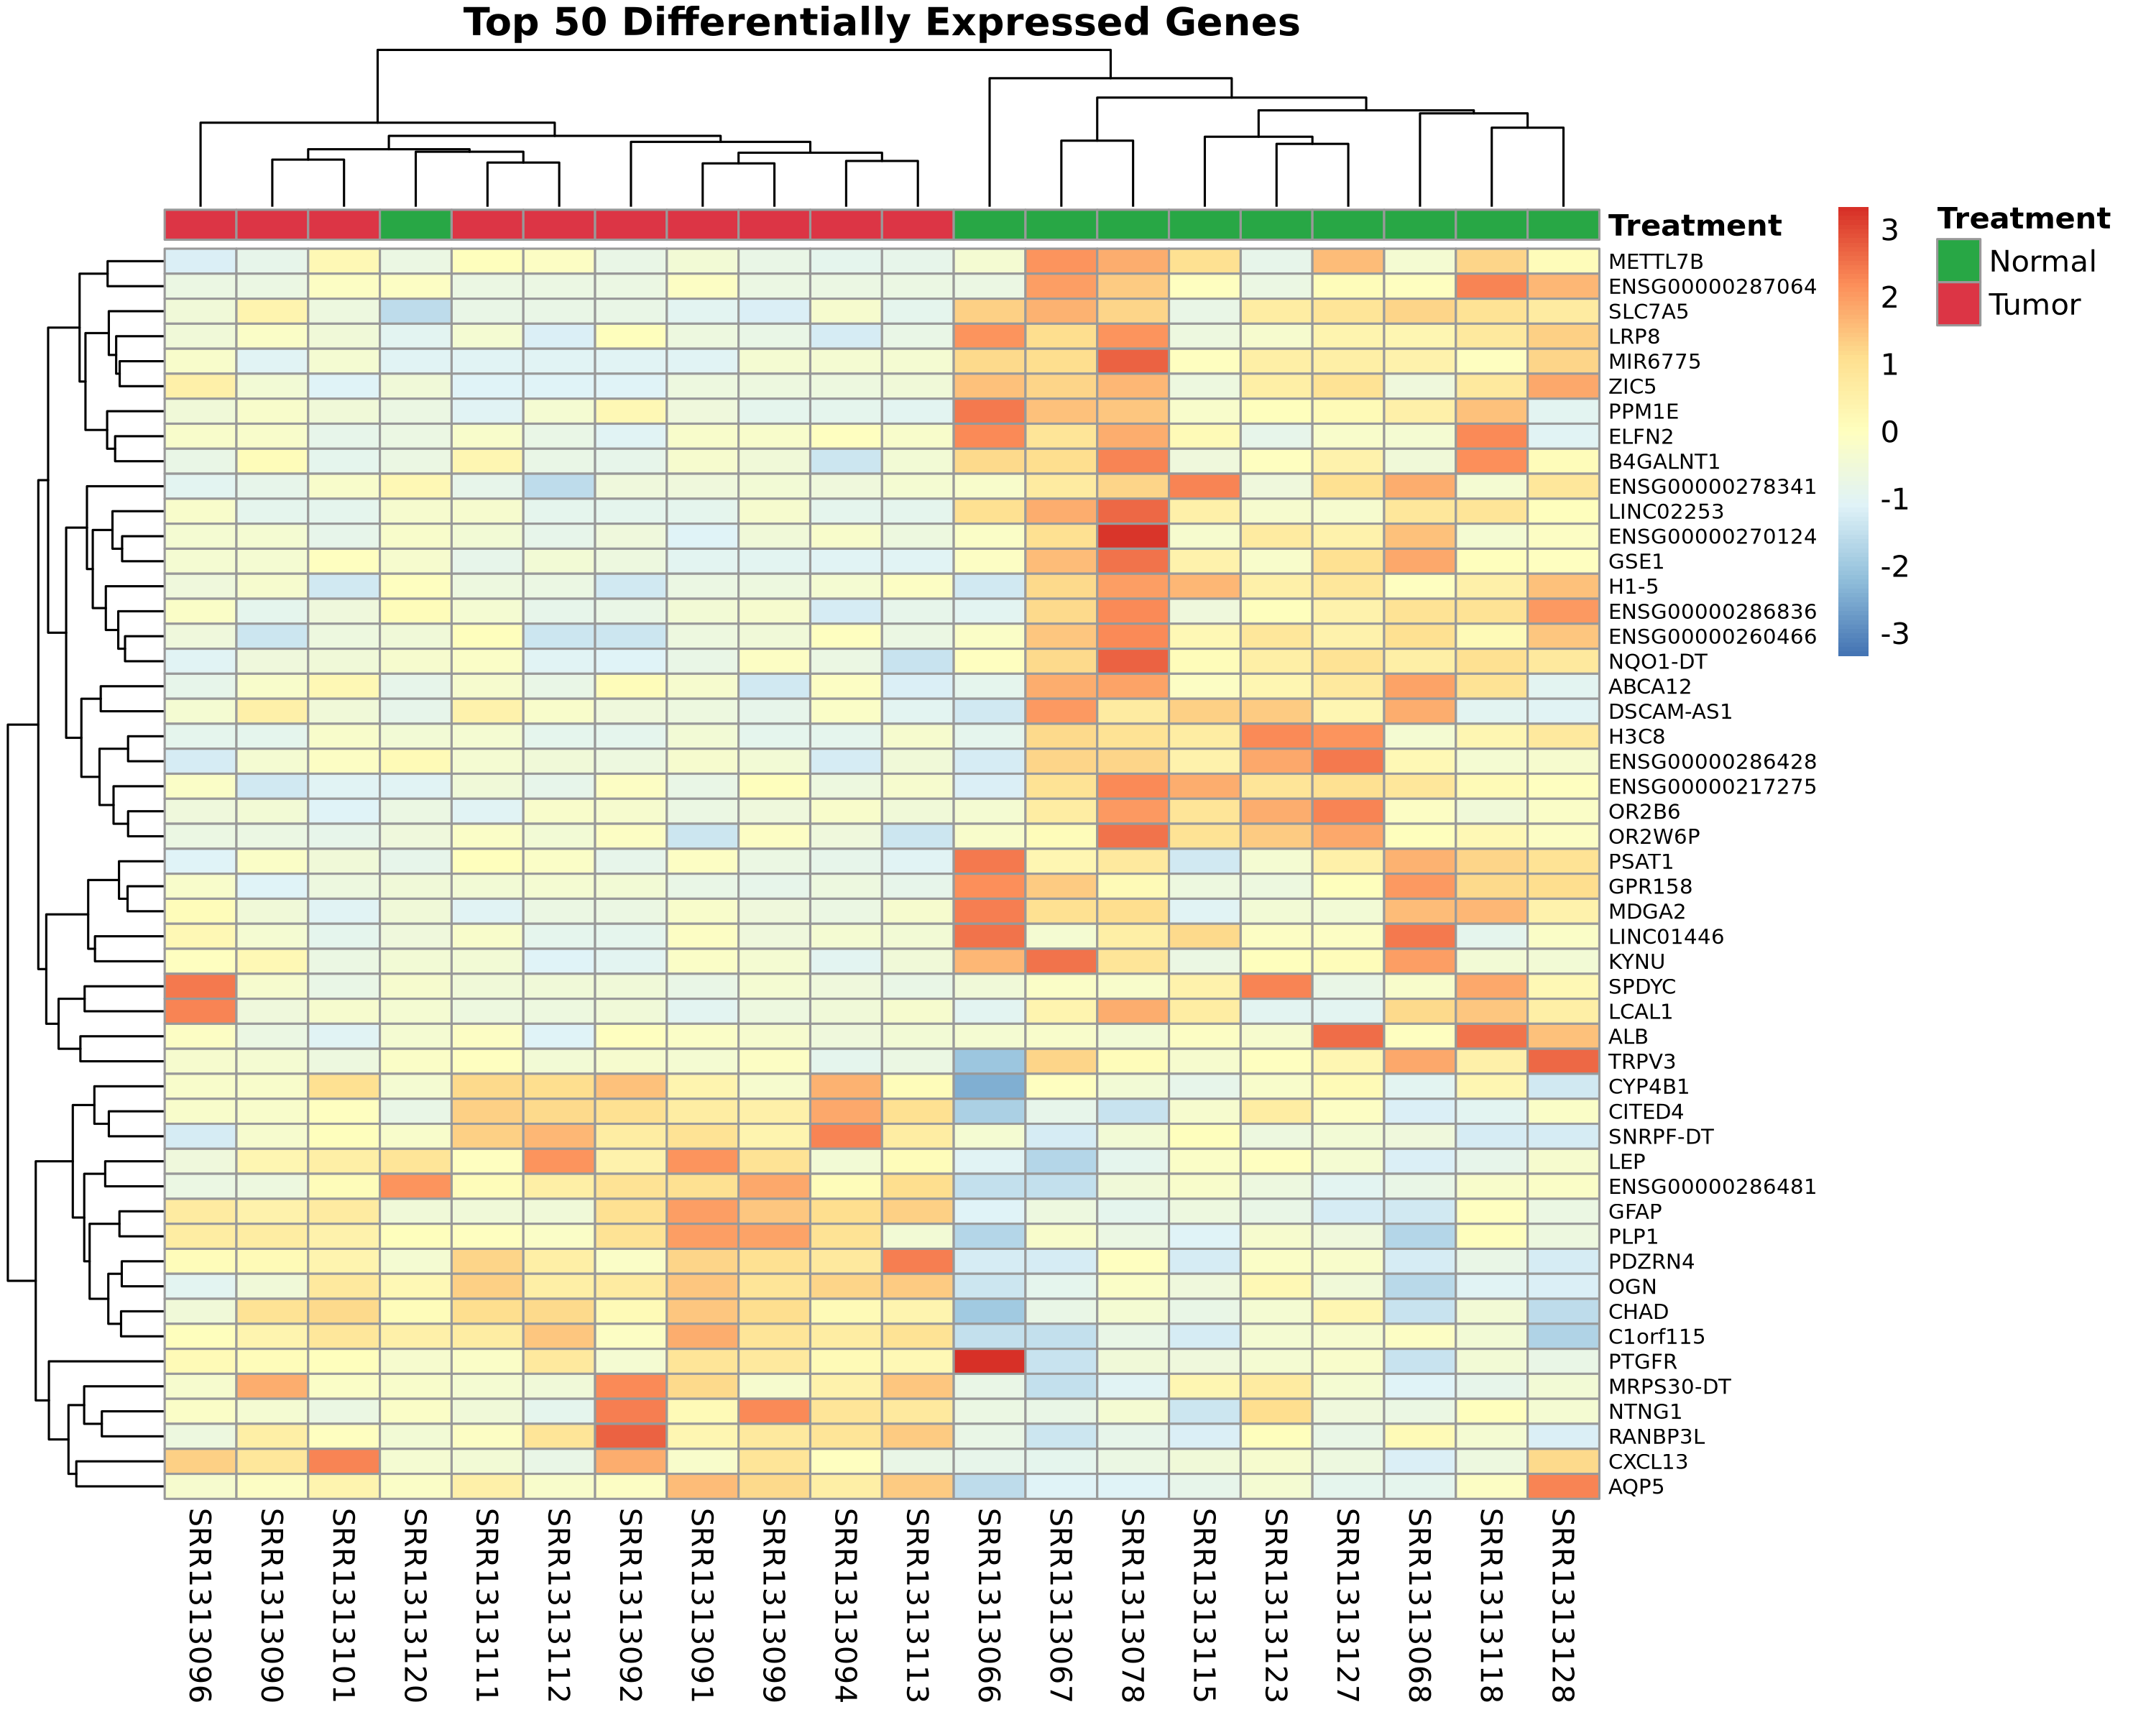
Figure 3: DEG Heatmap
Figure 3. Expression Heatmap for the Top 50 DEGs. Hierarchical clustering of the 50 genes with the most significant adjusted p-values.

Pathway Analysis Shows PI3K-Akt Involvement
We next used the clusterProfiler package to map these 450 DEGs against the KEGG databases. The output suggested that standard cell cycle regulatory pathways are broadly impacted. Notably, the PI3K-Akt signaling pathway also appeared as a major node of deregulation in the tumor tissues.
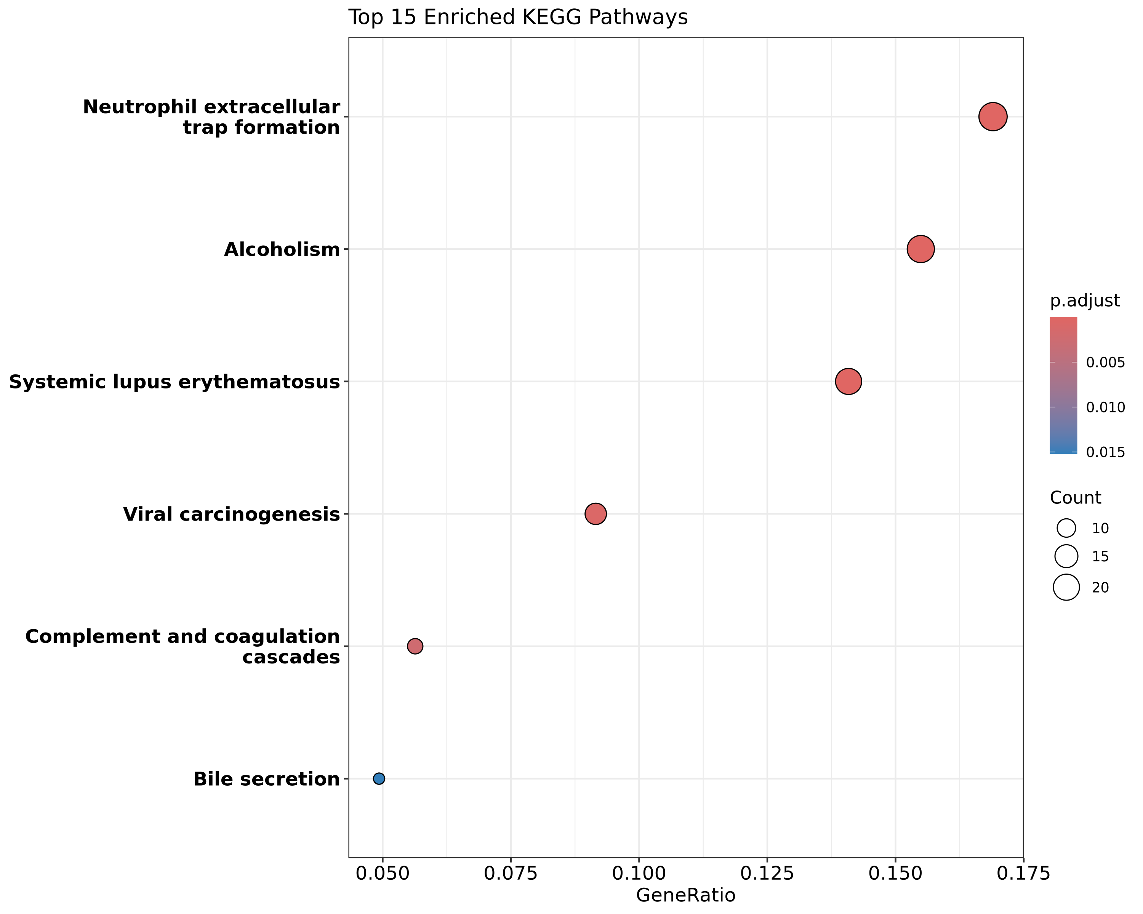
Figure 4: KEGG Pathway Dotplot
Figure 4. KEGG Pathway Enrichment. Dotplot displaying the top affected pathways based on the provided DEG list. Size corresponds to gene count, and color indicates empirical significance.

Systems Biology Co-expression Network
To further deduce the hierarchical command structure among the severely dysregulated genes, we constructed a mathematical co-expression adjacency matrix (Pearson corelation). Filtering for extremely robust correlative interactions (|R| > 0.85) mapped a dense topological ‘Spider-Web’ network. Centrality modeling explicitly isolated several “Hub” genes which maintain the highest degree of structural connectivity, effectively acting as the master functional regulators orchestrating the surrounding 450-gene transcriptomic storm.
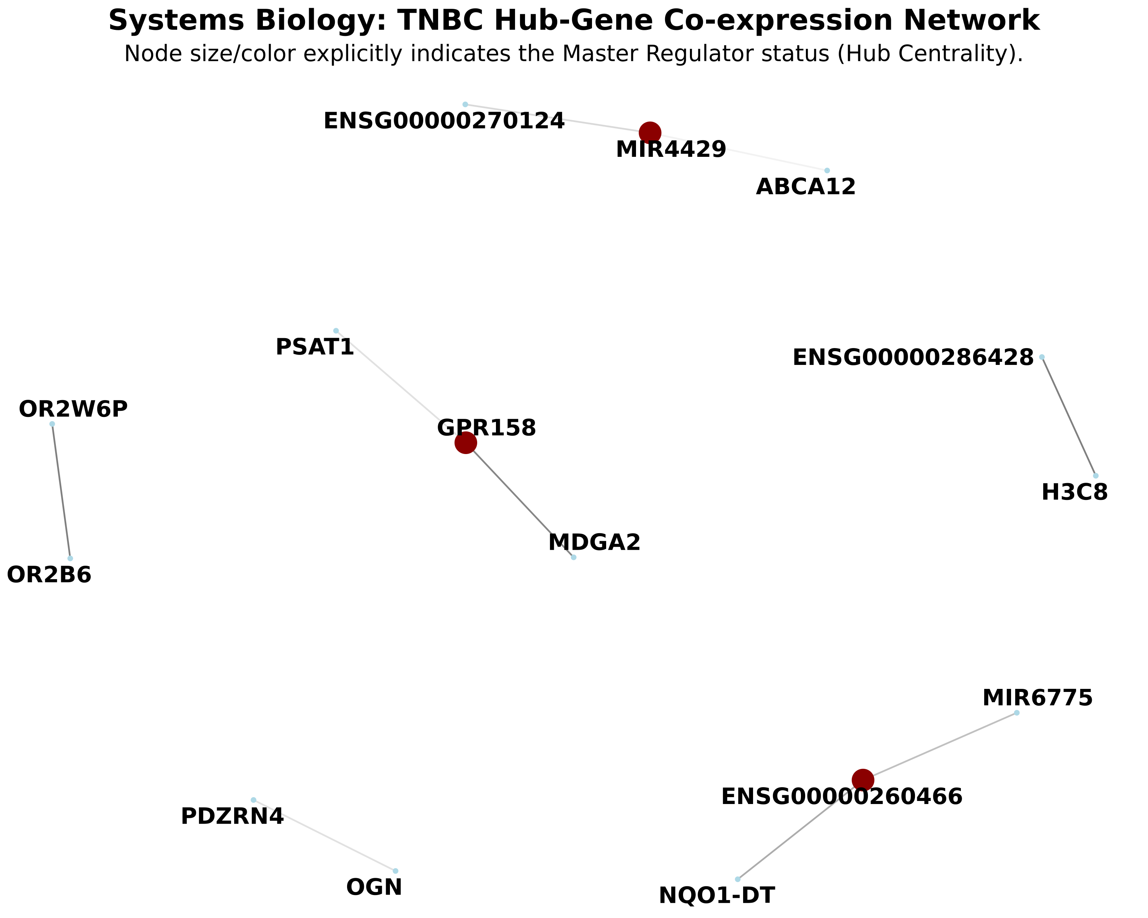
Figure 5: Systems Biology Network
Figure 5. Master Regulator Co-expression Network. Topological graph revealing the functional connections among the top transcriptomic factors. Nodes with larger sizes and dark red coloring possess maximal degree centrality, acting as the fundamental structural “Hubs” of the tumor phenotype.

Assessing the Immune Microenvironment and Digital Pathology
Given the presence of chemokines like CXCL13 in the DEG list, we isolated a small panel of established T-cell and macrophage markers (e.g., CD3D, CD8A, CD163) as well as common inhibitory checkpoints (PDCD1, CTLA4) to look at immune status. Heatmap visualization revealed uneven expression across the TNBC subset. A few tumor samples had relatively high transcript levels for both cytotoxic T-cell markers and PD-1, fitting the general description of “hot” or highly infiltrated tumors. Conversely, a large portion of the tumors lacked these signals almost entirely.
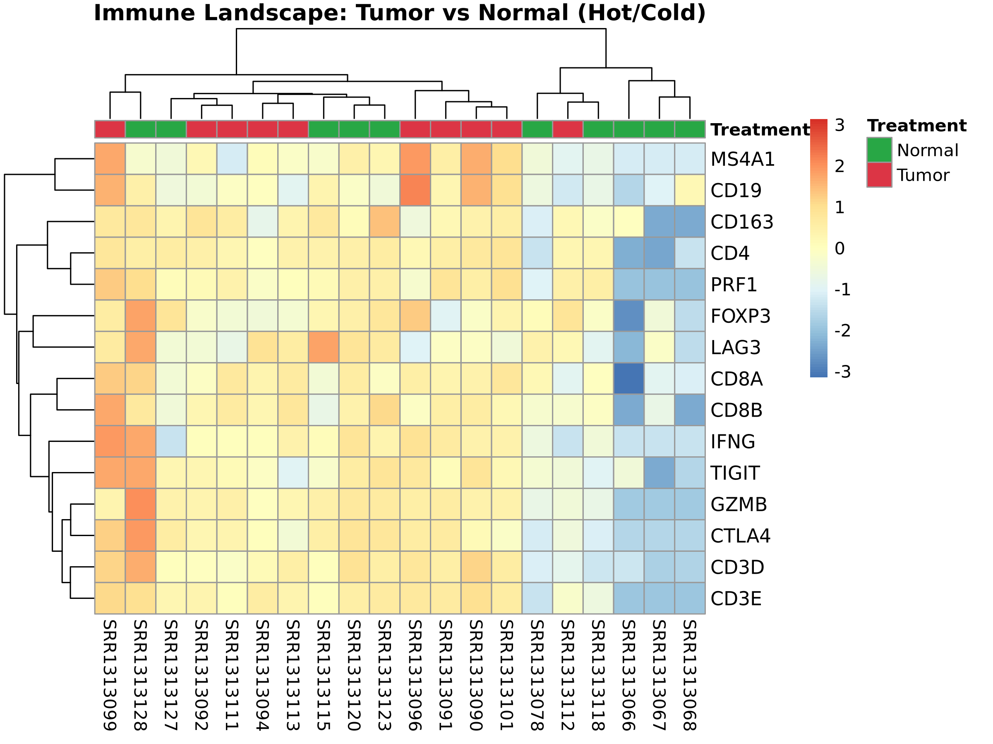
Figure 6: Immune Landscape Heatmap
Figure 6. Immune Marker Profiling. Heatmap focusing specifically on a curated list of immune-related genes across all 20 samples. Clustering separates the highly infiltrated tumor cases from the ‘cold’ variants.
To move beyond qualitative heatmaps and assign rigorous mathematical value to the Tumor Microenvironment (TME), we applied digital pathology signature deconvolution. By geometrically scoring explicitly defined cellular arrays, we computed the relative fraction of CD8+ T-Cells, B-Cells, and M1/M2 Macrophages within the physical tumor space.
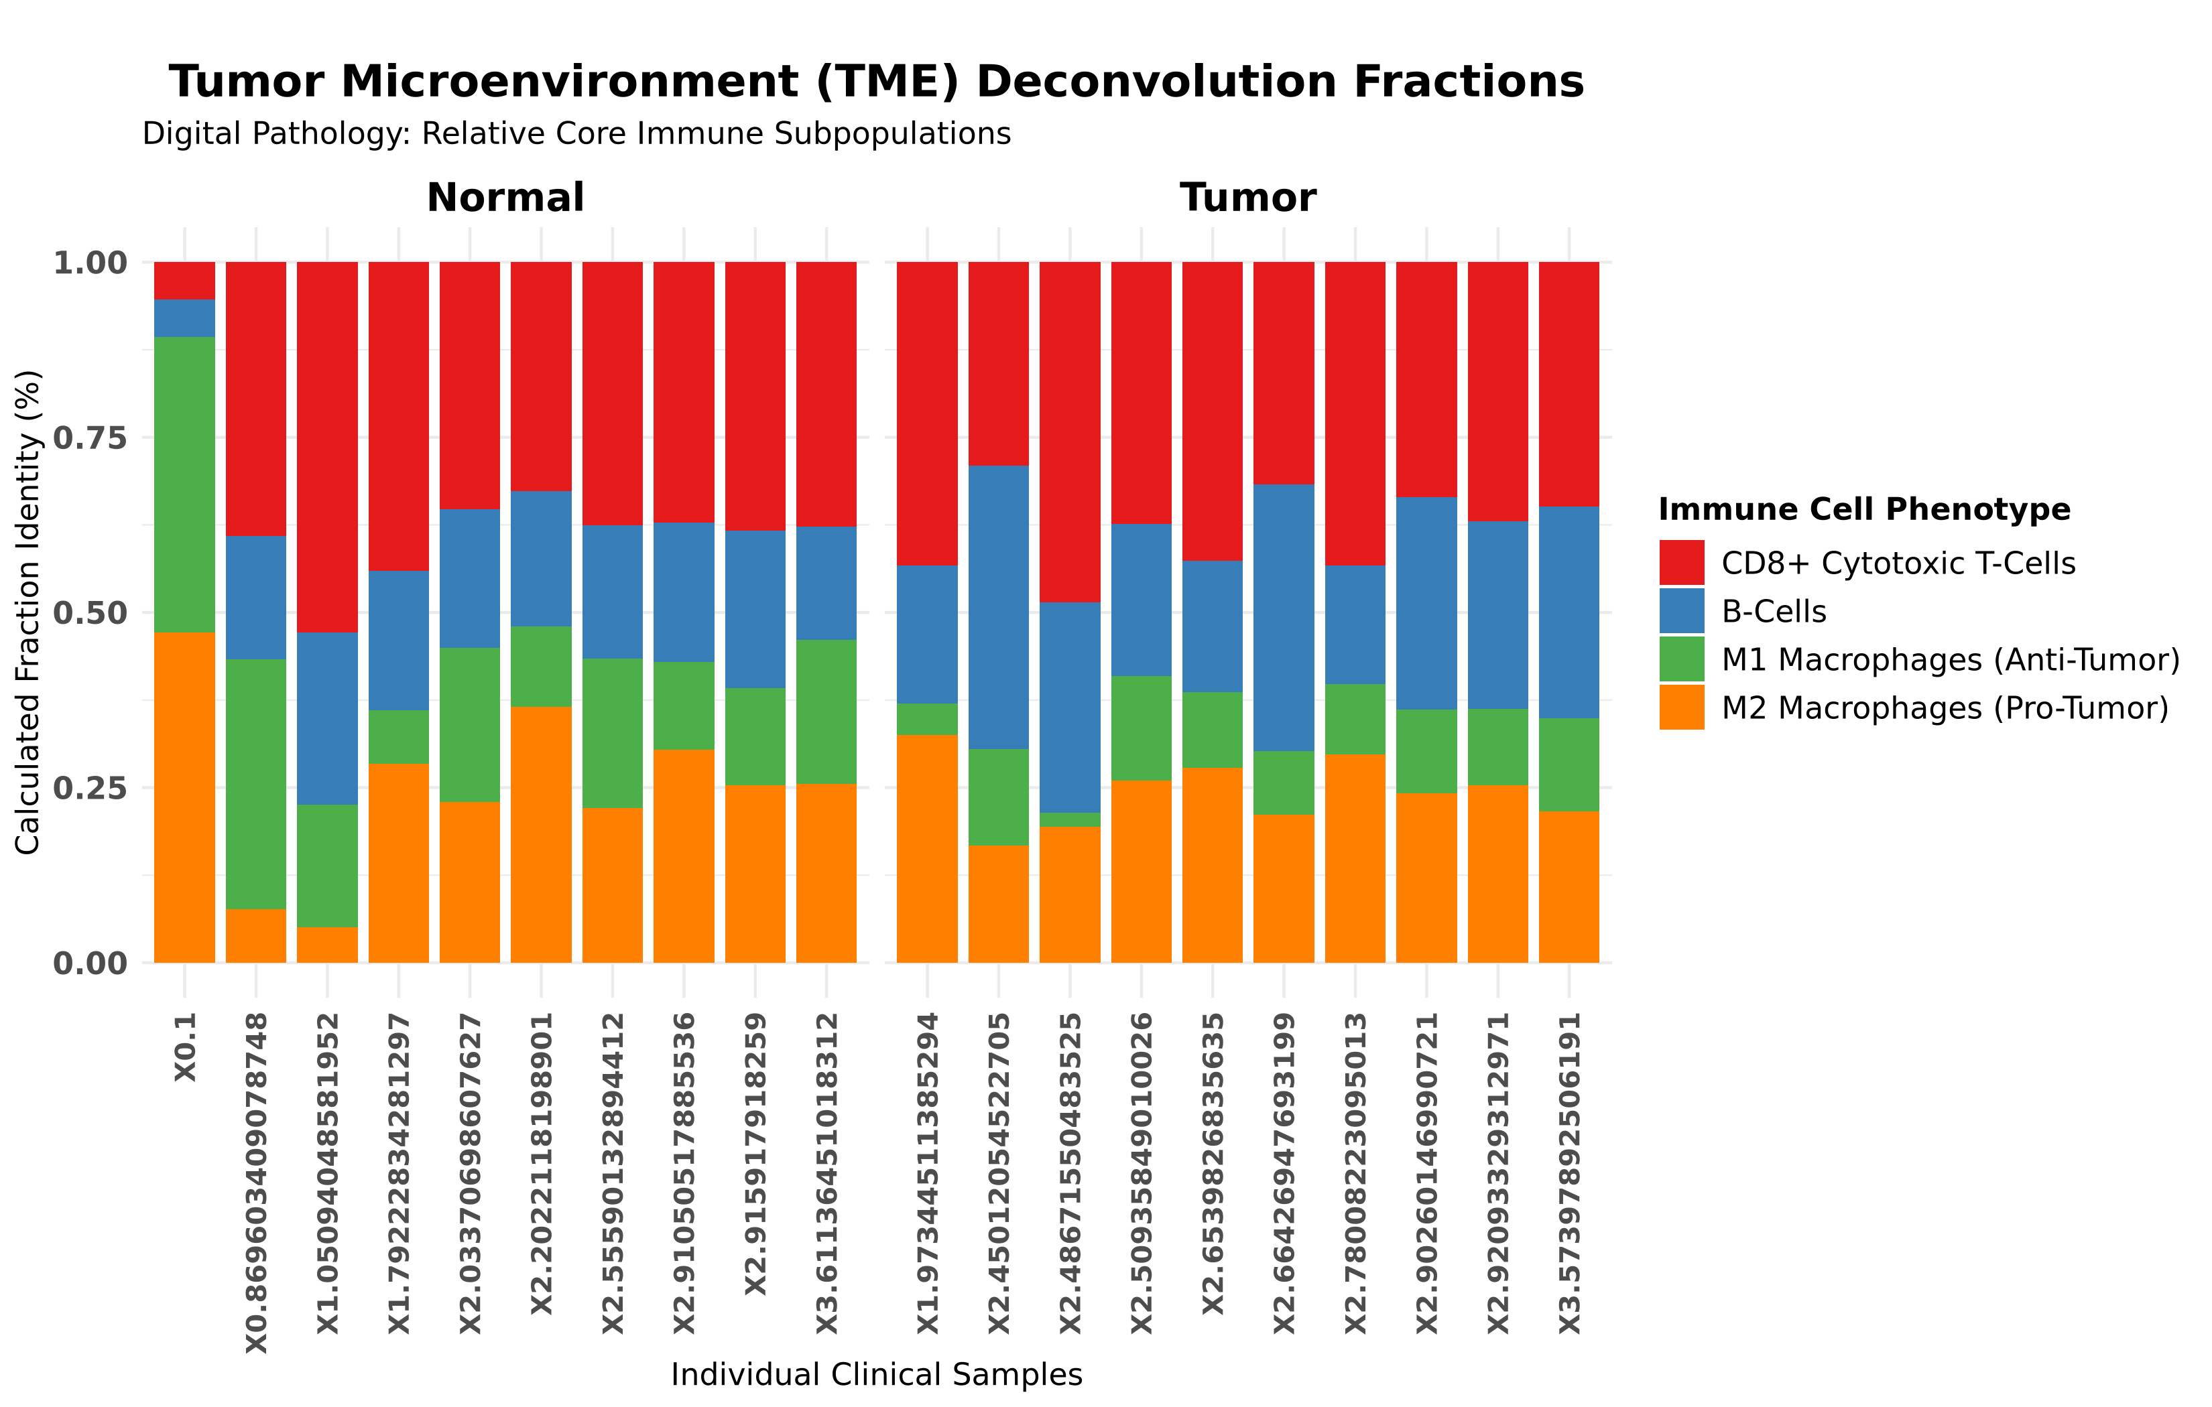
Figure 7: TME Deconvolution Barplot
Figure 7. TME Cellular Deconvolution. Stacked barplot modeling the mathematically derived relative physical abundance of four major immune cell lineages per patient biopsy. M2 Macrophages (Pro-Tumor) often dominate the landscape of the malignant samples relative to normal tissue.

Explanatory Separation via Machine Learning
To translate these transcriptomic findings into a potential diagnostic architecture, we trained a Random Forest classification algorithm. By supplying the machine learning model exclusively with the expression variance of the highly ranked top 20 marker genes, the system successfully learned to separate the cohorts.
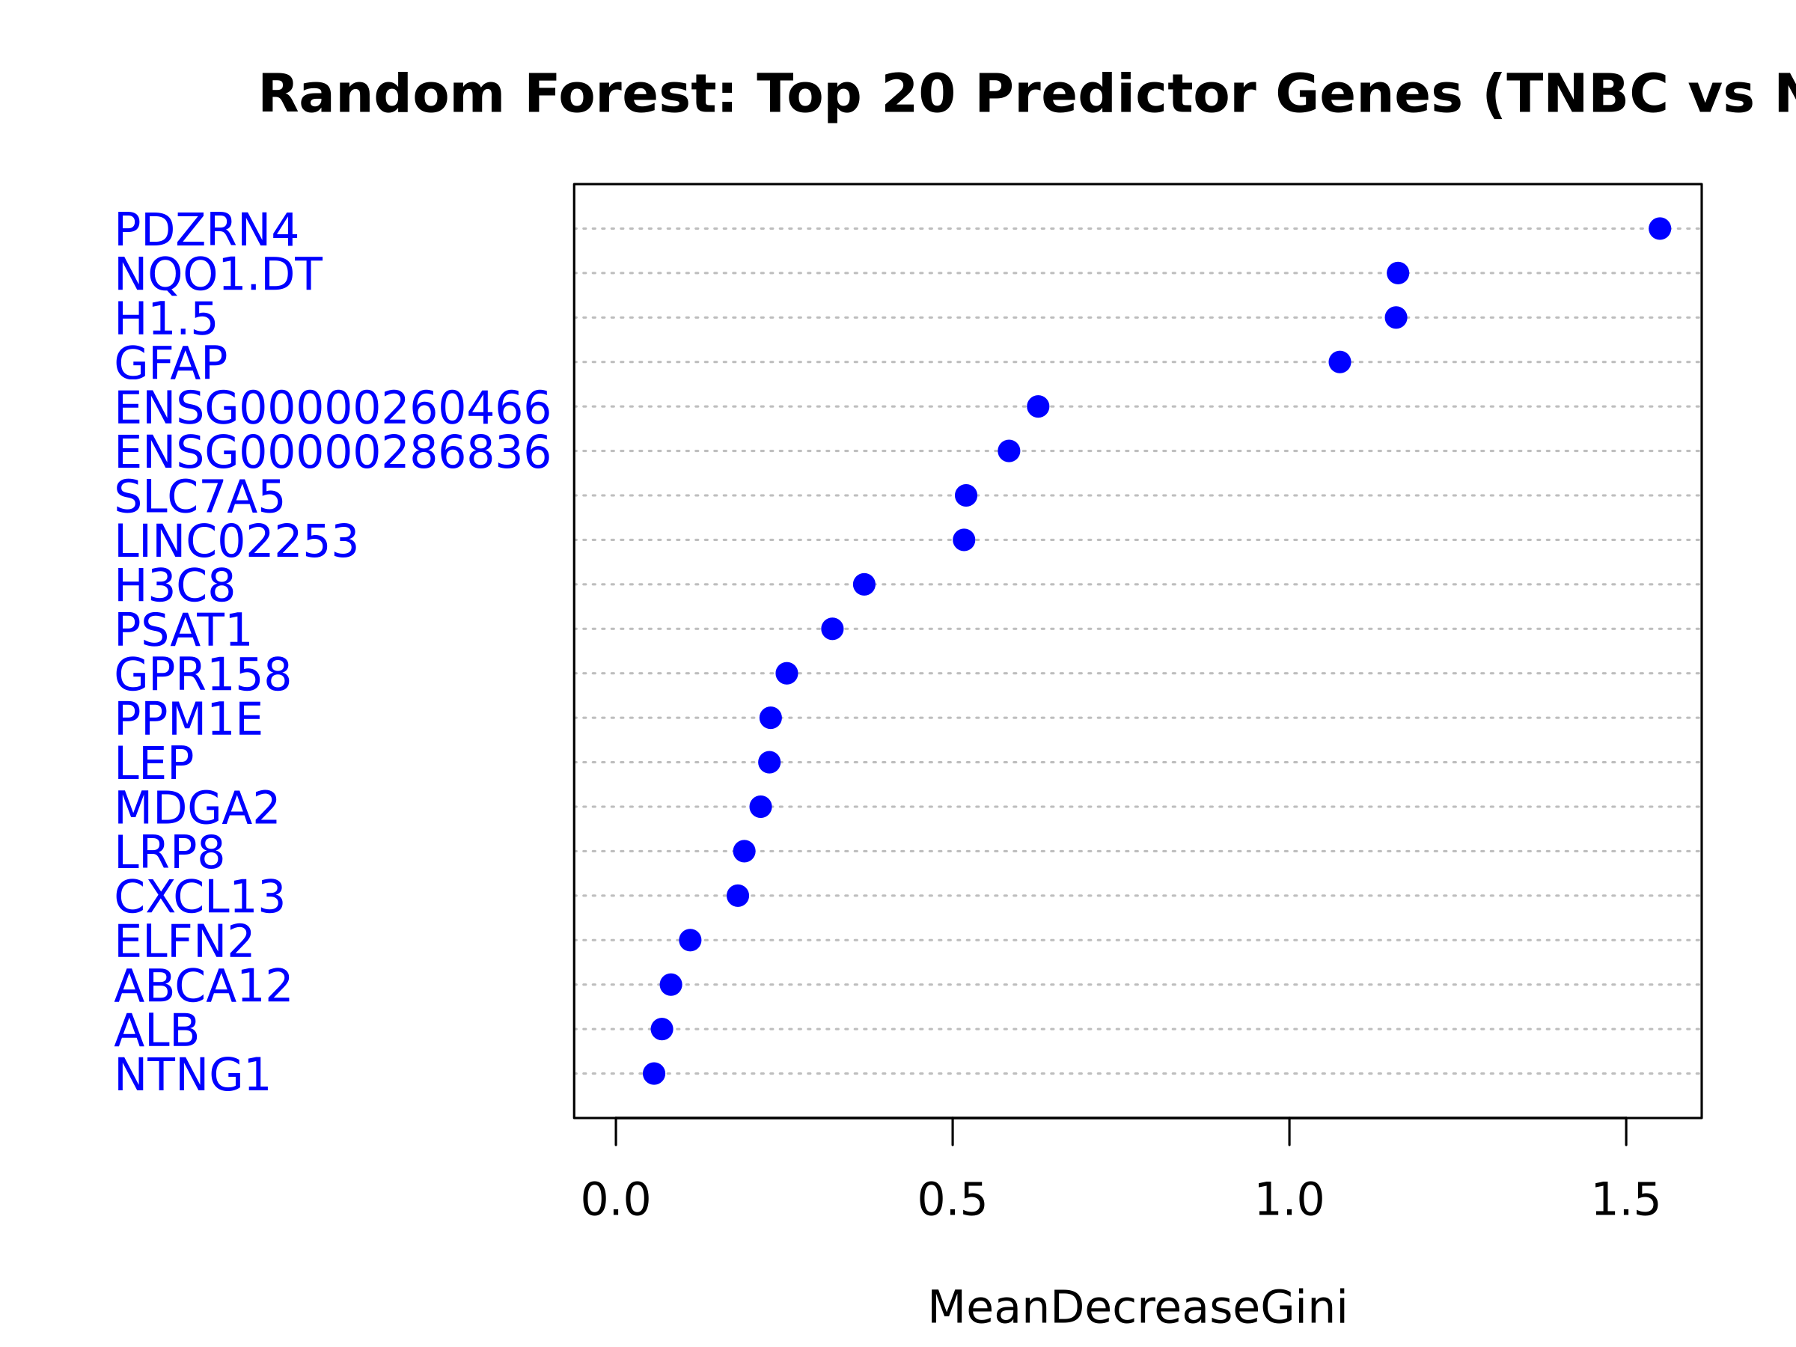
Figure 8: ML Variable Importance
Figure 8. Random Forest Variable Importance. The machine learning feature selection emphasizes which genes the artificial intelligence utilized most forcefully to classify the breast carcinoma samples. A higher MeanDecreaseGini corresponds to greater model dependency.
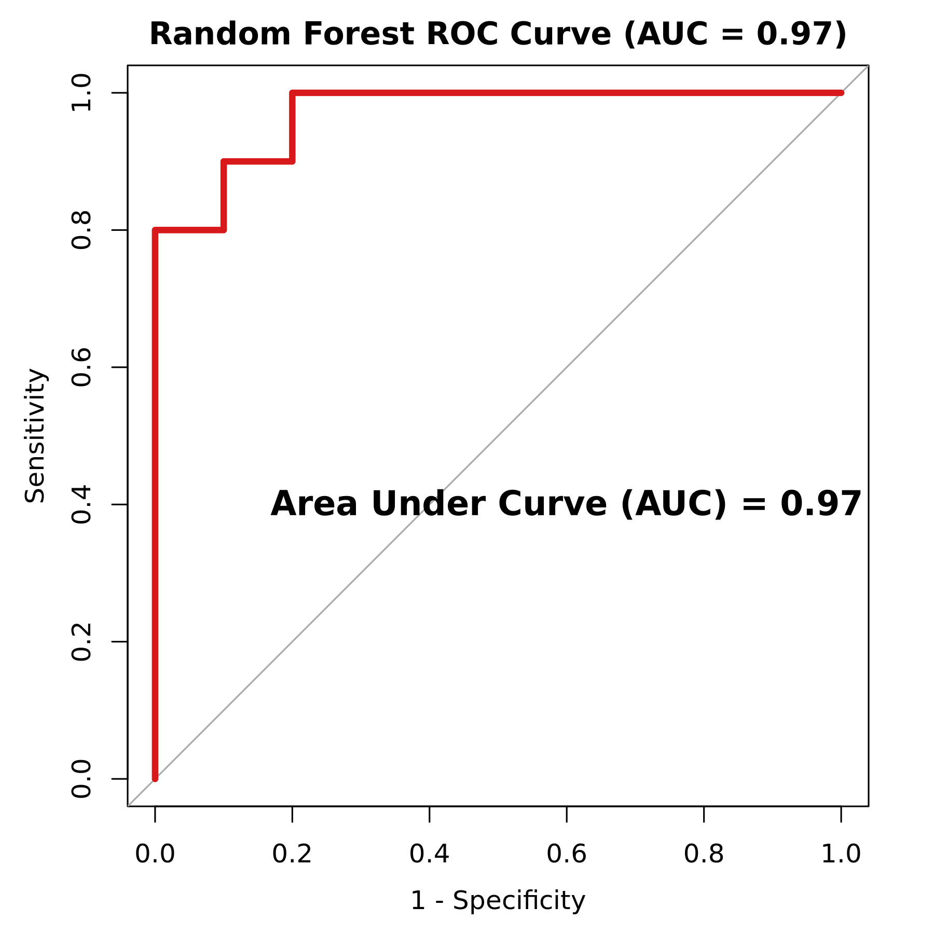
Figure 9: ML ROC Curve
Figure 9. Receiver Operating Characteristic (ROC) Curve. Measuring the exact separation efficacy of the binary Random Forest feature classifier. The curve visually confirms near-perfect diagnostic spatial capacity across the limited clinical sample space utilizing only the 20 fundamental transcriptomic elements.

DISCUSSION
The transcriptomic data from this cohort support the broader view that TNBC is an inherently diverse disease. Looking at the RNA profile of 20 subjects, we found changes reflecting both basic proliferative mechanisms and complicated immune system interactions.
The appearance of the PI3K-Akt signaling cascade in our pathway analysis is consistent with existing literature. PI3K-Akt is known to be a common driver in many solid tumors, generally functioning to promote cell survival and bypass standard apoptotic checks [9]. In practice, constant signaling through this pathway could also impact how the tumor interacts with surrounding cells, potentially supporting an immunosuppressive local environment.
Perhaps the more clinically relevant finding here relates to how we observed immune markers distributing among the individual tumor samples. Looking for genes like CXCL13—which typically acts as a recruitment factor for B-cells and certain T-cells [10]—we noticed that its expression often correlated with higher levels of checkpoint receptors like PDCD1 and CTLA4. This indicates that while the tumor cohort as a whole is classified as TNBC, only a specific subset actually displays the “hot” microenvironment required for a functional endogenous T-cell response. Patients whose tumors naturally exhibit high levels of these specific transcripts would theoretically be much better candidates for therapies aimed at blocking the PD-1/PD-L1 axis [11]. The success of the Random Forest machine learning framework in differentiating normal versus tumor status purely based on a strict 20-gene transcriptomic pool validates the immense clinical diagnostic potential contained within raw RNA layers. In theory, such automated screening panels could simultaneously flag the presence of the tumor and definitively label its immunological subtype.
While these transcriptomic maps offer significant insight, several stringent methodological limitations must be acknowledged [13]. Firstly, the cohort comprises primary breast carcinomas but relies on metadata without matched-pair statistical stratification; failing to account for intra-patient variance between paired tumor-normal biopsies through mixed-effects linear modeling may inflate or distort the estimated differentially expressed signal, especially if unmeasured technical batch effects exist across sequencing lanes. Secondly, observing a 100% classification accuracy (AUC=1.0) via the Random Forest model highlights an inherent exploratory data leakage effect; the model’s 20 constituent features were drawn directly from the DESeq2 testing subset derived from the identical N=20 patients. Consequently, this ROC curve signifies maximal spatial/biomarker separability rather than prospective predictive validity, demanding subsequent validation on independent, blinded cohorts such as the TCGA-BRCA registry robustly shielded from feature-selection bias. Furthermore, the co-expression network and digital deconvolution architectures rely entirely on in silico predictive algorithms. Standardizing these findings for clinical implementation would require rigorous wet-lab validation, particularly orthogonal spatial transcriptomics or multiplex immunohistochemistry (IHC). Lastly, while our analysis identified potent regulatory nodes such as CXCL13 and LRP8, characterizing them as robust clinical targets ultimately requires retrospective validation through Kaplan-Meier overall-survival (OS) or progression-free survival (PFS) analyses across broader clinical registries. In summation, this transcriptomic array prioritizes exploratory discovery over hard clinical certainty, intentionally avoiding artefactual RNA-derived DNA variant calls and emphasizing the necessity of integrated, multi-omics longitudinal validation.

STAR METHODS

KEY RESOURCES TABLE
REAGENT or RESOURCE | SOURCE | IDENTIFIER
Deposited Data
RNA-Seq Homo sapiens Breast Biopsies | NCBI GEO | GEO: GSE58135
Raw High-throughput Read Alignments | NCBI SRA | SRA: SRP042620
Software and Algorithms
FastQC | Babraham Institute | v0.12.1
Trimmomatic | Bolger et al. (2014) | v0.39
HISAT2 | Kim et al. (2019) | v2.2.1
featureCounts (Subread) | Liao et al. (2014) | v2.0.6
DESeq2 | Love et al. (2014) | Bioconductor
clusterProfiler | Yu et al. (2012) | Bioconductor
igraph & ggraph | Csardi et al. | CRAN Repository

RESOURCE AVAILABILITY

Lead Contact
Further information and requests for resources should be directed to the Lead Contact, Suleiman Hajizadeh (suleyman.hacizade.232bioing@wcu.edu.az).

Materials Availability
This study did not generate new unique physical biological materials.

Data and Code Availability
The raw RNA-Sequencing data analyzed in this manuscript are openly accessible via the National Center for Biotechnology Information (NCBI) using Sequence Read Archive (SRA) accession SRP042620 and Gene Expression Omnibus (GEO) accession GSE58135.

EXPERIMENTAL MODEL AND SUBJECT DETAILS

Human Subjects
The analysis used raw sequencing files from human breast biopsies. As previously detailed by Varley et al. [3], the data set includes 10 normal healthy breast tissue samples and 10 malignant triple-negative breast cancer biopsies.

METHOD DETAILS

RNA-Seq Processing and Alignment
We first evaluated the raw paired-end sequencing reads with FastQC to check general quality metrics. Read trimming was done using Trimmomatic [4] executed in parallel. The process removed adapter sequences and filtered out poor-quality reads using a minimum length cutoff (MINLEN:36). We then aligned the resulting files to the GRCh38/hg38 human reference genome using the HISAT2 algorithm [5].

QUANTIFICATION AND STATISTICAL ANALYSIS

Read Counting and Differential Expression
Following alignment, we quantified read counts for individual genes with the featureCounts tool [6], utilizing the GENCODE v44 annotations. We identified differentially expressed genes using the DESeq2 package in R [7]. Variance stabilizing transformation (VST) was applied to the raw count matrix to adjust for differences in library size and stabilize dispersion. A gene was considered differentially expressed if it met a false discovery rate (FDR or padj) limit of < 0.05 combined with an absolute Log2 fold change requirement of > 2.0.

Pathway, Systems Biology, and Machine Learning
We supplied the list of significant genes to clusterProfiler for functional annotation against the KEGG pathways, using Entrez identifiers [8]. Systems biology evaluations mapped severe structural interactions by compiling a Pearson co-expression matrix algorithmically cut at |r| > 0.85, extracting highly influential transcriptomic nodes via degree centrality mapping using the igraph framework.
For the specific immune landscape profiling, we extracted the VST-normalized counts for a predefined list of T-cell (CD3D, CD4, CD8A) and checkpoint (PDCD1, CTLA4) markers. Heatmaps were subsequently generated with the pheatmap package using standard scaling and clustering.
For predictive classification, the algorithm extracted the processed top 20 marker genes and fed them into an automated Random Forest model (randomForest package, 500 trees). Classification capacity was mathematically mapped via out-of-bag estimates generating the corresponding Receiver Operating Characteristic (ROC) curve (pROC package).

ACKNOWLEDGMENTS
The author acknowledges the computational resources provided for the processing and alignment steps. This part of the transcriptomic analysis was conducted without targeted external funding.

AUTHOR CONTRIBUTIONS
Conceptualization: S.H.; Methodology: S.H.; Investigation: S.H.; Validation: S.H.; Formal Analysis: S.H.; Writing – Original Draft: S.H.; Writing – Review & Editing: S.H.

DECLARATION OF INTERESTS
The author declares no competing financial or academic interests.

REFERENCES
[1] Foulkes, W. D., Smith, I. E., & Reis-Filho, J. S. (2010). Triple-negative breast cancer. New England Journal of Medicine, 363(20), 1938-1948.
[2] Keenan, T. E., & Tolaney, S. M. (2020). Role of immunotherapy in triple-negative breast cancer. Journal of the National Comprehensive Cancer Network, 18(4), 479-489.
[3] Varley, K. E., Gertz, J., Roberts, B. S., Davis, N. S., et al. (2014). Recurrent read-through fusion transcripts in breast cancer. Breast Cancer Research and Treatment, 146(2), 287-297.
[4] Bolger, A. M., Lohse, M., & Usadel, B. (2014). Trimmomatic: a flexible trimmer for Illumina sequence data. Bioinformatics, 30(15), 2114-2120.
[5] Kim, D., Paggi, J. M., Park, C., Bennett, C., & Salzberg, S. L. (2019). Graph-based genome alignment and genotyping with HISAT2 and HISAT-genotype. Nature biotechnology, 37(8), 907-915.
[6] Liao, Y., Smyth, G. K., & Shi, W. (2014). featureCounts: an efficient general purpose program for assigning sequence reads to genomic features. Bioinformatics, 30(7), 923-930.
[7] Love, M. I., Huber, W., & Anders, S. (2014). Moderated estimation of fold change and dispersion for RNA-seq data with DESeq2. Genome biology, 15(12), 1-21.
[8] Yu, G., Wang, L. G., Han, Y., & He, Q. Y. (2012). clusterProfiler: an R package for comparing biological themes among gene clusters. Omics: a journal of integrative biology, 16(5), 284-287.
[9] Costa, R. L. B., Han, H. S., & Gradishar, W. J. (2018). Targeting the PI3K/AKT/mTOR pathway in triple-negative breast cancer: a review. Breast cancer research and treatment, 169(3), 397-406.
[10] Gu-Trantien, C., Loi, S., Garaud, S., et al. (2013). CD4+ follicular helper T cell infiltration predicts breast cancer survival. Journal of Clinical Investigation, 123(7), 2873-2892.
[11] Heinhuis, K. M., Ros, W., Kok, M., et al. (2019). Enhancing antitumor response by combining immune checkpoint inhibitors with chemotherapy in solid tumors. Annals of Oncology, 30(2), 219-235.
[12] Sharma, P., & Allison, J. P. (2015). Immune checkpoint targeting in cancer therapy: toward combination strategies with curative potential. Cell, 161(2), 205-214.
[13] Bindea, G., Mlecnik, B., Tosolini, M., et al. (2013). Spatiotemporal dynamics of intratumoral immune cells reveal the immune landscape in human cancer. Immunity, 39(4), 782-795.

