Basic ML Workflow
A typical Machine Learning project follows this process:

Collect Data
↓
Clean Data
↓
Prepare Features & Target
↓
Split Data
↓
Train Model
↓
Test Model
↓
Evaluate Performance
↓
Make Predictions

Features → Target → Train/Test Split → Model → Prediction

1. Linear Regression
$$y=mx+b$$
- $x$ (Input): Years of Experience.
- $y$ (Prediction): Expected Salary.
- $b$ (Intercept/Bias): The starting salary for someone with 0 years of experience.
- $m$ (Slope/Weight): The yearly raise. How much the salary increases for every 1 additional year of experience.
The Scenario
Imagine a company pays a base starting salary of $40,000, and on average, employees get a $5,000 raise for every year they work there.
Your model is simply: $y=5000x+40000$
If you want to predict the salary for someone with 3 years of experience:
- $y=5000\left(3\right)+40000$
- $y=15000+40000$
- $y=55000$
Visualizing the Model
In machine learning, we don't guess $m$ and $b$. We plot our actual historical data (like a spreadsheet of current employees' salaries and experience) and the algorithm calculates the perfect $m$ and $b$ to draw a line straight through the middle of them.

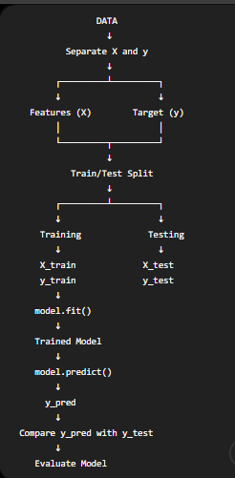
Day 4 — Introduction to LLMs & Generative AI

Understand LLMs
↓
Understand Generative AI
↓
Understand API
↓
Get Gemini API key
↓
Install Gemini Python SDK
↓
Send prompt from Python
↓
Receive AI-generated response

What is an LLM?
LLM = Large Language Model
An LLM is a machine-learning model trained on very large amounts of text and designed to process and generate language.
Examples include models in the Gemini and GPT families.
The basic idea:
Large amount of text
↓
Training
↓
Learn patterns in language
↓
LLM
↓
Generate / understand text

How Does an LLM Generate Text

Your prompt
↓
Model processes the input
↓
Predicts likely next token
↓
Adds that token
↓
Predicts the next token
↓
Repeats
↓
Generated response

What is Context?
Context is the information the model receives around the current request and uses to generate an answer.
For example:
User:
My name is Ali.

User:
What is my name?
If the conversation context is preserved, the model can use the earlier information.
This becomes very important when building:
- Chatbots
- AI assistants
- Agents
- Document assistants

his distinction is extremely important.

Training
The model learns from data.
Data
↓
Training
↓
Learn parameters
↓
Trained model
Training is computationally expensive and is generally done by the model provider.

Inference
Inference means using the trained model to produce an output.
Your Prompt
↓
Trained Model
↓
Response
When you call the Gemini API from Python, you are generally performing inference, not training Gemini yourself

Real-Life API Analogy
Imagine a restaurant.
You
↓
Waiter
↓
Kitchen
↓
Food
↓
Waiter
↓
You
Think of:
You = Python program

Waiter = API

Kitchen = Gemini servers

Food = AI response
The Complete Request Flow
Python Program
│
│ Prompt
↓
google-genai
│
│ API Request
↓
Gemini API
│
↓
Gemini Model
│
│ Generated output
↓
Gemini API
│
↓
Python Program
│
↓
response.text

Generative AI vs LLM vs Gemini API
Don't mix these terms.

Generative AI
The broader technology/category.
Generative AI
├── Text generation
├── Image generation
├── Audio generation
├── Video generation
└── Code generation

LLM
A model designed primarily around language.
LLM
↓
Processes/generates language

Gemini
Google's family of generative AI models/services.

Gemini API
The programmatic interface that lets your application communicate with Gemini.
So
Generative AI
↓
LLM
↓
Gemini
↓
Gemini API
↓
Python Application

What is Hallucination?
One of the most important concepts when working with LLMs is hallucination.
An LLM can sometimes generate information that sounds convincing but is incorrect, unsupported, or fabricated.
Example:
User:
What happened in a fictional event?

Model:
It may confidently provide an invented explanation.
Therefore:
LLM output should not automatically be treated as factual.
This is especially important for:
- Legal information
- Medical information
- Financial decisions
- Current events
- Technical specifications
- Research
As your AI projects become more advanced, you will learn techniques to reduce these problems.
Temperature is a generation-control parameter, not the model's intelligence level
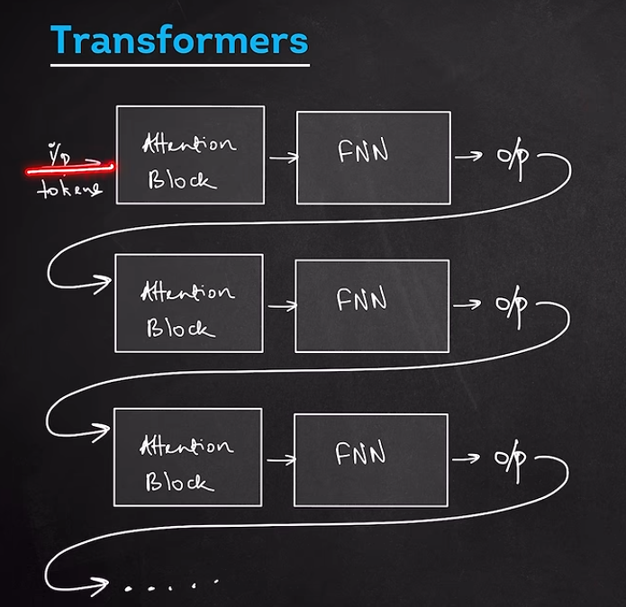

14. Keyword Search vs Semantic Search
This distinction is extremely important for your AI journey.

Keyword search
Suppose the database contains:
"I enjoy developing software using Python."
User searches:
"I like coding in Python."
A simple keyword system may struggle because the words aren't identical.

Semantic search
Embeddings understand that:
coding
and
developing software
can have similar meaning.
Therefore:
Query
↓
Embedding
↓
Compare with document embeddings
↓
Find closest meaning
That's semantic search

Project Matters for RAG
This tiny project is actually teaching you one of the core components of RAG.
RAG means:
Retrieval-Augmented Generation
A simplified RAG system looks like:
Documents
↓
Split into chunks
↓
Generate embeddings
↓
Store embeddings
↓
User asks question
↓
Generate query embedding
↓
Find similar chunks
↓
Retrieve relevant information
↓
Send information to LLM
↓
Generate answer
For your learning path, I would eventually recommend understanding:
Sentence Transformers
↓
FAISS / Chroma
↓
RAG
↓
LLM
↓
AI Agent

