**DHCP Server Configuration on Interface**

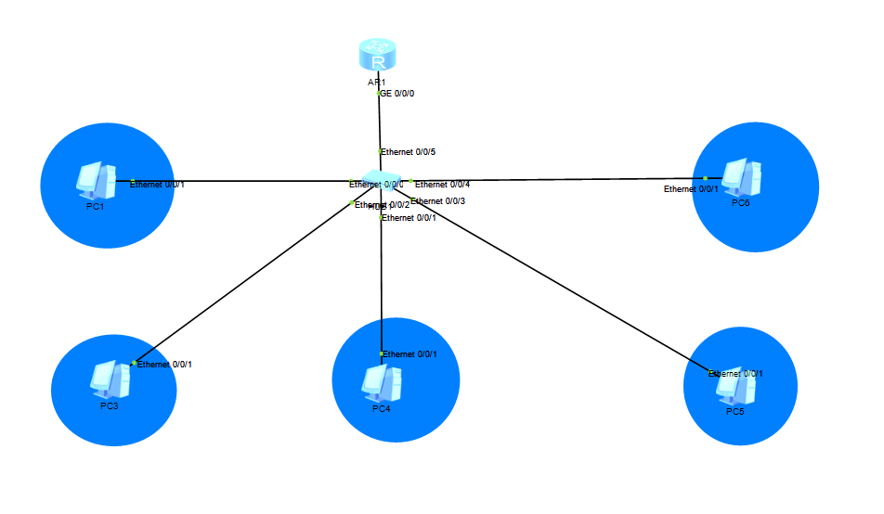**MS CYBER SECURITY 2019**

**SULEMAN SHAHID**

**DHCP Server Statistics Before PC(s) get their IP(s)**

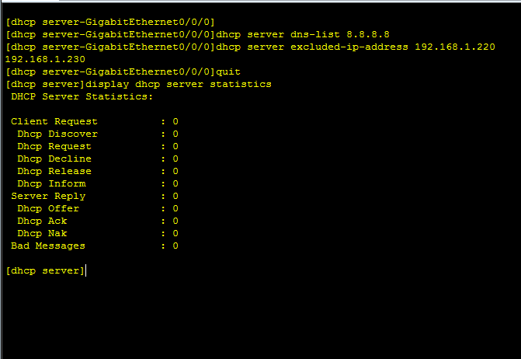

**PC 1:**

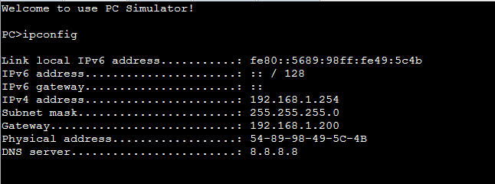

**PC 3:**

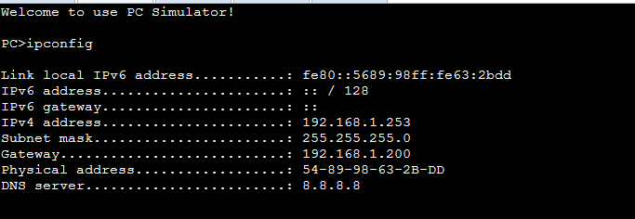

**PC 4:**

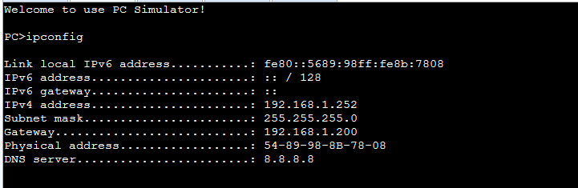

**PC 5:**

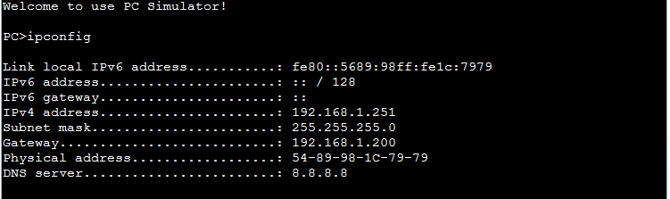

**PC 6:**

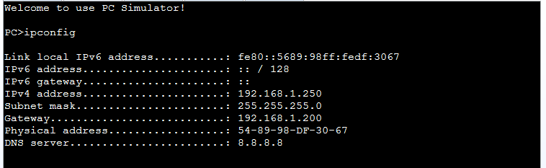

**DHCP Server Statistics after PC(s) get their IP(s)**

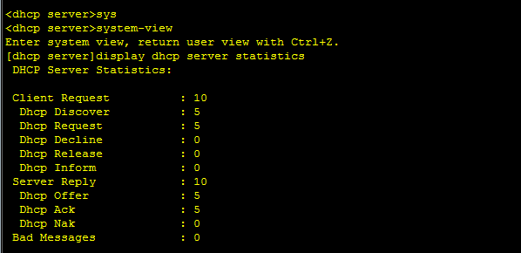

**DHCP Server IP Pool:**

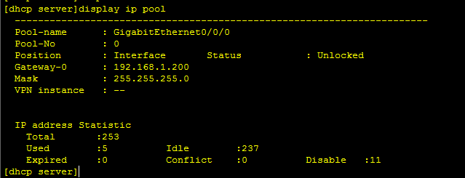

**DHCP Server Current Configurations**

[dhcp server]display current-configuration

[V200R003C00]

#

sysname dhcp server

#

snmp-agent local-engineid 800007DB03000000000000

snmp-agent

#

clock timezone China-Standard-Time minus 08:00:00

#

portal local-server load portalpage.zip

#

drop illegal-mac alarm

#

set cpu-usage threshold 80 restore 75

#

dhcp enable

#

aaa

authentication-scheme default

authorization-scheme default

accounting-scheme default

domain default

domain default_admin

local-user admin password cipher %$%$K8m.Nt84DZ}e#<0`8bmE3Uw}%$%$

local-user admin service-type http

#

firewall zone Local

priority 15

#

interface Ethernet0/0/0

#

interface Ethernet0/0/1

#

interface Ethernet0/0/2

#

interface Ethernet0/0/3

#

interface Ethernet0/0/4

#

interface Ethernet0/0/5

#

interface Ethernet0/0/6

#

interface Ethernet0/0/7

#

interface GigabitEthernet0/0/0

ip address 192.168.1.200 255.255.255.0

dhcp select interface

dhcp server excluded-ip-address 192.168.1.220 192.168.1.230

dhcp server dns-list 8.8.8.8

#

interface GigabitEthernet0/0/1

#

interface NULL0

#

user-interface con 0

authentication-mode password

user-interface vty 0 4

user-interface vty 16 20

#

wlan ac

#

return