# Department of Computing

# CS344: Web Engineering

# Lab 7: Getting Started with Laravel

# Date: 13th August 2015

# Time: 09:00-12:00

# Instructor: Fahad Ahmed Satti

# 

# Lab 7: Getting started with Laravel

## Installation steps:

1. Downloaded composer from laravel website.
2. Ran the setup.
3. Gave php.exe path to the installation setup.
4. Downloaded laravel-master zip folder from GithHub.
5. Extracted the laravel-master zip folder.
6. Placed laravel-master extracted folder to www in wamp.
7. After installation, went to wamp; enabled extensions: php_openssl, php_curl, php_socket.
8. Then enabled ssl_module on wamp icon->Apache->Apache Modules
9. Then opened cmd and changed directory to :\wamp\www\laravel-master\laravel-master
10. In cmd, entered composer install command.
11. After dependencies were installed, clicked on wamp icon->Apache->Apache Modules and enabled rewrite_module.
12. With all this, installation completed.

## Sample code:

<?php

/**

* Laravel - A PHP Framework For Web Artisans

*

* @package Laravel

* @author Taylor Otwell <taylorotwell@gmail.com>

*/

/*

|--------------------------------------------------------------------------

| Register The Auto Loader

|--------------------------------------------------------------------------

|

| Composer provides a convenient, automatically generated class loader for

| our application. We just need to utilize it! We'll simply require it

| into the script here so that we don't have to worry about manual

| loading any of our classes later on. It feels nice to relax.

|

*/

require __DIR__.'/../bootstrap/autoload.php';

/*

|--------------------------------------------------------------------------

| Turn On The Lights

|--------------------------------------------------------------------------

|

| We need to illuminate PHP development, so let us turn on the lights.

| This bootstraps the framework and gets it ready for use, then it

| will load up this application so that we can run it and send

| the responses back to the browser and delight our users.

|

*/

$app = require_once __DIR__.'/../bootstrap/app.php';

/*

|--------------------------------------------------------------------------

| Run The Application

|--------------------------------------------------------------------------

|

| Once we have the application, we can handle the incoming request

| through the kernel, and send the associated response back to

| the client's browser allowing them to enjoy the creative

| and wonderful application we have prepared for them.

|

*/

$kernel = $app->make(Illuminate\Contracts\Http\Kernel::class);

$response = $kernel->handle(

$request = Illuminate\Http\Request::capture()

);

$response->send();

$kernel->terminate($request, $response);

## Output:

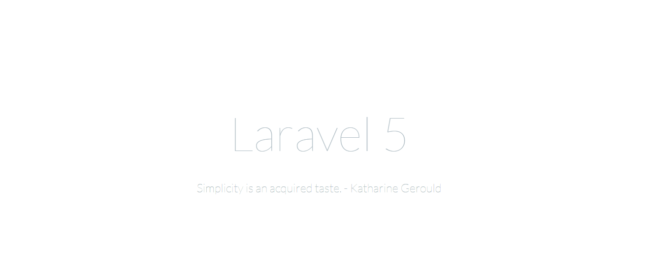

## Useful Links:

<http://laravel.com/docs/4.2#install-laravel> **(For composer)**

<http://www.wikihow.com/Install-Laravel-Framework-in-Windows> **(For installation instructions)**

## GitHub Link: