MongoDB Aggregation
1. Filter Documents ($match)
The $match stage filters documents to pass only those that match the specified condition(s) to the next pipeline stage. It operates similarly to the standard find() query.
Code:-
db.employees.aggregate([
{
$match: { dept: "IT" }
}
])
output:-
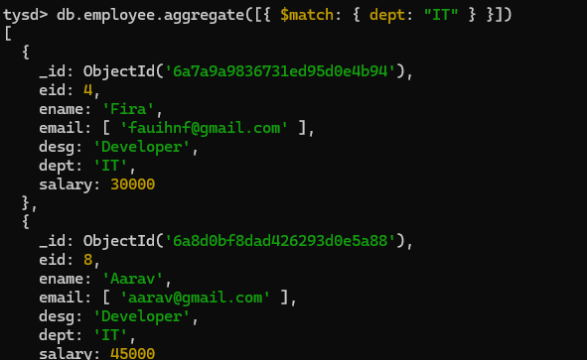
2. Group & Aggregate Data ($group)
The $group stage groups documents by a specified identifier key and performs aggregation operations (such as sum, average, count) on each group.
Code:-
db.employees.aggregate([
{
$group: {
_id: "$dept",
totalSalary: { $sum: "$salary" },
avgSalary: { $avg: "$salary" },
totalEmployees: { $sum: 1 }
}
}
])
Output:-
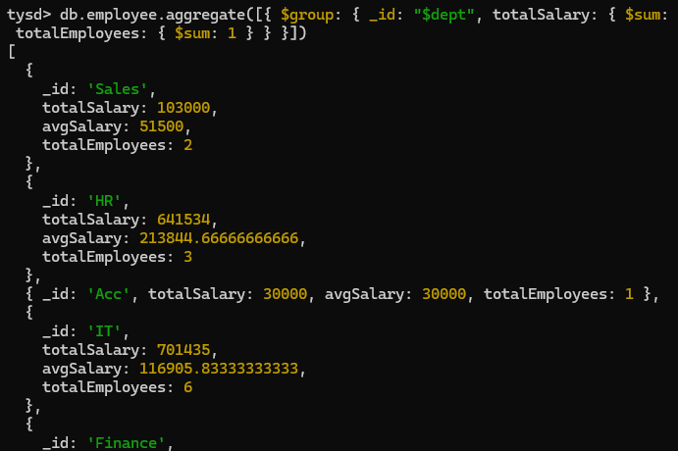

3. Sort Results ($sort)
The $sort stage takes all input documents and sorts them by the specified field(s) in ascending (1) or descending (-1) order.
Code:-
db.employees.aggregate([
{
$sort: { salary: -1 }
}
])
Output:-
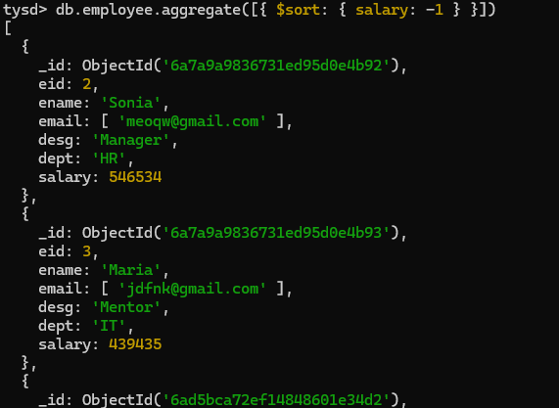
4. Combined Pipeline ($match + $group + $sort)
Aggregation stages can be chained sequentially. This pipeline filters employees with a salary greater than 40,000, groups them by department to calculate totals and averages, and sorts departments by average salary in descending order.
Code:
db.employees.aggregate([
// Step 1: Filter salary > 40000
{
$match: { salary: { $gt: 40000 } }
},
// Step 2: Group by department
{
$group: {
_id: "$dept",
totalSalary: { $sum: "$salary" },
avgSalary: { $avg: "$salary" },
employeeCount: { $sum: 1 }
}
},
// Step 3: Sort by average salary (highest first)
{
$sort: { avgSalary: -1 }
}
])
Output:-
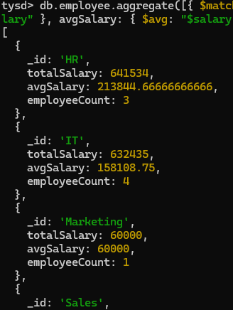

5. Project Specific Fields ($project)
The $project stage reshapes documents by including, excluding, or renaming fields, as well as computing new fields.
Code:-
db.employees.aggregate([
{
$project: {
_id: 0,
employeeName: "$ename",
designation: "$desg",
salary: 1
}
}
])
Output:-
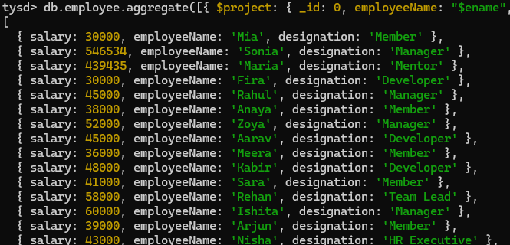
6. Pagination ($sort + $skip + $limit)
Combines sorting with $skip and $limit stages to implement efficient pagination across result sets (e.g., retrieving the top earners after skipping initial records).
Code:-
db.employees.aggregate([
{ $sort: { salary: -1 } },
{ $skip: 2 },
{ $limit: 3 }
])
Output:-


