SS PHARMACEUTICALS
Semester Project
PROJECT REPORT
Hospital Management System

Developed by

Group Members

Suleman Saqib (243342) | Zain-ul-Abideen (241152) |
Abdul Wahab (241066)

Submitted to
Miss Amina Tariq

16th May, 2026

1. Introduction

The Hospital Management System (HMS) is a full-stack web application developed as a Semester Project for SS Pharmaceuticals. It digitizes core hospital operations including patient management, appointment scheduling, pharmacy inventory, and billing through a secure, role-based web dashboard.

2. Objectives

- Provide a centralized digital platform for hospital administration.
- Enable secure, role-based access for hospital staff.
- Manage patients, doctors, appointments, pharmacy, and billing.
- Display real-time KPIs on an administrative dashboard.
- Offer a public-facing website for patient information.

3. Technology Stack

Layer | Technology | Purpose
Frontend | React 18, Vite, Tailwind CSS | SPA UI with fast build tooling
Backend | Node.js, Express.js | RESTful API server
Database | Oracle 19c | Relational data management
Security | JWT, bcryptjs | Authentication & password hashing
HTTP | Axios | Frontend API communication

4. System Architecture

The system follows a three-tier MVC architecture:
- Frontend (React SPA) communicates with the backend via REST API calls using Axios.
- Backend (Express.js) exposes six API route groups protected by JWT middleware.
- Database (Oracle 19c) stores all data, accessed through an oracledb connection pool.

API Routes

Route | Module
/api/auth | Login & JWT issuance
/api/patients | Patient management
/api/appointments | Appointment scheduling
/api/staff | Doctor & staff management
/api/pharmacy | Medicine & prescriptions
/api/billing | Invoices & payments

5. Database Design

The Oracle 19c schema consists of 8 tables with auto-increment IDENTITY primary keys and foreign key constraints:

Table | Description
departments | Hospital departments (Cardiology, ICU, etc.)
staff | Doctors, nurses, admins, pharmacists
patients | Patient demographics and contact details
admissions | Inpatient ward and bed tracking
appointments | OPD scheduling with status lifecycle
medicines | Pharmacy inventory with stock thresholds
prescriptions | Doctor-issued prescriptions, dispensing flag
billing | Invoices, payment modes, and statuses

5.1 Database PL/SQL Objects & Optimizations
To enhance security, enforce business rules directly at the data layer, and optimize query latency, the database layer was upgraded with PL/SQL database objects including Views, Stored Procedures, Cursors, Triggers, and Exception Handling.
Database Views
- patient_details_v: Left-joins patients with their active admission status, current bed/ward details, and their attending doctor name to simplify frontend views.
- appointment_details_v: Merges appointments with patient profile details, doctor designations, and departments for cleaner list retrieves.
- billing_summary_v: Combines patient billing records with contact info and dynamically computes remaining invoice balances.
- medicine_inventory_v: Categorizes stock levels into 'ok', 'low', or 'out_of_stock' status based on min_quantity thresholds.
Stored Procedures with Cursors & Custom Exception Handling
- sp_add_prescription: A transactional procedure that validates patients, checks doctor active status, validates medicine stock, inserts the prescription, and decrements stock. If stock is insufficient, it raises a custom application error (-20001) that is trapped and handled by the Node.js API.
- sp_discharge_patient: Automatically discharges an inpatient and calculates room, appointment, and pharmacy charges. It uses Cursors to aggregate all related treatments, calculate the room charge based on stay duration, and automatically insert the corresponding billing record.
Database Triggers
- trg_update_billing_status: A BEFORE INSERT OR UPDATE trigger on the billing table that automatically calculates and sets status ('paid', 'partial', 'pending') based on paid_amount versus total_amount, removing redundancy in Node.js controller files.

6. System Modules

Module | Key Features
Public Website | Home, About, Services, Contact pages (no login required)
Authentication | JWT login, bcrypt password verification, private route guards
Dashboard | Real-time KPIs: patients, appointments, revenue, staff count
Patient Management | Full CRUD for patient records, linked to admissions and billing
Staff Management | Add/update doctors and staff with department and shift assignment
Appointments | Book and manage appointments with status tracking
Pharmacy | Inventory management, low-stock alerts, prescription handling
Billing | Invoice generation, multi-mode payment, status tracking
Analytics | Revenue trends, patient stats, operational metrics

7. Security

- Passwords hashed with bcryptjs — never stored in plain text.
- JWT tokens issued on login and validated on every protected API request.
- React Private Route component blocks unauthenticated access to dashboard routes.
- CORS restricted to frontend origin (http://localhost:5173).
- Sensitive credentials stored in .env file, excluded from version control.

8. Installation & Setup

Database
- Run backend/db/schema.sql in Oracle SQL Developer.
- Create user: CREATE USER hms_user IDENTIFIED BY hms_password; and grant DBA.

Backend
- cd backend && npm install
- Create .env with DB_USER, DB_PASSWORD, DB_CONNECT, JWT_SECRET.
- Start: npm run dev (runs on port 5000)

Frontend
- cd frontend && npm install && npm run dev (runs on port 5173)
- Default login — Email: admin@hospital.com | Password: admin123

9. Conclusion

The HMS successfully digitalizes hospital operations through a clean, secure, and scalable full-stack application. Built with React, Node.js, and Oracle 19c, it covers the complete hospital workflow from patient registration to billing, and serves as a strong foundation for future enhancements such as multi-role portals, real-time notifications, and mobile access.

Output
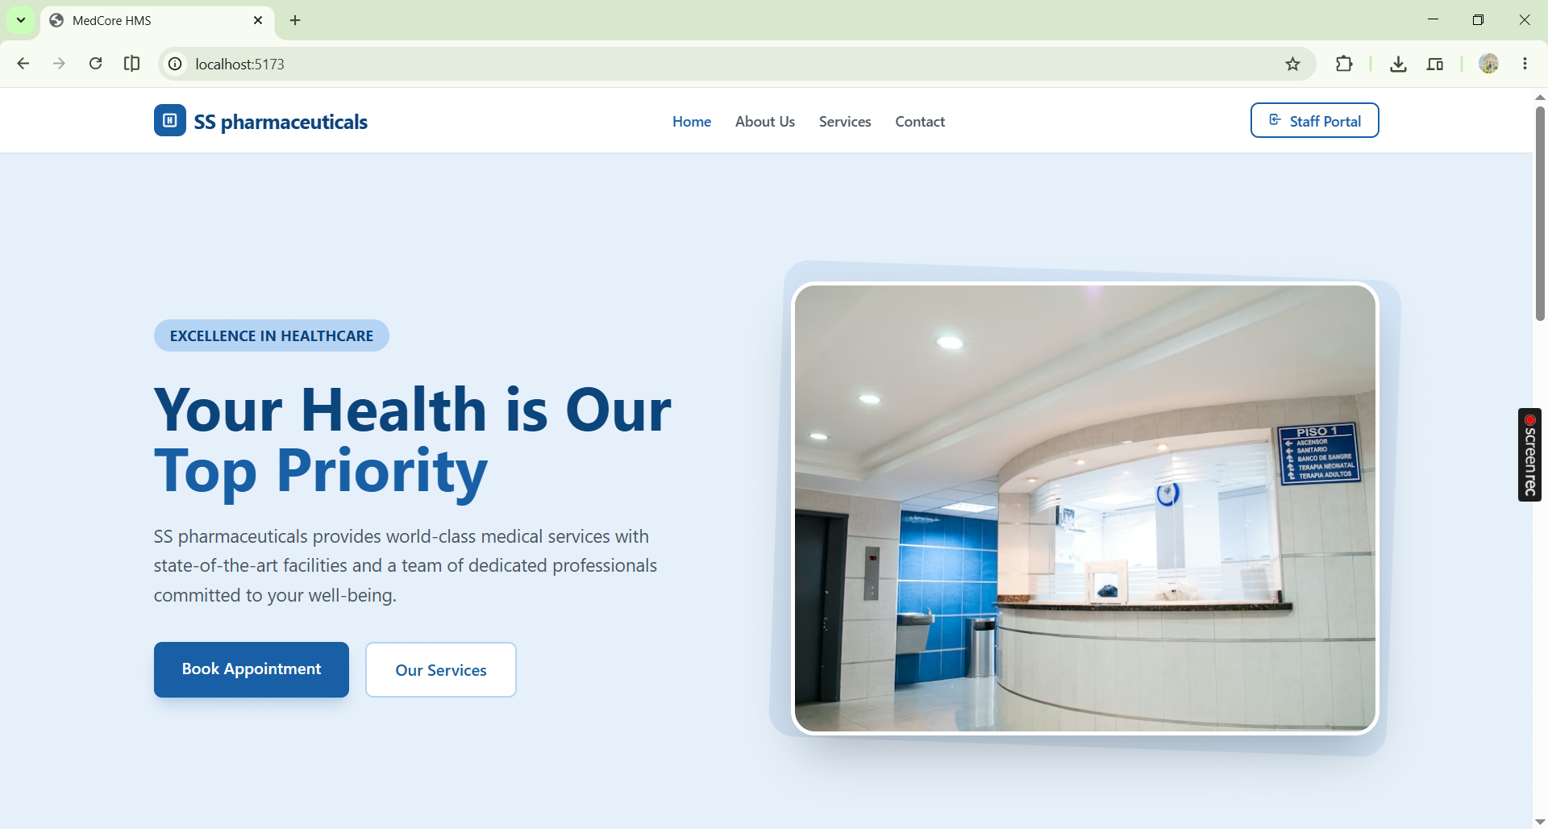

Login Page

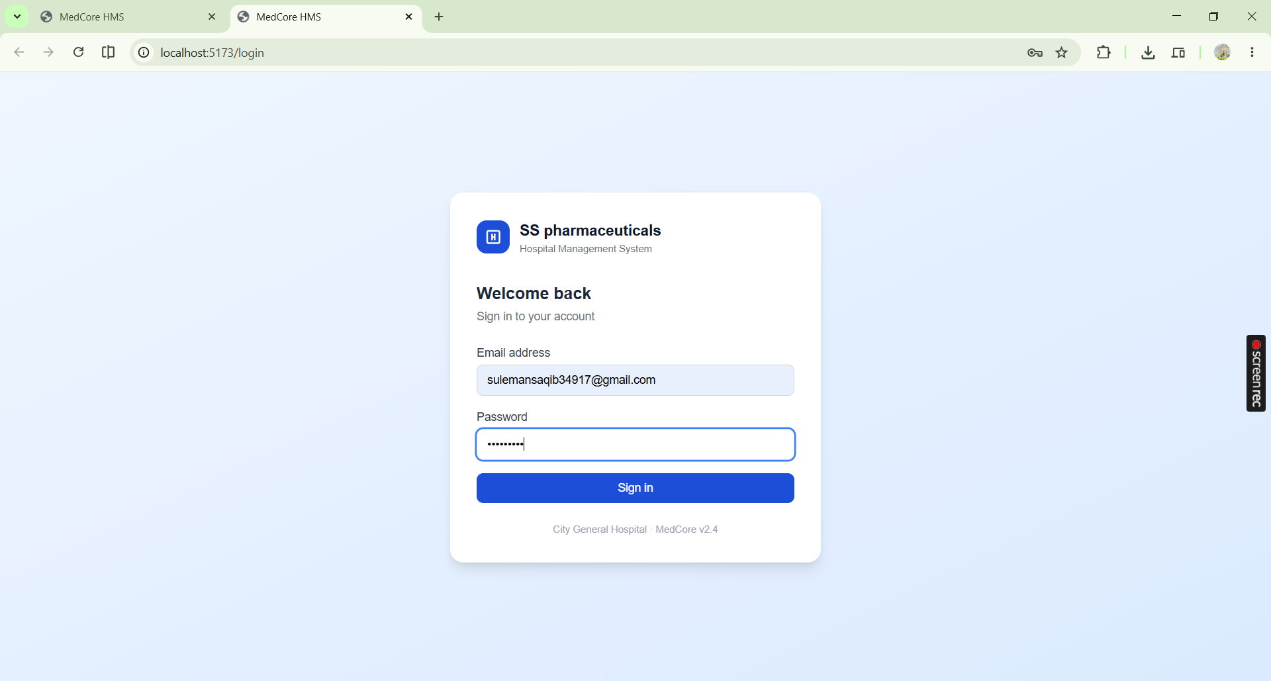

Logged In Interface

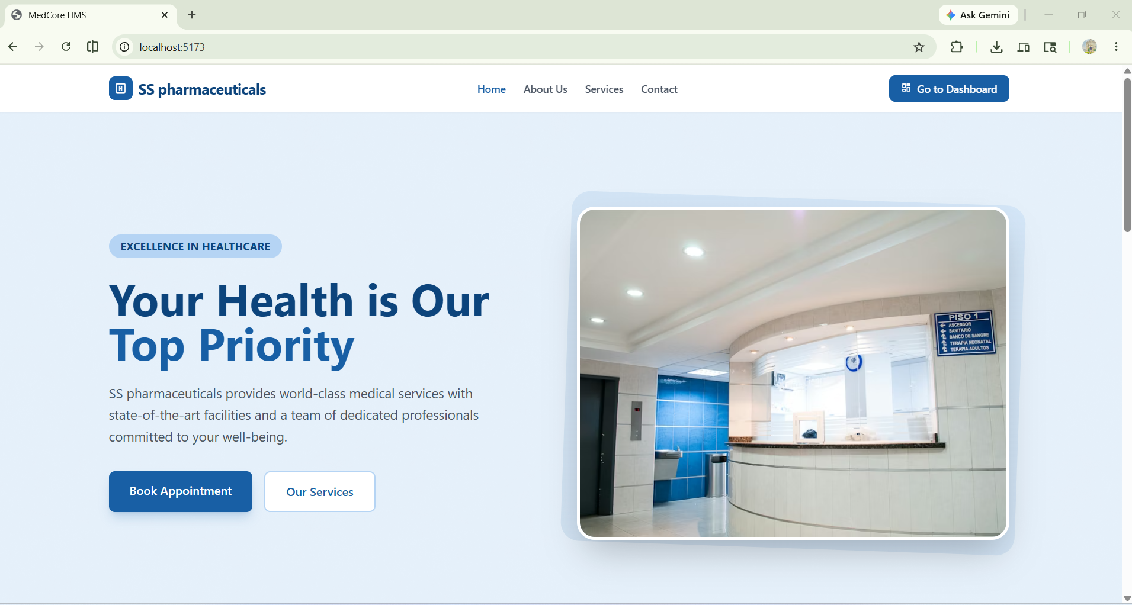

Dashboard Interface

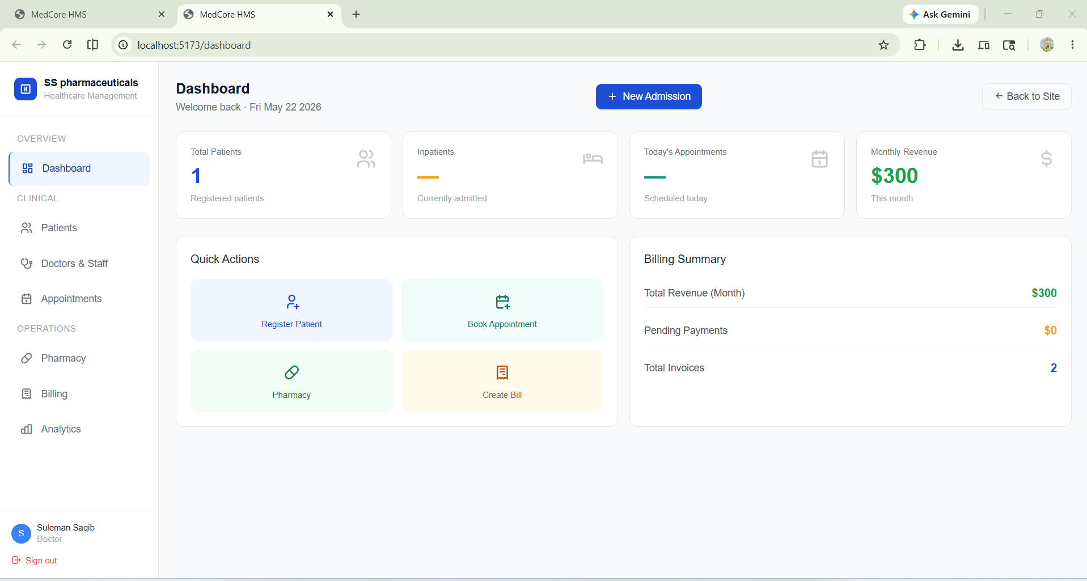
Patient Page

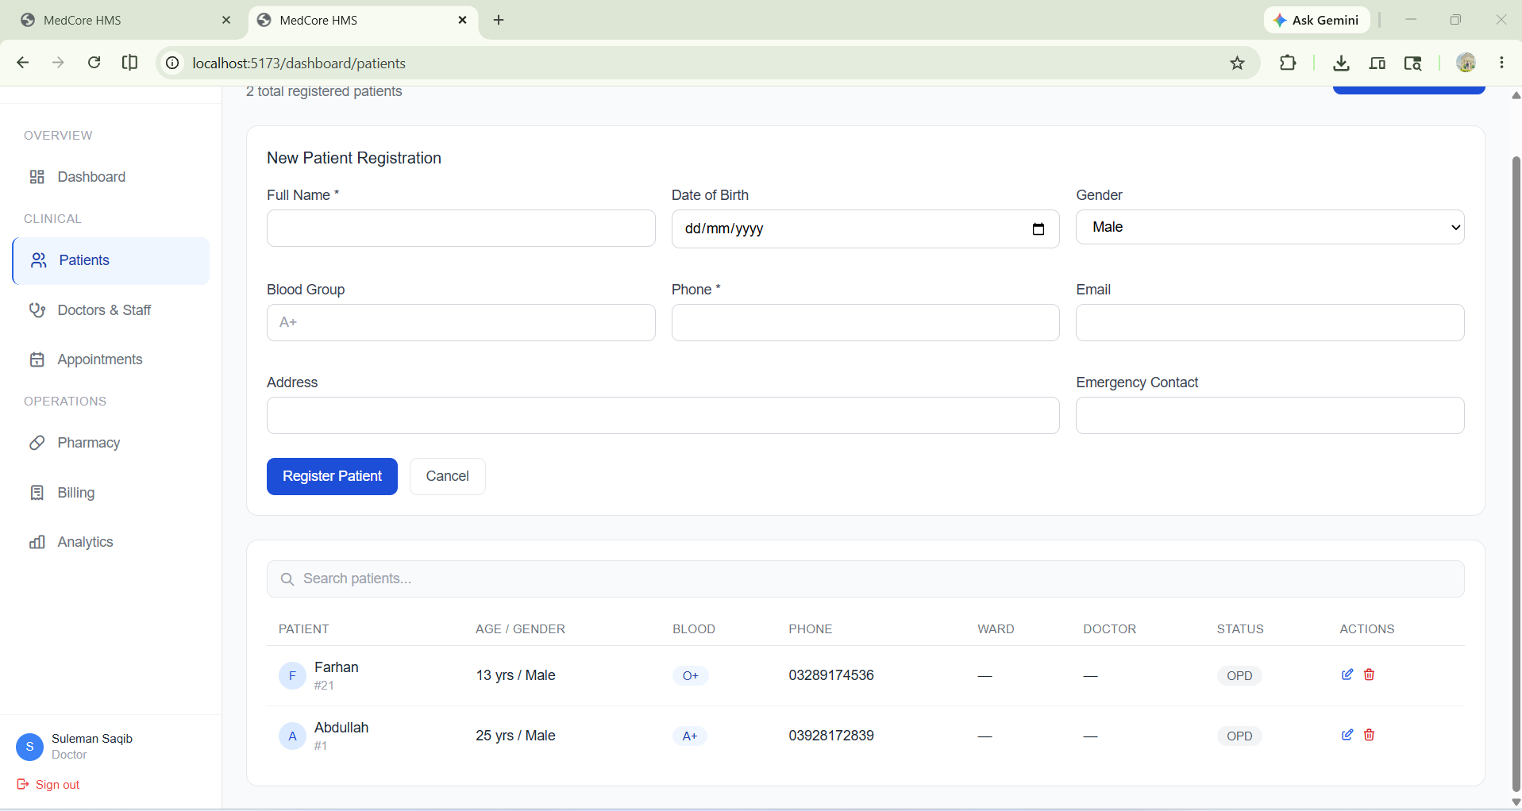

Registration Page

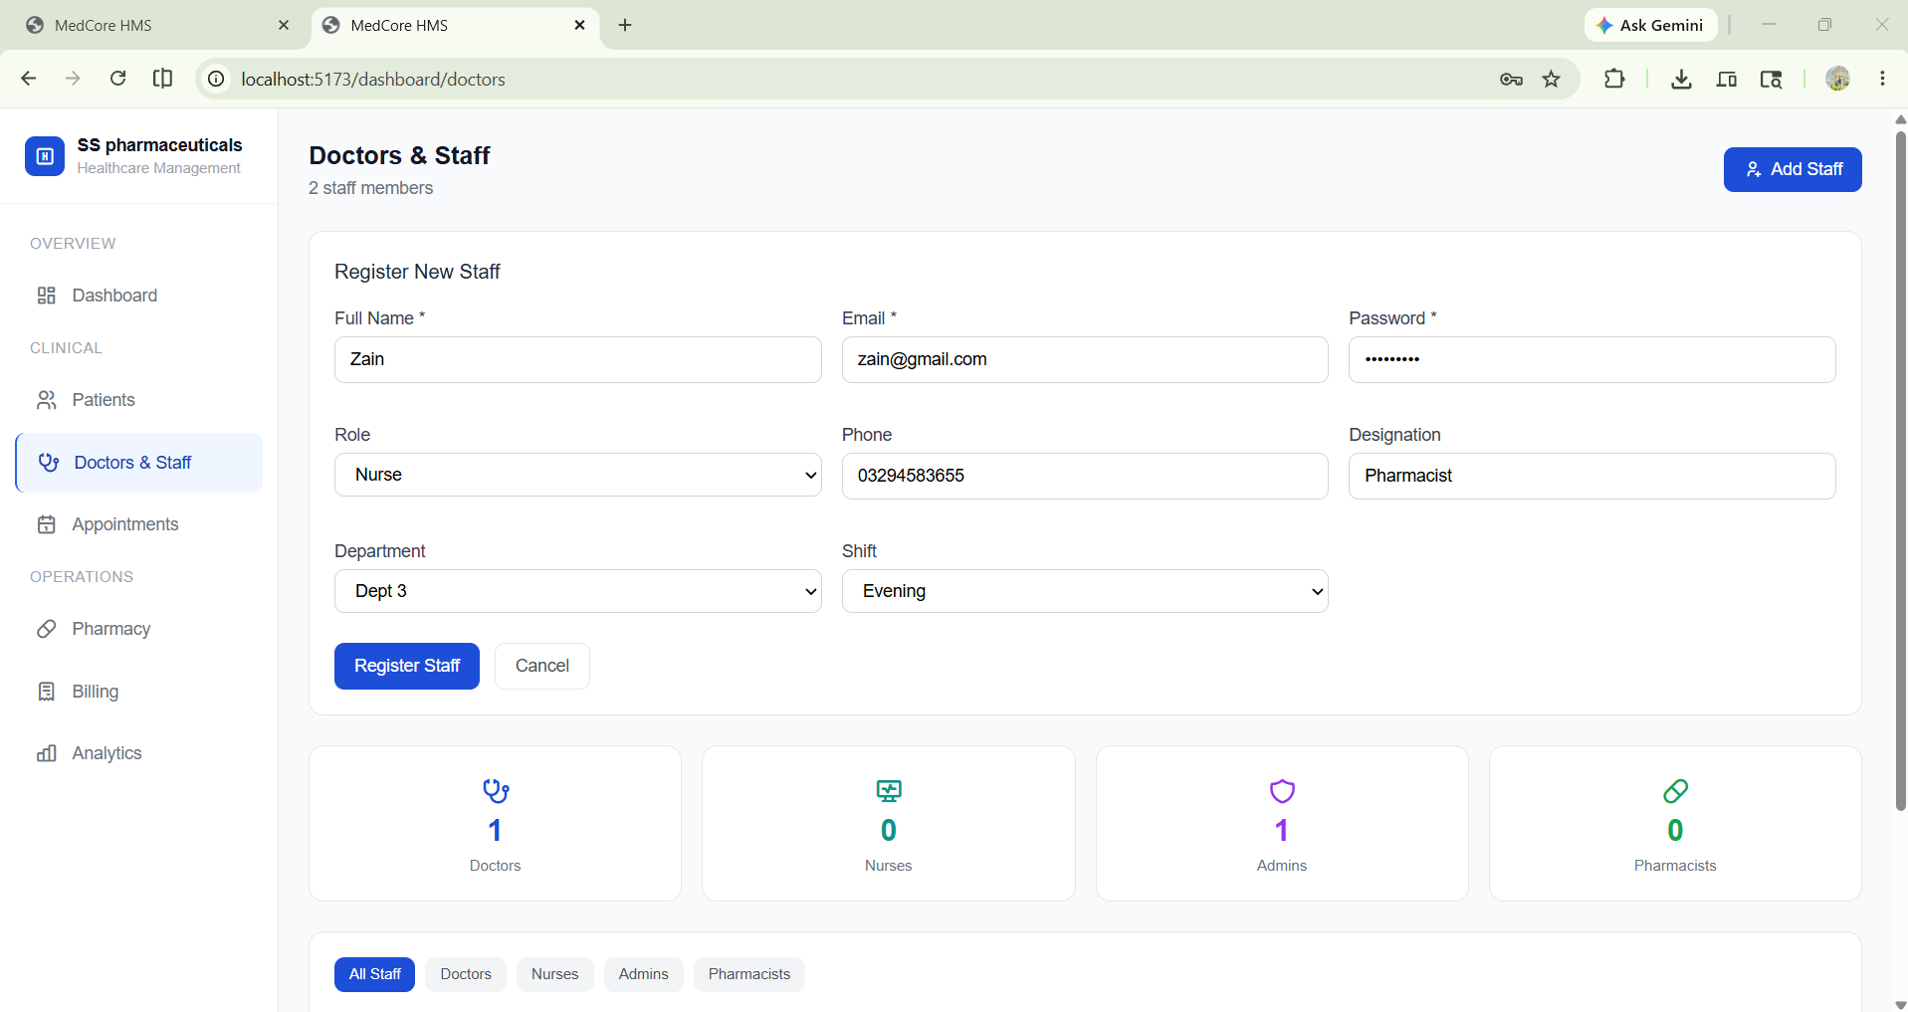
Appointment

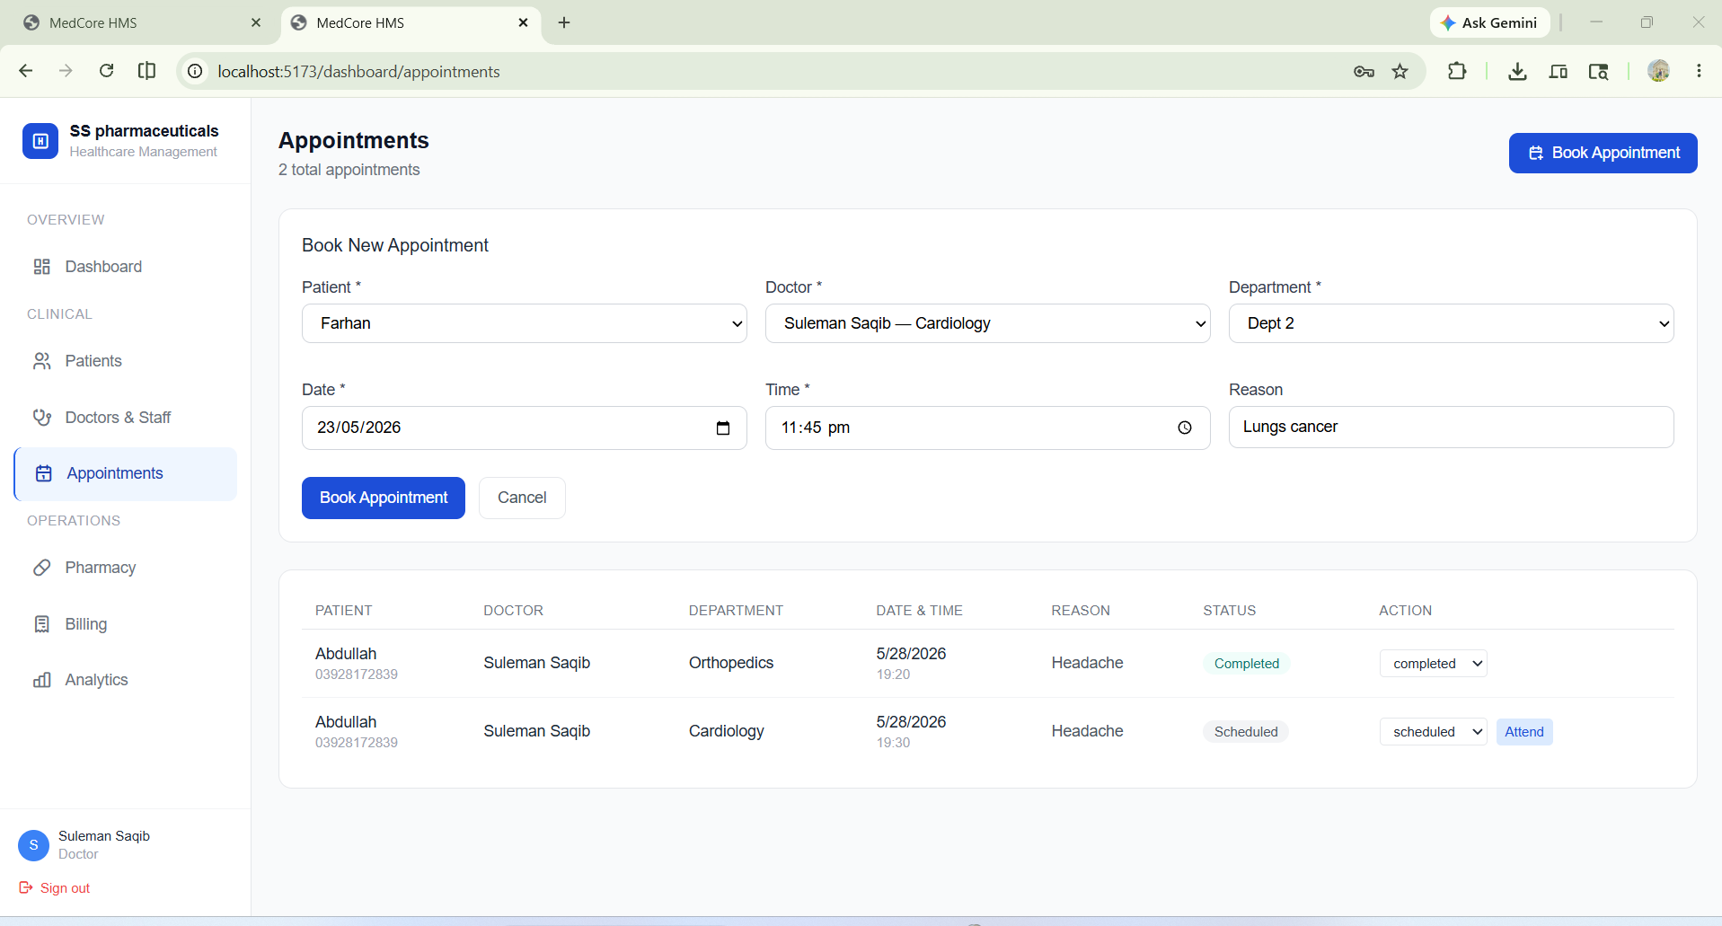

Pharmacy

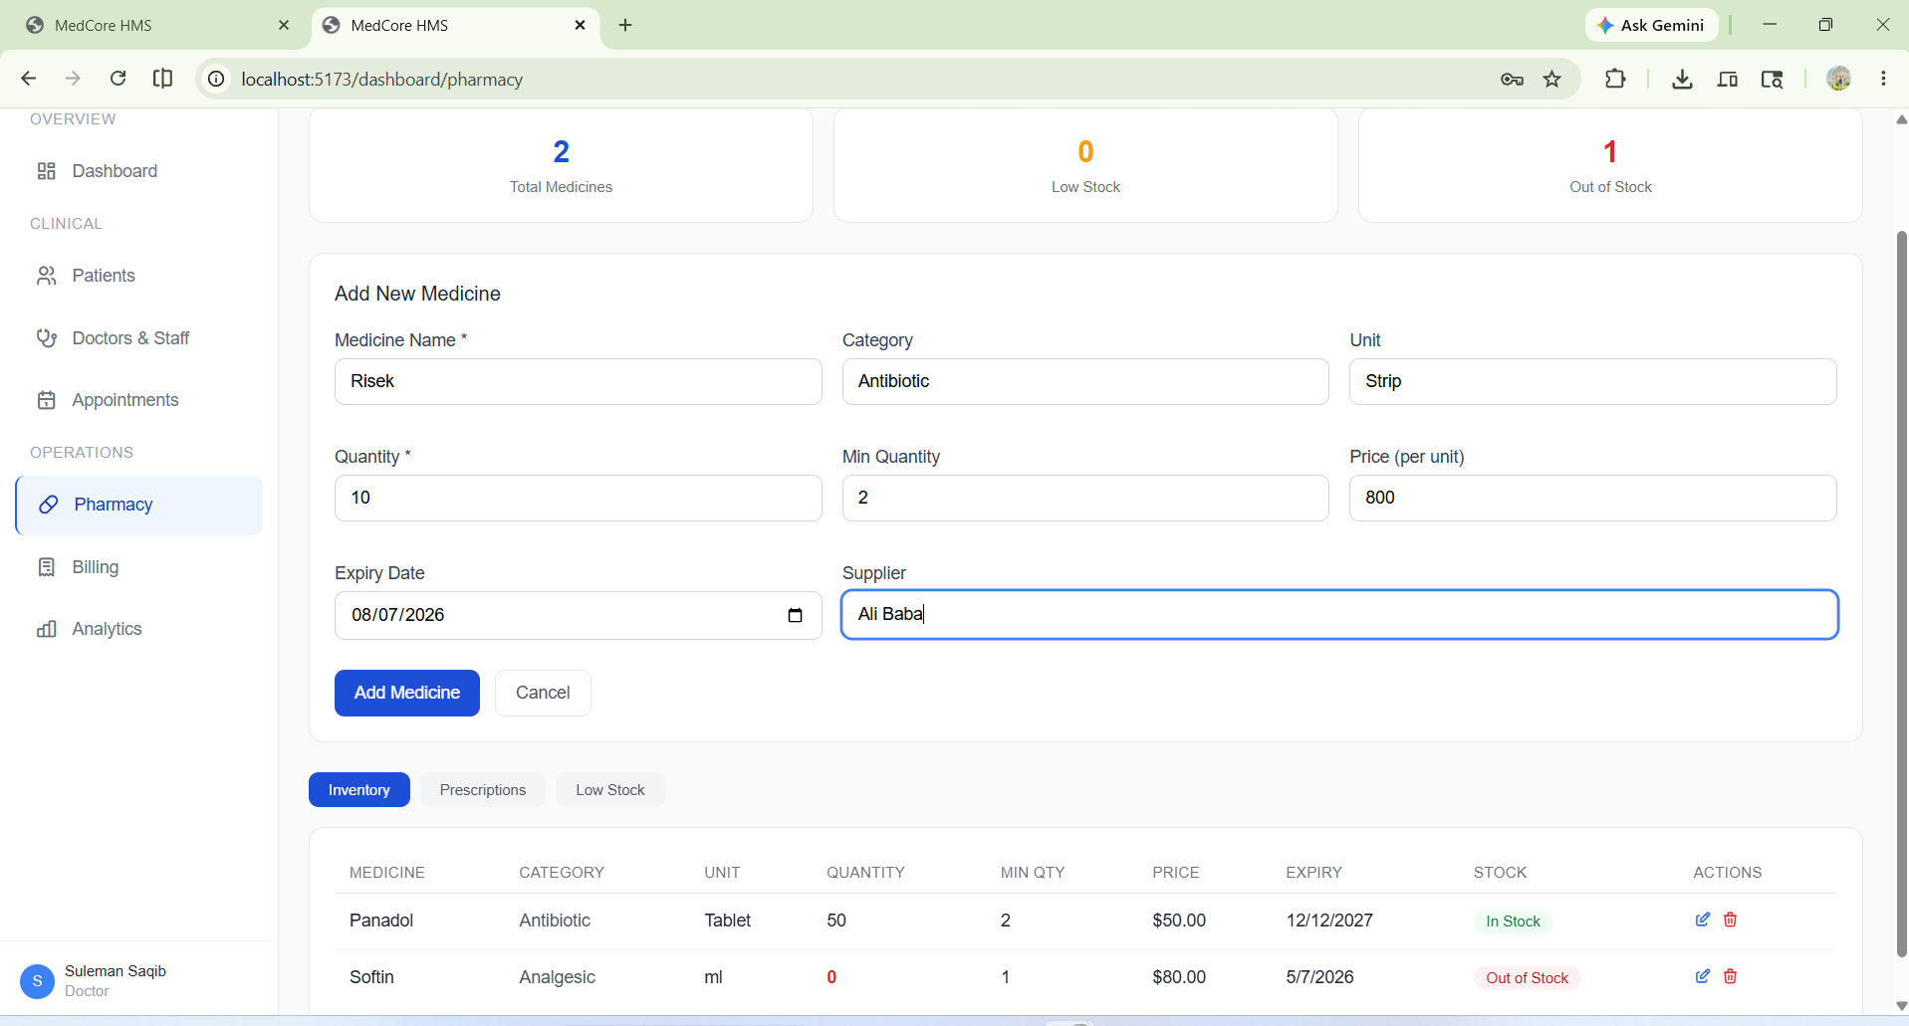
Prescribe

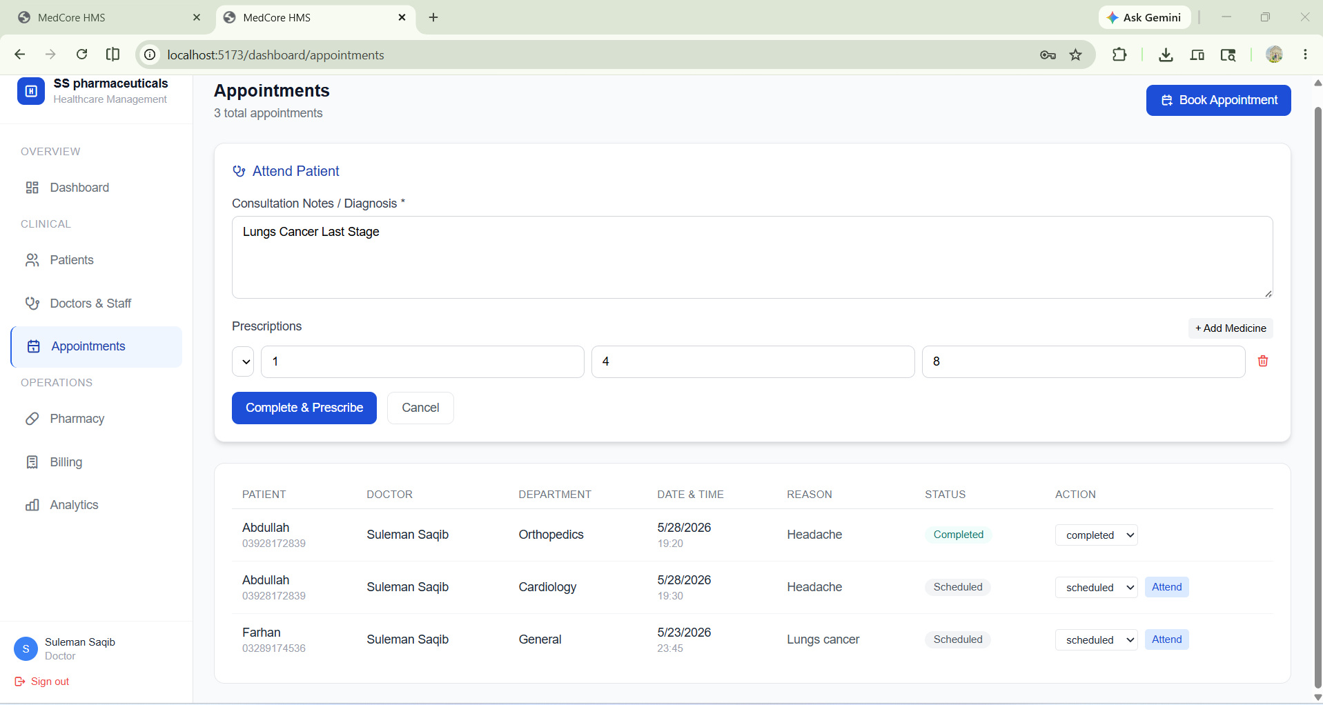

Billing System

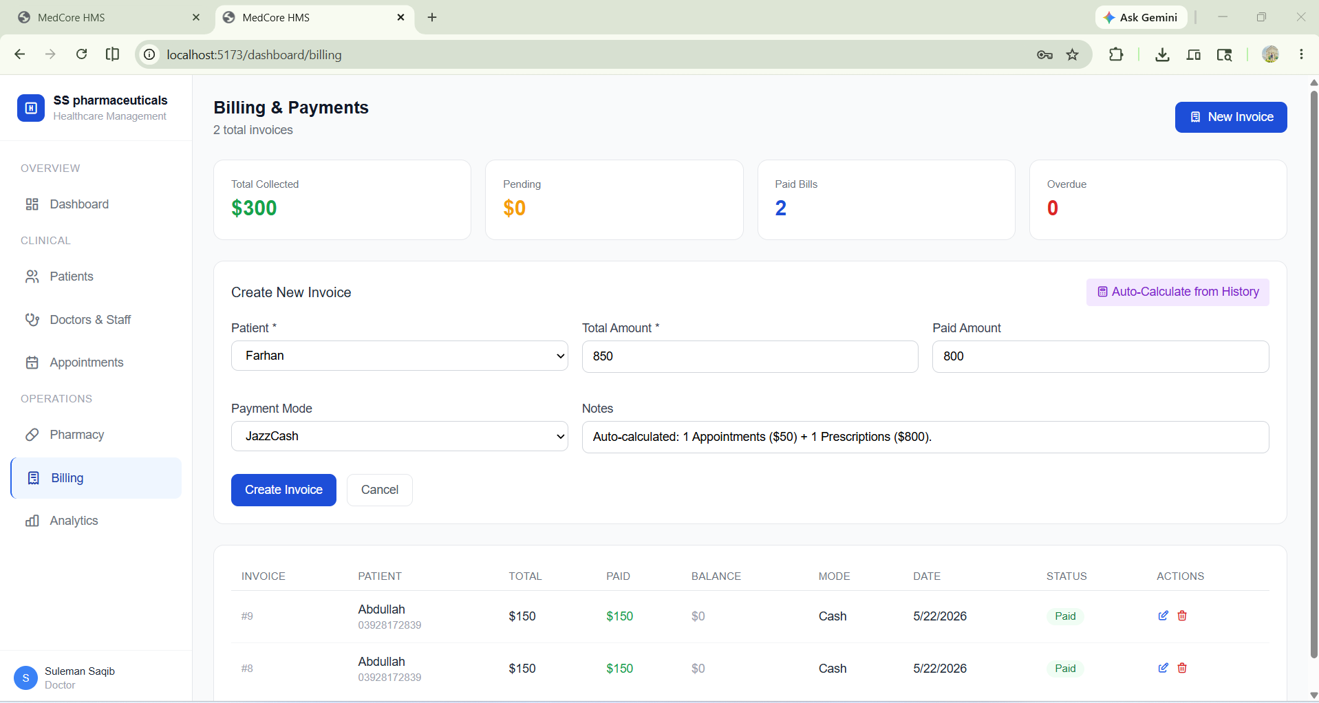
Analytics

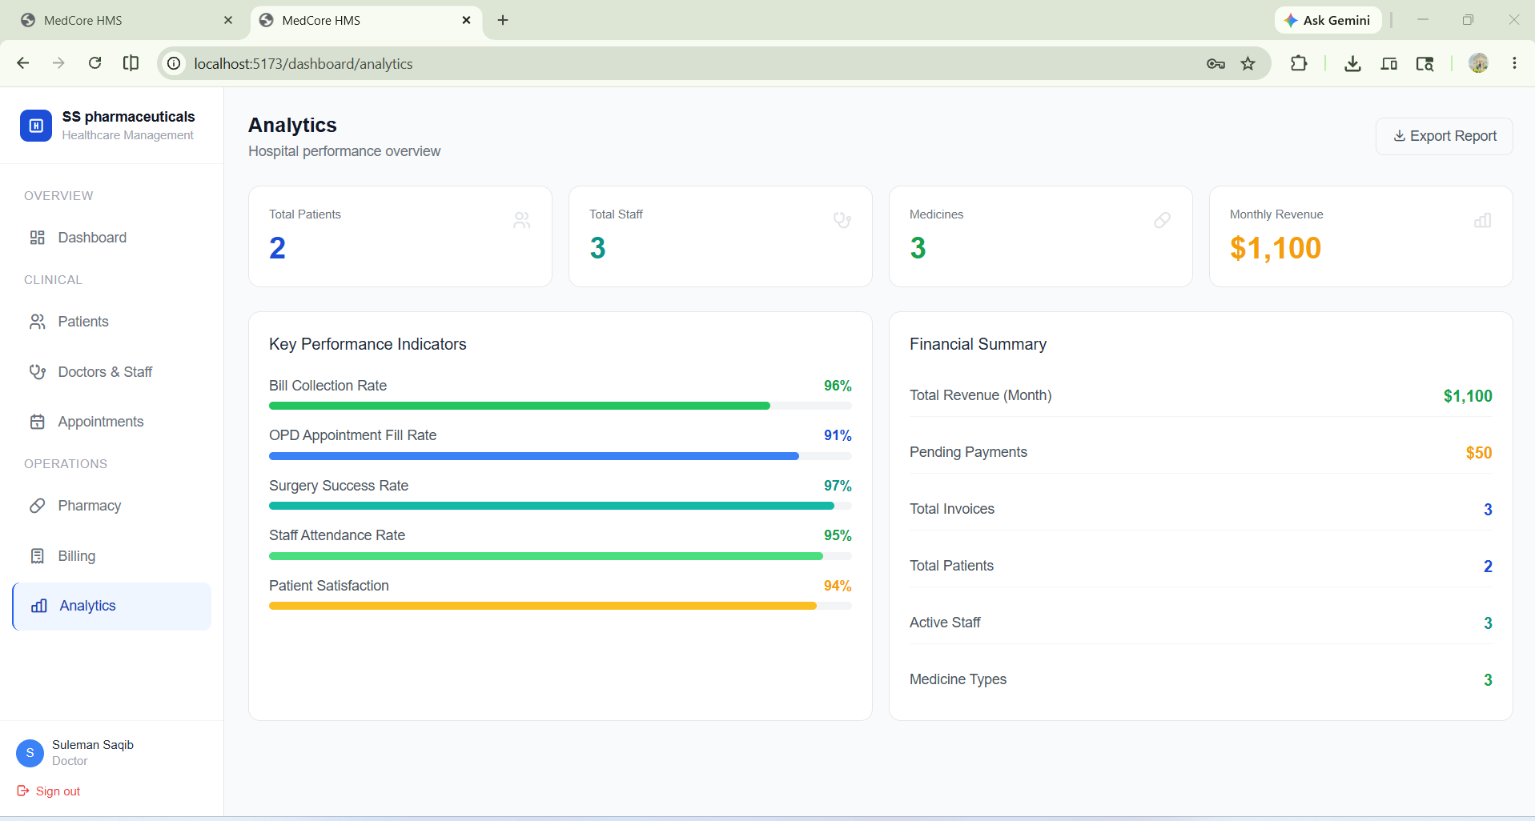
— End of Report —

