SS PHARMACEUTICALS
Semester Project
PROJECT REPORT
Hospital Management System

Developed by

Group Members

Suleman Saqib (243342) | Zain-ul-Abideen (241152) |
Abdul Wahab (241066)

Submitted to
Miss Amina Tariq

16th May, 2026

1. Introduction

The Hospital Management System (HMS) is a full-stack web application developed as a Semester Project for SS Pharmaceuticals. It digitizes core hospital operations including patient management, appointment scheduling, pharmacy inventory, and billing through a secure, role-based web dashboard.

2. Objectives

- Provide a centralized digital platform for hospital administration.
- Enable secure, role-based access for hospital staff.
- Manage patients, doctors, appointments, pharmacy, and billing.
- Display real-time KPIs on an administrative dashboard.
- Offer a public-facing website for patient information.

3. Technology Stack

Layer | Technology | Purpose
Frontend | React 18, Vite, Tailwind CSS | SPA UI with fast build tooling
Backend | Node.js, Express.js | RESTful API server
Database | Oracle 19c | Relational data management
Security | JWT, bcryptjs | Authentication & password hashing
HTTP | Axios | Frontend API communication

4. System Architecture

The system follows a three-tier MVC architecture:
- Frontend (React SPA) communicates with the backend via REST API calls using Axios.
- Backend (Express.js) exposes six API route groups protected by JWT middleware.
- Database (Oracle 19c) stores all data, accessed through an oracledb connection pool.

API Routes

Route | Module
/api/auth | Login & JWT issuance
/api/patients | Patient management
/api/appointments | Appointment scheduling
/api/staff | Doctor & staff management
/api/pharmacy | Medicine & prescriptions
/api/billing | Invoices & payments

5. Database Design

The Oracle 19c schema consists of 8 tables with auto-increment IDENTITY primary keys and foreign key constraints:

Table | Description
departments | Hospital departments (Cardiology, ICU, etc.)
staff | Doctors, nurses, admins, pharmacists
patients | Patient demographics and contact details
admissions | Inpatient ward and bed tracking
appointments | OPD scheduling with status lifecycle
medicines | Pharmacy inventory with stock thresholds
prescriptions | Doctor-issued prescriptions, dispensing flag
billing | Invoices, payment modes, and statuses

6. System Modules

Module | Key Features
Public Website | Home, About, Services, Contact pages (no login required)
Authentication | JWT login, bcrypt password verification, private route guards
Dashboard | Real-time KPIs: patients, appointments, revenue, staff count
Patient Management | Full CRUD for patient records, linked to admissions and billing
Staff Management | Add/update doctors and staff with department and shift assignment
Appointments | Book and manage appointments with status tracking
Pharmacy | Inventory management, low-stock alerts, prescription handling
Billing | Invoice generation, multi-mode payment, status tracking
Analytics | Revenue trends, patient stats, operational metrics

7. Security

- Passwords hashed with bcryptjs — never stored in plain text.
- JWT tokens issued on login and validated on every protected API request.
- React Private Route component blocks unauthenticated access to dashboard routes.
- CORS restricted to frontend origin (http://localhost:5173).
- Sensitive credentials stored in .env file, excluded from version control.

8. Installation & Setup

Database
- Run backend/db/schema.sql in Oracle SQL Developer.
- Create user: CREATE USER hms_user IDENTIFIED BY hms_password; and grant DBA.

Backend
- cd backend && npm install
- Create .env with DB_USER, DB_PASSWORD, DB_CONNECT, JWT_SECRET.
- Start: npm run dev (runs on port 5000)

Frontend
- cd frontend && npm install && npm run dev (runs on port 5173)
- Default login — Email: admin@hospital.com | Password: admin123

9. Conclusion

The HMS successfully digitalizes hospital operations through a clean, secure, and scalable full-stack application. Built with React, Node.js, and Oracle 19c, it covers the complete hospital workflow from patient registration to billing, and serves as a strong foundation for future enhancements such as multi-role portals, real-time notifications, and mobile access.

Output
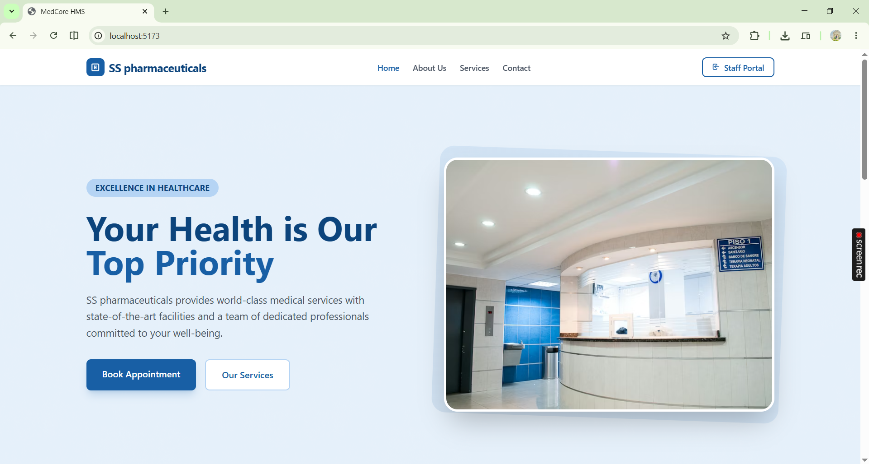
Login Page
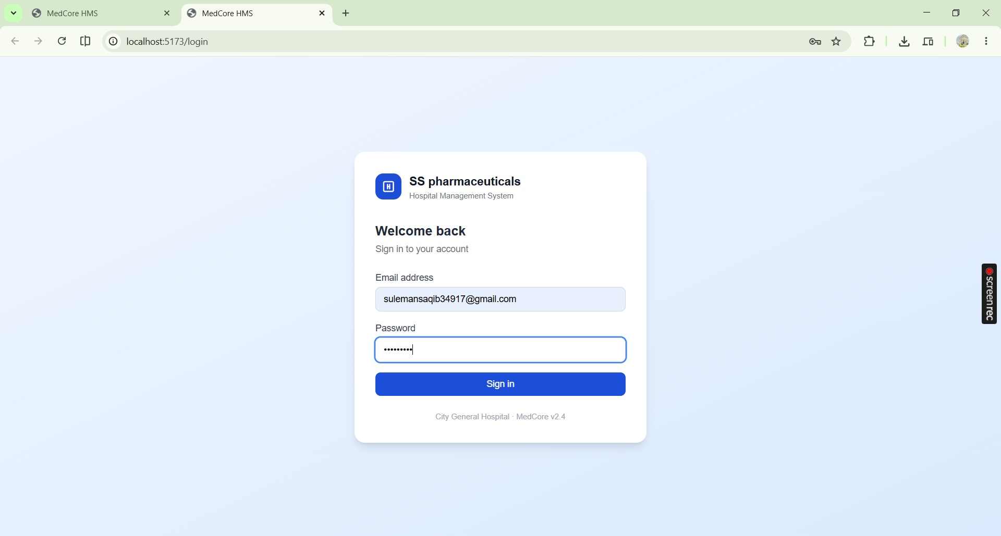

Logged In Interface
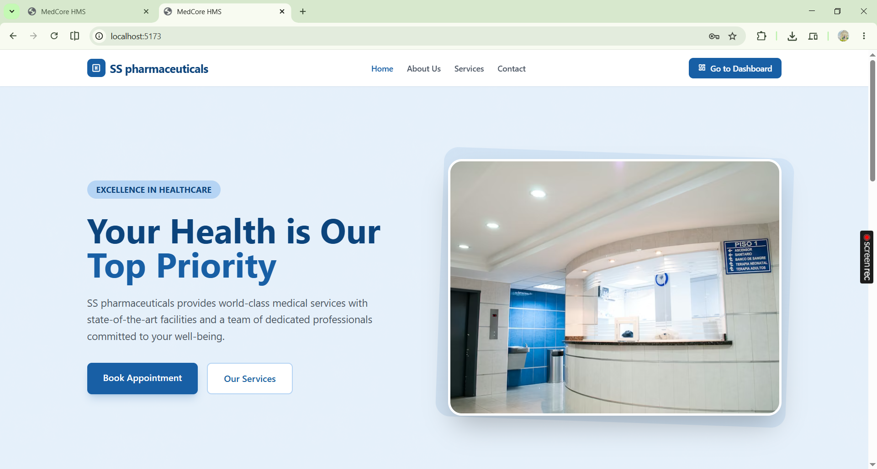
Dashboard Interface
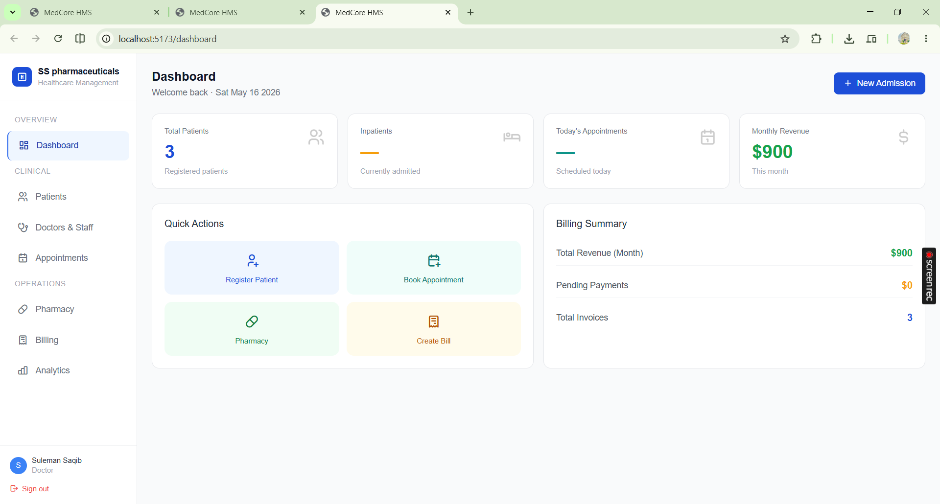

Patient Page
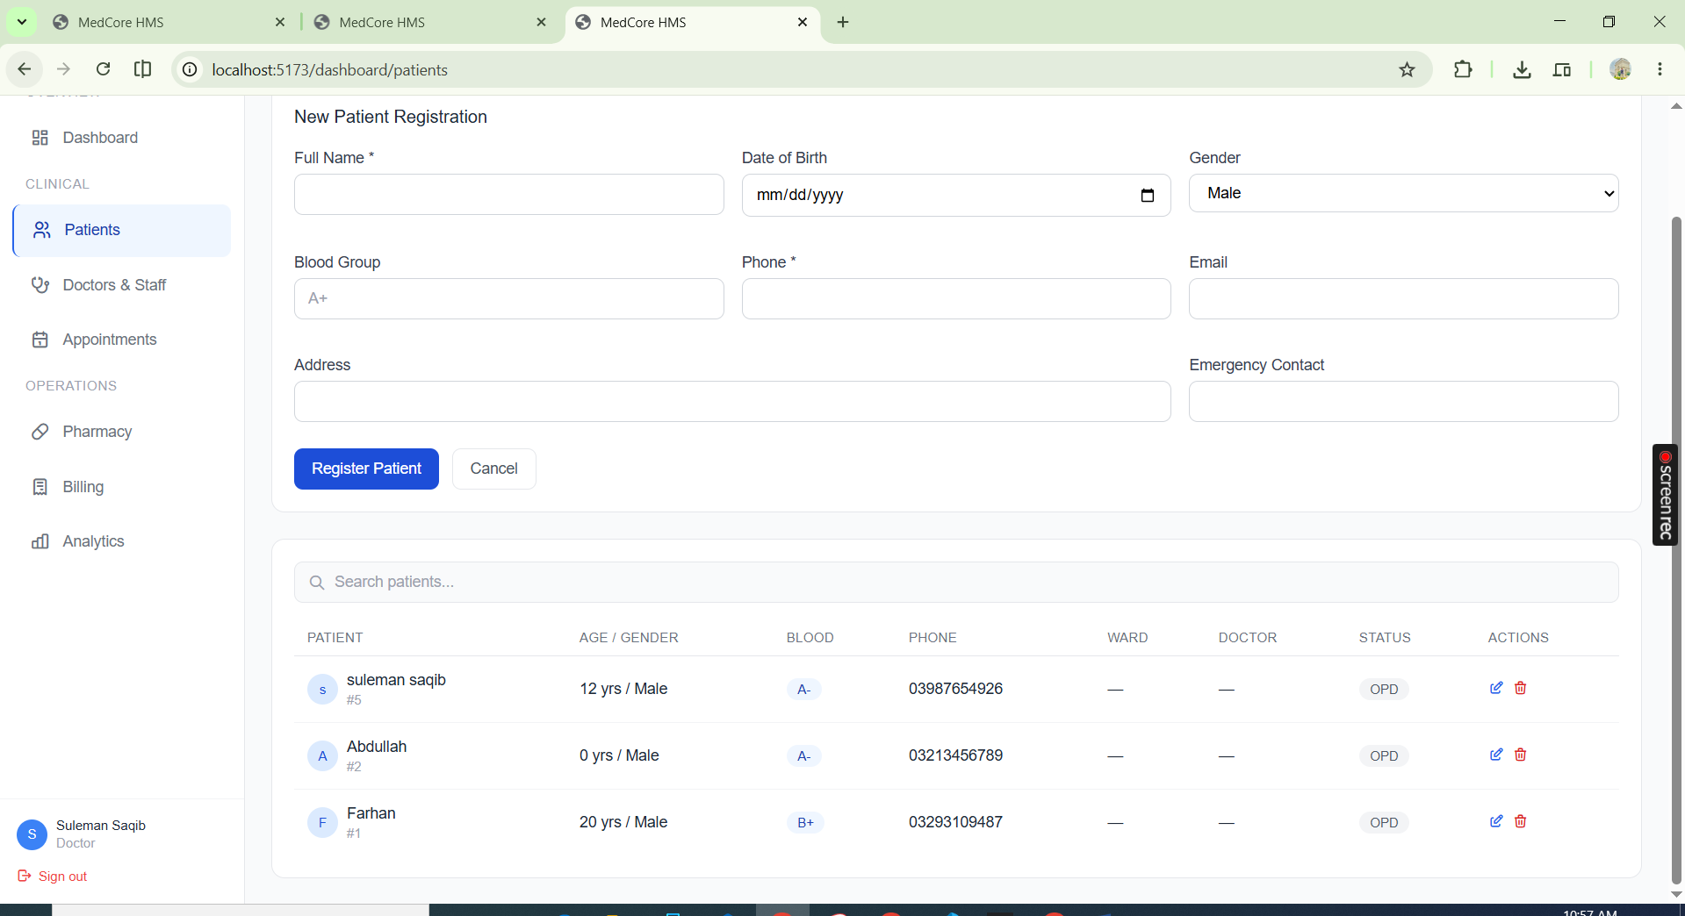
Registration Page
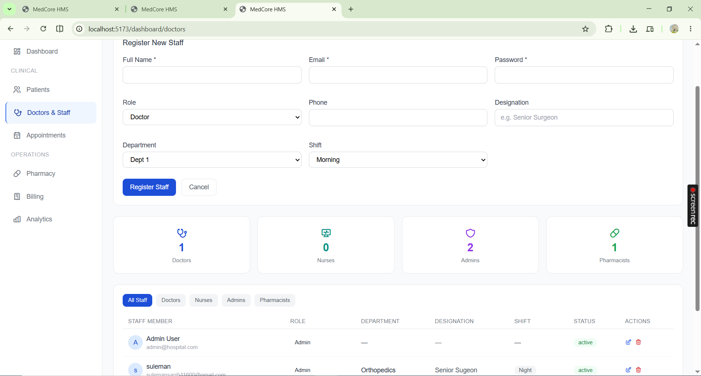

Appointment
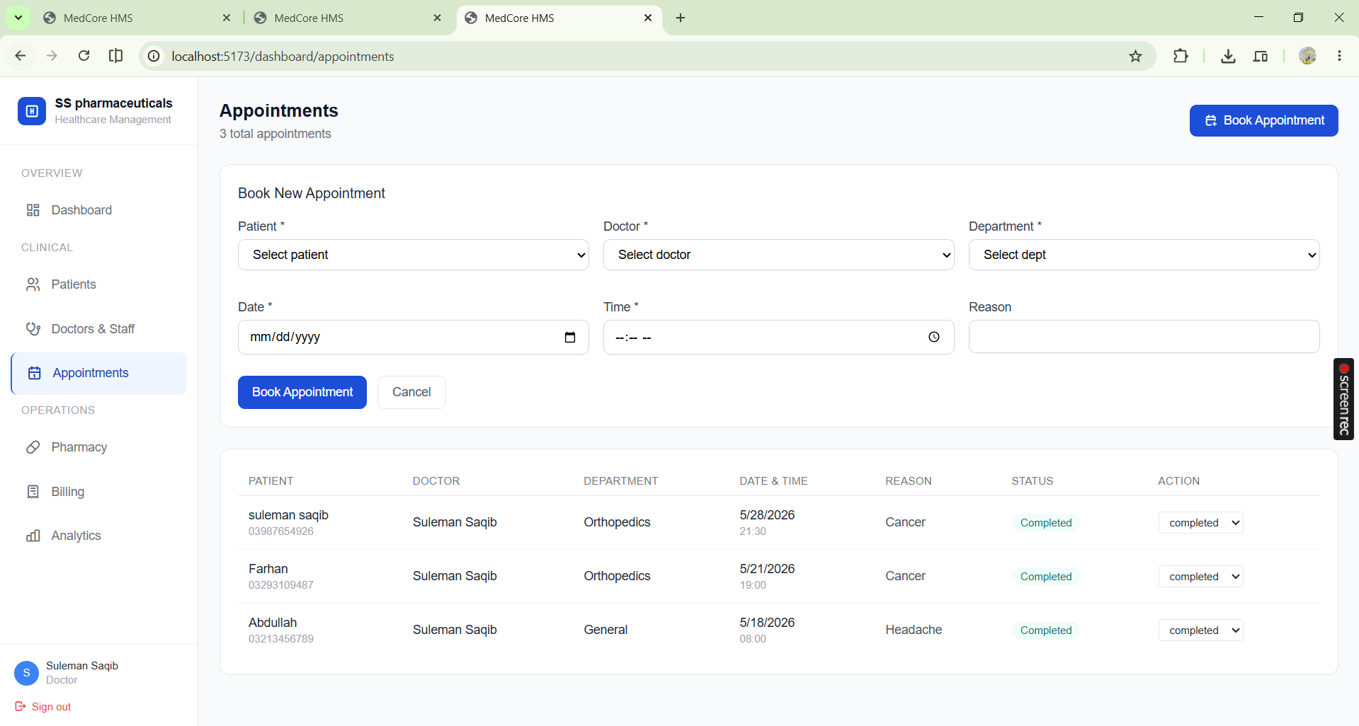
Pharmacy
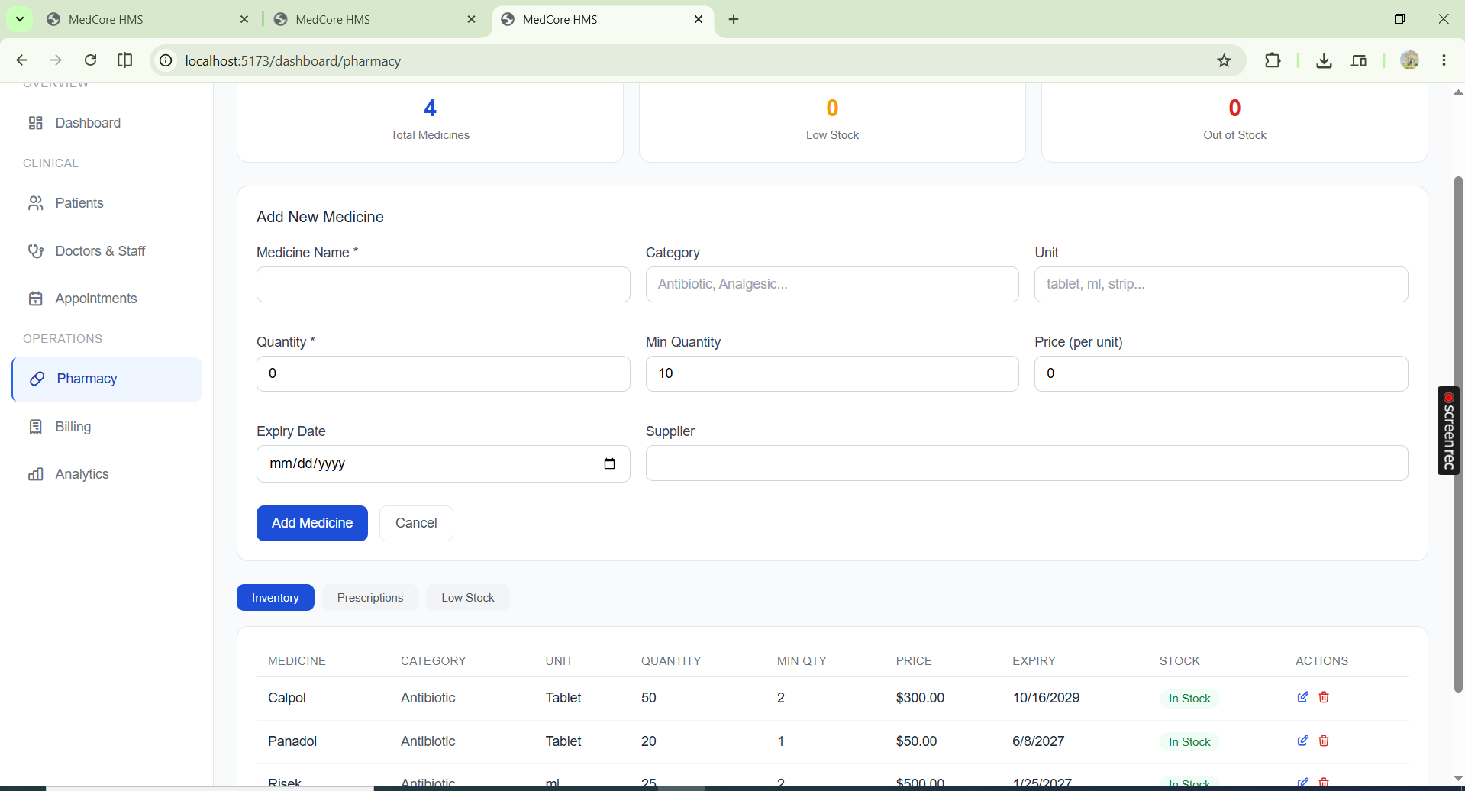

Billing System
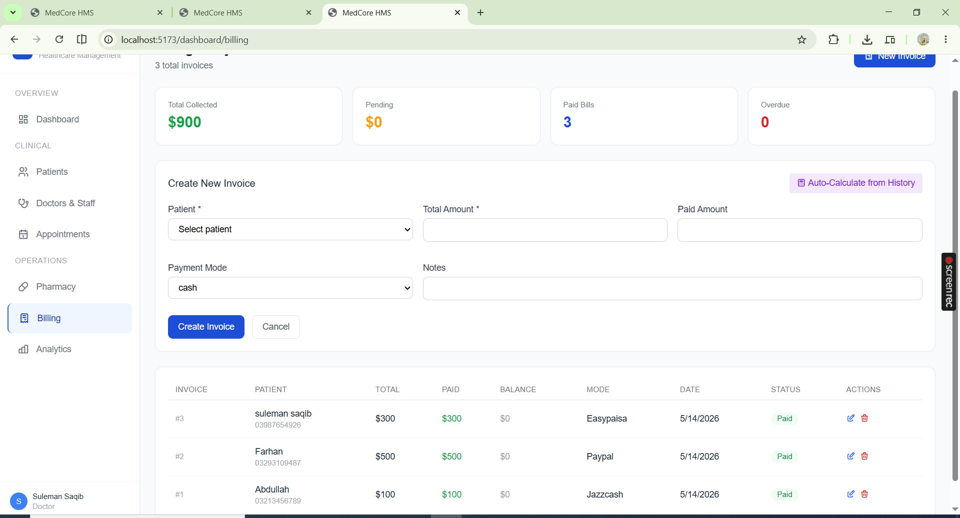

Analytics
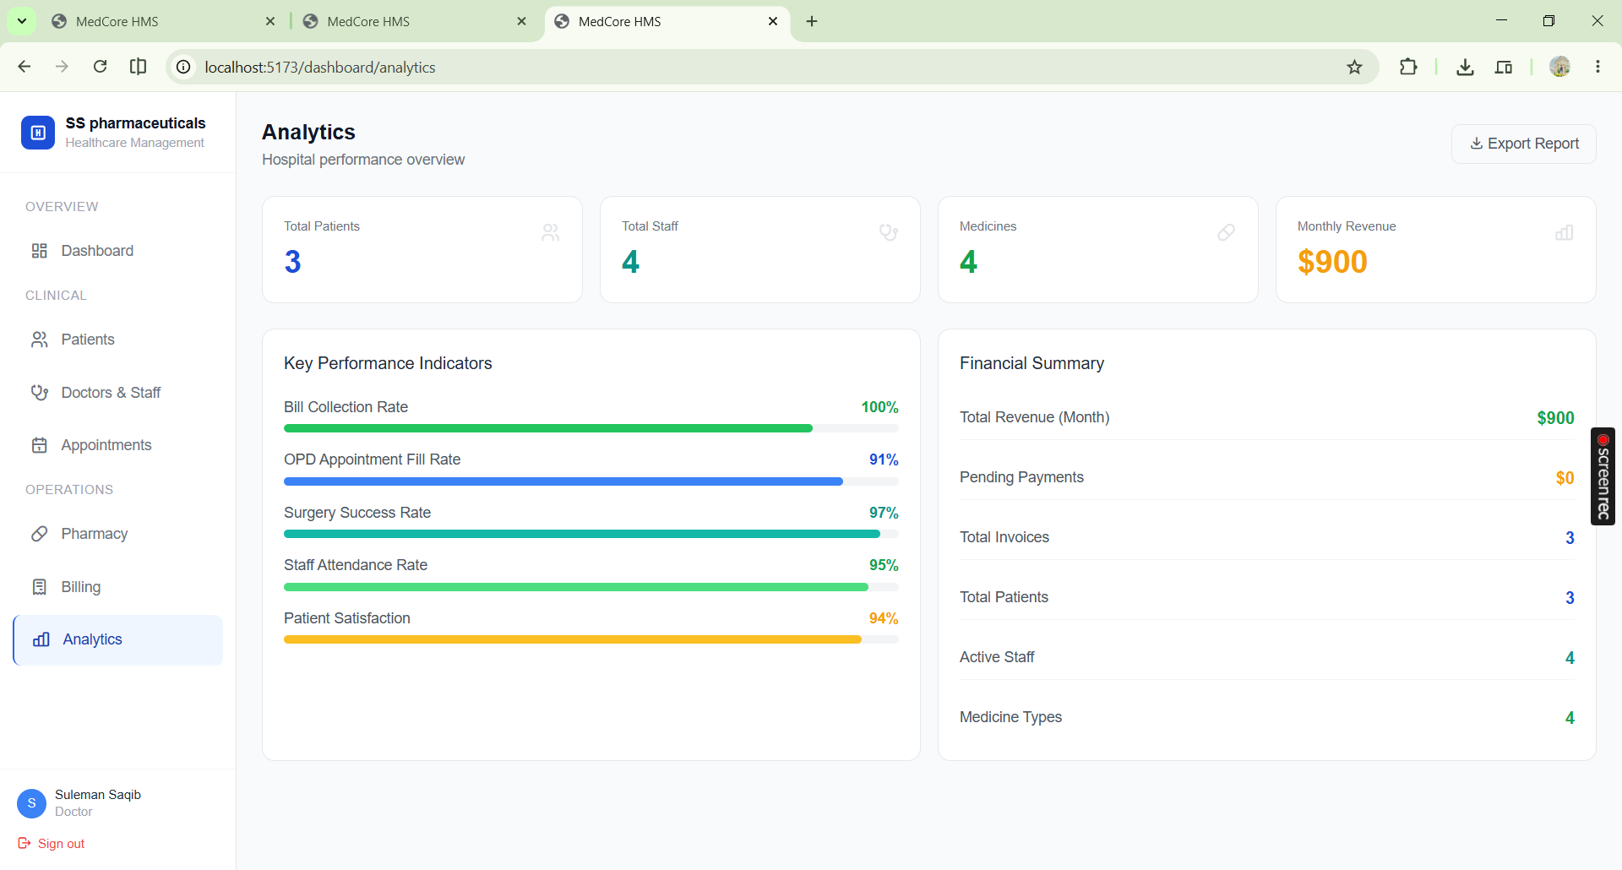
— End of Report —

