
Documentation of Lecture project.
Topic: Notebook e-store website with Laravel
https://github.com/Suleyman001/LaravelProject
Subject: Web Programming II

Members of project:
SULEYMAN Jumaniyazov EG6X6K
ALBERTO Balazs Sandor NKNHIK

Academic Year: 2024-2025
John Von Neumann University

Introduction with Thanks

We are immensely grateful to the divine presence that has granted me the fortitude, vitality, and determination to accomplish this endeavor.
Our heartfelt gratitude extends to my beloved family members whose unwavering support and various forms of assistance have propelled me to this juncture of our educational journey.
We extend our sincere appreciation to Dr. Subecz Zoltan, our esteemed supervisor, whose invaluable guidance, insightful feedback, and unwavering encouragement have been instrumental in bringing this project to fruition.
We express profound gratitude to the esteemed members of the evaluation committee for graciously agreeing to assess our work.
Lastly, We extend heartfelt thanks to all the educators who have imparted their knowledge and wisdom, as well as to all individuals who have supported and assisted us throughout my academic and professional pursuits.

Catalog
THANKS 2
INSTRUCTION 4
1) Description : 5
2) Download 5
3) Then opening application after successful installation and creating out entity 6
Chapter II : Analysis and presentation of the subject 7
1) Analysis of the project : 7
CHAPTER III: conception 9
1) Introduction : 9
2) UML : 9
3) Conclusion 13
CHAPITRE IV : Implementation 13
1) Introduction : 14
2) Application Presentation : 14
Conclusion 26
WEBOGRAPHIE 28

INSTRUCTION

- Create a spectacular responsive website for your chosen topic. Use the principles of Dynamic layout design for your pages.
- Use Authentication: Registration, Login, Logout. Use at least 3-level user system with roles: „guest”, „logged-in user”, „admin”, some menu elements are visible for all users, some only for logged-in users and some only for admins.
- Create a CRUD application on the site. Everybody can see all contents. The logged-in user can modify and delete only his/her own contents. The admin can modify and delete all contents.
- Create a page with a form where the user can retrieve data from the database. Use textboxes, dropdown list and Radio buttons on the form. Use all tables in the database for the queries.
- Create a page with a form where the user can add new data to one of the tables in the database. Use server side validation for the form.
- Create a page with a graph, based on the database. Use https://www.chartjs.org/ for the graph.
- Upload the application to an Internet hosting site. Choose an Internet service provider where you can select a PHP version for the version of Laravel application. Or choose Laravel version for the PHP version on your internet site. Or choose a Laravel deployment platform.
- Use the GitHub (github.com) version tracking system. Upload not only the finished application in one step, but also the sub-states in at least 5 steps per person.
- Use the project work method on GitHub.

INTRODUCTION

Project Overview
A comprehensive Laravel web application for notebook inventory management with multi-level user authentication and role-based access control.

Development Stages

1. Project Initialization
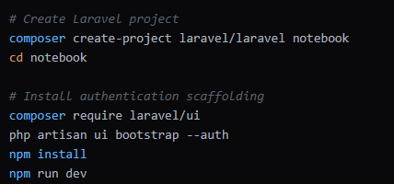

2. Database Design
- Design database schema:
  - Users table
  - Notebooks table
  - Processors table
  - Operating Systems table

- Create migrations
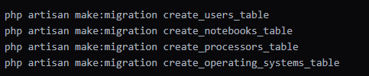

3. User Authentication & Roles
- Update User Model
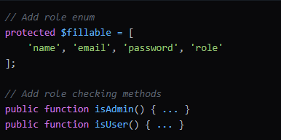

- Modify Registration
- Add role selection in registration form
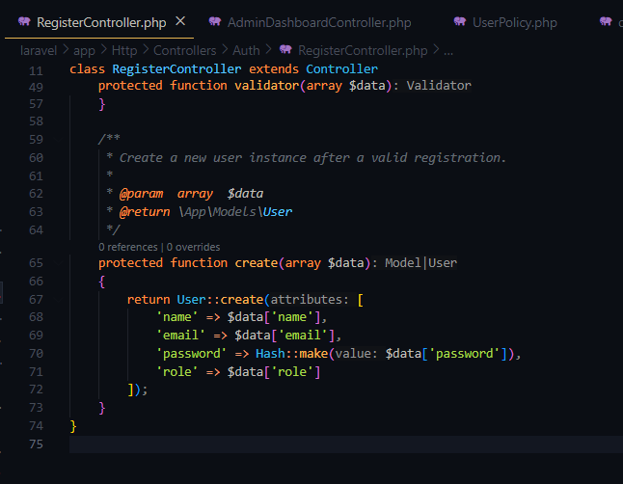
- Update RegisterController to handle role selection

4. Middleware & Authorization
- Create Role Middleware
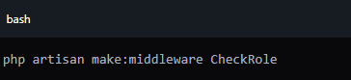
- Register Middleware in Kernel
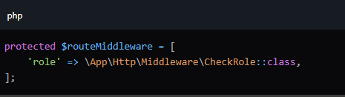

- Implement Role-Based Route Protection

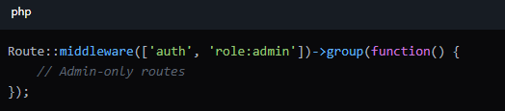

5. Models & Relationships
- Define Notebook Model Relationships

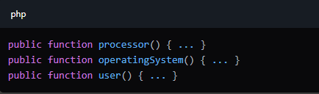

6. Controllers Development

- Index method with filtering
- CRUD functionalities
- Role-based access control

Notebook Controller
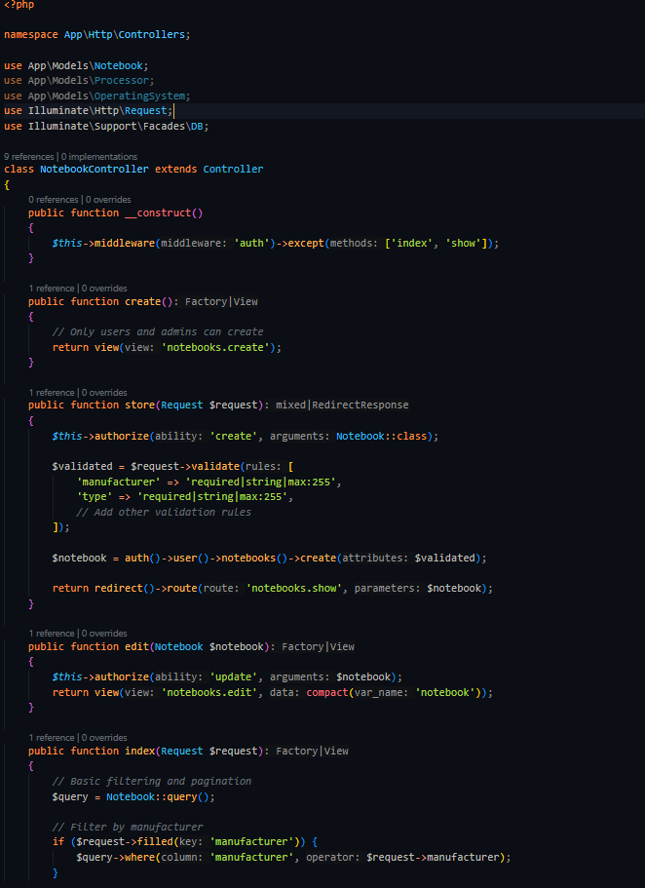
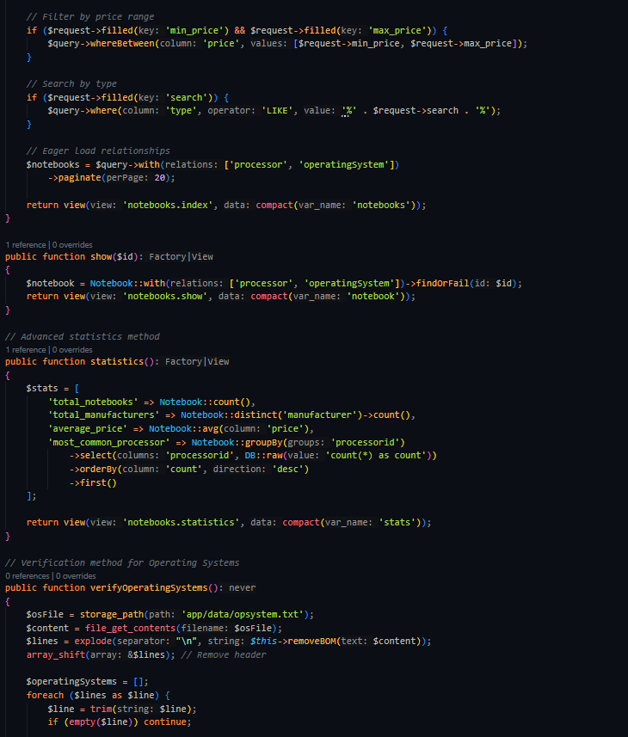
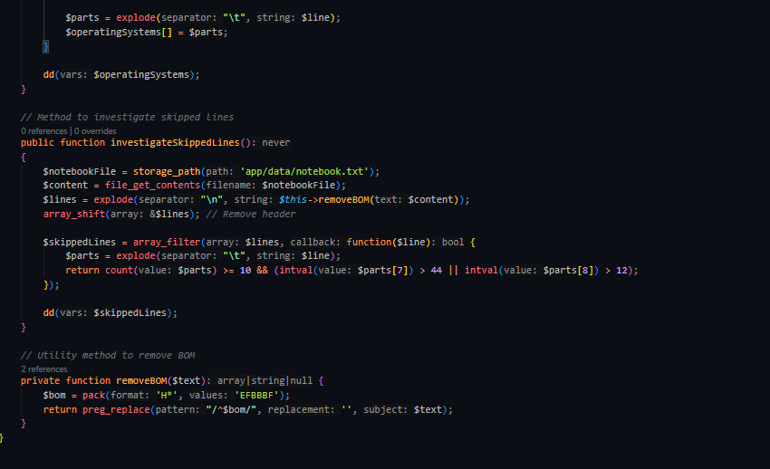
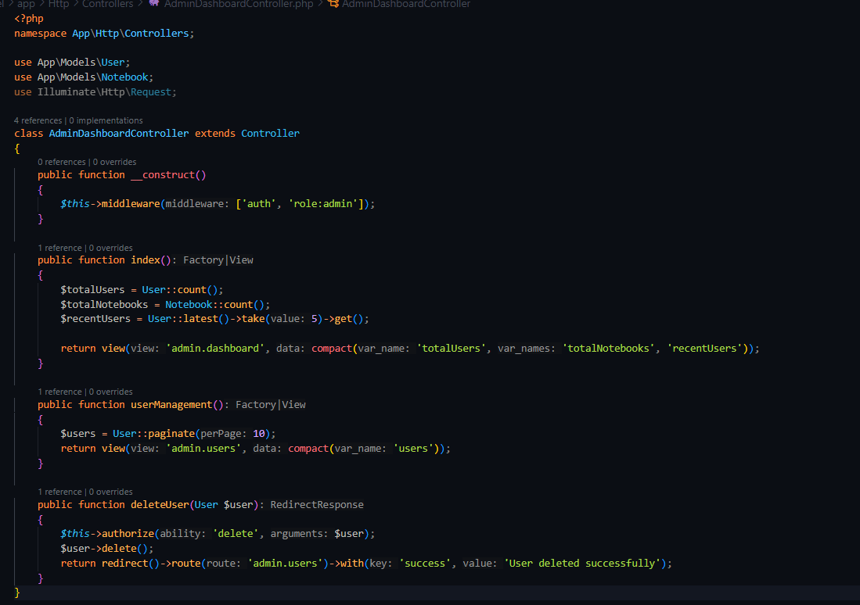
- AdminDashboardController
7. Views Creation
- Notebook Views
- Index (list notebooks)
- Show (notebook details)
- Create/Edit forms
- Admin Views
- Dashboard
- User management
- Role-based navigation
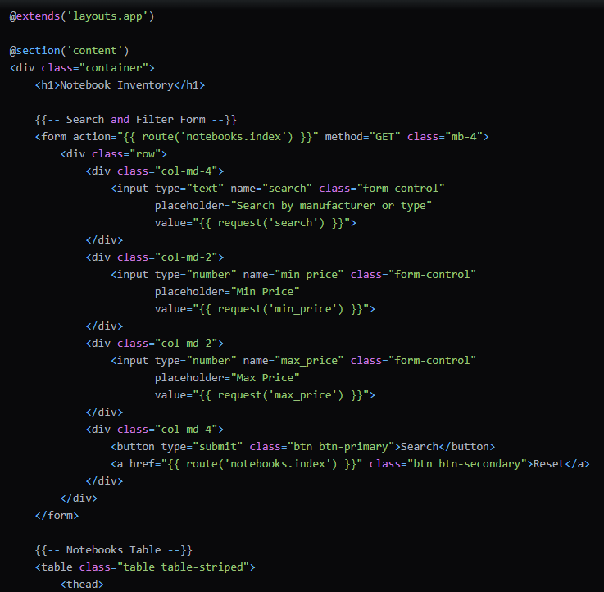
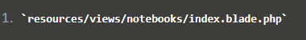
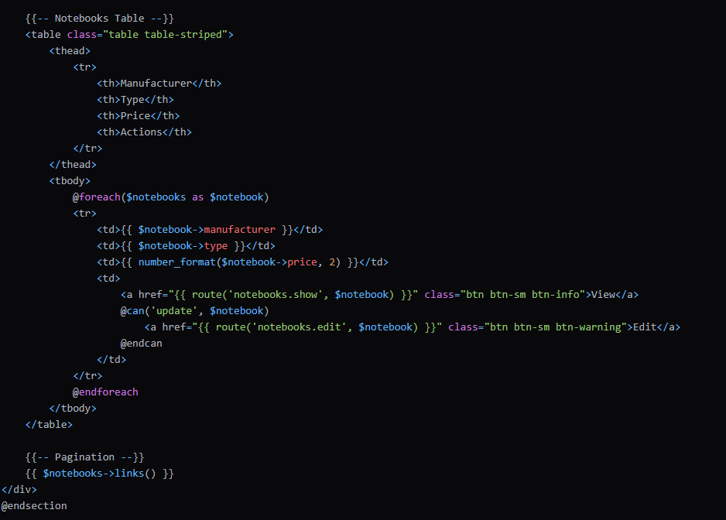
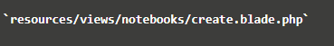
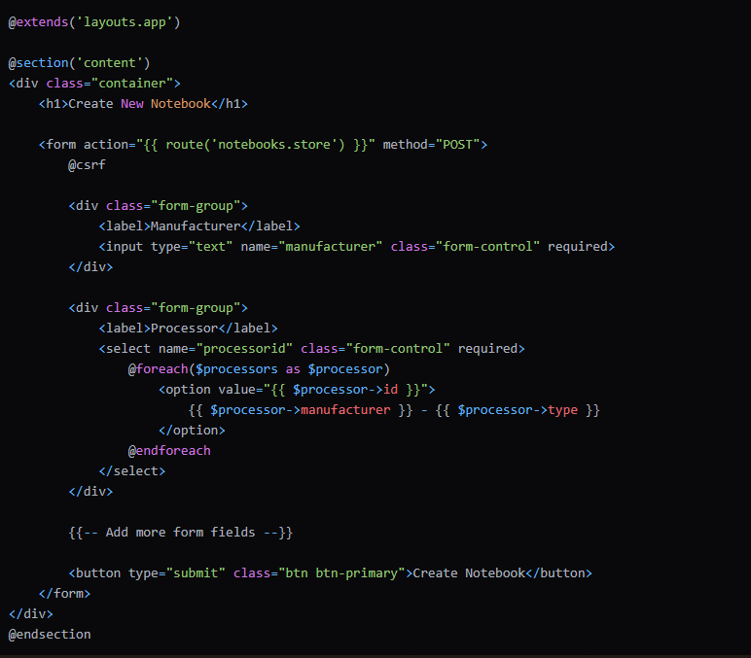
Admin Views
resources/views/admin/dashboard.blade.php

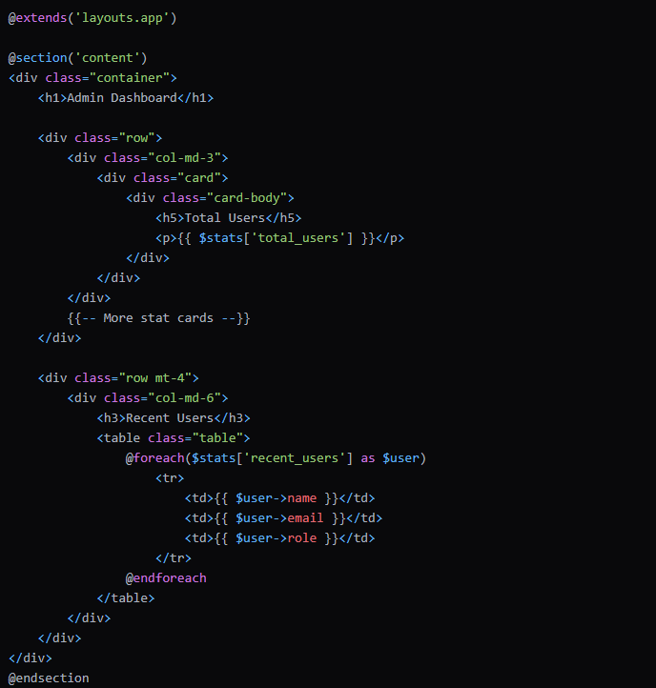

8. Seeding Initial Data
- Create DatabaseSeeder
- Import processors
- Import operating systems
- Import notebooks
- Create initial users
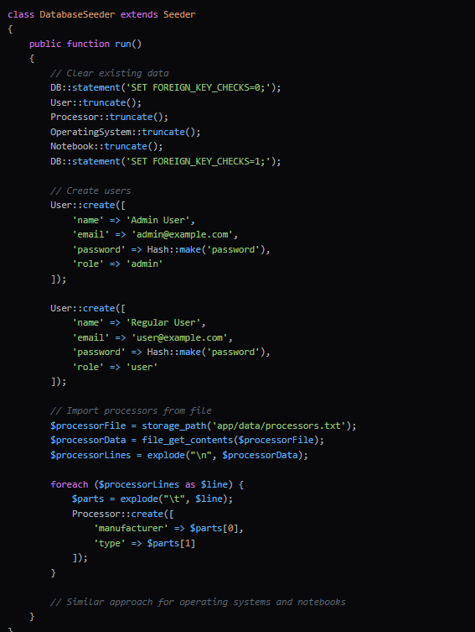

9. Authentication Flow
- User Registration
- Select role (guest/user/admin)
- Create user account
Registration Controller (app/Http/Controllers/Auth/RegisterController.php)

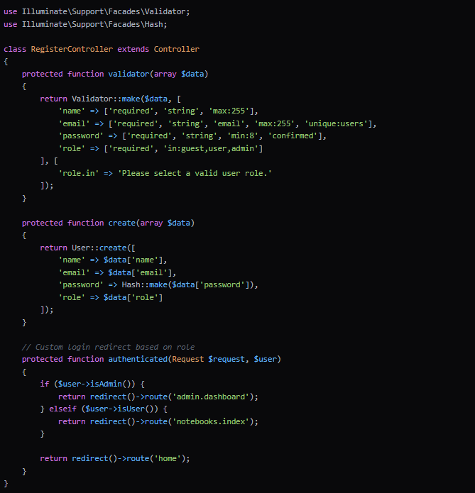

- Login
- Authenticate user
- Redirect based on role
- Apply access restrictions

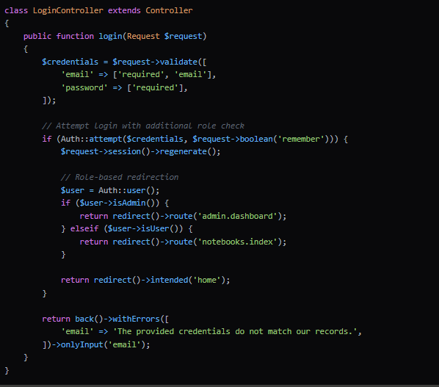

10. Route Configuration
- Public Routes
- Notebook listing
- Statistics
- Home page
- Authenticated Routes
- Create/Edit notebooks
- Admin dashboard
- User-specific actions

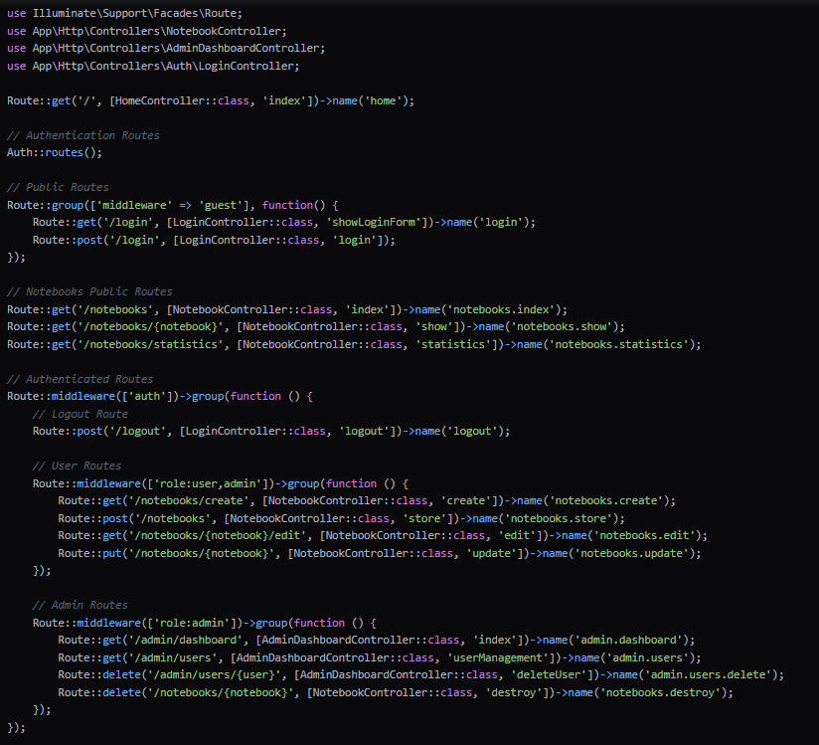

11. Security Implementations
- Policy Creation

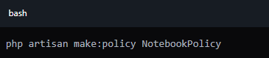

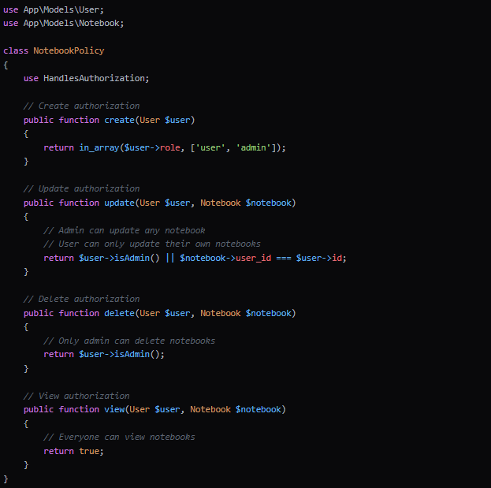

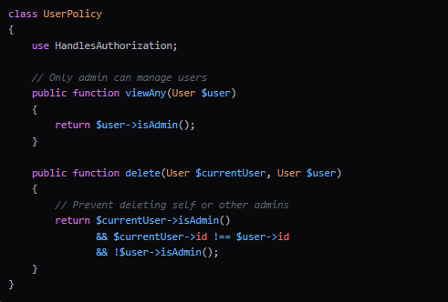

- Authorization Checks
- Notebook creation
- Editing
- Deletion
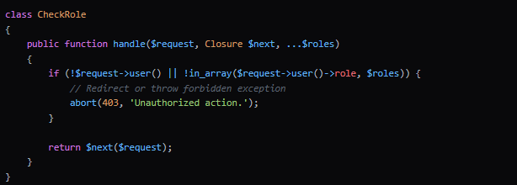

12. Additional Features
- Search functionality
- Price filtering
- Pagination
- Role-based navigation

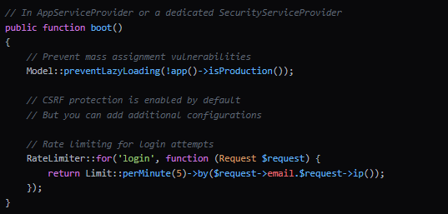

Thanks for attention

