Infosys Springboard Virtual Internship 6.0
Completion Report

Team details
Team A consisting of 6 members
Batch Number : 13
Start date: 2 February 2026
Name: Sulfa Saji
Internship Duration: 8 Weeks

Roles Assigned:
- System Design and Planning
- Zone Detection and Interface Development
- Tracking and Simulation Logic
- Data Logging and Analysis
- Alert System and Reporting
Collaboration:
Worked as a team to design, develop, test, and integrate all modules of the project.

1. Project Title

CrowdCount: People Counting Using Video Analytics

2. Project Objective
The main objective of this project is to develop an AI-powered system capable of tracking and counting people in real-time using visual data from surveillance sources such as CCTV cameras and video feeds. The project aims to monitor crowd density within user-defined zones to identify potential overcrowding incidents and generate automated alerts. It also focuses on creating a reliable reporting mechanism that logs traffic data and captures visual evidence of overcrowding, thereby improving crowd management and public safety.

3. Project description in detail

The CrowdCount Video Analytics System is built using YOLOv8, a real-time object detection algorithm. The project focuses on identifying and tracking people in live surveillance scenarios using an efficient deep learning model.
From the initial stage of development, the YOLOv8 Nano (N) model was selected due to its suitability for real-time applications. It offers faster processing speeds, lower computational requirements, and reliable performance on standard hardware systems.
The Nano model provides an effective balance between speed and accuracy, making it ideal for continuous video analysis and crowd monitoring tasks.
The final system uses the YOLOv8 Nano model for real-time crowd monitoring across user defined zones. When the number of people exceeds the defined overcrowding limit in any zone:

- A screenshot is automatically captured
- Crowd movement details are continuously recorded
- An analytical report is generated including:
o Total visitors across all zones
o Peak crowd time and count
o Identification of the most crowdedzone
A visual alert system triggers real-time on-screen warnings, and the generated logs along with data visualization graphs are stored for security personnel to assist in immediate crowd management and response.

4. Timeline Overview

Week | Activities Planned | Activities Completed
Week 1 | Camera initialization and basic zone drawing implementation | Opened live video feed, implemented mouse-based rectangle drawing, and JSON saving
Week 2 | Advanced zone management and user interface enhancements | Added multi-zone support, zone colors, delete/reset controls, and instruction  overlays
Week 3 | Object detection model setup and initial integration | Integrated YOLOv8n environment, drew bounding boxes, and added total global people count
Week 4 | Unique person tracking and zone-specific counting | Assigned unique IDs, tracked movement, and counted detection centroids within zones
Week 5 | Directional counting and logic refinement | Implemented virtual line crossing for entry/exit tracking and prevented double
 |  | counting
Week 6 | Data logging and alert system development | Saved crowd data to CSV, created live statistics dashboard, and triggered overcrowding alerts
Week 7 | Data analysis, reporting, and visualization | Configured system event logs, generated text reports, and created crowd trend graphs
Week 8 | Final system testing and project completion | Verified tracking accuracy, tested alert triggers, and verified data storage processes

5a. Key Milestones

Milestone | Description | Date Achieved
Project Kickoff | Initialized the CrowdCount project, established live camera feed functionality, and implemented basic interactive zone drawing. | Week 1
Prototype/First Draft | Developed a functional prototype featuring multi-zone management, user interface controls, and basic YOLOv8n people detection. | Week 3
Mid-Term Review | Evaluated real-time per-zone counting, verified unique ID person tracking, and confirmed accurate people counting logic. | Week 5
Final Submission | Delivered the complete system featuring entry/exit analytics, continuous CSV data logging, trend graphs, and automated overcrowding alerts. | Week 8
Presentation | Demonstrated the live monitoring dashboard displaying real-time visual analytics, alert notifications, and exported analytical reports. | Week 8

5b. Project execution details

The execution of the CrowdCount People Counting System was carried out in four progressive, modular phases to ensure a structured integration of the computer vision logic, artificial intelligence models, and data analytics functionalities.
Phase 1: Environment Setup and Core Video Processing (Milestone 1)
The project was initiated by establishing the foundational video processing pipeline using the OpenCV library. A live, continuous camera feed connection was initialized alongside necessary error-handling protocols to prevent crashes upon hardware failures. During this phase, custom mouse callback functions were developed, allowing users to interactively draw rectangular bounding areas directly over the live video. A backend JSON-storage mechanism (zones.json) was implemented to record these coordinates, ensuring that drawn zones persisted automatically across application restarts.
Phase 2: Multi-Zone Management and User Interface Development (Milestone 2)
Once basic video processing was achieved, the system was expanded to support dynamic multizone management. An array of predefined colors was configured so that every newly drawn zone was distinctly identifiable by color, alongside custom text labels (e.g., "Zone 1", "Zone 2"). The user interface (UI) was significantly enhanced with an instruction overlay and dedicated keyboard listener events. This provided administrators with hotkeys to delete specific or recent zones, clear the screen, toggle full-screen mode, and seamlessly capture manual screenshots. File-saving reliability was also reinforced by integrating Python’s atexit module, guaranteeing that all zone layouts were automatically saved to the JSON file before closing.
Phase 3: AI Model Integration and Unique Identity Tracking (Milestone 3)
With the visual layout fully functional, the artificial intelligence engine was integrated. The system utilized the highly efficient Ultralytics YOLOv8 Nano (YOLOv8n) model to perform high-speed, real-time people detection.The counting algorithm was engineered by calculating the centroid (center X, Y coordinates) of every generated bounding box. The script mathematically verified whether these centroids fell inside the user-defined rectangular zones. To prevent the system from double-counting stationary individuals, standard detection was upgraded to unique identity tracking. The AI assigned a continuous ID to every detected person, while a virtual bisecting line was programmed into each zone. By cross-referencing a tracked ID's position against this virtual line, the system reliably recorded precise "Entry" and "Exit" movements rather than static frame counts.
Phase 4: Dashboard Analytics, Overcrowding Alerts, and Data Logging (Milestone 4)
The final execution phase involved transforming the live data into actionable intelligence. A realtime dashboard panel was coded to overlay active system tallies—including total global limits, zone-specific entries, and active inhabitants—directly onto the video feed. A local database was configured to continuously append timestamped tracking records into a CSV file (count_data.csv).To ensure safety and immediate crowd response, a logical overcrowding threshold was embedded into the system. Whenever the active person count within a specific zone surpassed the maximum defined limit, the system was programmed to trigger a highvisibility, red text warning on the video stream and trigger an automatic screenshot capture for visual evidence. Finally, an analytical script was developed to comb through the stored CSV database. This script automatically calculated peak crowd times, determined the most heavily trafficked zones, and utilized Matplotlib to generate visual trend graphs and bar charts for security reporting. The execution concluded with rigorous end-to-end system testing validating detection accuracy, tracking stability, and file-saving operations.

6. Snapshots / Screenshots
Milestone 1 Screenshot
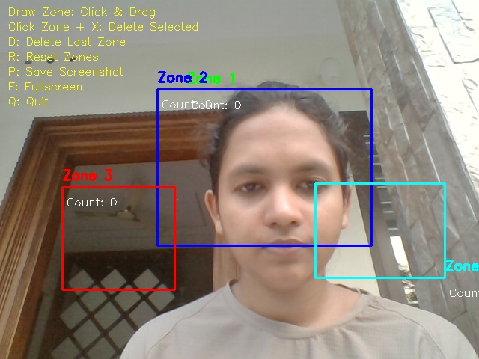
Milestone 2 Screenshot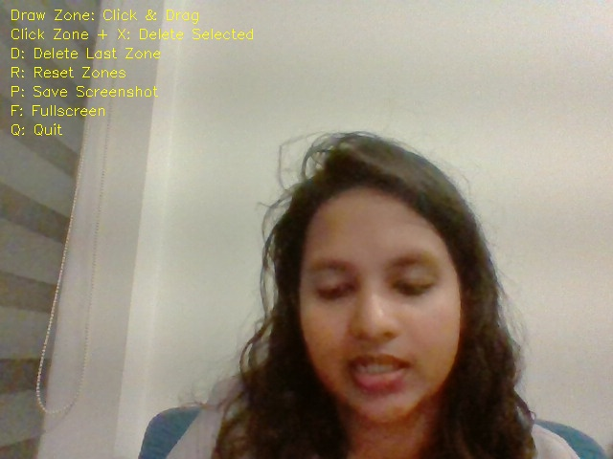
Milestone 3 Screenshot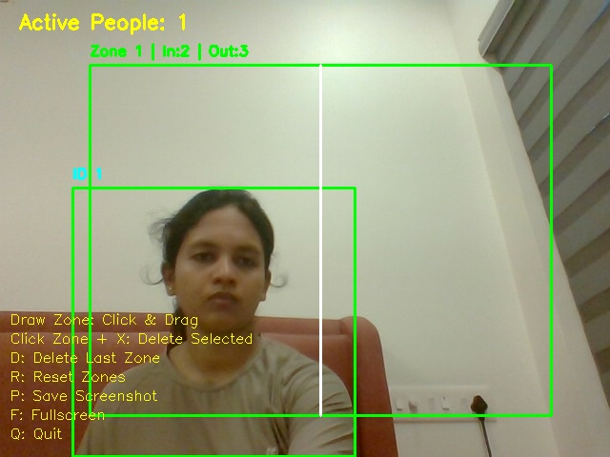
Milestone 4 Screenshot
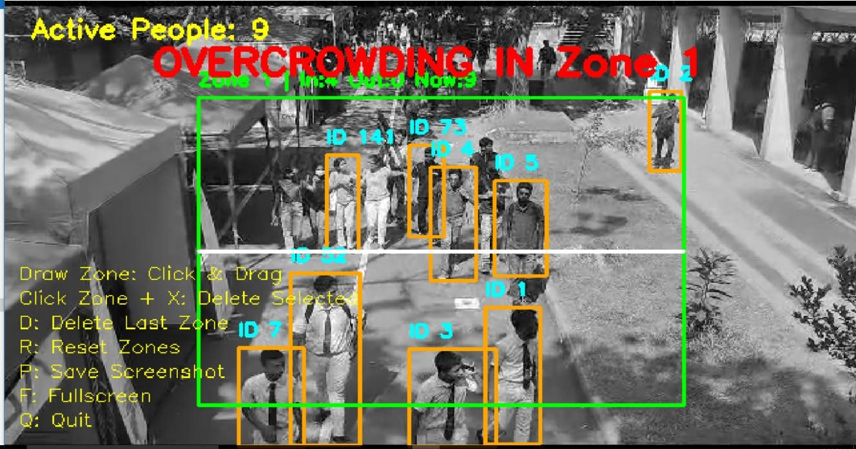

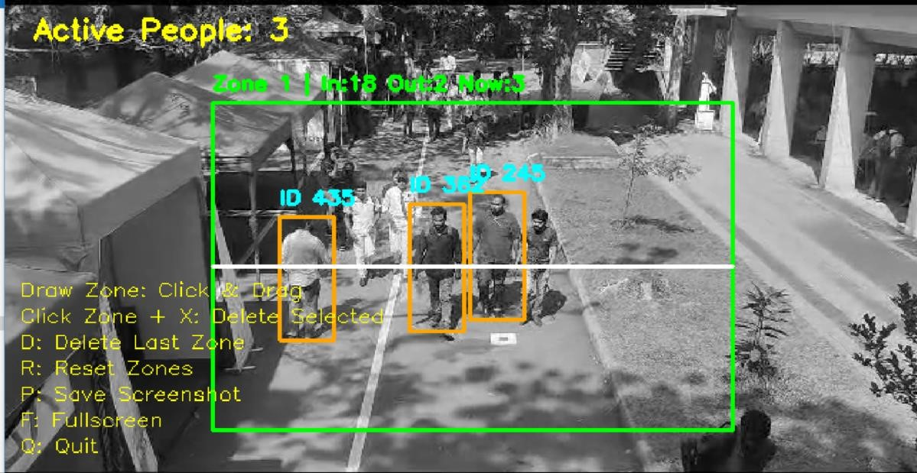

7. Challenges Faced

- Double Counting and ID Stability (Technical)
Challenge: The system initially over-counted people by detecting the same stationary individual in every frame, and fast-moving dense crowds occasionally caused tracking IDs to switch or drop.
Resolution: Solved by implementing YOLOv8 unique tracking (persist=True) and programming a virtual crossing line inside each zone. People are now only logged as an 'Entry' or 'Exit' upon physically crossing the line.
- Real-Time Processing Performance (Technical)
Challenge: Running complex computer vision analysis alongside live video rendering caused significant frame drops and lag on standard CPU hardware.
Resolution: Optimized the system by utilizing the highly efficient YOLOv8 Nano (yolov8n.pt) model, which balances maximum processing speed with lower computational requirements.
- Lighting and Camera Angle Reliability (Technical)
Challenge: Variable environmental lighting and poor camera perspectives caused detection confidence to fluctuate, leading to brief undetected moments or false positives.
Resolution: Fixed by tuning the AI confidence threshold to 0.5 and filtering detections strictly to the "human" class (cls == 0), eliminating false positives while maximizing detection accuracy.
- Data Loss and Workflow Interruptions (Operational)
Challenge: During live testing, stopping and restarting the camera program erased all user-drawn analytical zones, requiring tedious manual setup on every reboot.
Resolution: Prevented data loss by integrating an auto-save script (atexit) that instantly records all zone coordinates into a persistent JSON database the moment the application closes.

8. Learnings & Skills Acquired
- Learned object detection using YOLOv8
- Worked with OpenCV for real-time video processing
- Implemented tracking and centroid-based counting
- Used JSON and CSV for data storage
- Created graphs using Matplotlib
- Improved debugging and problem-solving skills
- Gained experience in real-time system design

9. Testimonials from team
During the internship, I actively contributed to the development of a crowd monitoring system by working on key modules including zone detection, tracking simulation, and alert generation. I consistently completed my assigned tasks within deadlines and demonstrated steady improvement in both my technical knowledge and practical implementation skills.
A key strength of mine was the ability to identify issues in tracking and counting logic and enhance the system to achieve more accurate and reliable results. I also successfully integrated various components into a fully functional system, showcasing my capability in handling end-to-end development.
This internship provided me with valuable hands-on experience in computer vision applications and strengthened my confidence in addressing real-world problems through programming and analytical thinking.

10. Conclusion
CrowdCount demonstrates the practical application of deep learning and computer vision for intelligent people counting. By combining YOLOv8 detection with ByteTrack multi-object tracking and zone-based directional logic, the system provides accurate and structured real-time analytics.
The system also incorporates crowd analytics, visualization, and overcrowding alert mechanisms, making it suitable for real-world monitoring applications. The modular design allows future scalability into a full surveillance and crowd intelligence platform.

The internship provided valuable hands-on experience in developing a real-time crowd monitoring system using computer vision. It strengthened my understanding of video processing, tracking logic, and system integration while working on a complete end-to-end project.

It also improved my ability to design, implement, and refine a system based on performance and challenges. Overall, this experience complements my academic studies and has strengthened my interest in areas like computer vision and data analytics, equipping me for future technical career opportunities.

11. Acknowledgements
I would like to sincerely thank Infosys Springboard for providing me with this valuable internship opportunity and a platform to explore real-world applications of AI and computer vision.
I am deeply grateful to my mentor for their continuous guidance, technical support, and encouragement throughout the internship. Their insights played a crucial role in helping me understand complex concepts and successfully complete the project.
I would also like to thank my team members for their cooperation, teamwork, and shared efforts in overcoming challenges and achieving our project goals.
This internship has been a great learning experience, and I truly appreciate the support and resources provided throughout this journey.

