Amazon Product Sentiment Analysis
Author ShihabBattah, Author SuliemanAlwardat , Author HamzaAlkaabneh
College of Computer and Information Technology , JUST, Jordan
Email: [sralbattah , hmalkaabneh , sjhamidalwardat ] 23@cit.just.edu.jo

Abstract—
The paper aims to assess various methods and models used for classifying consumer sentiment as positive, negative, or neutral, emphasizing the role of deep learning algorithms and pretrained word embedding’s.
Sentiment analysis is a classification process whereby machine learning techniques are applied on text-driven datasets to analyze its sentiment, a message being positive or negative about a certain topic.

Keywords—
MachineLearning , Sentiment Analysis , Amazon , User reviews , Natural Language Processing.

I. Introduction
As customers usually want the best quality for the lowest price but can’t directly check it, reviews from other customers seem to be the most reliable way to decide whether to buy the product or not.
Product Feedback for Improvement Customer reviews offer vital information that can help businesses to enhance their offerings. By attentively examining both good and negative comments, companies might identify reoccurring problems that might demand action[1].
By giving customers knowledge of product quality and performance, customer reviews are essential for e-commerce. Reviews are a reliable source in the lack of actual contact with items, allowing possible purchasers to decide wisely depending on the experiences of prior consumers[1].
The Amazon Product Reviews dataset has significant real-world relevance due to its massive scale and comprehensive coverage of consumer sentiment and product-related information.
Understanding customer behavior and product performance at scale , Knowledge Gaps Lack of experience towards Sentiment Analysis Techniques.

The Goal of this paper is to Use Sentiment Analysis for predicting whether the review is positive , neutral or negative and to determine the percent of the product reviews whether it will be listed as useful or not.

II. Related Work
Bedoriya, R., & Banerjee, S [1] Used Techniques such Term Frequency-Inverse Document Frequency (TF-IDF), Word2Vec, and contextual embeddings such as BERT convert the text data into numerical representations
Dadhich/2021[1] BERT outperforms other models in sentiment classification for reviews.
Sanjay/2020 [1] Naive Bayes and SVM show different effectiveness in sentiment classification.
[2] LSTM networks are very suitable for classification of the sentiment on product reviews. These results do not depend on the type of product where the reviews are given to
Wassan et al. (2021)[4], Sultan (2022)[8], and bin Harunasir et al (2023)[9] all investigated the effectiveness of various ML techniques for Amazon product sentiment analysis, demonstrating the continuous utility and optimization of models like Naive Bayes (NB), Support Vector Machines (SVM), and Random Forest.
Dey S (2020)[5] performed a direct comparative study between the Support Vector Machine and Naive Bayes classifier specifically for sentiment analysis on Amazon product reviews, a common approach to benchmark established classification algorithms.
Maurya and Pratap (2022)[10] also contributed to this area by applying and comparing multiple SML algorithms to the Amazon review dataset.
Wang (2024)[14] proposed a fusion approach by integrating Word2vec embeddings with the SVM classifier, showcasing a strategy to enhance classification performance by improving the feature representation of the text data.
Shrestha and Nasoz (2019)[6] were early contributors, applying Deep Learning techniques for sentiment analysis on Amazon reviews and ratings, highlighting the move beyond traditional ML.
Iftikhar et al. (2023)[15] focused on classifying Amazon product reviews using a combination of Machine Learning, Deep Learning methods, and the highly effective pre-trained model, BERT (Bidirectional Encoder Representations from Transformers).
Shaik Vadla et al (2024)[13] employed an AI-driven sentiment analysis approach utilizing BERT to enhance product design, demonstrating the practical application and high performance of this transformer model.

III. Dataset Description and Statistical Analysis
- Total Records: 568k+
Total Columns: 10
Numerical , Text , Time , Rating

- 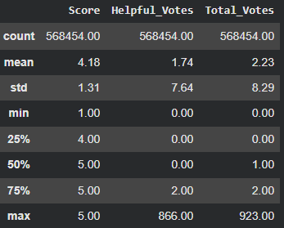
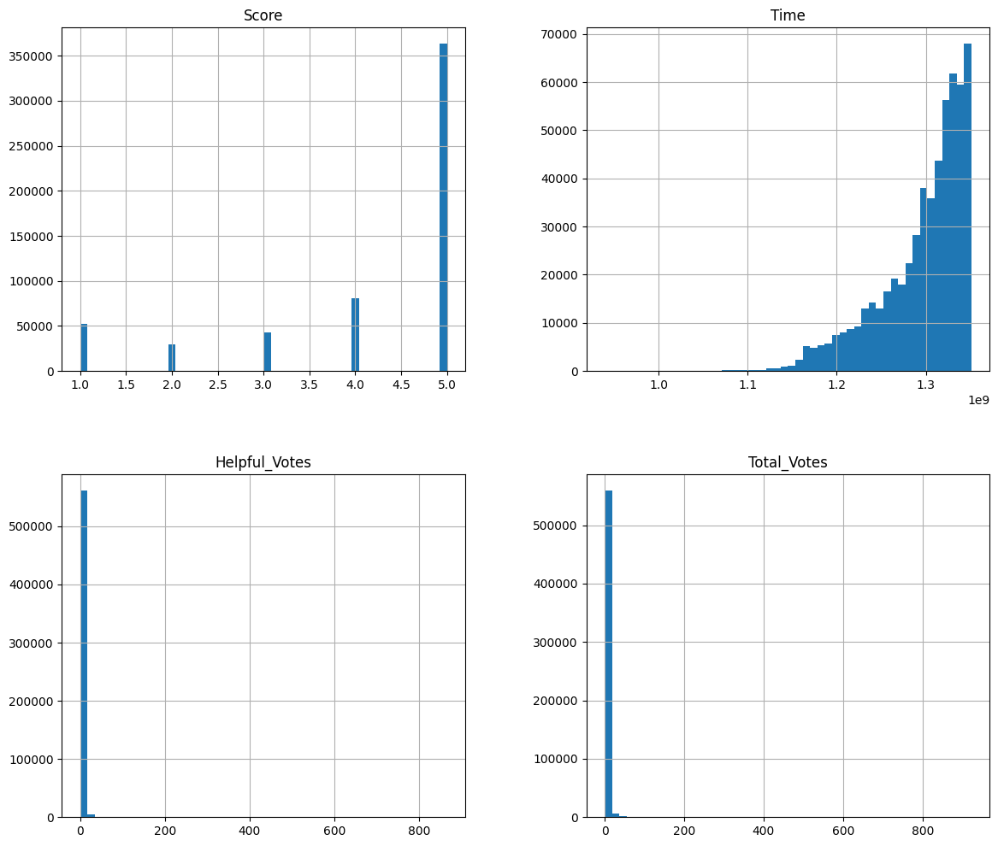

IV. Methodology
- Data Preprocessing
Issue Type | Feature(s) | Description | Evidence (count/%)
Missing Values | ProfileName , Summary | 0.00457% missing in ProfileName  0.00475% missing in Summary | 26 out of 568454 in Profile Name  27 out of 568454 in Summary
Outliers | Helpful_Votes ,Total_Votes | Extreme right tail, IQR = 2 | Helpful_Votes 37002 suspected  Total_Votes 52643 suspected
Duplicates | All features | Repeated rows in transactions table | ZERO

- Handling Missing Values : Deletion because , there is small percentage of missing values.
- Encoding Categorical Variables : No categorical variables to be encoded.
- Outlier Treatment : We detect outliers using 2 methods : boxplot , IQR Rule by using IQR Rule we got a precise conclusion about the outliers.
We left the outliers because , the values of them represent a real values based on people reviews and the logic of the outliers doesn’t work on these features cause it is consider as a count features.
- Preprocessing and cleaning the text: We started by setting all of the texts to lowercase. After that, we started normalizing the repeated characters in a word (e.g., gooood->good), then we removed all of the special characters and websites that are in the text after that we removed the stopwords from the text using the NLTK library and tokenized them by creating two lists:
1-tokens(list of lists): it contains nested lists where each inner list represents a single review and it has every word(token) in it as a single string value
2-clean_text: every single value in it represents the tokens for a single review rejoined together with spaces
After that we performed lemmatization for each token using SpaCy as we found it to be having a better efficiency than the WordNetLemmatizer as it struggled to accurately determine the lemma when the Part-of-Speech (POS) tag (noun, verb, adjective, etc.) was not explicitly provided.

V. Model Implementation
After processing the data to the models we apply two models to classify the reviews as one of three classes :- ( 1 for Positive , 0 for Neutral , -1 for Negative ) the two models we used are :- ( BERT and LSTM ) , each model needed a special preprocessing for LSTM we pass it a data with sequences of each sentence how many it frequent and for BERT it required a raw data cause the BERT have it’s own processing techniques to build it’s layers.

VI. Evaluation
Performance | LSTM | BERT
Validation Loss | 0.3814
Validation Accuracy | 85.90 %

VII. Discussion
The challenges we faced with our first project within a new field of machine learning ( sentiment analysis) the difference between BERT and LSTM and there capability.

VIII. Conclusion and Future Work

References
- Bedoriya, R., & Banerjee, S. (2025). A Review on Sentiment Classification of Amazon Product Review dataset using NLP technique. International Journal of Advanced Research and Multidisciplinary Trends (IJARMT), 2(1), 654-669.‏
- Güner, L., Coyne, E., & Smit, J. (2019). Sentiment analysis for amazon. com reviews. Big Data in Media Technology (DM2583) KTH Royal Institute of Technology, 9.
- Chen, M., & Sun, Y. (2017). Sentimental Analysis with Amazon Review Data.
- Wassan, S., Chen, X., Shen, T., Waqar, M., & Jhanjhi, N. Z. (2021). Amazon product sentiment analysis using machine learning techniques. Revista Argentina de Clínica Psicológica, 30(1), 695.‏
- Dey, S., Wasif, S., Tonmoy, D. S., Sultana, S., Sarkar, J., & Dey, M. (2020, February). A comparative study of support vector machine and Naive Bayes classifier for sentiment analysis on Amazon product reviews. In 2020 international conference on contemporary computing and applications (IC3A) (pp. 217-220). IEEE.‏
- Shrestha, N., & Nasoz, F. (2019). Deep learning sentiment analysis of amazon. com reviews and ratings. arXiv preprint arXiv:1904.04096.‏
- Dadhich, A., & Thankachan, B. (2021). Sentiment analysis of amazon product reviews using hybrid rule-based approach. In Smart Systems: Innovations in Computing: Proceedings of SSIC 2021 (pp. 173-193). Singapore: Springer Singapore.
- Sultan, N. (2022). Sentiment analysis of amazon product reviews using supervised machine learning techniques. Knowledge Engineering and Data Science, 5(1), 9.‏
- bin Harunasir, M. F., Palanichamy, N., Haw, S. C., & Ng, K. W. (2023). Sentiment analysis of amazon product reviews by supervised machine learning models. Journal of Advances in Information Technology, 14(4), 857-862.‏
- Maurya, S., & Pratap, V. (2022, May). Sentiment analysis on amazon product reviews. In 2022 international conference on machine learning, big data, cloud and parallel computing (COM-IT-CON) (Vol. 1, pp. 236-240). IEEE.‏
- Sangeetha, J., & Kumaran, U. (2023). Sentiment analysis of amazon user reviews using a hybrid approach. Measurement: Sensors, 27, 100790.‏
- Sjaif, N. N. A. (2022). Sentiment analysis using term based method for customers’ reviews in amazon product. International Journal of Advanced Computer Science and Applications, 13(7).‏
- Shaik Vadla, M. K., Suresh, M. A., & Viswanathan, V. K. (2024). Enhancing product design through AI-driven sentiment analysis of Amazon reviews using BERT. Algorithms, 17(2), 59.‏
- Wang, H. (2024). Word2vec and SVM fusion for advanced sentiment analysis on Amazon reviews. Highlights Sci. Eng. Technol, 85, 743-749.‏
- Iftikhar, S., Alluhaybi, B., Suliman, M., Saeed, A., & Fatima, K. (2023). Amazon products reviews classification based on machine learning, deep learning methods and BERT. TELKOMNIKA (Telecommunication Computing Electronics and Control), 21(5), 1084-1101.‏

