
Computer Information Systems Department
DS330–Deep Learning
First Semester 2025-2026
Instructor: Dr. Amera Al_Amery

Project Title & Category
Multi-Class Animal Classification (e.g., “Predicting The type of animals via image”).
Category examples: Computer Vision , Data Analytics ,Classification, etc.

Team Members
Name  ShihabBattah  SuliemanAlwardat  HamzaAlkaabneh | JUST ID  168257  170096  170985 | Email  Sralbattah23@cit.just.edu.jo  sjhamidalwardat23@cit.just.edu.jo  hmalkaabneh23@cit.just.edu.jo

Problem Statement
We Aim to identify animals by their images. To identify all animals species from other. EDUCATION.

Introduction
The image classification is a wide approach in Machine Learning and it have a lot of uses in life.
In this project we aim to build a model to analyze and identify every possible animal using the Animal Image Dataset from Kaggle with 90 different class and 5400 image a 60 image for each class to build an “Image Classifier Model”.

Related Work
ResNets and VGG-16 are two ultra-fine CNN architectures that showed excellent performance in image classification and are able to generalize well to input datasets.[2]
On VGG19, GoogLeNet (InceptionV3), ResNet50, and DenseNet121, we used transfer learning. The best multi-classification accuracy was attained by GoogLeNet (87%), followed by ResNet50 (83%), DenseNet (81%), and VGG19 (53%). This evidence suggests that transfer learning outperforms training models from scratch for this task.[1]
Image classification technology has a wide range of applicationscenarios and is also a key research direction in the field of machinelearning. With the emergence of a large number of excellent deep convolutional neural networks such as GoogLeNet , VGGNet and ResNet
Image classification technology has a wide range of application scenarios and is also a key research direction in the field of machinelearning. With the emergence of a large number of excellent deepconvolutional neural networks such as GoogLeNet [1], VGGNet[2],and ResNet[3]

Dataset
Animals Images Dataset from Kaggle with 90 class , 5400 image JPG formatted and 60 image for each animal , remove misleading images that may corrupt the model and duplicated images.

Methods or Algorithms
Resizing all images to a uniform dimension to be compatible with transfer learning
Normalizing pixel values
Splitting the dataset into training and validation and test sets.
Applying data augmentation (e.g., random rotations, horizontal flips, zooms) to the training set to prevent overfitting and improve model generalization
Using dropout to reduce overfitting
Using AveregePolling to reduce the inputs
We Will be using : Classification , Transfer Learning

Experimental Results
Performance | MobileNet Without Tunning | MobileNet With Tunning
Validation Loss | 0.5069 | 0.4908
Validation Accuracy | 86.01% | 88.14%

Performance | ResNet Without Tunning | ResNet With Tunning
Validation Loss | 0.4939 | 0.4347
Validation Accuracy | 85.73% | 89.34%

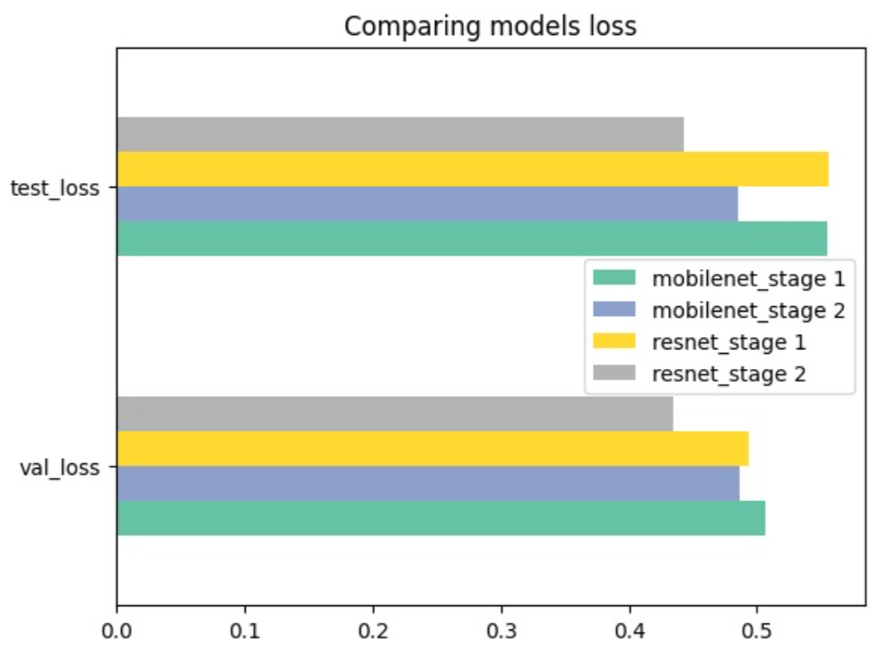
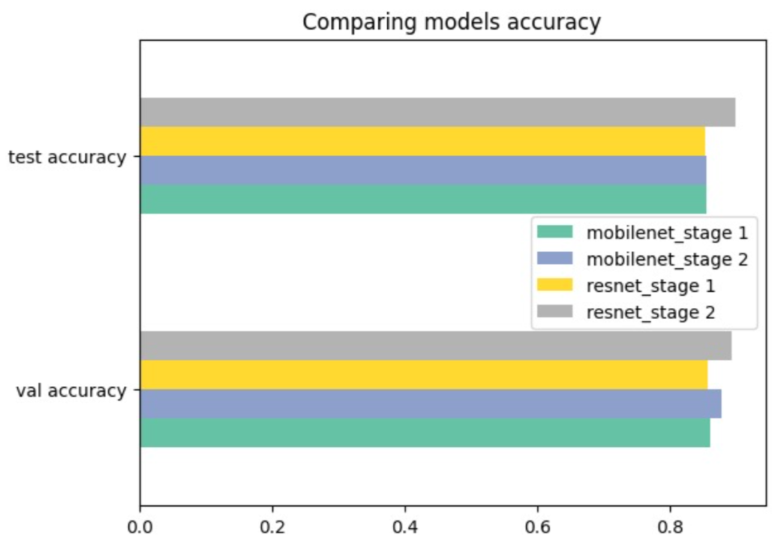
MobileNet Visualization
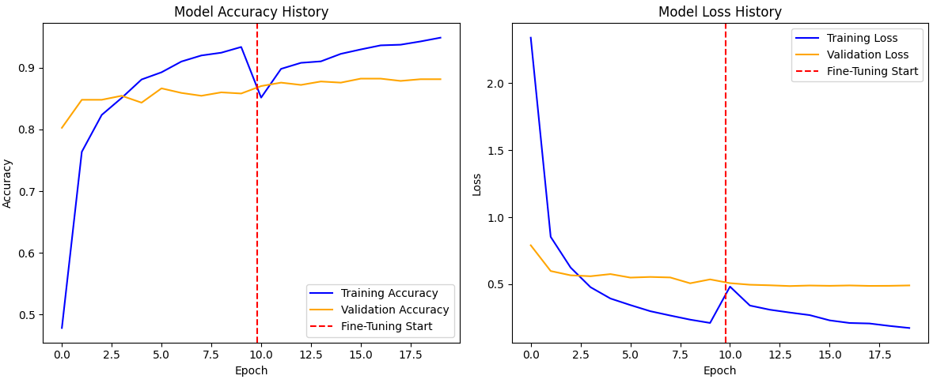

ResNet Visualization
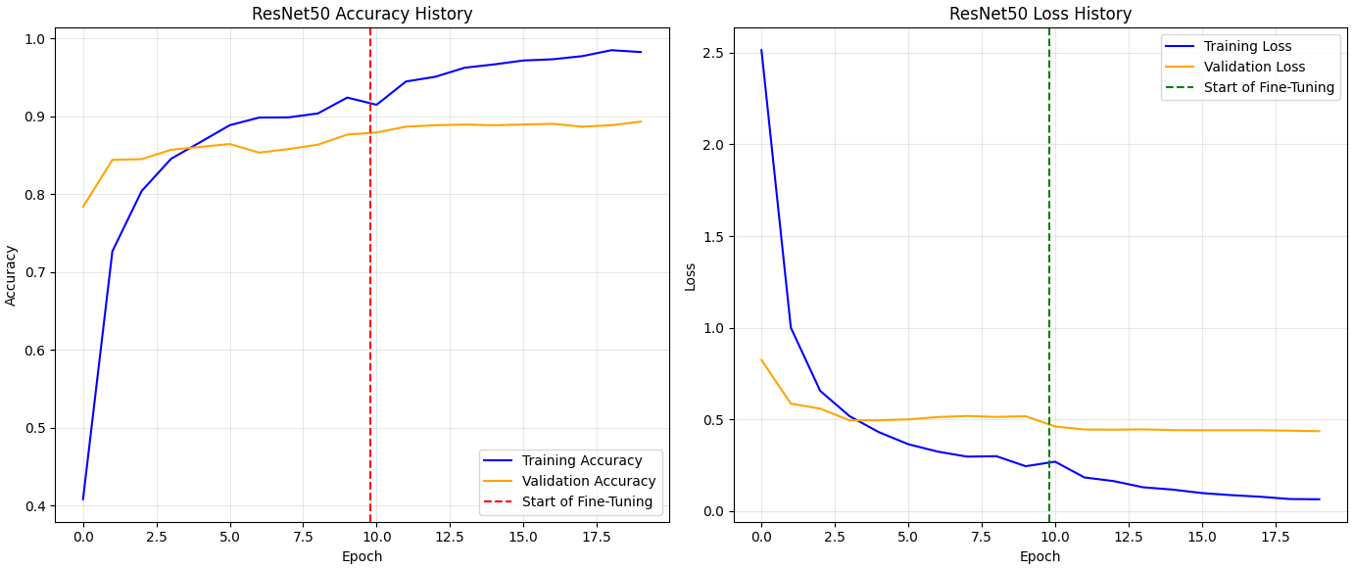

Conclusions & Future Work
ResNet Model outperformed MobileNet with (89.34%) accuracy and Validation loss (0.4347)
Both models perform good on this data with 5400 image without any problems towards execution.
For the next work , we plan to make a new model with higher capability to handle any image whether with noises or without and have a high reliability percentage.

Background Reading
References :
1 - Boukar, M. M., Mahamat, A. A., Djibrine, O. H., & Abubakar, U. B. (2024, February). Improving the accuracy of animal species classification in camera trap images using transfer learning. In 2024 International Conference on Artificial Intelligence, Computer, Data Sciences and Applications (ACDSA) (pp. 1-6). IEEE.
2 - Sharma, R., Pasi, N., & Shanu, S. (2020, February). An Automated Animal Classiﬁcation System: A Transfer Learning Approach. In 5th International conference on next generation computing technologies (NGCT-2019).
3 - Hu, M., & You, F. (2020, November). Research on animal image classification based on transfer learning. In Proceedings of the 2020 4th International Conference on Electronic Information Technology and Computer Engineering (pp. 756-761).
Kaggle :- Link
Google Images search engine: https://images.google.com/

