CFD入门练习5

**1.对带源项的扩散方程,满足以下初始条件,及边界条件。**

**(1)求该方程的解析稳态解。**

**(2)使用FOHS引入辅助变量，将上述方程改写为双曲方程组，考虑均匀网格(8,16,32,64,128…)，用不同的数值方法求解稳态解，并与(1)中的解析解进行对比，测试原始变量和它在方向的导数的空间精度。**

**解：**(1)方程的解析稳态解为：。

(2)本题使用DG(P0)+DG(P0)，DG(P0P1)+DG(P0)，DG(P0P2)+rDG(P0P1)三种显式欧拉方法求解变形后双曲方程组的稳态解。这里仅展示网格数为8,16,32,64，CFL=0.01的稳态数值解与解析解的比较图，并给出3种方法的空间精度比较图。

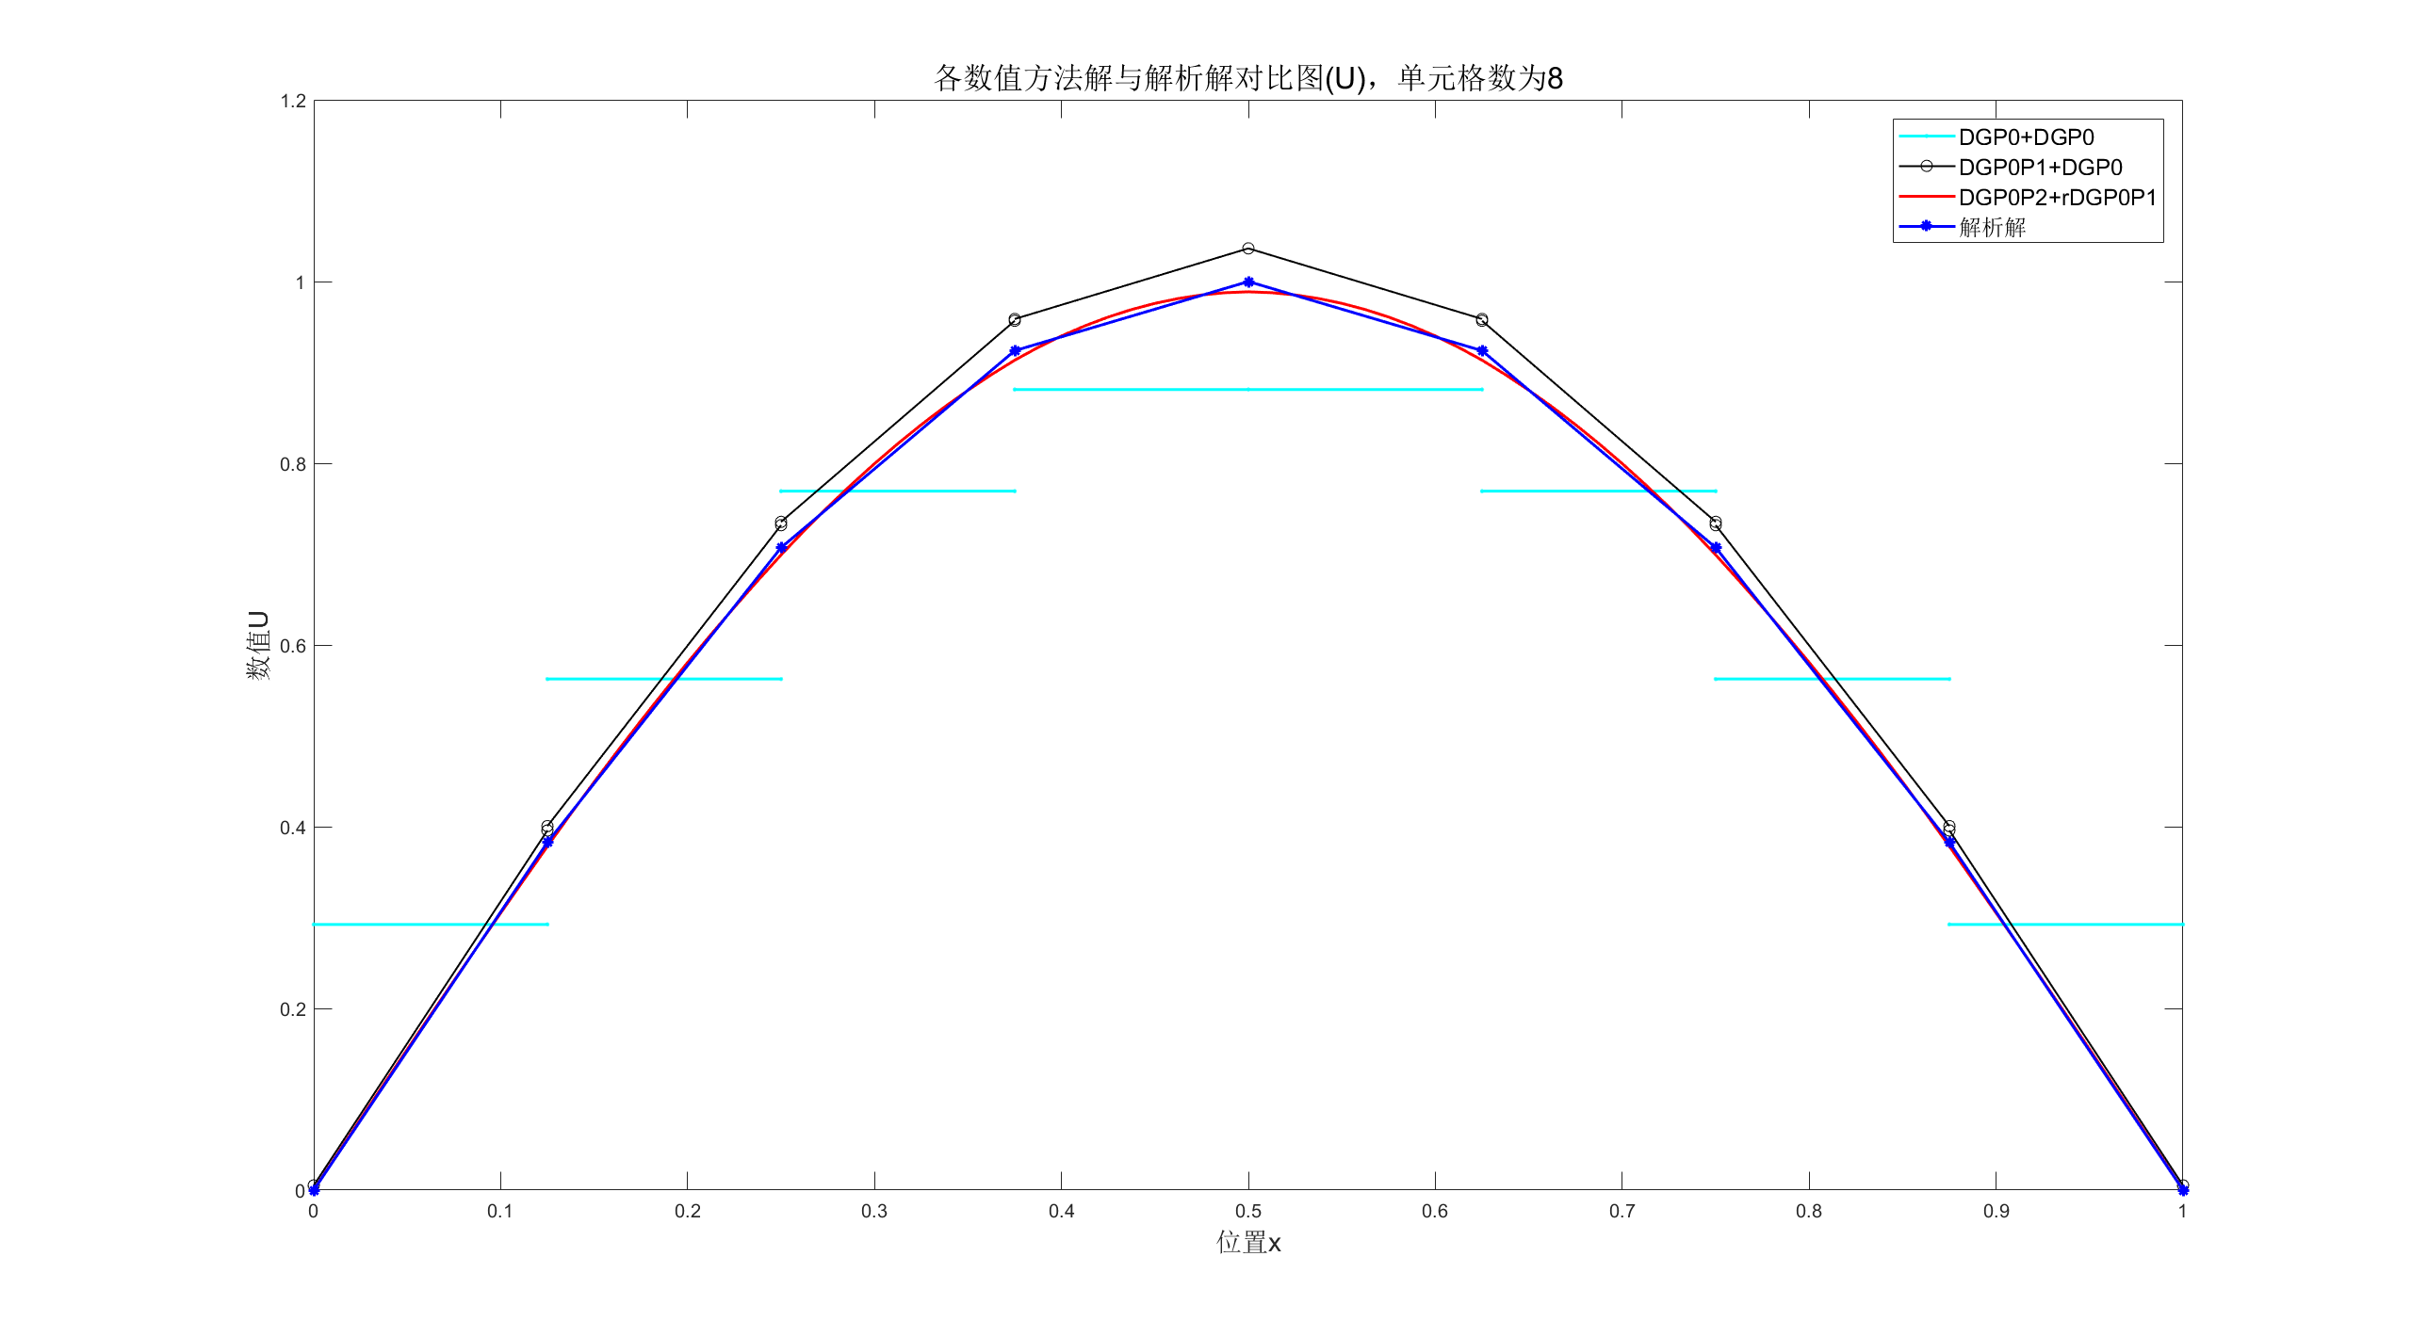**比较稳态数值解与解析解：**

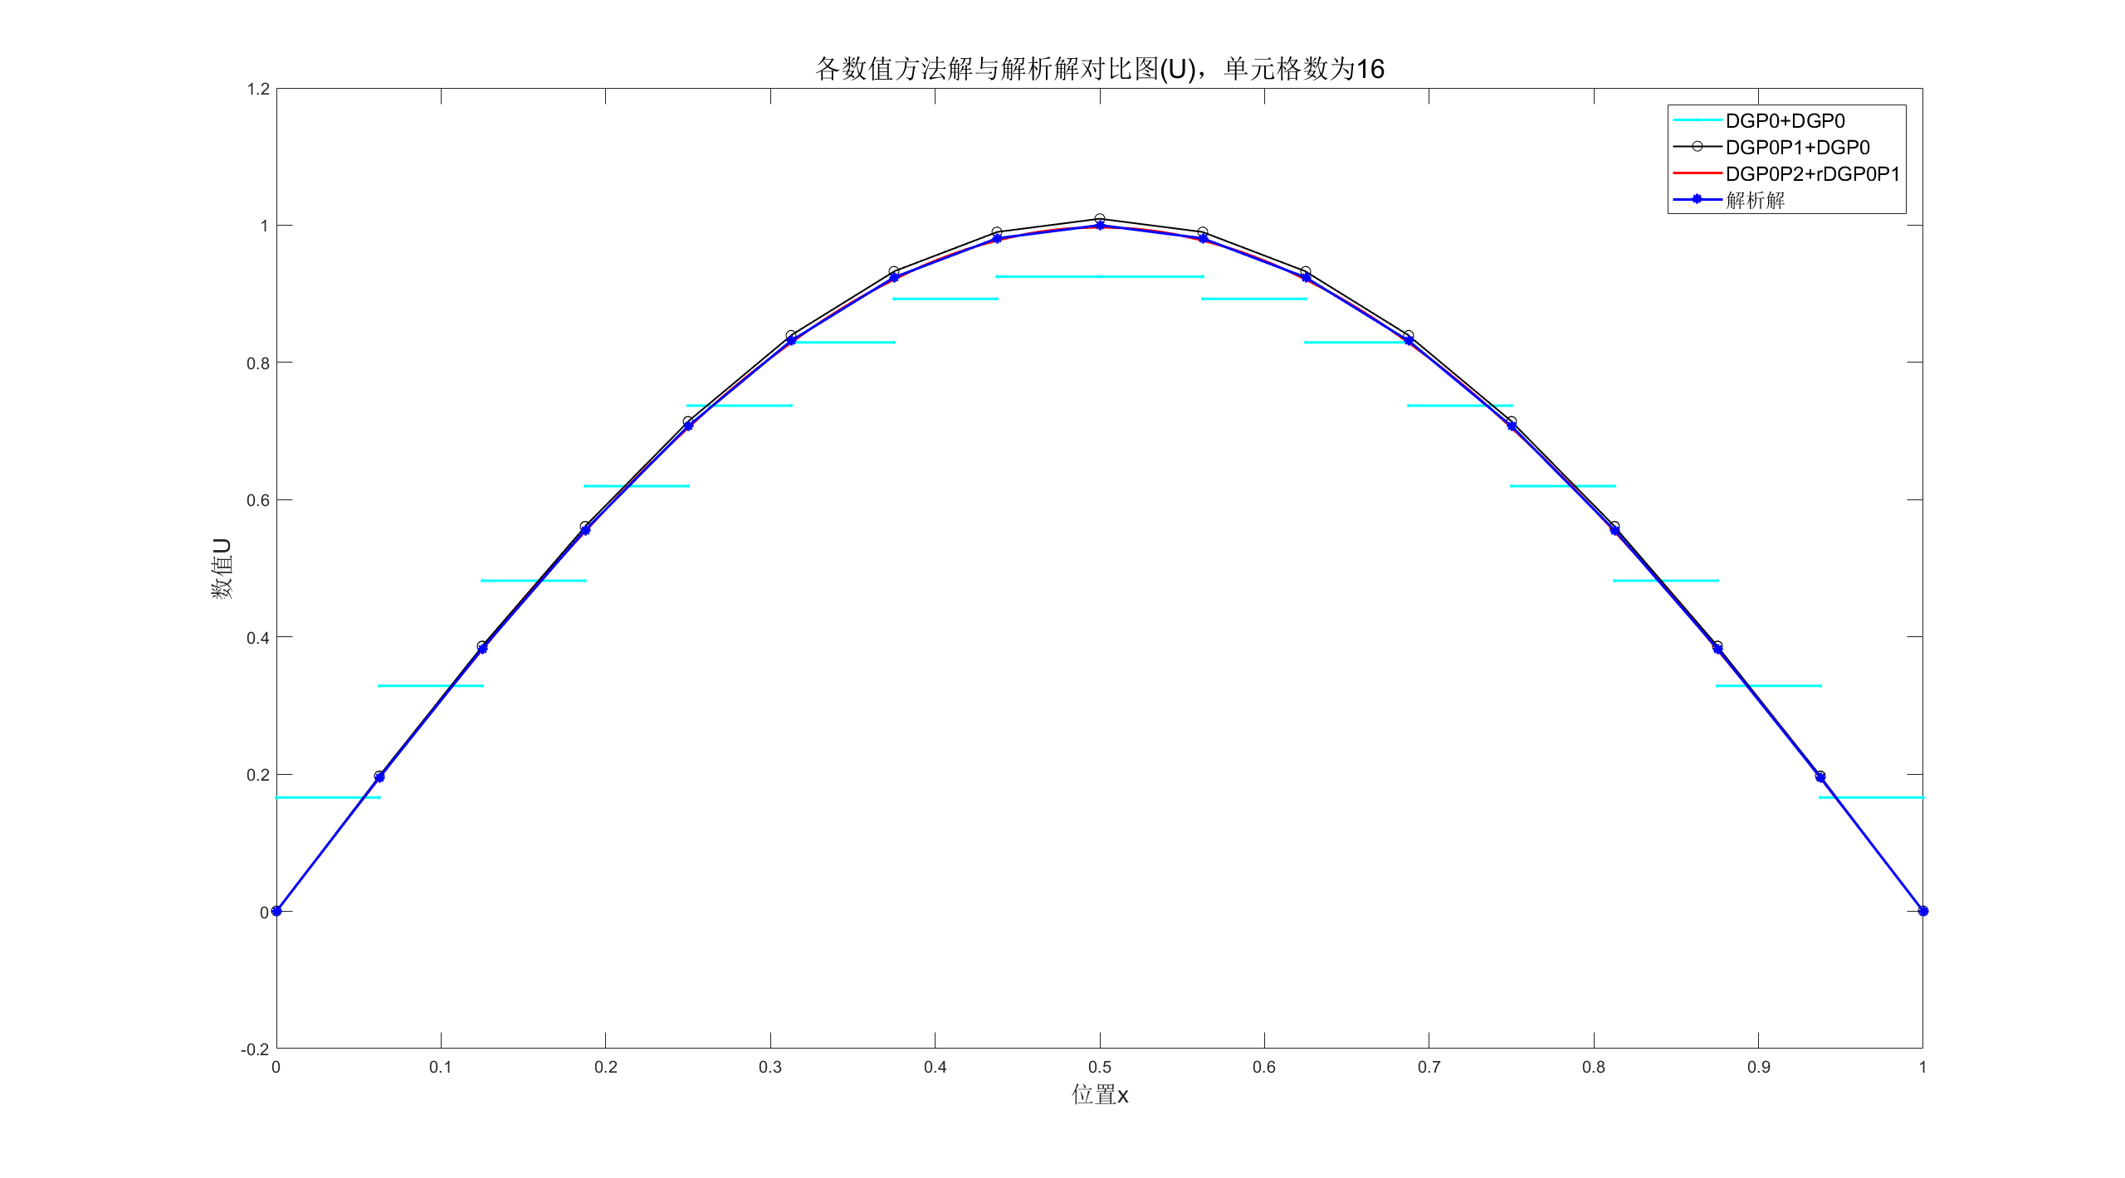

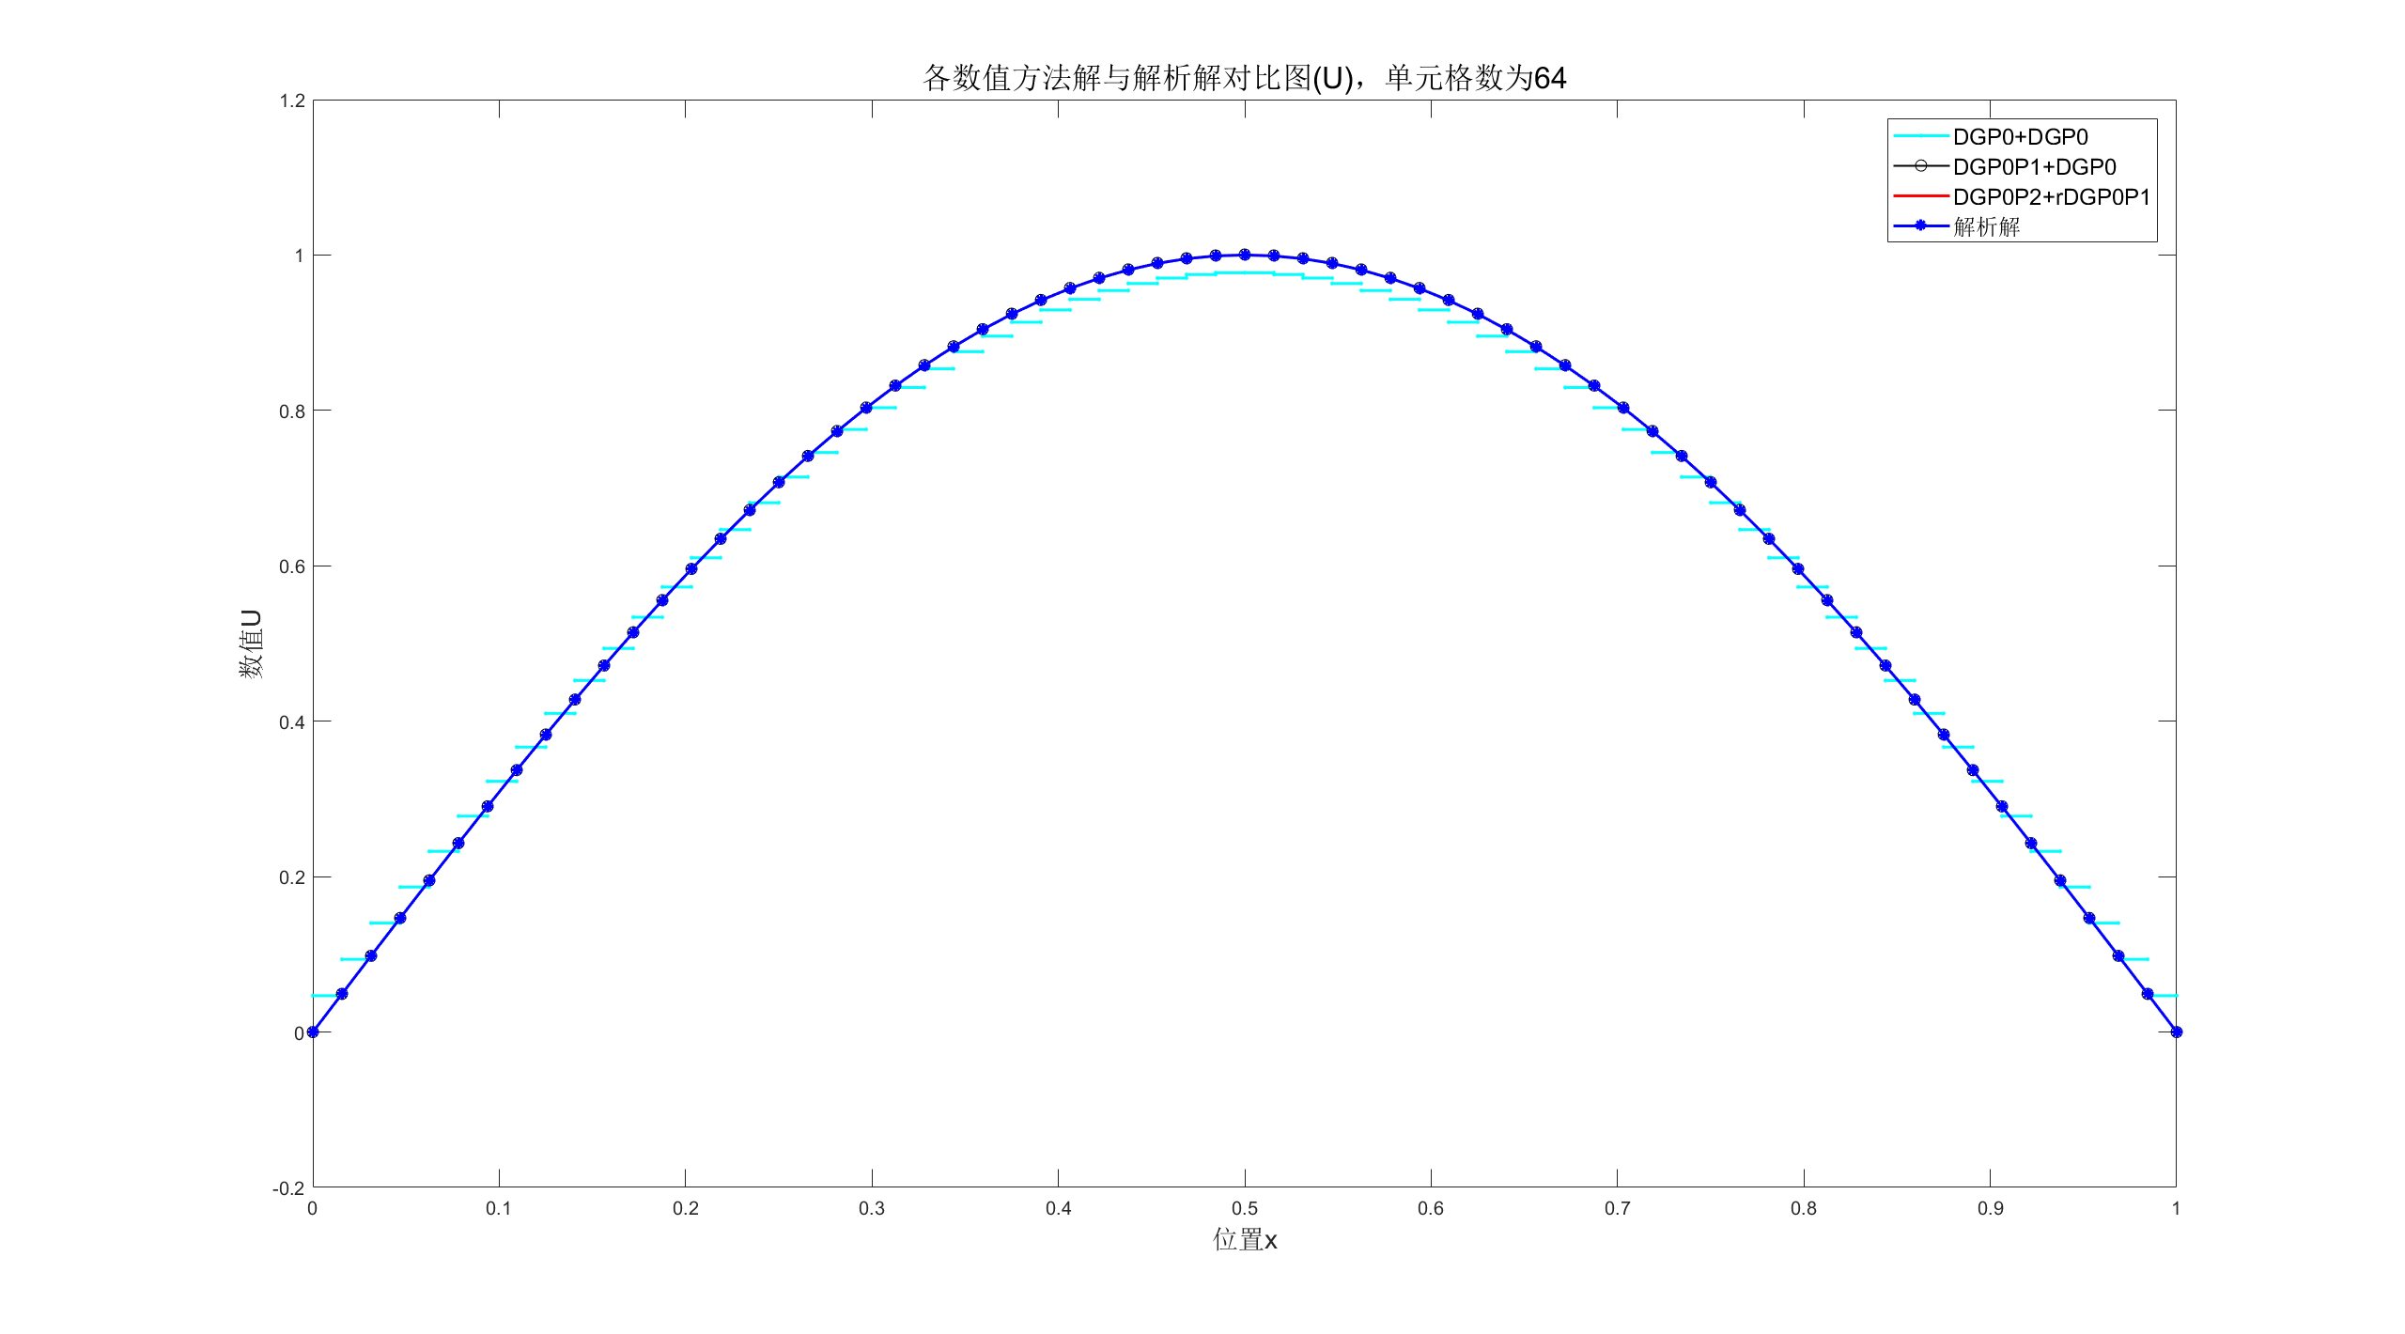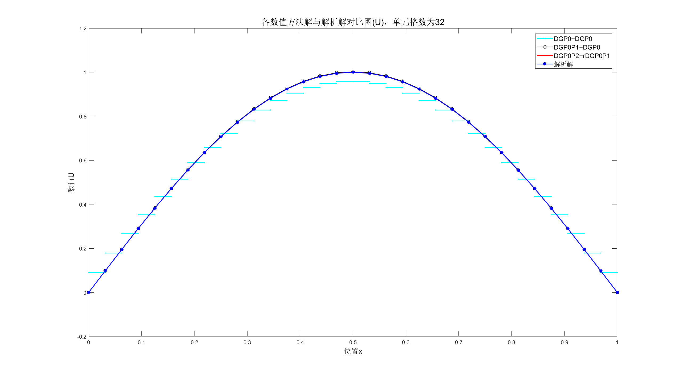

**图1：**3种数值方法求得的稳态解与解析解比较图

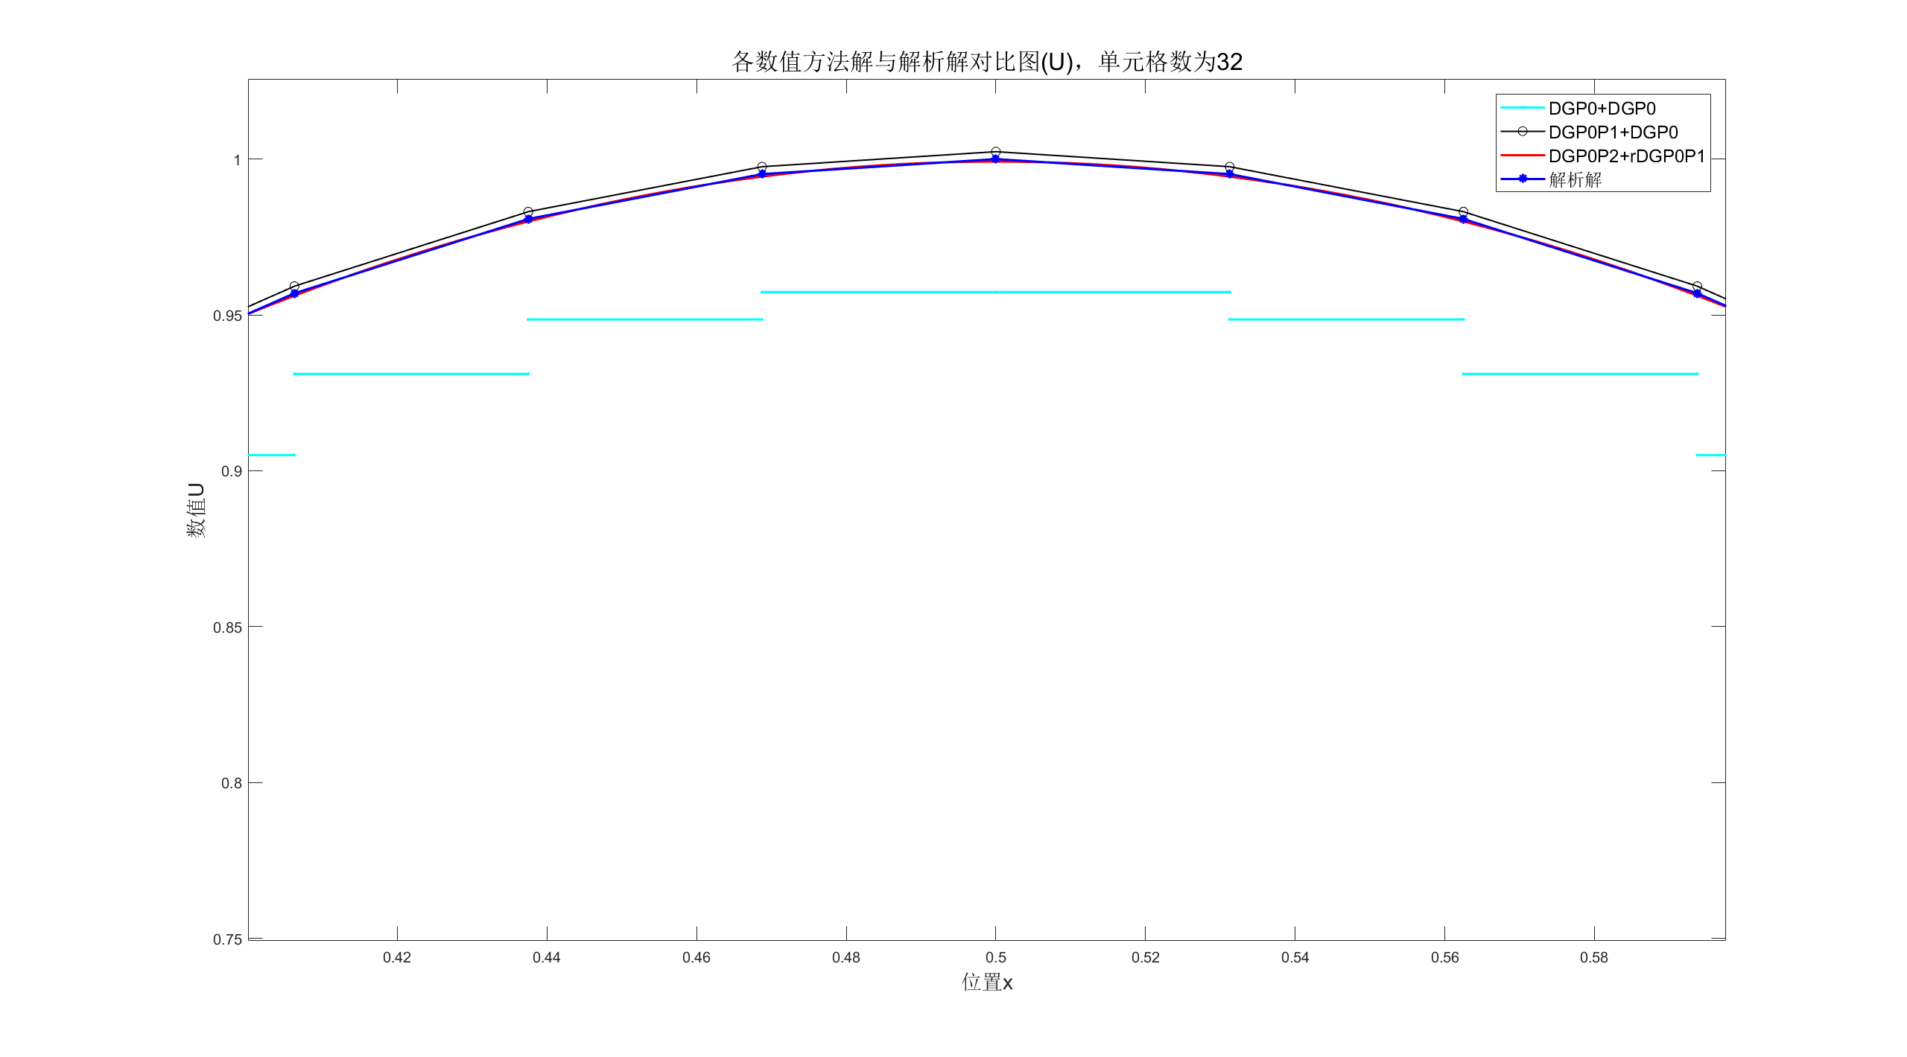此外，这里给出单元格数为32与64的稳态解与解析解局部（放大）比较图。

**图2：**稳态解与解析解局部（放大）比较图（单元格数为32）

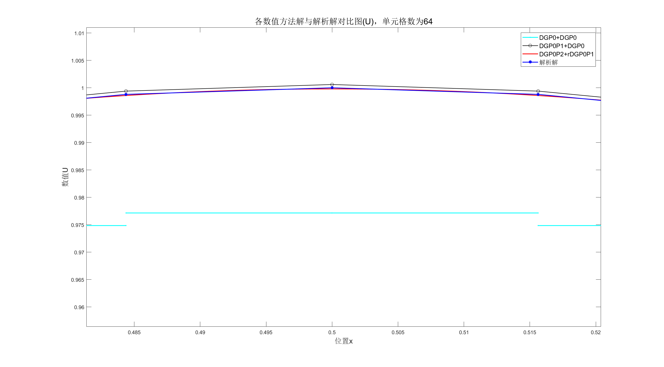

**图3：**稳态解与解析解局部（放大）比较图（单元格数为64）

**比较3种方法稳态数值解的空间精度：**

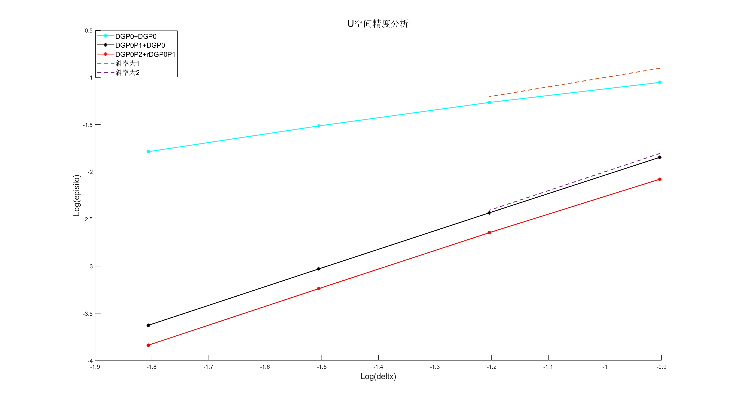

**图4：**3种方法稳态数值解的空间精度

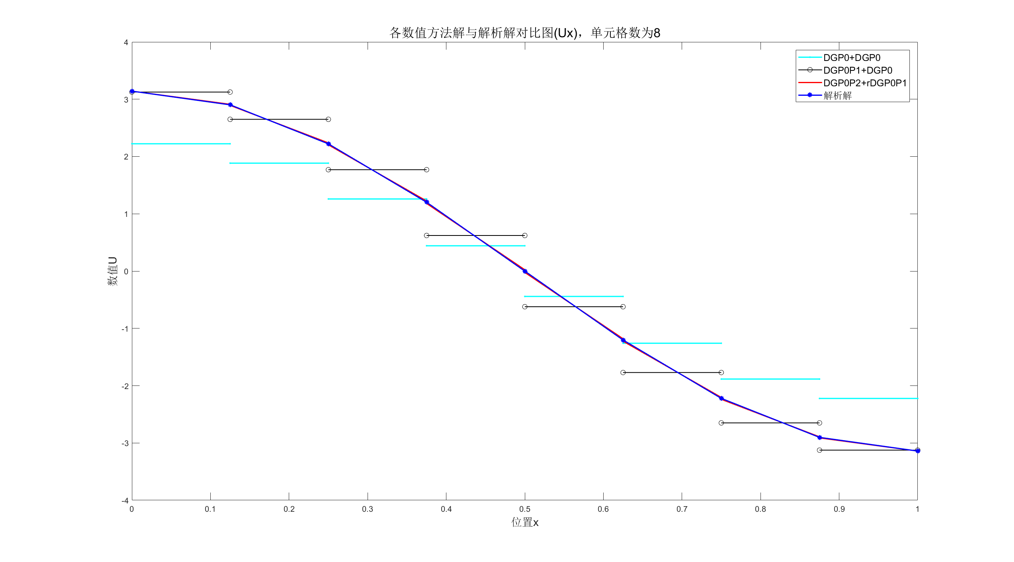**比较稳态数值解与解析解：**

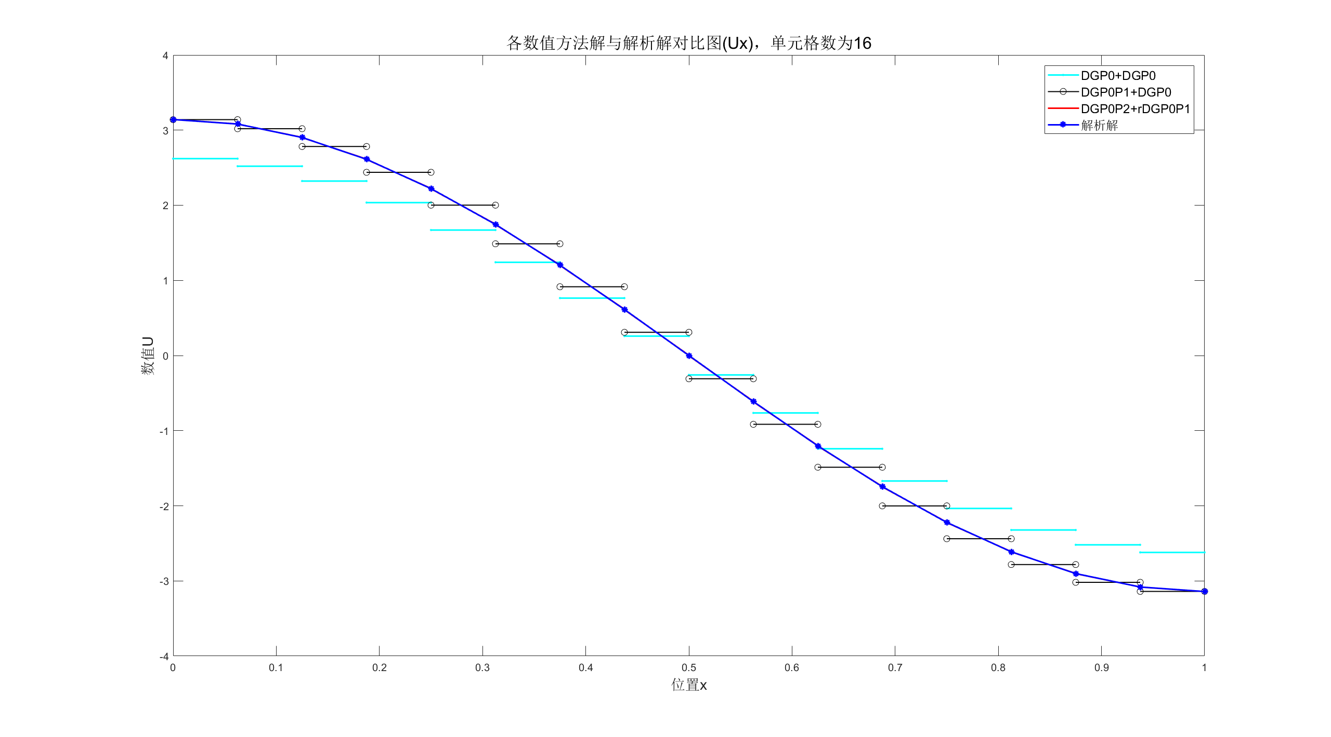

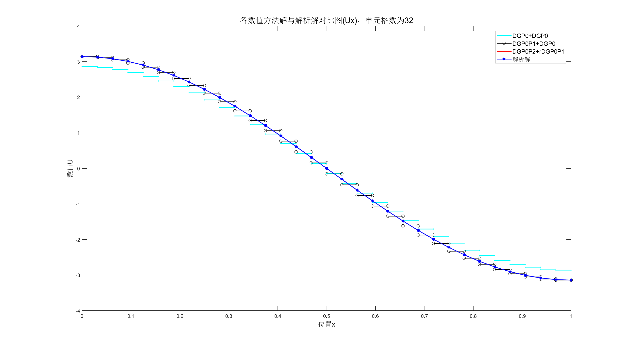

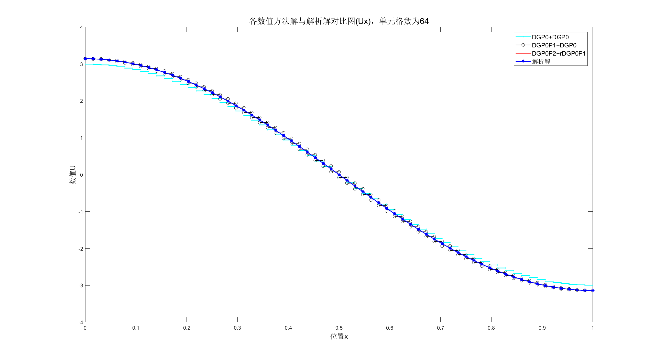

**图5：**3种数值方法求得的稳态解与解析解比较图

**比较3种方法稳态数值解的空间精度：**

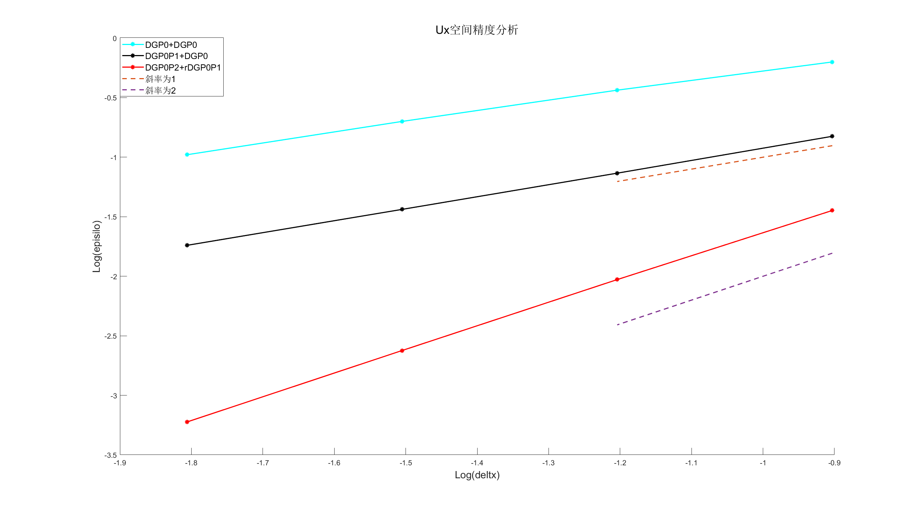

**图6：**3种方法稳态数值解的空间精度

**附录**

本题修改后采用主程序调用子程序的模式

**主程序**

clc

clear all

close all

%% Pre-processing

Unit**=**64**;**CFL**=**0.01**;**endto**=**0.5**;**endx**=**1**;**deltx**=**1**/**Unit**;**numberx**=**endx**/**deltx**+**1**;**

Uexasolution**=**zeros**(**2**,**numberx**);**

UDGP0plusDGP0**=**zeros**(**2**,**numberx**-**1**);**

UDGP0P1plusDGP0**=**zeros**(**2**,**numberx**-**1**);**

UDGP0P2plusrDGP0P1**=**zeros**(**2**,**numberx**-**1**);**

Unumsolution1**=**zeros**(**1**,**2**);**

Unumsolution2**=**zeros**(**2**,**numberx**-**1**);**

Acc**=**zeros**(**3**,**4**);**a1**=[**1**/**8**,**1**/**16**,**1**/**32**,**1**/**64**];**a2**=[**1**/**8**,**1**/**16**];**

%% solve the question

%solve the exasolution

x**=**0**;**

**for** k**=**1**:**numberx

Uexasolution**(**1**,**k**)=**sin**(**pi**\***x**);**

Uexasolution**(**2**,**k**)=**pi**\***cos**(**pi**\***x**);**

x**=**x**+**deltx**;**

**end**

UDGP0plusDGP0**=**subDGP0plusDGP0**(**Unit**,**CFL**,**endto**);**%acquire u and ux

UDGP0P1plusDGP0**=**subDGP0P1plusDGP0**(**Unit**,**CFL**,**endto**);**%acquire u and ux

UDGP0P2plusrDGP0P1**=**subDGP0P2plusrDGP0P1**(**Unit**,**CFL**,**endto**);**%acquire u and ux*deltx and uxx*deltx^2

%% post-processing

%plot the u

%plot the DGP0

figure

x**=**0**\***deltx**:**deltx**:**1**\***deltx**;**

Unumsolution1**(**1**,**1**)=**UDGP0plusDGP0**(**1**,**1**);**Unumsolution1**(**1**,**2**)=**UDGP0plusDGP0**(**1**,**1**);**

plot**(**x**,**Unumsolution1**,**'-c.'**,**'linewidth'**,**1.5**);**hold on

H1**=**plot**(**x**,**Unumsolution1**,**'-c.'**,**'linewidth'**,**1.5**);**hold on

**for** i**=**2**:**numberx**-**1

x**=(**i**-**1**)\***deltx**:**deltx**:**i**\***deltx**;**

Unumsolution1**(**1**,**1**)=**UDGP0plusDGP0**(**1**,**i**);**Unumsolution1**(**1**,**2**)=**UDGP0plusDGP0**(**1**,**i**);**

plot**(**x**,**Unumsolution1**,**'-c.'**,**'linewidth'**,**1.5**)**

**end**

%plot the DGP0P1

**for** i**=**1**:**numberx**-**1

Unumsolution2**(**1**,**i**)=**UDGP0P1plusDGP0**(**1**,**i**)-**0.5**\***UDGP0P1plusDGP0**(**2**,**i**)\***deltx**;**

Unumsolution2**(**2**,**i**)=**UDGP0P1plusDGP0**(**1**,**i**)+**0.5**\***UDGP0P1plusDGP0**(**2**,**i**)\***deltx**;**

**end**

x**=**0**\***deltx**:**deltx**:**1**\***deltx**;**

Unumsolution1**(**1**,**1**)=**Unumsolution2**(**1**,**1**);**Unumsolution1**(**1**,**2**)=**Unumsolution2**(**2**,**1**);**

plot**(**x**,**Unumsolution1**,**'-ko'**,**'linewidth'**,**1**);**hold on

H2**=**plot**(**x**,**Unumsolution1**,**'-ko'**,**'linewidth'**,**1**);**hold on

**for** i**=**2**:**numberx**-**1

x**=(**i**-**1**)\***deltx**:**deltx**:**i**\***deltx**;**

Unumsolution1**(**1**,**1**)=**Unumsolution2**(**1**,**i**);**Unumsolution1**(**1**,**2**)=**Unumsolution2**(**2**,**i**);**

plot**(**x**,**Unumsolution1**,**'-ko'**,**'linewidth'**,**1**)**

**end**

%plot the DGP0P2

hold on

k**=**1**;**

x**=**0**\***deltx**:**0.1**\***deltx**:**1**\***deltx**;**

p**=[**0.5**\***UDGP0P2plusrDGP0P1**(**3**,**k**)/**deltx**^**2**,**UDGP0P2plusrDGP0P1**(**2**,**k**)/**deltx**-**UDGP0P2plusrDGP0P1**(**3**,**k**)*(**k**-**0.5**)/**deltx**,**0.5**\*(**UDGP0P2plusrDGP0P1**(**3**,**k**)/**deltx**^**2**)*((**k**-**0.5**)\***deltx**)^**2**+**UDGP0P2plusrDGP0P1**(**1**,**k**)-**UDGP0P2plusrDGP0P1**(**2**,**k**)/**deltx**\*((**k**-**0.5**)\***deltx**)-**UDGP0P2plusrDGP0P1**(**3**,**k**)/**24**];**

y**=**polyval**(**p**,**x**);**

plot**(**x**,**y**,**'-r'**,**'linewidth'**,**1.5**);**hold on

H3**=**plot**(**x**,**y**,**'-r'**,**'linewidth'**,**1.5**);**hold on

**for** k**=**2**:**numberx**-**1

x**=(**k**-**1**)\***deltx**:**0.1**\***deltx**:**k**\***deltx**;**

p**=[**0.5**\***UDGP0P2plusrDGP0P1**(**3**,**k**)/**deltx**^**2**,**UDGP0P2plusrDGP0P1**(**2**,**k**)/**deltx**-**UDGP0P2plusrDGP0P1**(**3**,**k**)*(**k**-**0.5**)/**deltx**,**0.5**\*(**UDGP0P2plusrDGP0P1**(**3**,**k**)/**deltx**^**2**)*((**k**-**0.5**)\***deltx**)^**2**+**UDGP0P2plusrDGP0P1**(**1**,**k**)-**UDGP0P2plusrDGP0P1**(**2**,**k**)/**deltx**\*((**k**-**0.5**)\***deltx**)-**UDGP0P2plusrDGP0P1**(**3**,**k**)/**24**];**

y**=**polyval**(**p**,**x**);**

plot**(**x**,**y**,**'-r'**,**'linewidth'**,**1.5**)**

**end**

%plot the exact

y**=**0**:**deltx**:**endx**;**

plot**(**y**,**Uexasolution**(**1**,:),**'-b*'**,**'linewidth'**,**1.5**)**

H4**=**plot**(**y**,**Uexasolution**(**1**,:),**'-b*'**,**'linewidth'**,**1.5**);**hold on

lgd**=**legend**([**H1**,**H2**,**H3**,**H4**],**'DGP0+DGP0'**,**'DGP0P1+DGP0'**,**'DGP0P2+rDGP0P1'**,**'解析解'**);**

lgd**.**FontSize**=**12**;**

xlabel**(**'位置x'**,**'fontsize'**,**14**)**

ylabel**(**'数值U'**,**'fontsize'**,**14**)**

title**(**'各数值方法解与解析解对比图(U)，单元格数为64'**,**'fontsize'**,**16**)**

hold off

%plot the ux

%DGP0

figure

x**=**0**\***deltx**:**deltx**:**1**\***deltx**;**

Unumsolution1**(**1**,**1**)=**UDGP0plusDGP0**(**2**,**1**);**Unumsolution1**(**1**,**2**)=**UDGP0plusDGP0**(**2**,**1**);**

plot**(**x**,**Unumsolution1**,**'-c.'**,**'linewidth'**,**1.5**);**hold on

H1**=**plot**(**x**,**Unumsolution1**,**'-c.'**,**'linewidth'**,**1.5**);**hold on

**for** i**=**2**:**numberx**-**1

x**=(**i**-**1**)\***deltx**:**deltx**:**i**\***deltx**;**

Unumsolution1**(**1**,**1**)=**UDGP0plusDGP0**(**2**,**i**);**Unumsolution1**(**1**,**2**)=**UDGP0plusDGP0**(**2**,**i**);**

plot**(**x**,**Unumsolution1**,**'-c.'**,**'linewidth'**,**1.5**)**

**end**

%DGP0P1

x**=**0**\***deltx**:**deltx**:**1**\***deltx**;**

Unumsolution1**(**1**,**1**)=**UDGP0P1plusDGP0**(**2**,**1**);**Unumsolution1**(**1**,**2**)=**UDGP0P1plusDGP0**(**2**,**1**);**

plot**(**x**,**Unumsolution1**,**'-ko'**,**'linewidth'**,**1**);**hold on

H2**=**plot**(**x**,**Unumsolution1**,**'-ko'**,**'linewidth'**,**1**);**hold on

**for** i**=**2**:**numberx**-**1

x**=(**i**-**1**)\***deltx**:**deltx**:**i**\***deltx**;**

Unumsolution1**(**1**,**1**)=**UDGP0P1plusDGP0**(**2**,**i**);**Unumsolution1**(**1**,**2**)=**UDGP0P1plusDGP0**(**2**,**i**);**

plot**(**x**,**Unumsolution1**,**'-ko'**,**'linewidth'**,**1**)**

**end**

%DGP0P2

**for** i**=**1**:**numberx**-**1

Unumsolution2**(**1**,**i**)=**UDGP0P2plusrDGP0P1**(**2**,**i**)/**deltx**-**0.5**\***UDGP0P2plusrDGP0P1**(**3**,**i**)/**deltx**;**

Unumsolution2**(**2**,**i**)=**UDGP0P2plusrDGP0P1**(**2**,**i**)/**deltx**+**0.5**\***UDGP0P2plusrDGP0P1**(**3**,**i**)/**deltx**;**

**end**

x**=**0**\***deltx**:**deltx**:**1**\***deltx**;**

Unumsolution1**(**1**,**1**)=**Unumsolution2**(**1**,**1**);**Unumsolution1**(**1**,**2**)=**Unumsolution2**(**2**,**1**);**

plot**(**x**,**Unumsolution1**,**'-r'**,**'linewidth'**,**1.5**);**hold on

H3**=**plot**(**x**,**Unumsolution1**,**'-r'**,**'linewidth'**,**1.5**);**hold on

**for** i**=**2**:**numberx**-**1

x**=(**i**-**1**)\***deltx**:**deltx**:**i**\***deltx**;**

Unumsolution1**(**1**,**1**)=**Unumsolution2**(**1**,**i**);**Unumsolution1**(**1**,**2**)=**Unumsolution2**(**2**,**i**);**

plot**(**x**,**Unumsolution1**,**'-r'**,**'linewidth'**,**1.5**)**

**end**

%exact

y**=**0**:**deltx**:**endx**;**

plot**(**y**,**Uexasolution**(**2**,:),**'-b*'**,**'linewidth'**,**1.5**)**

H4**=**plot**(**y**,**Uexasolution**(**2**,:),**'-b*'**,**'linewidth'**,**1.5**);**hold on

lgd**=**legend**([**H1**,**H2**,**H3**,**H4**],**'DGP0+DGP0'**,**'DGP0P1+DGP0'**,**'DGP0P2+rDGP0P1'**,**'解析解'**);**

lgd**.**FontSize**=**12**;**

xlabel**(**'位置x'**,**'fontsize'**,**14**)**

ylabel**(**'数值U'**,**'fontsize'**,**14**)**

title**(**'各数值方法解与解析解对比图(Ux)，单元格数为64'**,**'fontsize'**,**16**)**

hold off

%determine the accuracy of space U

%DGP0

Acc**(**1**,**1**)=**accuracy**(**8**,**subDGP0plusDGP0**(**8**,**CFL**,**endto**));**

Acc**(**1**,**2**)=**accuracy**(**16**,**subDGP0plusDGP0**(**16**,**CFL**,**endto**));**

Acc**(**1**,**3**)=**accuracy**(**32**,**subDGP0plusDGP0**(**32**,**CFL**,**endto**));**

Acc**(**1**,**4**)=**accuracy**(**64**,**subDGP0plusDGP0**(**64**,**CFL**,**endto**));**

%DGP0P1

Acc**(**2**,**1**)=**accuracy1**(**8**,**subDGP0P1plusDGP0**(**8**,**CFL**,**endto**));**

Acc**(**2**,**2**)=**accuracy1**(**16**,**subDGP0P1plusDGP0**(**16**,**CFL**,**endto**));**

Acc**(**2**,**3**)=**accuracy1**(**32**,**subDGP0P1plusDGP0**(**32**,**CFL**,**endto**));**

Acc**(**2**,**4**)=**accuracy1**(**64**,**subDGP0P1plusDGP0**(**64**,**CFL**,**endto**));**

%DGP0P2

Acc**(**3**,**1**)=**accuracy2**(**8**,**subDGP0P2plusrDGP0P1**(**8**,**CFL**,**endto**));**

Acc**(**3**,**2**)=**accuracy2**(**16**,**subDGP0P2plusrDGP0P1**(**16**,**CFL**,**endto**));**

Acc**(**3**,**3**)=**accuracy2**(**32**,**subDGP0P2plusrDGP0P1**(**32**,**CFL**,**endto**));**

Acc**(**3**,**4**)=**accuracy2**(**64**,**subDGP0P2plusrDGP0P1**(**64**,**CFL**,**endto**));**

figure

hold on

plot**(**log10**(**a1**),**log10**(**Acc**(**1**,:)),**'-c*'**,**'linewidth'**,**1.5**)**

H1**=**plot**(**log10**(**a1**),**log10**(**Acc**(**1**,:)),**'-c*'**,**'linewidth'**,**1.5**);**

plot**(**log10**(**a1**),**log10**(**Acc**(**2**,:)),**'-k*'**,**'linewidth'**,**1.5**)**

H2**=**plot**(**log10**(**a1**),**log10**(**Acc**(**2**,:)),**'-k*'**,**'linewidth'**,**1.5**);**

plot**(**log10**(**a1**),**log10**(**Acc**(**3**,:)),**'-r*'**,**'linewidth'**,**1.5**)**

H3**=**plot**(**log10**(**a1**),**log10**(**Acc**(**3**,:)),**'-r*'**,**'linewidth'**,**1.5**);**

plot**(**log10**(**a2**),**1**\***log10**(**a2**),**'--'**,**'linewidth'**,**1.5**)**

H4**=**plot**(**log10**(**a2**),**1**\***log10**(**a2**),**'--'**,**'linewidth'**,**1.5**);**

plot**(**log10**(**a2**),**2**\***log10**(**a2**),**'--'**,**'linewidth'**,**1.5**)**

H5**=**plot**(**log10**(**a2**),**2**\***log10**(**a2**),**'--'**,**'linewidth'**,**1.5**);**

lgd**=**legend**([**H1**,**H2**,**H3**,**H4**,**H5**],**'DGP0+DGP0'**,**'DGP0P1+DGP0'**,**'DGP0P2+rDGP0P1'**,**'斜率为1'**,**'斜率为2'**);**

lgd**.**FontSize**=**12**;**

xlabel**(**'Log(deltx)'**,**'fontsize'**,**14**)**

ylabel**(**'Log(episilo)'**,**'fontsize'**,**14**)**

title**(**'U空间精度分析'**,**'fontsize'**,**16**)**

%determine the accuracy of space Ux

%DGP0

Acc**(**1**,**1**)=**accuracyUx**(**8**,**subDGP0plusDGP0**(**8**,**CFL**,**endto**));**

Acc**(**1**,**2**)=**accuracyUx**(**16**,**subDGP0plusDGP0**(**16**,**CFL**,**endto**));**

Acc**(**1**,**3**)=**accuracyUx**(**32**,**subDGP0plusDGP0**(**32**,**CFL**,**endto**));**

Acc**(**1**,**4**)=**accuracyUx**(**64**,**subDGP0plusDGP0**(**64**,**CFL**,**endto**));**

%DGP0P1

Acc**(**2**,**1**)=**accuracyUx**(**8**,**subDGP0P1plusDGP0**(**8**,**CFL**,**endto**));**

Acc**(**2**,**2**)=**accuracyUx**(**16**,**subDGP0P1plusDGP0**(**16**,**CFL**,**endto**));**

Acc**(**2**,**3**)=**accuracyUx**(**32**,**subDGP0P1plusDGP0**(**32**,**CFL**,**endto**));**

Acc**(**2**,**4**)=**accuracyUx**(**64**,**subDGP0P1plusDGP0**(**64**,**CFL**,**endto**));**

%DGP0P2

Acc**(**3**,**1**)=**accuracyUx1**(**8**,**subDGP0P2plusrDGP0P1**(**8**,**CFL**,**endto**));**

Acc**(**3**,**2**)=**accuracyUx1**(**16**,**subDGP0P2plusrDGP0P1**(**16**,**CFL**,**endto**));**

Acc**(**3**,**3**)=**accuracyUx1**(**32**,**subDGP0P2plusrDGP0P1**(**32**,**CFL**,**endto**));**

Acc**(**3**,**4**)=**accuracyUx1**(**64**,**subDGP0P2plusrDGP0P1**(**64**,**CFL**,**endto**));**

figure

hold on

plot**(**log10**(**a1**),**log10**(**Acc**(**1**,:)),**'-c*'**,**'linewidth'**,**1.5**)**

H1**=**plot**(**log10**(**a1**),**log10**(**Acc**(**1**,:)),**'-c*'**,**'linewidth'**,**1.5**);**

plot**(**log10**(**a1**),**log10**(**Acc**(**2**,:)),**'-k*'**,**'linewidth'**,**1.5**)**

H2**=**plot**(**log10**(**a1**),**log10**(**Acc**(**2**,:)),**'-k*'**,**'linewidth'**,**1.5**);**

plot**(**log10**(**a1**),**log10**(**Acc**(**3**,:)),**'-r*'**,**'linewidth'**,**1.5**)**

H3**=**plot**(**log10**(**a1**),**log10**(**Acc**(**3**,:)),**'-r*'**,**'linewidth'**,**1.5**);**

plot**(**log10**(**a2**),**1**\***log10**(**a2**),**'--'**,**'linewidth'**,**1.5**)**

H4**=**plot**(**log10**(**a2**),**1**\***log10**(**a2**),**'--'**,**'linewidth'**,**1.5**);**

plot**(**log10**(**a2**),**2**\***log10**(**a2**),**'--'**,**'linewidth'**,**1.5**)**

H5**=**plot**(**log10**(**a2**),**2**\***log10**(**a2**),**'--'**,**'linewidth'**,**1.5**);**

lgd**=**legend**([**H1**,**H2**,**H3**,**H4**,**H5**],**'DGP0+DGP0'**,**'DGP0P1+DGP0'**,**'DGP0P2+rDGP0P1'**,**'斜率为1'**,**'斜率为2'**);**

lgd**.**FontSize**=**12**;**

xlabel**(**'Log(deltx)'**,**'fontsize'**,**14**)**

ylabel**(**'Log(episilo)'**,**'fontsize'**,**14**)**

title**(**'Ux空间精度分析'**,**'fontsize'**,**16**)**

**子程序**

**subDGP0plusDGP0(用来计算此方法的数值解)**

**function** Unumsolution**=**subDGP0plusDGP0**(**Unit**,**CFL**,**endto**)**

deltx**=**1**/**Unit**;**tol**=**0.01**;**

nu**=**1**;**Lr**=**1**/(**2**\***pi**);**Tr**=**Lr**^**2**/**nu**;**

abslambda**=**sqrt**(**nu**/**Tr**);**deltto**=**CFL**\***deltx**/**abslambda**;**%伪时间变量

endx**=**1**;**

numberx**=**endx**/**deltx**+**1**;**

Ucurrent**=**zeros**(**2**,**numberx**-**1**);**

Unext**=**zeros**(**2**,**numberx**-**1**);**

B1**=**1**;**

C**=[**B1**,**0**;**0**,**B1**/**deltx**];**Mto**=[**deltx**,**0**;**0**,**1**/**deltx**];**

A**=[**abslambda**,**0**;**0**,**abslambda**];**

R**=**zeros**(**2**,**numberx**-**1**);**

F1**=**zeros**(**2**,**numberx**-**1**);**

F2**=**zeros**(**2**,**numberx**-**1**);**

V0**=**zeros**(**1**,**numberx**-**1**);**

%% solve the question

%initial condition set up

x**=**0**;**

**for** k**=**1**:**numberx**-**1

Ucurrent**(**1**,**k**)=(**x**+**deltx**/**2**)^**2**-(**x**+**deltx**/**2**);**

x**=**x**+**deltx**;**

**end**

V0**=**Ucurrent**(**1**,:);**

x**=**0**;**

**for** k**=**1**:**numberx**-**1

Ucurrent**(**2**,**k**)=(**2**\*(**x**+**deltx**/**2**)-**1**)\***deltx**;**

x**=**x**+**deltx**;**

**end**

x**=**0**;**

**for** k**=**1**:**numberx**-**1

R**(**1**,**k**)=**pi**\*(**cos**(**pi**\***x**)-**cos**(**pi**\*(**x**+**deltx**)));**

R**(**2**,**k**)=-**Ucurrent**(**2**,**k**)/(**Tr**\***deltx**);**

x**=**x**+**deltx**;**

**end**

**for** k**=**2**:**numberx**-**1

F1**(:,**k**)=**0.5**\*([-**nu**\***Ucurrent**(**2**,**k**-**1**)/**deltx**;-**Ucurrent**(**1**,**k**-**1**)/(**Tr**\***deltx**)]+[-**nu**\***Ucurrent**(**2**,**k**)/**deltx**;-**Ucurrent**(**1**,**k**)/(**Tr**\***deltx**)])-**0.5**\***A**\*([**Ucurrent**(**1**,**k**);**Ucurrent**(**2**,**k**)/**deltx**]-[**Ucurrent**(**1**,**k**-**1**);**Ucurrent**(**2**,**k**-**1**)/**deltx**]);**

**end**

F1**(:,**1**)=**0.5**\*([-**nu**\***Ucurrent**(**2**,**1**)/**deltx**;-**0**/(**Tr**\***deltx**)]+[-**nu**\***Ucurrent**(**2**,**1**)/**deltx**;-**Ucurrent**(**1**,**1**)/(**Tr**\***deltx**)])-**0.5**\***A**\*([**Ucurrent**(**1**,**1**);**Ucurrent**(**2**,**1**)/**deltx**]-[**0**;**Ucurrent**(**2**,**1**)/**deltx**]);**

**for** k**=**1**:**numberx**-**2

F2**(:,**k**)=**0.5**\*([-**nu**\***Ucurrent**(**2**,**k**)/**deltx**;-**Ucurrent**(**1**,**k**)/(**Tr**\***deltx**)]+[-**nu**\***Ucurrent**(**2**,**k**+**1**)/**deltx**;-**Ucurrent**(**1**,**k**+**1**)/(**Tr**\***deltx**)])-**0.5**\***A**\*([**Ucurrent**(**1**,**k**+**1**);**Ucurrent**(**2**,**k**+**1**)/**deltx**]-[**Ucurrent**(**1**,**k**);**Ucurrent**(**2**,**k**)/**deltx**]);**

**end**

F2**(:,**numberx**-**1**)=**0.5**\*([-**nu**\***Ucurrent**(**2**,**numberx**-**1**)/**deltx**;-**Ucurrent**(**1**,**numberx**-**1**)/(**Tr**\***deltx**)]+[-**nu**\***Ucurrent**(**2**,**numberx**-**1**)/**deltx**;-**0**/(**Tr**\***deltx**)])-**0.5**\***A**\*([**0**;**Ucurrent**(**2**,**numberx**-**1**)/**deltx**]-[**Ucurrent**(**1**,**numberx**-**1**);**Ucurrent**(**2**,**numberx**-**1**)/**deltx**]);**

**for** k**=**1**:**numberx**-**1

R**(:,**k**)=**R**(:,**k**)+**F1**(:,**k**)-**F2**(:,**k**);**

**end**

%solve the exasolution

x**=**0**;**

**for** k**=**1**:**numberx

Uexasolution**(**1**,**k**)=**sin**(**pi**\***x**);**

Uexasolution**(**2**,**k**)=**pi**\***cos**(**pi**\***x**)\***deltx**;**

x**=**x**+**deltx**;**

**end**

%solve the numsolution

**for** n**=**deltto**:**deltto**:**endto

**for** k**=**1**:**numberx**-**1

Unext**(:,**k**)=**Ucurrent**(:,**k**)+**Mto**\**R**(:,**k**)\***deltto**;**

**end**

**if** var**(**Ucurrent**(**1**,:)-**Unext**(**1**,:))<**tol**\***V0

**break**

**end**

Ucurrent**=**Unext**;**

x**=**0**;**

**for** k**=**1**:**numberx**-**1

R**(**1**,**k**)=**pi**\*(**cos**(**pi**\***x**)-**cos**(**pi**\*(**x**+**deltx**)));**

R**(**2**,**k**)=-**Ucurrent**(**2**,**k**)/(**Tr**\***deltx**);**

x**=**x**+**deltx**;**

**end**

**for** k**=**2**:**numberx**-**1

F1**(:,**k**)=**0.5**\*([-**nu**\***Ucurrent**(**2**,**k**-**1**)/**deltx**;-**Ucurrent**(**1**,**k**-**1**)/(**Tr**\***deltx**)]+[-**nu**\***Ucurrent**(**2**,**k**)/**deltx**;-**Ucurrent**(**1**,**k**)/(**Tr**\***deltx**)])-**0.5**\***A**\*([**Ucurrent**(**1**,**k**);**Ucurrent**(**2**,**k**)/**deltx**]-[**Ucurrent**(**1**,**k**-**1**);**Ucurrent**(**2**,**k**-**1**)/**deltx**]);**

**end**

F1**(:,**1**)=**0.5**\*([-**nu**\***Ucurrent**(**2**,**1**)/**deltx**;-**0**/(**Tr**\***deltx**)]+[-**nu**\***Ucurrent**(**2**,**1**)/**deltx**;-**Ucurrent**(**1**,**1**)/(**Tr**\***deltx**)])-**0.5**\***A**\*([**Ucurrent**(**1**,**1**);**Ucurrent**(**2**,**1**)/**deltx**]-[**0**;**Ucurrent**(**2**,**1**)/**deltx**]);**

**for** k**=**1**:**numberx**-**2

F2**(:,**k**)=**0.5**\*([-**nu**\***Ucurrent**(**2**,**k**)/**deltx**;-**Ucurrent**(**1**,**k**)/(**Tr**\***deltx**)]+[-**nu**\***Ucurrent**(**2**,**k**+**1**)/**deltx**;-**Ucurrent**(**1**,**k**+**1**)/(**Tr**\***deltx**)])-**0.5**\***A**\*([**Ucurrent**(**1**,**k**+**1**);**Ucurrent**(**2**,**k**+**1**)/**deltx**]-[**Ucurrent**(**1**,**k**);**Ucurrent**(**2**,**k**)/**deltx**]);**

**end**

F2**(:,**numberx**-**1**)=**0.5**\*([-**nu**\***Ucurrent**(**2**,**numberx**-**1**)/**deltx**;-**Ucurrent**(**1**,**numberx**-**1**)/(**Tr**\***deltx**)]+[-**nu**\***Ucurrent**(**2**,**numberx**-**1**)/**deltx**;-**0**/(**Tr**\***deltx**)])-**0.5**\***A**\*([**0**;**Ucurrent**(**2**,**numberx**-**1**)/**deltx**]-[**Ucurrent**(**1**,**numberx**-**1**);**Ucurrent**(**2**,**numberx**-**1**)/**deltx**]);**

**for** k**=**1**:**numberx**-**1

R**(:,**k**)=**R**(:,**k**)+**F1**(:,**k**)-**F2**(:,**k**);**

**end**

**end**

Unumsolution**(**1**,:)=**Ucurrent**(**1**,:);**Unumsolution**(**2**,:)=**Ucurrent**(**2**,:)/**deltx**;**

**end**

**subDGP0P1plusDGP0**

**function** Unumsolution**=**subDGP0P1plusDGP0**(**Unit**,**CFL**,**endto**)**

%% Pre-processing

deltx**=**1**/**Unit**;**tol**=**0.01**;**

nu**=**1**;**Lr**=**1**/(**2**\***pi**);**Tr**=**Lr**^**2**/**nu**;**

abslambda**=**sqrt**(**nu**/**Tr**);**deltto**=**CFL**\***deltx**/**abslambda**;**%伪时间变量

endx**=**1**;**

numberx**=**endx**/**deltx**+**1**;**

Ucurrent**=**zeros**(**2**,**numberx**-**1**);**

Unext**=**zeros**(**2**,**numberx**-**1**);**

Unumsolution**=**zeros**(**2**,**numberx**-**1**);**

Mto**=[**deltx**,**0**;**0**,**deltx**/**12**+**1**/**deltx**];**

A**=[**abslambda**,**0**;**0**,**abslambda**];**

R**=**zeros**(**2**,**numberx**-**1**);**

F1**=**zeros**(**2**,**numberx**-**1**);**

F2**=**zeros**(**2**,**numberx**-**1**);**

V0**=**zeros**(**1**,**numberx**-**1**);**

%% solve the question

%initial condition set up

x**=**0**;**

**for** k**=**1**:**numberx**-**1

Ucurrent**(**1**,**k**)=(**x**+**deltx**/**2**)^**2**-(**x**+**deltx**/**2**);**

x**=**x**+**deltx**;**

**end**

V0**=**Ucurrent**(**1**,:);**

x**=**0**;**

**for** k**=**1**:**numberx**-**1

Ucurrent**(**2**,**k**)=(**2**\*(**x**+**deltx**/**2**)-**1**)\***deltx**;**

x**=**x**+**deltx**;**

**end**

x**=**0**;**

**for** k**=**1**:**numberx**-**1

R**(**1**,**k**)=**0**+**pi**\*(**cos**(**pi**\***x**)-**cos**(**pi**\*(**x**+**deltx**)));**

R**(**2**,**k**)=-**nu**\***Ucurrent**(**2**,**k**)/**deltx**+(-**pi**/**deltx**\*(**deltx**/**2**\***cos**(**pi**\*(**x**+**deltx**))-(-**deltx**/**2**)\***cos**(**pi**\***x**)-**1**/**pi**\*(**sin**(**pi**\*(**x**+**deltx**))-**sin**(**pi**\***x**))))-**Ucurrent**(**2**,**k**)/(**Tr**\***deltx**);**

x**=**x**+**deltx**;**

**end**

**for** k**=**2**:**numberx**-**1

F1**(:,**k**)=**0.5**\*([-**nu**\***Ucurrent**(**2**,**k**-**1**)/**deltx**;-**0.5**\*(-**nu**\***Ucurrent**(**2**,**k**-**1**)/**deltx**)-(**Ucurrent**(**1**,**k**-**1**)+**0.5**\***Ucurrent**(**2**,**k**-**1**))/(**Tr**\***deltx**)]+[-**nu**\***Ucurrent**(**2**,**k**)/**deltx**;-**0.5**\*(-**nu**\***Ucurrent**(**2**,**k**)/**deltx**)-(**Ucurrent**(**1**,**k**)-**0.5**\***Ucurrent**(**2**,**k**))/(**Tr**\***deltx**)])-**0.5**\***A**\*([**Ucurrent**(**1**,**k**)-**0.5**\***Ucurrent**(**2**,**k**);**Ucurrent**(**2**,**k**)/**deltx**]-[**Ucurrent**(**1**,**k**-**1**)+**0.5**\***Ucurrent**(**2**,**k**-**1**);**Ucurrent**(**2**,**k**-**1**)/**deltx**]);**

**end**

F1**(:,**1**)=**0.5**\*([-**nu**\***Ucurrent**(**2**,**1**)/**deltx**;-**0.5**\*(-**nu**\***Ucurrent**(**2**,**1**)/**deltx**)-**0**/(**Tr**\***deltx**)]+[-**nu**\***Ucurrent**(**2**,**1**)/**deltx**;-**0.5**\*(-**nu**\***Ucurrent**(**2**,**1**)/**deltx**)-(**Ucurrent**(**1**,**1**)-**0.5**\***Ucurrent**(**2**,**1**))/(**Tr**\***deltx**)])-**0.5**\***A**\*([**Ucurrent**(**1**,**1**)-**0.5**\***Ucurrent**(**2**,**1**);**Ucurrent**(**2**,**1**)/**deltx**]-[**0**;**Ucurrent**(**2**,**1**)/**deltx**]);**

**for** k**=**1**:**numberx**-**2

F2**(:,**k**)=**0.5**\*([-**nu**\***Ucurrent**(**2**,**k**)/**deltx**;**0.5**\*(-**nu**\***Ucurrent**(**2**,**k**)/**deltx**)-(**Ucurrent**(**1**,**k**)+**0.5**\***Ucurrent**(**2**,**k**))/(**Tr**\***deltx**)]+[-**nu**\***Ucurrent**(**2**,**k**+**1**)/**deltx**;**0.5**\*(-**nu**\***Ucurrent**(**2**,**k**+**1**)/**deltx**)-(**Ucurrent**(**1**,**k**+**1**)-**0.5**\***Ucurrent**(**2**,**k**+**1**))/(**Tr**\***deltx**)])-**0.5**\***A**\*([**Ucurrent**(**1**,**k**+**1**)-**0.5**\***Ucurrent**(**2**,**k**+**1**);**Ucurrent**(**2**,**k**+**1**)/**deltx**]-[**Ucurrent**(**1**,**k**)+**0.5**\***Ucurrent**(**2**,**k**);**Ucurrent**(**2**,**k**)/**deltx**]);**

**end**

F2**(:,**numberx**-**1**)=**0.5**\*([-**nu**\***Ucurrent**(**2**,**numberx**-**1**)/**deltx**;**0.5**\*(-**nu**\***Ucurrent**(**2**,**numberx**-**1**)/**deltx**)-(**Ucurrent**(**1**,**numberx**-**1**)+**0.5**\***Ucurrent**(**2**,**numberx**-**1**))/(**Tr**\***deltx**)]+[-**nu**\***Ucurrent**(**2**,**numberx**-**1**)/**deltx**;**0.5**\*(-**nu**\***Ucurrent**(**2**,**numberx**-**1**)/**deltx**)-**0**/(**Tr**\***deltx**)])-**0.5**\***A**\*([**0**;**Ucurrent**(**2**,**numberx**-**1**)/**deltx**]-[**Ucurrent**(**1**,**numberx**-**1**)+**0.5**\***Ucurrent**(**2**,**numberx**-**1**);**Ucurrent**(**2**,**numberx**-**1**)/**deltx**]);**

**for** k**=**1**:**numberx**-**1

R**(:,**k**)=**R**(:,**k**)+**F1**(:,**k**)-**F2**(:,**k**);**

**end**

%solve the numsolution

**for** n**=**deltto**:**deltto**:**endto

**for** k**=**1**:**numberx**-**1

Unext**(:,**k**)=**Ucurrent**(:,**k**)+**Mto**\**R**(:,**k**)\***deltto**;**

**end**

**if** var**(**Ucurrent**(**1**,:)-**Unext**(**1**,:))<**tol**\***V0

**break**

**end**

Ucurrent**=**Unext**;**

x**=**0**;**

**for** k**=**1**:**numberx**-**1

R**(**1**,**k**)=**0**+**pi**\*(**cos**(**pi**\***x**)-**cos**(**pi**\*(**x**+**deltx**)));**

R**(**2**,**k**)=-**nu**\***Ucurrent**(**2**,**k**)/**deltx**+(-**pi**/**deltx**\*(**deltx**/**2**\***cos**(**pi**\*(**x**+**deltx**))-(-**deltx**/**2**)\***cos**(**pi**\***x**)-**1**/**pi**\*(**sin**(**pi**\*(**x**+**deltx**))-**sin**(**pi**\***x**))))-**Ucurrent**(**2**,**k**)/(**Tr**\***deltx**);**

x**=**x**+**deltx**;**

**end**

**for** k**=**2**:**numberx**-**1

F1**(:,**k**)=**0.5**\*([-**nu**\***Ucurrent**(**2**,**k**-**1**)/**deltx**;-**0.5**\*(-**nu**\***Ucurrent**(**2**,**k**-**1**)/**deltx**)-(**Ucurrent**(**1**,**k**-**1**)+**0.5**\***Ucurrent**(**2**,**k**-**1**))/(**Tr**\***deltx**)]+[-**nu**\***Ucurrent**(**2**,**k**)/**deltx**;-**0.5**\*(-**nu**\***Ucurrent**(**2**,**k**)/**deltx**)-(**Ucurrent**(**1**,**k**)-**0.5**\***Ucurrent**(**2**,**k**))/(**Tr**\***deltx**)])-**0.5**\***A**\*([**Ucurrent**(**1**,**k**)-**0.5**\***Ucurrent**(**2**,**k**);**Ucurrent**(**2**,**k**)/**deltx**]-[**Ucurrent**(**1**,**k**-**1**)+**0.5**\***Ucurrent**(**2**,**k**-**1**);**Ucurrent**(**2**,**k**-**1**)/**deltx**]);**

**end**

F1**(:,**1**)=**0.5**\*([-**nu**\***Ucurrent**(**2**,**1**)/**deltx**;-**0.5**\*(-**nu**\***Ucurrent**(**2**,**1**)/**deltx**)-**0**/(**Tr**\***deltx**)]+[-**nu**\***Ucurrent**(**2**,**1**)/**deltx**;-**0.5**\*(-**nu**\***Ucurrent**(**2**,**1**)/**deltx**)-(**Ucurrent**(**1**,**1**)-**0.5**\***Ucurrent**(**2**,**1**))/(**Tr**\***deltx**)])-**0.5**\***A**\*([**Ucurrent**(**1**,**1**)-**0.5**\***Ucurrent**(**2**,**1**);**Ucurrent**(**2**,**1**)/**deltx**]-[**0**;**Ucurrent**(**2**,**1**)/**deltx**]);**

**for** k**=**1**:**numberx**-**2

F2**(:,**k**)=**0.5**\*([-**nu**\***Ucurrent**(**2**,**k**)/**deltx**;**0.5**\*(-**nu**\***Ucurrent**(**2**,**k**)/**deltx**)-(**Ucurrent**(**1**,**k**)+**0.5**\***Ucurrent**(**2**,**k**))/(**Tr**\***deltx**)]+[-**nu**\***Ucurrent**(**2**,**k**+**1**)/**deltx**;**0.5**\*(-**nu**\***Ucurrent**(**2**,**k**+**1**)/**deltx**)-(**Ucurrent**(**1**,**k**+**1**)-**0.5**\***Ucurrent**(**2**,**k**+**1**))/(**Tr**\***deltx**)])-**0.5**\***A**\*([**Ucurrent**(**1**,**k**+**1**)-**0.5**\***Ucurrent**(**2**,**k**+**1**);**Ucurrent**(**2**,**k**+**1**)/**deltx**]-[**Ucurrent**(**1**,**k**)+**0.5**\***Ucurrent**(**2**,**k**);**Ucurrent**(**2**,**k**)/**deltx**]);**

**end**

F2**(:,**numberx**-**1**)=**0.5**\*([-**nu**\***Ucurrent**(**2**,**numberx**-**1**)/**deltx**;**0.5**\*(-**nu**\***Ucurrent**(**2**,**numberx**-**1**)/**deltx**)-(**Ucurrent**(**1**,**numberx**-**1**)+**0.5**\***Ucurrent**(**2**,**numberx**-**1**))/(**Tr**\***deltx**)]+[-**nu**\***Ucurrent**(**2**,**numberx**-**1**)/**deltx**;**0.5**\*(-**nu**\***Ucurrent**(**2**,**numberx**-**1**)/**deltx**)-**0**/(**Tr**\***deltx**)])-**0.5**\***A**\*([**0**;**Ucurrent**(**2**,**numberx**-**1**)/**deltx**]-[**Ucurrent**(**1**,**numberx**-**1**)+**0.5**\***Ucurrent**(**2**,**numberx**-**1**);**Ucurrent**(**2**,**numberx**-**1**)/**deltx**]);**

**for** k**=**1**:**numberx**-**1

R**(:,**k**)=**R**(:,**k**)+**F1**(:,**k**)-**F2**(:,**k**);**

**end**

**end**

Unumsolution**(**1**,:)=**Ucurrent**(**1**,:);**Unumsolution**(**2**,:)=**Ucurrent**(**2**,:)/**deltx**;**

**end**

**subDGP0P2plusrDGP0P1**

**function** Unumsolution**=**subDGP0P2plusrDGP0P1**(**Unit**,**CFL**,**endto**)**

%% Pre-processing

deltx**=**1**/**Unit**;**tol**=**0.01**;**

nu**=**1**;**Lr**=**1**/(**2**\***pi**);**Tr**=**Lr**^**2**/**nu**;**

abslambda**=**sqrt**(**nu**/**Tr**);**deltto**=**CFL**\***deltx**/**abslambda**;**%伪时间变量

endx**=**1**;**

numberx**=**endx**/**deltx**+**1**;**

Ucurrent**=**zeros**(**2**,**numberx**-**1**);**

Ucurrent1**=**zeros**(**1**,**numberx**-**1**);**

Unext**=**zeros**(**2**,**numberx**-**1**);**

Unumsolution**=**zeros**(**3**,**numberx**-**1**);**

Mto**=[**deltx**,**0**;**0**,**deltx**/**12**+**1**/**deltx**];**

A**=[**abslambda**,**0**;**0**,**abslambda**];**

R**=**zeros**(**2**,**numberx**-**1**);**

F1**=**zeros**(**2**,**numberx**-**1**);**

F2**=**zeros**(**2**,**numberx**-**1**);**

V0**=**zeros**(**1**,**numberx**-**1**);**

%initial condition set up

x**=**0**;**

**for** k**=**1**:**numberx**-**1

Ucurrent**(**1**,**k**)=(**x**+**deltx**/**2**)^**2**-(**x**+**deltx**/**2**);**

x**=**x**+**deltx**;**

**end**

V0**=**Ucurrent**(**1**,:);**

x**=**0**;**

**for** k**=**1**:**numberx**-**1

Ucurrent**(**2**,**k**)=(**2**\*(**x**+**deltx**/**2**)-**1**)\***deltx**;**

x**=**x**+**deltx**;**

**end**

**for** k**=**1**:**numberx**-**1

Ucurrent1**(**1**,**k**)=**2**\***deltx**^**2**;**

**end**

x**=**0**;**

**for** k**=**1**:**numberx**-**1

R**(**1**,**k**)=**0**+**pi**\*(**cos**(**pi**\***x**)-**cos**(**pi**\*(**x**+**deltx**)));**

R**(**2**,**k**)=-**nu**\***Ucurrent**(**2**,**k**)/**deltx**+(-**pi**/**deltx**\*(**deltx**/**2**\***cos**(**pi**\*(**x**+**deltx**))-(-**deltx**/**2**)\***cos**(**pi**\***x**)-**1**/**pi**\*(**sin**(**pi**\*(**x**+**deltx**))-**sin**(**pi**\***x**))))-**Ucurrent**(**2**,**k**)/(**Tr**\***deltx**);**

x**=**x**+**deltx**;**

**end**

**for** k**=**2**:**numberx**-**1

F1**(:,**k**)=**0.5**\*([-**nu**\*(**Ucurrent**(**2**,**k**-**1**)/**deltx**+**0.5**\***Ucurrent1**(**1**,**k**-**1**)/**deltx**);-**0.5**\*(-**nu**\*(**Ucurrent**(**2**,**k**-**1**)/**deltx**+**0.5**\***Ucurrent1**(**1**,**k**-**1**)/**deltx**))-(**Ucurrent**(**1**,**k**-**1**)+**0.5**\***Ucurrent**(**2**,**k**-**1**)+**Ucurrent1**(**1**,**k**-**1**)/**12**)/(**Tr**\***deltx**)]+[-**nu**\*(**Ucurrent**(**2**,**k**)/**deltx**-**0.5**\***Ucurrent1**(**1**,**k**)/**deltx**);-**0.5**\*(-**nu**\*(**Ucurrent**(**2**,**k**)/**deltx**-**0.5**\***Ucurrent1**(**1**,**k**)/**deltx**))-(**Ucurrent**(**1**,**k**)-**0.5**\***Ucurrent**(**2**,**k**)+**Ucurrent1**(**1**,**k**)/**12**)/(**Tr**\***deltx**)])-**0.5**\***A**\*([**Ucurrent**(**1**,**k**)-**0.5**\***Ucurrent**(**2**,**k**)+**Ucurrent1**(**1**,**k**)/**12**;**Ucurrent**(**2**,**k**)/**deltx**-**0.5**\***Ucurrent1**(**1**,**k**)/**deltx**]-[**Ucurrent**(**1**,**k**-**1**)+**0.5**\***Ucurrent**(**2**,**k**-**1**)+**Ucurrent1**(**1**,**k**-**1**)/**12**;**Ucurrent**(**2**,**k**-**1**)/**deltx**+**0.5**\***Ucurrent1**(**1**,**k**-**1**)/**deltx**]);**

**end**

F1**(:,**1**)=**0.5**\*([-**nu**\*(**Ucurrent**(**2**,**1**)/**deltx**-**0.5**\***Ucurrent1**(**1**,**1**)/**deltx**);-**0.5**\*(-**nu**\*(**Ucurrent**(**2**,**1**)/**deltx**-**0.5**\***Ucurrent1**(**1**,**1**)/**deltx**))-**0**/(**Tr**\***deltx**)]+[-**nu**\*(**Ucurrent**(**2**,**1**)/**deltx**-**0.5**\***Ucurrent1**(**1**,**1**)/**deltx**);-**0.5**\*(-**nu**\*(**Ucurrent**(**2**,**1**)/**deltx**-**0.5**\***Ucurrent1**(**1**,**1**)/**deltx**))-(**Ucurrent**(**1**,**1**)-**0.5**\***Ucurrent**(**2**,**1**)+**Ucurrent1**(**1**,**1**)/**12**)/(**Tr**\***deltx**)])-**0.5**\***A**\*([**Ucurrent**(**1**,**1**)-**0.5**\***Ucurrent**(**2**,**1**)+**Ucurrent1**(**1**,**1**)/**12**;**Ucurrent**(**2**,**1**)/**deltx**-**0.5**\***Ucurrent1**(**1**,**1**)/**deltx**]-[**0**;**Ucurrent**(**2**,**1**)/**deltx**-**0.5**\***Ucurrent1**(**1**,**1**)/**deltx**]);**

**for** k**=**1**:**numberx**-**2

F2**(:,**k**)=**0.5**\*([-**nu**\*(**Ucurrent**(**2**,**k**)/**deltx**+**0.5**\***Ucurrent1**(**1**,**k**)/**deltx**);**0.5**\*(-**nu**\*(**Ucurrent**(**2**,**k**)/**deltx**+**0.5**\***Ucurrent1**(**1**,**k**)/**deltx**))-(**Ucurrent**(**1**,**k**)+**0.5**\***Ucurrent**(**2**,**k**)+**Ucurrent1**(**1**,**k**)/**12**)/(**Tr**\***deltx**)]+[-**nu**\*(**Ucurrent**(**2**,**k**+**1**)/**deltx**-**0.5**\***Ucurrent1**(**1**,**k**+**1**)/**deltx**);**0.5**\*(-**nu**\*(**Ucurrent**(**2**,**k**+**1**)/**deltx**-**0.5**\***Ucurrent1**(**1**,**k**+**1**)/**deltx**))-(**Ucurrent**(**1**,**k**+**1**)-**0.5**\***Ucurrent**(**2**,**k**+**1**)+**Ucurrent1**(**1**,**k**+**1**)/**12**)/(**Tr**\***deltx**)])-**0.5**\***A**\*([**Ucurrent**(**1**,**k**+**1**)-**0.5**\***Ucurrent**(**2**,**k**+**1**)+**Ucurrent1**(**1**,**k**+**1**)/**12**;**Ucurrent**(**2**,**k**+**1**)/**deltx**-**0.5**\***Ucurrent1**(**1**,**k**+**1**)/**deltx**]-[**Ucurrent**(**1**,**k**)+**0.5**\***Ucurrent**(**2**,**k**)+**Ucurrent1**(**1**,**k**)/**12**;**Ucurrent**(**2**,**k**)/**deltx**+**0.5**\***Ucurrent1**(**1**,**k**)/**deltx**]);**

**end**

F2**(:,**numberx**-**1**)=**0.5**\*([-**nu**\*(**Ucurrent**(**2**,**numberx**-**1**)/**deltx**+**0.5**\***Ucurrent1**(**1**,**numberx**-**1**)/**deltx**);**0.5**\*(-**nu**\*(**Ucurrent**(**2**,**numberx**-**1**)/**deltx**+**0.5**\***Ucurrent1**(**1**,**numberx**-**1**)/**deltx**))-(**Ucurrent**(**1**,**numberx**-**1**)+**0.5**\***Ucurrent**(**2**,**numberx**-**1**)+**Ucurrent1**(**1**,**numberx**-**1**)/**12**)/(**Tr**\***deltx**)]+[-**nu**\*(**Ucurrent**(**2**,**numberx**-**1**)/**deltx**+**0.5**\***Ucurrent1**(**1**,**numberx**-**1**)/**deltx**);**0.5**\*(-**nu**\*(**Ucurrent**(**2**,**numberx**-**1**)/**deltx**+**0.5**\***Ucurrent1**(**1**,**numberx**-**1**)/**deltx**))-**0**/(**Tr**\***deltx**)])-**0.5**\***A**\*([**0**;**Ucurrent**(**2**,**numberx**-**1**)/**deltx**+**0.5**\***Ucurrent1**(**1**,**numberx**-**1**)/**deltx**]-[**Ucurrent**(**1**,**numberx**-**1**)+**0.5**\***Ucurrent**(**2**,**numberx**-**1**)+**Ucurrent1**(**1**,**numberx**-**1**)/**12**;**Ucurrent**(**2**,**numberx**-**1**)/**deltx**+**0.5**\***Ucurrent1**(**1**,**numberx**-**1**)/**deltx**]);**

**for** k**=**1**:**numberx**-**1

R**(:,**k**)=**R**(:,**k**)+**F1**(:,**k**)-**F2**(:,**k**);**

**end**

%solve the exasolution

k**=**1**;**

**for** x**=**0**:**deltx**:**endx

Uexasolution**(**1**,**k**)=**sin**(**pi**\***x**);**

Uexasolution**(**2**,**k**)=**pi**\***cos**(**pi**\***x**);**

k**=**k**+**1**;**

**end**

%solve the numsolution

**for** n**=**deltto**:**deltto**:**endto

**for** k**=**1**:**numberx**-**1

Unext**(:,**k**)=**Ucurrent**(:,**k**)+**Mto**\**R**(:,**k**)\***deltto**;**

**end**

**if** var**(**Ucurrent**(**1**,:)-**Unext**(**1**,:))<**tol**\***V0

**break**

**end**

Ucurrent**=**Unext**;**

**for** k**=**2**:**numberx**-**2

Ucurrent1**(**1**,**k**)=[**deltx**;-**deltx**]\[**Ucurrent**(**2**,**k**+**1**)\***deltx**-**Ucurrent**(**2**,**k**)\***deltx**;**Ucurrent**(**2**,**k**-**1**)\***deltx**-**Ucurrent**(**2**,**k**)\***deltx**];**

**end**

Ucurrent1**(**1**,**1**)=[**deltx**;-**deltx**]\[**Ucurrent**(**2**,**2**)\***deltx**-**Ucurrent**(**2**,**1**)\***deltx**;**Ucurrent**(**2**,**1**)\***deltx**-**Ucurrent**(**2**,**1**)\***deltx**];**

Ucurrent1**(**1**,**numberx**-**1**)=[**deltx**;-**deltx**]\[**Ucurrent**(**2**,**numberx**-**1**)\***deltx**-**Ucurrent**(**2**,**numberx**-**1**)\***deltx**;**Ucurrent**(**2**,**numberx**-**2**)\***deltx**-**Ucurrent**(**2**,**numberx**-**1**)\***deltx**];**

x**=**0**;**

**for** k**=**1**:**numberx**-**1

R**(**1**,**k**)=**0**+**pi**\*(**cos**(**pi**\***x**)-**cos**(**pi**\*(**x**+**deltx**)));**

R**(**2**,**k**)=-**nu**\***Ucurrent**(**2**,**k**)/**deltx**+(-**pi**/**deltx**\*(**deltx**/**2**\***cos**(**pi**\*(**x**+**deltx**))-(-**deltx**/**2**)\***cos**(**pi**\***x**)-**1**/**pi**\*(**sin**(**pi**\*(**x**+**deltx**))-**sin**(**pi**\***x**))))-**Ucurrent**(**2**,**k**)/(**Tr**\***deltx**);**

x**=**x**+**deltx**;**

**end**

**for** k**=**2**:**numberx**-**1

F1**(:,**k**)=**0.5**\*([-**nu**\*(**Ucurrent**(**2**,**k**-**1**)/**deltx**+**0.5**\***Ucurrent1**(**1**,**k**-**1**)/**deltx**);-**0.5**\*(-**nu**\*(**Ucurrent**(**2**,**k**-**1**)/**deltx**+**0.5**\***Ucurrent1**(**1**,**k**-**1**)/**deltx**))-(**Ucurrent**(**1**,**k**-**1**)+**0.5**\***Ucurrent**(**2**,**k**-**1**)+**Ucurrent1**(**1**,**k**-**1**)/**12**)/(**Tr**\***deltx**)]+[-**nu**\*(**Ucurrent**(**2**,**k**)/**deltx**-**0.5**\***Ucurrent1**(**1**,**k**)/**deltx**);-**0.5**\*(-**nu**\*(**Ucurrent**(**2**,**k**)/**deltx**-**0.5**\***Ucurrent1**(**1**,**k**)/**deltx**))-(**Ucurrent**(**1**,**k**)-**0.5**\***Ucurrent**(**2**,**k**)+**Ucurrent1**(**1**,**k**)/**12**)/(**Tr**\***deltx**)])-**0.5**\***A**\*([**Ucurrent**(**1**,**k**)-**0.5**\***Ucurrent**(**2**,**k**)+**Ucurrent1**(**1**,**k**)/**12**;**Ucurrent**(**2**,**k**)/**deltx**-**0.5**\***Ucurrent1**(**1**,**k**)/**deltx**]-[**Ucurrent**(**1**,**k**-**1**)+**0.5**\***Ucurrent**(**2**,**k**-**1**)+**Ucurrent1**(**1**,**k**-**1**)/**12**;**Ucurrent**(**2**,**k**-**1**)/**deltx**+**0.5**\***Ucurrent1**(**1**,**k**-**1**)/**deltx**]);**

**end**

F1**(:,**1**)=**0.5**\*([-**nu**\*(**Ucurrent**(**2**,**1**)/**deltx**-**0.5**\***Ucurrent1**(**1**,**1**)/**deltx**);-**0.5**\*(-**nu**\*(**Ucurrent**(**2**,**1**)/**deltx**-**0.5**\***Ucurrent1**(**1**,**1**)/**deltx**))-**0**/(**Tr**\***deltx**)]+[-**nu**\*(**Ucurrent**(**2**,**1**)/**deltx**-**0.5**\***Ucurrent1**(**1**,**1**)/**deltx**);-**0.5**\*(-**nu**\*(**Ucurrent**(**2**,**1**)/**deltx**-**0.5**\***Ucurrent1**(**1**,**1**)/**deltx**))-(**Ucurrent**(**1**,**1**)-**0.5**\***Ucurrent**(**2**,**1**)+**Ucurrent1**(**1**,**1**)/**12**)/(**Tr**\***deltx**)])-**0.5**\***A**\*([**Ucurrent**(**1**,**1**)-**0.5**\***Ucurrent**(**2**,**1**)+**Ucurrent1**(**1**,**1**)/**12**;**Ucurrent**(**2**,**1**)/**deltx**-**0.5**\***Ucurrent1**(**1**,**1**)/**deltx**]-[**0**;**Ucurrent**(**2**,**1**)/**deltx**-**0.5**\***Ucurrent1**(**1**,**1**)/**deltx**]);**

**for** k**=**1**:**numberx**-**2

F2**(:,**k**)=**0.5**\*([-**nu**\*(**Ucurrent**(**2**,**k**)/**deltx**+**0.5**\***Ucurrent1**(**1**,**k**)/**deltx**);**0.5**\*(-**nu**\*(**Ucurrent**(**2**,**k**)/**deltx**+**0.5**\***Ucurrent1**(**1**,**k**)/**deltx**))-(**Ucurrent**(**1**,**k**)+**0.5**\***Ucurrent**(**2**,**k**)+**Ucurrent1**(**1**,**k**)/**12**)/(**Tr**\***deltx**)]+[-**nu**\*(**Ucurrent**(**2**,**k**+**1**)/**deltx**-**0.5**\***Ucurrent1**(**1**,**k**+**1**)/**deltx**);**0.5**\*(-**nu**\*(**Ucurrent**(**2**,**k**+**1**)/**deltx**-**0.5**\***Ucurrent1**(**1**,**k**+**1**)/**deltx**))-(**Ucurrent**(**1**,**k**+**1**)-**0.5**\***Ucurrent**(**2**,**k**+**1**)+**Ucurrent1**(**1**,**k**+**1**)/**12**)/(**Tr**\***deltx**)])-**0.5**\***A**\*([**Ucurrent**(**1**,**k**+**1**)-**0.5**\***Ucurrent**(**2**,**k**+**1**)+**Ucurrent1**(**1**,**k**+**1**)/**12**;**Ucurrent**(**2**,**k**+**1**)/**deltx**-**0.5**\***Ucurrent1**(**1**,**k**+**1**)/**deltx**]-[**Ucurrent**(**1**,**k**)+**0.5**\***Ucurrent**(**2**,**k**)+**Ucurrent1**(**1**,**k**)/**12**;**Ucurrent**(**2**,**k**)/**deltx**+**0.5**\***Ucurrent1**(**1**,**k**)/**deltx**]);**

**end**

F2**(:,**numberx**-**1**)=**0.5**\*([-**nu**\*(**Ucurrent**(**2**,**numberx**-**1**)/**deltx**+**0.5**\***Ucurrent1**(**1**,**numberx**-**1**)/**deltx**);**0.5**\*(-**nu**\*(**Ucurrent**(**2**,**numberx**-**1**)/**deltx**+**0.5**\***Ucurrent1**(**1**,**numberx**-**1**)/**deltx**))-(**Ucurrent**(**1**,**numberx**-**1**)+**0.5**\***Ucurrent**(**2**,**numberx**-**1**)+**Ucurrent1**(**1**,**numberx**-**1**)/**12**)/(**Tr**\***deltx**)]+[-**nu**\*(**Ucurrent**(**2**,**numberx**-**1**)/**deltx**+**0.5**\***Ucurrent1**(**1**,**numberx**-**1**)/**deltx**);**0.5**\*(-**nu**\*(**Ucurrent**(**2**,**numberx**-**1**)/**deltx**+**0.5**\***Ucurrent1**(**1**,**numberx**-**1**)/**deltx**))-**0**/(**Tr**\***deltx**)])-**0.5**\***A**\*([**0**;**Ucurrent**(**2**,**numberx**-**1**)/**deltx**+**0.5**\***Ucurrent1**(**1**,**numberx**-**1**)/**deltx**]-[**Ucurrent**(**1**,**numberx**-**1**)+**0.5**\***Ucurrent**(**2**,**numberx**-**1**)+**Ucurrent1**(**1**,**numberx**-**1**)/**12**;**Ucurrent**(**2**,**numberx**-**1**)/**deltx**+**0.5**\***Ucurrent1**(**1**,**numberx**-**1**)/**deltx**]);**

**for** k**=**1**:**numberx**-**1

R**(:,**k**)=**R**(:,**k**)+**F1**(:,**k**)-**F2**(:,**k**);**

**end**

**end**

Unumsolution**([**1**,**2**],:)=**Ucurrent**;**Unumsolution**(**3**,:)=**Ucurrent1**;**

**end**

**accuracy(计算P0U的空间精度)**

**function** A**=**accuracy**(**Unit**,**Unumsolution**)**

%% Pre-processing

deltx**=**1**/**Unit**;**endx**=**1**;**

numberx**=**endx**/**deltx**+**1**;**

%calculate the accuracy of space DGp0+DGP0

I1**=**0**;**t**=[-**1**/**sqrt**(**5**),**0**,**1**/**sqrt**(**5**)];**W**=[**5**/**9**,**8**/**9**,**5**/**9**];**

k**=**1**;**%determine the correctness of the program

**for** x**=**0**:**deltx**:**endx**-**deltx

**for** i**=**1**:**3

xi**=**deltx**/**2**\***t**(**i**)+**0.5**\*(**2**\***x**+**deltx**);**

**for** m**=**1**:**numberx**-**1

**if** xi**>(**m**-**1**)\***deltx**&&**xi**<**m**\***deltx

fi**=(**sin**(**pi**\***xi**)-**Unumsolution**(**1**,**m**))^**2**;**k**=**k**+**1**;**

**end**

**end**

I1**=**I1**+**W**(**i**)\***fi**;**

**end**

**end**

I1**=**I1**\***0.5**\***deltx**;**

A**=**sqrt**(**I1**);**

**end**

**accuracy1(计算P0P1U的空间精度)**

**function** A1**=**accuracy1**(**Unit**,**Unumsolution**)**

%% Pre-processing

deltx**=**1**/**Unit**;**endx**=**1**;**

numberx**=**endx**/**deltx**+**1**;**

%calculate the accuracy of space

I1**=**0**;**t**=[-**1**/**sqrt**(**5**),**0**,**1**/**sqrt**(**5**)];**W**=[**5**/**9**,**8**/**9**,**5**/**9**];**

k**=**1**;**%determine the correctness of the program

**for** x**=**0**:**deltx**:**endx**-**deltx

**for** i**=**1**:**3

xi**=**deltx**/**2**\***t**(**i**)+**0.5**\*(**2**\***x**+**deltx**);**

**for** m**=**1**:**numberx**-**1

**if** xi**>(**m**-**1**)\***deltx**&&**xi**<**m**\***deltx

fi**=(**sin**(**pi**\***xi**)-(**Unumsolution**(**1**,**m**)+**Unumsolution**(**2**,**m**)*(**xi**-((**m**-**1**)\***deltx**+**deltx**/**2**))))^**2**;**k**=**k**+**1**;**

**end**

**end**

I1**=**I1**+**W**(**i**)\***fi**;**

**end**

**end**

I1**=**I1**\***0.5**\***deltx**;**

A1**=**sqrt**(**I1**);**

**end**

**accuracy2(计算P0P2U的空间精度)**

**function** A2**=**accuracy2**(**Unit**,**Unumsolution**)**

%% Pre-processing

deltx**=**1**/**Unit**;**endx**=**1**;**

numberx**=**endx**/**deltx**+**1**;**

%calculate the accuracy of space

I1**=**0**;**t**=[-**1**/**sqrt**(**5**),**0**,**1**/**sqrt**(**5**)];**W**=[**5**/**9**,**8**/**9**,**5**/**9**];**

k**=**1**;**%determine the correctness of the program

**for** x**=**0**:**deltx**:**endx**-**deltx

**for** i**=**1**:**3

xi**=**deltx**/**2**\***t**(**i**)+**0.5**\*(**2**\***x**+**deltx**);**

**for** m**=**1**:**numberx**-**1

**if** xi**>(**m**-**1**)\***deltx**&&**xi**<**m**\***deltx

fi**=(**sin**(**pi**\***xi**)-(**Unumsolution**(**1**,**m**)+**Unumsolution**(**2**,**m**)/**deltx**\*(**xi**-((**m**-**1**)\***deltx**+**deltx**/**2**))+**Unumsolution**(**3**,**m**)*(-**1**/**24**+(**xi**-((**m**-**1**)\***deltx**+**deltx**/**2**))^**2**/(**2**\***deltx**^**2**))))^**2**;**k**=**k**+**1**;**

**end**

**end**

I1**=**I1**+**W**(**i**)\***fi**;**

**end**

**end**

I1**=**I1**\***0.5**\***deltx**;**

A2**=**sqrt**(**I1**);**

**end**

**accuracyUx(计算P0Ux的空间精度)**

**function** A1**=**accuracyUx**(**Unit**,**Unumsolution**)**

%% Pre-processing

deltx**=**1**/**Unit**;**endx**=**1**;**

numberx**=**endx**/**deltx**+**1**;**

%calculate the accuracy of space

I2**=**0**;**t**=[-**1**/**sqrt**(**5**),**0**,**1**/**sqrt**(**5**)];**W**=[**5**/**9**,**8**/**9**,**5**/**9**];**

k**=**1**;**%determine the correctness of the program

**for** x**=**0**:**deltx**:**endx**-**deltx

**for** i**=**1**:**3

xi**=**deltx**/**2**\***t**(**i**)+**0.5**\*(**2**\***x**+**deltx**);**

**for** m**=**1**:**numberx**-**1

**if** xi**>(**m**-**1**)\***deltx**&&**xi**<**m**\***deltx

fi**=(**pi**\***cos**(**pi**\***xi**)-**Unumsolution**(**2**,**m**))^**2**;**k**=**k**+**1**;**

**end**

**end**

I2**=**I2**+**W**(**i**)\***fi**;**

**end**

**end**

I2**=**I2**\***0.5**\***deltx**;**

A1**=**sqrt**(**I2**);**

**end**

**accuracyUx1(计算rDGP0P1Ux的空间精度)**

**function** A1**=**accuracyUx1**(**Unit**,**Unumsolution**)**

%% Pre-processing

deltx**=**1**/**Unit**;**endx**=**1**;**

numberx**=**endx**/**deltx**+**1**;**

%calculate the accuracy of space

I2**=**0**;**t**=[-**1**/**sqrt**(**5**),**0**,**1**/**sqrt**(**5**)];**W**=[**5**/**9**,**8**/**9**,**5**/**9**];**

k**=**1**;**%determine the correctness of the program

**for** x**=**0**:**deltx**:**endx**-**deltx

**for** i**=**1**:**3

xi**=**deltx**/**2**\***t**(**i**)+**0.5**\*(**2**\***x**+**deltx**);**

**for** m**=**1**:**numberx**-**1

**if** xi**>(**m**-**1**)\***deltx**&&**xi**<**m**\***deltx

fi**=(**pi**\***cos**(**pi**\***xi**)-(**Unumsolution**(**2**,**m**)/**deltx**+(**xi**-((**m**-**1**)\***deltx**+**deltx**/**2**))\***Unumsolution**(**3**,**m**)/**deltx**^**2**))^**2**;**k**=**k**+**1**;**

**end**

**end**

I2**=**I2**+**W**(**i**)\***fi**;**

**end**

**end**

I2**=**I2**\***0.5**\***deltx**;**

A1**=**sqrt**(**I2**);**

**end**