Running head: Sullivan et al. Grassland seed rain methods comparison
Are they two seeds in a pod? Comparing seed rain recovery using artificial grass carpets
versus sticky traps in grasslands.

Lauren L. Sullivan^{1,2,3,4†}, Melissa H. DeSiervo^{5,6}, Larissa M. Kahan^{1,3,4}, and
Lauren G. Shoemaker^{5‡}
¹Department of Plant Biology, Michigan State University, East Lansing, MI, 48824, USA
²W. K. Kellogg Biological Station, Michigan State University, Hickory Corners, MI, 49060, USA
³Ecology, Evolution and Behavior Program, Michigan State University, East Lansing, MI, 48824, USA
⁴Division of Biological Sciences, University of Missouri, Columbia, MO,
65203, USA
⁵Department of Botany, University of Wyoming, Laramie, WY, 82071, USA
⁶Department of Biology, Union College, Schenectady NY, 12308
Corresponding Authors: †llsull@msu.edu, ‡lshoema1@uwyo.edu

Keywords: seed arrival, plant ecology, community ecology, methods, artificial grass carpet, sticky traps, seed rain, grasslands

Type of Article: Application Article

ABSTRACT
Premise. Seed dispersal is a critical process for plant community assembly, however natural rates of seed arrival are rarely quantified when compared to other assembly mechanisms, especially in herbaceous communities. This discrepancy arises from the difficulty in recovering small seeds.
Methods. Here we compare the utility of artificial grass carpet squares (‘artificial grass’) for capturing seed rain to classic ‘sticky trap’ methods. We placed paired sticky traps and artificial grass squares in two grassland ecosystems. We added known numbers of seeds of multiple species to each trap, and recovered seeds at one week, one month and two month intervals.
Results. We found that both trap types lost seeds through time at similar rates, but each trap type had pros and cons. Overall sticky traps retained more seeds and thus represented a measure of primary dispersal, but recovering seeds was difficult and was hindered by debris stuck to the traps. Alternatively, artificial grass traps represented effective dispersal as seeds were lost through time to secondary dispersal and granivory, but recovered seeds could be handled easily and retained for long-term storage and germination.
Discussion. We encourage the broad adoption of seed rain studies to increase links between theoretical and empirical community ecology. Both sticky traps and artificial grass traps provide ways to measure seed rain in grasslands, but vary in the types of information they provide.

INTRODUCTION
Dispersal is a critical process that structures populations and communities, linking local patch-scale dynamics to regional landscape-level processes (Amarasekare, 2003; Snyder and Chesson, 2003; Leibold and Chase, 2018). Within plant communities, seed dispersal is one of the primary mechanisms of arrival to new habitats, allowing species to track changing environmental conditions and promoting landscape connectivity (Cubiña and Aide, 2001; Simberloff, 2009; Beckman and Sullivan, 2023). Dispersal also plays a critical role in assembly and long-term diversity patterns, such as maintaining source-sink dynamics (Mouquet and Loreau, 2003; Craig et al., 2025), allowing long-term species coexistence (Snyder and Chesson, 2003; Berkley et al., 2010), and maintaining genetic diversity in populations (Jordano, 2017). A species’ dispersal ability also has direct management implications, often increasing native diversity after restoration, or alternatively, facilitating the invasion of non-native species (Von Der Lippe and Kowarik, 2007; Brudvig et al., 2009; Sperry et al., 2019). Despite its importance as a critical process for populations and communities (Schupp and Fuentes, 1995; Levine and Murrell, 2003; Vellend, 2010), dispersal is notoriously difficult to quantify empirically (Bullock et al., 2006; Beckman and Sullivan, 2023). These methodological challenges have created a gap between our theoretical understanding of the importance of dispersal versus our empirical understanding and use in applied settings (Bolker et al., 2003), making dispersal arguably the least empirically understood mechanism of community assembly (HilleRisLambers et al., 2012; Vellend, 2016).
One way to measure seed dispersal is by estimating seed rain, or the seeds that fall into a given area (Arruda et al., 2018). While this method quantifies only a single point in the dispersal trajectory of a seed (the arrival stage; Travis et al., 2012), it is arguably the most important phase to understand for plant community ecology, as it provides information on the number and type of seeds that arrive to a specific location. If seeds are recovered before post-dispersal seed predation or secondary dispersal occurs, then this is considered a measure of primary dispersal. However, if seeds that fall to a given area are then lost, this measure of seed arrival is considered to be effective dispersal as it constitutes the seeds that have a chance to germinate and establish in a given area (Nathan and Muller-Landau, 2000). Quantifying seed rain as a measure of seed arrival across many different natural environments is critical for building strong links between plant community ecology experiments and theory (Myers and Harms, 2009).
Seed rain is typically measured through the use of seed traps placed on or near the ground in an ecosystem of interest (Kollmann and Goetze, 1998; Cottrell, 2004). Seed traps are commonly used in forest systems to measure seed rain (Cottrell, 2004; Rogers et al., 2017; Piotto et al., 2019; Huanca Nuñez et al., 2021), and when there are known parents, dispersal trajectories can be calculated using inverse modeling (Nathan and Muller-Landau, 2000; Wälder et al., 2009). These traps are considered to measure “seed capture”, as traps are empty when placed in the field, and seeds that fall into the traps from the surrounding community are captured and measured when traps are removed. Seed rain measurements, however, are much less common in ecosystems with predominantly herbaceous communities (e.g. grasslands, tundra), with only a handful of studies estimating seed rain in grasslands specifically (Rabinowitz and Rapp, 1980; West and Durham, 1991; Schott and Hamburg, 1997; Kettenring and Galatowitsch, 2011; Willand et al., 2015; Wynne et al., 2024). This dearth of knowledge on herbaceous seed rain likely occurs because capturing small herbaceous seeds is challenging (Myers and Harms, 2009) and seed identification resources for even common species’ can be scarce (Wynne et al., 2024). The main method for capturing seed rain in grasslands is via sticky traps, where a flat surface (often a Petri dish) is sprayed with a sticky substance, and seeds that falls onto the surface are captured and later recorded (Rabinowitz and Rapp, 1980). Sticky traps present multiple practical problems, including that they need to be replaced frequently because the sticky surface can become completely covered in leaves and debris, thereby blocking newly fallen seeds from capture. Furthermore, sticky traps are no longer sticky once temperatures fall below freezing, despite this being a critical time for seed dispersal in temperate grasslands (Rabinowitz and Rapp, 1980). Lastly, using captured seeds from sticky traps for additional work, such as germination trials or trait measurement, is rarely possible as seeds become coated with the sticky residue.
An alternative method for measuring seed rain is to use artificial grass carpets. With this method, artificial grass patches are fixed to the ground, capturing seeds that fall and become lodged in the artificial grass strands. This method has previously been used to sample seed rain in the Arctic (Ulf Molau, 1996; Molau and Larsson, 2000), and provides a potential solution to the many issues that arise with collecting seed rain via sticky traps in grasslands more generally. Artificial grass can remain in the field for long periods of time and still capture seeds, withstand large temperature and hydrologic fluctuations, and collected seeds can be germinated after capture should visual identification not be possible due to lack of seed identification resources (Ulf Molau, 1996; Wolters et al., 2004). These features make artificial grass traps a viable option for seed rain studies in grasslands. For example, recently Wynne et al. (2024) used artificial grass carpets for capturing seed rain in a successional chronosequence of temperate tallgrass prairies and were able to identify ∼27,000-124,000 seeds per square meter depending on the age of the grassland. Although the artificial grass carpet method appears promising for widespread use for collecting seed rain in grasslands, we currently lack a comparison between this and the sticky trap method to compare their ability to capture seeds and to consider potential biases across methods.
Here, we investigate the effectiveness of traditional sticky traps (Tangle-Trap® resin on Plexiglass® Petri plates) as compared to artificial grass traps for measuring seed rain in grasslands. While our ultimate goal is to use these traps to capture seed rain in the wild, we first need to quantify how well each trap type retains known numbers of seeds under field-conditions. Thus, we conduct “seed recovery” experiments where we put known numbers of seeds on each trap type and see how well we are able to recover these same seeds at distinct time intervals. This recovery measure provides information on how confident we can feel in whether we are measuring primary or effective seed dispersal. If we recover most seeds, we consider this primary dispersal. If we recover less seeds, we consider this effective dispersal. We examined the seed retention efficacy of both methods through time, comparing the proportion of seeds recovered across two temperate grassland ecosystems, a diversity of species, and a range of seed sizes. While traditional sticky traps had a higher recovery rate of smaller seeds, both methods recovered a decently high proportion of seeds overall, and seeds from artificial grass traps were in better condition for counting, identification, and post-processing measurements. As such, we suggest that sticky trap capture data are more likely to measure primary dispersal, whereas artificial grass trap capture data are more likely to measure effective dispersal. By having a robust comparison of different seed rain capture methods, we can better advance our empirical understanding of dispersal, narrowing the current gap between theory and data, and advancing our understanding of the role of dispersal in grassland restoration and conservation.

METHODS

Study sites
We replicated experimental tests of seed capture methods for detecting seed rain in two distinct grassland communities: a shortgrass prairie in northern Colorado, and a tallgrass prairie in central Missouri (Fig. 1A, B). The Colorado (CO) study occurred on private land bordering the Cathy Fromme Prairie Open Space, a 267 ha remnant of native shortgrass prairie. The site is relatively flat, surrounded by mature cottonwood trees, and receives approximately 38 cm of precipitation annually (Balok et al., 1995). The Missouri (MO) study occurred on a restored tallgrass prairie owned by the University of Missouri. The prairie was located on campus, and is surrounded by buildings and foot traffic, and receives approximately 108 cm of annual precipitation (Gu et al., 2015).

Experimental design
We tested the effectiveness of sticky traps versus artificial grass carpets for seed retention through time. Following standard protocol (Rabinowitz and Rapp, 1980; Kollmann and Goetze, 1998; Chabrerie and Alard, 2005), sticky traps consisted of 10 cm x 10 cm Plexiglass plates coated with Tangle-Trap® sticky coating. To compare this standard method to artificial grass traps, we used 10 cm x 10 cm synthetic lawn turf squares (TrafficMASTER® TruGrass Emerald Artificial Turf) with blade heights between 1.5 to 2.5 cm tall.
At the two sites, we replicated 10 blocks of paired sticky and artificial grass traps that we collected 1 week, 1 month, and 2 months after deployment to examine seed recovery through time. We initially deployed all traps on July 10, 2019 in Colorado and July 17, 2019 in Missouri. Each block consisted of three sticky traps and three artificial grass traps for a total of 10 replicates of each trap type for each time point and each site. Within each block, paired traps were placed side by side, closer to each other than the replicates in other blocks. When deploying traps, we removed any litter or vegetation directly under the traps so that they were placed directly on the soil surrounded by natural vegetation (Fig. 1E). We used two ground staples to secure opposite sides of each trap. On each trap, we then placed 20 seeds of 8 locally occurring species that were not found in the neighboring vegetative community at our study sites. Seed mixes were chosen such that they encompassed a range of functional groups and seed mass (see Table 1 for species and associated seed mass, Fig. 1C, D). At the Colorado site, we used only 10 seeds for the species at the highest end our seed mass range, Yucca glauca, due to their large size (~7x10mm, Fig. 1D), resulting in a total of 150 (CO) and 160 (MO) seeds per trap.
We collected paired sticky and artificial grass traps 1 week, 1 month, and 2 months after deployment. All traps were taken back to the lab for processing. We recorded the total number of seeds of each focal species that were recaptured on each trap, and noted if seed fragments were evident to suggest seed herbivory or animal activity.
At the Missouri site, we also wanted to test the efficacy of the sticky traps after they had been in the field for some time and accumulated leaves and other debris. Therefore, at the initial trap deployment date, we placed an additional sticky trap at each block that was coated in Tangle-Trap®, but did not have the seed mix added initially. After one month of sitting in the grassland and accumulating leaves and other debris naturally, we added the same seed mix as above to these traps, and then collected these traps along with the two month traps. We termed this treatment, the ‘post-sticky’ treatment. We recovered and identified seeds from these traps in the same manner as mentioned above. This allowed us to more closely examine how well sticky traps recovered seeds after longer periods of time in the field.

Statistical analysis
We explored both absolute and relative seed recovery. To visualize how relative seed recovery varied across species and trap type, we calculated log response ratios of seed recovery of sticky traps relative to artificial grass traps for each species at each site (i.e. the log of % recovery on sticky traps divided by % recovery on artificial grass traps). For this formulation, values greater than zero indicate seeds are more likely to be recovered on sticky traps, values of less than zero are more likely to be recovered on grass traps, and values of zero indicate seeds are equally likely to be recovered on both traps. This allows for ease of visualization of which trap type tends to recover relatively more seeds of a given species at a given time.
To determine how absolute seed recovery depended on the trap type, seed mass and the amount of time the traps remained in the field, we used generalized linear mixed effects models using the ‘glmmTMB’ package (Brooks et al., 2017) in R v4.3.3. (R Core Team, 2024). The percent of recovered seeds was our response variable, and accordingly we used a binomial model with weights specified as the number of seeds placed on the traps to account for differing numbers of seeds per species used in the experiment. Our predictor variables included the interaction of trap type, seed mass and time in the field. We also included an additive random intercept for block nested within site (MO or CO). We used a backward selection approach to determine which interactions we kept in the model, and removed non-significant interactions when they arose. We calculated contrasts between trap type predictions for given seed masses using ‘emmeans’ (Lenth, 2023).
To determine how well the sticky traps recovered seeds once the traps had been in the field for some time and acquired debris, we explored how recovery differed between the poststicky treatment and the other trap types that contained seeds for one month. At the Missouri site only, we subset our data to all traps that had seeds on them for one month (artificial grass, sticky and post-sticky). We then ran a similar generalized linear mixed effects model as above, with our response variable as the proportion of seeds recovered (modeled as a binomial distribution), our predictor variable as trap type, and two additive random intercepts, one for block and one for species. We then calculated contrasts with ‘emmeans’ between trap type.
We wrangled and visualized data with the ‘tidyverse’ package (Wickham et al., 2019), and ran all code in R Studio v2024.12.0+467 (Posit Team, 2024).

RESULTS
Absolute and relative seed recovery varied by species and time (Figs. 2,3). There was high variability among absolute recovery by species, with some species having higher recovery broadly (e.g. S. scoparium, B. dactyloides), others had low recovery across all trap types (e.g. H. annuus), but most falling somewhere in the middle. We also observed that some species were more likely to be recovered on sticky traps (positive log response ratio, e.g. C. tinctoria, D. purpurea), others were more likely to be recovered on artificial grass traps (negative log response ratio, e.g. H. annuus, S. heterolepis), and many were equally likely to be recovered on either trap type (e.g. S. scoparium, B. dactyloides). These trends often varied with time.
We next explored how trap type, seed mass, and the time the traps spent in the field altered the absolute proportion of seeds recovered. We found a significant interaction between seed mass and trap type, and a significant additive effect of time (Table 2). On average, sticky traps recovered more seeds than artificial grass traps, with sticky traps recovering ∼ 74% ± 13% SD of seeds, and artificial grass traps recovering ∼ 52% ± 18% SD of seeds. However, this relationship depended on seed mass (Fig. 4). As seed mass increased, the proportion of seeds recovered increased on artificial grass traps, but decreased on sticky traps. For small seed masses, artificial grass traps caught significantly fewer seeds (log odds estimate at seed mass of 0, estimate= −1.56 ± 0.04 SE, p < 0.001). However, at large seed sizes, artificial grass traps caught significantly more seeds (log odds estimate at seed mass of 0.02, estimate= 0.75 ± 0.13 SE, p < 0.001). Additionally, the longer the traps were in the field, the more seeds were lost (Fig. S1). Across both trap types, ∼ 30% seeds were lost for each month the traps spent in the field. This loss was due in-part to seed predation as we noted seed fragments left on both trap types post-consumption.
Finally, to determine how well the sticky traps continue to capture seeds after some time in the field, we conducted the ‘post-sticky’ trial at the Missouri site. We found that sticky traps caught a significantly larger proportion of seeds than the post-sticky treatment, but there was no difference found between the seeds captured with the artificial grass and the post-sticky treatments (Fig. 5, Table 3). The post-sticky traps captured ∼ 30% less seeds than the sticky traps.

DISCUSSION
A broader understanding of the natural rates of seed rain in grasslands is necessary to understand the role of seed arrival for the assembly and reassembly of plant communities under global change (Myers and Harms, 2009; Arruda et al., 2018). Standardized methods for estimating seed arrival and dispersal dynamics that are flexible and can adequately recover seeds under a myriad of conditions is critical, given that grasslands span ∼ 40% of the Earth’s surface, and occur on all continents across a wide range of precipitation and temperature regimes (Buisson et al., 2022). Here we provide a test of the seed recovery efficacy of two methods for measuring seed rain in grassland communities: artificial grass traps and sticky traps. These methods are both easy to deploy because of their size and minimal impact on the local community (as compared to other funnel or pitfall-based methods; Kollmann and Goetze, 1998). While both methods are successful for recovering seeds, our experimental comparison highlights that sticky traps are more likely to represent primary dispersal because they lose fewer seeds through time, whereas the artificial grass traps represent effective dispersal because fewer seeds remained at each point and thus had fewer opportunities for future germination. Obtaining estimates of local primary and effective dispersal across a range of grassland communities will help bridge the gap between dispersal theory and empiricism (Amarasekare, 2003; Bolker et al., 2003; Myers and Harms, 2009).
We find that both the artificial grass and sticky trap methods have high rates of seed recovery (72% for sticky traps on average, compared to 52% for artificial grass traps), with decreasing recovery through time (~30% seeds lost per month overall). Seed loss from both trap types was due to both abiotic and biotic reasons, such as strong rainfall events washing seeds off the artificial grass or herbivory of seeds. In our study, we found evidence for both scenarios; for example a large, single day rainfall event decreased seed recovery at the Colorado site between time point 1 (1 week after deployment) and time point 2 (1 month after deployment). Evidence of both insect and small mammal herbivory occurred across both sites, with hundreds of ants on some sticky traps (Fig. 1G), cottontail rabbit (Sylvilagus sp.) feces on artificial grass (Fig. 1F), and husks of seeds post-consumption found on both trap types, especially after longer periods of time. These findings indicate that no trap type is a perfect representation of primary dispersal, but the sticky traps come the closest. Alternatively, the artificial grass traps represents a measure of effective dispersal (Nathan and Muller-Landau, 2000), where recovered seeds are those that have escaped granivory or secondary dispersal and could potentially germinate and contribute to the aboveground community. Therefore, the artificial grass trap method arguably represents more “ecologically relevant dispersal” for the local community, because the traps allow for seed loss that would occur naturally on the soil surface - leading to recovered seeds being those that have the potential to germinate. We suggest future studies examine herbivory rates on artificial grass traps, deploying paired traps in herbivore removal and control plots to estimate the levels of biotic seed removal. Artificial grass trap methods could be extended from our current focus on seed rain to examine herbivory rates or even conduct preference experiments in grasslands (Edwards and Crawley, 1999; Bakker and Olff, 2003).
While sticky traps are more commonly used in field studies (e.g. Rabinowitz and Rapp, 1980) and retain more seeds on average, our results demonstrate these traps have some drawbacks. Sticky traps capture everything that comes in contact with the surface of the plate (Fig. 1G), and thus sorting seeds from plant and soil debris as well as insect bodies can be difficult. Recovery is especially difficult for small seeds that have the potential to stick to debris in the trap and be easily missed. In our work we were focused on finding a known set of species. However, once the identity of seeds are unknown (as in classic seed rain capture studies, compared to our comparative methods-focused recovery approach), the ability to lose seeds due to accidentally sticking to other material will decrease seed capture. We also noticed that some species with thinner seed coats changed color after being in contact with Tangle-Trap® for long periods of time, which can hinder identification if seeds are not removed and identified quickly. Given how time-consuming seed capture and identification can be (Wynne et al., 2024), it is critical to have a method that allows samples to be stored for long periods and remain unaffected. In addition, it is nearly impossible to remove seeds from sticky traps and then germinate them to determine viability or identity, whereas this is quite simple with artificial grass traps. The potential to germinate ‘unknowns’ is, in our view, a key advantage of artificial grass traps, given unknowns are extremely likely in seed rain studies (Wynne et al., 2024). Finally, the timing of sticky traps is extremely important for their effectiveness. Sticky traps no longer capture seeds effectively once they have been frozen (Ulf Molau, 1996), which makes post-frost seed rain collection impossible despite many temperate seeds dispersing late in the growing season or under snowy conditions (Rabinowitz and Rapp, 1980; Molau and Larsson, 2000). In addition, our results from the Missouri site clearly show that sticky traps work best when they are in the field for short periods of time, or else debris collects on the trap and hinders seed capture and recovery (Fig. 5). This is in comparison to artificial grass traps that continue to effectively collect and store seeds regardless of time or temperature.
Our results demonstrated that the relationship between seed mass and seed recovery changes with trap type (Fig. 4). As seed size increases, we see a small decrease in the proportion of seeds recovered on sticky traps, but a large increase in the proportion of seeds recovered on artificial grass traps. This result likely arises from differences in the body size of the granivores consuming seeds from the traps. Broadly, there is a positive relationship between granivore body size and the size of seeds they consume (Muñoz and Bonal, 2008), with smaller-bodied insect granivores tending to favor smaller seeds than larger-bodied small mammal granivores (Rey et al., 2002; Radtke, 2011; Vaz Ferreira et al., 2011; Maron et al., 2012). The loss of smaller seeds from the artificial grass traps likely reflects how well the Tangle-Trap® captures insects like ants that attempt to remove seeds from these traps, but instead become stuck to the surface of the trap (Fig. 1G). Therefore, more smaller seeds remain to be recaptured on the sticky traps because insect granivores are not removing them. Conversely, larger seeds are more likely to be recovered on the artificial grass traps. Here, larger seeds are likely consumed by small mammals, and are likely easier to consume from sticky traps because they are fixed on the soil surface and not hidden among the strands of grass as they are in the artificial grass traps. This decrease in handling time could increase consumption rates of larger seeds from sticky traps. While the exact reason for why we find this interaction between trap type and seed mass should be further explored, this result underscores the importance of considering the difference in the results provided by the different trap methods. If the goal is to understand primary seed dispersal and to quantify the number and type of seeds that fall regardless of their fate, we encourage the use of sticky traps that are replaced very frequently (and of course considering all possible concerns listed above). However, if the goal is to understand effective dispersal, which focuses more on which seeds remain in an area and are available to germinate and establish into the vegetative community, we encourage the use of artificial grass traps because they allow natural processes such as secondary dispersal and granivory to occur.
Here we present a methodological comparison between the seed recovery ability of artificial grass traps and sticky traps for measuring seed rain in grasslands. While we find both methods effectively recover seeds, the trap types each have their own pros and cons. Sticky traps are a better measure of primary dispersal if they are replaced frequently. Artificial grass traps are effective at seed recovery under a wider range of weather conditions (e.g. can capture seeds post-frost), and allow for future, downstream use of seeds once the traps have been removed from the field. This method will allow for coordinated understanding of seed rain across grasslands (Myers and Harms, 2009; Arruda et al., 2018). Future seed rain studies will do well to consider the time they leave the traps out in the field, as seeds tend to be increasingly lost through time (Fig. S1). This seed loss is inevitable, and represents the fates of seeds on the soil surface (Chambers and Macmahon, 1994; Forget et al., 2005), as small mammals and insects consume many seeds in grasslands throughout the season (Howe et al., 2002; Peters, 2007; Kuli-Révész et al., 2021). Deciding how often to replace seed rain traps can often be dictated by person-power and ability to get to field sites. Therefore, we suggest replacing traps at a rate that is feasible and interpreting results with caution given seeds are lost through time on all trap types.

Acknowledgements
The authors thank Maya Parker-Smith and Kate Wynne for help with data collection, Frank Baker for seed photography, Jennifer Shoemaker for access to the CO site, the University of Missouri Division of Biological Sciences for access to the MO site, and the HALT writing group for accountability. LGS was supported by The James S. McDonnell Foundation grant #220020513, LGS and MHD were supported by NSF grant #2019528, LLS and LMK were supported by NSF grant #2441141.

Author Contributions
LLS and LGS designed and implemented experiment, conducted statistical analysis, and wrote the manuscript, all authors helped with data collection and manuscript editing.

Data Availability
Code and data for analysis and figure generation can be found at Github (https://github.com/Sullivan-Lab/project_CarpetMethods), and will be made available at Dryad upon publication.

References
Amarasekare, P. 2003. Competitive coexistence in spatially structured environments: a synthesis. Ecology Letters 6: 1109–1122. https://doi.org/10.1046/j.1461-0248.2003.00530.x
Arruda, A. J., E. Buisson, P. Poschlod, and F. A. O. Silveira. 2018. How have we studied seed rain in grasslands and what do we need to improve for better restoration? Restoration Ecology 26. https://doi.org/10.1111/rec.12686
Bakker, E. S., and H. Olff. 2003. Impact of different-sized herbivores on recruitment opportunities for subordinate herbs in grasslands. Journal of Vegetation Science 14: 465–474. https://doi.org/10.1111/j.1654-1103.2003.tb02173.x
Balok, R., R. Albers, K. Manci, K. McBride, J. Miller, D. Mosnik, V. Taylor, et al. 1995. Cathy Fromme Prairie site management plan. Natural Resources Department, City of Fort Collins, Colorado.
Beckman, N. G., and L. L. Sullivan. 2023. The Causes and Consequences of Seed Dispersal. Annu. Rev. Ecol. Evol. Syst. 2023 54: 2023. https://doi.org/10.1146/annurev-ecolsys-102320
Berkley, H. A., B. E. Kendall, S. Mitarai, and D. A. Siegel. 2010. Turbulent dispersal promotes species coexistence. Ecology Letters 13: 360–371. https://doi.org/10.1111/j.1461-0248.2009.01427.x
Bolker, B. M., S. W. Pacala, and C. Neuhauser. 2003. Spatial dynamics in model plant communities: what do we really know? The American Naturalist 162: 135–48. https://doi.org/10.1086/376575
Brooks, M., E., K. Kristensen, K. Benthem J. ,van, A. Magnusson, C. Berg W., A. Nielsen, H. Skaug J., et al. 2017. glmmTMB Balances Speed and Flexibility Among Packages for Zero-inflated Generalized Linear Mixed Modeling. The R Journal 9: 378. https://doi.org/10.32614/RJ-2017-066
Brudvig, L. A., E. I. Damschen, J. J. Tewksbury, N. M. Haddad, and D. J. Levey. 2009. Landscape connectivity promotes plant biodiversity spillover into non-target habitats. Proceedings of the National Academy of Sciences of the United States of America 106: 9328–32. https://doi.org/10.1073/pnas.0809658106
Buisson, E., S. Archibald, A. Fidelis, and K. N. Suding. 2022. Ancient grasslands guide ambitious goals in grassland restoration. Science 377: 594–598. https://doi.org/10.1126/science.abo4605
Bullock, J. M., K. Shea, and O. Skarpaas. 2006. Measuring plant dispersal: an introduction to field methods and experimental design. Plant Ecology 186: 217–234. https://doi.org/10.1007/s11258-006-9124-5
Chabrerie, O., and D. Alard. 2005. Comparison of three seed trap types in a chalk grassland: toward a standardised protocol. Plant Ecology 176: 101–112. https://doi.org/10.1007/s11258-004-0024-2
Chambers, J. C., and J. A. Macmahon. 1994. A day in the life of a seed: Movements and fates of seeds and their implications for natural and managed systems. Annual Review of Ecology and Systematics 25: 263–292.
Cottrell, T. R. 2004. Seed rain traps for forest lands: Considerations for trap construction and study design. BC Journal of Ecosystems and Management 5: 1–6.
Craig, E. F., M. Szojka, R. M. Germain, and L. G. Shoemaker. 2025. Species occupancy is inflated by sink populations in productive environments but not unproductive environments. Ecology 106: e70089. https://doi.org/10.1002/ecy.70089
Cubiña, A., and T. M. Aide. 2001. The Effect of Distance from Forest Edge on Seed Rain and Soil Seed Bank in a Tropical Pasture. Biotropica 33: 260–267. https://doi.org/10.1111/j.1744-7429.2001.tb00177.x
Edwards, G. R., and M. J. Crawley. 1999. Herbivores, seed banks and seedling recruitment in mesic grassland. Journal of Ecology 87: 423–435. https://doi.org/10.1046/j.1365-2745.1999.00363.x
Forget, P. M., J. E. Lambert, P. E. Hulme, and S. B. Vander Wall eds. 2005. Seed Fate: Predation, Dispersal and Seedling Establishment. CABI Publishing, Cambridge.
Gu, L., S. G. Pallardy, K. P. Hosman, and Y. Sun. 2015. Drought-influenced mortality of tree species with different predawn leaf water dynamics in a decade-long study of a central US forest. Biogeosciences 12: 2831–2845. https://doi.org/10.5194/bg-12-2831-2015
HilleRisLambers, J., P. B. Adler, W. S. Harpole, J. M. Levine, and M. M. Mayfield. 2012. Rethinking community assembly through the lens of coexistence theory. Annual Review of Ecology, Evolution, and Systematics 43: 227–248. https://doi.org/10.1146/annurev-ecolsys-110411-160411
Howe, H. G., J. S. Brown, and B. Zorn-Arnold. 2002. A rodent plague on prairie diversity. Ecology Letters 5: 30–36. https://doi.org/10.1046/j.1461-0248.2002.00276.x
Huanca Nuñez, N., R. L. Chazdon, and S. E. Russo. 2021. Seed‐rain–successional feedbacks in wet tropical forests. Ecology 102: e03362. https://doi.org/10.1002/ecy.3362
Jordano, P. 2017. What is long-distance dispersal? And a taxonomy of dispersal events. Journal of Ecology 105: 75–84. https://doi.org/10.1111/1365-2745.12690
Kettenring, K. M., and S. M. Galatowitsch. 2011. Seed Rain of Restored and Natural Prairie Wetlands. Wetlands 31: 283–294. https://doi.org/10.1007/s13157-011-0159-6
Kollmann, J., and D. Goetze. 1998. Notes on seed traps in terrestrial plant communities. Flora 193: 31–40. https://doi.org/10.1016/S0367-2530(17)30813-7
Kuli-Révész, K., D. Korányi, T. Lakatos, Á. R. Szabó, P. Batáry, and R. Gallé. 2021. Smaller and Isolated Grassland Fragments Are Exposed to Stronger Seed and Insect Predation in Habitat Edges. Forests 12: 54. https://doi.org/10.3390/f12010054
Leibold, M. A., and J. M. Chase. 2018. Metacommunity Ecology. Vol. 59. Princeton University Press.
Lenth, R. V. 2023. emmeans: Estimated Marginal Means, aka Least-Squares Means. R Package Version 1.8.4-1.
Levine, J. M., and D. J. Murrell. 2003. The community-level consequences of seed dispersal patterns. Annual Review of Ecology, Evolution, and Systematics 34: 549–574. https://doi.org/10.1146/annurev.ecolsys.34.011802.132400
Maron, J. L., D. E. Pearson, T. Potter, and Y. K. Ortega. 2012. Seed size and provenance mediate the joint effects of disturbance and seed predation on community assembly. M. Rees [ed.]. Journal of Ecology 100: 1492–1500. https://doi.org/10.1111/j.1365-2745.2012.02027.x
Molau, U., and E.-L. Larsson. 2000. Seed rain and seed bank along an alpine altitudinal gradient in Swedish Lapland. Canadian Journal of Botany 78: 728–747. https://doi.org/10.1139/cjb-78-6-728
Mouquet, N., and M. Loreau. 2003. Community Patterns in Source‐Sink Metacommunities. The American Naturalist 162: 544–557. https://doi.org/10.1086/378857
Muñoz, A., and R. Bonal. 2008. Are you strong enough to carry that seed? Seed size/body size ratios influence seed choices by rodents. Animal Behaviour 76: 709–715. https://doi.org/10.1016/j.anbehav.2008.03.017
Myers, J. A., and K. E. Harms. 2009. Seed arrival, ecological filters, and plant species richness: A meta-analysis. Ecology Letters 12: 1250–1260. https://doi.org/10.1111/j.1461-0248.2009.01373.x
Nathan, R., and H. Muller-Landau. 2000. Spatial patterns of seed dispersal, their determinants and consequences for recruitment. Trends in Ecology & Evolution 15: 278–285. https://doi.org/10.1016/S0169-5347(00)01874-7
Peters, H. A. 2007. The significance of small herbivores in structuring annual grassland. Journal of Vegetation Science 18: 175–182. https://doi.org/10.1111/j.1654-1103.2007.tb02528.x
Piotto, D., D. Craven, F. Montagnini, M. Ashton, C. Oliver, and W. W. Thomas. 2019. Successional, spatial, and seasonal changes in seed rain in the Atlantic forest of southern Bahia, Brazil. A. Martínez-Yrízar [ed.]. PLOS ONE 14: e0226474. https://doi.org/10.1371/journal.pone.0226474
Posit Team. 2024. RStudio: Integrated Development Environment for R. Posit Software, PBC, Boston, MA.
R Core Team. 2024. R: A Language and Environment for Statistical Computing. R Foundation for Statistical Computing, Vienna, Austria.
Rabinowitz, D., and J. K. Rapp. 1980. Seed rain in a North American tall grass prairie. Journal of Applied Ecology 17: 793–802.
Radtke, T. M. 2011. Granivore seed-size preferences. Seed Science Research 21: 81–83. https://doi.org/10.1017/S0960258511000031
Rey, P. J., J. L. Garrido, J. M. Alcántara, J. M. Ramírez, A. Aguilera, L. García, A. J. Manzaneda, et al. 2002. Spatial variation in ant and rodent post‐dispersal predation of vertebrate‐dispersed seeds. Functional Ecology 16: 773–781. https://doi.org/10.1046/j.1365-2435.2002.00680.x
Rogers, H. S., E. R. Buhle, J. HilleRisLambers, E. C. Fricke, R. H. Miller, and J. J. Tewksbury. 2017. Effects of an invasive predator cascade to plants via mutualism disruption. Nature Communications 8: 6–13. https://doi.org/10.1038/ncomms14557
Schott, G. W., and S. P. Hamburg. 1997. The seed rain and seed bank of an adjacent native tallgrass prairie and old field. Canadian Journal of Botany 75: 1–7. https://doi.org/10.1139/b97-001
Schupp, E. W., and M. Fuentes. 1995. Spatial patterns of seed dispersal and the unification of plant population ecology. Ecoscience 2: 267–275.
Simberloff, D. 2009. The role of propagule pressure in biological invasions. Annual Review of Ecology, Evolution, and Systematics 40: 81–102. https://doi.org/10.1146/annurev.ecolsys.110308.120304
Snyder, R. E., and P. Chesson. 2003. Local dispersal can facilitate coexistence in the presence of permanent spatial heterogeneity. Ecology Letters 6: 301–309. https://doi.org/10.1046/j.1461-0248.2003.00434.x
Sperry, K. P., H. Hilfer, I. Lane, J. Petersen, P. M. Dixon, and L. L. Sullivan. 2019. Species diversity and dispersal traits alter biodiversity spillover in reconstructed grasslands. Journal of Applied Ecology 56: 2216–2224. https://doi.org/10.1111/1365-2664.13469
Travis, J. M. J., K. Mustin, K. a. Bartoń, T. G. Benton, J. Clobert, M. M. Delgado, C. Dytham, et al. 2012. Modelling dispersal: an eco-evolutionary framework incorporating emigration, movement, settlement behaviour and the multiple costs involved. Methods in Ecology and Evolution 3: 628–641. https://doi.org/10.1111/j.2041-210X.2012.00193.x
Ulf Molau. 1996. Seed rain monitoring at ITEX sites. In U. Molau, and P. Molgaard [eds], ITEX Manual, 42.
Vaz Ferreira, A., E. M. Bruna, and H. L. Vasconcelos. 2011. Seed predators limit plant recruitment in Neotropical savannas. Oikos 120: 1013–1022. https://doi.org/10.1111/j.1600-0706.2010.19052.x
Vellend, M. 2010. Conceptual synthesis in community ecology. The Quarterly Review of Biology 85: 183–206.
Vellend, M. 2016. The theory of ecological communities. Princeton University Press.
Von Der Lippe, M., and I. Kowarik. 2007. Long-Distance Dispersal of Plants by Vehicles as a Driver of Plant Invasions. Conservation Biology 21: 986–996. https://doi.org/10.1111/j.1523-1739.2007.00722.x
Wälder, K., W. Näther, and S. Wagner. 2009. Improving inverse model fitting in trees—Anisotropy, multiplicative effects, and Bayes estimation. Ecological Modelling 220: 1044–1053. https://doi.org/10.1016/j.ecolmodel.2009.01.034
West, Neil. E., and S. Durham. 1991. Seed Rain On and Near a Coal Stripmine in Southwestern Wyoming. Proceedings of the American Society of Mining and Reclamation: 573–582.
Wickham, H., M. Averick, J. Bryan, W. Chang, L. D. McGowan, R. François, G. Grolemund, et al. 2019. Welcome to the Tidyverse. Journal of Open Source Software 4: 1686. https://doi.org/10.21105/joss.01686
Willand, J. E., S. G. Baer, and D. J. Gibson. 2015. Propagule abundance and richness are equivalent or higher in communities restored with local ecotypes relative to cultivars of dominant species. M. Zobel [ed.]. Journal of Vegetation Science 26: 421–430. https://doi.org/10.1111/jvs.12257
Wolters, M., J. Geertsema, E. R. Chang, R. M. Veeneklaas, P. D. Carey, and J. P. Bakker. 2004. Astroturf seed traps for studying hydrochory. Functional Ecology 18: 141–147. https://doi.org/10.1111/j.1365-2435.2004.00813.x
Wynne, K. C., M. J. Parker‐Smith, E. M. Murdock, and L. L. Sullivan. 2024. Quantifying seed rain patterns in a remnant and a chronosequence of restored tallgrass prairies in north central Missouri. Journal of Applied Ecology 61: 3017–3027. https://doi.org/10.1111/1365-2664.14806

Site | Family | Species | Seed Mass (mg)
Colorado | Agavaceae | Yucca glauca (Nuttall) | 19.902 (± 0.518)
 | Poaceae | Buchloe dactyloides (Nutt.) Engelm. | 11.785 (± 0.555)
 | Asteraceae | Helianthus annuus (Linnaeus) | 6.750 (± 0.330)
 | Fabaceae | Dalea purpurea (Ventenat) | 1.545 (± 0.060)
 | Iridaceae | Sisyrinchium angustifolium (Miller) | 0.840 (± 0.044)
 | Asteraceae | Solidago rigida (Linnaeus) | 0.759 (± 0.025)
 | Poaceae | Bouteloua gracilis (Kunth) Lag. Ex Griffiths | 0.540 (± 0.073)
Missouri | Asteraceae | Echinacea pallida (Nuttall) Nuttall | 4.600 (± 0.183)
 | Fabaceae | Desmodium canadense (Linnaeus) de Candolle in A.P. de Candolle and A.L.P.P. de Candolle | 4.420 (± 0.302)
 | Fabaceae | Lespedeza capitata (Michaux) | 3.280 (± 0.099)
 | Poaceae | Sporobolus heterolepis (A. Gray) A. Gray | 2.000 (± 0.087)
 | Poaceae | Schizachyrium scoparium (Michx.) Nash | 1.830 (± 0.114)
 | Asteraceae | Rudbeckia hirta (Linnaeus) | 0.250 (± 0.010)
 | Asteraceae | Coreopsis tinctoria (Nuttall) | 0.215 (± 0.014)

Table 1: A list of all species used in the experiments in Colorado (CO) and Missouri
(MO). Seed mass is measured in milligrams and reported as mean and standard deviation.

 | Estimate | St. Error | z value | p value
Intercept(artificial grass) | 0.589 | 0.185 | 3.18 | 0.001
trap type(sticky) | 1.558 | 0.044 | 35.24 | <0.0001
seed mass | 102.518 | 5.683 | 18.04 | <0.0001
time | -0.857 | 0.024 | -36.24 | <0.0001
trap type(sticky):seed mass | -115.204 | 7.667 | -15.03 | <0.0001
Table 2: Summary table of our statistical model results from our generalized linear mixed effects model exploring how trap type, seed mass and time since deployment alters the proportion of seeds recovered.
 | Estimate | St. Error | z value | p value
Intercept(post-sticky) | 0.152 | 0.286 | 0.53 | 0.596
artificial grass | 0.166 | 0.33 | 0.507 | 0.612
sticky | 1.647 | 0.394 | 4.18 | <0.0001
Table 3: Summary table from our statistical model results from our ‘post-sticky’ analysis using a generalized linear mixed effects model exploring how trap type (post-sticky, vs artificial grass vs sticky) alters the proportion of seeds recovered.
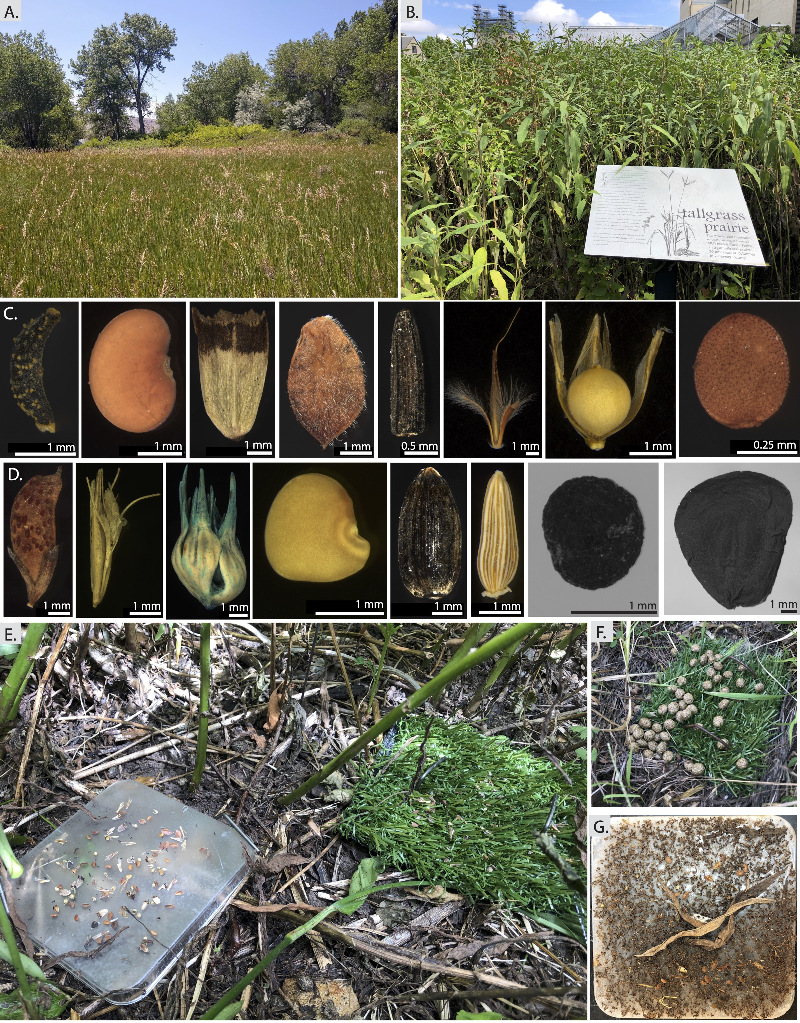
Figure 1: Depiction of our experimental sites, seeds, and methods. A) The Colorado grassland site. B) The Missouri grassland site. C) Missouri seeds used in the experiment (from left to right: Coreposis tinctoria, Desmodium canadense, Echinacea pallida, Lespedeza capitata, Rudbeckia hirta, Schizachyrium scoparium, Sporobolus heterolepis, Triodanis perfoliata). D) Colorado seeds used in the experiment (from left to right: Amorpha fruticosa, Bouteloua gracilis, Buchloe dactyloides, Dalea purpurea, Helianthus annuus, Solidago rigida, Sisyrinchium angustifolium, Yucca glauca). E) A comparison of the sticky and artificial grass traps after they were placed in the field. F) artificial grass traps with rabbit droppings. G) Sticky traps covered in ant bodies and leaves.

Figure 2: Proportion of seeds recovered for each species from both artificial grass (purple) and sticky (pale pink) traps at the A) Missouri site, and B) Colorado site. For each state, panels are in seed size ordered from smallest (left) to largest (right).
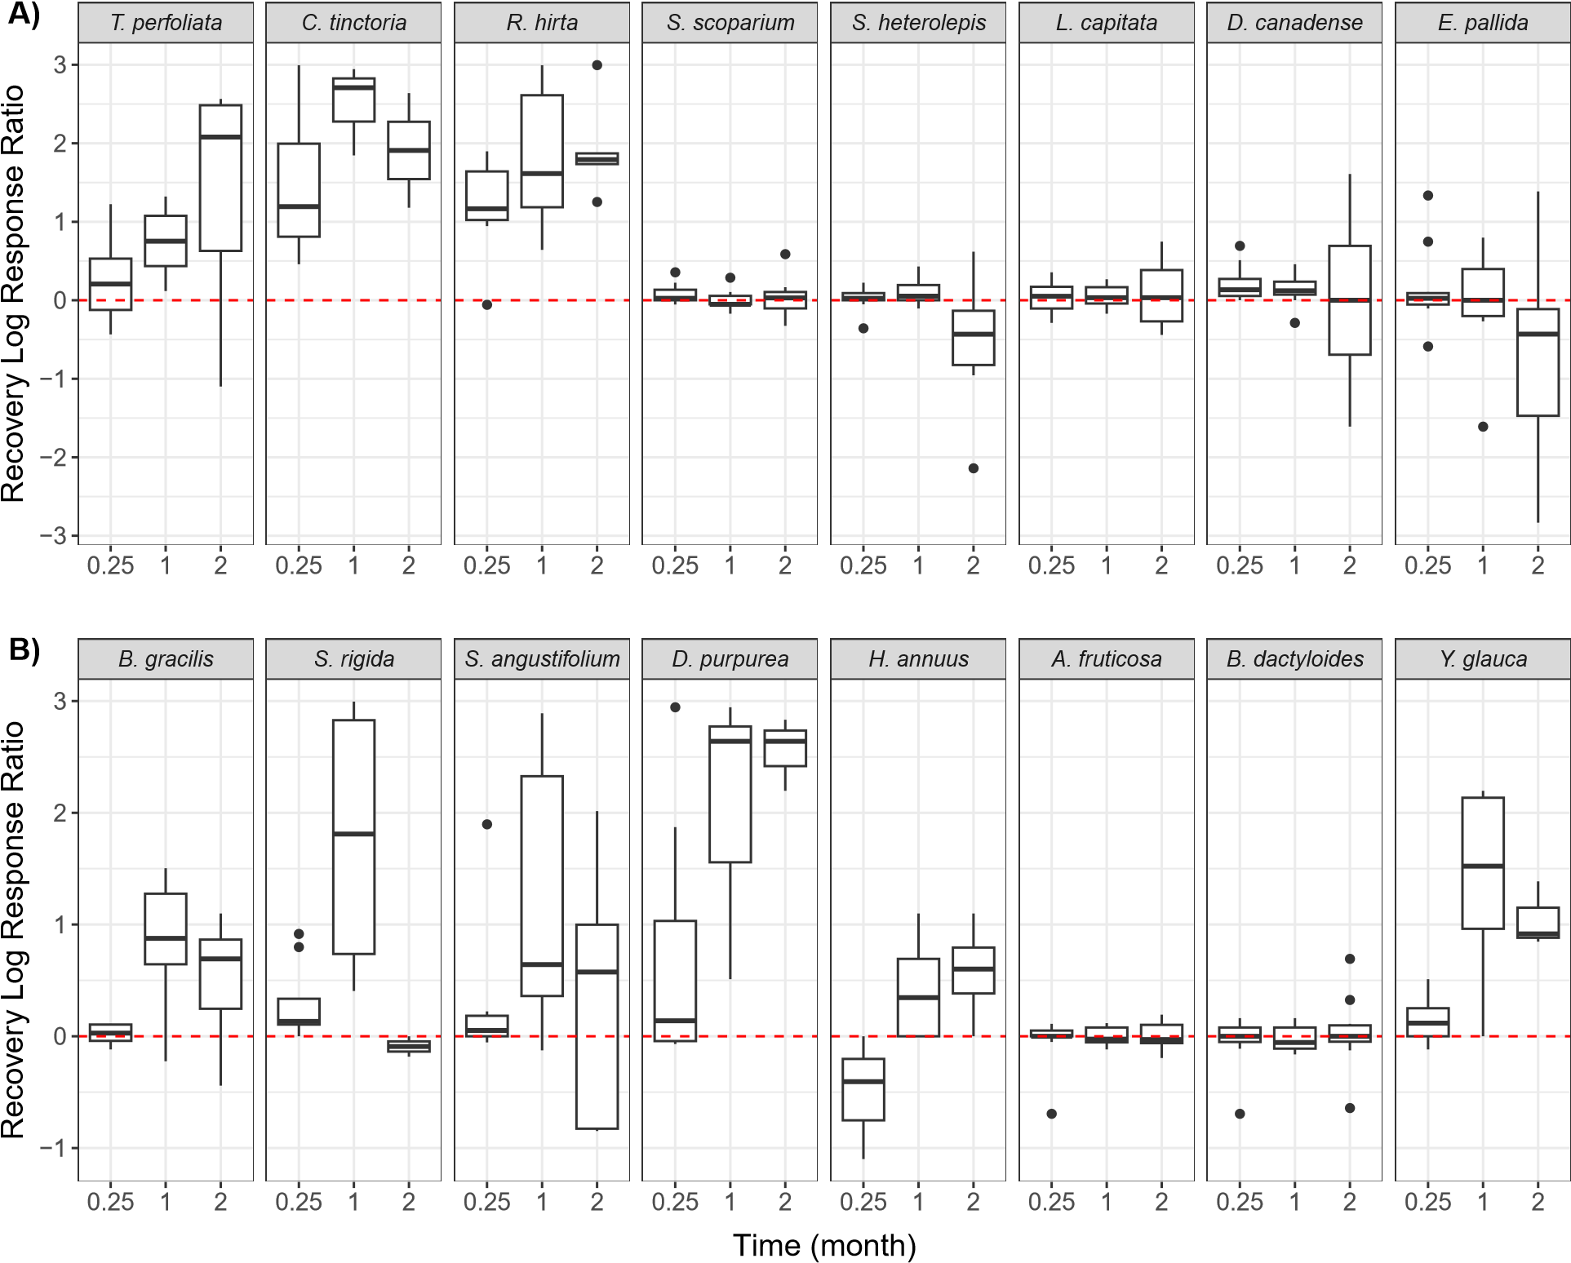
Figure 3: Log response ratio of proportion of seeds recovered in sticky traps relative to proportion of seeds recovered on artificial grass traps from the A) Missouri site, and B) Colorado site. For each state, panels are in seed size ordered from smallest (left) to largest (right). Values of zero (red dashed line) represent equal likelihood of recapture in sticky vs artificial grass traps. Values above zero indicate where seeds were more likely to be recovered on sticky traps. Values below zero represent where seeds more likely to be recovered on artificial grass traps.
Figure 4: Proportion of seeds recovered in relationship to seed mass with respect to trap type (pink points are artificial grass traps, orange points are sticky traps). As seed mass increases, we find a decrease in the proportion of seeds recovered from sticky traps, and an increase in proportion of seeds recovered from artificial grass traps. Points and lines represent model predicted values, points have been jittered.

Figure 5: Proportion of seeds recovered with respect to trap type for the traps that had been out in the field for one month in Missouri (i.e. sticky, artificial grass and post-sticky traps). Data are mean model predicted values, and error bars represent standard deviation.

