Design Document for:

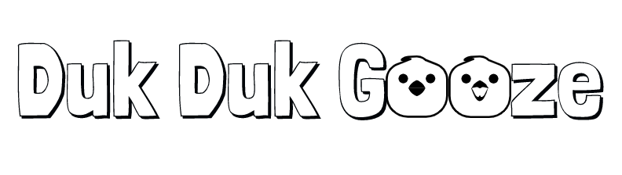
Madness and Mayhem in a Maze

Play as a Corporate Lackey who must drink Energy Drinks to stay awake as he dodges his deadlines and responsibilities that have personified themselves as Giant Ducks.

Programming Digital Game Engines

Sean O'Sullivan

K00180620

Table of Contents

Game Overview 3
Game Design Goals 3
Goal #1 3
Goal #2 3
Goal #3 3
Common Questions 3
What is the game? 3
Why create this game? 3
Where does the game take place? 3
What do I control? 3
How many characters do I control? 3
Feature Set 4
General Features 4
Gameplay 4
The Game World 5
Overview 5
Camera 5
Game Engine 5
User Interface 5
Sound Design 5
Game Characters 6
EMPLOYEE 42 6
Giant Ducks 6
Power Ups 7
Overview 7
Power Up Details #1 7
Power Up Details #2 7
Power Up Details #3 7
Class Diagram 8
Appendix 9
Implementation Notes 9

Game Overview

Game Design Goals

Goal #1

Design a game based on a maze. I want to create a game that uses the setting as one of its mechanics, I want to surprise the player and I want them to not expect what is going to happen next.

Goal #2

Sleek visual style. Using the smooth low-poly assets we were provided in the Create with Code course, I want to keep everything else in the game matching this style.

Goal #3

Ease of use. I want the player to be able to play and complete the game with little to no direction. With short and concise levels and gameplay.

Common Questions

What is the game?

The game is a puzzle platformer where the player must navigate to the end of the maze while avoiding enemies. Once the player collects a Power Up at the end of the maze the rules of the maze change, and the player can clear out the enemies from the maze to win the level. The game features 3 levels that scale up in difficulty as the player progresses.

Why create this game?

This game is a homage to PacMan as well as a critique on work culture where we are living to work instead of working to live.

Where does the game take place?

The game takes place in the ugly, winding streets of a dystopian society where we join our main character on his daily commute.

What do I control?

Duk Duk Gooze puts the player in control of EMPLOYEE 42, a low-level desk jockey at G Corp, the producer of the hit sugar free and heavily caffeinated GOOZE energy drink. Employees at G Corp must keep consuming the product to ensure that their productivity stays at a healthy 92.342% and unwanted distractions like sleep and a social life are kept to a minimum.

How many characters do I control?

If the player fails to complete a level, EMPLOYEE 42 will be replaced by 43, 44, 45 etc.

Feature Set

General Features

Isometric camera style
Sleek, low-poly art style
Unique Enemy
Fun, Physics based Power Up system
Scalable Difficulty

Gameplay

Navigate a series of challenging mazes
Avoid a terrifying enemy
Collect a Power Up to level the playing field

The Game World

Overview

Set in a dystopian society where corporations have taken control of the world and individualism has been stricken out. People have been sold to these corporations at birth and must work there till they expire. They are given a number and must spend their days at work or traveling to work and sometimes a bit of both. The planet is littered with towering skyscrapers, the city planning has been efficient as possible, grass and trees have been replaced with office buildings and cubicles. The denizens of this world must navigate a winding, grey maze of bleak, empty streets.

Camera

The Orthodontic camera view provides a sleek, smooth surface that the player can navigate through as well as making the Assets pop in the scene. The camera will be in a fixed position, which gives a clear overhead view for the player to see everything in the scene.

Game Engine

For the development this game, I will be using Unity as it is a free and easy to learn engine that still has very powerful capabilities under the hood. It also supports cross platform development, that can be utilized if I wish to port the game to other platforms. Unity’s built in Physics engine will handle all the collisions in the game, as well as providing a fun experience for the Power Ups. Unity also breaks down Animation into easy to use and understand way and this well help with all the animations in the game.

User Interface

The game will have a title screen displaying the Logo and a button to start the game. When the player is playing the game, if the player dies, they will be given the option to restart the level or return to the title screen. Once the player has completed the levels, they will be brought to a credits screen and given the option to return to the title screen.

Sound Design

The game will have a lo-fi beat to set the scene of EMPLOYEE 42 feeling drowsy and the music will get more frantic and erratic as the player progresses, mirroring the characters mental state. I will use the premade Sound Effects from the Create with Code Assets.

Game Characters

EMPLOYEE 42

EMPLOYEE 42 has worked at G Corp his entire life, he was sold to the corporation at birth for one of those clicky pens that have four different colours. At 14, he was the only one in his class voted most likely to reach an efficiency rate of 95% by his classmates. The award was taken from him however as the concept of voting was deemed to conflict with the interests of the corporation. The teacher that encouraged the exercise has since been re-educated. EMPLOYEE 42 has achieved no other accolades.

Giant Ducks

The Giant Ducks that EMPLOYEE 42 encounters on his commute are a side effect of his frequent consumption of Gooze. The Ducks roam the winding streets and if EMPLOYEE 42 is caught by one he falls into a deep sleep that will cause him to fall behind on his deadlines and he will be reprimanded for his failures. The only way to repel the ducks is to keep consuming the Gooze or to take 5 days off from work. EMPLOYEE 42 must chose the former.

Power Ups

Overview

The player must seek and consume a can of Gooze to progress the level. Once this is obtained, the player can freely move through the world and they can seek out the enemy and destroy them to progress to the next level. The Power Up does not time out.

Power Up Details #1

The Power Up causes the obstacles in the maze to be destroyed. They will react to the player colliding with them and play a sound effect when destroyed.

Power Up Details #2

The player can run into enemies and they will be hit with an impulse force and fly off the map. Once they are out of view of the player they will be destroyed.

Power Up Details #3

The player will have a particle effect on them when they have obtained the power up.

Class Diagram

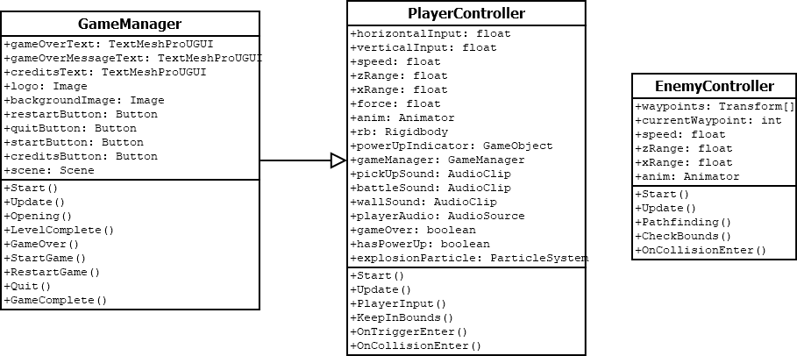

Appendix

Implementation Notes

On completion of the project that were a few things that did not make the final build. When creating the walls for the maze I was getting a bug that caused the walls to fall through the ground. I liked how this looked so I wanted this to be part of the game. When the player picked up a Power Up, I wanted them to break through the walls or float off when touched. In the final build however I just stuck with the blocks being destroyed as the sound effect causes a satisfying effect and I was getting more bugs when I was trying to implement it. There is also a bug with the enemy’s movement, they face one direction and do not face the direction they are travelling. I found a solution to fix this, similar with how the Player faces the direction that they move in, but the motion of the enemy turning causes it to get caught on walls and the enemies need physics for when the Player has a power up and can send them flying. I commented out the code for both of these planned features.

