Lab1

First of all I have Arch Linux (gnome edition) already installed to my laptop :3

I have configured Kitty terminal.
I started by making the ip shell script to my working directory
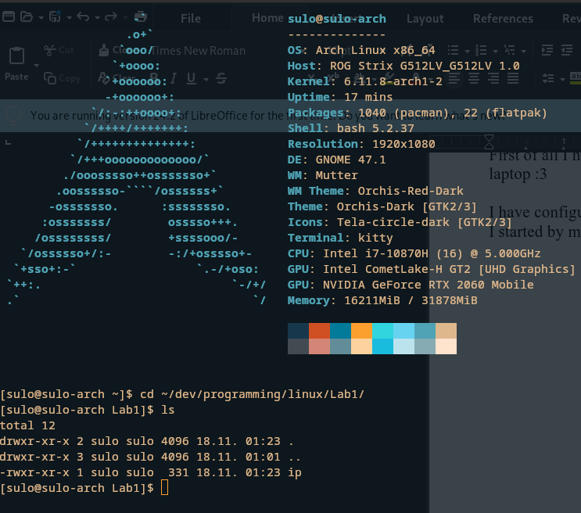

The script:
#!/bin/bash
# Check if the option -v is provided
if [[ "$1" == "-v" ]]; then
#grab ip, subnet and broadcast addresses
ip addr show | grep -E 'inet|broadcast' | awk '{print "IP Address: " $2 " Subnet Mask: " $4 " Broadcast Address: " $6}'
else
#grab only the ip addresses
ip addr show | grep -oP 'inet \K[\d.]+'
fi

Then I copied the script to /usr/bin and made it executable with chmod +x ip. I ran the command from my terminal by writing the command name. Ip I couldn’t get to work even if I removed the default system ip command (no shit xD) so I named the .sh script to ipcheck and then it worked without problems.
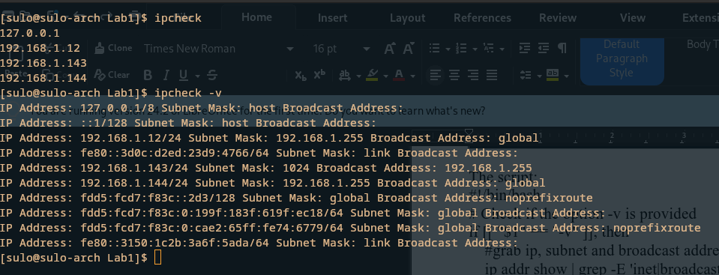

Hope this was the right way of doing this.

