Medical Insurance Charges Analysis
Part A: Categorical and Group Comparison Analysis

1. Background and Problem Statement
This report analyzes a medical insurance cost dataset with 1,338 individual beneficiaries. The dataset includes demographic and health-related variables: age, sex, BMI, number of children/dependents, smoking status, U.S. region, and individual medical costs billed by health insurance.
The response variable is insurance charges. This variable is important because it represents the medical cost billed for each individual and can be used to understand which factors are associated with higher or lower insurance costs.
Problem statement: insurance charges vary substantially across individuals. This analysis examines whether charges differ across important categorical groups and whether smoking status remains significant after controlling for BMI.

2. Dataset Overview
Variable | Description | Data Type
age | Age of primary beneficiary | Quantitative / continuous
sex | Insurance contractor gender | Categorical
bmi | Body mass index | Quantitative / continuous
children | Number of dependents covered by insurance | Quantitative / discrete
smoker | Smoking status | Categorical
region | Residential area in the U.S. | Categorical
charges | Individual medical costs billed by insurance | Quantitative / continuous

3. Objectives and Hypotheses
- Identify whether insurance charges differ by smoking status.
- Test whether insurance charges differ across U.S. regions.
- Use Tukey post-hoc testing to determine which regions differ after ANOVA.
- Test whether smoking status affects charges after controlling for BMI using ANCOVA.
- Test whether smoking status and region are related using a chi-square test.
Main hypotheses:
- Smokers and non-smokers have different mean insurance charges.
- At least one region has a different mean insurance charge.
- Smoking status significantly affects insurance charges after controlling for BMI.
- Smoking status and region may be related.

4. Descriptive Statistics

4.1 Continuous Variables
Variable | Mean | Median | SD | Min | Max
Age | 39.21 | 39.00 | 14.05 | 18.00 | 64.00
BMI | 30.66 | 30.40 | 6.10 | 15.96 | 53.13
Charges | 13,270.42 | 9,382.03 | 12,110.01 | 1,121.87 | 63,770.43

The mean insurance charge was higher than the median, which suggests that charges are right-skewed due to a smaller number of very high charges.

4.2 Categorical Variables
Variable | Category | Count | Percent
sex | female | 662 | 49.48%
sex | male | 676 | 50.52%
smoker | no | 1,064 | 79.52%
smoker | yes | 274 | 20.48%
region | northeast | 324 | 24.22%
region | northwest | 325 | 24.29%
region | southeast | 364 | 27.20%
region | southwest | 325 | 24.29%
children | 0 | 574 | 42.90%
children | 1 | 324 | 24.22%
children | 2 | 240 | 17.94%
children | 3 | 157 | 11.73%
children | 4 | 25 | 1.87%
children | 5 | 18 | 1.35%

5. Visualizations
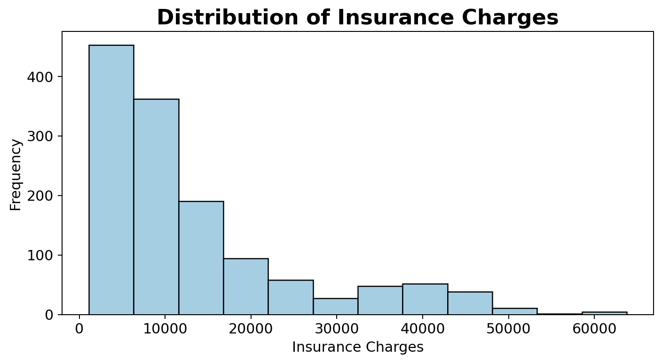
Figure 1. Distribution of insurance charges.
The histogram shows that insurance charges are right-skewed. Most individuals have lower charges, while a smaller group has very high charges.
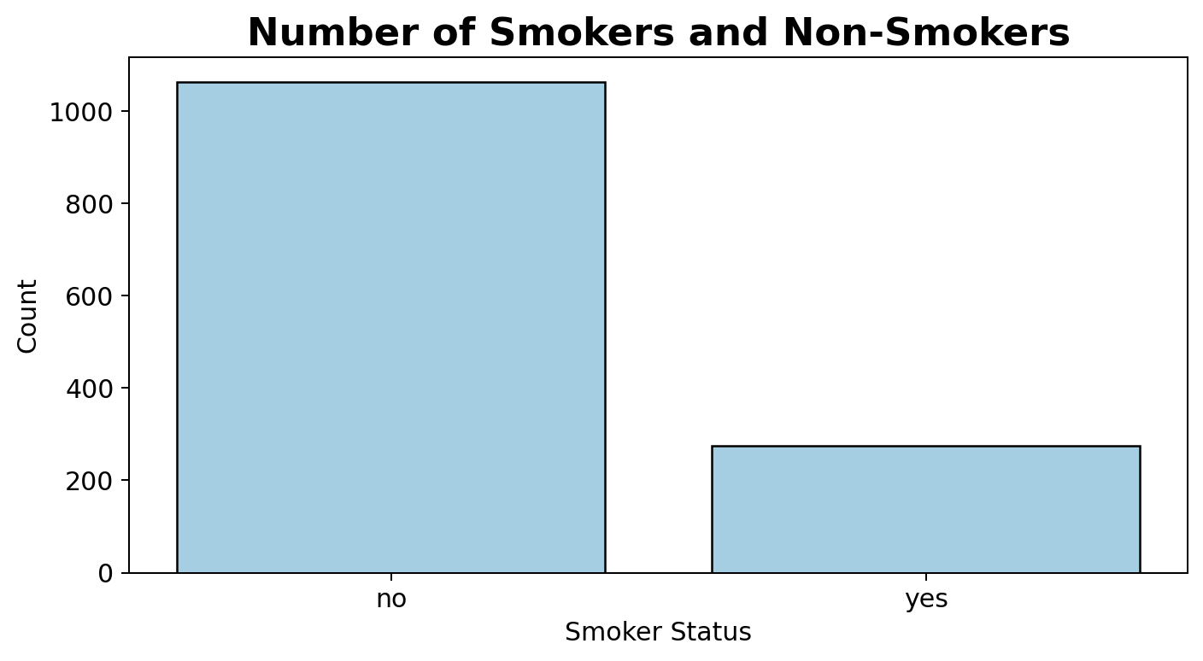
Figure 2. Number of smokers and non-smokers.
Most observations are non-smokers: 1,064 non-smokers compared with 274 smokers.
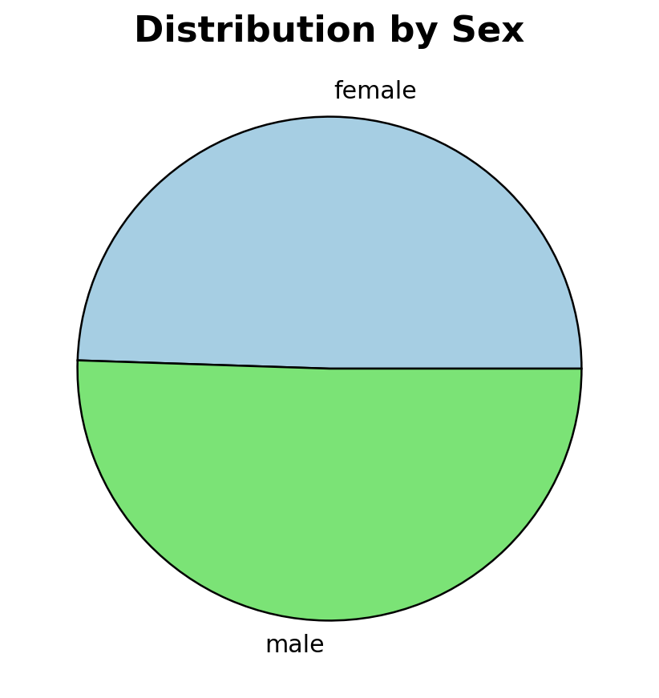
Figure 3. Distribution by sex.
The dataset is almost evenly split by sex, with 662 females and 676 males.
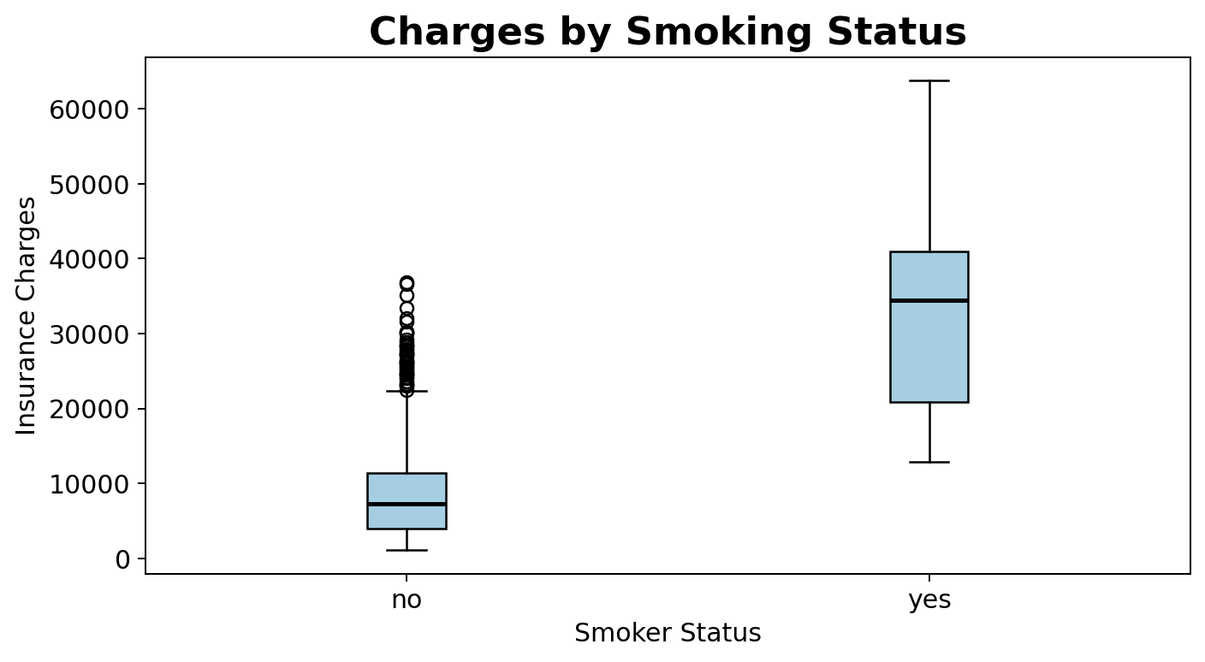
Figure 4. Insurance charges by smoking status.
The boxplot shows a large difference in charges between smokers and non-smokers, with smokers having substantially higher charges.

6. t-Test: Charges by Smoking Status
Hypotheses: H0: mean charges are equal for smokers and non-smokers. Ha: mean charges are different for smokers and non-smokers.
Group | Mean Charges | Standard Deviation | n
Non-smokers | $8,434.27 | $5,993.78 | 1,064
Smokers | $32,050.23 | $11,541.55 | 274

Test | Statistic | df | p-value | Decision
Welch two-sample t-test | t = -32.752 | 311.85 | < 2.2e-16 | Reject H0

Conclusion: smokers had significantly higher insurance charges than non-smokers.

6.1 t-Test Assumption Checks
Assumption | Result | Interpretation
Normality, non-smokers | Shapiro p < 2.2e-16 | Not fully met
Normality, smokers | Shapiro p = 3.625e-09 | Not fully met
Equal variance | F-test p < 2.2e-16 | Not met

Because the equal variance assumption was not met, the Welch t-test was used. Welch testing is more appropriate than the pooled two-sample t-test when group variances are unequal.

7. ANOVA: Charges by Region
Hypotheses: H0: mean charges are equal across all regions. Ha: at least one region has a different mean charge.
Region | Mean Charges | Standard Deviation | n
Northeast | $13,406.38 | $11,255.80 | 324
Northwest | $12,417.58 | $11,072.28 | 325
Southeast | $14,735.41 | $13,971.10 | 364
Southwest | $12,346.94 | $11,557.18 | 325

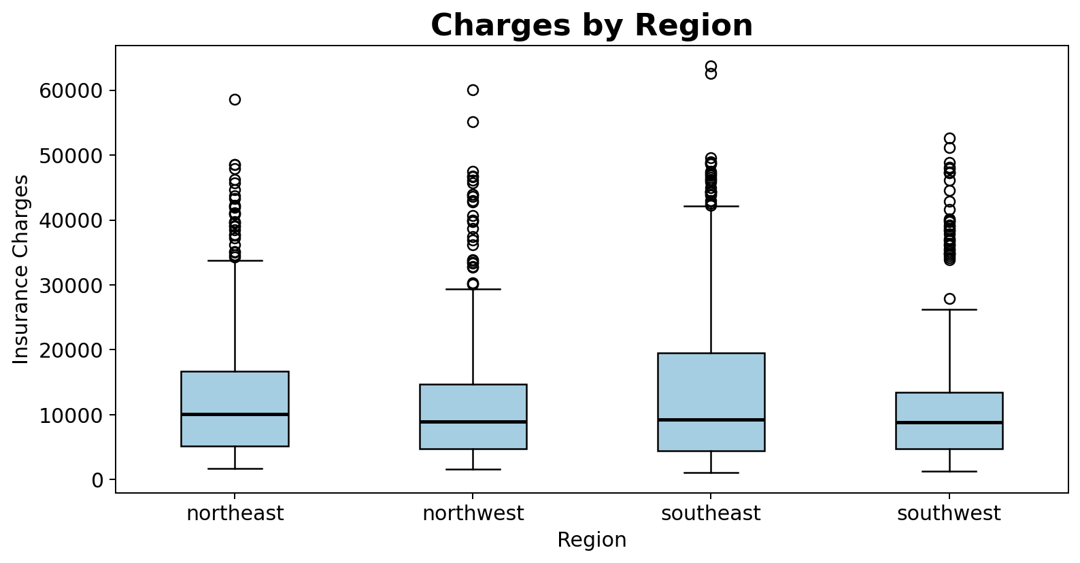
Figure 5. Insurance charges by region.
Test | F-value | p-value | Decision
One-way ANOVA | 2.970 | 0.0309 | Reject H0

Conclusion: insurance charges differed significantly by region.

7.1 Tukey Post-Hoc Test
Comparison | Adjusted p-value | Result
Southwest vs Southeast | 0.0477 | Significant
Southeast vs Northwest | 0.0583 | Not significant
Other comparisons | > 0.05 | Not significant

The only significant pairwise regional difference was between Southeast and Southwest. The Southeast region had significantly higher average charges than the Southwest region.

7.2 ANOVA Assumption Checks
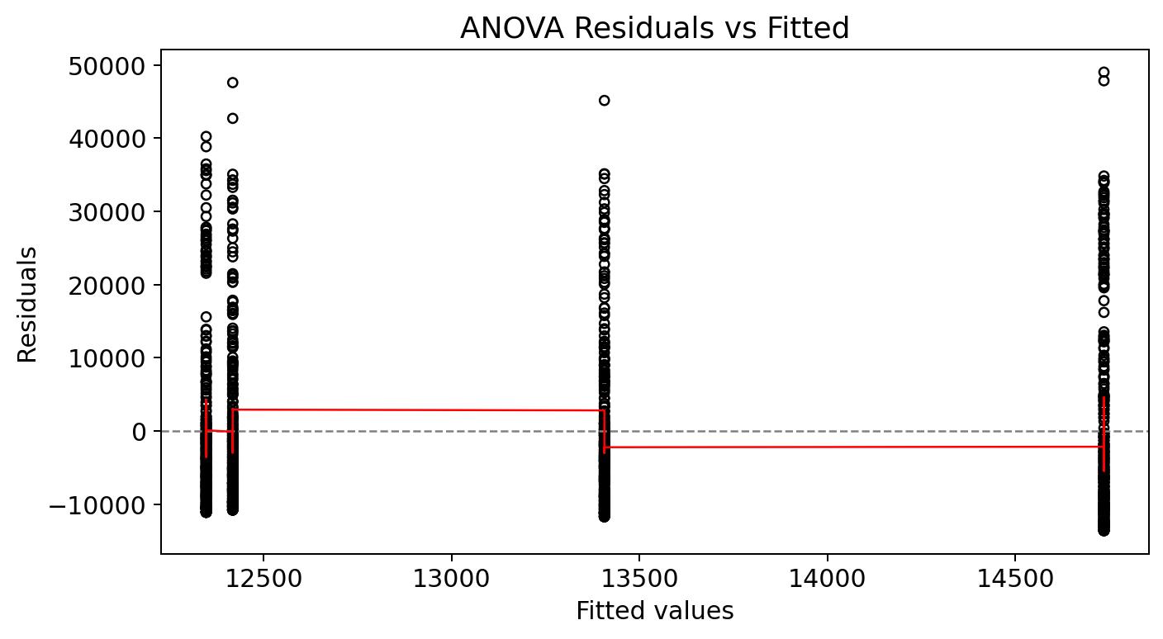
Figure 6. ANOVA residuals versus fitted values.
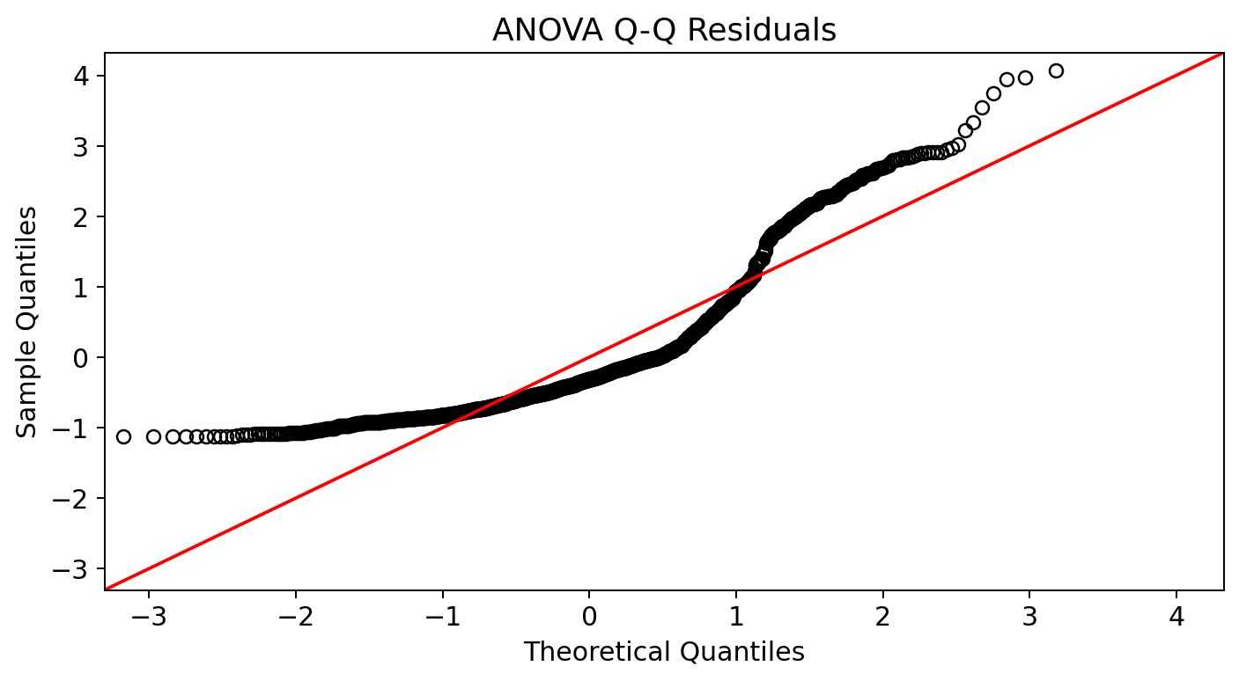
Figure 7. ANOVA Q-Q residual plot.
Assumption | Result | Interpretation
Residual pattern | Uneven spread in residual plot | Possible unequal variance
Normality of residuals | Shapiro p < 2.2e-16 | Not fully met
Equal variance | Bartlett p = 1.009e-05 | Not met

Because the ANOVA assumptions were not fully met, the ANOVA result should be interpreted with caution.

8. ANCOVA: Smoking Status Controlling for BMI
The ANCOVA tested whether smoking status affects insurance charges after controlling for BMI. The dependent variable was charges, the categorical independent variable was smoker, and the covariate was BMI.
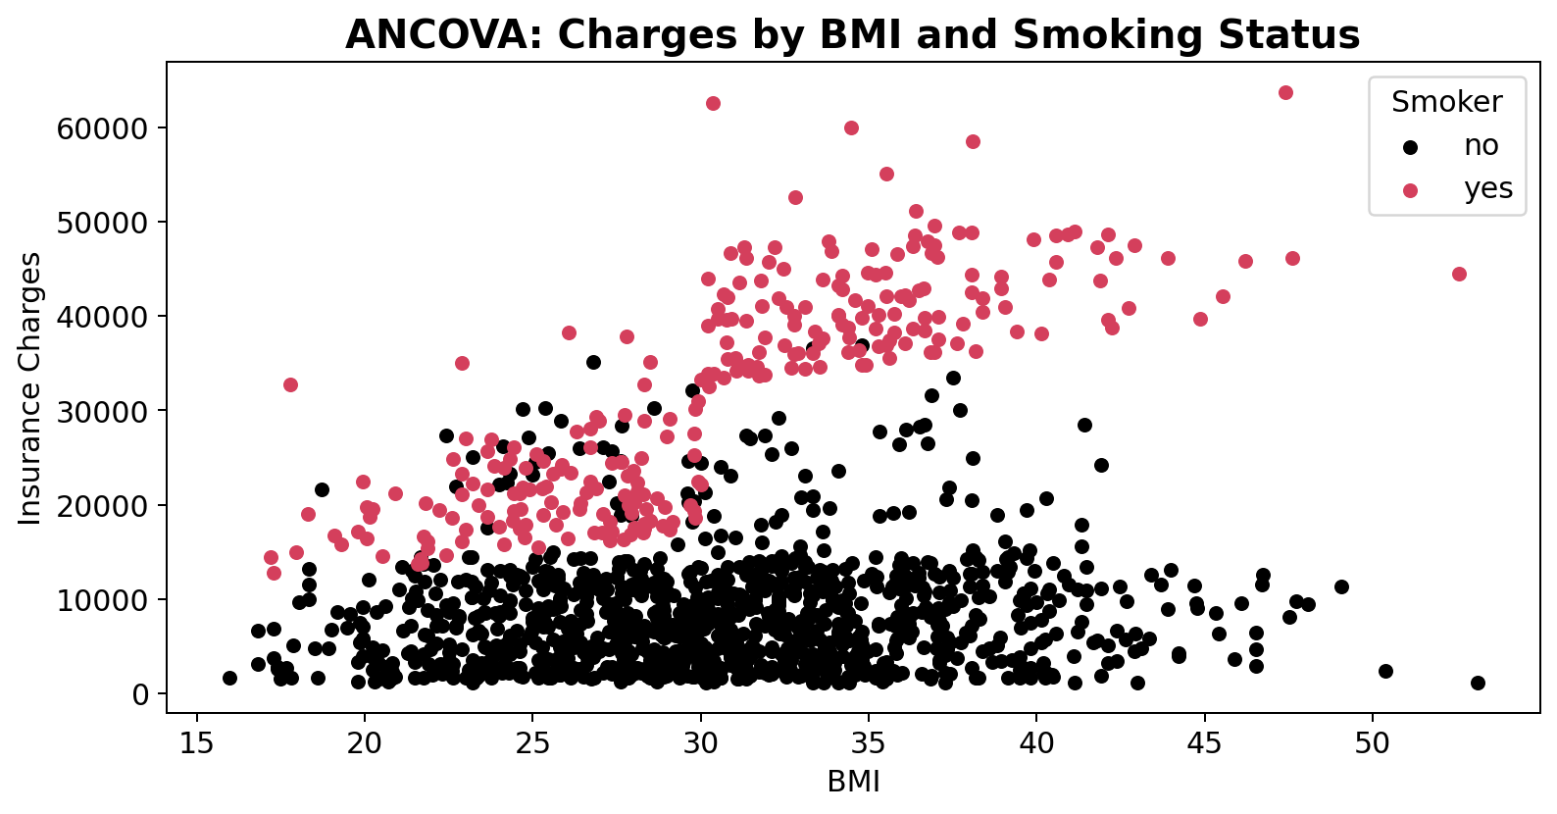
Figure 8. BMI and insurance charges by smoking status.
Variable | F-value | p-value | Result
Smoker | 2419 | < 2e-16 | Significant
BMI | 149 | < 2e-16 | Significant

Conclusion: smoking status and BMI both significantly affected insurance charges.

8.1 ANCOVA Assumption Checks
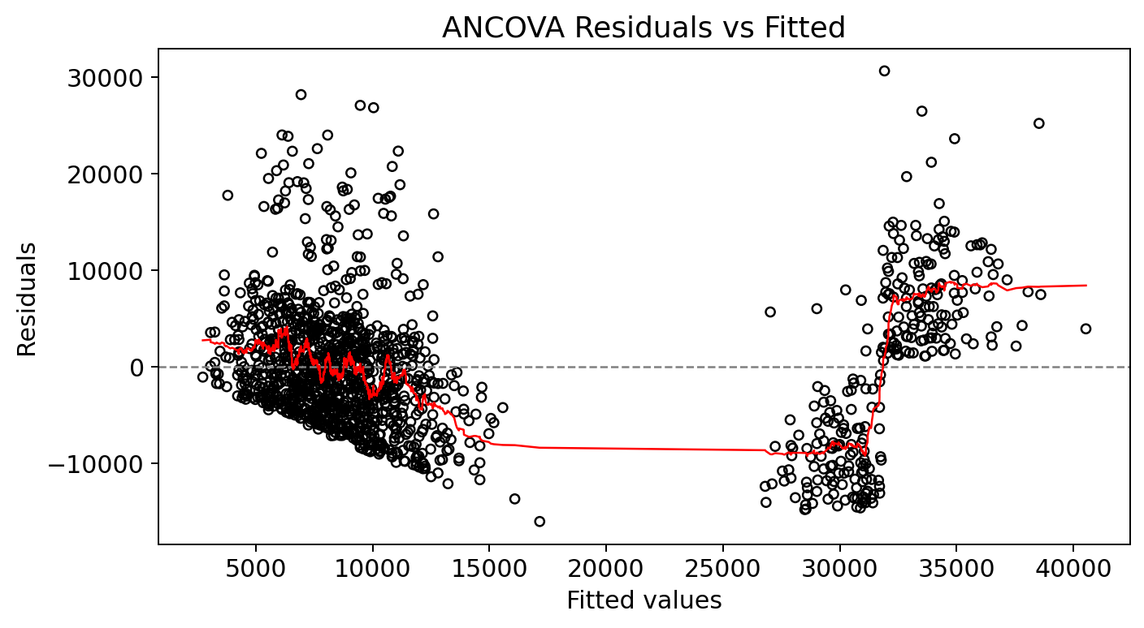
Figure 9. ANCOVA residuals versus fitted values.
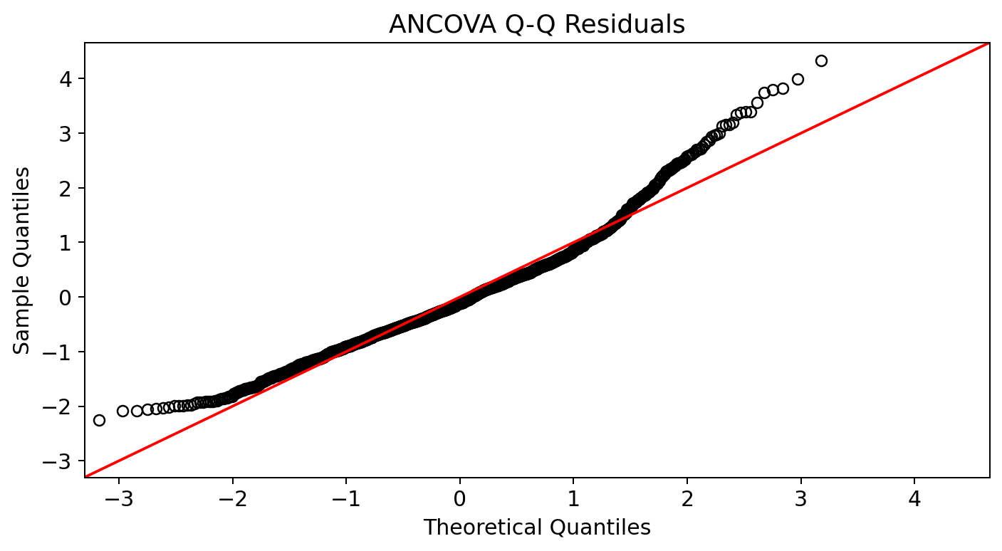
Figure 10. ANCOVA Q-Q residual plot.
Assumption | Result | Interpretation
Homogeneity of slopes | Smoker x BMI interaction p < 2e-16 | Equal slopes not met
Residual pattern | Pattern visible in residual plot | Constant variance not fully met
Normality of residuals | Shapiro p < 2.2e-16 | Not fully met

The significant smoker x BMI interaction means the relationship between BMI and charges differs between smokers and non-smokers. Therefore, the equal slopes assumption was not met, and the interaction is important to mention when interpreting the ANCOVA results.

9. Chi-Square Test: Smoker and Region
Hypotheses: H0: smoker status and region are independent. Ha: smoker status and region are related.
Smoker | Northeast | Northwest | Southeast | Southwest
no | 257 | 267 | 273 | 267
yes | 67 | 58 | 91 | 58

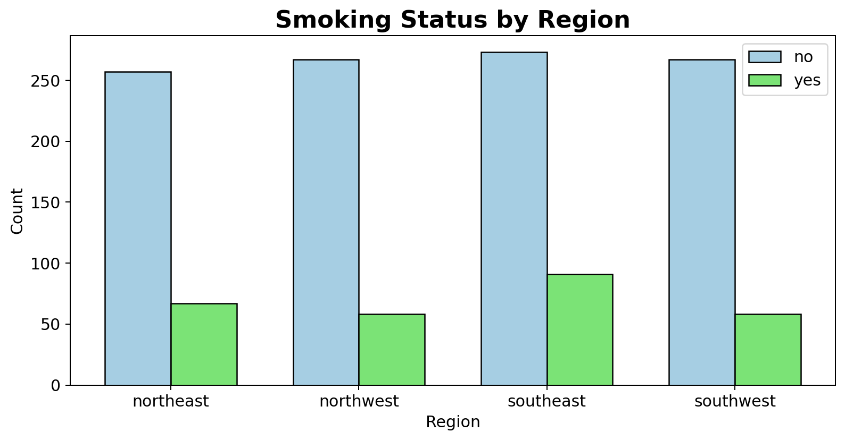
Figure 11. Smoking status by region.
Test | Statistic | df | p-value | Decision
Pearson chi-square test | X-squared = 7.3435 | 3 | 0.0617 | Fail to reject H0

Assumption check: all expected counts were at least 5, so the chi-square expected count assumption was met.
Conclusion: smoker status and region were not significantly related at the 0.05 significance level.

10. Final Conclusion and Recommendations
- Smoking status was strongly associated with insurance charges. Smokers had much higher average charges than non-smokers.
- Region had a statistically significant effect on charges, with the Southeast significantly higher than the Southwest in the Tukey comparison.
- BMI and smoking status were both significant in the ANCOVA model.
- The significant smoker x BMI interaction suggests the effect of BMI on charges differs by smoking status.
- Smoker status and region were not significantly related in the chi-square test.
Recommendation: insurance cost prediction models should strongly consider smoking status and BMI because they were the most important risk-related factors in this portion of the analysis. Regional differences may also be relevant, but the ANOVA assumption checks suggest that the regional findings should be interpreted with caution.

11. Notes on Assumptions
Several tests showed violations of normality and equal variance assumptions. This is partly due to the strongly right-skewed distribution of insurance charges. These assumption checks do not erase the observed group differences, but they do mean the statistical results should be interpreted carefully. In a full model, transformations of charges or robust/nonparametric methods could be considered as follow-up analysis.

