HOW WE WILL CONSIDER UNIT-TESTING

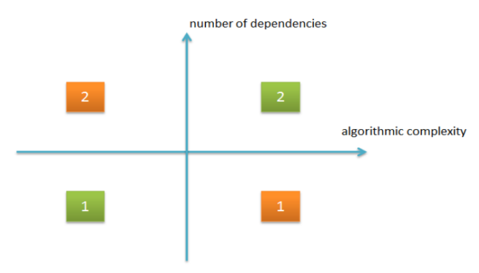

Green 1: Simple code with no dependency. This may not be verified. Simple time and process calculations. Simple code for mathematical solutions.

Green 2: Complex code with many dependencies. Complex code of intra-channel communications, where data is exchanged between the manager and developers, where one code depends on the other.

Red 1: complex code with no dependencies. Algorithms and product-logic. These are important parts of the system that we definitely test.

Red 2: Not very complex code with dependencies. This code links the different components, i.e., deadlines, progress, and developer status. Tests are important to clarify exactly how the interaction should take place.

-Test one thing at a time. Each test should test only one subject.

- If the process is too complex (for example, the final analysis of the entire process of the completed project), divide it into several parts and check them separately.