Draxler Forum Content Plan
  - 10 disclosed community post drafts and a practical publishing sequence
Plan for English-language automotive communities. The copy uses a natural forum voice without hiding the commercial interest: the poster always discloses their link to Draxler and never presents a 3D visual as a photo of a completed customer car.
Core idea: give the audience a useful, specific reason to discuss fitment, proportion, brake visibility, finish or function first, then provide a clear route to the catalog. This mirrors the strongest build and fitment threads among BMW, Mercedes, Porsche and Audi owners.
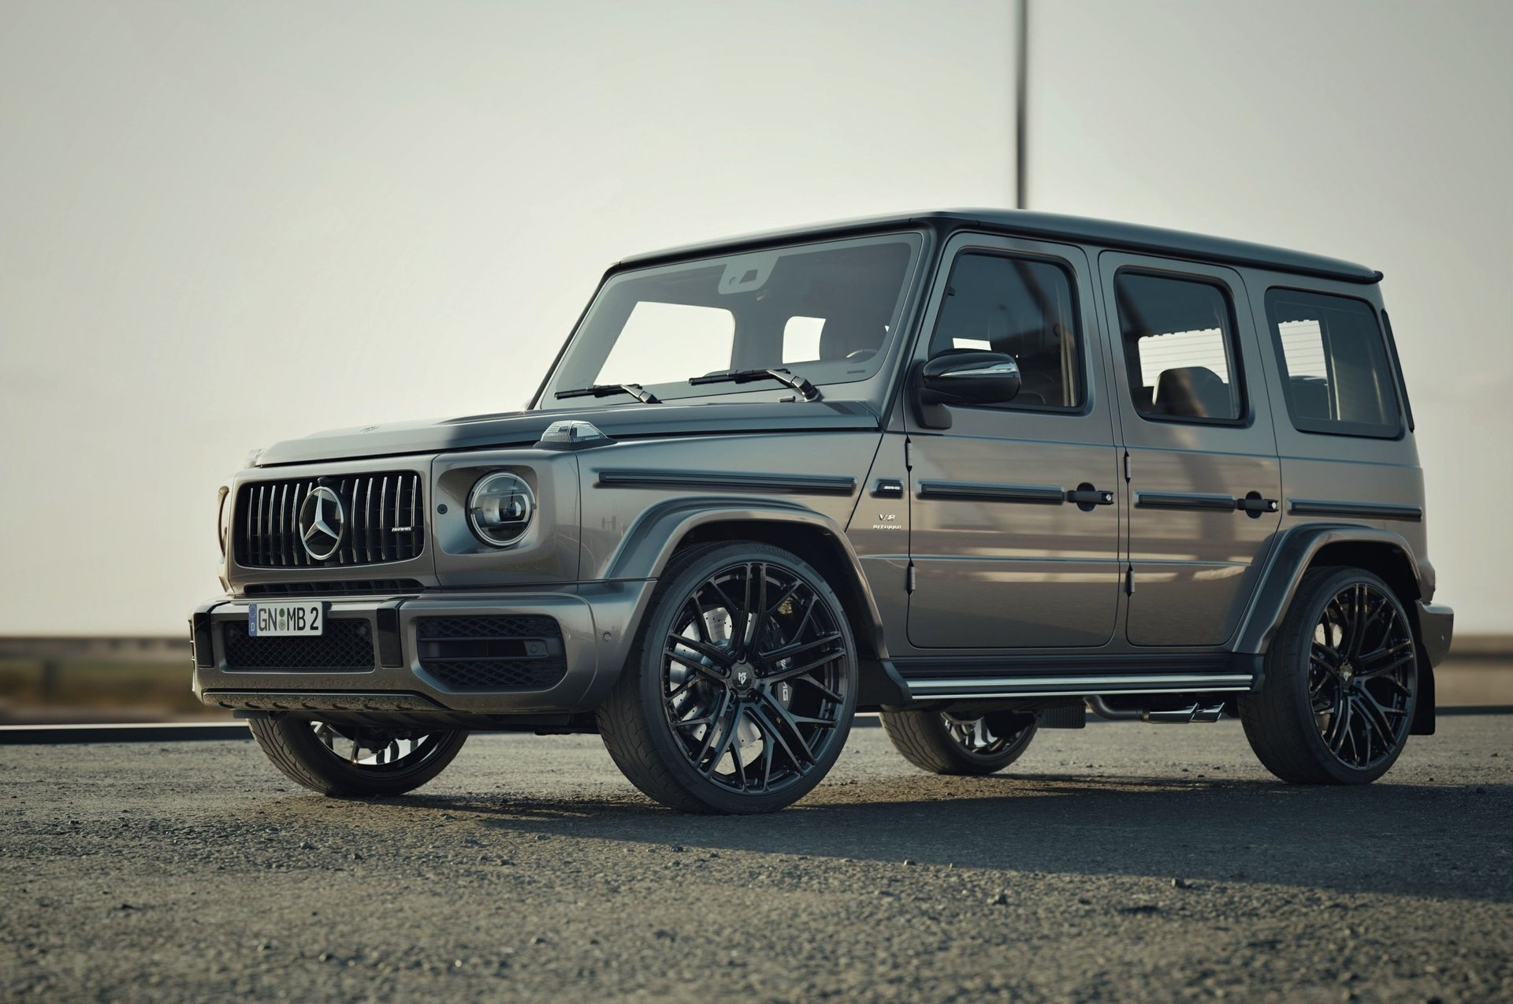
Draxler site visual Mercedes AMG G 63 project
Prepared 20 October 2026

How these posts should behave
Forum voice matters more than brand voice here. Strong discussions do not sell ‘perfect wheels’ in the first sentence. The poster frames one real question, names the limitations and leaves room for disagreement. That is why most drafts below open with full disclosure and a 3D visual study, while technical numbers are offered only after the specific vehicle has been checked.
- No stealth seeding. Put ‘I work with Draxler’ or ‘I’m with the Draxler team’ in the first sentence.
- Label every 3D image as a 3D configuration or visual study. Do not call it an owner build, delivered car or customer car.
- Do not state ET, width, weight, brake clearance, load rating or lead time until it is confirmed for the individual car. Ask for the car data instead and return with a verified specification.
- Use one CTA per post. Direct Draxler links are mandatory in this plan, but keep only one link and comply with the forum’s commercial-link policy.
- Post only in an approved vendor section or after moderator approval. If a community does not permit brand representatives, do not evade that rule with a new account or private messages.

What the research shows
Observed pattern | What Draxler should do
Bimmerpost build threads | The strongest responses centre on a specific car, staggered fitment, tyres and a direct answer on rubbing or brake clearance. Visual taste comes after fitment.
MBWorld Vossen gallery | A product gallery works within the exact model section and is refreshed with visuals. It suits an approved vendor presence, not a random drive-by thread.
Rennlist fitment threads | Trust threshold is high: platform accuracy, separate front and rear details, and clear statements about what is physically installed.
Audizine dealer threads | Catalog announcements belong in an approved vendor context, but the thread needs updates, answers and facts rather than a one-time advertisement.
Reddit owner discussions | Readers quickly ask about diameter, tyres, clearance, maintenance and price. Unsupported hype earns irony rather than leads.

Draxler source material used
Draxler presents Luxury, Sport and Off Road series and a catalog of DRX models. Its website includes visuals for a Mercedes AMG G 63, Rolls Royce Phantom, Porsche and Ford Raptor. The posts below use those assets only as brand visuals or reference images; they are not proof of a completed customer installation.
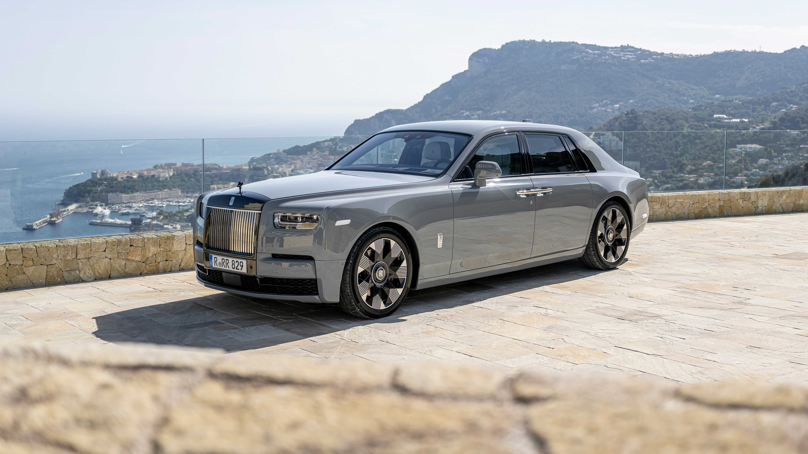  Luxury site visual | 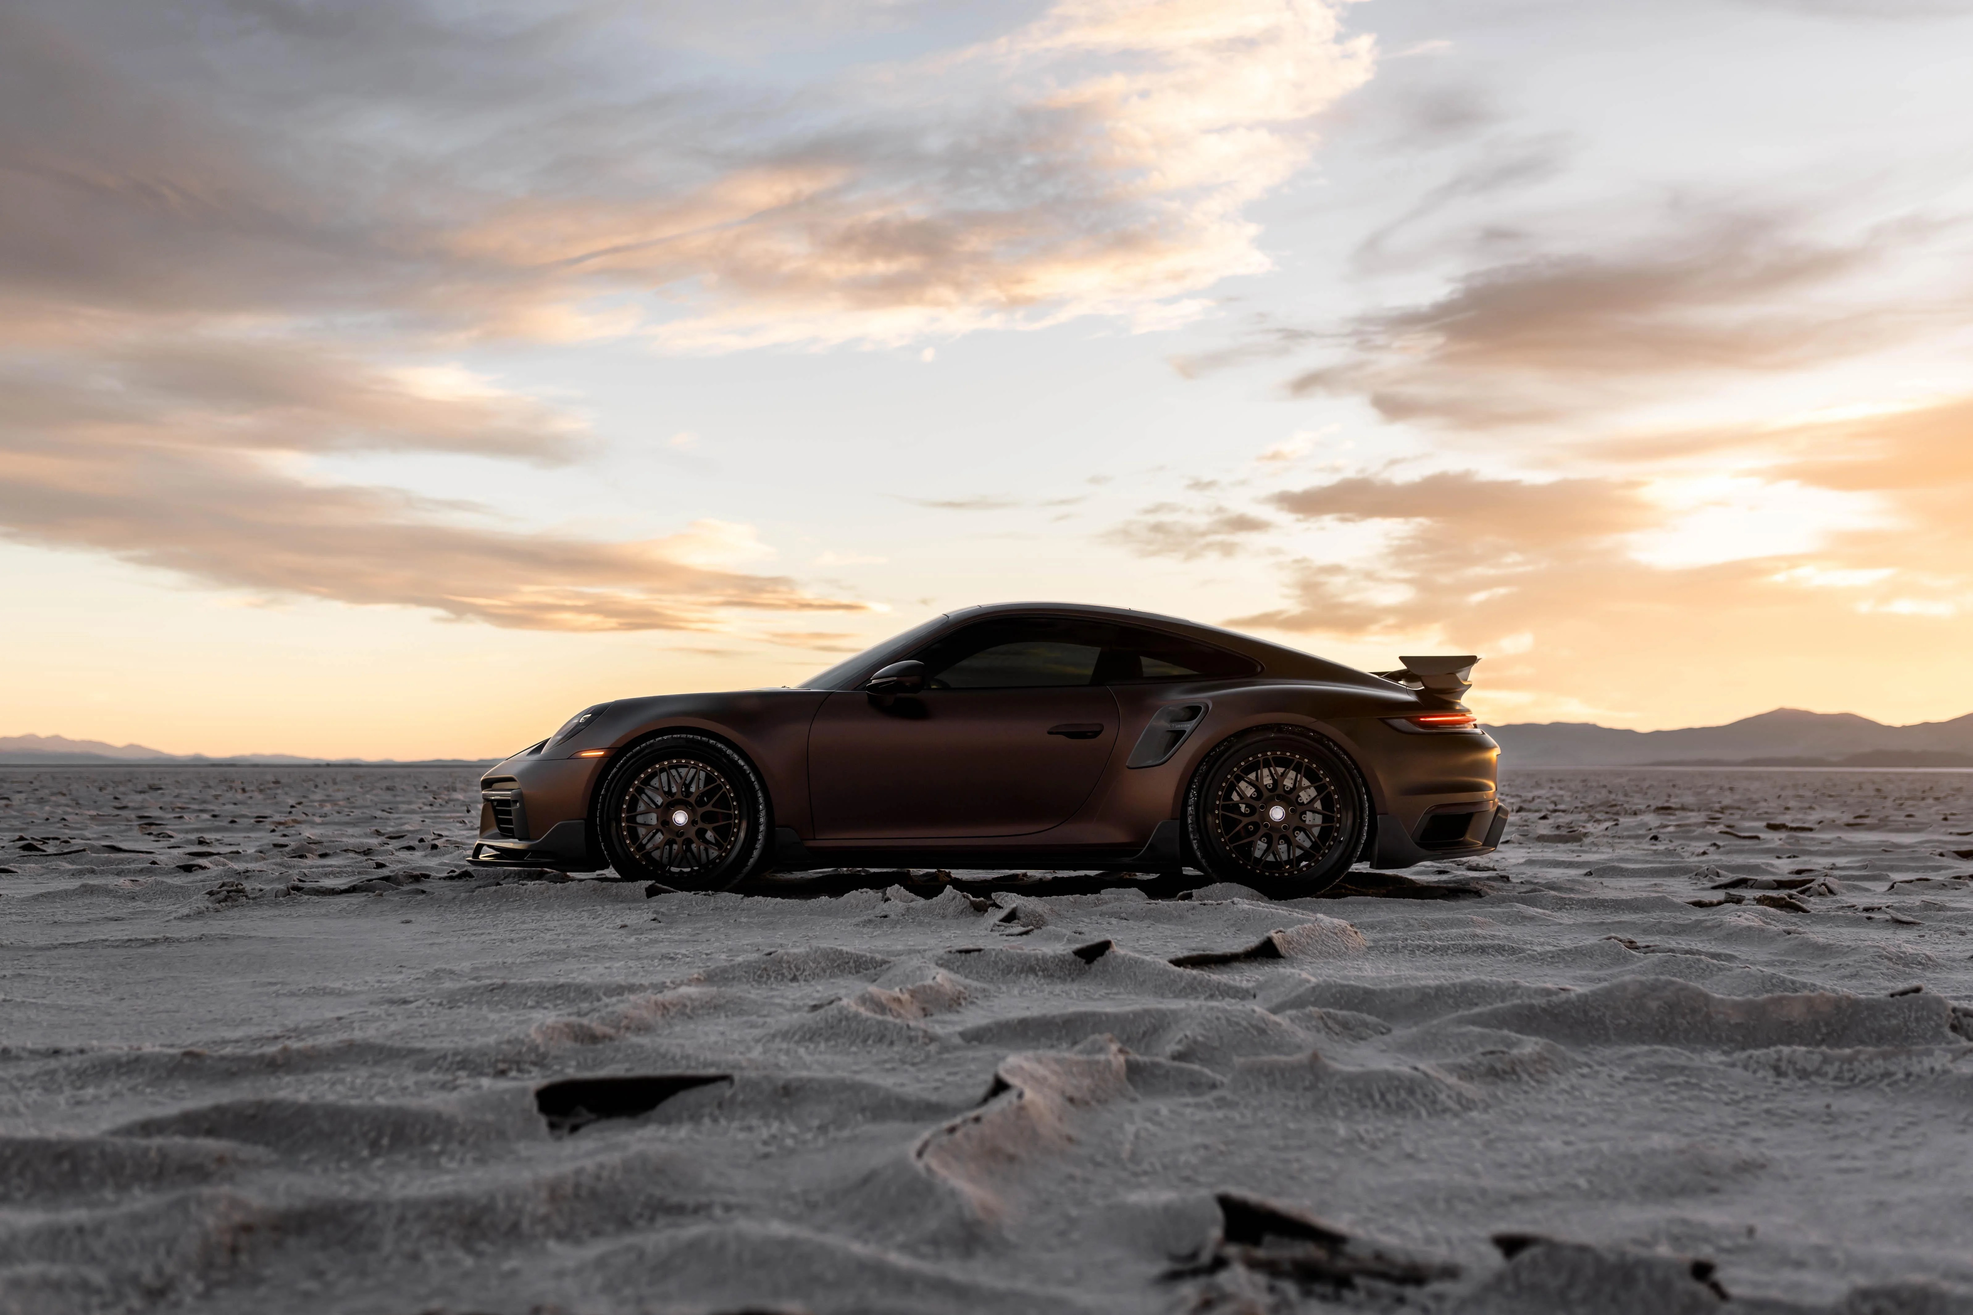  Sport site visual | 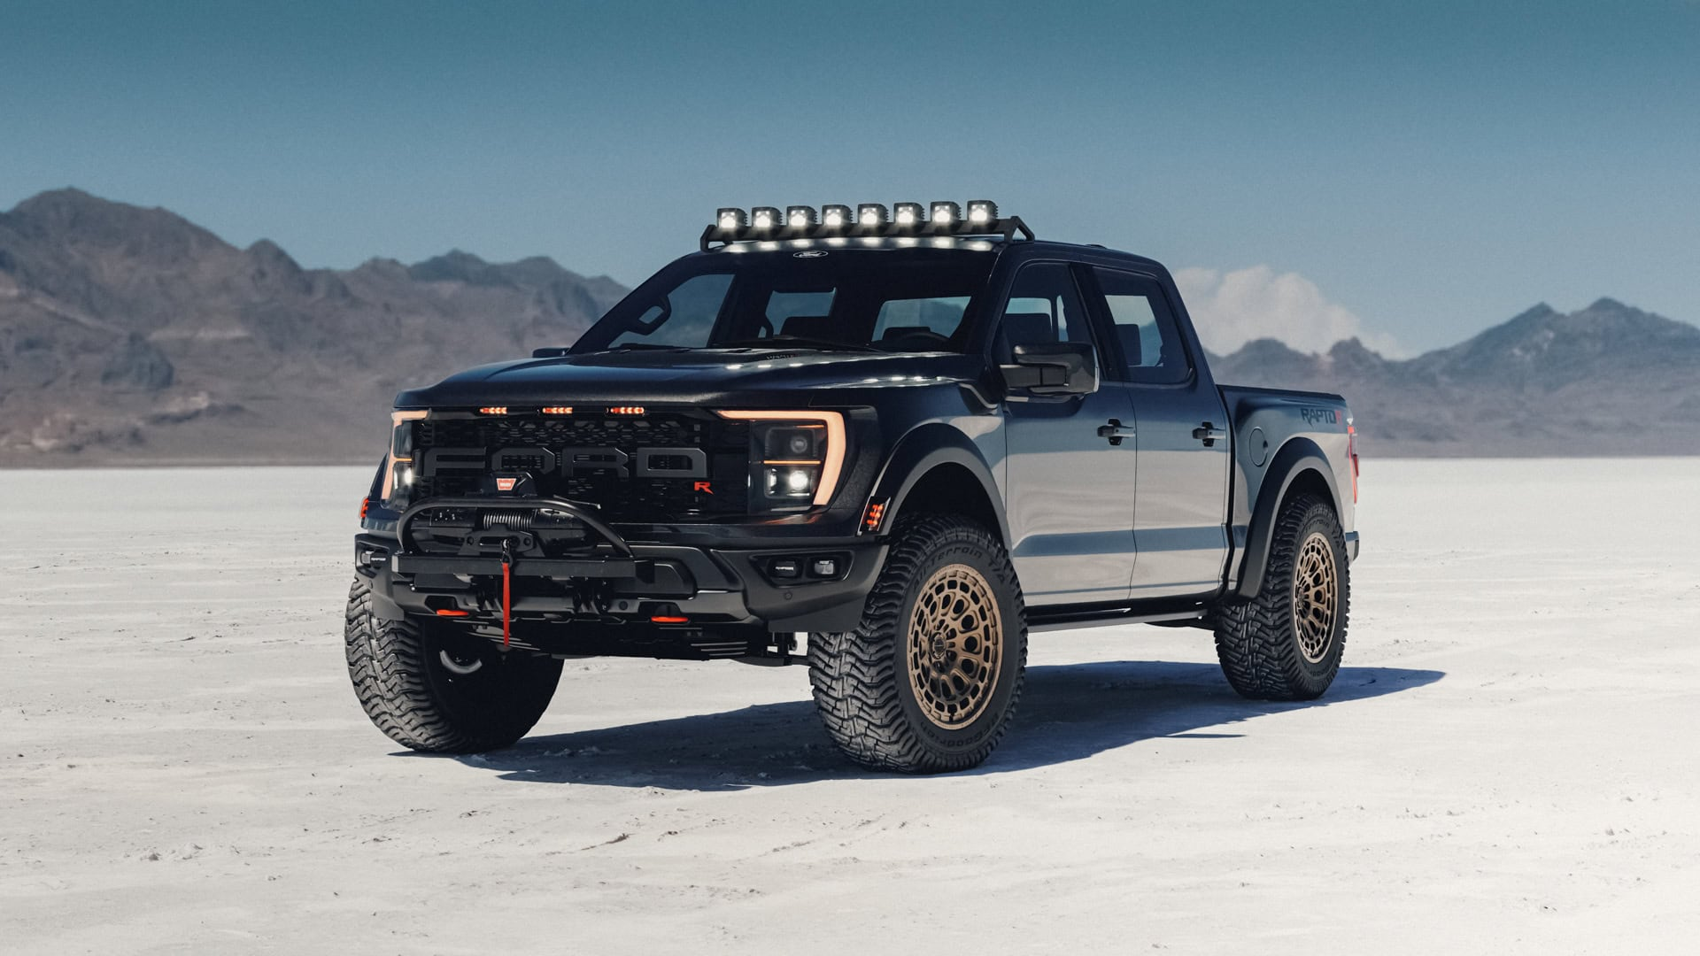  Off Road site visual
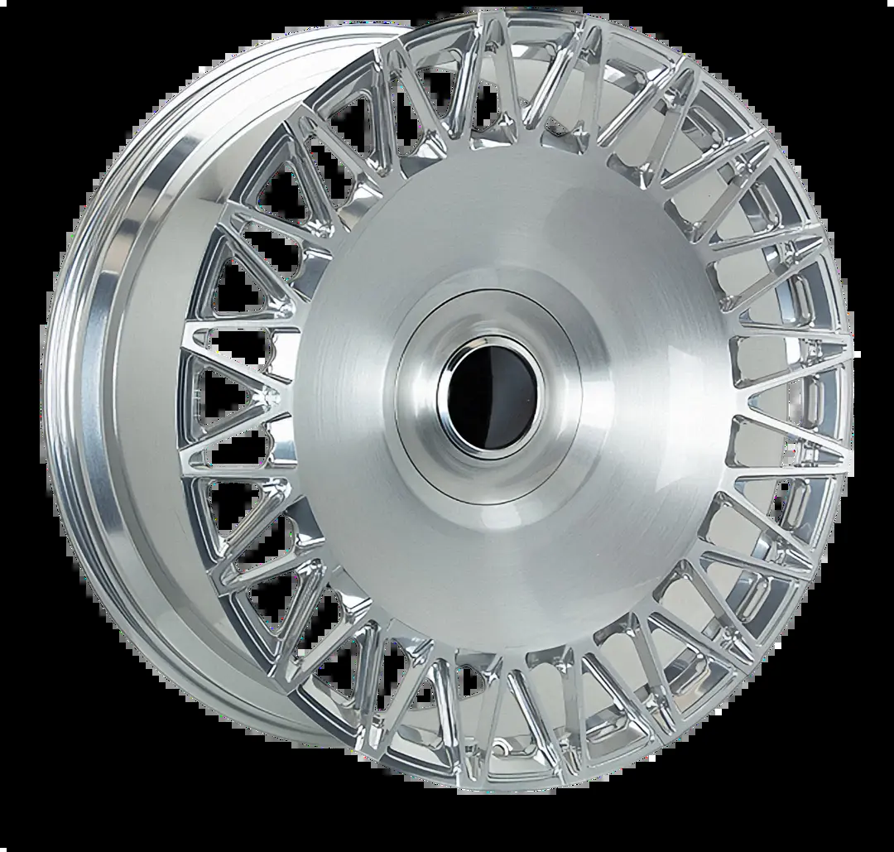  DRX 101 catalog image | 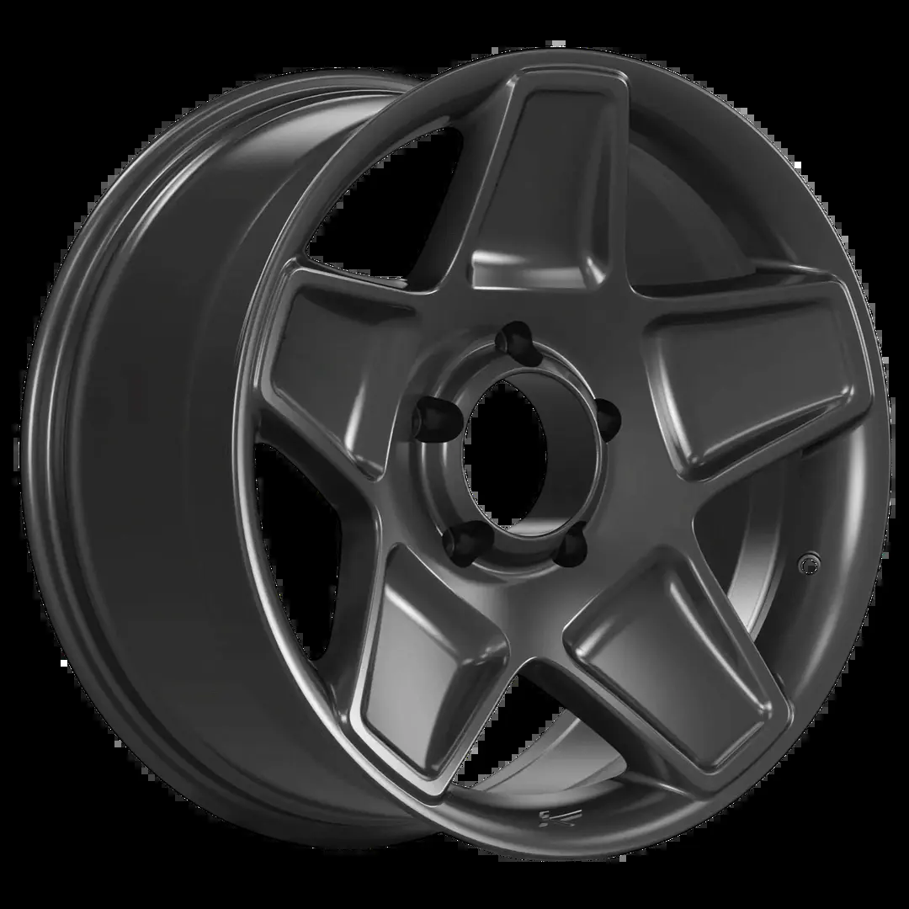  DRX 301 catalog image | G 63 project visual

Publishing rhythm
Week | Posts | Purpose
1 | BMW G80 and Mercedes G 63 | Earn discussion through visual judgement rather than product claims.
2 | Porsche 992 and Audi RS6 | Show that the team can listen to platform-specific fitment preferences.
3 | BMW X7 and Mercedes S Class | Shift to luxury proportion and finish without claiming completed builds.
4 | Tesla Model S and Ford Raptor | Test two different practical objections: range ride and off-road function.
5 | Draxler fitment log and engineering AMA | Convert useful answers into a durable, disclosed reference thread.

01 BMW M3 G80 3D fitment vote
Target forum: Bimmerpost G80 G82 Wheel Tire Suspension section. Do not start in general discussion; request vendor permission first or publish from an account the community already recognizes.
Post format: 3D visual study plus one direct question. Around 110 words, with no price and no fitment promise.
Visual: A fresh Draxler 3D configurator screenshot of a G80. Add a clear 3D configuration label on the image. Use a DRX Sport wheel close-up as the second image.
Link use: Use the direct catalog link in the copy. Keep it to one link and confirm the section permits commercial links before posting.
Direct URL: https://draxlerwheels.com/catalog
Before posting: Do not call the concept a completed car. Before replying, have the VIN year, brake package, ride height and customer tyre preference ready.
Ready to post
Full disclosure: I’m with Draxler. We put together this G80 study to settle the visual direction before we lock any geometry. This is a 3D configuration, not a photo of a completed customer car.
The question is deliberately simple: does the brushed face with the darker inner barrel keep the car OEM+ enough, or would you go full satin dark here? I like that the spokes leave the brakes visible without making the front end look busy, but side renders can lie.
We have not published an offset or tyre package because those will be checked against the actual car, brakes and ride height. I’d rather get roasted for the finish now than promise a fitment from a screen. Would you spec this as a 19 20 staggered setup or keep it square?
Draxler catalog: https://draxlerwheels.com/catalog
First author reply: Good point on the sidewall. We will not choose wheel diameter until we have the tyre and suspension plan. The attached image is only the design decision stage; I’ll post confirmed width and ET if the forum allows a build follow-up.

02 BMW X7 G07 luxury SUV proportion study
Target forum: Bimmerpost X7 G07 forum, wheel and tyre topic or an existing X7 modification thread. Do not create a standalone brand post in the general BMW subreddit without approval.
Post format: 3D finish comparison. Around 100 words, built around one choice between two finishes.
Visual: A G07 3D screenshot with two finish variants side by side. Use the Draxler DRX 101 catalog image as the second slide.
Link use: Include the direct catalog link in the copy. Do not write ‘perfect fitment’ until the vehicle has been checked.
Direct URL: https://draxlerwheels.com/catalog/vip/drx-101
Before posting: Check which factory dimensions and load requirements apply to the specific X7. Do not state 22 or 23 inches as a fixed recommendation until confirmed.
Ready to post
I’m with Draxler, and this is a 3D visual study rather than a delivered X7. We are trying to keep the wheel large enough for the body without making the car look like it is sitting on a concept-car set.
Same design, two directions: brushed clear face with a dark barrel, or a quieter satin graphite. On a big SUV I usually prefer some contrast so the wheel does not disappear, but the polished route can get loud fast.
Fitment will be engineered from the real vehicle and tyre plan, so this is not an offset recommendation. Which one reads more factory-plus to you, and would you rather see a dense luxury pattern or something more open around the brakes?
Draxler catalog: https://draxlerwheels.com/catalog/vip/drx-101
First author reply: That is exactly the feedback we needed. We are keeping the visual discussion separate from the engineering sheet; no dimensions will be advertised until the car, brakes and load requirements are in front of us.

03 Mercedes AMG G 63 project reveal
Target forum: MBWorld G Class W463 section or a moderator-approved showcase thread. This fits the gallery-compilation format, but only with visible vendor disclosure.
Post format: Project visual reveal. Around 105 words, with less technical copy and a more specific question about proportion.
Visual: Draxler Mercedes AMG G 63 site image. The post must caption it ‘Draxler project visual, not a customer delivery photo.’ Add a same-angle 3D configurator screenshot when available.
Link use: Include the direct project URL in the copy. Do not add WhatsApp, a lead form or multiple links.
Direct URL: https://draxlerwheels.com/catalog/projects
Before posting: Prepare an honest answer about whether the visual is a render or photography. Do not claim a specific diameter, PCD or brake clearance from the image.
Ready to post
Full disclosure: I’m part of the Draxler team. Posting this as a G 63 visual study because the wheel treatment is doing most of the work here. This is a Draxler project visual, not a customer delivery photo.
We kept the finish dark and the spoke geometry fairly open so the wheel reads as one solid form instead of a black circle. The thing I’m still unsure about is the stance: does the wheel look properly planted here, or does the G need more sidewall and less visual diameter to stay believable?
No fitment claim attached to this image. If there is interest, I can follow up with a real spec sheet once we are working from a specific G 63 and brake package.
Project reference: https://draxlerwheels.com/catalog/projects
First author reply: Agreed on the sidewall. We would treat that as an actual vehicle decision, not something to copy from the render. The point of this post is to hear whether the design direction belongs on a G before geometry is frozen.

04 Mercedes S Class luxury finish study
Target forum: MBWorld S Class W223 section or an approved luxury build thread. Do not frame it as ‘new wheels for every S Class’; focus on one specific visual study.
Post format: 3D luxury concept. Around 100 words, with restrained language and no aggressive tone.
Visual: A 3D configurator capture on a W223 or Maybach specification. Use the Draxler Luxury site image as a second design-reference frame and label it site visual.
Link use: Include one direct catalog link in the copy. Do not send readers straight to a messenger.
Direct URL: https://draxlerwheels.com/catalog
Before posting: Verify whether the selected car is an S Class or Maybach and do not use incorrect badges in the mock-up. Do not promise OEM cap compatibility.
Ready to post
I’m with Draxler. This is a 3D S Class study, not an installed car, and I wanted to ask the people who actually live with these cars where the line is.
The temptation is to add more finish contrast and more spoke detail. We went the other way: a clean luxury face, enough negative space to see the brakes, and a finish that stays quiet next to all that chrome. My concern is that the design could be too restrained once it is moving.
Would you keep it satin titanium, or add a polished lip detail? We will only set width, offset and tyre after the actual chassis and brake package are checked. This post is just about proportion and taste.
Draxler catalog: https://draxlerwheels.com/catalog
First author reply: The OEM-cap point is useful. We will not assume it; centre-bore and cap compatibility are part of the final specification, not a render detail.

05 Porsche 992 Carrera GTS brake visibility question
Target forum: Rennlist 992 aftermarket wheel fitment thread or a vendor-approved 992 forum post. If the rules prohibit commercial links, get moderator approval before posting the required direct link.
Post format: 3D performance visual. Around 120 words, with a deliberately narrow question about spoke density and brake visibility.
Visual: A Draxler 3D screenshot specifically on a 992. Second image: Porsche visual from the Draxler site, captioned ‘site visual and design reference, not a completed install.’
Link use: The direct Draxler catalog link is required in the copy. Keep it as the only link and do not add a purchase form.
Direct URL: https://draxlerwheels.com/catalog
Before posting: Do not state 20 21, centre lock, Pirelli or PCCB compatibility without confirmation. On Rennlist, accuracy matters more than a polished story.
Ready to post
Full disclosure: I’m with Draxler. We mocked this up on a 992 as a 3D study before we build a real application. It is not an installed customer car and there are no fitment numbers hidden in the render.
The brief was brake visibility without making the wheel look too delicate for the rear haunches. I think this spoke count works from the side, but I’m less sure about it at a three-quarter angle where the car already has a lot going on.
For those who have lived with aftermarket 992 wheels: would you rather see a more open face, or does this keep enough visual mass? Once we are working from a specific car, tyre and brake package we can publish only the confirmed dimensions.
Draxler catalog: https://draxlerwheels.com/catalog
First author reply: Completely fair. We will not use the usual generic 20 21 language as a substitute for an actual spec. The next useful update would be a measured application, not another render.

06 Audi RS6 C8 finish comparison
Target forum: Audizine C8 RS6 section, ideally inside an existing wheel and tyre discussion or an approved advertiser thread. Confirm current vendor rules on the day you post.
Post format: Two 3D renders and a short request for critique. Around 105 words.
Visual: Side-by-side Draxler 3D captures of a C8 with brushed-silver and satin-dark variants. Caption the image ‘3D visual study; final fitment to be validated.’
Link use: Include the direct catalog link in the copy, not a purchase form. The post should stay about the design decision.
Direct URL: https://draxlerwheels.com/catalog
Before posting: Prepare a question about winter sets and wheel cleaning. Do not write ‘RS6 owners all prefer’ or make another broad generalisation.
Ready to post
I’m with Draxler. We are using this C8 RS6 3D study to decide whether the car wants contrast or a complete blackout. The two images are not a delivered build and the final fitment will be checked against the actual car.
Silver makes the spoke design easy to read and gives the car a more OE-plus feel. Satin dark feels more aggressive, but I worry that it loses the wheel completely once the car is rolling.
If this were yours, which direction would you take? Also interested in the practical answer: for people who daily an RS6, do you regret dense spokes because of cleaning, or is that a non-issue once the finish is right?
Draxler catalog: https://draxlerwheels.com/catalog
First author reply: Thanks for bringing up cleaning. It is a better question than a quick like or dislike, and it is exactly why we are asking before locking a finish for a real application.

07 Tesla Model S Plaid aero visual study
Target forum: Tesla Motors Club Wheels Tires Suspension section. Do not use Reddit as a direct sales channel without explicit approval for a vendor post.
Post format: 3D design prompt. Around 100 words, openly acknowledging that it is not a road test.
Visual: A Model S 3D configurator screenshot with the wheel visual. Use two angles so readers can see the face and sidewall, and label it 3D configuration.
Link use: Include one direct Draxler home-page link in the copy, subject to forum rules.
Direct URL: https://draxlerwheels.com/
Before posting: Do not claim an effect on range, noise, ride or weight: a 3D image does not prove it. Ask the audience for real-world concerns.
Ready to post
Full disclosure: I work with Draxler. This is a Model S Plaid 3D wheel study, not an owner review and definitely not a range claim.
We tried to give the side profile a cleaner, more technical look without copying an aero cover. The visual is doing what we wanted, but a screen says nothing about ride, range, noise or durability. Those are the reasons I’m asking before this goes any further.
If you run aftermarket wheels on a Plaid, what was the first compromise you noticed in real life? And visually, would you keep this face this open, or add more surface area so it sits better with the car’s body side?
Draxler: https://draxlerwheels.com/
First author reply: That is the right distinction. We will treat the visual as a design discussion only; any weight or efficiency statement would need measured data from a real setup.

08 Ford Raptor off road functional design check
Target forum: Ford Raptor Forum wheel and tyre section or a moderator-approved vendor thread. Select a community where brands may answer technical questions.
Post format: A site visual plus a 3D reference. Around 115 words, with the first question about function rather than appearance.
Visual: Draxler Off Road Ford site visual and DRX 301 catalog image. Caption them ‘site visual and wheel design reference.’ Add a 3D capture with the customer tyre profile when possible.
Link use: Include one direct catalog link in the copy. Do not use ‘beadlock capable’ as a promise for a particular finished configuration without engineering confirmation.
Direct URL: https://draxlerwheels.com/catalog
Before posting: Gather the intended tyre, trail use, load, brake package, valve protection, true beadlock requirement and local legality. Do not publish a load rating from a render.
Ready to post
I’m with Draxler. This is a design study for our Off Road direction, not a product test or a claim that this exact Raptor setup is ready to order.
The visual question is easy. The functional question is not: if a wheel looks beadlock-inspired but does not solve a real trail requirement, most of you will spot that immediately. Before we spec a real application, what matters most to you - true beadlock function, load rating, valve protection, easy cleaning, or simply keeping enough sidewall?
The image is there to show the design language. Any final wheel would still need to be engineered around the actual truck, tyre and use case. I would rather collect the non-glamorous requirements now.
Draxler catalog: https://draxlerwheels.com/catalog
First author reply: Appreciate the direct answer. We will not confuse a visual direction with a functional certification. The useful next step is a real requirement list, then a confirmed application.

09 Draxler disclosed fitment log
Target forum: One approved vendor section on Bimmerpost, MBWorld or Audizine. This is a long-term reference thread, not a post to broadcast across every community at once.
Post format: Opening post for an updateable fitment log. Around 115 words, with no inflated promises or discount CTA.
Visual: One Draxler catalog wheel image and one visual study. Add new photos only when the source, publication permission and caption are all clear.
Link use: Pin one neutral catalog link in the first message if the moderator permits it. Build traffic through useful updates, not repeated links.
Direct URL: https://draxlerwheels.com/catalog
Before posting: Agree on an update cadence with the moderator. Prepare one template: chassis, ride height, wheel width, ET, tyre, brake notes, measured weight when available and image origin.
Ready to post
Hi all - I’m with Draxler, and with moderator permission I’m opening this as a fitment reference thread, not a stream of catalog drops.
When we have a confirmed application, the update will list the chassis, wheel width, offset, tyre, ride height and any brake or clearance note that has actually been checked. If a post is only a 3D study, it will say so in the first line. If the image is a site visual, it will say that too.
We will not fill the thread with prices, artificial urgency or copied claims. If you have a platform that is poorly served by current wheel options, post the car, brake and tyre basics. Useful edge cases are more valuable to us than a generic compliment.
Draxler catalog: https://draxlerwheels.com/catalog
First author reply: That is the standard we are aiming for. The next update should earn its place with real dimensions and an honest caption, otherwise it does not go into the log.

10 Forged wheel engineering AMA
Target forum: Vendor-approved technical section or a scheduled moderator-approved AMA. Do not run an AMA without an engineer or product lead who can answer for engineering and production.
Post format: Opening AMA post. Around 115 words. This is the only block where it helps to state plainly which questions are welcome.
Visual: One neutral DRX catalog image and one small diagram or 3D screenshot. Do not attach ten renders; the answers are the main content.
Link use: Include the direct Draxler home-page link in the copy. Keep it as the only commercial link and confirm permission first.
Direct URL: https://draxlerwheels.com/
Before posting: An engineer or product lead must be in the AMA. Agree in advance which subjects the team can answer honestly, including unknowns and limitations.
Ready to post
I’m with Draxler. With moderator approval, we would like to run a practical forged-wheel AMA here. This is not a launch announcement and we are not going to pretend every question has a glamorous answer.
Ask about design choices, monoblock versus multi-piece intent, finish maintenance, brake clearance, why an offset that looks good in a render may not work on a real car, or what information we need before modelling a custom set. If we do not have a confirmed answer for a chassis, we will say so rather than turn a guess into a sales line.
We will bring the relevant engineering person into the replies. The goal is to leave behind a useful technical thread, not to convert every comment into a quote request.
Draxler: https://draxlerwheels.com/
First author reply: Great question. We will answer it in the thread with the assumptions stated up front. If the answer depends on actual brake dimensions or ride height, we will spell that out instead of giving a universal number.

Links and reference examples
Use these as format references, not as copy. Do not transfer another brand’s claims, measurements, imagery or wording to Draxler. Forum rules change, so check them on the day you post.
Draxler home - Source for brand language, configurator entry point and forging claims presented by the brand.
Draxler catalog - Source for Luxury, Sport, Off Road series, DRX model codes and project visual references.
MBWorld Vossen Forged Gallery Compilation Thread - Example of a platform specific visual gallery thread.
Rennlist 992 Aftermarket Wheels Official Fitment Thread - Example of fitment-led conversation in a model-specific community.
Audizine Vossen Dealer Thread - Example of a clearly commercial vendor format, useful only where approved.
Bimmerpost G20 330i Wheel Setup - Example of discussion turning to real tyre, wheel size and rubbing questions.

Final posting checklist
- A visible disclosure of brand affiliation appears in the first sentence.
- Each 3D screenshot is labelled as a visual study, and each site image is labelled as a site visual.
- Every width, ET, tyre, load rating and clearance claim is verified or omitted as a fixed fact.
- Live forum rules have been reviewed and required moderator permission obtained.
- Each post contains one focused question, one direct Draxler link, no manufactured urgency, no fake reviews and no concealed push to private messages.

