1. Change text of Medicine to Anti biotics, also this tab only contains antibiotics.

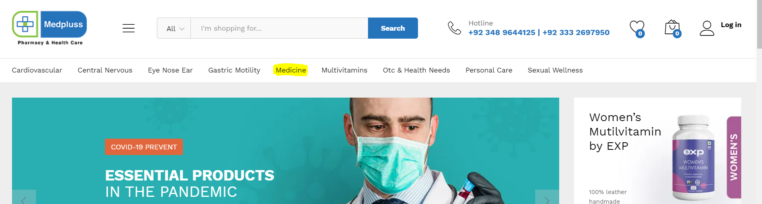

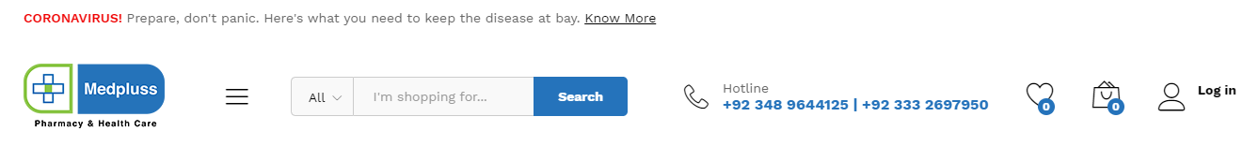

1. Remove text Health care and write Pharmacy only large text.



1. Background color of this section needs to be changed, mostly likely the color will be sky blue.

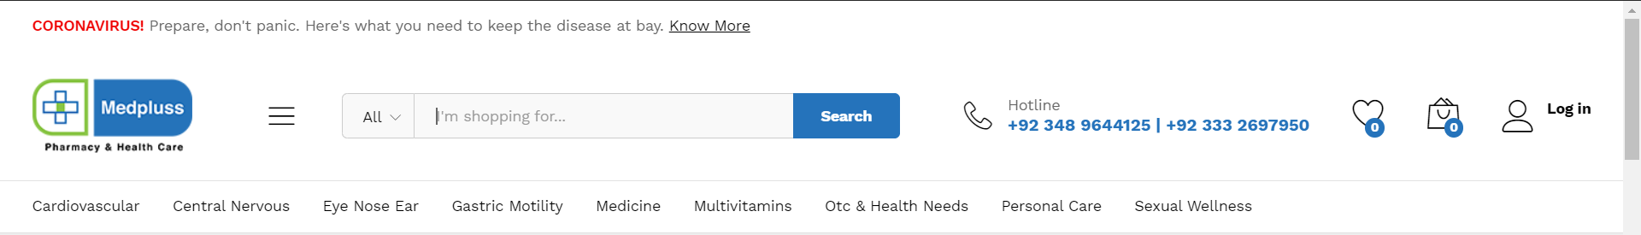

1. Text should be in medium size also add background color like light grey or sky blue.

1. Delivery Charges options must be added (charges will be given after sometime)

1. On hover background color + color will be changed.



1. Icons not giving the actual meaning the content so this needs to be accurate.

