

The Healing Infirmary

A Software Project Submitted

By

|  |  |
| --- | --- |
| Name | ID |
| **Sultana, Sharmin** | 18-37151-1 |
| **Sayed, Ahnaf** | 18-36920-1 |
| **Mollah, Fahad** | 18-36702-1 |
| **Rafia, Sayeda** | 18-36450-1 |

Under the supervision of

**Abhijit Bhowmik**

Associate Professor

Department of Computer Science

Faculty of Science and Technology

American International University Bangladesh

Fall Semester 2021-2022

**Disclaimer**

This is to certify that this project is our original work. No part of this has been submitted elsewhere partially or fully for the award of any other degree. Any material reproduced in this project has been properly acknowledged.



________________________________________

1. Name: Sultana, Sharmin

ID No: 18-37151-1



________________________________________

2. Name: Sayed, Ahnaf

ID No: 18-36920-1



________________________________________

3. Name: Mollah, Fahad

ID No: 18-36702-1

________________________________________

4. Name: Rafia, Sayeda

ID No: 18-36450-1

**Approval**

The Software Project or Project titled “The Healing Infirmary” system has been submitted to the following respected members of the Board of Examiners of the Faculty of Science and Information Technology in partial fulfillment of the requirements for the degree of Bachelor of Science in Software Engineering on 20th December 2021 by the following students and has been accepted satisfactory.

|  |  |
| --- | --- |
| __________________________  **Abhijit Bhowmik**  Associate Professor & Supervisor  Department of Computer Science  American International University- Bangladesh | _____________________________ Md. Al-AminLecturer & External Department of Computer Science  American International University- Bangladesh |
| ____________________________  **Dr Md. Mahbub Chowdhury Mishu**  Head(Undergraduate)  Department of Computer Science  American International University- Bangladesh |  |
| **Professor Dr. Tafazzal Hossain**  Dean in Charge  Faculty of Science & Technology American International University-Bangladesh |

|  |
| --- |
|  |
| **Dr. Carmen Z. Lamagna**  Vice Chancellor  American International University-Bangladesh |

**Acknowledgements**

We would like to take the chance to express our gratitude to our honorable teacher and supervisor Abhijit Bhowmik, for his continuous guidance and support regarding this report. Besides this, we have found so many sincere and productive advices from many people that we would like pay homage to them. We convey our gratitude to our honorable Vice Chancellor, Dr. Carmen Z. Lamagna for encouragement.

Table of Contents

**Chapter 1: Statement of Work** 7

1.1 Purpose/Objectives 9

1.2 Scope 9

1.3 Proposed System 9

1.4 System Features 10

1.5 Environment 12

1.5.1 Organizations Involved 12

1.5.2 Processing 12

1.5.3 Security 13

1.6 Assumptions 13

1.7 Constraints 13

1.8 Proposed System 15

1.8.1 Description/Improvements of Proposed System 15

1.8.2 Resources 16

1.8.3 Hardware 16

1.8.4 Software 16

1.8.5 Operating Environment 16

1.9 Project Time & Cost 16

1.9.1 Project Period 16

1.9.2 Project Schedule 17

1.9.3 Domain & Hosting Package 17

1.10 Risk assessment 19

1.11 Assessing overall project risk 20

**Chapter 2: Software Requirement Specification** 21

2.1 Objectives and Scope 21

2.2 Overview of the Present System 22

2.3 Data Flow Diagram of the Present System 22

2.4 Weakness of the Present System 22

2.5 Overview of the Proposed System 22

2.6 Benefits of Proposed System 23

2.7 System Features 23

2.8 Hardware and Software Requirements 25

2.8.2 Hardware 25

2.8.3 Software 25

2.9 Human Resource Requirements 26

2.10 Constraints and Limitations 26

2.11 Budget 27

2.12 Conclusion 27

**Chapter-3: Diagram** 27

3.1 Use Case Diagram 28

3.1.1. Admin Use Case Diagram 28

3.1.2. Doctor Use Case Diagram 29

3.1.3. Patient Use Case Diagram 30

3.1.4. Accountant Use Case Diagram 31

3.1.5. Pharmacy Use Case Diagram 32

3.2 Activity Diagram 33

3.3 ER Diagram 33

3.4 Class Diagram ...............................................................................................................34

3.5 Prototype .......................................................................................................................34

**Chapter-4: Software Project Management Plan** 37

4.1 Document History and Distribution 37

4.1.1 Revision History 37

4.1.2 Distribution 37

4.2 Overview 38

4.2.1 Purpose, Objectives and Project Scope 38

4.2.2 Project Scope 38

4.2.3 Assumptions and Constraints 38

4.3 Project Deliverables 39

4.3.1 The list of project deliverables is: 39

4.3.2 Schedule and Budget Summary 39

4.4 Evolution of the Software Project Management Plan 40

4.4.1 Definitions 40

4.5 Project Organization 40

4.5.1 External Interfaces 40

4.5.2 Internal Structure 41

4.5.3 Roles and Responsibilities 41

4.6 Managerial Process Plans 41

4.6.1 Project Start-up Plan 41

4.6.2 Estimation Plan 41

4.6.3 Staffing Plan 42

4.6.4 Resource Acquisition Plan 42

4.6.5 Project Staff Training Plan 42

4.7 Work Plan 42

4.7.1 Budget Allocation 42

Budget Allocation 42

4.8 Control Plan 43

4.8.1 Requirements Control Plan 43

4.8.2 Schedule Control Plan 43

4.8.3 Budget Control Plan 43

4.8.4 Quality Control Plan 43

4.8.5 Reporting Plan 44

4.8.6 Metrics Collection Plan 44

4.9 Risk Management Plan 44

4.10 Closeout Plan 44

4.11 Technical process plans 45

4.12 Process Model 45

4.13 Methods, Tools and Techniques 45

4.14 Infrastructure Plan 46

4.15 Product Acceptance Plan 46

4.16 Supporting Process Plans 46

4.17 Configuration Management Plan 46

4.18 Verification and Validation Plan 46

4.19 Documentation Plan 47

4.20 Quality Assurance Plan 47

4.21 Reviews and Audits Plan 47

4.22 Problem Resolution Plan 47

4.23 Subcontractor Management Plans 47

4.24 Process Improvement Plan 47

**REFERENCES 48**

**Figures**

3.1.1. Admin Use Case Diagram.......................................................................................... 28

3.1.2. Doctor Use Case Diagram.......................................................................................... 29

3.1.3. Patient Use Case Diagram.......................................................................................... 30

3.1.4. Accountant Use Case Diagram.................................................................................. 31

3.1.5. Pharmacy Use Case Diagram..................................................................................... 32

3.2 Activity Diagram............................................................................................................ 33

3.3 ER Diagram....................................................................................................................33

3.4 Class Diagram................................................................................................................34

3.5 Prototype........................................................................................................................ 34

3.5.1 Homepage of the System............................................................................................. 34

3.5.2 Recent News Page....................................................................................................... 35

3.5.3 Login page................................................................................................................... 35

3.5.4 Doctor Dashboard....................................................................................................... 36

3.5.5 Patient Dashboard....................................................................................................... 36

4.12 Process Model..............................................................................................................44

**Tables**

1. Term Expansion (Table 1.1) ........................................................................................17
2. Project Schedule (Table 1.2) .......................................................................................17
3. Estimated Service Cost (Table 1.3) .............................................................................19
4. Risk Information Sheet (Table 1.4) .............................................................................20
5. Budget (Table 2.1) .......................................................................................................27
6. Revision History (Table 4.1) .......................................................................................36
7. Distribution (Table 4.2) ...............................................................................................36
8. Schedule Budget Summary (Table 4.3) .......................................................................38
9. Definitions (Table 4.4) ................................................................................................39
10. Budget Allocation (Table 4.5) .....................................................................................41
11. Risk Management Plan (Table 4.6) .............................................................................43

**Chapter 1: Statement of Work**

## Purpose/Objectives

|  |
| --- |
| The feasibility study of this project is a kind of analysis that gives an idea about various benefits that are most likely associated with it. The main goal is to verify and cover all issues and resources invested in this project results or it will lead to a desirable outcome and that it is a successful one.  This study will help to make sure that all kinds of investments that are needed for this project are met and considers the factors that are not directly related to it. The project will progress to the next level after specifying the total cost required for completion.  The feasibility study helped and assisted various kinds of companies to understand which projects they should accept to develop and which project they should decline to develop. As this study comprehend a small part of the available resources, it is still a better option than investing in a project that shows no sign of worthiness producing any kind of profit and a lot of time and money will be misspent on a project that has no value at all. |
|  |
|  |
|  |

## 1.2 Scope

The scope of the project is much specified as it outlines what kind of services **“The Healing Infirmary”** systemwill provide to the Users. Those system services are:

* By developing **“The Healing Infirmary”** system Users will feel free to get information and proper services.
* This system will make the administrative work will be easy for the employees.
* Users will able to book their appointment with the doctor.
* Users will also able to book their ambulance service from the system.
* Medicine ordering system for the Users.
* Customization and improvement of existing system.
* Individual information module for each client or patient and notification system.

## 1.3 Proposed System

This software or web application is intended for implementing **“The Healing Infirmary”** systemthat would make the life of patients much easier. All the patients don’t need to go through various kind of hassle for booking appointment with doctors by going to hospital. Patients can easily access from anywhere by sit at home and they can register online to book an appointment with the doctor at ease. They can also order any kind of medicine through online using doctor’s prescription and can book for ambulance service. Patients can interact online and consult their problems with the doctor using the system. Patients can also book for emergency ambulance booking system without logging into the system. There will be payment system that will be much easier for the patients as any kind of payment will be done through online mobile banking system and credit card system.

Below benefits /improvements of proposed system is being developed:

* Online patient or client registration instead of traditional form full up.
* Online booking appointment for patients without facing any hassle.
* Online ambulance booking system for patients.
* Online medicine ordering system for patients using doctor’s prescription.
* Non registered patient can order medicine using cash on home delivery.
* Fast and safe booking.
* Online payment system.
* Time remainder notification system for next visit or appointment with doctor.
* Appointment remainder notification system.
* Efficient time management.
* Offering any kind of discount.
* Online interaction with the doctor on daily basis using the system.
* Schedule and appointment history.
* Fast & safe booking.
* Checking bill information.
* Patient satisfaction.
* Messaging system.

## 1.4 System Features

There are 5 types of Users here. They are:

* Admin
* Doctor
* Accountant
* Patient
* Pharmacy

In this project, the **“Admin”** has the following features:

* Login
* Add doctor
* Remove Doctor
* View Patient List
* Add Accountant
* Remove Accountant
* Fix salary
* Can recover password
* Read complain
* Logout

In this project the **“Doctor”** has the following features:

* Login
* See how many patients has taken appointment
* See patient details who has taken appointment
* Consult with patient by messaging
* Write prescription
* Update appointment info
* Update personal information
* Update availability
* Change password
* Logout

In this project the **“Patient”** has the following features:

* Login
* Apply for appointment
* Consult with doctor by messaging
* Book for ambulance
* Can view notification
* Notification for next visit or appointment remainder with doctor
* Update profile
* See bill info
* Check discount
* Can text admin for any complain
* Registered and non-registered users can order medicine using cash on home delivery from pharmacy
* Emergency ambulance book without login
* Logout

In this project the **“Accountant”** has the following features:

* Login
* See patient bill info
* Set, update, remove discounts
* Update patient bill info
* Give clearance of patient payment
* Update personal profile
* Logout

In this project the **“Pharmacy”** has the following features:

* Login
* See patient prescription
* Can see patient’s medicine order
* Make bill info
* Modify medicine
* Logout

## 1.5 Environment

## 1.5.1 Organizations Involved

Project Client: ABHIJIT BHOWMIK.

Developer: The Healing Infirmary System Team.

User: Online Users or Customers.

## 1.5.2 Processing

* In this web application there will be a graphical user interface (GUI) by which users will be able to interact this application from any browser.
* This is a website or web application which any browser will be able view the website or web application.
* There will be a database where all kinds of information regarding the patients will be stored.
* The doctors will be able to view the information regarding the patients from the database.
* The admin can view all kinds of information regarding the system and can modify or update it.
* The patients can view only their own personal information and can get emergency information about the doctors as well.
* The login and logout system will be completely authenticated and secure.
* The data transmission for all type of users will be safe and secure.
* All kinds of transaction and billing information records will be stored securely.

## 1.5.3 Security

System’s security requirements:

* To access this application user authentication is mandatory.
* All registered users need to provide their mobile number and email for verification.
* A client or user identity confirmation can be verified using the registered email address and mobile number.
* If in case user forgets their password, they can recover it by confirming their identity through verification.
* A client or user must need to be a registered user to login to and use the features of the application.
* If the client or user tries to login from a new device they will be notified through their email or mobile.

## 1.6 Assumptions

For this project, some third-party software will be used to build up this project. These are free components, most of the software are open source. Web browsers like Mozilla Firefox and Google Chrome etc. to access user interface. The software we used are open source so there is no scope for anything being illegal here. All the contents of our project will not be affected because we are not using anything for which it becomes illegal to use and the contents of the project are completely genuine.

Some open-source libraries and software used for this project are as follows:

* PHP ZIP files Library for compressing files
* PHP Session to verify user login,
* For dynamic interface some Ajax library is used.
* MOO tools, JQuery etc.

## 1.7 Constraints

* Usage outside regulation: In this project data transmission from client to server through TCP/IP and we are not using any public key encryption service like SSL certificate in this project. So, this might lead to some constraints regarding any kind of data passing of user. It may also create problems like confidentiality and integrity. Both registered and unregistered users are valid and can use the software through client application with help of any internet browser on server side. In case of any kind of missing password found by anonymous or unknown user, the responsibility goes to valid user.
* Bandwidth limitations: The server connection might be lost due to technical errors for that it includes both hardware and internet connection. For this kind of cases, we need to run query again.
* Databases: We will be using MySQL Database software for this this project. If the user queries exceed more than database server’s limitations then we need to check databases and refresh table data again in case of lack of database caching.
* Parallel operations: The use of other internet applications with this software may hamper and might slow the connection speed, this may occur problems taking time to run a query for slow connections.
* Language requirements: The main programming language of this software is PHP. In case any user wants to use Oracle Database then we need to use bind variable technique.
* Communications protocols: TCP/IP is the communication protocols we are using to interact with the server. Other protocol is not considerable if user wants.
* Security considerations: If users are not willing to buy the SSL-security then there will be no public key encryption service like SSL certificate for the client applications. So, this will create some constraints in case of passing any kind of user data.

In case of internet security, the following issues might be seen –

* **Authentication problem:** Server may or might not recognize or confirm the actual valid user.
* **Confidentiality problem:** Both the user and intended server fails to understand message contents.
* **Integrity problem:** The server or sender may not able to ensure that there is no alteration of message without detection.
* **Eavesdrop**: There might be intercept messaging or actively insertion of messages into the connection.
* **Impersonation:** There might be fake source address in packet.
* **Hijacking:** The connection might be taken over or hijacked by a hacker into the ongoing connection by removing sender or server and inserting hacker himself in place.
* **Denial of service:** Services will be prevented from being used by others.

## 1.8 Proposed System

This software or web application is intended for implementing **“The Healing Infirmary”** system that would make the life of patients much easier. All the patients don’t need to go through various kind of hassle for booking appointment with doctors by going to hospital. Patients can easily access from anywhere by sit at home and they can register online to book an appointment with the doctor at ease. They can also order any kind of medicine through online using doctor’s prescription and can book for ambulance service. Patients can interact online and consult their problems with the doctor using the system. Patients can also book for emergency ambulance booking system without logging into the system. There will be payment system that will be much easier for the patients as any kind of payment will be done through online mobile banking system and credit card system.

Below benefits /improvements of proposed system is being developed:

* Online patient or client registration instead of traditional form full up.
* Online booking appointment for patients without facing any hassle.
* Online ambulance booking system for patients.
* Online medicine ordering system for patients using doctor’s prescription.
* Non registered patient can order medicine using cash on home delivery.
* Fast and safe booking.
* Online payment system.
* Time remainder notification system for next visit or appointment with doctor.
* Efficient time management.
* Offering any kind of discount.
* Online interaction with the doctor on daily basis using the system.
* Schedule and appointment history.
* Fast & safe booking.
* Checking bill information.
* Patient satisfaction.
* Messaging system.

## 1.8.1 Description/Improvements of Proposed System

* Satisfaction of the patients
* Reduce and low labor cost
* Low error tendency regarding data passing and data entry
* Authentication, safe and secure transaction
* Fast paced transaction system
* Efficient monitoring performance
* Reduce system loading time
* To get medicine cash on home delivery as soon as possible

## 1.8.2 Resources

All the resource needed is provided below.

## 1.8.3 Hardware

➢ Minimum requirements for server:

* Processor: Xeon based microprocessor
* RAM: 16 GB
* System Type: Linux (64 bit)
* Storage: 256 GB SSD
* For Storage Service: Network File System (NFS)

➢ Minimum requirements for client:

* Processor: Dual-core
* RAM: 2 GB
* System: Windows, MAC OS X, Linux
* Web Browser: Firefox, Google Chrome, Opera

## 1.8.4 Software

* Notepad++ / Sublime Text
* PHP, MySQL
* Apache

## 1.8.5 Operating Environment

The system will be operated from the external (your preferred data center) Linux Serverin which site will be hosted. Hosting server has 99% Uptime. This website is platform independent. User application is accessible through various kinds of browsers like Opera, Mozilla Firefox, and Google Chrome etc. This website is a web application where client application has user interfaces through browser and main part is hosted on Apache Server. IBM or MAC any platform user can use. Operating System can be used Windows of any version from Windows 98, Windows XP/Vista to Windows 10, MAC OS X 10.5 or above.

## 

## 1.9 Project Time & Cost

## 1.9.1 Project Period

* Expected time of completion of project is 4 months.

## 1.9.2 Project Schedule

**Term Expansion**

|  |  |
| --- | --- |
| **Term** | **Description** |
| **BA** | **Business Analyst** |
| **PM** | **Project Manager** |
| **D** | **Developer** |
| **QT** | **Quality Tester** |

Table 1.1

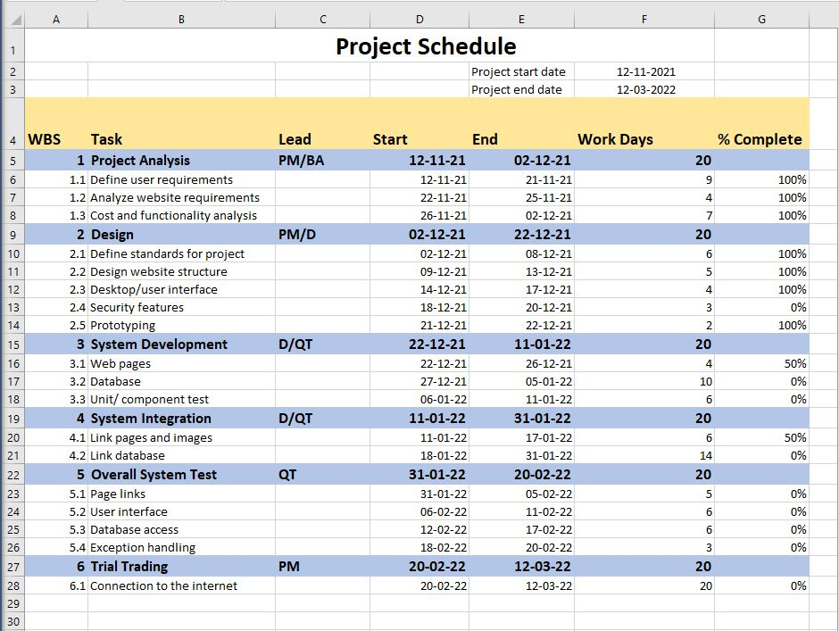

Table 1.2

## 1.9.3 Domain & Hosting Package

**Domain**

* **.com** 950 Taka/year
* **.net** 950 Taka/year
* **.org** 950 Taka/year
* **.biz** 850 Taka/year
* **.info** 850 Taka/year
* **.xyz** 200 Taka/year

**Hosting Package A:** Great for small websites

* Web Space: 1GB SSD Storage
* Bandwidth: 30GB/monthly
* RAID 10 SSD Server
* Unlimited Sub Domains
* Unlimited Email Accounts
* Unlimited Databases
* Tk. 1500/year

**Hosting Package B:** Perfect for medium sized websites

* 3GB SSD Storage
* 90 GB Bandwidth Monthly
* RAID 10 SSD Server
* Lite Speed Web Server
* Three Addon Domains
* Unlimited Sub Domains
* Unlimited Email Accounts
* Unlimited Databases
* Tk. 2500/year

**Hosting Package C:** For the demanding sites

* 5 GB SSD Storage
* 150 GB Bandwidth Monthly
* RAID 10 SSD Server
* Lite Speed Web Server
* Five Addon Domains
* Unlimited Sub Domains
* Unlimited Email Accounts
* Unlimited Databases
* Tk. 3500/year

**Hosting Package C:** For the highly demanding sites

* 20 GB SSD Storage
* 500 GB Bandwidth Monthly
* RAID 10 SSD Server
* Lite Speed Web Server
* Nine Addon Domains
* Unlimited Sub Domains
* Unlimited Email Accounts
* Unlimited Databases
* Tk. 7000/year

**1.9.4 Estimated service cost**

**Estimated Service Cost**

|  |  |
| --- | --- |
| **Description** | **Cost Assumption** |
| Site launch (hosting) | 20,000 BDT |
| Maintenance (1 year) | 50,000 BDT |
| Developers | 1,25,000 BDT |
| **Grand total** | **1,95,000 BDT** |

## 

Table 1.3

## 1.10 Risk assessment

The project has identified 10 risks that will create risk for the project as described below. The risk description, risk probability, risk rating and impact are described in the following Risk Information Sheet [Table 1.4].

**Risk Information Sheet**

|  |  |  |  |  |
| --- | --- | --- | --- | --- |
| **Risk No.** | **Risk Description** | **Risk Probability** | **Risk Rating** | **Impact** |
| **Risk No. 1** | Software team does not have good experience in distributed database management. | 60% | Medium | 3 |
| **Risk No. 2** | Requirement inflation. | 60% | Medium | 3 |
| **Risk No. 3** | Employee turnover like if any personnel leave the project taking critical information with them that significantly delays or derails the project. | 50% | Medium | 3 |
| **Risk No. 4** | Insignificant amount of cost increase. | 40% | Low | 2 |
| **Risk No. 5** | Project containing with bug. | 70% | High | 1 |
| **Risk No. 6** | Project security system. | 70% | High | 1 |
| **Risk No. 7** | Not understandable for user. | 50% | Medium | 3 |
| **Risk No. 8** | Weak algorithm. | 60% | Medium | 3 |
| **Risk No. 9** | Quality degradation barely noticeable. | 40% | Low | 2 |
| **Risk No. 10** | Good timeline of project for poor productivity. | 50% | Medium | 3 |

Table 1.4

## 1.11 Assessing overall project risk

**1. Have software engineer team formally committed to support the project?**

**Answer:** Yes. All the members are formally committed to support the project. They also ensure that they will give all types of available facilities.

**2. Are requirements fully understood by the software engineering team and their customers?**

**Answer:** Yes. As the software engineering team or the developers has the sound knowledge about the requirements so it is easily understandable by the team. The requirements details are well organized also informative, so it is under stable by the customers.

**3. Are end-users enthusiastically committed to the project and the system/product to be built?**

**Answer:** Yes. Because the end-users are expecting that, they will be able to find all kind of information about Chain Store Management System.

**4. Have user been involved fully in the definition of requirements?**

**Answer:** Yes. The user has been fully involved in the definition of requirements. They are aware of the application requirements.

**5. Is project scope stable?**

**Answer:** Yes. Project scope is stable because the minimum and mandatory scope is almost covered by the software engineering team. If any further scope will arise then just adding it with the old ones.

**6. Does the software engineering team have the right mix of skills?**

**Answer:** Yes. The software engineering team has the right mix of skills. The team members have the capability of doing their work in a team, ability to work in pressure and also have sound knowledge according to the software implementation.

**7. Are project requirements stable?**

**Answer:** Yes. Currently all possible requirements are being listed, and seem that if anything would be added later to the list will not make the project unstable. All requirements for this project are easily available that will enthusiast the end-user to use it.

**8. Does the project team have experience with the technology to be implemented?**

**Answer:** Yes. The project team has experience with the technology to be implemented because they have the sound knowledge about the technologies and the technologies are also implemented by them before.

**9. Does the project team and client are aware about the possible risks?**

**Answer:** Yes. Project team prepare the possible risk assessment and aware of handling the risk. Client is also being notified.

# 

# **Chapter 2: Software Requirement Specification**

## 2.1 Objectives and Scope

Our project **“The Healing Infirmary”** system seeks to boost the day-to-day situation of patient enrollment, doctor lists, report creation, and so on. It is intended to accomplish the following goals:

1. To update all perceptions of accepting details and emergency clinic complexities.

2. Arranging patient appointments with professionals in a way that is beneficial to both parties.

3. Appropriately booking the services of certain experts and urgent situations so that the clinic's offices are fully utilized in a powerful and effective manner.

4. If the hospital shop issues pharmaceuticals to patients, it should reduce the medical shop's stock status and vice versa.

5. It should be able to handle test data from patients who were seen in the medical hospital's medical lab.

6. Whenever an exchange is conducted, the stock should be replenished as a result.

7. Patients' information should be kept up to date, and their records should be preserved in the system for auditable reasons.

## 2.2 Overview of the Present System

There are now just a few systems in Bangladesh, such as Bangladesh Eye Hospital, that are exclusively focused on identifying and arranging appointments with doctors.

Bangladesh Eye Hospital website allows customers to search for physicians and schedule appointments at specific locations. There is no way to communicate with or consult with the appointed doctors through the internet. There is no way to produce reports automatically based on the data of specific patients. Patients must schedule an appointment and come to the hospital for consultation.

Our solution eliminates all of these annoyances and delivers a more convenient and smooth service.

## 2.3 Data Flow Diagram of the Present System

It is not essential.

## 2.4 Weakness of the Present System

• There is a lack of information and provision of all types of examinations.

• There is no schedule manager.

## 2.5 Overview of the Proposed System

Non-registered users will only be able to see the website under the arrangement. If a person registers, they will be able to look for doctor availability and schedule appointments. They will be offered a time schedule to connect and consult with the assigned doctor online after completing the booking. They'll get an auto-generated report depending on the information they submit, such as how much physical activity they should do, what kind of food and medicine they should take, and so on. The patient can review the report with their doctor and afterwards adjust it to their liking.

## 2.6 Benefits of Proposed System

* Online patient or client registration instead of traditional form full up.
* Online booking appointment for patients without facing any hassle.
* Online ambulance booking system for patients.
* Online medicine ordering system for patients using doctor’s prescription.
* Non registered patient can order medicine using cash on home delivery.
* Fast and safe booking.
* Online payment system.
* Time remainder notification system for next visit or appointment with doctor.
* Efficient time management.
* Offering any kind of discount.
* Online interaction with the doctor on daily basis using the system.
* Schedule and appointment history.
* Fast & safe booking.
* Checking bill information.
* Patient satisfaction.
* Messaging system.

## 2.7 System Features

There are 5 types of Users here. They are:

* Admin
* Doctor
* Accountant
* Patient
* Pharmacy

In this project, the **“Admin”** has the following features:

* Login
* Add doctor
* Remove Doctor
* View Patient List
* Add Accountant
* Remove Accountant
* Fix salary
* Can recover password
* Read complain
* Logout

In this project the **“Doctor”** has the following features:

* Login
* See how many patients has taken appointment
* See patient details who has taken appointment
* Consult with patient by messaging
* Write prescription
* Update appointment info
* Update personal information
* Update availability
* Change password
* Logout

In this project the **“Patient”** has the following features:

* Login
* Apply for appointment
* Consult with doctor by messaging
* Book for ambulance
* Can view notification
* Notification for next visit or appointment remainder with doctor
* Update profile
* See bill info
* Check discount
* Can text admin for any complain
* Registered and non-registered users can order medicine using cash on home delivery from pharmacy
* Emergency ambulance book without login
* Logout

In this project the **“Accountant”** has the following features:

* Login
* See patient bill info
* Set, update, remove discounts
* Update patient bill info
* Give clearance of patient payment
* Update personal profile
* Logout

In this project the **“Pharmacy”** has the following features:

* Login
* See patient prescription
* Can see patient’s medicine order
* Make bill info
* Modify medicine
* Logout

## 2.8 Hardware and Software Requirements

## 2.8.2 Hardware

Minimum requirements for server:

* Processor: Xeon based microprocessor
* RAM: 16 GB
* System Type: Linux (64 bit)
* Storage: 256 GB SSD
* For Storage Service: Network File System (NFS)

➢ Minimum requirements for client:

* Processor: Dual-core
* RAM: 2 GB
* System: Windows, MAC OS X, Linux
* Web Browser: Firefox, Google Chrome, Opera

## 2.8.3 Software

* Notepad++ / Sublime Text.
* PHP, MySQL.
* Apache

## 2.9 Human Resource Requirements

The total human resource needed for implementing and operating the system is mentioned below.

* **Hardware Specialist:** To administer the lab's computers, a part-time hardware specialist is required. So, if there is a hardware issue, he or she may come and fix it.
* **Computer operator/Data entry operator:** In the event that a certain user lacks the system's know-how, a computer operator is required to upload the online query to the system.

## 2.10 Constraints and Limitations

**Assumptions and Dependencies**

* The users have sufficient knowledge of computers.
* The user’s computer should have Internet connection and Internet server capabilities.
* The users know the English language, as the user interface will be provided in English.

**Constraints**

* Bandwidth limitations: It may lose server connection for technical error (Depends on Hardware/Internet connection). We need to run query again.
* Databases: Databases we are using myphp Database. User queries more than server’s limitations we need to check databases and refresh table data.
* Parallel operations: Parallel use of other Internet application with this software may hamper in bandwidth, may occur taking time for a query for slow connections.
* Language requirements: If any user wants to use any language other than what we used for MyPHP Database, we need to use bind variable technique.
* Communications protocols: Communication protocols we are using- TCP/IP to interact with the server. Other protocol is not considerable, if user wants.

## 2.11 Budget

|  |  |
| --- | --- |
| **Description** | **Cost Assumption** |
| Site launch (hosting) | 20,000 BDT |
| Maintenance (1 year) | 50,000 BDT |
| Developers | 1,25,000 BDT |
| **Grand total** | **1,95,000 BDT** |

Table 2.1

## 2.12 Conclusion

The project manager's past expertise and a study of frequent scenarios led to the development of this Requirement Specification Document. As a result, any unique situations that arise throughout the creation process may cause the values and timeliness of this text to be jeopardized.

# **Chapter-3: Diagram**

## 3.1 Use Case Diagram

## 3.1.1. Admin Use Case Diagram

|  |
| --- |
|  |

Figure 1: Admin Use Case Diagram

## 3.1.2. Doctor Use Case Diagram

## 

|  |
| --- |
|  |

Figure 2: Doctor Use Case Diagram

## 3.1.3. Patient Use Case Diagram

|  |
| --- |
|  |

## 

Figure 3: Patient Use Case Diagram

## 3.1.4. Accountant Use Case Diagram

|  |
| --- |
|  |

## 

Figure 4: Accountant Use Case Diagram

## 3.1.5. Pharmacy Use Case Diagram

|  |
| --- |
|  |

Figure 5: Pharmacy Use Case Diagram

## 3.2 Activity Diagram

|  |
| --- |
|  |

Figure 6: Activity Diagram

**3.3 ER Diagram**

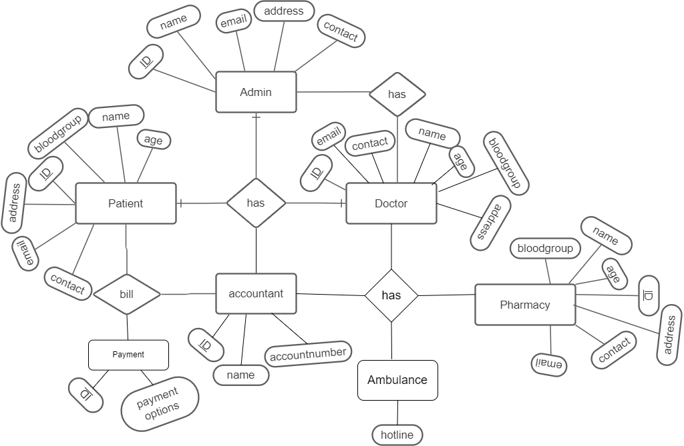

Figure 7: ER Diagram

**3.4 Class Diagram**

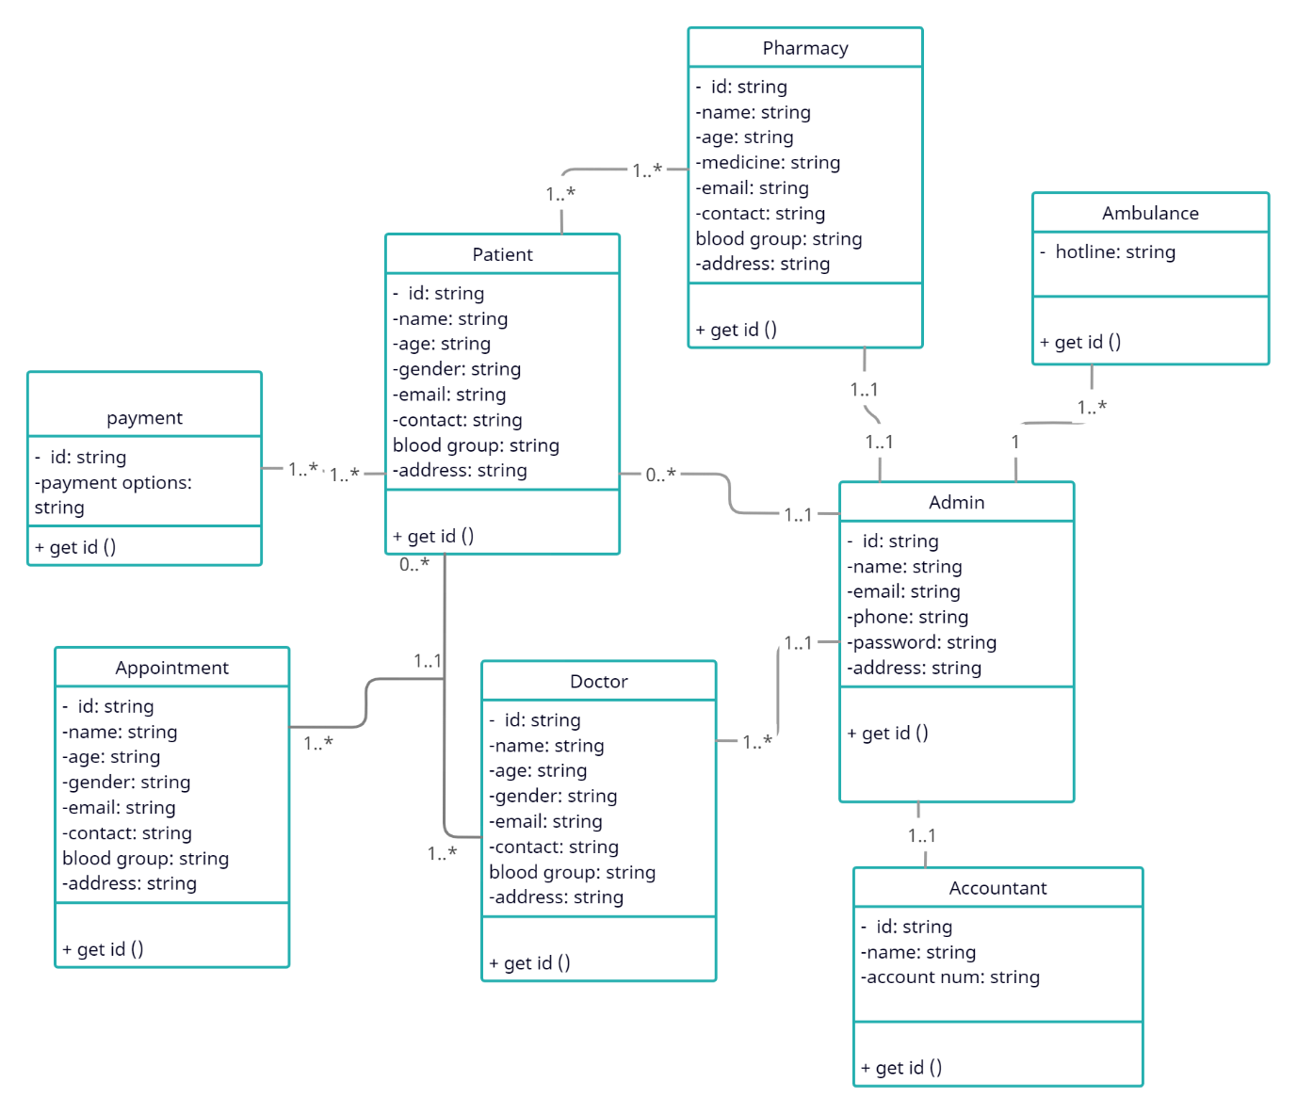

Figure 8: Class Diagram

## 3.5 Prototype

3.5.1 Homepage of the System

|  |
| --- |
|  |

Figure 9: Homepage of the System

3.5.2 Recent News Page



Figure 10: News (Recent update news)

3.5.3 Login page

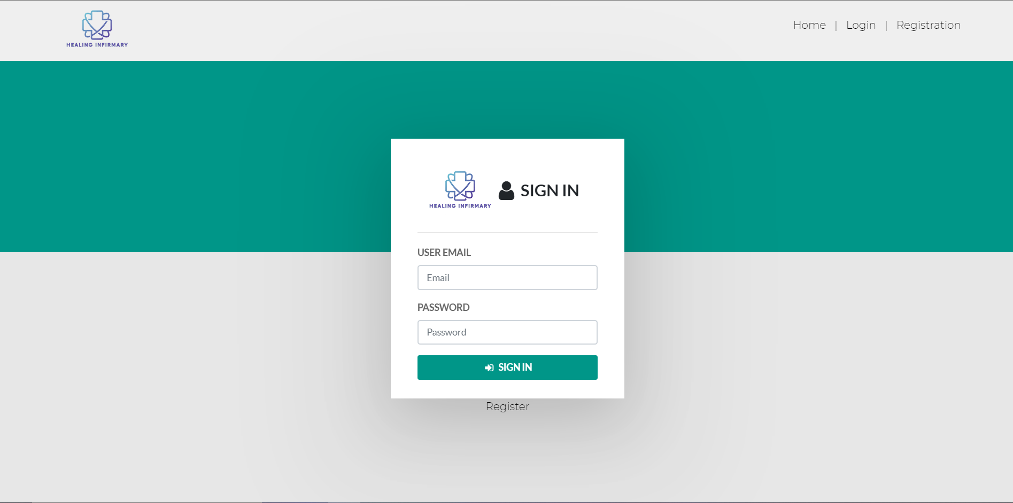

# 

Figure 11: Login Page

3.5.4 Doctor Dashboard

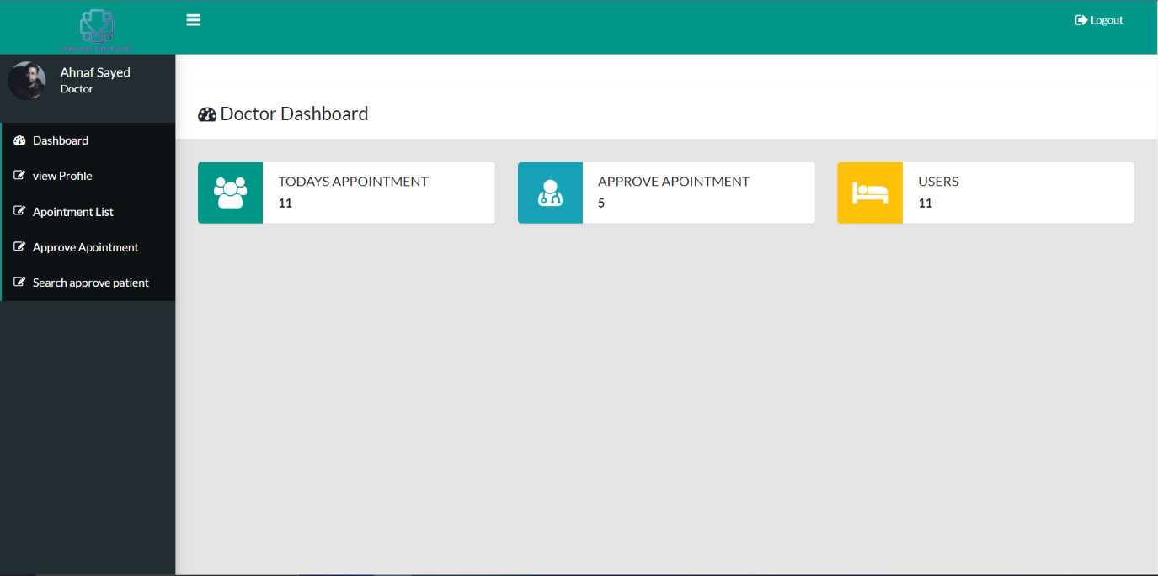

Figure 12: Doctor Dashboard

3.5.5 Patient Dashboard

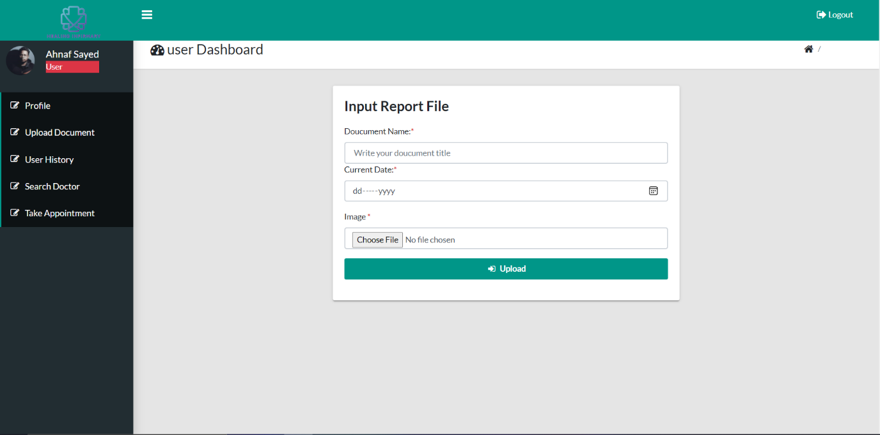

Figure 13: Patient Dashboard

# **Chapter-4: Software Project Management Plan**

## 4.1 Document History and Distribution

The development of The Healing Infirmary System is a knowledge-based system where user can get all kind of information of particular hospital, Clinic, Pathology labs. Also, users can enjoy premium services. Users can benefit from this service by saving valuable time.

## 4.1.1 Revision History

|  |  |  |  |  |
| --- | --- | --- | --- | --- |
| **Revision** | **Duration** | **Revision Date** | **Description of Change** | **Author** |
| 01 | 2 Months | May 20th, 2021 | Primary Phase | Sharmin Sultana |
| 02 | 3 Months | July 23th, 2021 | Major Fixes | Ahnaf Sayed |
| 03 | 2 Months | October 24th, 2021 | N/A | Fahad Mollah |

Table 4.1

These versions will show up there and also on its service work good.

## 4.1.2 Distribution

|  |  |  |
| --- | --- | --- |
| **Recipient Name** | **Recipient Organization** | **Distribution Method** |
| Abhijit Bhowmik | AIUB | Soft Copy |

Table 4.2

Soft copy and Hard copy Distributed copy mention on the table.

## 4.2 Overview

## 4.2.1 Purpose, Objectives and Project Scope

The main objective of this documentation to help ensure consent and expectations. The documentation either explains how the software operates or how to use it, or may mean different things to people in different roles. It is important to record information that can help support the proper treatment plan and the reasoning for such services. The essential mark of our endeavor is to give a paper-less hospital up to 90%. It moreover targets giving minimal effort depending robotization of the current structures. The structure moreover gives superior security of data at every level of both patient and system Admin.

## 4.2.2 Project Scope

* To development **“The Healing Infirmary”** system where the system will be used in any hospital, clinic, pathology labs to get the information from the patients and then storing that data for future usage.
* The intentions of the system are to reduce over-time pay and increase the number of patients that can be treated accurately.
* Users can do monitor their medical reports, prescription, doctor availability using personal device.

Facility to create a daily report, contact with doctor and take suggestions.

## 4.2.3 Assumptions and Constraints

The assumptions during the projects are-

* Our development team members have all the required skills for this project.
* Correct number of handhelds arrive on target delivery date with no delay.
* We will get all the recourse we need during the project.

The constraints during the projects are-

* Technical support.
* Promotional support.
* Cost.

## 4.3 Project Deliverables

## 4.3.1 The list of project deliverables is:

1. Statement of Work (SOW).
2. Software Requirements Specification (SRS).
3. Software Project Management plan (SPMP).
4. Software Design Plan (SDP).

## 4.3.2 Schedule and Budget Summary

|  |  |
| --- | --- |
| **Schedule** | |
| **milestone or major project deliverable** | **planned completion date(day)** |
| SOW | January 7th, 2022 |
| SRS | January 11th, 2022 |
| SPMP | January 22nd, 2022 |
| SDP | February 5th, 2022 |
| Soft testing plan | February 17th, 2022 |
| Presentation & project progress | March 3rd, 2022 |
| Technical documentation | With completed product |
| Software evaluation report | Along with final submission |

Table 4.3

## 4.4 Evolution of the Software Project Management Plan

The preliminary drafts of the Software Project Management Plan will be submitted to the project manager and after approval, copies of the same will be distributed to the members of the group on the date as referred to in section 4.3

## 4.4.1 Definitions

|  |  |
| --- | --- |
| **Terms** | **Description** |
| 1. SOW | Statement of Work |
| 1. SRS | Software Requirement Specification |
| 1. SPMP | Software Project Management Plan |
| 1. SDP | Software Design Plan |
| 1. SQATP | Software Quality Assurance and Testing Plan |
| 1. Impact | 1-catastrophic  2-critical  3-marginal  4-negligible |

Table 4.4

## 4.5 Project Organization

Project organization depends on two major Structures

## 4.5.1 External Interfaces

The system user relationship would be responsible for the developer's community and the client contact's formal association. Everyone in the community will be able to communicate with the client, but all communications with the client will be recorded. All user requests for services or configuration item changes will be in writing and approved by the project’s Configuration Control Board (CCB), which consists of all team members. Any procedure will be carried out under the supervision of the project manager and according to the schedule.

## 4.5.2 Internal Structure

For this project, there are four developers. Everyone has their own areas of responsibility, and everyone contributes equally to the project. Since there are only four people in the team, each one has several responsibilities. All will be held equally accountable for any progress achieved in the project. If necessary, the members of the team will switch sections over the course of the project, and each developer will continue to perform multiple tasks. Both of these techniques will be recorded for future use.

## 4.5.3 Roles and Responsibilities

The software developers are responsible for all documentation to be developed and also for all work to be done.

## 4.6 Managerial Process Plans

## 4.6.1 Project Start-up Plan

This section describes the materials and resources required to start the project. Because most of this information was pre-defined for the team, this section will not describe the rational for many of these choices.

## 4.6.2 Estimation Plan

As previously stated in that, the total development time is estimated to be within 4 months and the total internal cost to be BDT. These figures were obtained by expert judgment by analogy, that is, by comparison with similar projects.

## 4.6.3 Staffing Plan

Each team member will be available for 5 hours per day as the project purpose. This time includes the team and supervisor meetings, document preparation and inspection, and tool development.

## 4.6.4 Resource Acquisition Plan

All resources for the project will be available at the start of the project and will not change substantially over time. Below are the planned changes:

* The team member’s roles will change according to project needs.
* Available work hours will change according to the needs.
* The technical writer will change after completing a documentation.

## 4.6.5 Project Staff Training Plan

No additional staff training is needed for this project**.** Provided document will assist them.

## 4.7 Work Plan

Work Activities and Schedule Allocation

## Budget Allocation

|  |  |  |
| --- | --- | --- |
| Budget Allocation | | |
|  | **Hours** | **Costs** |
| Contract Labor | 0 | 0 BDT |
| Agency Labor | 0 | 0 BDT |
| Non-Labor Costs | 4 | 3370 BDT |
| Total Hours / Implementation Cost | 4 | 3370 BDT |

Table 4.5

## 4.8 Control Plan

## 4.8.1 Requirements Control Plan

After the Software Requirement Specification has been published, any modifications to the requirements must be brought to the attention of the group members and addressed accordingly. Any adjustments will only be made with the supervisor's permission and only if they are feasible and permissible within the project's constraints and resources in terms of group member knowledge and competence. After the changes to the Software Requirement Specification document have been made, an updated version of the document will be issued, and the history of the changes will be kept track of.

## 4.8.2 Schedule Control Plan

According to the schedule done in previous section, if the activities needed to complete the project starts fall behind schedule, all the group members must be available to do over hour work in order to make up for the slipped time.

## 4.8.3 Budget Control Plan

We may calculate the average monthly income by adding all the earnings for the year and dividing it by the number of months. We will be able to calculate the average monthly expense by keeping track of all expenditures. The difference between "Project Budget" and "Expenses" will tell us if the project is exceeding budget and cost reduction measures should be taken. If the expenses exceed income, measures to minimize expenses must be made in order to complete the project on budget. The project manager or the group leader, as well as the other members of the group in this scenario, will keep track of the expenses, which will be published and accessible via the Weekly Status Report.

## 4.8.4 Quality Control Plan

Crucial changes to the milestones or budget or to the project, must be authorized and documented by each group members. Everyone in the group will be responsible for completing the project on time and on budget. The group members will meet with the supervisor on a daily basis to accomplish this. At each meeting, the group's developers will report on the day's progress and challenges. Everyone will double-check that everything is progressing according to the plan and that the project specification document and project management strategies are being followed to the letter. Any major challenges that the members of the group face or might face must be swiftly reported to the rest of the group.

## 4.8.5 Reporting Plan

Updates or modifications made to the project's documentation or development or to the project as a whole will be instantly communicated to the rest of the group members.

## 4.8.6 Metrics Collection Plan

The metrics focus on measurements that may be applied to the class and the design characteristics that identify the class-localization, encapsulation, information hiding, inheritance, and object abstraction techniques-because since the system is object-oriented.

## 4.9 Risk Management Plan

|  |  |  |  |  |
| --- | --- | --- | --- | --- |
| Risks | Probability | Impact | Rating | RMMM |
| Project Manager Availability | 55% | 3 | Medium | R-1 |
| Schedule Slips | 70% | 1 | High | R-2 |
| System Goes Hour | 65% | 3 | Medium | R-3 |
| Project Canceled | 15% | 4 | Low | R-4 |
| False Feature-Rich | 50% | 2 | Low | R-5 |
| Programmers Don’t Have Good Knowledge | 55% | 3 | Medium | R-6 |
| Late Delivery | 65% | 3 | Medium | R-7 |
| Customer Participation in Beta Testing | 20% | 4 | Low | R-8 |

### Table 4.6: Risk Management Plan

## 4.10 Closeout Plan

The close-out plan will be initiated as soon as the project is complete. The close-out plan includes the following tasks,

* Electronic copies of all the documents and project information will be stored on hard drives and cloud backups will be performed.
* After the project is completed, a physical copy of all the documents along with the project details will be produced.

## 4.11 Technical process plans

The technical process plans will be thoroughly written out in this part along with process model to be followed for the development of the project.

## 4.12 Process Model

During the development of the project, the XP (extreme Programming) agile process model will be used. Extreme Programming (XP) is an iterative development approach that produces software progressively rather than producing the entire product at the end of the timeline. Typically, programmers work in pairs, with one writing code and the other observing. They then switch tasks when a specified amount of time has passed. This eliminates the possibility of making an error in the first place.

Figure 12: Process Model

As the project must be completed within a short time, group members can focus on the coding and deliver the complete project as soon as possible by adopting the XP process model.

## 

## 4.13 Methods, Tools and Techniques

The project, Healing Infirmary, will run on any computer running a web browser. The user interface of the project will be developed using PHP, HTML and CSS. Secondly, MySQL will be used as the database for the project and finally, the web application will be hosted using Apache Web server.

## 4.14 Infrastructure Plan

Four Intel Core i5 10th Gen Personal Computers running Windows 8 to 11, MacOS, or any Linux-based operating system are available as hardware resources. Furthermore, group members can use other hardware that will allow them to work on the project steadily. VSCode, Notepad++, Adobe Dreamweaver, and Adobe Photoshop will be used to develop the project.

## 4.15 Product Acceptance Plan

Each project milestone will be formally accepted by the project manager or the group leader and the rest of the group members by signing relevant acceptance documents. At the end of each phase, members of the project group will perform an acceptance test. Performing acceptance test after each phase might expose issues in the project or lead to improvements. On the completed product, the members of the group will conduct the acceptance testing.

## 4.16 Supporting Process Plans

The Software Project Management Plan will include strategies for the supporting activities that are part of the software project. Only a handful of the plans offered include configuration management, verification and validation, software documentation, quality assurance, reviews and audits, problem resolution, and subcontractor management.

## 4.17 Configuration Management Plan

Every delivery on a project should be considered a configuration item. The configuration item and accompanying file will be named after the document, such as SOW or SRS, and the version number will be included. For example, all preliminary versions submitted to the project manager for approval would be labeled with the acronym 0.1, 0.2. After the project manager agrees the basic SPMP, this baseline document will be provided to project members in version 1.0. The project manager's or the group leader’s informal updates will be numbered 1.1, 1.2, and so on, while the committee's next comprehensive delivery will be version 2.0, etc.

## 4.18 Verification and Validation Plan

The verification and validation plan for this project, as well as tools, techniques, and responsibilities for the verification and validation of work activities, must be included in the Software Project Management Plan. The verification and validation plan will be contained in a separate document and updated as needed.

## 4.19 Documentation Plan

IEEE standards would be followed for all documentation needs. All of the papers will be debated and evaluated with the group members before their baseline versions are released and given to the members of the group on the required dates.

## 4.20 Quality Assurance Plan

Ongoing project quality will be assured by the project manager or the group leader. Furthermore, assuring the overall quality of the project will also be a task for the rest of the group members.

## 4.21 Reviews and Audits Plan

Review and audits would be part of the Software Quality Assurance and Verification & Validation Plan, which would be created in accordance with specified departmental standards.

## 4.22 Problem Resolution Plan

The project manager or the group leader and the rest of the group members would resolve all concerns informally. To put it another way, there is no clear strategy in place. If the need for such a plan arises, the Software Project Management Plan will be updated to reflect this.

## 4.23 Subcontractor Management Plans

There are no third parties that would contribute to the ongoing project. Therefore, currently there is no Subcontractor Management Plan in place.

## 4.24 Process Improvement Plan

Once the project has been completed, the project manager or the group leader will review it on a regular basis and notify the rest of the group members if any changes are needed.

## REFERENCES

1. [Boo91] G. Booch, Object-oriented design with applications, Benjamin/Cummings, 1991.
2. [Bru95] G. Bruno, Model-based software engineering, Chapman & Hall, 1995.
3. [Cut05] Cutter Consortium, Software project success and failure.
4. *Square Hospitals Ltd – AT SQUARE WE CARE*. (2006). Square Hospitals Ltd. <https://www.squarehospital.com/appointment>
5. *Ask a doctor online*. (2014). E-Hospital Services Inc. <https://www.e-hospitalservices.net/>
6. Evercare Hospital Dhaka. (2021, April 7). *Evercare Hospital Dhaka | Transforming Healthcare*. Evercarebd. <https://www.evercarebd.com/dhaka/>
7. Misra, N. (2015, October 27). *Project: Meaning, Features and Categories*. Your Article Library. <https://www.yourarticlelibrary.com/india-2/rural-development/project-meaning-features-and-categories/66728>
8. *Trending color palettes – Coolors*. (2014). Coolors.Co. <https://coolors.co/palettes/trending>
9. *Figma: the collaborative interface design tool.* (2011). Figma. <https://www.figma.com/?fuid>=