**Week 1 Group Case Study Assignment**

**Business Profile**

**Introduction**

New Century Wellness Group was founded by internal medicine specialists Timothy Jones and Dolores Garcia ten years ago, which offers preventive medicine and fitness, as well as traditional medical care services.

**Organizational Structure**

A diagram that describes the organizational structure contains the roles and responsibilities of the team members and the relationship among them. This structural diagram called as Organizational chart. The organization chart for the office staff shows the functions of the staff with their designations.

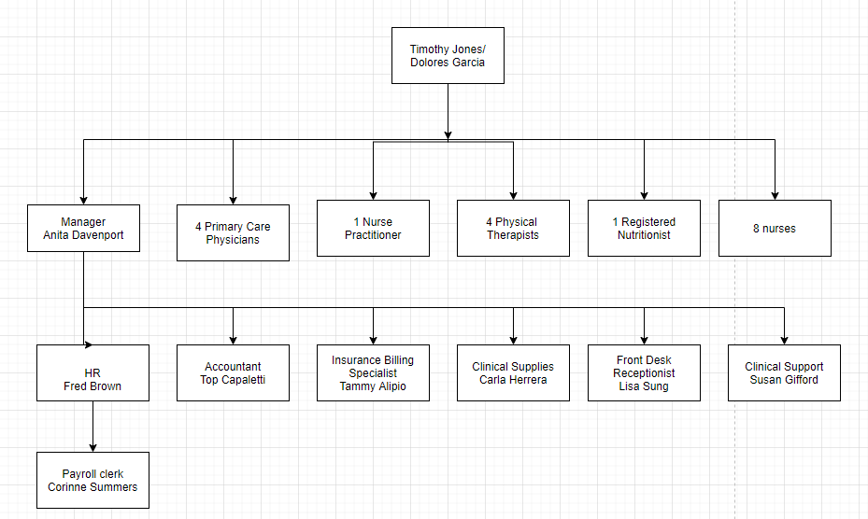

**Products / Services**

* Medical Care
* Preventive Medicine
* Fitness

The clinic currently has a patient base of 8,000 patients from 325 different employers, many of which provide insurance coverage for employee wellness and health maintenance. Currently, New Century accepts insurance plans from 25 licensed health insurance providers. New Century is also considering opening another location, near a new medical center. New Century has competition from other health care providers, but no other clinic offers the same range of services.

**Contact Information**

New Century Wellness Group.

Brea, California

2. Identify six business processes that New Century performs, and explain who has primary responsibility for each process. Also describe what data is required and what information is generated by each process.

**Business Processes**

1. **Employee Benefits:**

Responsibility: Fred Brown takes care of human resources and employee benefits.

Data Required: The details required regarding employee are starting date, health plans details, transportation benefits, percentage of salary contributed towards retirement plan like 401k, number of paid vacation days per calendar year. Data required for this process includes worked-hours, per hour rate and hours worked per month. Information produced from this system includes salary paid, days taken off. Perks given to employees, employee interviewing, hiring, placement

1. **Medical records**

Medical records and health information specialists organize, manage, and code health information data. They use various classification systems to code and categorize patient information for insurance reimbursement purposes, for databases and registries, and to maintain patients' medical and treatment histories. Susan Gifford is responsible for maintaining medical records. Data needed, Personal Identifiable Information, Protected Health Information. Information generated include .Medical records, X-ray results

1. **Inventory management:**

An inventory management system is key in healthcare organizations that need to keep track of medical supplies, order and dispense prescriptions, or sell health products to patients. ... When managed properly, perpetual inventory systems are an efficient and accurate way to track inventory for your healthcare system. Data required include required healthcare supplies. Information generated includes supplies purchased and record. Carla Herrera is responsible for ordering for new supplies of medicines to clinic, organizing both office and supplies of clinic

1. **Patient Scheduling**

**Scheduling** aims to improve the match between **healthcare** resources (doctors, nurses, rooms, equipment, and medicines) and patient needs. ... It does this by tracking the availability of resources, projecting future demands for service and automating the assignment of resources to needs**.** Lisa Sung responsible for patient scheduling, Data needed**,** Patient information**,** Insurance Information.Doctor schedule. Information Generated include Patient appointment **and** patient record in database.

5. **Payroll, Tax reporting, profit distribution**

Corinne Summers performs tax reporting and profit distribution. Data needed include employee’s work hour’s schedule, companies’ tax info, .direct deposit information Info Generated includes Paychecks, .Earning statements, and Federal taxes

3. Based on what you know at this point, is it likely that you will recommend a transaction processing system, a business support system, or a user productivity system? What about an ERP system? Explain your reasons.

**Significance of systems used in New Century Health Clinic**

Following are the significance:

• **Transaction System:**

A transaction system used to track all the financial details of the patient such as payment, amount of charges for the medicines and insurance claims if any. By using this system we can reduce the costs of the administrative functions, the insurance reimbursement can be done fast, and to control the reports.

• **Business support system:**

A business support system is used to analyze the workloads of the providers, the need of staff required according future plan and the turnaround time for claims and payments.

• **User Productivity system:**

A user productivity system used to increase the efficiency of the office and can improve the satisfaction of the patient.

1. Describe the systems development method you plan to use, and explain the pros and cons of using this method.

**System development method**

The **New Century clinic** has to store all information in the computer system. At first, the New Century clinic has to identify the ongoing procedures, based on the small and medium size companies.

The procedures include how to manage patient records, payments of accounts, insurance transactions, providing services, payroll and human resources.

**New Century** mainly deals with the insurance companies; there are several opportunities for the information of the insurance claim and details of payment using EDI. To maintain the clinic information in an efficient way the New Century should consider the different packages such as horizontal and vertical.

The Following table describes possible systems that are taken to be considered:

The Following table describes possible systems that are taken to be considered:

|  |  |  |  |
| --- | --- | --- | --- |
| **System** | **Type of System** | **Use** | **Benefit** |
| Accounts receivable | Vertical or horizontal | Tracking money of the clinic for the rented services, goods sold, sending bills or statements based on monthly to patients and insurance companies. | Identifies the overdue accounts and credit risks |
| Accounts payable | Vertical or horizontal | Sending checks to the suppliers and generating a journal for purchases | Increases the clinic’s control over purchasing and minimize manual data entry |
| Inventory | Vertical or horizontal | Tracking inventories of the clinic and office supplies | Leads to better inventory management |
| Payroll | Horizontal | Generating checks and tax forms for employees managing profit distribution to existing partners | Monitoring and managing pay to individual employees, determines the costs of completing jobs |
| Voice mail | Horizontal | Messaging will happen to internal and external people in the clinic | Allows patients to contact office at any time |
| Fax | Horizontal | Submitting forms to insurance companies, ordering office and clinic supplies | Process of insurance claims are faster |
| Word processing | Horizontal | Creating letters, memos, faxes, agendas and newsletters. | Easy to edit and more professional looking |
| Scheduling; automated calendars | Vertical or horizontal | Schedules tracking and management, taking printouts of available appointments on that day. | Providing effective and efficient services to customers |
| Database management | Horizontal | Providing access to records of patients, employees and insurance companies | Provide better opportunity to each person in an and out of organization |
| Spreadsheets | Horizontal | Planning budgets, costs and profits | Increases the control over the costs, budgets, profits |
| Intranet | Horizontal | Sharing the data throughout the clinic | Reduce the use of paper |
| Web-based | Internet | Creating a Web page to the clinic used to answer the frequently asked questions by patients | Provides better customer service |
| E-mail | Internet | Sending reminder e-mails to patients and easy to communicate with employers, insurance companies | More efficient, less expensive than long-distance calls |
| EDI | Internet | Tracking claim data and status of reimbursement | Insurance reimbursement can be done faster, reduction of administrative costs. |