**Figure 2.15**

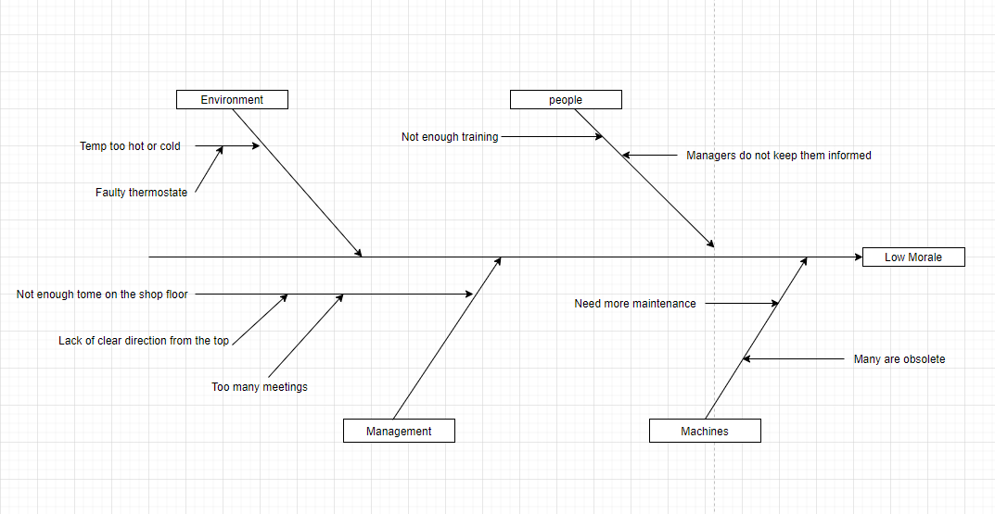

**Fishbone Diagram**

**Figure 2.17**

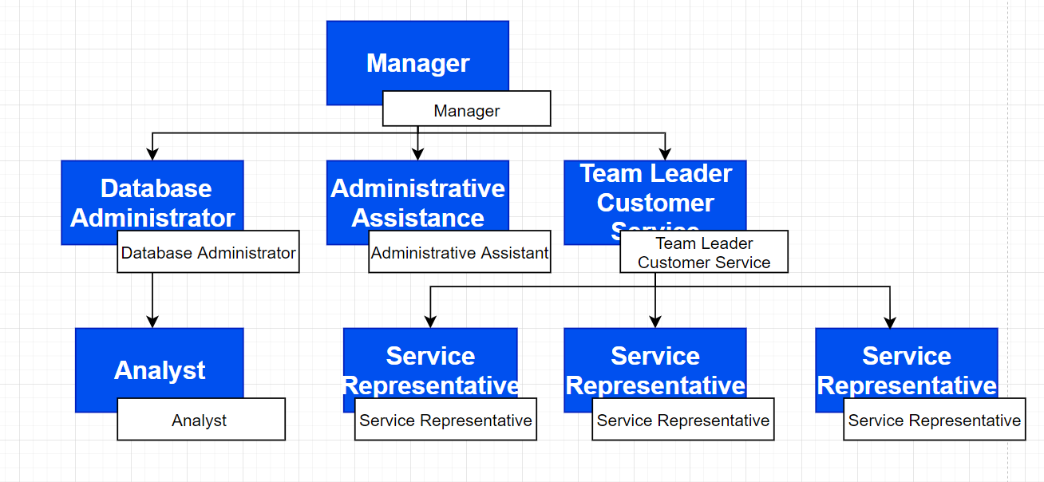

**Organization Chart**