Slide 1



Slide 2



* Triple constraint is a four components group (time, scope, cost and quality of the product) represented by a triangle with time, scope and cost at corner side and quality at the central theme. There must a balance among all these components as the change in any one will impact the other components.

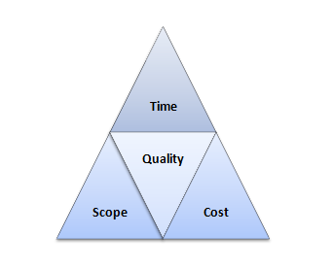

Slide 3



* Project life cycle includes project planning, analysis, design, implementation, and budget. A project life cycle can have many models but each model represents a single phase to build the deliverables of the project. A project life cycle consists of initiating the project, it’s planning, monitoring and controlling, executing, and closing.

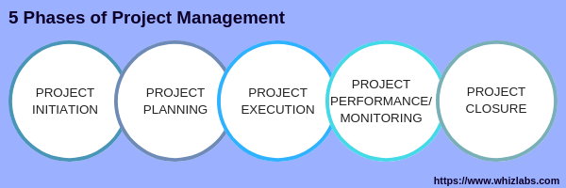

Slide 4



Slide 5



Slide 6



Slide 7



* Work Breakdown Structure is one of the important project management terms.A work breakdown structure (WBS) is hierarchical that breaks down the work into manageable clods so that each level of WBS could be easily understood by the project team.
* A milestone is a scheduling process that describes the setof related deliverables.
* Stakeholders are the people engaged in and influenced by the project.
* A work plan is an outline of a group of goals with the help of which project team can reach those goals.
* The baseline is one of the most popular project management terms among project managers. A baseline is used to measure the performance of the project.
* Gantt chart is a bar chart that displays the scheduled information graphically.
* Change management is a project management plan that has authority to approve or reject the changes on the project.

Slide 8



* During the course of a project, Work or Work Package consists of an Activity.
* Business Case is referred to a doc file which is used to store data like costs, calculations, benefits etc.
* Use Cases help users by providing the requirement of software tests.
* Earned Value is termed as the methodology in which three main aspects of projects i.e. the actual work, project plan & value at which work is completed, are observed.
* The SWOT analysis refers to the planning by which you calculate these terms.
* Business Plan is termed as a doc file which evidently describes about the project goals.

Slide 9



Slide 10

