**Week 3 Mini-Case**

 "**Forest Point Construction**".

**Tasks**

1. What is the correct total time?

Ans: 40 Days.

1. What is the critical path?

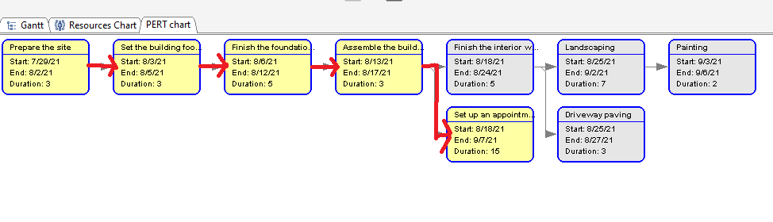

1. Create a Gantt chart that shows the WBS.

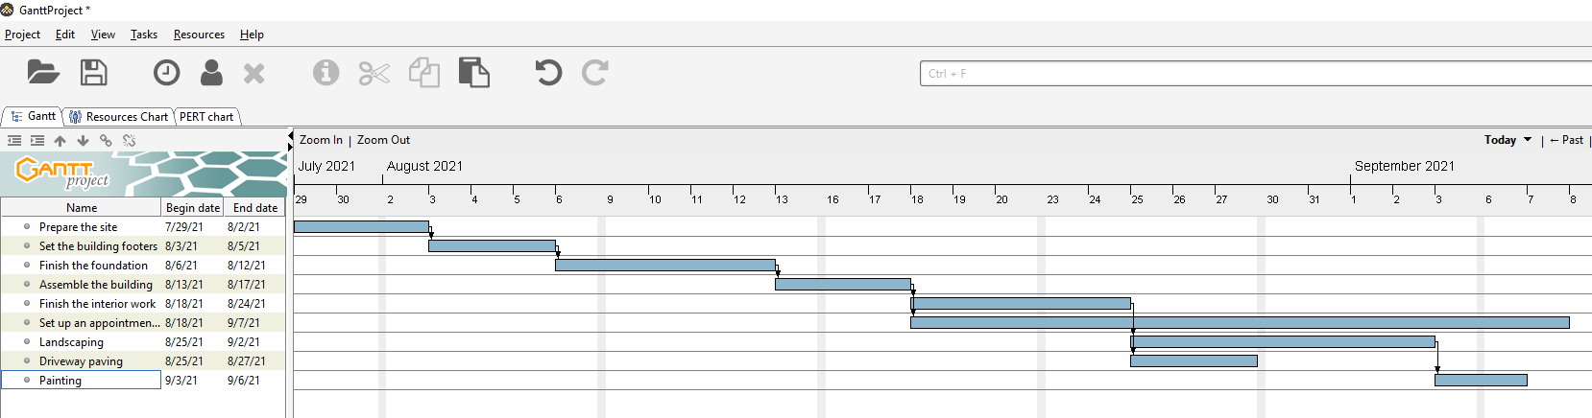

4. Create a PERT/CPM chart.

