1. **Using the task list above, create a Gantt chart using GanttProject (**[**www.ganttproject.biz**](http://www.ganttproject.biz)**).**

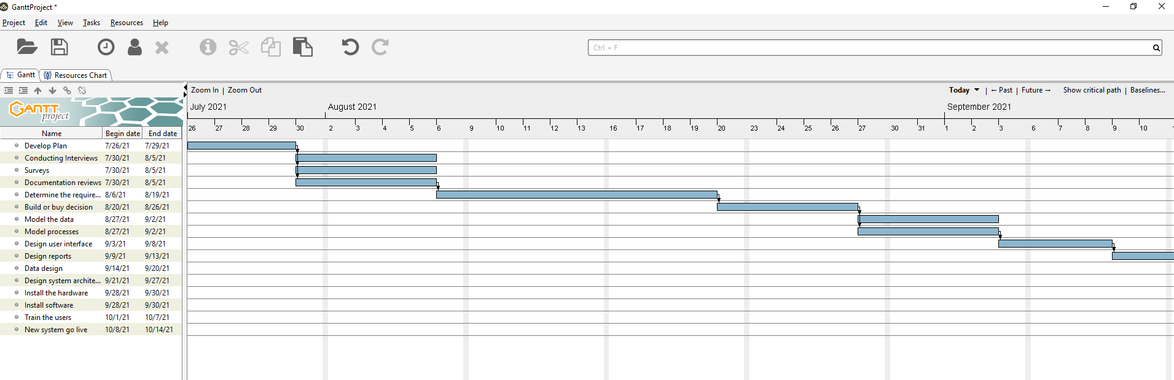

1. **View the PERT chart based on the task list.**

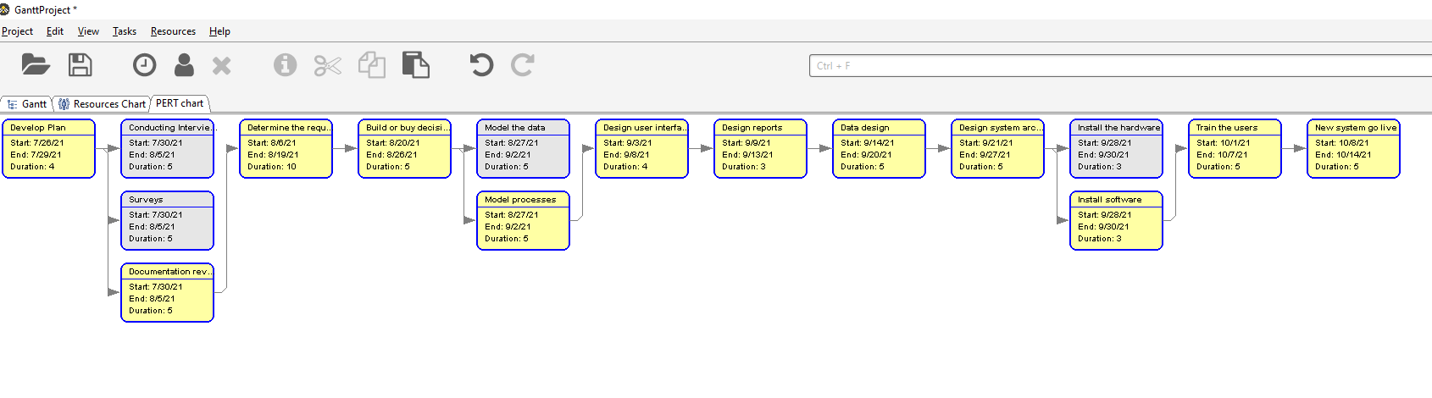

**a. How is the PERT chart different from the Gantt chart?**

The key difference between the two charts is the way in which they present project data.

A [Gantt chart](https://www.wrike.com/gantt-chart/) is a bar chart that lays out project tasks and timelines linearly. The y-axis is made up of individual tasks and the x-axis represents time. Gantt charts are great for improving efficiencies and optimizing [time management](https://www.pmi.org/learning/library/time-management-project-functions-schedules-5723), as PMs can adjust tasks in the chart as the project progresses to keep it on track for a timely delivery.

A [PERT](https://www.wrike.com/project-management-guide/faq/what-is-pert-in-project-management/) chart, on the other hand, is structured as a flow chart or [network diagram](https://www.wrike.com/project-management-guide/faq/what-is-a-network-diagram-in-project-management/) that displays all the project tasks in separate boxes and connects them with arrows to clearly show [task](https://www.wrike.com/project-management-guide/faq/what-is-a-task-in-project-management/) dependencies. Although PERT — short for Program Evaluation and Review Technique, charts don’t have dates along their x-axes like Gantt charts, the individual boxes that make up PERT charts identify the time needed to complete each task.

**b. What advantages or disadvantages do you see in each?**

**Advantages of Gantt chart:**

* It is to represent the Project schedules and Activities
* Easy to represent Tasks, Sub-tasks, Milestones and Projects Visually on a Graph
* Clear visibility of Dates and Time Frames
* It helps to see the Plans by Day, Week, Month, Quarter and Year
* Helps to effectively manage the Team
* And it helps in efficient Time Management
* Easy to group all sub tasks under a main task
* Also, we can see the Team Members and their responsible tasks
* Easy to Check the Project Status
* We can See the Completed % of Tasks
* Tasks in Progress and Pending work is clearly visible on Stacked Bars
* Helps Managers to easily coordinate with the teams
* Gantt chart is good tool for presenting in Team Meetings

## Disadvantages of Gantt chart:

* Require more efforts for Creating and Managing the Chart
* Updating a Chart is Very Time Consuming
* All Tasks are not visible in a single view of a Gantt
* Need to scroll and Click additional buttons to view remaining items
* Stacks represents only the time and not the hours of the work
* Not easy to re align the tasks from on section to another
* Not easy to calculate the aggregates

**Advantages of PERT:**

* **It provides a graphical display of project activities that helps the users understand the relationships among the activities.**
* **It is the ideal technique for tactical level planning and operational level control of projects.**
* **It is effective in planning single project activities in any type of industry.**
* **It allows project managers to do 'what if' analysis on project activities.**

**Disadvantages that limit the use of PERT:**

* **It cannot effectively handle situations in which two or more projects share available resources.**
* **It fails when there is a change in the precedence and sequential relationships of project activities.**
* **It requires a lot of information as input to generate an effective plan. This may prove too expensive.**

**c. Which do you prefer and why?**

I would prefer Gantt chart because, this real-time view of progress keeps the team on track for timely delivery, improves efficiency, and optimizes time management. Tracking the order of tasks and completed tasks is easier with a Gantt chart. **Gantt charts are better than PERT charts** for monitoring a project status once they’re underway. Gantt charts provide [project transparency](http://www.wrike.com/blog/campaign-transparency-to-guide-stakeholders/) to team members and stakeholders and clearly represent both task and overall [project timelines](https://www.thebalancecareers.com/what-is-project-time-management-3879177). With a Gantt chart, PMs can quickly identify whether a project is progressing as scheduled and know precisely where each task should be at any given point in time during the project cycle.

**3. Identify the critical path for the project**

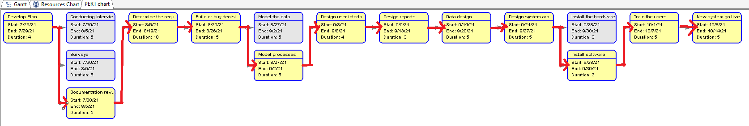

**4. Explain how the critical path is determined.**

Here are the steps to calculate the critical path in project management:

1. **Collect Activities:** Use a [work breakdown structure](https://www.projectmanager.com/work-breakdown-structure) to collect all the project activities that lead to the final deliverable.
2. **Identify Dependencies:** Figure out which tasks are dependent on other tasks before they can begin.
3. **Create a Network Diagram:** A critical path analysis chart, or [network diagram](https://www.projectmanager.com/blog/network-diagrams-free-tools), depicts the order of activities.
4. **Estimate Timeline:** Determine the duration of each activity.
5. **Use the Critical Path Algorithm:** The algorithm has two parts; a forward pass and a backwards pass.
6. **Forward Pass:** Use the network diagram and the duration of each activity to determine their earliest start (ES) and earliest finish (EF). The ES of an activity is equal to the EF of its predecessor, and its EF is determined by the formula EF = ES + t (t is the activity duration). The EF of the last activity identifies the expected time required to complete the entire project.
7. **Backward Pass:** Begins by assigning the last activity’s earliest finish as its latest finish. Then the formula to find the LS is LS = LF – t (t is the activity duration). For the previous activities, the LF is the smallest of the start times for the activity that immediately follows.
8. **Identify the Float of Each Activity:** The float is the length of time an activity can be delayed without increasing the total project completion time. Since the critical path has no float, the float formula reveals the critical path: Float = LS – ES
9. **Identify the Critical Path:** The activities with 0 float make up the critical path.
10. **Revise During Execution:** Continue to update the critical path network diagram as you go through the execution phase.

**5. How will you use the critical path as the project manager?**

Critical path provides a higher level of insight into project’s timeline and a correlation between tasks, giving me more understanding about which task durations I can modify, and which must stay the same. If I want to complete the project in a shorter time frame, it’s easy to see which tasks are the best candidates for duration reduction.

I get rid of competing priorities or lack of direction. Everyone on the team is aware of the tasks that need to take place and I can better allocate resources.

Throughout a project, I can identify tasks that have already been completed, the predicted remaining duration for tasks in progress, and any planned changes to future task durations. The result will be an always updated schedule which, when displayed against the original project timeline, will provide a visual way of comparing planned with actual progress. It also helpful to identify risks and take appropriate steps.