**Tasks**

1. Explain how an FDD can be used in requirements modeling

* Functional decomposition diagram (FDD) is used to identify functions and define their structure. It is a technique to decompose the complex problem into manageable pieces or individual elements to develop the application or product.
* Requirements models are used when gathering requirements for a new system. Requirements analysis is used to understand current systems of business process and to understand the use of the new system.
* FDD is used in requirements modelling to decompose the first level components with their functions and continue to decompose to lower levels until sufficient level of detail is achieved
* FDD in requirements modelling are used to depict the hierarchy of developing the new system, processes, and sub processes within the new system.
  + Sample FDD for marketing system.

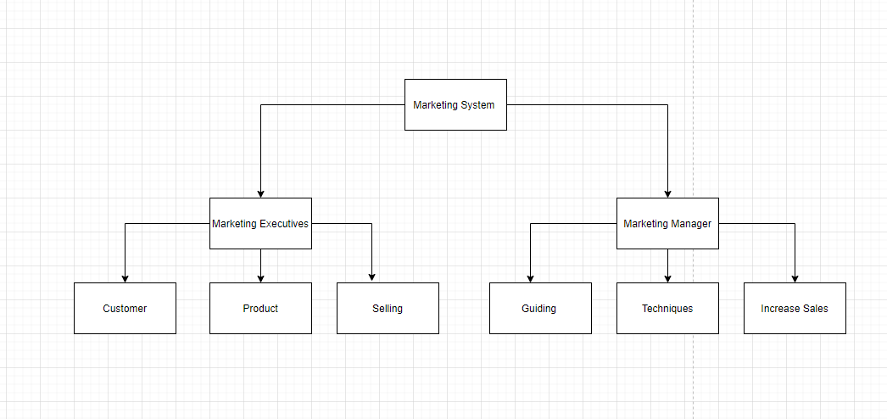

2) Describe BPM and how it can be used

* Business process modeling, often called process modelling is the pictorial representation or illustration of development of new system. In business activities, the information flow and decision logic in business processes.
* Business process model and notation will provide businesses with the capability of understanding their internal business procedures in a graphical notation. BPMN diagram is similar to flowchart.
* BPM can be used to develop a symbolic notation for new marketing system which helps marketing executive to sell the product.

Sample BPMN for marketing system.

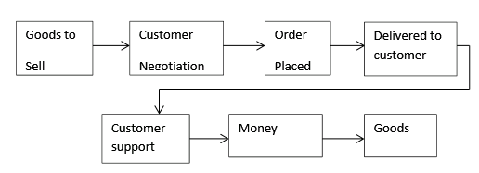

1. Explain how DFDs can be used in requirements modeling

* Data flow diagram shows the flow of data between the different entities and data sores in a system
* In DFD, the arrows are actually data transfer between the elements. Which are themselves parts of a system.
* A data flow diagram can be modeled early in the requirements elicitation process of the Analysis phase within the system development life cycle (SDLC) to define the project scope. DFD.s can provide a detailed
* Representation of system components. DFDs depict flow of data in the system at various levels.

Sample DFD for marketing system

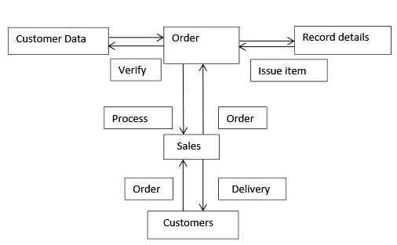

1. Describe the UML and how it can be used during systems development.

* UML is unifies modelling language used for modelling business process and analysis, design and implementation of software based systems. It uses graphic notation to create visual models of software systems
* The UML is a tool for specifying software systems.
* Standardized diagram types like use case diagrams, sequence diagrams, class diagram, activity diagram is used to help user to describe and visually map a software system’s design and structure.
* Using UML it is possible to model just about any kind of application, both specifically and independently of a target platform.
* It is used to define structure of system and helps in managing and simplifying complex systems.