Overview: Concepts

The App

This is an educational app, it is designed to look like a game but it is not really a game. The idea is it is adaptive – it serves lessons and questions to the student and the student doesn’t directly have a say in which lessons they will take. The user interface is very simplified – the purpose of this is so they can focus on the lesson.

UI Tech Stack
This should be a React Native app that works with React Native For Web. Initially the app will be optimized for a 16:9 layout which will work best on web and will not work well on mobile. The reason for using React Native Web is that eventually I will add support for portrait and release it on mobile too, but initially it will be web only.

The app should be written in typescript.

You will not need to do backend development, instead for now you can just have some predefined states in constants and swap between them from user interactions or timers or a combination of the two. This spec is for UI only.

App mode vs Video mode

There will be two modes, each will have a slightly different UI. The main one, App Mode, is the only one normal users will see. App Mode has buttons and interaction elements. Video Mode has zero interactive elements and is only used for making promotional videos, it will be accessible only by developers.

Not all scenes are relevant in video mode, but in the scenes section of this document if you see a video mode example we will need a layout for it.

Signed in as parent vs signed in as student

Accounts are created for parents. The sign in happens as the parent. The parent can then switch to a student. To go back to parent mode, a password is required.

Sign In / Create Flow
You won’t have to do much with the actual logic for the sign in or user create flow, I’ll make a lot of it later. You can create some basic placeholder state so we can navigate through the UI you make. The way the UX will flow is the following:
1) Sign in or create a parent account
2) Create or visit a student profile while in parent mode
3) Click the button to use the app as the student
4) The student will interact with the lessons
5) If the student wants to switch back to the parent, they have to enter a password.

Animations, graphics
The graphics of the app will be simple animated vector drawings. This is critical because the app will demand a lot of content and the labor + file size efficiency of simple vector graphics is superior. Please keep all design examples with graphics to have simple vector drawings.

The drawings will need to be cute and simple. We may go with a ‘kawaii’ style or something similar that is labor efficient but pleasant.

Since the animations are not ready, for the UI development you can use static svg images. For scenes that call out a transition that happens after an animation completes, you can just use a temporary timer.

Aspect Ratios
The app will be optimized for the 16:9 aspect ratio so all scenes will need designs in this aspect ratio.

For now we will lock the aspect ratio to 16:9 using black bands and for mobile devices it will be landscape only.

Are images in the scenes section designs?
They are not. They are rough sketches – not designs.

- They demonstrate key planned functionality and so it is important that no elements disappear from them.
- They demonstrate layout although there is definitely the chance for better layout.
- They demonstrate bad aesthetics and so they are not really designs.

The appearance of the app will be approached first from the components.

Color Themes
Colors should be specified in a theme and not directly in components. The theme should be swappable with with a context provider unless you have preferred alternative.

Component Design Concepts
The app should use React Native components, and they should be compatible with React Native Web.

Project components should be made available in a storybook.

Components should all be themeable.

Assets
Included with this spec are some sample assets what will get replaced with animated graphics in the future, these can be used as placeholders. Also some for example stickers.

Not included in this though are assets for buttons and iconography. The reason for that which ever assets and iconography you use in the UI you build will probably permanently be part of the project. So for that reason please provide those and also provide evidence that no license is needed for those or it’s an open source type license.

For sound, you can skip audio. I will implement it later.

State
For the most part, the app you will build will be UI only and so you can make a few hardcoded scenes (still put them in a scene provider please).

For demonstrating transitions you can just use timers which on time out swap the state in the scene provider. Your demonstration will not need to use real business logic but will need real UI logic, so for example on showing a question and answer section you could hardcode a right and wrong answers to demonstrate what happens when a right one vs a wrong one are selected. Later on I can make the business logic work, we just need a temporary way to show getting right and wrong answers and the movement that happens on screen.

Font
The font should be open source, Poppins might be a good one (that’s a clean google font). Maybe font should be specified by the theme.

Components

Buttons
There are 4 main shapes of buttons in the app.
Rectangular – These rectangles with rounded edges look like traditional buttons
Square – These are a lot like the rectangle buttons but have square proportions
Clickable Containers – These look like containers but they probably should have some visual clue that they are also buttons. Examples of these are in the parent menus in the scenes.
Round Buttons – There are a few round buttons such as the close buttons.

In the scenes rough drafts there are other buttons such as square buttons with sharp edges but really those are just mistakes in the sketches because having more than 4 button styles would probably be overkill.

There are a lot of common use cases such as playing video, pausing, continuing lessons, etc. so there should be some standardized implementations / extensions of the 4 main base buttons.

Layouts
It seems like there are only a few layouts used in these sketches so it makes sense to use components for layouts.

This will also make it easier if we ever start supporting other aspect ratios.

Answer Boxes
These are the brightly colored boxes in the question and answer section of the app. I haven’t really designed examples of answers but the containers for them need to be a decent size. In app mode they will hold both the answer plus 2 interaction buttons. There will always be 3 answers, and in 16:9 AR will vertically be 1/3rd the screen height minus margins.

Graphic Container
Not directly visible, should be used to hold a graphic and apply invisible padding either vertical or horizontal to allow the graphic to maintain its proper aspect ratio. Basically the graphics it contains should be as big as possible without distorting the graphic or clipping it.

Text Container
This one is probably pretty straight forward, mostly will be used for controlling text styling now and in the future states since the text will be animated in the future.

Mode Provider
This is a very minimalist context provider, used to switch modes between app mode and video mode. You don’t need much logic for this one but in the future I may use it to inject the control scripts video mode will use, for now it can control a single enum-like state or boolean.

Theme Provider
This will be used to provide the color theme for the app. Many components will make use of this. For now we won’t let the user choose the theme, we will just have the app start with one theme. But we want to be able to switch themes in the future so using a theme provider will let us handle that.

Scene Provider
Because video, audio, text, and even layout will need to sync, it might make sense to have a scene provider. It might have a state for a scene, and the scene can be one of several types.
Example types:
LessonScene – Has a graphic, has audio, has text, and has a type of ‘lesson’ or something.
QuestionScene – Has a graphic +audio + text for the question, has those 3 for each of the 3 answers too, has a type of ‘q+a’.

Since this is more of an app than a website it might be possible to use the scene provider for all routing but that could be overkill.

Sticker
Stickers display in pop ups when getting right answers, and also appear in the stickers page. Stickers can have a progress float param .0 to 1.0 for progress where for example a .6 would show the sticker progress at 60%. It should also have a prevProgress float param. If the sticker is not 100% complete, it should be a silhouette.

Sticker Progress Circle
This can have a progress and a prevProgress value. If there is a differential it should animate spinning up. If they are both 1.0 the progress circle can be invisible.

Sticker Earned
This is the big animated sticker earned pop up that happens.

Input
This is just an input text box. Can be plain text or password (obscured values).

Modal
There’s a modal that is used in many different pop ups.

There are probably many other components, this is just calling out some definite ones to make sure we make them as components and don’t just embed them in other components.

Scenes

Lesson Instructions – App + Video Mode
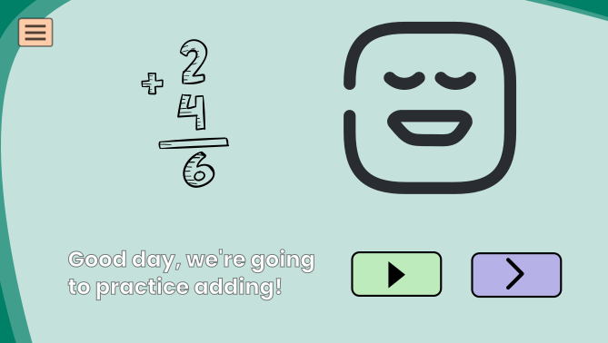  - | App Mode – Lesson Instructions  In app mode the instructional videos have text, a play / pause / replay button, and a next button. The next button should be inactive until the video has been played.
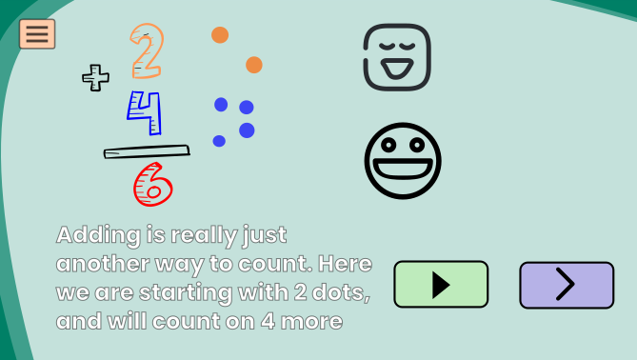 | Sometimes the text is a little long, we could probably just shrink the text if it will take more than 4 lines. At some point though there will probably be a max text length that we will cap our content with.

Video Mode:

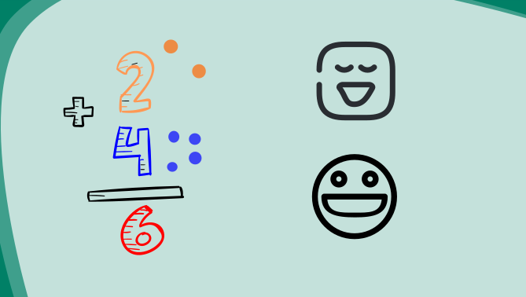 | For instructions in video mode, there is very little layout as the entire screen is the animated vector drawing. There is no text, instead it is audio only.  Probably the background can be more interesting.
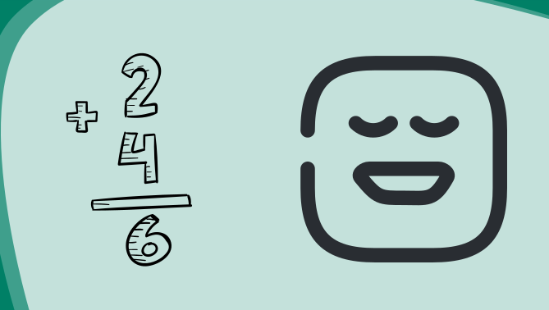
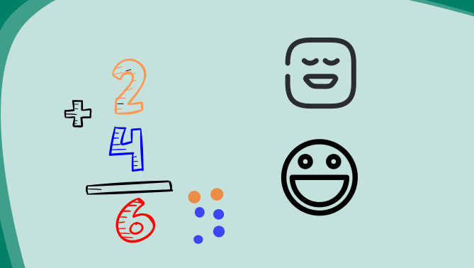

Lesson Questions – App + Video Mode

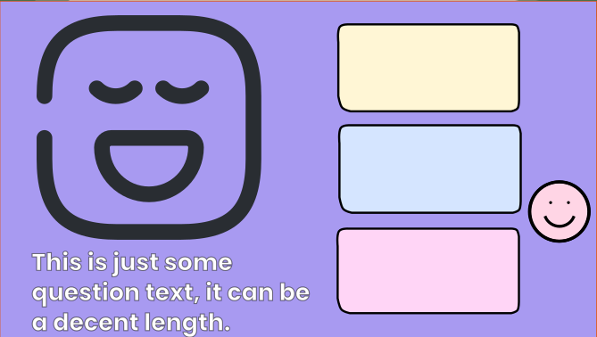 | Video Mode, lesson questions  Since there is no user to interact with these, in the place where there are normally buttons for the answers there will be a character that moves around and narrates what it is thinking.  I didn’t really demonstrate it here but there are answers in the 3 colored boxes
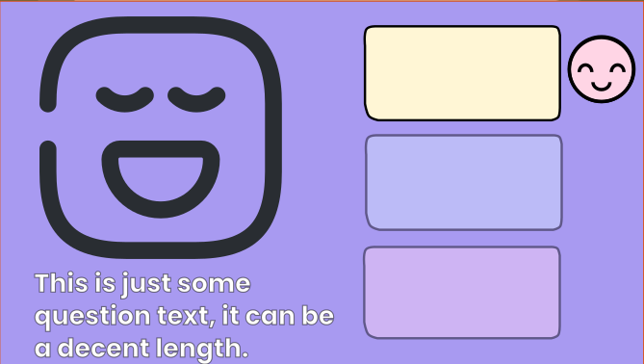 | It will then ‘select’ an answer and the other answers will fade out.
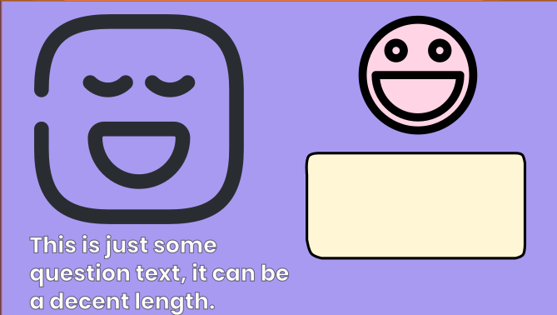 | The character and the answer will become the focus of the screen.

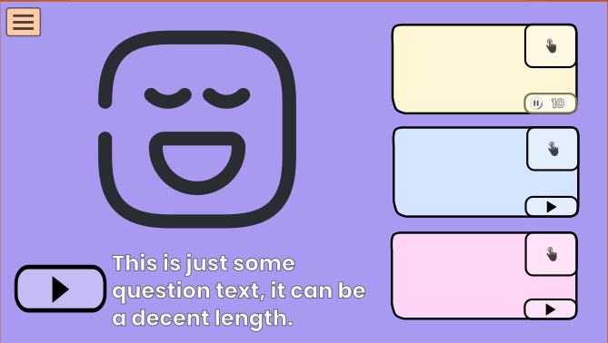 | App Mode, lesson questions  In app mode there will be a question with an animated graphic, there will also be 3 possible answers. Each of those could also have an animation and will have play / pause buttons too. Even if there is no animated graphic, the play button will say the answer out loud.  There is also a larger button to select the answer.
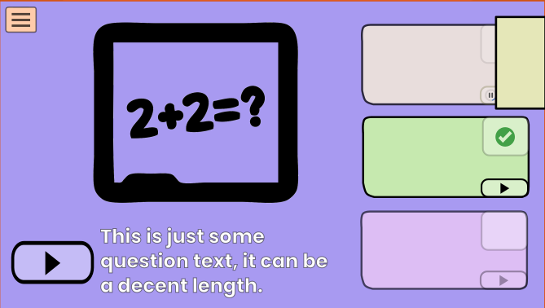 | Answering, Correct Answer  When an answer is selected and it is the correct answer, a green check mark appears over the selection button. The other two answers begin fading out, and a box slides out over one of the 2 free spaces.
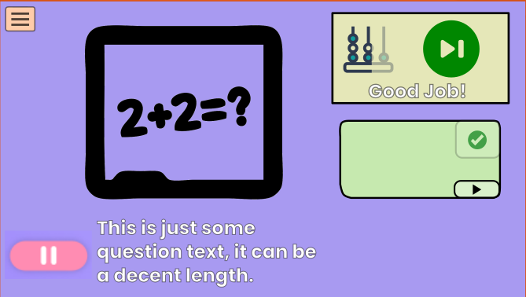 | The box will then show the reward the student gets for getting the correct answer.  After the graphic animation is complete and if the student DID NOT complete a sticker, the green continue button shows up.
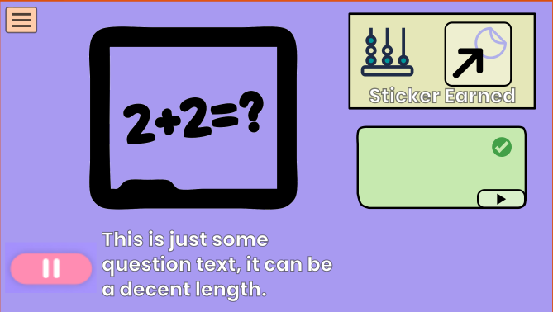 | If the student DID complete a sticker, the button instead is a go to stickers button.

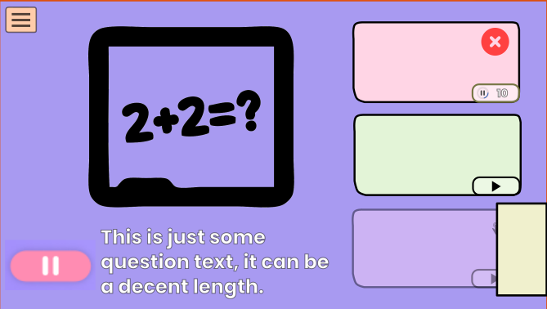 | When a user gets the wrong answer, the selection they incorrectly selected turns red and a red x fades in. A box slides out over the third answer and the correct answer is highlighted in green.
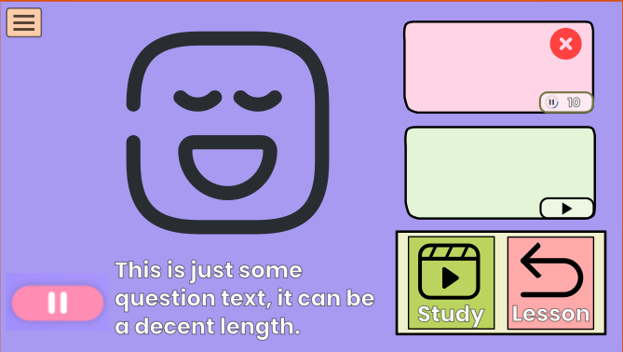 | The user will need to choose to study or continue on. The reason the button to continue the lesson looks like a ‘go back’ arrow is because you cannot really advance in a category until you master a subject.

Sticker Screen – App Mode Only
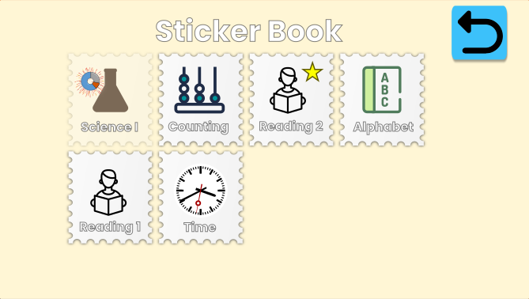 | When you visit the sticker book, sticker progress since you last visited will have a progress circle animate. In this example it’s hard to see but the progress circle by the silhouette ‘beaker’ sticker will animate filling out. The earned difference is marked in red on the progress spinner.
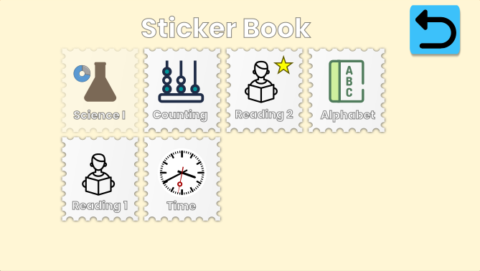 | The animation for that progress will be the red progress gap filling up with the blue progress. This progress spinner will be a component and not an animated graphic because the animation will need to be dynamic.
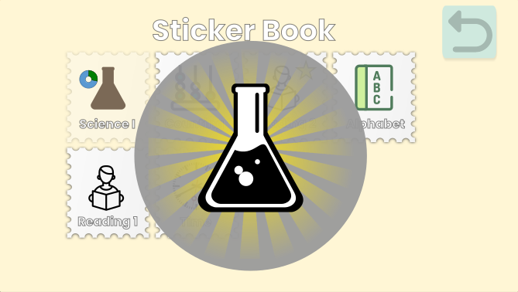 | If you complete progress on the sticker, a big pop up appears. This should have a lot of movement, with a ‘floating’ effect (zoom / unzooming it on an animation curve), and the rays behind it could also be animated. This persists for a bit
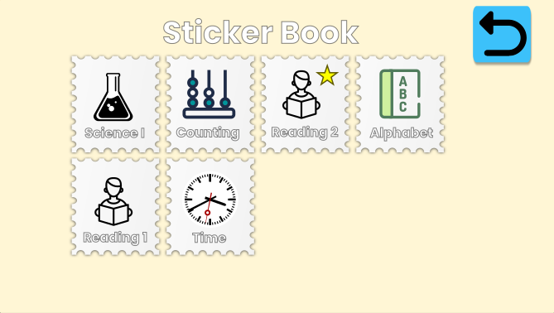 | Then when the pop up animation goes away the sticker fades in from the silhouette to the real one.

In Lesson Menu – App Mode Only

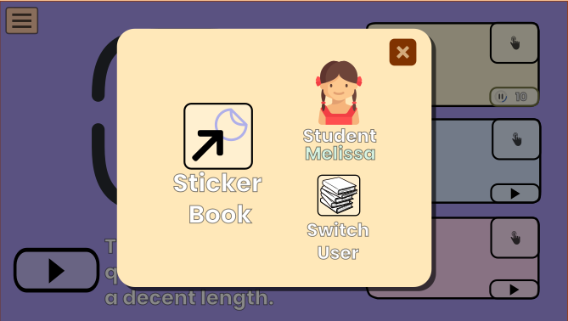 | The menu available to students is very limited. They should get very few distractions from the lessons served to them. Here there are only 3 options:  1) Go to the sticker book  2) Switch user  3) Close the menu
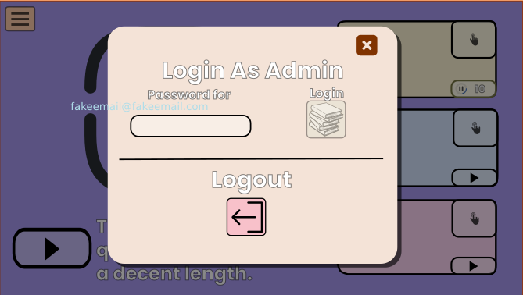 | Switch User has two options:  Login as admin, which requires a password. The password field will not auto-fill.  Logout which does not require a password.  There is also the option to close the modal.
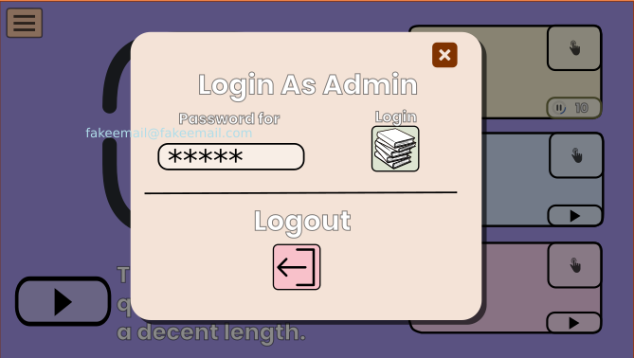 | Once a password of sufficient length has been entered the button will become active.

Parent / Admin Mode

Parent Menu – Students – App Mode Only
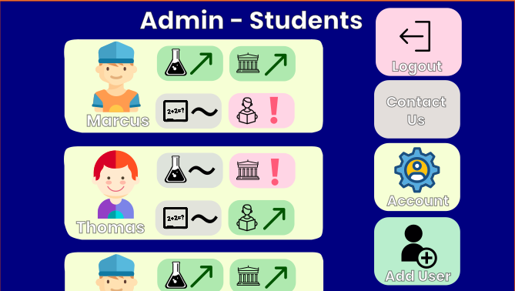 | This is the entry page for parents. It shows all the students in a scroll-able list (for most families there would only be a few). The students have a summary of their current performance with the 4 categories. On the right there are 4 button options.  I don’t know what contact us or account or Add User will look like, I neglected to rough draft those, I’ll copy the style from other pages for those so you don’t need to worry about designing those.

Parent Menu – Individual Student – App Mode Only
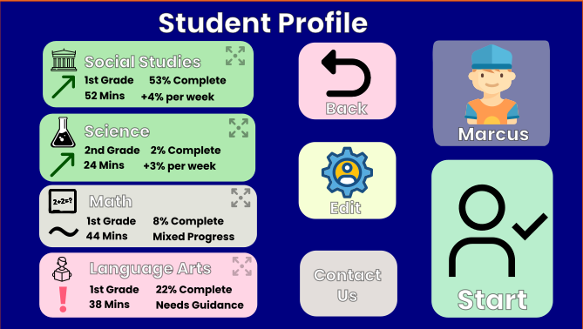 | When a student is selected, this screen which is a summary of the student shows.  On it is a more detailed description of the state of the 4 categories for the student. The key values here are time they spend on average per week on a subject, progress momentum, US Department Of Education grade level equivalence, etc. These are clickable.  Buttons are to edit their profile, contact us, and also to start lessons for them – switch the app to student mode.

Parent Menu – Subject – App Mode Only
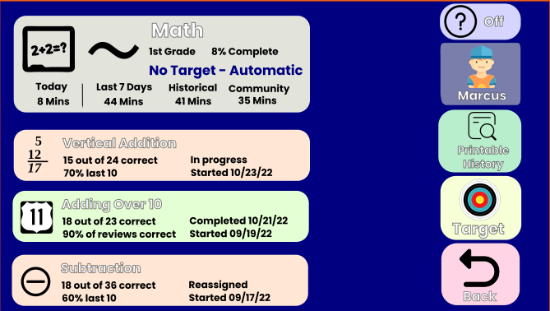 | When a user clicks one of the 4 expandable categories from the student page, a detailed page for the category opens up. The top left box is another summary with mostly the same info from the previous page’s summaries. The boxes below that are a scroll-able list of the subjects in the category, sorted by time criteria.  The right has a toggle for help, a button to view a printable history of their answers in the category, a button where the parent can specify a more aggressive or slower progress target (not included in these designs), and a back button.
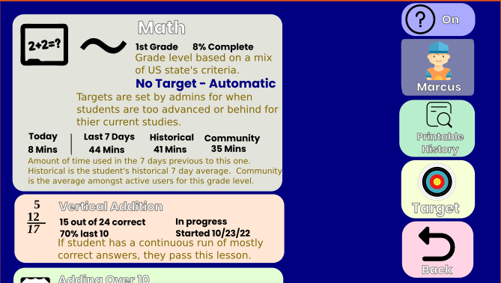 | When the help button is selected dynamic text descriptions of the meanings of the sections displays. This is needed because the amount of details can potentially be confusing, especially on this screen.

Parent Menu – History – App Mode Only

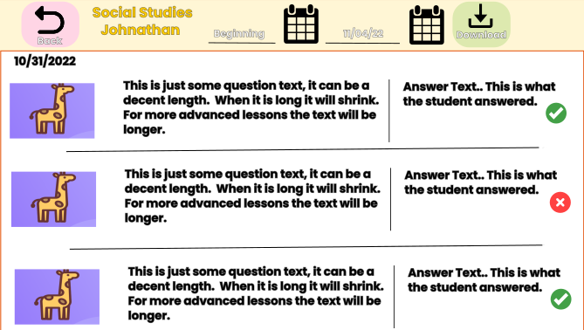 | The printable history page basically lets the parent download a printable history for the category in a time range. This is in case the parent is using the app the help in home school teaching and needs a mandated ability to print history. The UX of this page isn’t extremely important.

Homepage

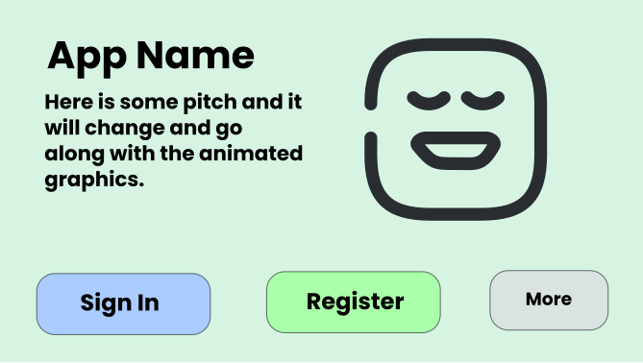 | The homepage is going to be very minimalist at first. Just the app name, probably a logo, some text that changes with the animated image to the right, and a few choices. I’m not sure what “More” will lead to, for now it can be a non-functional button
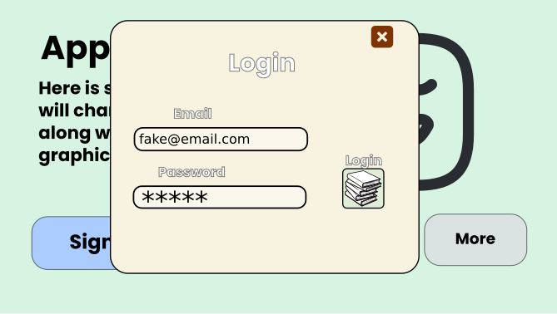 | Login
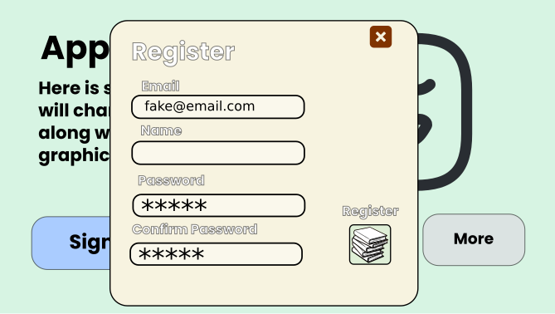 | Register

