

Project Title
Sultan Olaogun
SID: 2228531

MOD002691 Final Project
Final Project Report
BEng Software Engineering
Submitted: April 2026

Abstract

The

Acknowledgements

Razvan and Phillip, My mother and father and Lorenzo
Table of Contents
Abstract…………………………………………………………………………….... ii
Acknowledgements……………………………………………………………......... iii
Table of Contents………………………………………………………………….....iv
List of Figures……………………………………………………………………...... vi
List of Tables……………………………………………………………………….. vii
1.0 Introduction……………………………………………………………………… 1
1.1 Aims of the study…………………………………………………………………1
1.2 Background……………………………………………………………………….2
2.0 Methodology……………………………………………………………………... 4
2.1 A description of Methodology…………………………………………………… 4
2.2 Use of acronyms………………………………………………………………… 4
2.3 Presenting equations……………………………….…………………………….. 5
2.3.1 Academic style and grammar…………………………………………………. 6
2.4 Pseudocode……….…………………………………………………………….... 8
3.0 Implementation and Results……………………………………………………… 9
3.1 Presenting Tables……………………………………………………………….. 10
3.2 Computer code………………………………………………………………….. 11
3.3 Summary………………………………………………………………………... 13
4.0 Discussion………………………………………………………………………. 14
4.1 Purpose of a Discussion chapter………………………………………………... 14
4.2 Presenting Figures………………………………………………………………. 14
4.3 variations to chapter structure…………………………………………………... 17
5.0 Conclusion………………………………………………………………………. 18
5.1 Writing up the project…………………………………………………………. 18
5.2 Using a spell-checker…………………………………………………………… 19
5.3 Formatting the Table of Contents……………………………………………… 19
5.4 Project submission……………………………………………………………… 20
References………………………………………………………………………….. viii
Appendix I…………………………………………………………………………... ix
Appendix II…………………………………………………………………………... x
Appendix III………………………………………………………………………….xi
Appendix IV…………………………………………………………………………xii

List of Figures

Figure 4.1: Tests for Roundness (R) and Circularity (C) on four pre-defined shapes…15
Figure 4.2: Digital Hi Lo logic tester circuit diagram………………………………….16

List of Tables

Table 3.1: Comparison of in-game 3-marine resource building completion times……………………………………………………………………. 10
Table 3.2: Comparison of run time executions…………………………………… 12

1.0 Introduction

Each.

  - Aims of the study
State

  - Background
.
2.0 Methodology

  - A description of Methodology
The project used an Agile methodology that was slightly modified to be able to be used by a solo developer. Components of the project were built iteratively and tested at the end of a components completion before being fully integrated into the project. The project was designed this way to ensure the multiple different technologies would work together in a real world environment. Each system was designed to only interact with a select few other system in order to reduce complexity.
Initial prototyping focused on the backend infrastructure first as the foundational layer for the project. The database was designed and implemented first using MySQL and hosted using AWS Relational Database Service (RDS) and tested and accessed using SQL queries in MySQL Workbench. The API was then set up and configured to process GET and POST responses from users and set up to integrate AWS Lambda Python 3 functions to access data. I then designed and implemented the Lambda functions and continuously tested data retrieval and updates using Windows PowerShell. Once it was established the backend systems were working as expected and data could successfully be retrieved and updated, the next step became to move onto the user facing elements of the project
The ESP-32 code and wiring as well as the Android app were designed and implemented simultaneously as they both accessed the same backend system. I used Android Studio to develop the app and the Arduino Integrated Development Environment (IDE) to write and flash the firmware for the ESP-32.
2.2 Specific Technology Selection
An
2.2.1 Database
The choice to use MySQL was driven primarily by practical performance considerations and data structure requirements. The project requires data stored to be in a structured environment, with a one to one relationship and clear child/parent relationships. For this a traditional SQL database was believed to be the best decision. SQL also provided an advantage in terms of familiarity due to previous experience working with the language in previous projects, this would reduce development time required to complete this component of the project, as opposed to learning then configuring NoSQL databases such as DynamoDB. As mentioned previously, the backend was developed using AWS free tier which offers an additional $100 credit for activating an AWS RDS, which would effectively reduce the cost incurred to zero. MySQL was chosen specifically because of its performance in read heavy environments, and to polling the database in real time relies more heavily on read operations as opposed to writes.
2.2.2 Lambda
Lambda with Python 3.14 runtime was chosen as the API execution method because of the language characteristics and serverless execution model. While Lambda has no operations that it needs to execute the service remains idle until it is needed. With home automation systems having sporadic request patterns where no operations may be required for an extended period of time, and AWS’s pay-as-you-go pricing model where cost is only incurred when a service is used, the need for a serverless solution becomes apparent. This solution is less expensive and uses less compute resources than a traditional always-on server solution. During the selection for the language that would be used in Lambda, the main factor that shaped decision making was how long it would take to initially startup or cold start as due to the sporadic nature of home automation systems, there would likely be long gaps in between operations and this would cause the server to be slower on startup. A custom runtime or Node.js have the fastest cold starts but based on familiarity with different runtimes, and the length of time it would have taken to learn to use them, the decision was made to opt for runtime with the next fastest cold start, being Python. Python was also chosen because of its extensive repertoire of well maintained libraries that would be needed to facilitate database connections and JSON parsing. While Python is slower than other languages after the cold start stage as Python is an interpreted language, the difference in latency is negligible and would not cause any significant latency issues on the back-end.
2.2.3 Microcontroller
When deciding the method that would be used to access the cloud based database and drive the LED lights, it was necessary to consider which solution would be the most practical. It was initially planned to use an Arduino R4 Wi-Fi microcontroller but limitations to accessing the boards built in ESP-32 chip made it necessary to make changes to the design. The ESP-32-S3 chip that was built into the board boasts a greater quantity of RAM than the Arduino R4 board itself that would be required for TLS but libraries required to facilitate connection were designed to use the boards DRAM which is not sufficient for TLS as opposed to the slower but more voluminous PSRAM. The choice was then made to use a standalone ESP-32 WROVER which has sufficient DRAM for TLS. Using a Raspberry Pi Module was also considered because of its greater computational capabilities but this was deemed as excessive for the scope of the project as a Raspberry Pi would have a greater power consumption and the operating system would only unnecessarily add to the complexity of the project.
2.2.4 User Interface
When deciding how the user would interact with the system, during the early stages of design and testing, the plan was to use an Infrared (IR) remote control and IR receiver to control the lights. This idea was abandoned as it lacked the ability to scale up the project and allow the user to control multiple lights with their device without building and designing a new custom IR remote controller to allow the user to control more than one set of lights, which would increase the cost of the project and the time required to complete. For this reason, there was a change made to pivot to designing a simple android application as part of the front end and user interface with Java working to interact with an API and give information about the lights current state to the user.
2.2.4 Lighting
The lights used in the project were WS2812B Addressable RGB (ARGB) lights with 144 individual lights. The plan was to use a set number of individual lights to represent individual rooms in a house.
2.3 Testing Methodology
Testing was done along side integration of components to examine how the system behaved in specific circumstances. AWS CloudWatch was used to give additional information when components would not act as anticipated and gave valuable information that aided in fixing errors and improving performance. PowerShell’s Invoke-RestMethod cmdlet served as the primary API testing tool during development and provided access to send HTTPS requests directly to the API without the need for a user interface during earlier stages of development. It allowed for the sending of JSON payloads and would also allow for logging of responses from the API. This approach enabled sequential implementation of new methods and testing without requiring other components such as the Android application or the ESP-32.
Hardware testing began with smaller testing to isolate key issues. Initial LED testing used a smaller set of LED lights to verify data integrity and ensure the correct colours and number of LED’s could be displayed before implementing multiple room control. This incremental approach allowed for the discovery of power inadequacies and data driving related issues, which were later fixed.
Full integration testing with multiple rooms being controlled by the users device via the Android application to change light colours in real time, database state verification and physical LED appearance was done using the Serial Monitor in the Arduino IDE to provide JSON payloads that had been converted to RGB/HSV values to verify whether the correct data had been successfully extracted from the database.
  - Limitations
The method by which room occupancy was logged requires user disciple in practice. Should a user unintentionally trigger an event where a person has been erroneously detected to have left or arrived in the room, It could cause unintended changes in the physical LED’s state. For this reason an option to manually change the number of people currently in a room was added to the Android application. Another limitation is that the system is designed to detect the number of people who enter or leave a room and it is unable to accurately count the actual number of people in a specific room.
Power requirements were not conducted quantitatively prior to implementation and the solution had to be changed at multiple points throughout the lifecycle of the project due to this oversight. Power consumption was also not accounted for which caused issues during development as the solution had to be changed from a battery powered solution to a dedicated power supply in order to facilitate long term operation of both LED’s and microcontroller.

3.0 Design

3.1 Architecture Overview
The system architecture implements a 3 tiered model, implementing user presentation, application logic and data storage. The presentation tier cosnsists of the Android application that provides the user with an interface for controlling the lights and adjusting settings. The application utilises API gateway access for HTTPS endpoint exposure and AWS Lambda functions for logic exectutions on database hosted on AWS RDS.
Communication flows follow a response and request pattern with Android application and ESP-32 acting as the client the user interacts with the API. User actions in the application trigger POST requests to update the database data while the ESP-32 microcontroller sends GET requests at set intervals to update the physical LED lights on the user end. This architecture decouples the application from the microcontroller and handles any erroneous data. This allows for a user to be able to control more than one light source and any other microcontrollers to be able to be controlled using different devices.
The decision to have ESP-32 polling as opposed to data being pushed by the server to the microcontroller on update from the application component simplified the architecture significantly. While a push-on-update system would reduce latency and require fewer requests to be made and reduce server load, it requires more complex architecture and server-side management of resources. A polling based architecture would be more tolerant of network issues such as temporary outages and can continue operations more seamlessly as GET requests can simply be made in the next polling cycle and retrieve data without regard for missed intervals.
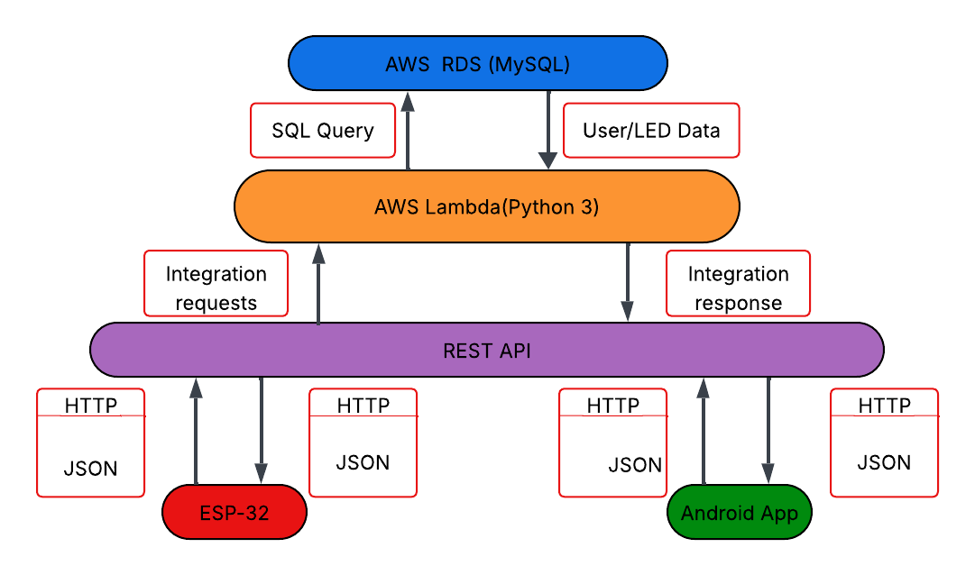

3.1 Database
The database consists of 4 tables to store data for rooms and lights. Those tables being rooms, led_state, motion_settings and occupancy. The rooms table serves as the central entity with the room_id serving as the primary key, the name field for a human readable representation of the individual room and a created_at timestamp for potential future integrations
The led_state table serves as the cloud-based state of the lights in a particular room. It contains room_id from rooms as the foreign key and light_id as the primary key for the database. It also contains the values for the lights, those values being: is_on for allowing the user to turn the lights on or off, hue, saturation and value for deciding the colour and intensity of the lights. The purpose of the last_updated timestamp is to help log changes for debugging and analytics.
The motion_setting and occupancy follow a similar and simple pattern. They both include room_id from rooms as a foreign key as well as their own respective id as their primary key. The motion_settings table includes a column named motion_sensing_enabled which determines whether or not motion sensing will be active and occupancy holds a column named people_count to store the number of people that are present in a room. Both tables also hold a last_updated column included for later development as well as debugging and analytics.

3.1 Lambda
Ipsum

3.1 API
Ipsum

3.1 ESP-32
Ipsum

3.1 Android App
Ipsum

4.0 Implementation and Results

.

3.1 Presenting Tables
A

  - Computer code
As
3.3 Summary
In.
5.0 Discussion

4.1 Purpose of a Discussion chapter
t.

4.2 Presenting Figures
A

4.3 Variations to chapter structure
This
6.0 Conclusion

The
- .

5.1 Writing up the project
).

5.2 Using a spell-checker
Only”.

5.3 Formatting the Table of Contents
.

5.4 Project submission
Prior
.
References

Berndtsson, M., Hansson, J., Olsson, B. and Lundell, B., 2006. Planning and Implementing your Final year project – with Success!: A Guide for Students in Computer Science and Information Systems. Springer.
Bock, P., 2001. Getting It Right. R&D Methods for Science and Engineering. Academic Press.
Burke, R., 2004. Project Management – Planning and Control Techniques. Wiley.
Cornford, T. and Smithson, S., 2005. Project research in Information Systems: A Student’s Guide. Palgrave Macmillan.
Dawson, C. W., 2009. Projects in Computing and Information Systems: A Student’s Guide. Addison Wesley.
Depoy, E., 2010. Introduction to Research: Understanding and Applying Multiple Strategies. Mosby.
Hakim, C., 2000. Research design: Successful designs for Social Economic Research. Routledge.
Trauth, E. M., 2001. Qualitative Research in IS: Issues and Trends. IGI Publishing.
Yin, R. K., 2008. Case Study Research: design and Methods. Sage publications.

Appendix I

Either provide a copy of your Interim Report (which ideally should include 5 items) or provide the Interim Report as a completely separate file document (either approach is acceptable).
Appendix II

Either provide a copy of your Poster at reduced size to fit onto one page, or provide the poster as a completely separate file document (either approach is acceptable).

Appendix III

How many Appendices will be included will be topic specific and advice should be sought from the supervisor. Typical reasons for additional appendices include;
- Presentation of computer source code. If a software deliverable has been written then a copy must be included in an appendix. One normally needs to provide user-instructions for running the code in a paragraph prior to the program or in a separate appendix. Be careful to avoid word-wrapping effects that can make the code difficult to read.
- Additional data results. If there is only a small amount of data results then all the results can be presented in the Results chapter and this appendix is not needed. If there is a large amount of data then a sample of that data should be presented in the Results chapter and all the data reproduced in full in the Appendix. Only in exceptional circumstances (where for example, the data might actually exceed the length of the project before the Appendices) might the data not be presented in an Appendix. Instead refer to the data being present in a separate folder, or consider a larger sample in a separate folder and refer to a Cloud-based storage (see also Appendix IV and section 5.4 of this document template).
- Additional information. If there is information that is relevant but somewhat superficial to the core of the project then that information could be placed in an Appendix instead of in the main text. One reason for doing this would be to ensure the main text of the project maintains its’ focus. Examples might include instructions for running a program, instructions for operating a camera, providing the detailed specification of a product, and providing the detailed background to some topic.
- Word limit constraints. The project maximum word limit is 10,000 words (and excludes any text in the appendices for which there is no limit). Some students may find it very difficult to keep their projects below the word limit of 10,000 words and if this is the case then as a last resort try moving some lesser important text into such an appendix. Note that the word limit is an equivalent word length, that is, the ‘number of words’ is a measure of work rather than absolute word length. Depending on content it is quite acceptable for the actual word length of the project to be less than the maximum limit assuming work/effort is also reflected in something the student has created for their project (e.g. a computer program). Whilst there is no lower word limit as a rule of thumb an absolute project word count of less than 7,500 is probably too short to adequately report the project (seek advice from supervisor).
Appendix IV

If your project has utilised electronic tools or generated large amount of data results, or code, or media files, or executables, or files of a non-standard format that are difficult to present as embedded Appendix within your project report, then they can be presented in a separate folder from the project report file. Such an Appendices could be referred to on this current page through use of a single statement such as:
Please see the separate folder ‘Appendix IV’ which contains all associated resources for this project.
Or alternatively:
Please visit the GitHub link below using the password ‘abracadabra’ to access further supporting resources for this project.
Section 5.4 of this template document gives further information about this approach.

