Bug Report 1

Title: Retry timer becomes less after first retry (reconnect storm)
Environment : Wokwi in VS Code, homework_buggy, Windows 11
Preconditions: CONNECTED
Steps:
- Enter NET DOWN
- Wait 10-20sec
- Enter NET UP
Expected: backoff_ms value should becomes bigger with each next retry
Actual: first backoff_ms=500 and each next backoff_ms=50 (reconnect storm)
Recovery behavior : reconnect=SUCCESS
Evidence:
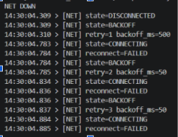
Severity: Medium
Reproducibility: Always

Bug Report 2

Title: Buffer overflowing after recovery
Environment : Wokwi in VS Code, homework_buggy, Windows 11
Preconditions: CONNECTED
Steps:
- Enter NET DOWN
- Enter SEND 10-12 times
- Enter NET UP
Expected: buffer is not bigger than 8, dropped should be 2-4, after NET UP only 8 newest messages are sent
Actual: buffer is bigger than 8, dropped is 0, after NET UP newest messages start sending again
Recovery behavior : reconnect=SUCCESS
Evidence:
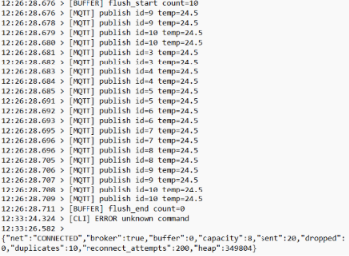
Severity: Major
Reproducibility: Always

Bug Report 3

Title: Duplicates messages after recovery
Environment : Wokwi in VS Code, homework_buggy, Windows 11
Preconditions: CONNECTED
Steps:
- Enter NET DOWN
- Enter SEND 10-12 times
- Enter NET UP
Expected: no duplicates
Actual: each message has duplicates, even buffer is bigger than 8 system starts sending same duplicates again
Recovery behavior : reconnect=SUCCESS
Evidence:
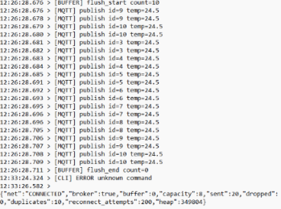
Severity: Medium
Reproducibility: Always

Bug Report 4

Title: Memory Leak after continues message sending
Environment : Wokwi in VS Code, homework_buggy, Windows 11
Preconditions: CONNECTED
Steps:
- Enter STATUS and observe a heap
- Enter STRESS 5-10 times
- Enter STATUS and observe a heap
- Compare heap before and after entering STRESS
Expected: heap should be almost the same with small deviation
Actual: after each STRESS heap becomes less and less, with 80bites per message
Evidence:
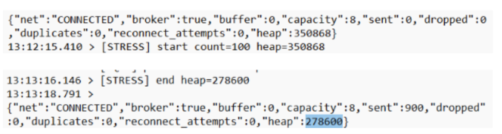
Severity: Critical
Reproducibility: Always

