String
Java String Reference (w3schools.com)
.length()
.toUpperCase()
.toLowerCase()
.indexOf()
String txt = "Please locate where 'locate' occurs!";
System.out.println(txt.indexOf("locate")); // Outputs 7
int a = indexOf("Q"); // -1
Escape character
\' = ' [Single quote]
\" = " [Double quote]
\\ = \ [Backslash]
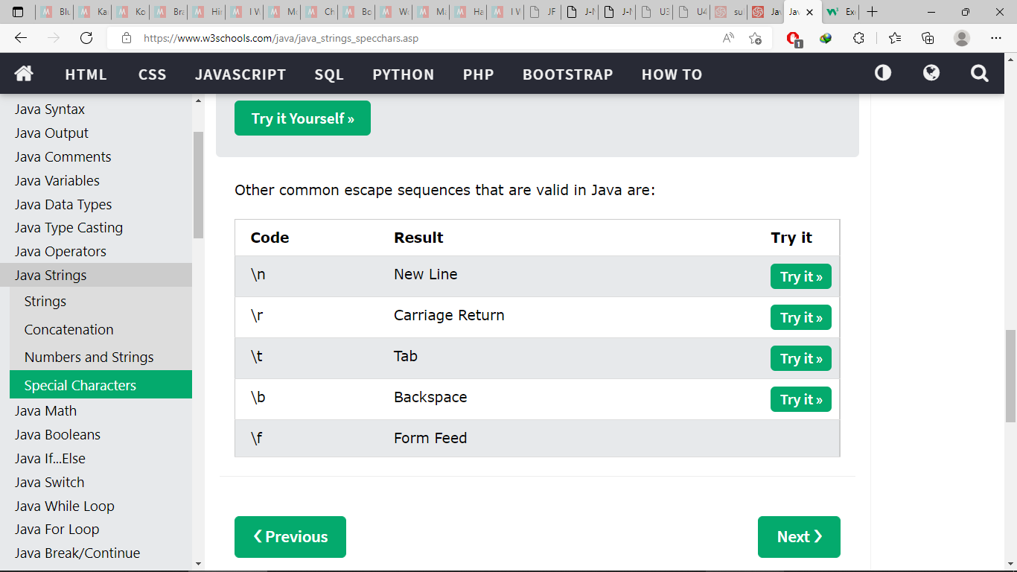
Math
Math.max(x,y)
Math.min(x,y)
Math.sqrt(x)
Math.abs(-4.6) // 4.6
Math.random()
returns a random number between 0.0 (inclusive), and 1.0 (exclusive)
int randomNum = (int) (Math.random() * 101); // 0 to 100
Git

