String

[Java String Reference (w3schools.com)](https://www.w3schools.com/java/java_ref_string.asp)

.length()

.toUpperCase()

.toLowerCase()

.indexOf()

String txt = "Please locate where 'locate' occurs!";

System.out.println(txt.indexOf("locate")); // Outputs 7

int a = indexOf("Q"); // -1

.split()

String text = "123 456";

String[] parts = text.split(" ");

int number1 = Integer.parseInt(parts[0]); //123

int number2 = Integer.parseInt(parts[1]); //456

.repeat()

System.out.println("*".repeat(3)); //***

String re = "*".repeat(3);

Escape character

\' = ' [Single quote]

\" = " [Double quote]

\\ = \ [Backslash]

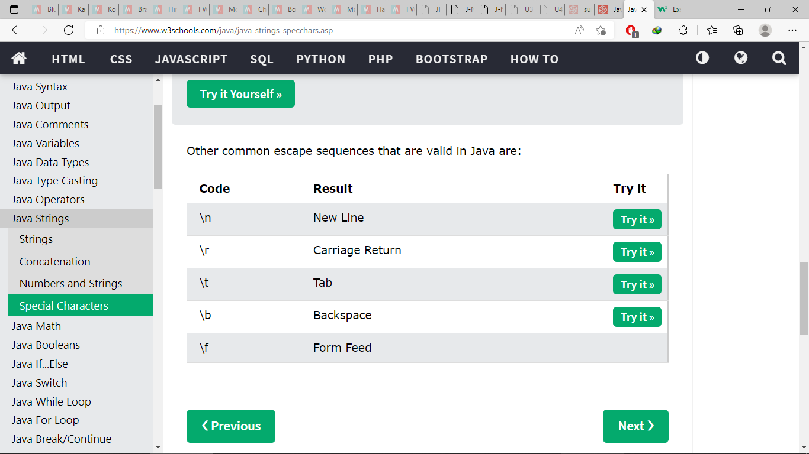

Math

Math.max(x,y)

Math.min(x,y)

Math.sqrt(x)

Math.abs(-4.6) // 4.6

Math.random()

returns a random number between 0.0 (inclusive), and 1.0 (exclusive)

int randomNum = (int) (Math.random() * 101); // 0 to 100

Git

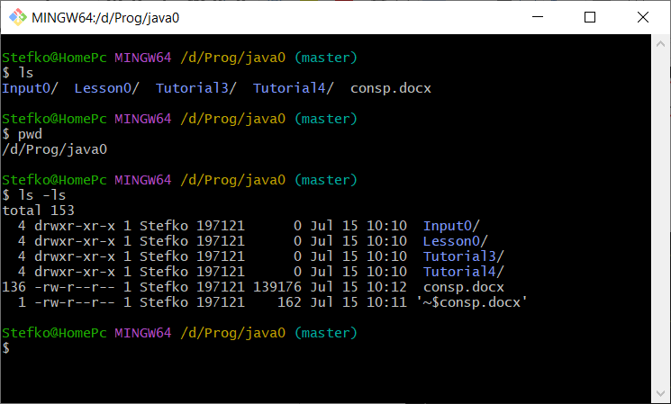

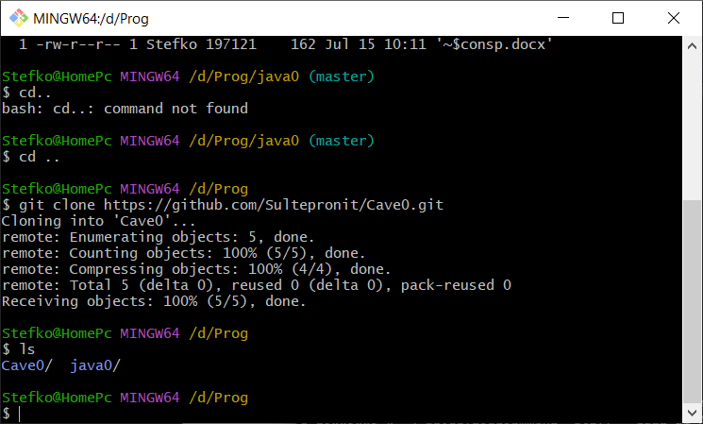

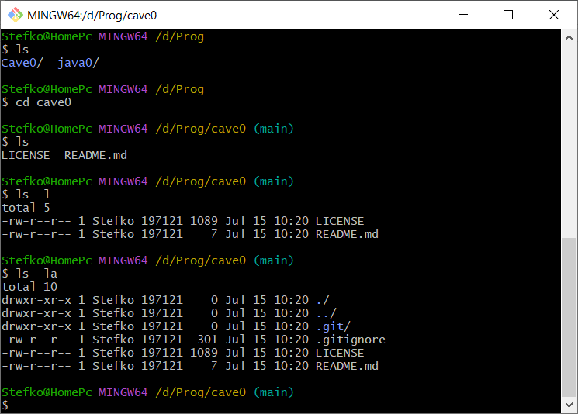

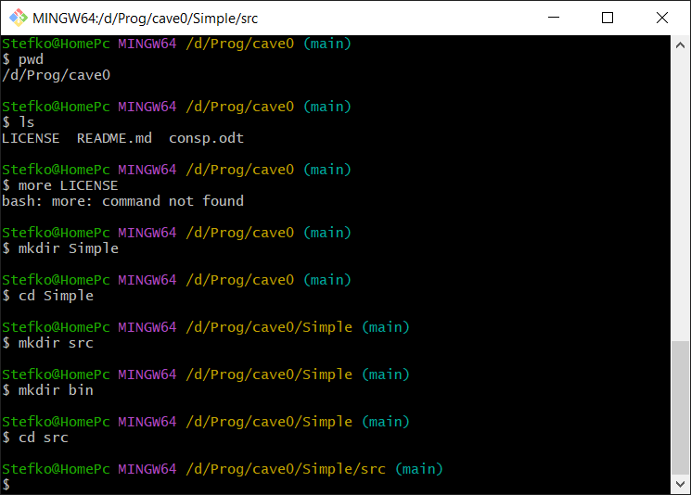

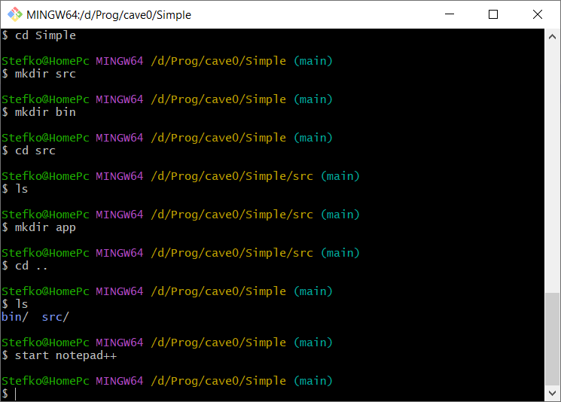

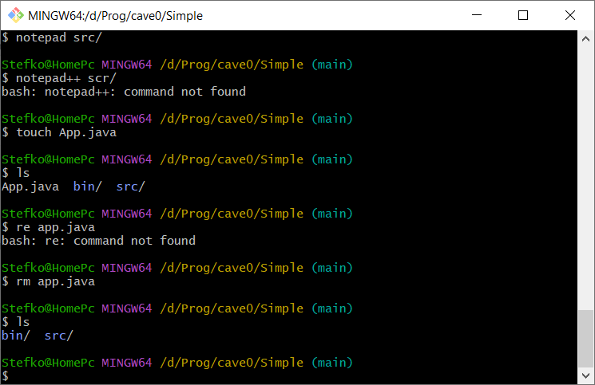

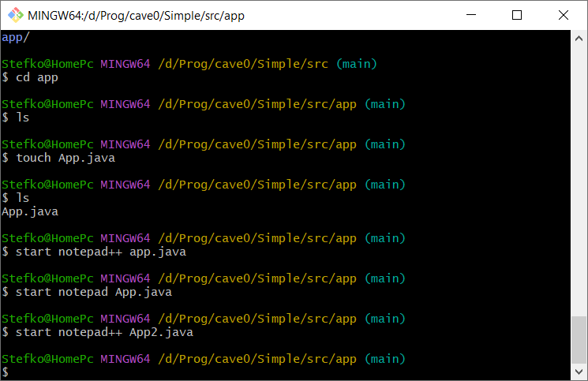

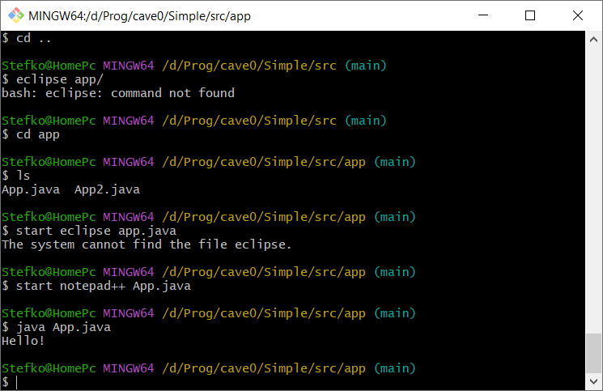

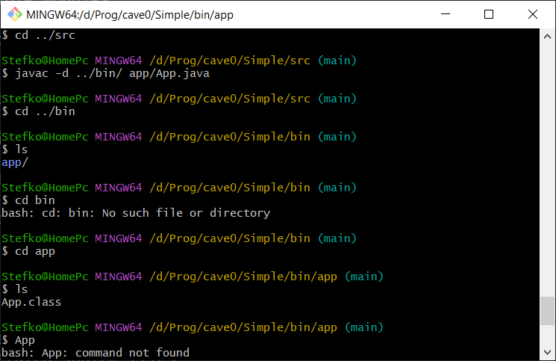

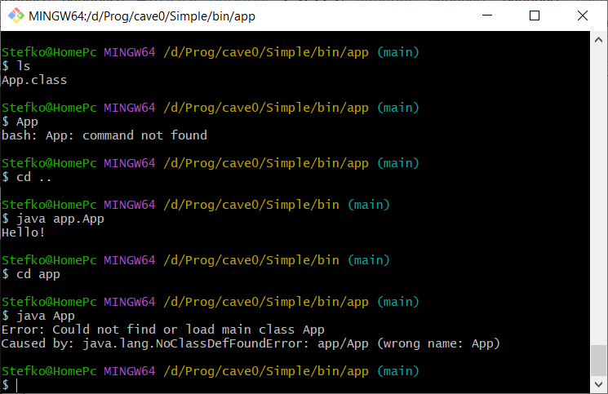

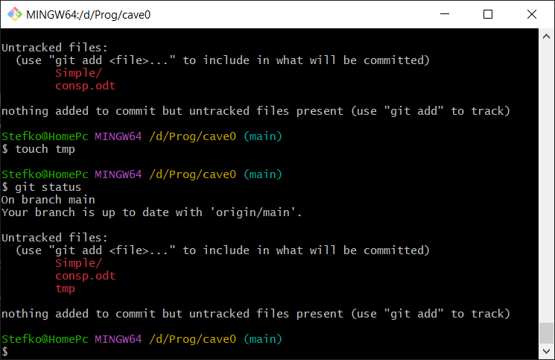

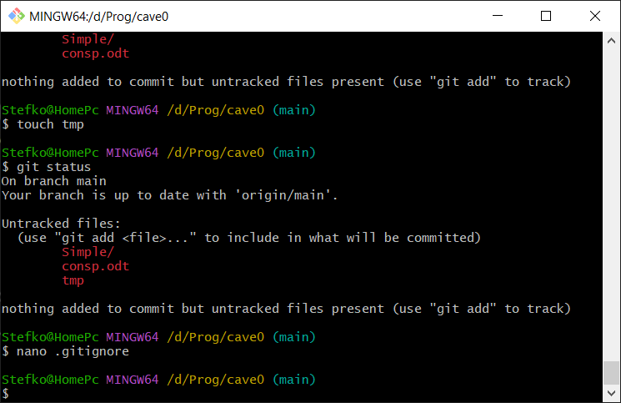

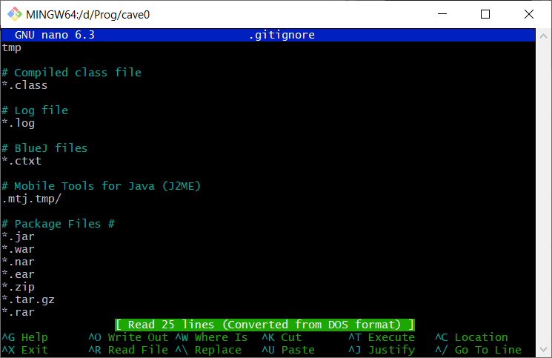

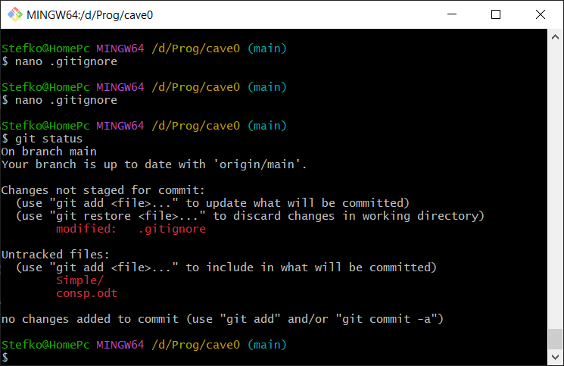

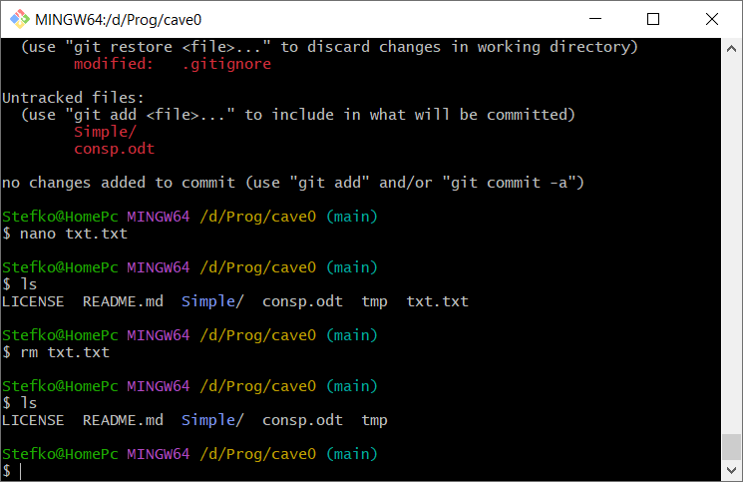

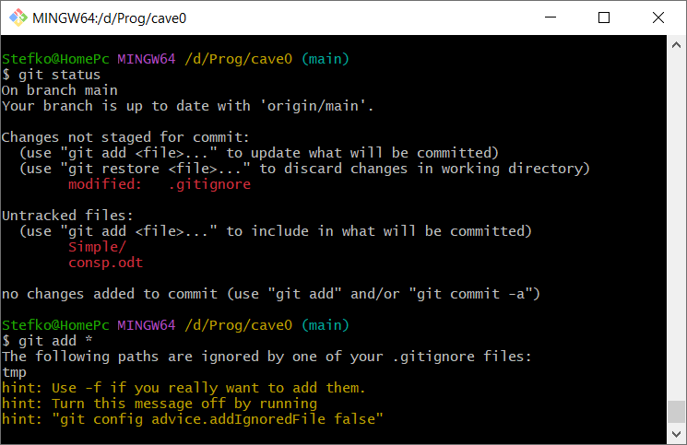

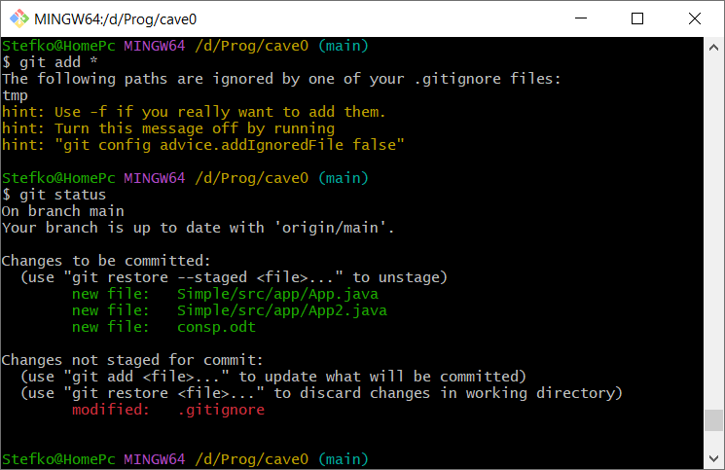

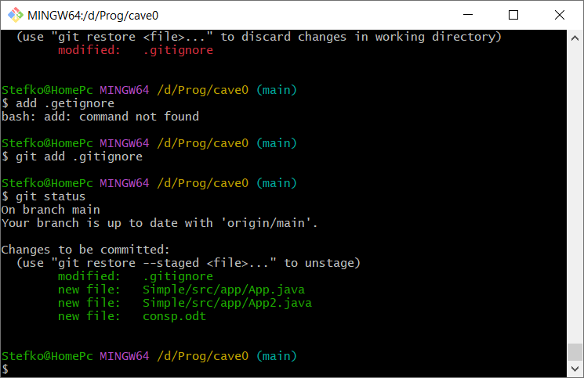

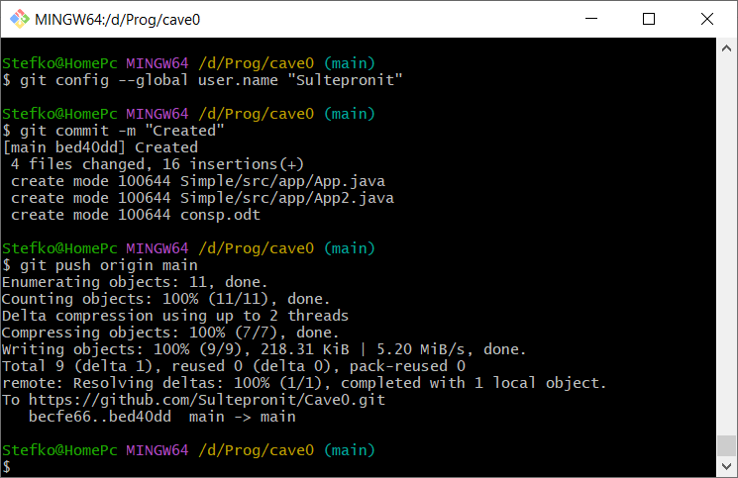

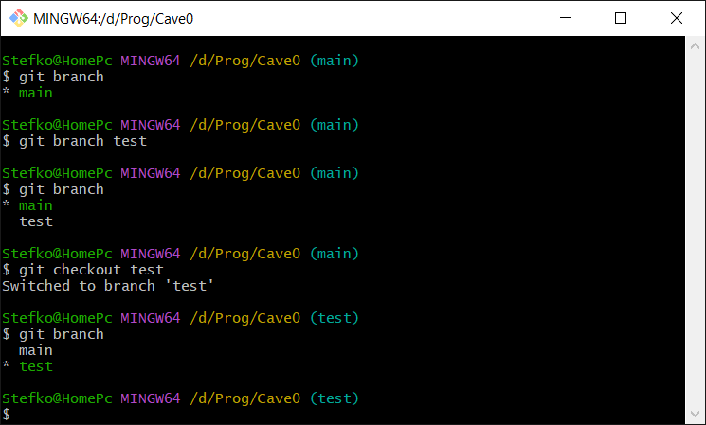

Edited in notepad++

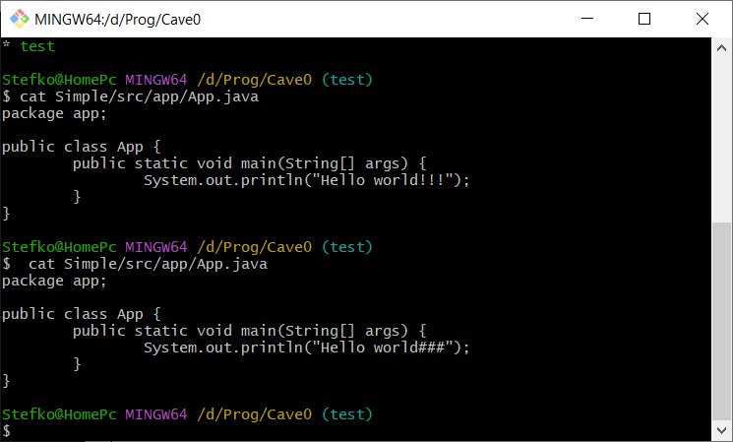

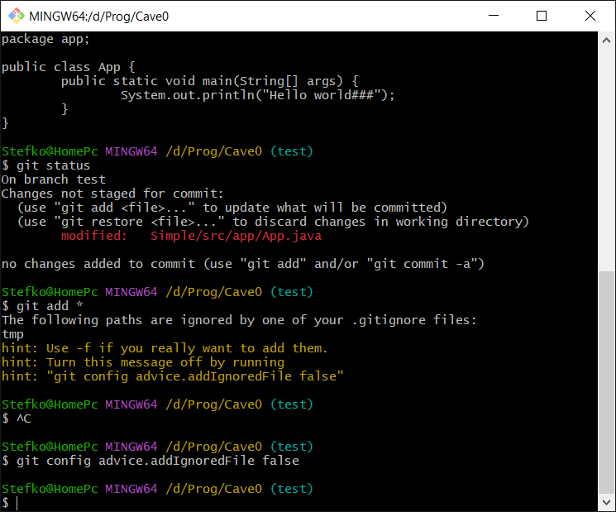

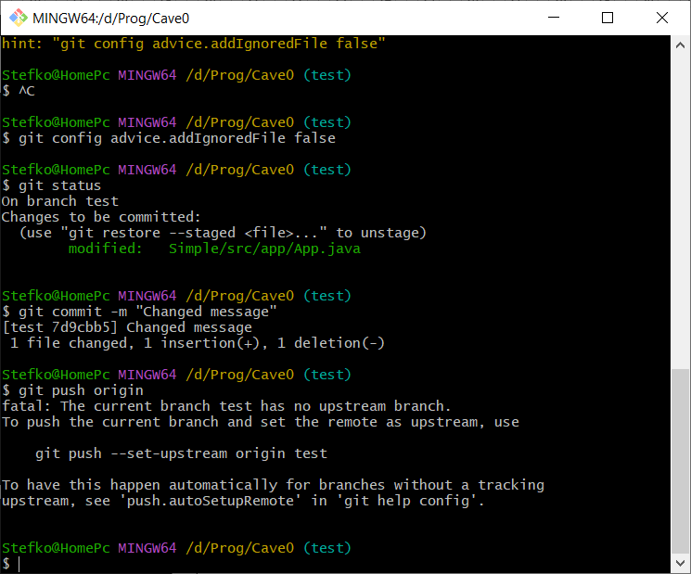

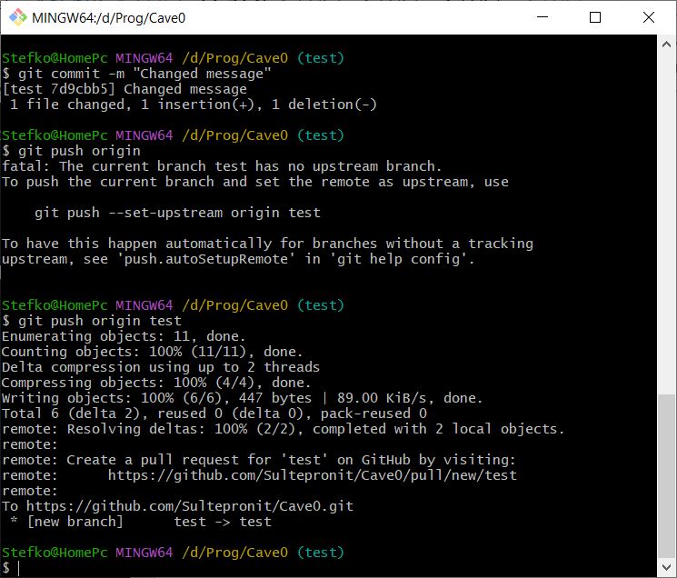

After that on github appeared “test” branch.

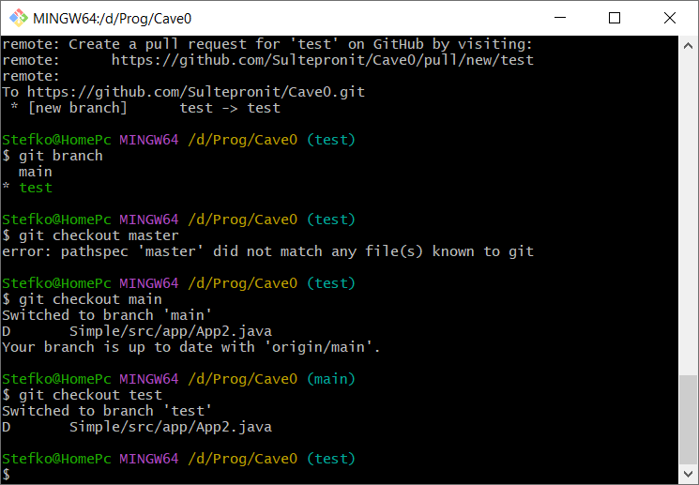

With this toggling, the contents of the file are changing

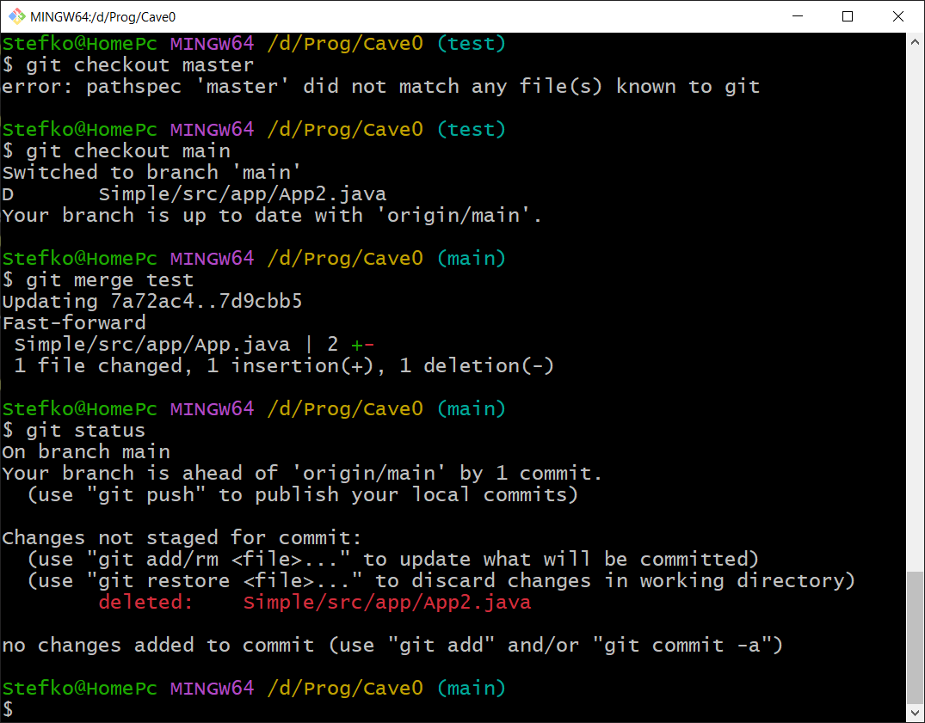

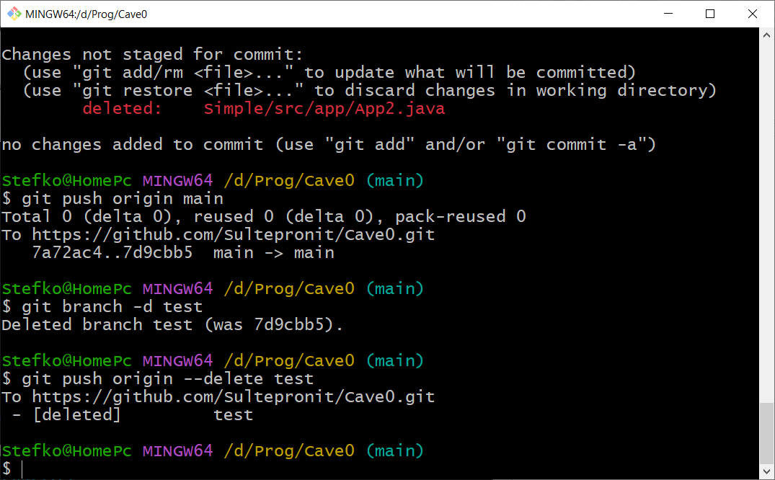

git log

If something goes wrong use **q** to quit

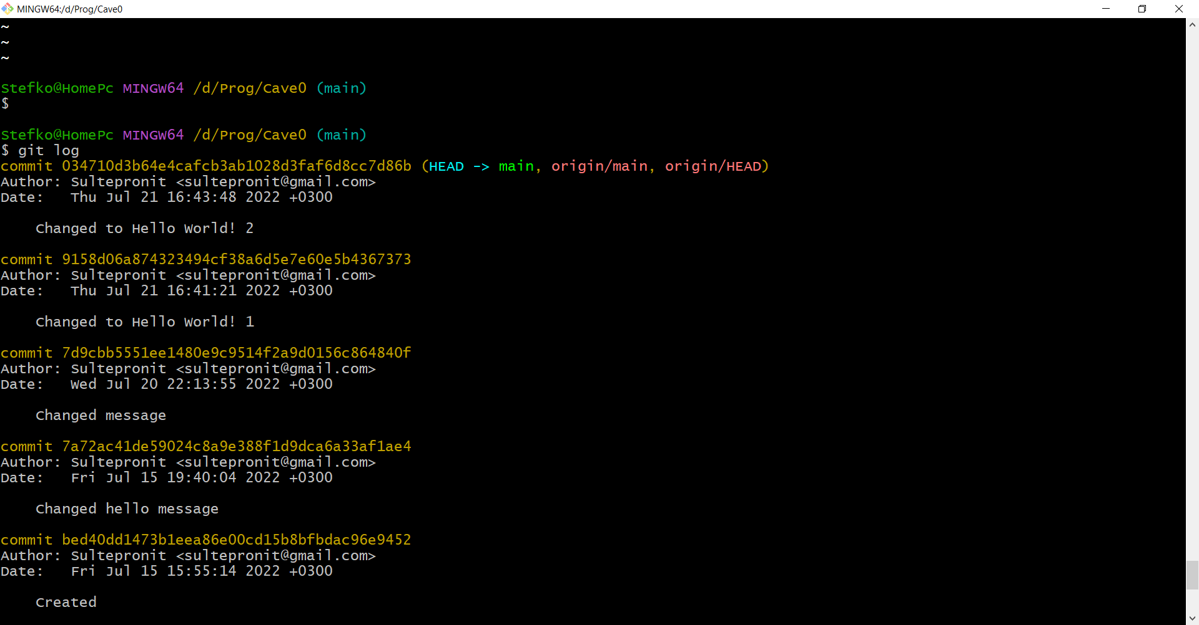

We have changed message several times. Last was “Hello world! 2”. However, after we copied code from **git log** info, and used it with **git checkout** command, code in our file App. java turned back to “Hello world! 1”.

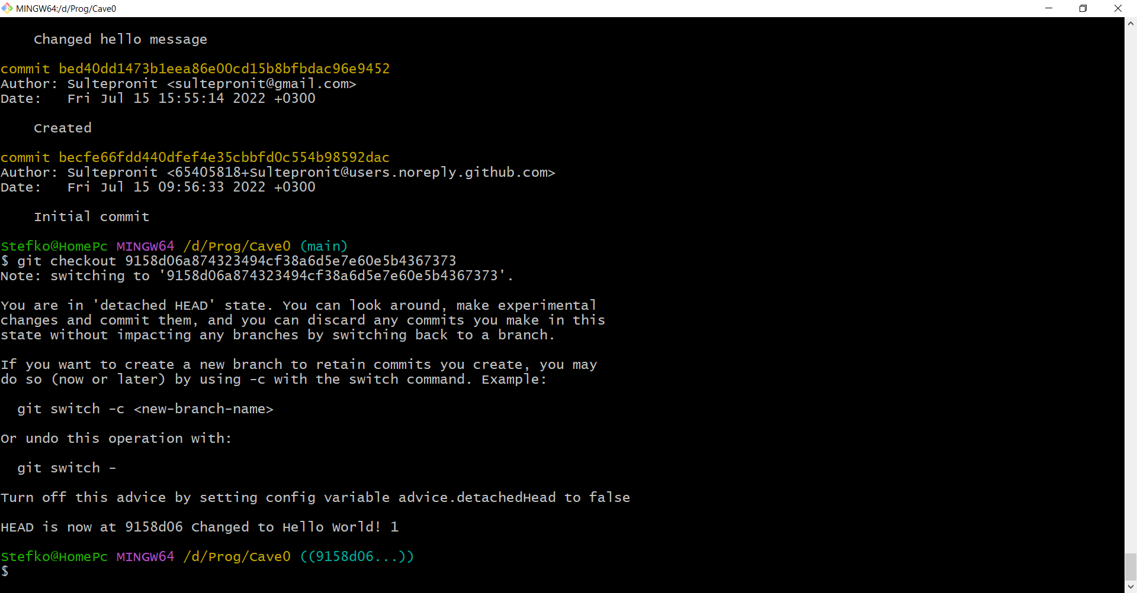

Now we get back to the least version with “Hello World!” statement.

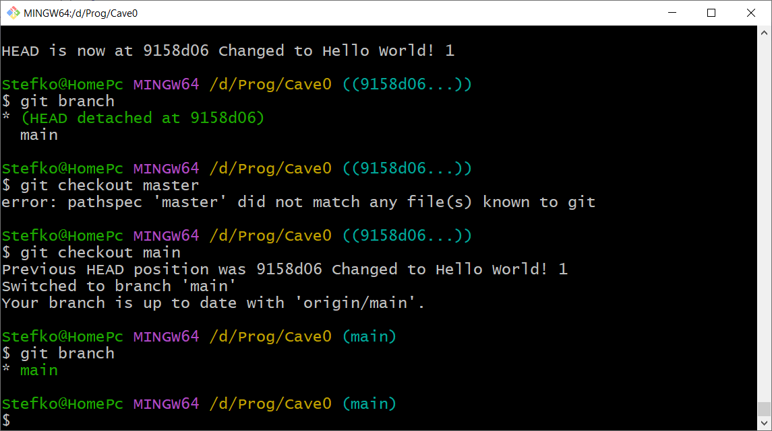

Here we created new “test” branch and again in our file appeared “Hello World! 1”

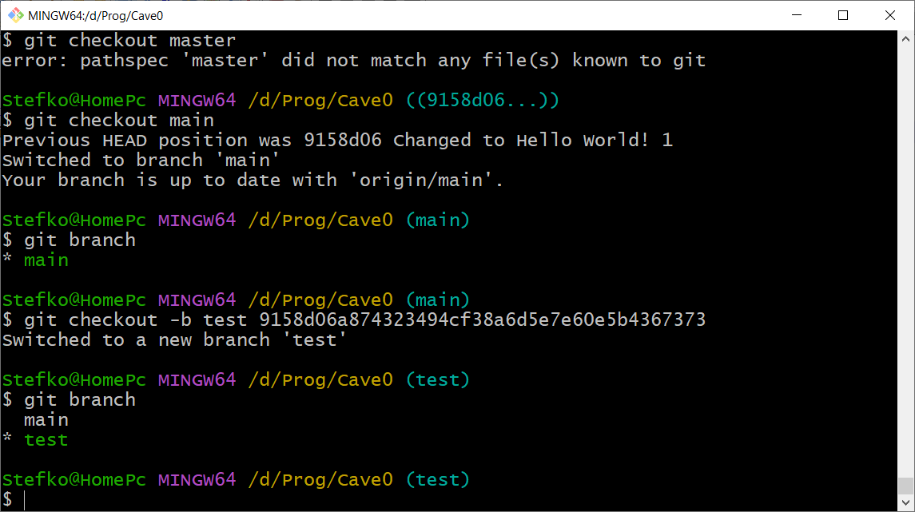

But in the end we just deleted new “test” branch

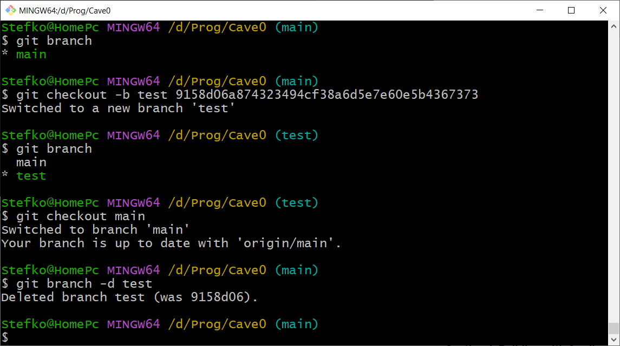

history

We can add and commit at the same time

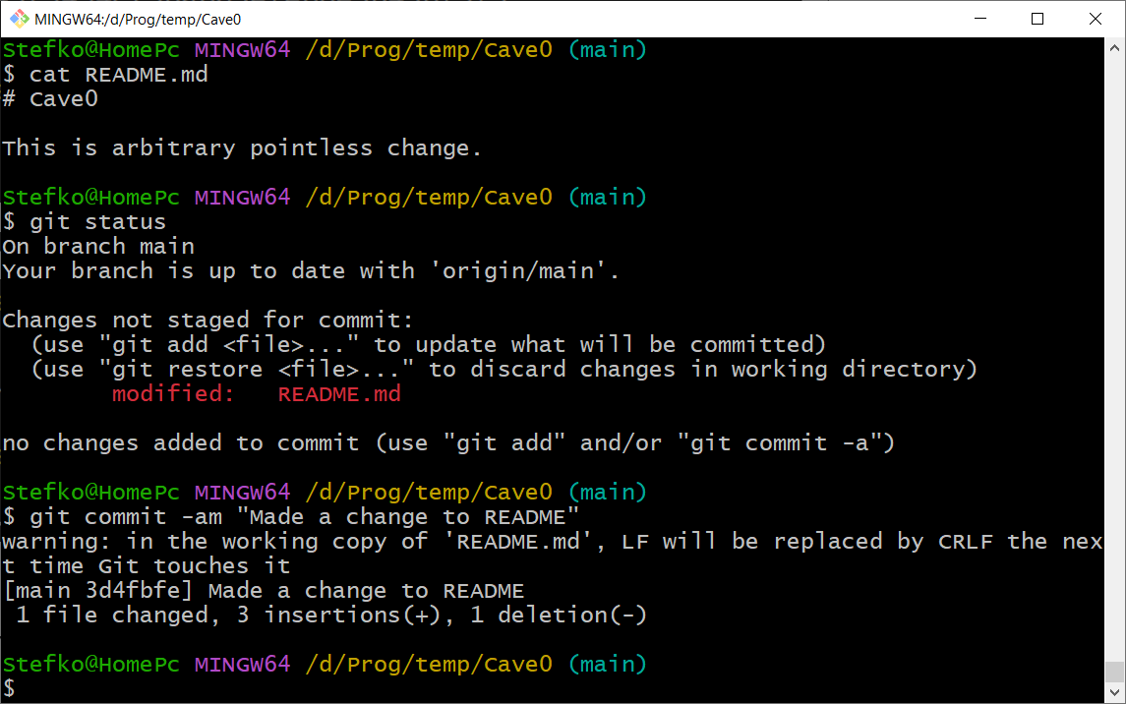

If there is possible changes at github, you should use **git pull origin** command to update

