String

[Java String Reference (w3schools.com)](https://www.w3schools.com/java/java_ref_string.asp)

.length()

.toUpperCase()

.toLowerCase()

.indexOf()

String txt = "Please locate where 'locate' occurs!";

System.out.println(txt.indexOf("locate")); // Outputs 7

int a = indexOf("Q"); // -1

Escape character

\' = ' [Single quote]

\" = " [Double quote]

\\ = \ [Backslash]

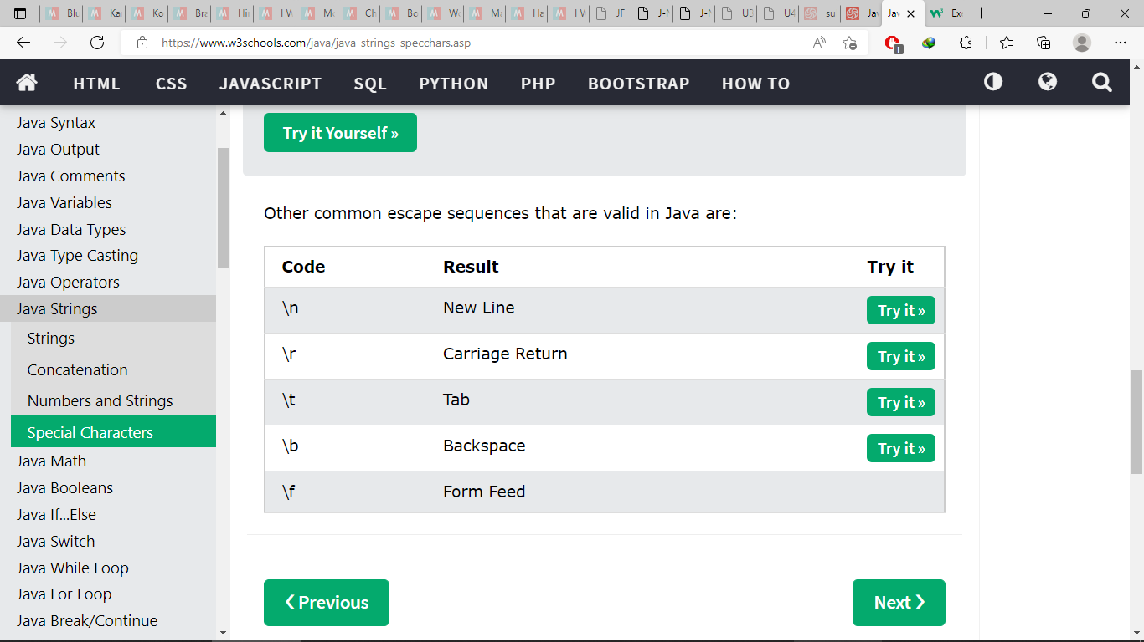

Math

Math.max(x,y)

Math.min(x,y)

Math.sqrt(x)

Math.abs(-4.6) // 4.6

Math.random()

returns a random number between 0.0 (inclusive), and 1.0 (exclusive)

int randomNum = (int) (Math.random() * 101); // 0 to 100