EXPLORATORY DATA ANALYSIS
E-Commerce Order Dataset
Data Analytics Internship – Project 2
Dataset File: Cleaned_Dataset.xlsx
Prepared by: Data Analytics Intern
Tools Used: Python (Pandas, NumPy, Matplotlib, Seaborn)
Submission Date: July 2026

1. Project Objective
The objective of this project is to perform a structured Exploratory Data Analysis (EDA) on a cleaned e-commerce order dataset. The analysis aims to understand the structure, quality, distribution, and relationships within the data, identify trends and outliers, and translate the findings into practical business insights and recommendations.

2. Dataset Overview
The dataset used for this analysis is Cleaned_Dataset.xlsx, an order-level e-commerce dataset covering the period from January 2023 to June 2025.

2.1 Dataset Summary
Attribute | Value
Total Records (Rows) | 1,200
Total Columns | 14
Time Period Covered | January 2023 – June 2025
Record Type | One row per customer order

2.2 Column Description
Column | Description
OrderID | Unique identifier for each order
Date | Date the order was placed
CustomerID | Unique identifier for each customer
Product | Product category purchased
Quantity | Number of units purchased
UnitPrice | Price per unit
ShippingAddress | Delivery address for the order
PaymentMethod | Method used to pay for the order
OrderStatus | Current status of the order
TrackingNumber | Shipment tracking reference
ItemsInCart | Number of items in the cart at checkout
CouponCode | Coupon applied to the order, if any
ReferralSource | Channel that referred the customer
TotalPrice | Final order value (Quantity × UnitPrice)

3. Tools and Technologies Used
- Python – core programming language for the analysis
- Pandas – data loading, cleaning checks, and aggregation
- NumPy – numerical computations
- Matplotlib – chart plotting and figure formatting
- Seaborn – statistical visualizations (histograms, boxplots, heatmap, pairplot, count plots)
- Microsoft Excel (.xlsx) – source data format, read using pandas

4. Data Quality Assessment
Before performing statistical and visual analysis, the dataset was checked for missing values and duplicate records to confirm data reliability.
Check | Result
Missing values (any column) | 0 – no missing values found
Duplicate rows | 0 – no duplicate records found

The dataset required no additional cleaning and was suitable for direct analysis.

5. Descriptive Statistics Summary
Descriptive statistics were calculated for the four numerical columns: Quantity, UnitPrice, ItemsInCart, and TotalPrice.
Statistic | Quantity | UnitPrice | ItemsInCart | TotalPrice
Count | 1200 | 1200 | 1200 | 1200
Mean | 2.95 | 356.41 | 5.49 | 1053.97
Median | 3 | 364.21 | 5 | 823.62
Std. Deviation | 1.41 | 197.18 | 2.28 | 819.86
Minimum | 1 | 11.39 | 1 | 11.39
25th Percentile (Q1) | 2 | 186.06 | 4 | 410.52
75th Percentile (Q3) | 4 | 521.57 | 7 | 1578.48
Maximum | 5 | 699.93 | 10 | 3456.4

Observation: The mean TotalPrice (₹1,053.97) is noticeably higher than the median (₹823.62), indicating a right-skewed distribution where a smaller number of high-value orders pull the average upward. Quantity, UnitPrice, and ItemsInCart show mean and median values that are close to each other, indicating relatively balanced distributions.

6. Exploratory Data Analysis
This section presents and explains each visualization generated during the analysis, describing the distributions, relationships, trends, and outliers observed in the dataset.

6.1 Histograms of Numerical Columns
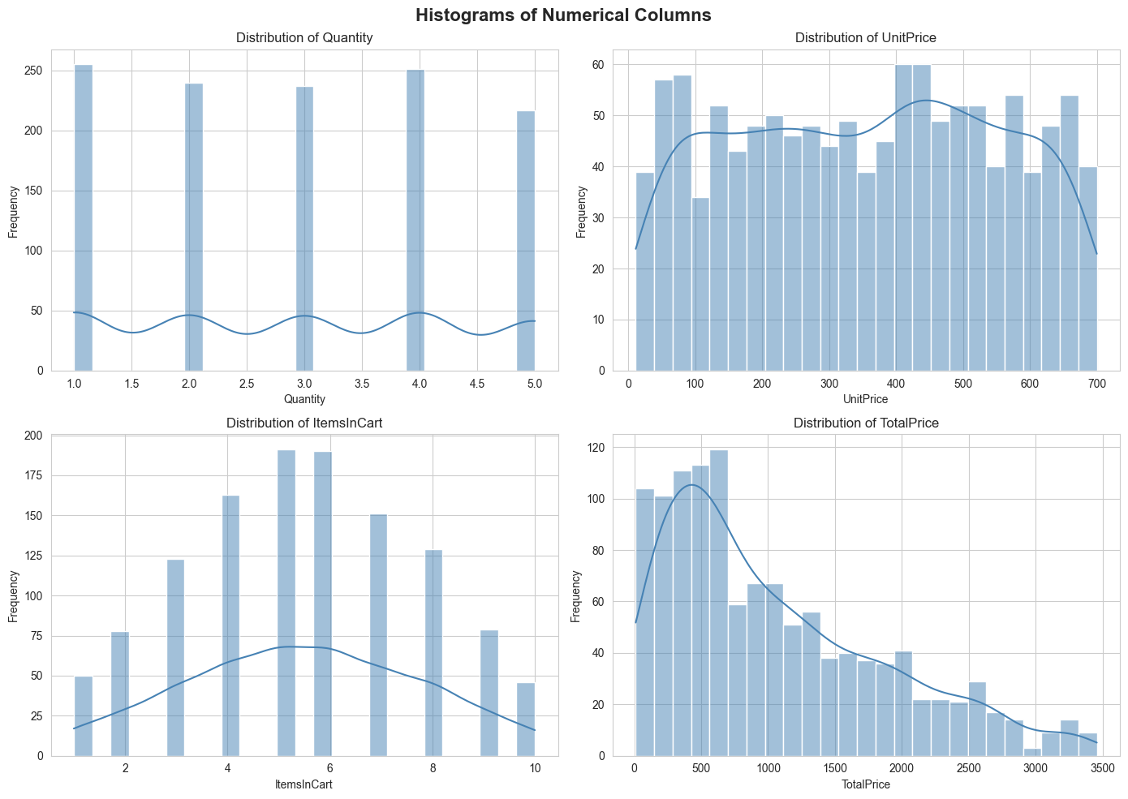
Figure 1: Distribution of Quantity, UnitPrice, ItemsInCart, and TotalPrice
- Quantity takes only whole values from 1 to 5, each occurring with roughly similar frequency (no single quantity dominates).
- UnitPrice is spread broadly and fairly evenly from about ₹11 to ₹700, with no single dominant price band.
- ItemsInCart follows a roughly bell-shaped pattern, peaking around 5–6 items per cart.
- TotalPrice is clearly right-skewed: most orders fall in the lower range (under ₹1,000), with a long tail of fewer, higher-value orders extending up to about ₹3,456.

6.2 Boxplots for Outlier Detection
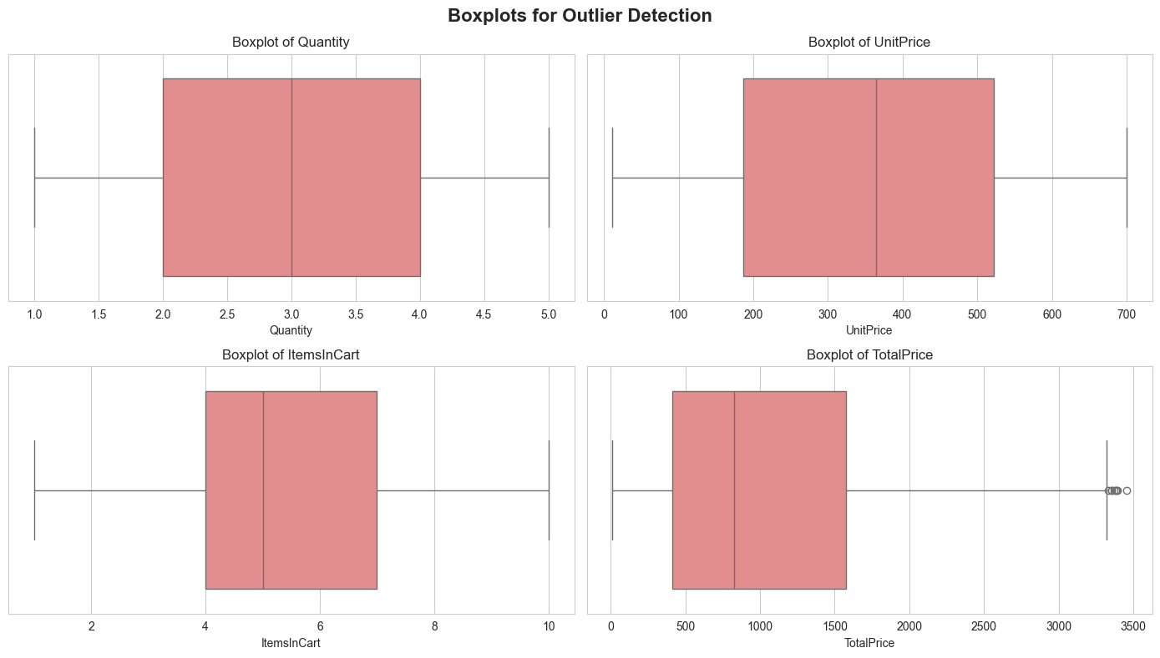
Figure 2: Boxplots of Quantity, UnitPrice, ItemsInCart, and TotalPrice
- Quantity, UnitPrice, and ItemsInCart show no visible outlier points — all values stay within the whisker range.
- TotalPrice is the only column showing outlier points, visible as small circles beyond the right whisker, corresponding to a small number of high-value orders (approximately 3,300 and above).
- The interquartile range (box width) for TotalPrice is wider than the other variables, consistent with its right-skewed distribution seen in the histogram.

6.3 Correlation Heatmap
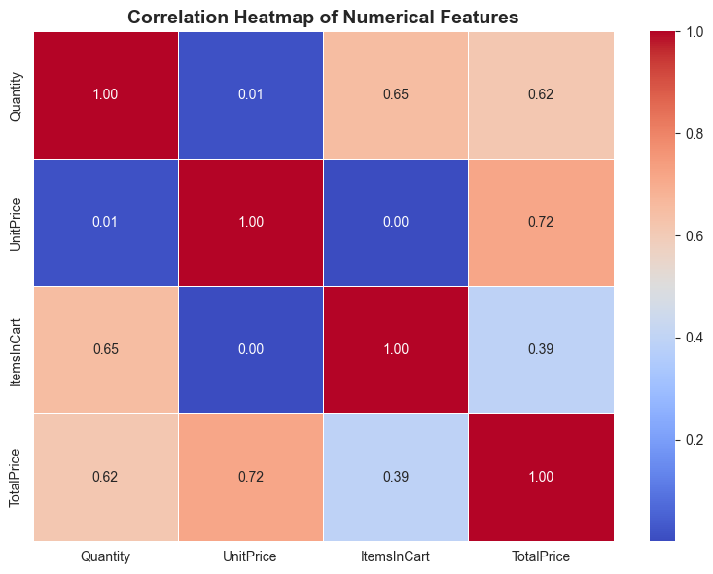
Figure 3: Correlation Heatmap of Numerical Features
- TotalPrice has a strong positive correlation with UnitPrice (0.72) and a moderately strong positive correlation with Quantity (0.62), which is expected since TotalPrice is derived from these two fields.
- Quantity and ItemsInCart show a moderate positive correlation (0.65).
- UnitPrice has almost no correlation with Quantity (0.01) or ItemsInCart (0.00), meaning the price of a product does not influence how many units or cart items a customer selects.
- ItemsInCart shows a weaker correlation with TotalPrice (0.39) compared to Quantity and UnitPrice, indicating cart size is a less important driver of final order value.

6.4 Pairplot of Numerical Variables
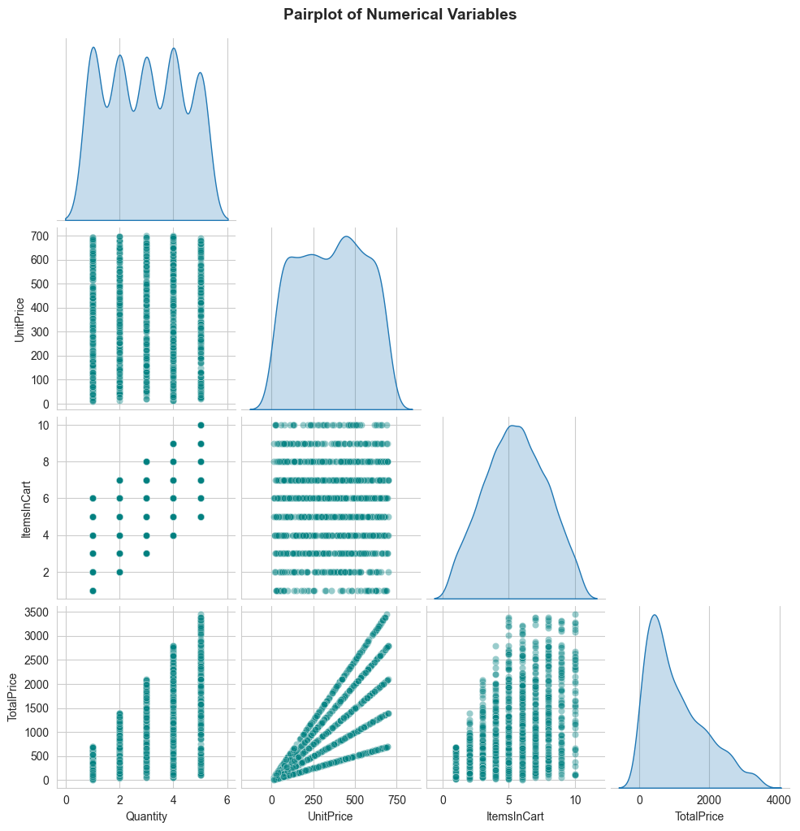
Figure 4: Pairplot Showing Pairwise Relationships Between Numerical Variables
- The scatter plots of Quantity vs. TotalPrice and UnitPrice vs. TotalPrice show clear diagonal, fan-shaped patterns, confirming the positive linear relationships also seen in the correlation heatmap.
- The UnitPrice vs. TotalPrice scatter shows distinct diagonal bands, each corresponding to a fixed Quantity value (1 to 5), which visually explains how TotalPrice is built from Quantity × UnitPrice.
- ItemsInCart does not show a clear linear pattern against the other variables, reinforcing that it behaves largely independently of order value.
- The diagonal density plots confirm the distribution shapes already seen in the histograms: TotalPrice is right-skewed, while Quantity, UnitPrice, and ItemsInCart are more evenly spread.

6.5 Count Plots for Categorical Columns
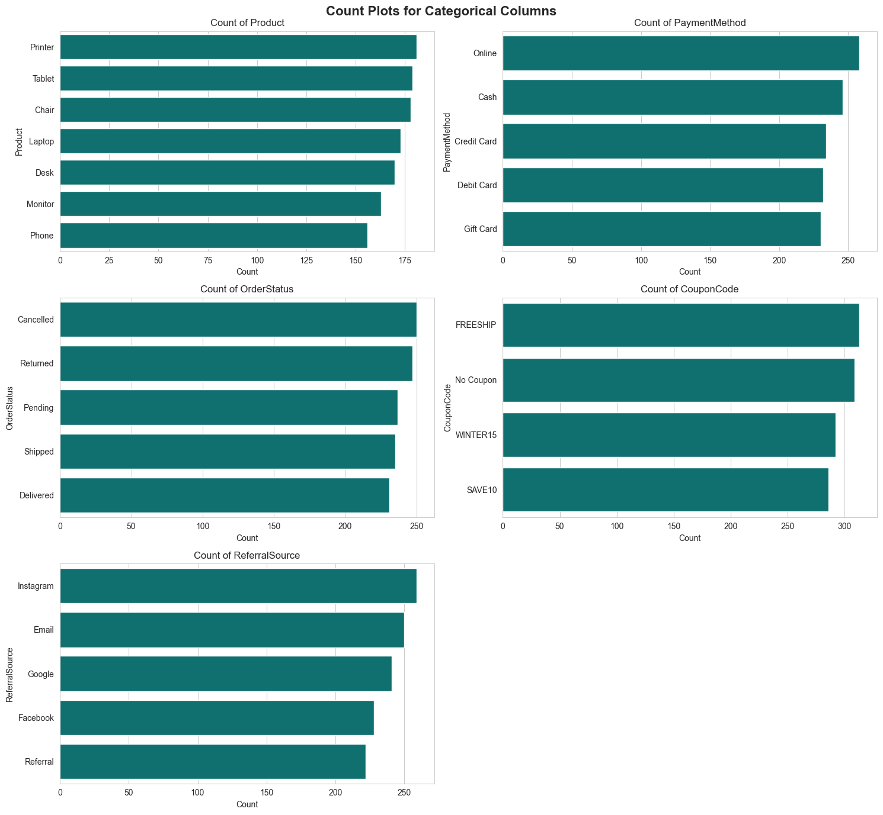
Figure 5: Count Plots of Product, PaymentMethod, OrderStatus, CouponCode, and ReferralSource
- Product: Sales are fairly evenly distributed across the seven product categories. Printer (181), Tablet (179), and Chair (178) are the top three by order count, while Phone (156) has the fewest orders.
- PaymentMethod: Online (258) is the most used payment method, followed closely by Cash (246), Credit Card (234), Debit Card (232), and Gift Card (230) — all five methods are used at broadly similar rates.
- OrderStatus: The five statuses (Cancelled: 250, Returned: 247, Pending: 237, Shipped: 235, Delivered: 231) are almost evenly split, meaning a large share of orders do not reach successful delivery.
- CouponCode: FREESHIP (313) and No Coupon (309) are used most often, followed by WINTER15 (292) and SAVE10 (286) — coupon usage is fairly balanced across all options.
- ReferralSource: Instagram (259) is the leading referral source, followed by Email (250), Google (241), Facebook (228), and Referral (222).

6.6 Average Total Price by Product
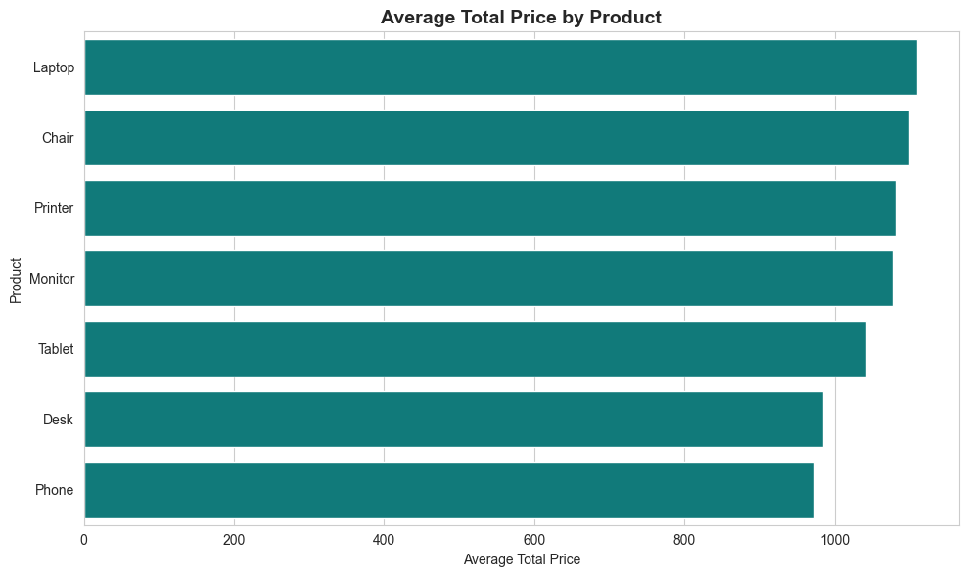
Figure 6: Average TotalPrice per Order by Product Category
- Laptop has the highest average order value (≈ ₹1,111), followed closely by Chair (≈ ₹1,099) and Printer (≈ ₹1,081).
- Monitor (≈ ₹1,078) and Tablet (≈ ₹1,042) fall in the middle range.
- Desk (≈ ₹985) and Phone (≈ ₹973) generate the lowest average order value among the seven product categories.
- The gap between the highest (Laptop) and lowest (Phone) average order value is roughly ₹138, showing product category has a moderate influence on order value.

6.7 Order Status Breakdown by Payment Method
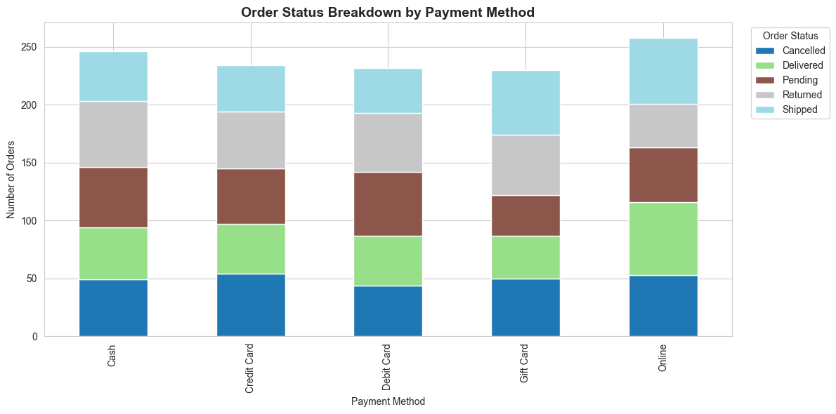
Figure 7: Stacked Bar Chart of OrderStatus by PaymentMethod
- Each payment method shows a similar internal split across the five order statuses (Cancelled, Delivered, Pending, Returned, Shipped).
- Online payments have the highest total order count among all methods, consistent with the count plot in Figure 5.
- No single payment method stands out with a disproportionately higher or lower share of Cancelled or Returned orders — the pattern of order outcomes looks broadly consistent regardless of how the customer paid.

6.8 Monthly Order Volume and Revenue Trend
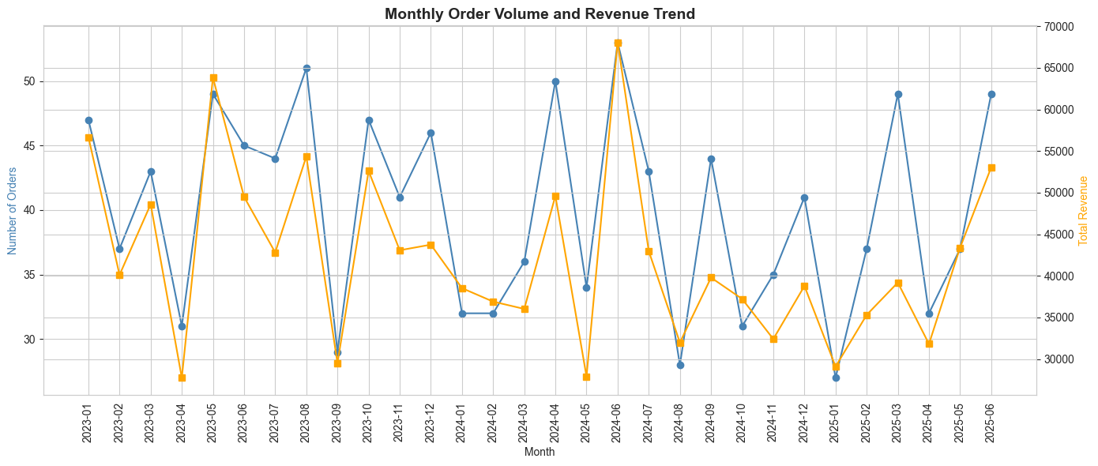
Figure 8: Monthly Order Count and Revenue, January 2023 – June 2025
- Both order volume and revenue fluctuate month to month rather than showing a steady upward or downward trend over the full period.
- Order count and revenue move closely together in most months — months with more orders generally also show higher revenue, consistent with the strong correlation between Quantity/UnitPrice and TotalPrice.
- The chart shows a visible dip around September 2023 and April/August 2024, where both order count and revenue drop noticeably, followed by recovery in the following months.
- A peak in order volume and revenue is visible around mid-2024 (June), followed by another rise toward June 2025, suggesting order activity is variable rather than seasonal in a single fixed pattern.

7. Key Findings
- The dataset is complete and clean: 1,200 records, 14 columns, zero missing values, and zero duplicate rows.
- TotalPrice is right-skewed (mean ₹1,053.97 vs. median ₹823.62), with a small number of high-value orders pulling the average upward.
- Outliers are minimal: only TotalPrice shows outlier points (via the IQR method), while Quantity, UnitPrice, and ItemsInCart show none.
- TotalPrice is most strongly correlated with UnitPrice (0.72) and Quantity (0.62); ItemsInCart has a weaker link to order value (0.39).
- UnitPrice and Quantity are essentially uncorrelated with each other (0.01), meaning higher-priced products are not systematically bought in larger or smaller quantities.
- Product categories, payment methods, coupon codes, and referral sources are all fairly evenly distributed, with no single category dominating the dataset.
- Order status is nearly evenly split across five outcomes, with Cancelled (250) and Returned (247) together accounting for roughly 41% of all orders.
- Laptop has the highest average order value (≈ ₹1,111) while Phone has the lowest (≈ ₹973).
- Order status outcomes look similar across all payment methods, suggesting payment method alone does not explain cancellations or returns.
- Monthly order volume and revenue move together but fluctuate over the observed period rather than trending steadily up or down.

8. Business Insights and Recommendations
- The combined Cancelled + Returned rate (≈ 41%) is the most significant pattern in the dataset and warrants closer investigation into checkout, delivery, or product-fit issues, since it affects a large share of all orders.
- Since ItemsInCart correlates only weakly with TotalPrice, strategies that simply encourage adding more items to the cart may not meaningfully increase order value; pricing or product-mix strategies may be more effective.
- Laptop and Chair categories generate the highest average order value and may be good candidates for promotional focus or premium bundling.
- Instagram and Email are the top two referral sources and could be prioritized for marketing spend, given their higher share of incoming orders.
- Because coupon usage (FREESHIP, WINTER15, SAVE10, No Coupon) is fairly evenly distributed, no single coupon type is currently dominating customer behavior, which may present an opportunity to test more targeted or higher-incentive offers.
- Since order outcomes are similar across all payment methods, efforts to reduce cancellations/returns should look beyond payment method toward other factors not captured directly in this dataset (e.g., delivery experience, product expectations).

9. Conclusion
This exploratory data analysis of the Cleaned_Dataset.xlsx e-commerce order data confirmed a clean, well-structured dataset of 1,200 orders with no missing values or duplicates. The analysis revealed a right-skewed order value distribution, strong relationships between TotalPrice and its underlying drivers (Quantity and UnitPrice), fairly even distribution across product, payment, coupon, and referral categories, and a notably high combined cancellation and return rate of approximately 41%. These findings provide a solid, data-driven foundation for further investigation into order fulfillment issues and for shaping targeted marketing and pricing strategies.

