

Assignment #02 – Technical Report
ROS 2-Based Line-Sensing DC Motor Control System
Actuators, Sensors and Signals (Fall 2026) · Prof. Muhammad Ilyas · Students:Ibraim Aidana,Maratova Aissulu,Ailenuer Anala;

1. Project Description
The project builds a complete sensing-to-actuation chain controlled by ROS 2. An Amperka Octoliner (8-channel infrared line sensor) is read by an Arduino Uno over I²C. The Arduino streams the eight readings to a ROS 2 computer over USB serial, two ROS 2 nodes process them and decide whether the motor should run, and the command is sent back to the Arduino, which drives a DC motor through an L298N motor driver. The motor runs (FORWARD) while the sensor sees a dark surface and stops (STOP) when light is detected under at least two channels.
Signal flow: Octoliner → Arduino Uno → USB serial → ROS 2 nodes → motor command → USB serial → Arduino → L298N → DC motor

2. Component List
Component | Qty | Role in the system
Arduino Uno | 1 | Reads the sensor over I²C, exchanges data with ROS 2 over USB serial (115200 baud), drives the L298N
Amperka Octoliner | 1 | 8-channel IR line sensor, I²C address 42, powered from 5 V
L298N motor driver | 1 | H-bridge: ENA = PWM speed, IN1/IN2 = direction; supplies the motor current
DC motor | 1 | Actuator
Motor battery | 1 | Separate motor supply to the L298N +12V
Breadboard, jumper wires, USB cable | – | Prototype wiring and the serial link to the PC
PC: Windows + WSL2 (Ubuntu 24.04) | 1 | ROS 2 Jazzy, Python 3 + pySerial, arduino-cli, usbipd-win (USB pass-through to WSL2)

3. Circuit Diagram / Connections
Connection | To | Connection | To
Octoliner VCC | Arduino 5V | L298N ENA | D9 (PWM), ENA jumper removed
Octoliner GND | Arduino GND | L298N IN1 | D7
Octoliner SDA | A4 | L298N IN2 | D8
Octoliner SCL | A5 | L298N OUT1 / OUT2 | DC motor
L298N +12V | Battery (+) | L298N GND | Battery (−) and Arduino GND (common ground)
Motor logic: FORWARD = IN1 HIGH, IN2 LOW, ENA PWM 180/255; STOP = IN1 and IN2 LOW, ENA 0. The motor is powered only through the driver, never from an Arduino pin, and all grounds are shared.
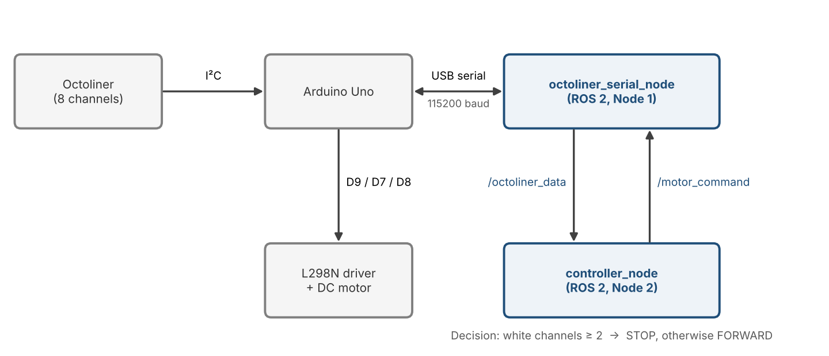
Figure 1. Hardware and ROS 2 node structure

4. ROS 2 Nodes and Topics
Node | Subscribes | Publishes | Function
octoliner_serial_node | /motor_command (String) | /octoliner_data (Int32MultiArray) | Serial bridge: reads “S,v0,…,v7” lines from the Arduino (~10 Hz), publishes the 8 values, writes FORWARD/STOP back; sends STOP on shutdown
controller_node | /octoliner_data | /motor_command | Decision logic: counts channels ≤ threshold (white); if count ≥ white_to_stop → STOP, else FORWARD
Parameters threshold (600) and white_to_stop (2) can be changed while running (ros2 param set), without re-uploading the Arduino. A custom serial bridge is used because rosserial exists only for ROS 1 and the Arduino Uno has too little memory (2 KB RAM) for micro-ROS. As a failsafe, the Arduino stops the motor if no command arrives for 1 s.

5. Results
Over a dark surface all channels read about 930–1005; under a light object the affected channels dropped to about 60–160, with edge channels at intermediate values (~500). The threshold was therefore set to 600, the midpoint, and two white channels are required for STOP so that a single noisy channel cannot stop the motor.
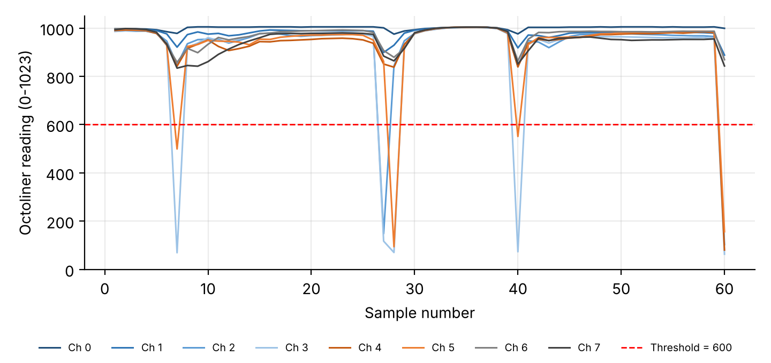
Figure 2. Octoliner readings over 60 samples (threshold line at 600)
# | Ch0 | Ch1 | Ch2 | Ch3 | Ch4 | Ch5 | Ch6 | Ch7 | White | Command
1 | 997 | 993 | 987 | 986 | 990 | 993 | 997 | 993 | 0 | FORWARD
7 | 978 | 921 | 847 | 69 | 842 | 499 | 858 | 834 | 2 | STOP
27 | 1001 | 899 | 148 | 117 | 851 | 862 | 907 | 884 | 2 | STOP
60 | 999 | 888 | 103 | 63 | 80 | 156 | 869 | 843 | 4 | STOP
The motor ran on FORWARD and stopped on STOP; with the nodes closed, the failsafe stopped it after 1 s. [confirm / edit]
[Insert screenshot: ros2 node list / rqt_graph and ros2 topic echo /octoliner_data]
Conclusion: sensing, serial communication, ROS 2 processing and actuation work as one chain. Keeping the decision logic in a ROS 2 node makes it easy to tune, while the Arduino only handles I/O and safety.

6. GitHub Repository
Full code (Arduino sketch, both ROS 2 nodes) and README: https://github.com/Suluai/assignment-2.git

