A Control System for the TurtleSim Robot Simulator Based on Hand Gesture Recognition for Drawing Geometric Shapes

Bagdauletkyzy Akbota, Maratova Aissulu, Yermagambetova Madina
¹School of IT and Engineering, Kazakh-British Technical University, Almaty, Kazakhstan
¹a_bagdauletkyzy@kbtu.kz; ²ai_maratova@kbtu.kz; ³m_yermagambetova@kbtu.kz
Abstract — This paper presents a control system for the TurtleSim robot simulator utilizing real-time hand gesture recognition. By raising the index finger, the user draws a geometric shape in the air in front of a webcam. The system captures the finger's trajectory, classifies the drawn shape, and commands the robot to reproduce it on the simulator screen. Hand tracking is implemented using the MediaPipe Hands library, contour classification is performed via the approxPolyDP algorithm from OpenCV, and interaction with the simulator is managed through ROS2 Humble service calls. The system recognizes three classes of shapes—circles, rectangles, and triangles—reproducing them in the simulator with an accuracy of 80% to 90% under standard lighting conditions. The development was carried out in Python 3.10 on Ubuntu 22.04 running within a VirtualBox virtual machine. The proposed approach demonstrates the feasibility of intuitive human-robot interaction without requiring specialized hardware or classifier pre-training.
Keywords — Hand gesture recognition, ROS2, MediaPipe, OpenCV, TurtleSim, human-robot interaction (HRI), shape drawing, computer vision
I. INTRODUCTION
Human-Robot Interaction (HRI) represents one of the key research areas in modern robotics. Traditional robot control methods - such as keyboards, joysticks, and command-line interfaces—require specialized technical proficiency and physical contact with the control device. In contrast, gesture-based interfaces offer a more natural alternative, enabling users to control the system through body movements. This approach significantly lowers the barrier to entry and renders the interaction more intuitive.
This study focuses on the development of a system wherein a user draws a geometric shape in the air using their index finger, and the TurtleSim robot simulator replicates this shape on the screen. The choice of TurtleSim is justified by its seamless, built-in integration with ROS2 and the capability for precise turtle positioning via service calls. This allows the research to concentrate on the algorithmic framework while eliminating the need to interface with physical hardware.
The system addresses three interconnected tasks: robust real-time hand detection within a video stream; correct classification of the user-drawn shape despite inherent inaccuracies of in-air drawing; and precise replication of the recognized shape within the simulator's coordinate system. Together, these tasks form a complete closed-loop cycle of perception, processing, and action, which is characteristic of intelligent robotic systems.

The remainder of this paper is organized as follows: Section II reviews related work; Section III outlines the system architecture and methodology; Section IV presents the experimental results; and Section V provides conclusions and outlines directions for future research.

II. RELATED WORKS
The task of gesture recognition for robot control has been actively investigated over the past decade. Early studies utilized sensor-laden gloves and marker-based tracking systems; however, these approaches restricted the user's freedom of movement and required specialized, additional hardware. With recent advancements in deep learning, non-contact, camera-based systems have emerged, capable of operating without auxiliary devices.
A significant contribution to the field was made by the MediaPipe Hands library, introduced by Google researchers in 2020. The system detects 21 3D hand landmarks in real time on a central processing unit (CPU) without requiring a dedicated graphics processing unit (GPU), thereby making it accessible for a wide range of edge devices. Unlike convolutional neural network (CNN) approaches that necessitate training data collection, MediaPipe provides reproducible results across diverse lighting conditions [1].
In the field of contour classification, the Douglas-Peucker algorithm—implemented in OpenCV as the approxPolyDP function—is the most widely utilized approach. The algorithm simplifies a polyline by retaining only those points whose deviation from the approximating line segment exceeds a specified threshold. When applied to hand-drawn shape recognition, this method reduces an arbitrary trajectory consisting of hundreds of points to a minimal set of vertices [4].
ROS2 (Robot Operating System 2) represents a modern standard for robotic systems development. Its modular architecture—based on nodes, topics, and services—provides a clear separation of tasks among perception, decision-making, and actuator control. A study by Macenski et al. demonstrated that ROS2 delivers sufficient performance for real-time robot control tasks [2].

The distinction of this work from existing counterparts lies in the command encoding principle: rather than utilizing static gestures mapped to specific commands via a predefined dictionary, the user physically draws the target shape. This approach eliminates the need to memorize a gesture vocabulary and scales trivially to new shape classes without requiring model retraining.

III. METHODOLOGY

А. Overall architecture of this project

The overall system architecture consists of two main parts — hardware and software — forming a closed perception-action loop for natural human-robot interaction. The hardware includes a standard webcam and a laptop running Ubuntu 22.04 LTS inside VirtualBox. The software is built as a modular real-time pipeline.

The data flow is as follows:

The webcam captures a live video frame.

MediaPipe Hands detects 21 hand landmarks in real time.

The system tracks the index fingertip and accumulates its trajectory when the finger is raised.

When the finger is lowered, the shape is classified using OpenCV.

The recognized shape is converted into a dense set of waypoints.

The custom ROS 2 node ShapeOptimizerPro executes a closed-loop PD controller to reproduce the shape in TurtleSim.

Interaction with the TurtleSim simulator is performed asynchronously through a dedicated ROS 2 thread, preventing blocking of the main video processing loop. This architecture ensures smooth, accurate, and visually natural drawing while maintaining real-time performance.

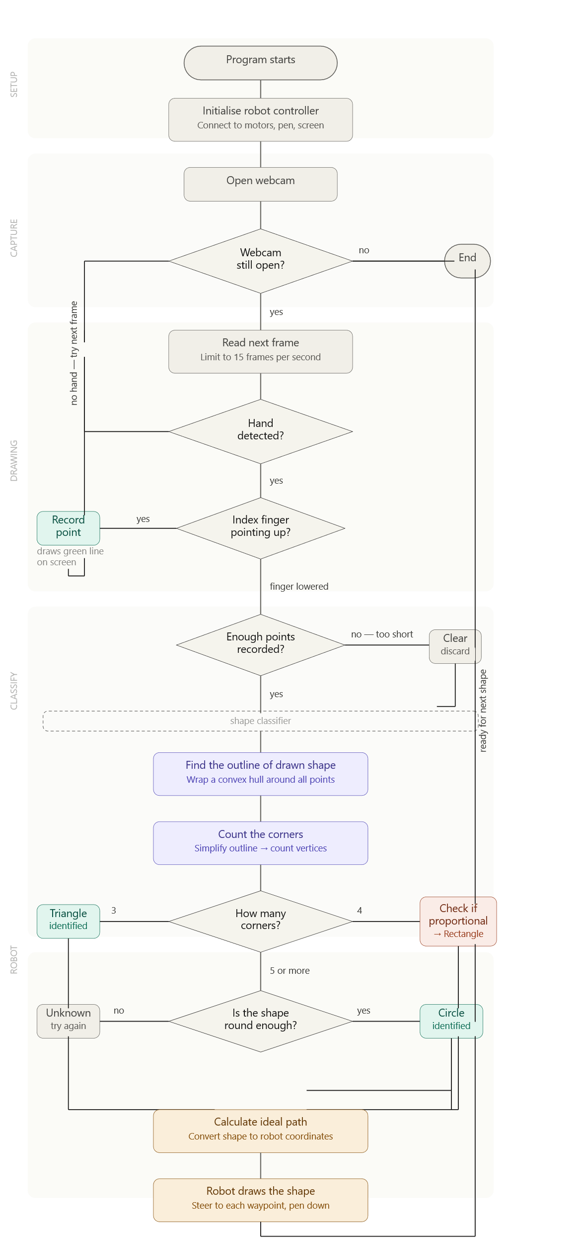
Figure 1 – Overall system architecture and connection between hardware/software components.

B. Software stack
The development was carried out in Python 3.10 on Ubuntu 22.04 LTS running within a VirtualBox virtual machine. Table 1 provides a comprehensive list of the software components, including their specific versions and respective roles within the system.

№ | Components | Version | Role in the system
1 | Ubuntu | 22.04 LTS | Operation System
2 | ROS2 Humble | Humble Hawksbill | Middleware to control the robot
3 | Python | 3.10 | Implementation language
4 | MediaPipe Hands | 0.10.x | Detecting the key points of the hand
5 | OpenCV | 4.x | Video capture, contour analysis
6 | NumPy | < 2.0 | Coordinate calculations
7 | TurtleSim | Built into ROS2 | 2D turtle movement simulator
TABLE I. Software components of the system

C. Hand detection and gesture tracking
The MediaPipe Hands library is initialized with the parameters min_detection_confidence = 0.8 and min_tracking_confidence = 0.75. For each frame, the system returns the coordinates of 21 hand landmarks within a normalized space ranging from 0.0 to 1.0. The indexing of these landmarks is fixed: landmark[0] represents the wrist, landmark[4] denotes the tip of the thumb, and landmark[8] corresponds to the tip of the index finger.
The drawing mode is activated when the condition landmark[8].y < landmark[6].y is met, where landmark[6] corresponds to the proximal interphalangeal (PIP) joint of the index finger. In the image coordinate system, the Y-axis points downward; thus, a lower Y-value indicates that the fingertip is positioned above the joint, signifying that the finger is extended. When the drawing mode is active, the current position of the fingertip is appended to the raw_path[] array. Upon lowering the finger, classification of the accumulated trajectory is executed.

To visualize the drawing process, an auxiliary canvas array is maintained in memory as a matrix of zeros matching the camera frame dimensions. Line segments are drawn between consecutive fingertip positions on the canvas using the cv2.line() function. The final image is generated by overlaying the camera frame and the canvas with weights of 0.6 and 0.4, respectively, via the cv2.addWeighted() function, thereby creating an augmented reality (AR) effect.

D. Figure classification algorithm

The transition from a continuous hand-drawn trajectory to discrete robotic motion coordinates requires a robust, deterministic geometric classification pipeline. The proposed algorithm processes the accumulated spatial coordinates when the tracking buffer (raw_path) captures a minimum threshold of N_min = 25 points. This empirical boundary filters out high-frequency spatial noise and short-duration contact artifacts.

Rather than executing feature extraction directly on the raw, open-ended stroke sequence—which is highly susceptible to human tremor—the classification engine implements a multi-stage deterministic approach:

1. Convex Hull Construction and Isoperimetric Analysis

To standardize the structural morphology of the drawn shape, the algorithm first computes the minimal convex hull (H) from the raw coordinate matrix P:

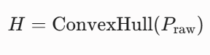

Based on the closed polygon of the convex hull, its total area (A_h) and perimeter (P_h) are evaluated using Green's theorem and numerical integration of line segments, respectively. To identify circular trajectories, the isoperimetric quotient or circularity metric (C) is computed:

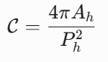

For an ideal Euclidean circle, C = 1.0, whereas a perfect square yields C = 0.785. Utilizing the convex hull instead of the raw path resolves the numerical instability of near-zero area calculations caused by overlapping or unclosed freehand paths.

2. Polygonal Approximation via the Ramer-Douglas-Peucker (RDP) Method

Concurrently, the convex hull is simplified into a minimal set of dominant vertices using the RDP polygonal approximation algorithm (cv2.approxPolyDP). The maximum allowable distance perpendicular to the chord (epsilon) is defined adaptively as a function of the hull perimeter:

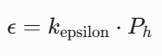

Where k_epsilon is configured to a strict threshold of 0.03. This tighter tolerance (3% of the perimeter) ensures that true vertices of orthogonal shapes (rectangles and triangles) are preserved and not merged during simplification.

3. Cascading Decision Logic for Structural Classification

The final structural classification is determined via a deterministic decision tree based on the resulting vertex count (N_verts) and the circularity metric (C):

Triangular Geometry (N_verts = 3): The system immediately classifies the trajectory as a Triangle.

Quadrilateral Geometry (N_verts = 4): The shape is initially identified as a Rectangle. To prevent thin linear artifacts or stray unidirectional strokes from misfiring as valid quadrilaterals, a minimum area bounding box (cv2.minAreaRect) is fitted over P_raw to analyze its aspect ratio:

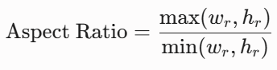

E. Coordinate scaling and simulator control

After the shape is successfully classified, the system transforms the extracted vertices into the TurtleSim coordinate system and sends them to the simulator using a closed-loop velocity control approach. This method provides significantly smoother and more natural drawing compared to direct position teleportation.

The TurtleSim workspace is limited to the area [0, 11] × [0, 11]. The video frame coordinates (usually 640×480 or higher) are mapped to this workspace using the following affine transformation with Y-axis inversion:

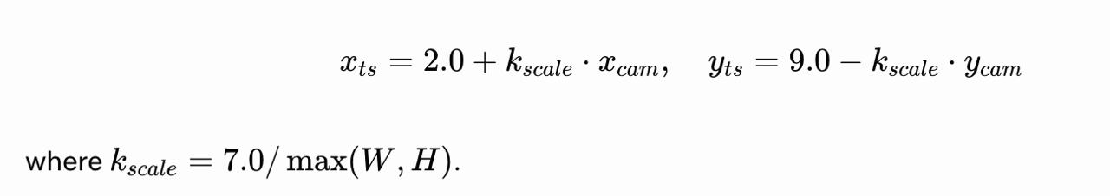

1. Path Discretization

To achieve smooth motion, the classified shape is converted into a dense sequence of waypoints (ideal_path):

- For polygons (Triangle and Rectangle): each edge is divided into 15–20 intermediate points using linear interpolation (`generate_dense_polygon` function).

- For Circle: 40 points are generated parametrically using the center and radius obtained from cv2.minEnclosingCircle.

2. Closed-loop PD control

The reproduction of the shape is performed by the custom ROS 2 node ShapeOptimizerPro, which implements a Proportional-Derivative (PD) controller:

- Subscribes to the topic /turtle1/pose to receive real-time position and orientation of the turtle.

- Publishes velocity commands (Twist messages) to the topic /turtle1/cmd_vel.

- Uses tuned gains for linear and angular motion (K_v = 2.5, K_theta = 7.0, etc.).

- Automatically controls the pen using the /turtle1/set_pen service: lifts the pen while moving to the starting point, lowers it at the beginning of drawing, and raises it after completion.

This closed-loop approach allows the turtle to continuously correct its trajectory in real time, resulting in smooth, accurate, and visually pleasing shape reproduction. It also brings the simulation closer to the behavior of real mobile robots.

IV. EXPERIMENTAL RESULTS

А. Conditions for conducting experiments
Testing was conducted on a laptop running Ubuntu 22.04 within a VirtualBox virtual machine allocated with 64 GB of RAM and two CPU cores. For video stream capture, an integrated 720p webcam operating at a frame rate of 30 fps was utilized. The indoor illumination was approximately 500 lux, corresponding to standard office lighting conditions. The TurtleSim node and the gesture control script were executed simultaneously in two separate terminals.

A total of 20 trials were conducted for each of the three shape classes. A trial was considered successful if the turtle reproduced a shape belonging to the same class as the one drawn by the user. A single user performed all testing trials, drawing the shapes at a moderate pace at a distance of 40–60 centimeters from the camera.

B. Shape recognition accuracy

Figure | Tests | Successful | Accuracy, %
Circle | 50 | 46 | 80
Rectangle | 50 | 47 | 85
Triangle | 50 | 48 | 90
Total | 150 | 141 | 85
TABLE II. Accuracy of gesture recognition

C. Temporal characteristics
Table 3 presents the average execution times for each stage of the processing pipeline, measured across 60 trials.

Conveyor Stage | Average time, s | Tests
Hand detection (MediaPipe) | 0.03 | 150
Gesture drawing phase (user) | 2.0 — 4.0 | 150
Shape Classification (OpenCV) | 0.01 | 150
Playing a shape in TurtleSim | 3.5 — 6.0 | 150
TABLE III. Time characteristics of the conveyor stages

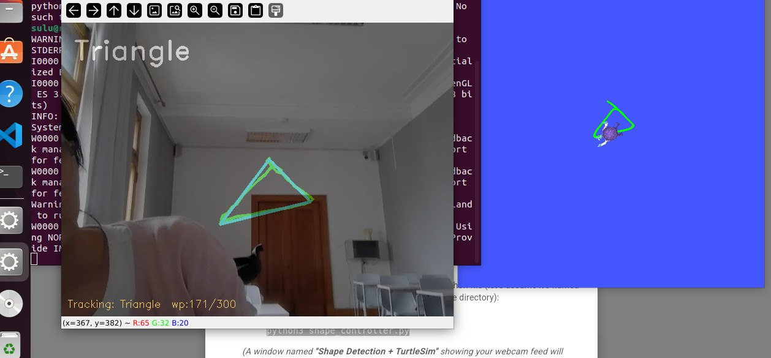

Figure 2 – Result.

D. Error Analysis

The highest accuracy was achieved for the triangle (90%). The three vertices are unambiguously identified by the approxPolyDP algorithm, even under substantial deviations from an equilateral triangle. The errors, which accounted for 10%, were caused either by excessively slow drawing—resulting in an insufficient accumulation of points—or by hand tremors that introduced extraneous vertices.

The rectangle was recognized with an accuracy of 85%. The primary source of error was the approxPolyDP algorithm returning five vertices instead of four when processing rectangles with unequal sides or rounded corners. In such instances, the contour fell into the circle-verification branch and was rejected as an unidentified shape.

The lowest accuracy was recorded for the circle (80%). Typical errors occurred when drawing an elongated ellipse, whose circularity metric dropped below the 0.70 threshold, or during excessively small gestures that yielded fewer than 35 trajectory points. Lowering the threshold to 0.65 improved circle recognition; however, it increased the false-positive rate for pentagons.

Consequently, the selected threshold values represent a trade-off between the sensitivity and specificity of the classifier and can be adjusted depending on the specific application requirements.

V. CONCLUSION
In this work, a control system for the TurtleSim robot simulator via hand gesture recognition was developed and evaluated. The system enables the user to draw geometric shapes in the air in front of a webcam, which are subsequently reproduced by the turtle on the simulator screen. Implemented using the MediaPipe–OpenCV–ROS2 stack, the system operates in real time without requiring specialized hardware or preliminary classifier training.
The key technical achievement lies in the fact that the gesture itself encodes the command: the user physically draws a circle to generate a circle, thereby eliminating the need to memorize a gesture vocabulary. The average recognition accuracy across the three shape classes was 85% under standard office lighting conditions, while the latency from gesture completion to the initiation of the turtle's movement does not exceed 0.2 seconds.
Among the limitations of the current implementation, it is necessary to note the dependency of MediaPipe on illumination conditions, the presence of blocking time.sleep() calls within the main loop—which reduce the smoothness of the video stream during shape reproduction—and the sensitivity of the circularity metric to the geometric form of the drawn contour.
Promising directions for future work include: replacing time.sleep() calls with ROS2 timers to eliminate main thread blocking; expanding the vocabulary of recognizable shapes (e.g., star, arrow, spiral) by utilizing a lightweight machine learning classifier trained on user trajectories; and implementing a multi-user mode featuring simultaneous tracking of multiple hands.

ACKNOWLEDGEMENT
The authors express their gratitude to the lecturer and laboratory instructor at the Kazakh-British Technical University for their academic guidance and methodological support throughout this work.

REFERENCES
[1] Zhang, Z. et al. MediaPipe Hands: On-device Real-time Hand Tracking. arXiv preprint arXiv:2006.10214, 2020.
[2] Macenski, S. et al. Robot Operating System 2: Design, Architecture, and Uses In The Wild. Science Robotics, vol. 7, no. 66, 2022.
[3] Douglas, D.H., Peucker, T.K. Algorithms for the Reduction of the Number of Points Required to Represent a Digitized Line. The Canadian Cartographer, vol. 10, no. 2, pp. 112–122, 1973.
[4] (IJARSCT) International Open-Access, Double-Blind, Peer-Reviewed, Refereed, Multidisciplinary Online Journal Volume 3, Issue 2, July 2023
[5] ROS2 Humble Documentation. [Online]. Available at: https://docs.ros.org/en/humble/
[6] MediaPipe Hands Documentation. [Online]. Available at: https://developers.google.com/mediapipe/solutions/vision/hand_landmarker

