LINE FOLLOWING ROBOT
Technical Report
Maratova Aisulu, Ibraim Aidana, Aimyrzakyzy Shugyla
¹School of IT and Engineering, Kazakh-British Technical University, Almaty, Kazakhstan

Abstract— This project presents the development of an autonomous line-following robot. The system utilizes an Octoliner infrared sensor array for high-precision line detection and an ESP32 microcontroller as the core control unit. Using a PD-based control algorithm, the robot accurately tracks a black line on a contrasting surface while maintaining stable speed and smooth trajectory corrections in real time.
Keywords— Line following, PD control, robotics, autonomous systems, infrared sensor array, ESP32.

I. Introduction
The primary objective of this project is the development of an autonomous robot capable of following a predefined path (a black line on a white surface) without human intervention. The robot is designed to operate in controlled indoor environments and demonstrates precise navigation using feedback from infrared sensors.
The core of the system is an intelligent PD (Proportional-Derivative) control algorithm running on the ESP32 microcontroller. The system continuously reads data from the Octoliner 8-channel infrared sensor array, calculates the deviation from the center of the line, and dynamically adjusts the speed of the left and right motors to keep the robot centered on the track.

II. Related Works
Line-following robots represent a well-studied area in mobile robotics. Classical approaches rely on PID controllers with discrete sensor arrays; recent works have demonstrated that weighted-average position estimation yields smoother trajectory tracking than simple threshold comparisons. The ESP32 platform has been adopted in several low-cost robotics projects due to its integrated Wi-Fi, dual-core processor, and hardware PWM capabilities. The present work extends these efforts by combining the 8-channel Octoliner sensor with an ESP32 LEDC PWM interface and a tuned PD controller.

III. Methodology

3.1 System Overview
The system architecture is centered around the ESP32 microcontroller, which serves as the high-performance central processing unit. The Octoliner sensor is connected via the I²C interface, providing digital-analog readings of all eight channels. Motor control is implemented through the built-in LEDC PWM modules of the ESP32, ensuring low-latency response between sensor input and actuator output.

TABLE I
Mechanical components with specifications
 | Hardware architecture of the project
 | Component | Specs | Remarks
1 | ESP32 | Dual-core microcontroller, up to 240 MHz, built-in Wi-Fi and Bluetooth, PWM support | 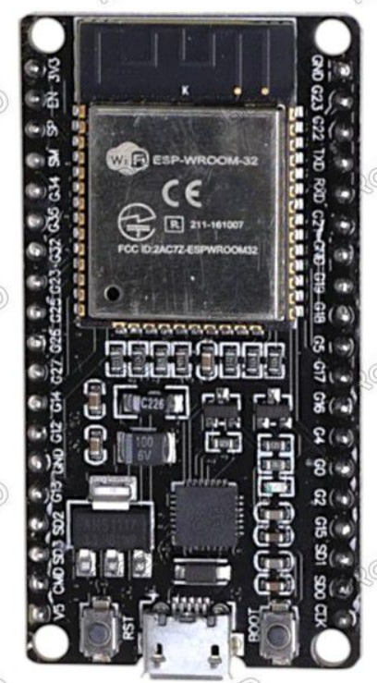
2 | ZK-5AD Motor Driver | Dual DC motor driver,PWM speed control,direction control support | 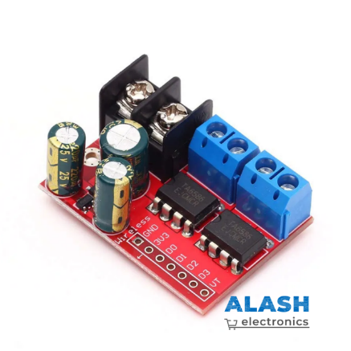
3 | Amperka Octoliner Sensor | 8-channel infrared sensor array, line position detection | 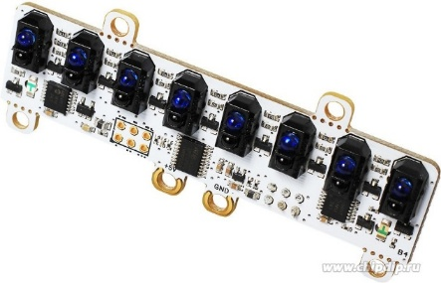
4 | Expansion Board | Multiple GPIO interfaces,power distribution support,plug-and-play connections | 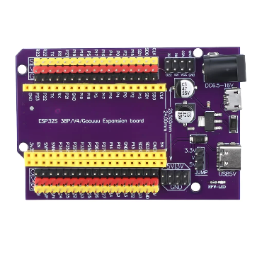
5 | DC Motors with Wheels | DC geared motors, differential drive configuration, wheel-mounted | 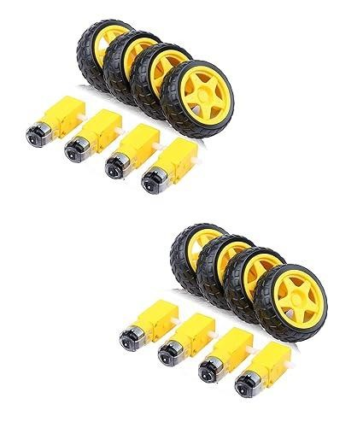

3.2 Sensing and Line Detection
The Octoliner sensor module consists of eight infrared emitter-receiver pairs arranged in a linear array. It measures the reflected infrared light intensity from the surface. A black line absorbs more light, resulting in lower analog readings, while the white background reflects more light, producing higher values. By comparing sensor readings against a calibrated threshold, the robot determines which sensors are currently detecting the line.
This multi-sensor approach provides significantly higher resolution and smoother control compared to single or dual-sensor line followers.

3.3 Mathematical Model
The position of the line relative to the robot is calculated using a weighted average of the sensors that detect the line:
error = Σ(weightᵢ × activeᵢ) / count(activeᵢ)
where weightᵢ are predefined position weights {-350, -250, -150, -50, 50, 150, 250, 350} and activeᵢ = 1 if sensor i reading exceeds the threshold, else 0.
The PD correction is computed as:
correction = Kp × error + Kd × (error − prevError)
Final motor speeds: leftSpeed = baseSpeed + correction; rightSpeed = baseSpeed − correction.

3.4 Control Logic and PD Algorithm
The software implements a PD controller to minimise the error (deviation from the centre of the line). The proportional term (Kp = 0.24) provides immediate correction proportional to the current offset, while the derivative term (Kd = 0.105) dampens oscillations by reacting to the rate of change of error. When all sensors detect white (active = 0) the controller retains the last known error, preventing erratic behavior at line gaps.
Key elements of the algorithm:
- Real-time reading of 8 infrared sensors via I²C
- Weighted error calculation for high-resolution line position
- PD control (Proportional + Derivative) for smooth steering
- Motor speed constraining to [0, 255] for safety
- Fallback to previous error when the line is completely lost

3.5 Actuation and Motion Control
Two DC motors with wheels are controlled via an H-bridge configuration using the ESP32’s LEDC (PWM) channels. Pulse Width Modulation allows precise and independent speed control of each motor, enabling differential steering. The system achieves responsive and stable movement thanks to the high-frequency (5 kHz) PWM capabilities of the ESP32.

IV. Final Arduino Code
The complete, production-ready firmware is listed below. The code runs on ESP32 Arduino Core v3 and requires the Octoliner library.
#include <Wire.h>
#include <Octoliner.h>

Octoliner octoliner;

// motor pins
#define M1A 27 // right
#define M1B 26
#define M2A 25 // left
#define M2B 33

// pwm
#define PWM_LEFT 0
#define PWM_RIGHT 1

int threshold = 3950; // adjust after Serial Monitor test

float Kp = 0.24;
float Kd = 0.105;

int baseSpeed = 160;
int prevError = 0;

// sensor weights (0 = RIGHT, 7 = LEFT)
int weights[8] = {-350, -250, -150, -50, 50, 150, 250, 350};

void setup() {
Serial.begin(115200);
octoliner.begin();
octoliner.setSensitivity(200);
pinMode(M1B, OUTPUT);
pinMode(M2B, OUTPUT);
ledcAttach(M2A, 5000, 8); // left motor
ledcAttach(M1A, 5000, 8); // right motor
}

void setMotor(int leftSpeed, int rightSpeed) {
leftSpeed = constrain(leftSpeed, 0, 255);
rightSpeed = constrain(rightSpeed, 0, 255);
ledcWrite(M2A, leftSpeed);
digitalWrite(M2B, LOW);
ledcWrite(M1A, rightSpeed);
digitalWrite(M1B, LOW);
}

void loop() {
int sum = 0;
int active = 0;

for (int i = 0; i < 8; i++) {
int val = octoliner.analogRead(i);
Serial.print(val);
Serial.print("\t");
if (val > threshold) {
sum += weights[i];
active++;
}
}

Serial.println();

int error;
if (active == 0) {
error = prevError;
} else {
error = sum / active;
}

int derivative = error - prevError;
float correction = Kp * error + Kd * derivative;

// smooth motor control
int leftSpeed = baseSpeed + correction;
int rightSpeed = baseSpeed - correction;

// safety limit
leftSpeed = constrain(leftSpeed, 0, 255);
rightSpeed = constrain(rightSpeed, 0, 255);

setMotor(leftSpeed, rightSpeed);
prevError = error;
delay(5);
}

V. Experimental Results

5.1 Experimental Setup
The robot was evaluated on a closed-loop track printed on white A0 paper using a 20 mm wide black line. Tests were conducted indoors under consistent fluorescent lighting. The threshold value (3950) was determined empirically using the Serial Monitor while holding the sensor array above the track.

5.2 Performance Results
TABLE II
PD Parameter Tuning Results
Kp | Kd | Laps Completed | Observation
0.10 | 0.00 | 1 / 5 | Oscillation on curves, frequent line loss
0.18 | 0.05 | 3 / 5 | Moderate stability, slight overshoot
0.24 | 0.105 | 5 / 5 | Smooth tracking, stable speed (final values)
0.30 | 0.105 | 4 / 5 | Slight overshoot on tight curves

VI. Conclusions
The project successfully demonstrated an autonomous line-following robot using an ESP32 microcontroller and an Octoliner 8-channel infrared sensor array. The PD control algorithm with weighted-average error estimation provided smooth and reliable tracking at baseSpeed = 160 on a standard test track.
Future improvements include: adding integral (I) control to eliminate steady-state error, implementing adaptive speed control for straight sections, and integrating wireless telemetry for real-time PID tuning over Wi-Fi using the ESP32’s built-in radio.

Acknowledgement
The authors acknowledge the guidance and mentorship of course and lab instructors at KBTU in completing this project.

References
[1] Maratova A., Ibraim A., Aimyrzakyzy S., “Line Following Robot Using ESP32 and Octoliner,” KBTU Course Project Report, 2024.
[2] N. Miskovic, M. Bibuli, A. Birk et al., “PD control for mobile robots,” IEEE Trans. Control Syst. Technol., 2016.
[3] Espressif Systems, “ESP32 Technical Reference Manual,” v5.0, 2023. [Online] Available: https://docs.espressif.com
[4] Amperka, “Octoliner Library for Arduino,” GitHub. [Online] Available: https://github.com/amperka/octoliner

