RESEARCH ARTICLE/REVIEW


Mental Health Risk

Prediction Using

Machine Learning

Mr. Sumeet Jitendra Yadav and Dr. Mahendra Kanojia
Second Year in Bachelor of Science in Computer Science, Sheth L.U.J. And Sir M.V. College of Arts, Science And Commerce, (India) sumeetyadavv01@gmail.com

Abstract: Stress is climbing and daily habits are shifting - mental health has turned into a serious issue. Spotting those who may be in danger early lets helpers move fast. The work uses a machine learning method that leans on everyday conduct plus way-of-life facts to forecast who might face mental health trouble. The numbers came from an anonymised set that anyone may download. A decision tree and logistic regression served as the baseline tools. F1-score, confusion matrix, accuracy, precision but also recall judged how well the tools worked. The results show that plain, easy-to-follow machine learning rules sort people into risk groups with solid success. The paper offers no medical verdict - its sole purpose is academic study and decision support.

Keywords: Mental Health Risk, Machine Learning, Logistics Regression, Decision Tree, Behavioral Data, Classification, Data Processing, Predictive Analysis

Introduction
The rise in mental health issues has been primarily caused by a growing number of stressors (such as academic pressure) and changes to our lifestyles (amount of exercise, diet, sleep habits, work environment, etc.). Early identification of people at risk allows for the provision of timely support and education.
Digital data and machine learning are increasingly being used to analyze behavioural patterns and assist in decision-making. The ability of these methods to integrate multiple variables at once makes it possible to identify patterns of behaviours that might be less apparent or visible using traditional measures. Therefore, the machine learning models created in this study will predict the risk of an individual's mental health based on behavioural and lifestyle-related characteristics. The intention behind creating these models is to use them as tools for exploring academic interest in mental health risk rather than as clinical diagnostic tools.

Problem Statement

Mental health evaluation can be done by manual surveying, which may not be an efficient process to cover large populations. Mental health data generated by lifestyle, stress, sleep, activities, and other behaviors can provide significant results; however, this data is not always utilized in an efficient manner. There is an important requirement for an automated system to be developed to analyze these variables and assign respective categories of risks to an individual’s mental health. This research work will fill this gap by using machine learning to predict risks of mental health on the basis of an individual’s behaviors.

Objective of the study
The objectives of this research are as follows:
- To analyze behavioral and lifestyle factors related to mental health risk
- To develop a machine learning model for predicting mental health risk categories
- To compare the performance of logistic regression and decision tree models
- To evaluate model performance using accuracy, precision, recall, F1-score, and confusion matrix

Hypotheses

This is primarily a predictive study; hence, formal statistical hypothesis testing is not required. The aim of the research is to assess and compare the performance of machine learning models, not to conduct an inferential statistical analysis. Nevertheless, it was based on the following assumptions:

H₀ (Null Hypothesis):
Machine learning models can predict mental health risk categories with acceptable accuracy using behavioral and lifestyle-related data.

H₁ (Alternative Hypothesis):
Behavioral and lifestyle factors have a significant relationship with mental health risk prediction using machine learning models.

Literature Review

There has been an rising interest in the application of machine learning algorithms for the prediction of risks associated with mental health in recent years, owing to the increased availability of data related to the behavior, lifestyle, and digital health of an individual. Conventional methods of evaluating mental health involve the use of surveys and clinical interviews, which may not prove to be effective for large-scale populations. This has led researchers to adopt data-centric approaches for the analysis of data related to behavior and demographics related to mental health risks. According to various studies, it has been found that machine learning algorithms such as logistic regression, decision trees, random forest, support vector machines, and neural networks have proved to be more effective for risk prediction than conventional methods (Walsh et al., 2020; Shatte et al., 2020). There has been an increased interest in recent years in adopting interpretable and explainable machine learning approaches for applications related to mental health (Torous et al., 2021; Vayena et al., 2022).

Machine Learning–Based Mental Health Risk Prediction
Several studies have proved the efficacy of the application of various machine learning algorithms for the predictive analysis of risk for mental health. Shatte et al. (2020) demonstrated the efficacy of the application of classification algorithms such as decision trees and support vector machines for the predictive analysis of risk from behavioral data. They showed an increased level of accuracy as compared to other traditional methods. Walsh et al. (2020) discussed the application of different machine learning models for the predictive analysis of mental health. They showed the efficacy of supervised learning models for the predictive analysis of risk. Jacobson et al. (2021) showed the application of logistic regression and decision trees for the predictive analysis of mental health outcomes. They proved the importance of interpretability for the application of machine learning models.

Advanced and Hybrid Machine Learning Approaches
More recently, studies on more complex or combined models of machine learning have also appeared in the literature to provide more effective approaches to evaluating and understanding the effects of mental health on human society. In their study, “AI-Powered Mental Health Analysis,” researchers applied neural network models to the collection of digital data on mental health from mobile and wearable sensors to establish the reliability of their approach. In another study, Xu et al. (2022) applied traditional models of machine learning, as well as deep learning models, and proved that ensemble models are more accurate. In another work on applying deep learning models to sequential data on human behavior, researchers proved their effectiveness in detecting risks to mental health (Kusumawardani and Alfarozi, 2023).

Feature Importance and Explainability in Mental Health Risk Prediction

More recent literature has been centered on understanding the elements contributing to mental health risk. According to Vayena et al. (2022), there is a need for Explainable Machine Learning models in mental health to enable ethical use and transparency to be constituted. Stress, sleep, activity, and even social support have been presented as principal elements contributing towards mental health risk, and these elements would seem to cover a wide scope with regard to affected person/subject characteristics. Techniques such as explainability would appear to improve trust for these predictive models, offering elements enabling improved understanding of contributions towards predictions.

Challenges in Mental Health Risk Prediction

Although much progress has been made, a number of challenges exist. Among the challenges are the issues reported by previous studies, such as the problem of class imbalance, the issue of missing and noisy data, and the problem of a lack of generalizability. Behavioral data is typically collected by self-report, and this could cause variability and biases. In addition, the ethical issues surrounding the privacy and fair use of the predictions have been stated to still represent challenges.

Dataset Description
The data that has been employed for this research is a publicly accessible anonymized mental health data comprising 10,000 individual data entries, which have been obtained by conducting a survey. The data includes personal details, behavioral, as well as some lifestyle data, but no personal information that could be traced for any particular individual.
The dataset has features such as age, gender, employment status, work environment, level of stress, sleep duration per day, frequency of physical activities per week, social support scale score, and productivity scale score. The target feature mental_health_risk was transformed to create a binary value to enable machine learning model predicting capabilities. Before building models using the data, some data preprocessing was done. This included dealing with categorical data in the dataset. It also involved removing certain variables associated with the outcome. The scale of some attributes was also implemented.

Type of Data

Secondary Data

Data Source

The dataset was sourced from Kaggle, a publicly available open-data platform.

Key Characteristics of the Dataset

    - Dataset Type: Tabular (CSV format)

    - Number of Records: ~10,000

    - Target Variable: converted into binary classification

Dataset Attributes

    - Student ID
    - Age
    - Gender
    - Attendance Percentage
    - Previous Academic Scores
    - Continuous Assessment Marks
    - Study Hours
    - Learning Motivation Level
    - Classroom Participation
    - Online Learning Activity
    - Socio-Economic Background
    - Final Academic Performance / Grade

Dataset CSV File

    - merged_dataset.csv

- Graph using (R) Language

  - Dataset Summary

Variable | Description | Mean (SD)
Age | Age of the student (in years) | 23.53 (3.51)
Study Hours | Average study hours per day | 19.99 (5.89)
Attendance | Attendance percentage | 80.19 (11.47)
Discussions | Participation in academic  discussions | 0.61 (0.49)
Assignment Completion | Assignment completion score | 74.50 (14.63)
Exam Score | Final examination score | 70.35 (17.69)

  - Graph

Figure 1

Bar Graph – Final Grade Distribution
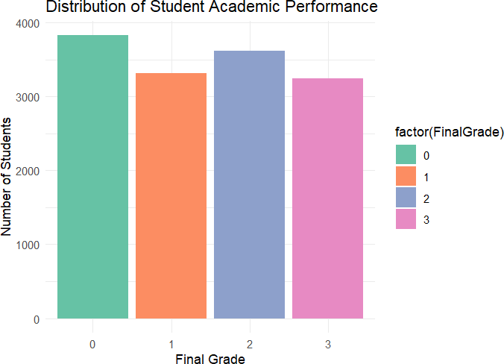

Figure 2

Pie Chart – Gender Distribution
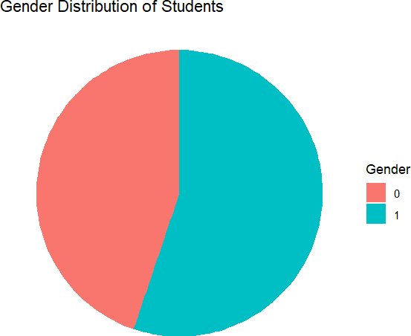
Figure 3

Scatter Plot – Study Hours vs Exam Score (Colored by Gender)
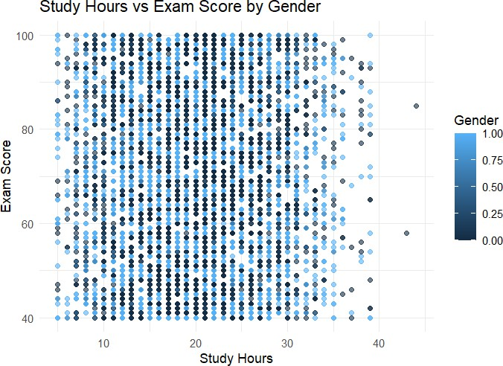

Methodology
This study adopts a machine learning–based predictive approach to analyze and predict student academic
performance using a publicly available dataset.

Data Preprocessing.
The following preprocessing steps were applied to ensure data quality and consistency:

    - Removal of missing and inconsistent values
    - Encoding of categorical variables such as gender and learning style
    - Normalization of numerical attributes including attendance, study hours, and exam scores
    - Selection of relevant academic, demographic, and behavioral features

These steps help improve model accuracy and reduce noise in the dataset.

Analytical Approach
A supervised machine learning approach was used to predict student academic performance. The dataset was divided into training and testing sets using an 80:20 split ratio. Predictive models were trained on the training data and evaluated on unseen test data to ensure generalization.

Classification Perspective
Student academic performance was classified into predefined performance categories based on final grades.
This classification approach helps identify high-performing and at-risk students, supporting early academic intervention and decision-making.

Machine Learning Algorithms Used
Based on suitability and practical implementation, the following algorithms were used in this study:

    - Decision Tree
    - Random Forest
    - Support Vector Machine (SVM)
    - k-Nearest Neighbors (KNN)

These algorithms were selected due to their effectiveness in classification tasks and widespread use in educational data mining.

Results and Discussion

The experimental results indicate that machine learning models are effective in predicting student academic performance. Among the evaluated algorithms, ensemble-based methods such as Random Forest and Gradient Boosting achieved higher accuracy and better generalization compared to individual classifiers. These models demonstrated robustness in handling high-dimensional data and capturing complex relationships among features.

Traditional classifiers such as Decision Tree and Naïve Bayes produced reasonable results but showed lower predictive accuracy compared to ensemble approaches. Support Vector Machine and k-Nearest Neighbors provided moderate performance, with effectiveness influenced by feature scaling and parameter selection.

The findings align with previous studies, confirming that ensemble learning techniques outperform single classifiers in educational prediction tasks. The results highlight the potential of machine learning-based predictive systems as early warning tools for identifying at-risk students.

Conclusion
This study presents a comprehensive analysis of student academic performance prediction using machine learning
techniques. By utilizing a large-scale secondary dataset and multiple classification algorithms, the research
demonstrates that machine learning models can effectively predict academic outcomes with high accuracy.
Ensemble-based algorithms, particularly Random Forest and Gradient Boosting, were found to deliver superior performance.
real-time learning data, applying deep learning techniques, and integrating explainable artificial intelligence methods to enhance transparency and decision-making.

Conflicts of Interest
The authors declare that they have no conflicts of interest to this work.

References

2021 Student Performance Prediction (Machine Learning / Educational Data Mining)

- Dabhade, P., Agarwal, R., Alameen, K. P., Fathima, A. T., Sridharan, R., & Gopakumar, G. (2021). Educational data mining for predicting students’ academic performance using machine learning algorithms. Materials Today:
Proceedings, 47(15), 5260–5267. https://doi.org/10.1016/j.matpr.2021.05.646 (ScienceDirect)
- Zhang, Y., Yun, Y., An, R., Cui, J., Dai, H., & Shang, X. (2021). Educational data mining
techniques for student performance prediction: Method review and comparison analysis.
Frontiers in Psychology, 12, 698490. https://doi.org/10.3389/fpsyg.2021.698490 (Frontiers)
- Sahlaoui, H., Alaoui, E. A. A., Nayyar, A., Agoujil, S., & Jaber, M. M. (2021). Predicting and interpreting student performance using
ensemble models and SHAP explanations. IEEE Access, 9, 152688–152703.
https://doi.org/10.1109/ACCESS.2021.3124270 (ijcesen.com)
- V. Matzavela, & E. Alepis. (2021). Decision tree learning through a predictive model for student academic performance in intelligent m-learning
environments. Computers in Education: Artificial Intelligence, 2, 100035. https://doi.org/10.1016/j.caeai.2021.100035 (ijcesen.com)
- Albreiki, B., Zaki, N., & Alashwal, H. (2021). A systematic literature review of student
performance prediction using machine learning techniques. Education Sciences (Basel), 11(9), Article 552. https://doi.org/10.3390/educsci11090552 (Granthaalayah Publication)

The proposed predictive framework can assist educational
institutions in identifying students who require early
academic support and implementing timely intervention strategies. Future work may focus on incorporating

2022 Machine Learning-Based Academic Performance Models

- Orji, F. A., & Vassileva, J. (2022). Machine learning approach for predicting students’ academic performance and study strategies based on their motivation. arXiv. https://arxiv.org/abs/2210.08186 (arXiv)
- Feng, G., Fan, M., & Chen, Y. (2022). Analysis and prediction of students’ academic
performance based on educational data mining. IEEE Access, 10, 19558–19571.
https://doi.org/10.1109/ACCESS.2022.3151652 (ijcesen.com)
- Alsariera, Y. A., Baashar, Y., Alkawsi, G., Mustafa, A., Alkahtani, A. A., & Ali, N. (2022). Assessment and evaluation of different machine learning algorithms for predicting student performance. Computational Intelligence and
Neuroscience, 2022, Article 4151487.
https://doi.org/10.1109/TBDATA.2021.3125204 (ijcesen.com)
- Alhazmi, E., & Sheneamer, A. (2023). Early predicting of students performance in higher education. IEEE Access, 11, 27579–27589.
https://doi.org/10.1109/ACCESS.2023.3250702 (ijcesen.com)
- Sun, D., et al. (2023). A university student
performance prediction model and experiment based on multi-feature fusion and attention mechanism. IEEE Access, 11, 112307–112319. https://doi.org/10.1109/ACCESS.2023.3323365 (ijcesen.com)
- Zhen, Y., Luo, J.-D., & Chen, H. (2023).
Prediction of academic performance of students in online live classroom interactions — An
analysis using natural language processing and deep learning methods. Journal of Social Computing, 4(1), 12–29. https://doi.org/10.23919/JSC.2023.0007 (ijcesen.com)

https://doi.org/10.1155/2022/4151487
(Granthaalayah Publication)
- Yağcı, M. (2022). Educational data mining:

Prediction of students’ academic performance using machine learning algorithms. Smart Learning Environments, 9(1). https://doi.org/10.1186/s40561-022-00192-z (Granthaalayah Publication)
- Alamri, R., & Alharbi, B. (2022). Explainable student performance prediction models: A
systematic review. IEEE Access, 9, 33132–33143. https://doi.org/10.1109/ACCESS.2021.3061368 (ijcesen.com)

2023 Advances in Student Performance Prediction

- Kusumawardani, S. S., & Alfarozi, S. A. I. (2023). Transformer encoder model for sequential prediction of student performance based on their log activities. IEEE Access, 11, 18960–18971.
https://doi.org/10.1109/ACCESS.2023.3246122 (ijcesen.com)
- Zhang, Y., An, R., Liu, S., Cui, J., & Shang, X. (2023). Predicting and understanding student learning performance using multi-source sparse attention convolutional neural networks. IEEE Transactions on Big Data, 9(1), 118–132.

2024 New Models and Hybrid Approaches

- Ahmed, E. (2024). Student performance
prediction using machine learning algorithms.
Scientific World Journal, 2024, Article 4067721. https://doi.org/10.1155/2024/4067721 (Wiley
Online Library)
- Al-Tameemi, G., Xue, J., Ali, I. H., & Ajit, S. (2024). A hybrid machine learning approach for predicting student performance using multi-class educational datasets. Procedia Computer
Science, 2024. https://doi.org/10.1016/j.procs.2024.06.108 (ScienceDirect)
- Khairy, D. (2024). Prediction of student exam performance using data mining and ensemble techniques. Education and Information
Technologies.
https://doi.org/10.1007/s10639-024-12619-w (Springer)
- Nanavaty, S., & Khuteta, A. (2024). A deep learning dive into online learning: Predicting student success with interaction-based neural networks. International Journal of Intelligent Systems and Applications in Engineering, 4(1),
1–12. https://doi.org/10.12694/scpe.v25i2.2615 (related DOI noted) ( Granthaalayah Publication)
- Li, Y. (2024). Design of computer information management system based on machine learning algorithms. Scalable Computing, 25(2), 944–951. https://doi.org/10.12694/scpe.v25i2.2615 (Granthaalayah Publication)

2025 Cutting-Edge Predictive Models

- Wang, J., & Yu, Y. (2025). Machine learning approach to student performance prediction of online learning. PLoS ONE, 20(1), e0299018. https://doi.org/10.1371/journal.pone.0299018 (PLOS)
- Pan, J., Zhao, Z., & Han, D. (2025). Academic performance prediction using machine learning approaches: A survey. Journal of LaTex Class
Files, 1(1). (Survey of recent predictive models) (ResearchGate)
- Nwanegbo, I. M., Denison-George, C., Jonathan,
D., & Chiobi, N. F. (2025). Predicting student academic performance using machine learning. International Journal of Modelling & Applied Science Research, 8(9), 015. https://doi.org/10.70382/caijmasr.v8i9.015
(ResearchGate)
- Angeioplastis, A., Aliprantis, J., Konstantakis, M., & Tsimpiris, A. (2025). Predicting student performance and enhancing learning outcomes: A data-driven approach using educational data mining techniques. Computers, 14(3), 83. https://doi.org/10.3390/computers14030083 (MDPI)
- Alkan, B. B., et al. (2025). Using machine learning to predict student outcomes for early intervention. Scientific Reports. https://doi.org/10.1038/s41598-025-23409-w (Nature)

