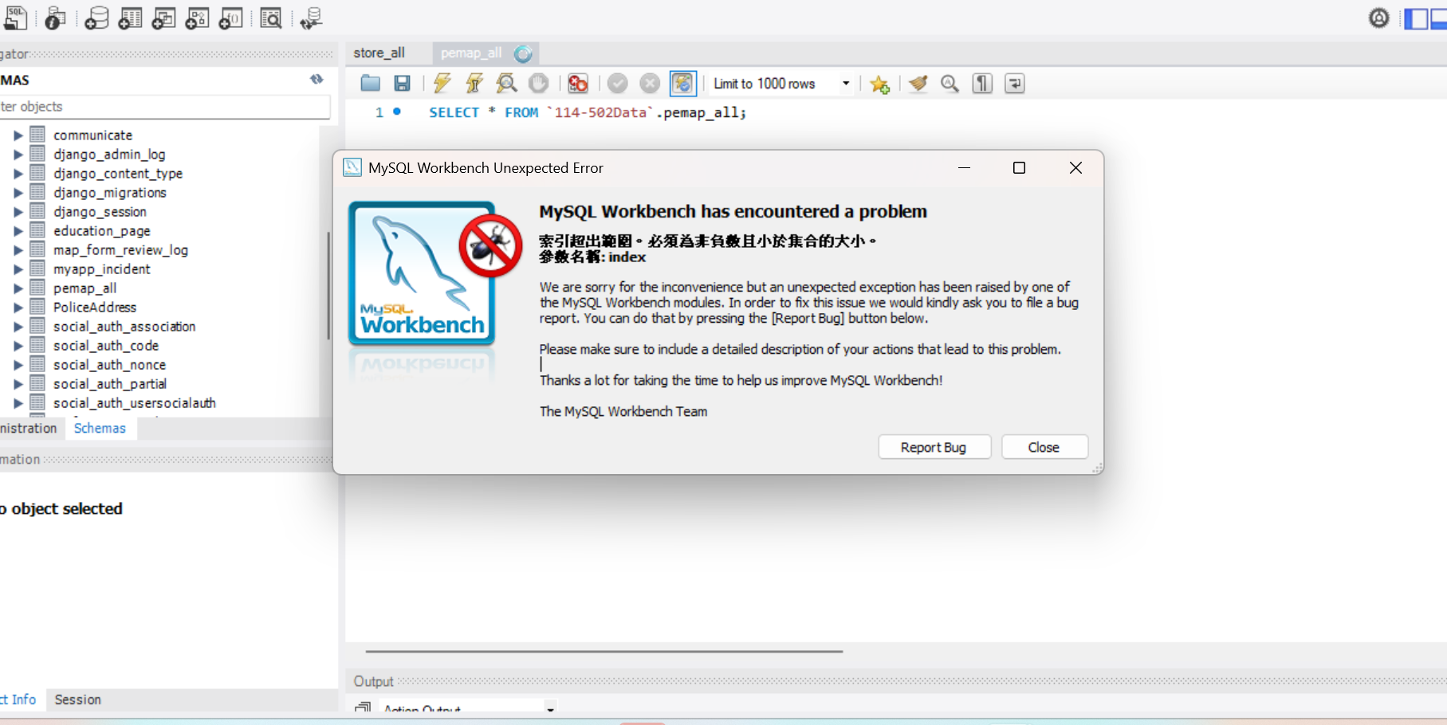

C:\Users\wusun\AppData\Roaming\MySQL\Workbench>

