Templates裡面的index0527
static裡面的haarcascade_frontalface_default.xml
view.py裡面找這段
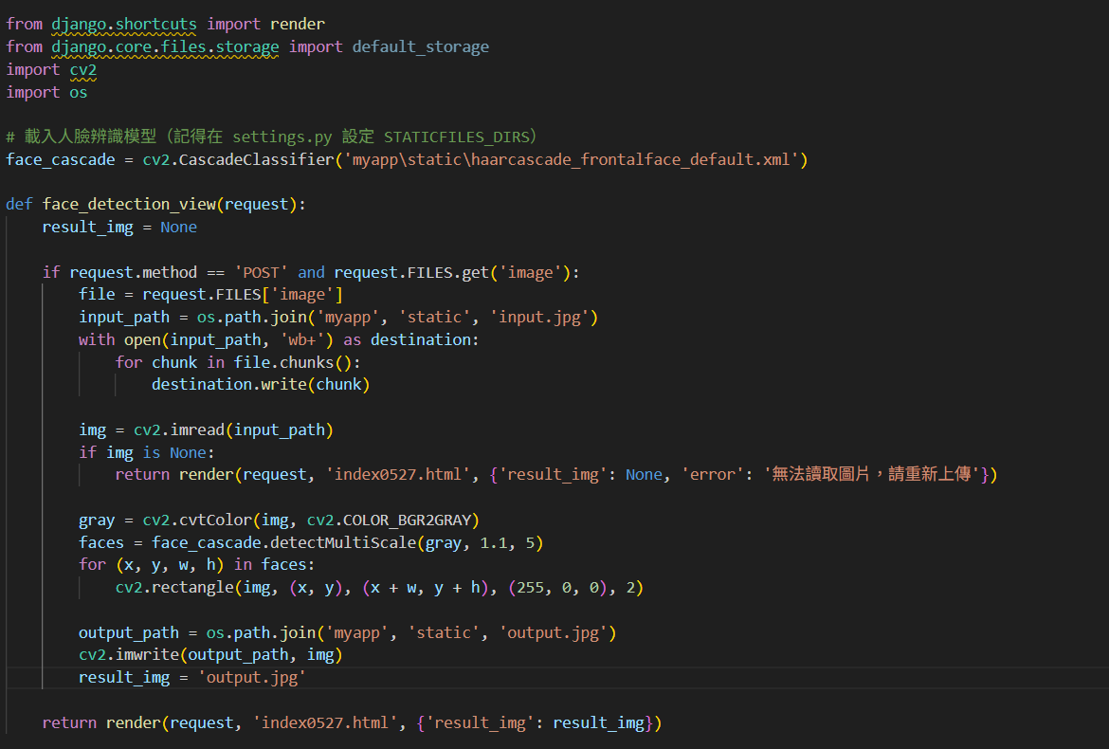

0528
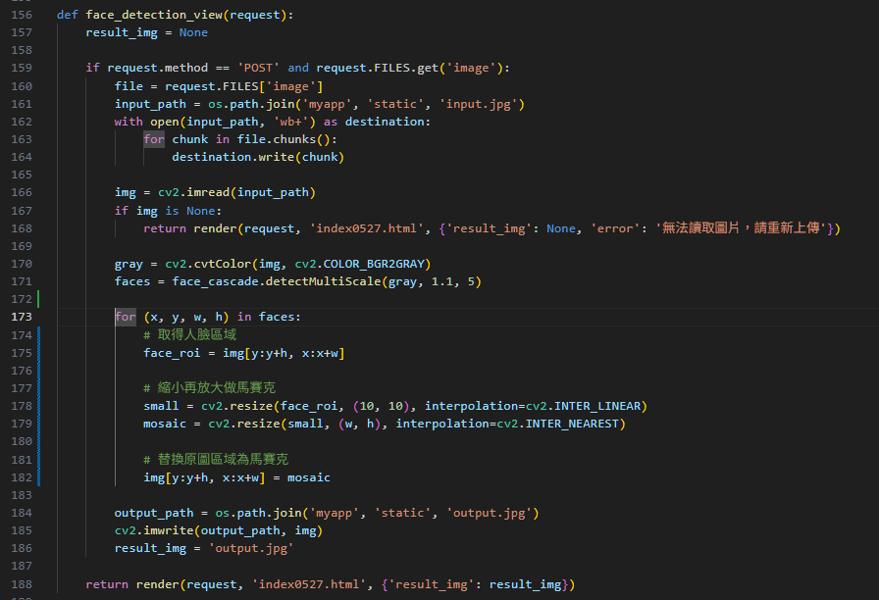
將後面程式修改成弄成馬賽克的!

#index0527.html

{% load static %}
<!DOCTYPE html>
<html lang="en">
<head>
<meta charset="UTF-8">
<title>人臉偵測系統</title>
</head>
<body>
<h2>上傳圖片進行人臉偵測</h2>
<form method="POST" enctype="multipart/form-data">
{% csrf_token %}
<input type="file" name="image" required>
<input type="submit" value="上傳並辨識">
</form>

{% if result_img %}
<h3>辨識結果：</h3>
<img src="{% static result_img %}" alt="辨識後的圖片" style="max-width:500px;">
{% endif %}
</body>
</html>

