GiftCloud – MySQL Database Design

# 1. Project Overview

**Project Name**: GiftCloud  
**Technology Used**: Spring Boot, MySQL, Postman  
**Purpose**: Manages users, gifts, and orders with admin and user roles.

# 2. Database Details

**Database Name: giftydb1**  
Tables Used:  
- users  
- gift  
- orders

# 3. Table Structures

## ➤ users Table

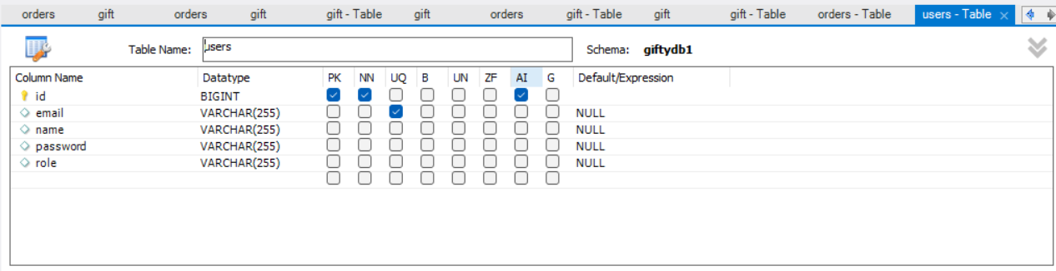

|  |  |  |
| --- | --- | --- |
| Column Name | Data Type | Description |
| id | INT | Primary Key |
| email | VARCHAR | User Email |
| name | VARCHAR | Full Name |
| password | VARCHAR | Encrypted Password |
| role | VARCHAR | Role (ADMIN/USER) |

Sample Data:

## ➤ Gift Table

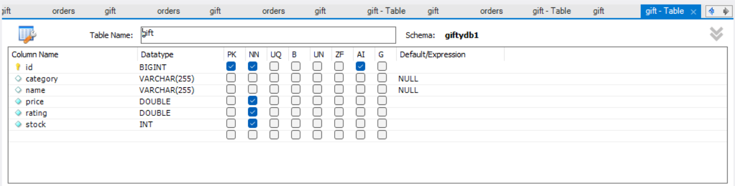

|  |  |  |
| --- | --- | --- |
| Column Name | Data Type | Description |
| id | INT | Primary Key |
| name | VARCHAR | Gift Name |
| price | DOUBLE | Gift Price |
| category | VARCHAR | Gift Category (optional) |
| Stock  Rating  Sample data: | INT  DOUBLE | Quantity Available  Rating |

## ➤ orders Table

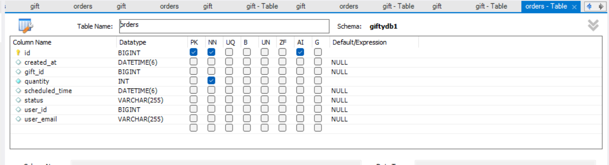

|  |  |  |
| --- | --- | --- |
| Column Name | Data Type | Description |
| id | INT | Primary Key |
| user_id | INT | Foreign Key from users |
| gift_id | INT | Foreign Key from gift |
| status | VARCHAR | ORDERED / DELIVERED |
| order_date | DATE | Order Placed Date |

# Sample data: