Gifty Delivery - REST API Endpoints (For Postman Screenshots)

# 1. User Registration (POST) and Get All Users (GET)

* POST <http://localhost:9999/api/users/register>

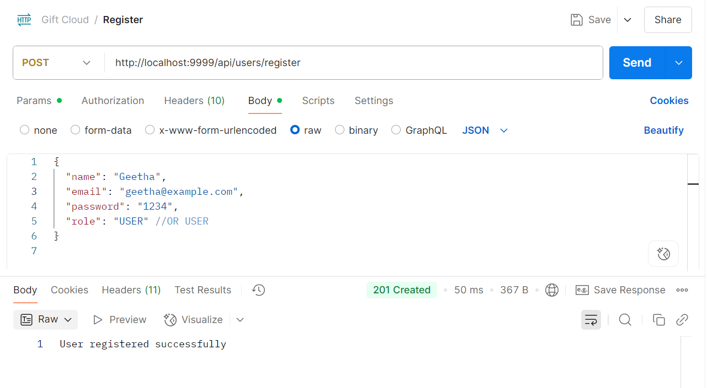

* GET <http://localhost:9999/api/users/all>

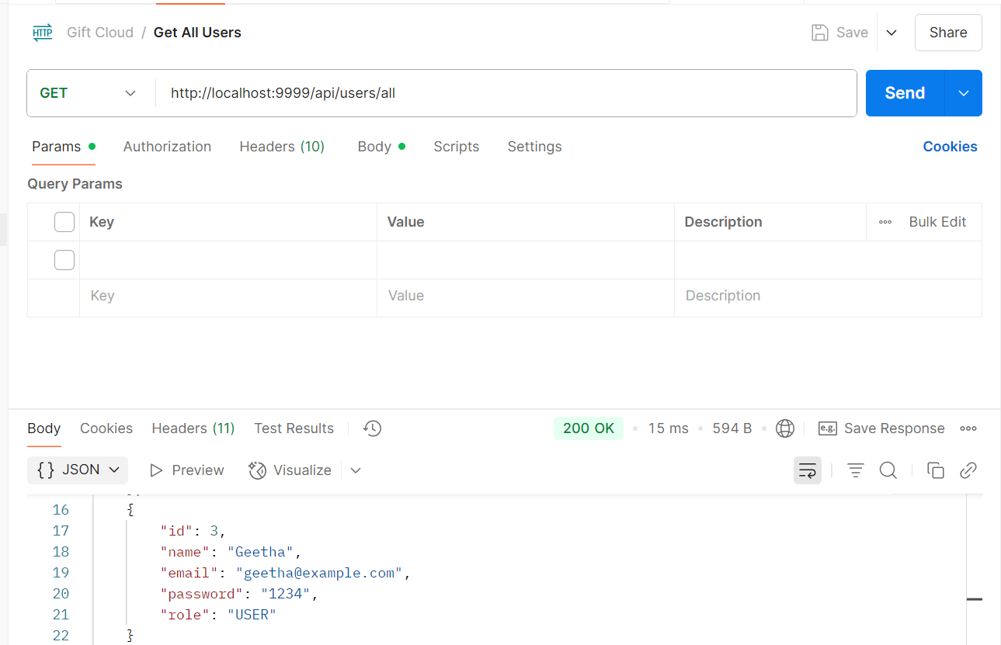

* 2. User Login (POST)

Post <http://localhost:9999/api/users/login>

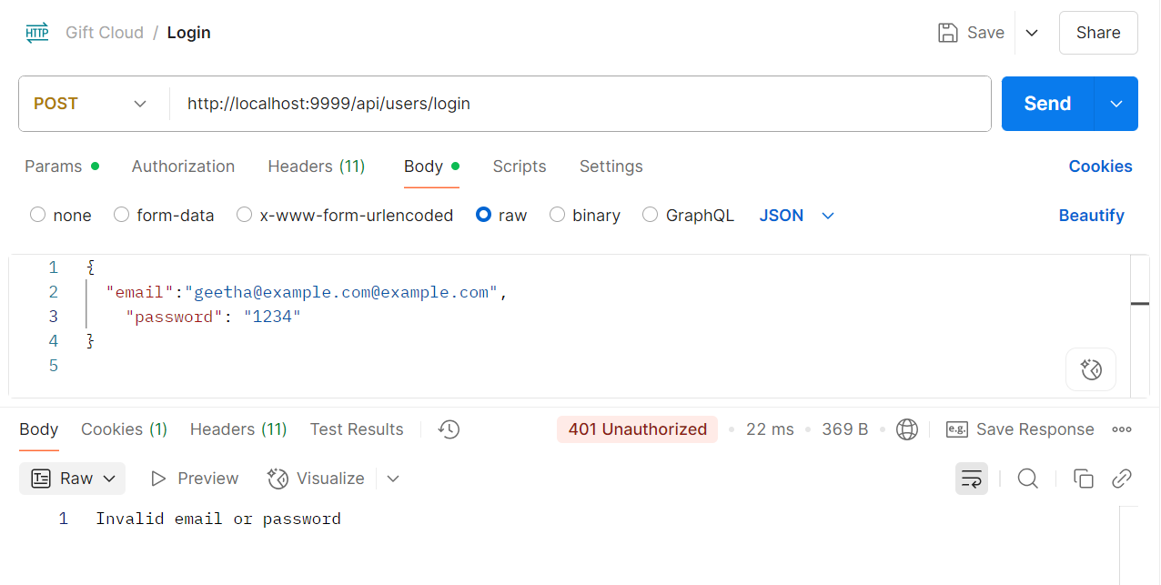

# 

# 3. Update User (PUT) and Get User By ID (GET)

* PUT <http://localhost:9999/api/users/1>

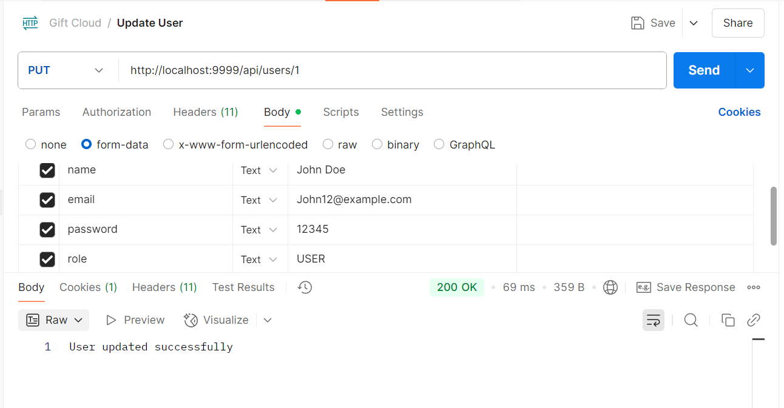

* GET <http://localhost:9999/api/users/1>

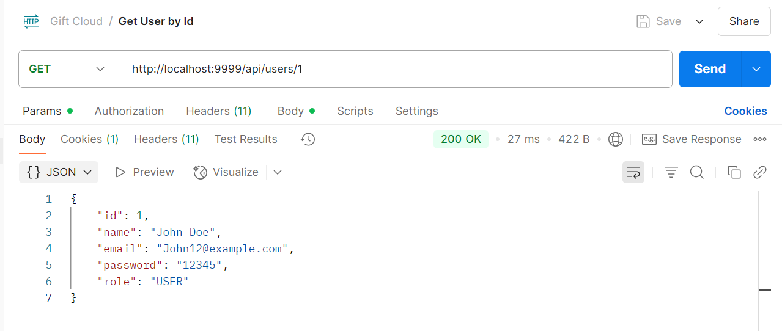

# 4. Add Gifts (Post)

Post <http://localhost:9999/api/gifts>

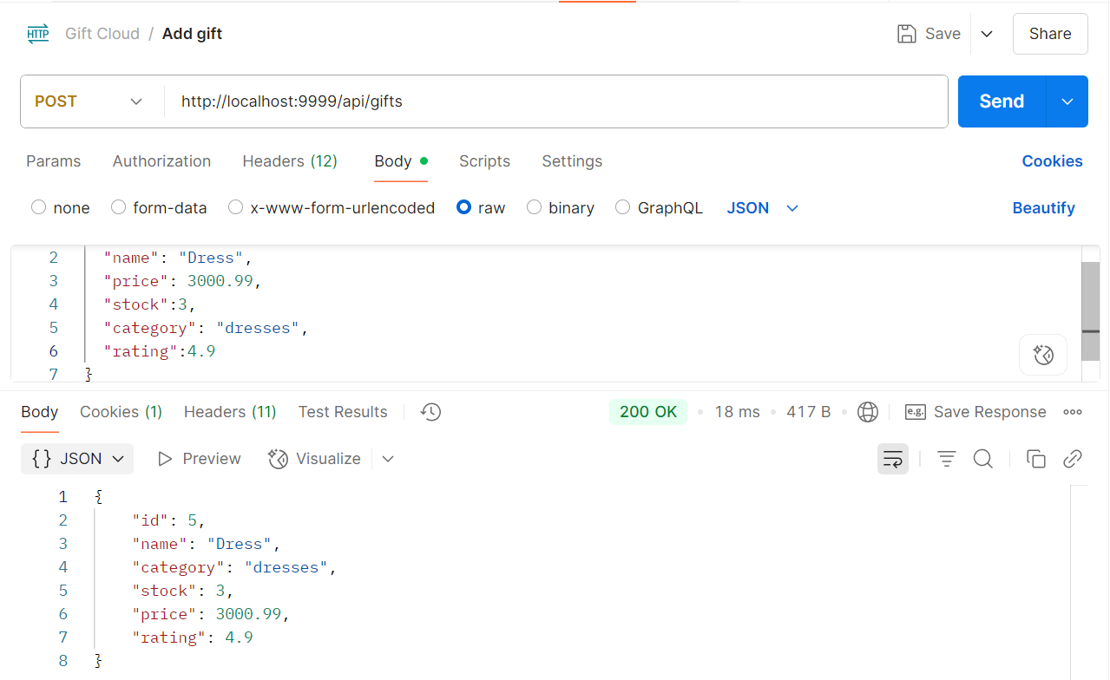

# 4. View all Gifts (Get)

Get <http://localhost:9999/api/gifts>

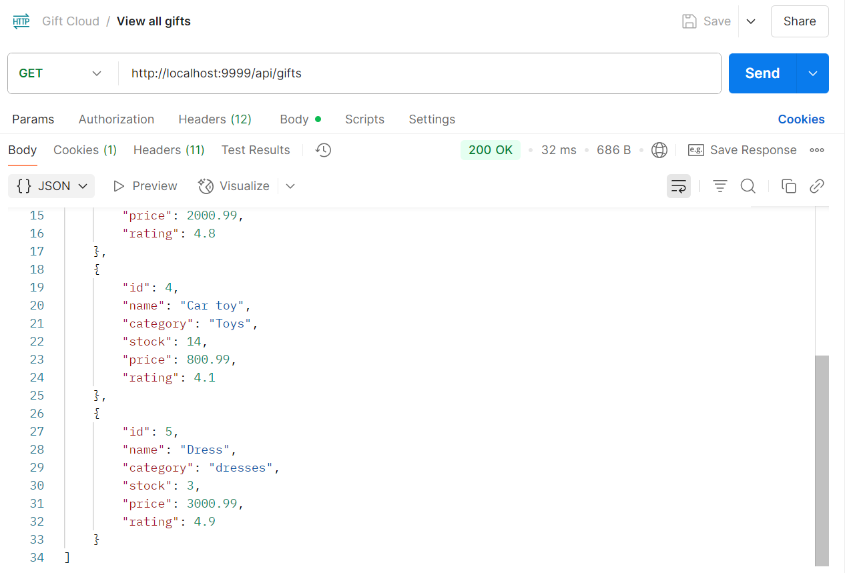

# 5 Update Gifts (Put)

Put <http://localhost:9999/api/gifts/5>

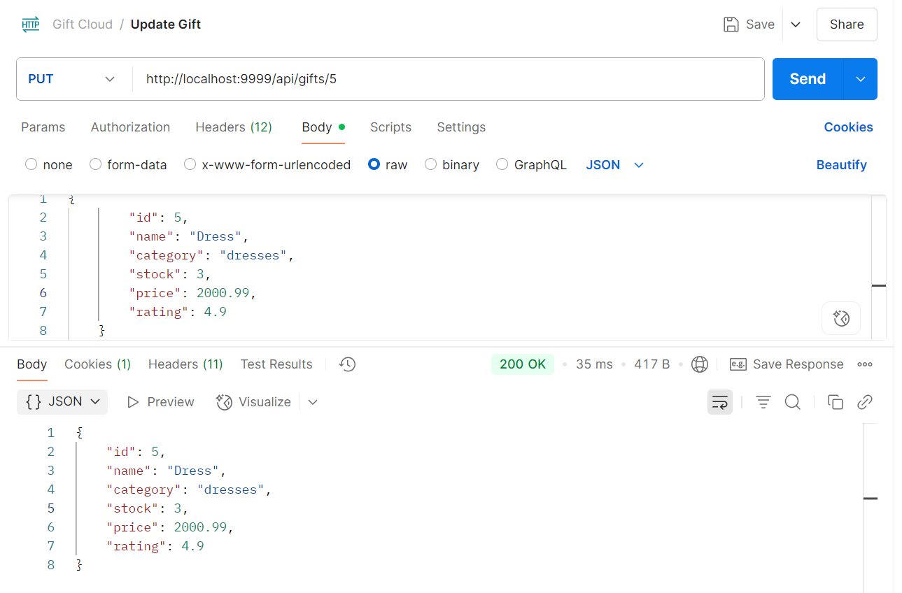

# 6 Get Gifts By Id (Get)

Get http://localhost:9999/api/gifts/5

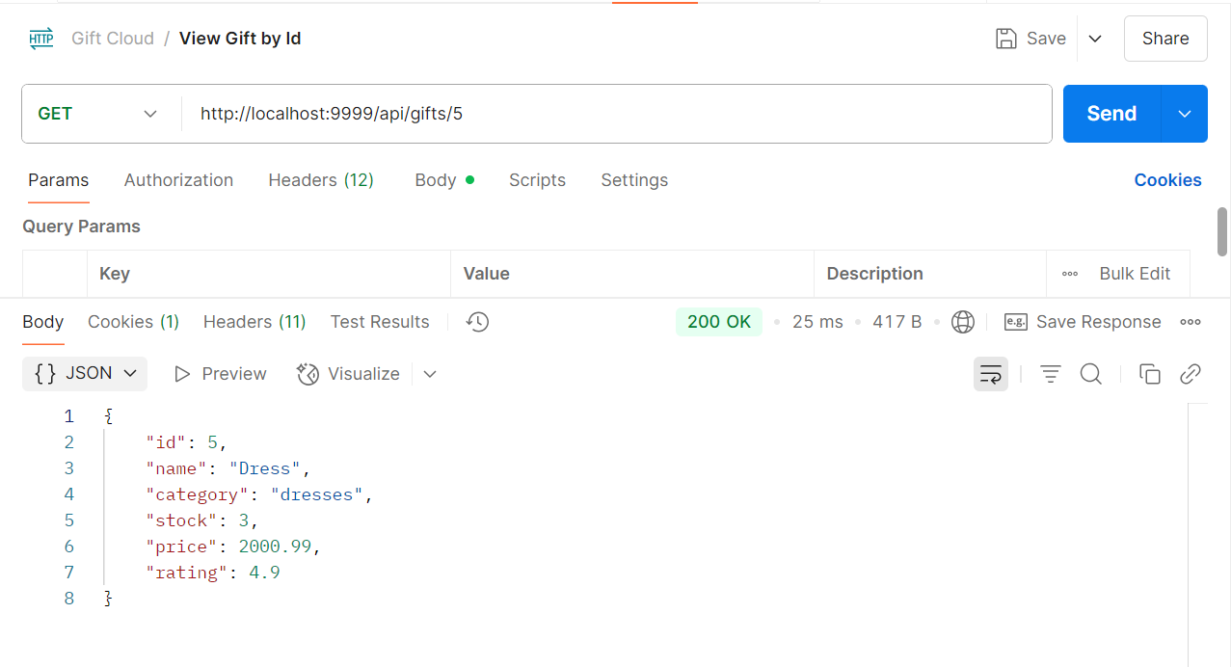

# 7 Delete Gifts By Id (Delete)

Delete <http://localhost:9999/api/gifts/5>

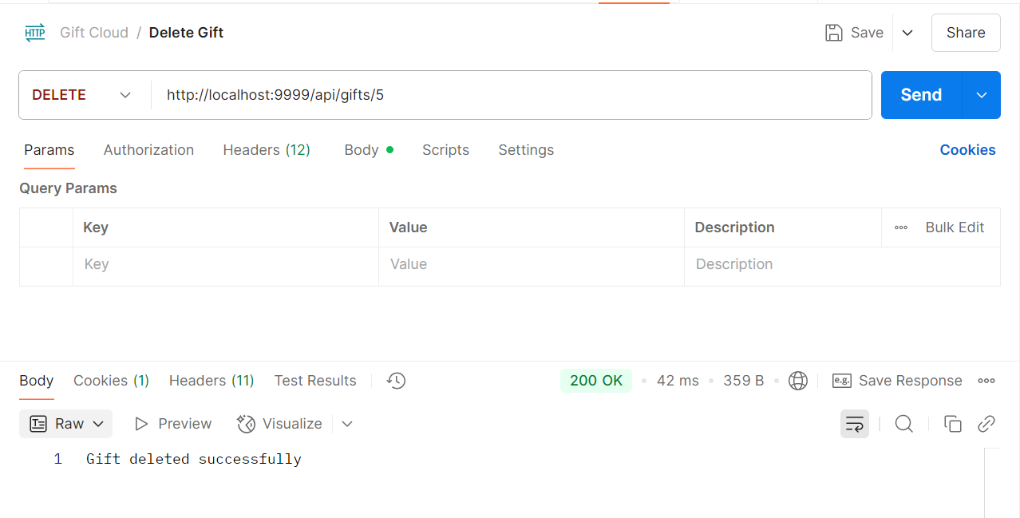

# 6 Get Gifts By Id (Get)

Get http://localhost:9999/api/gifts/5

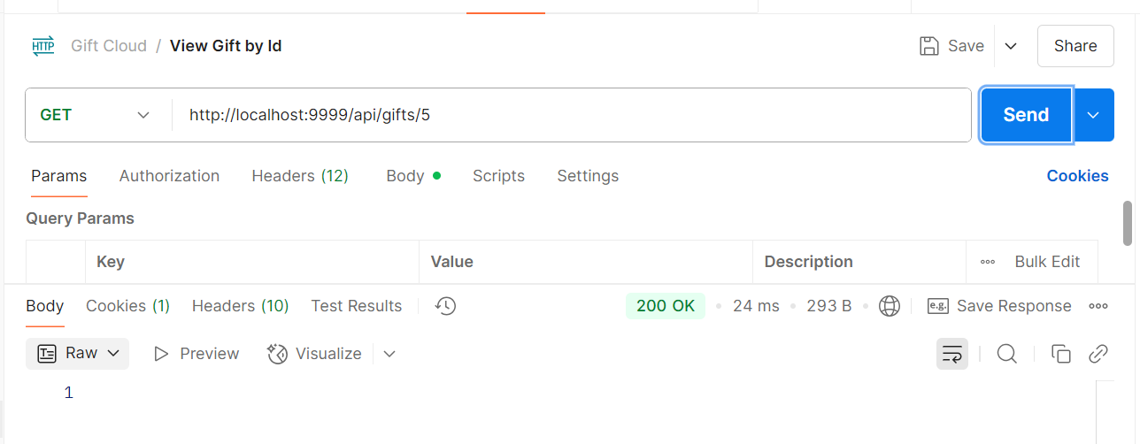

# 7 Place Order(post)

Post <http://localhost:9999/api/orders>

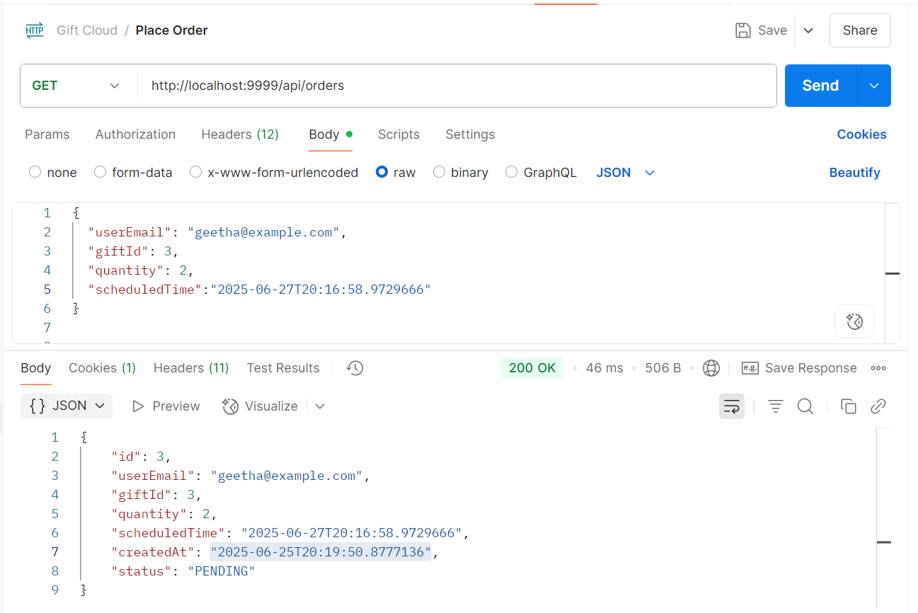

# 8 View All Order(Get)

Get <http://localhost:9999/api/orders>

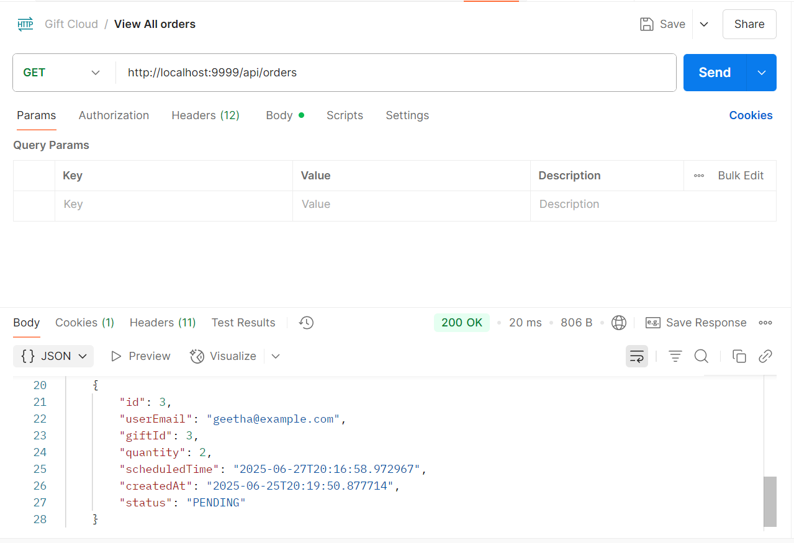

# 9 Deliver Order(Put)

Put <http://localhost:9999/api/orders/deliver/3>

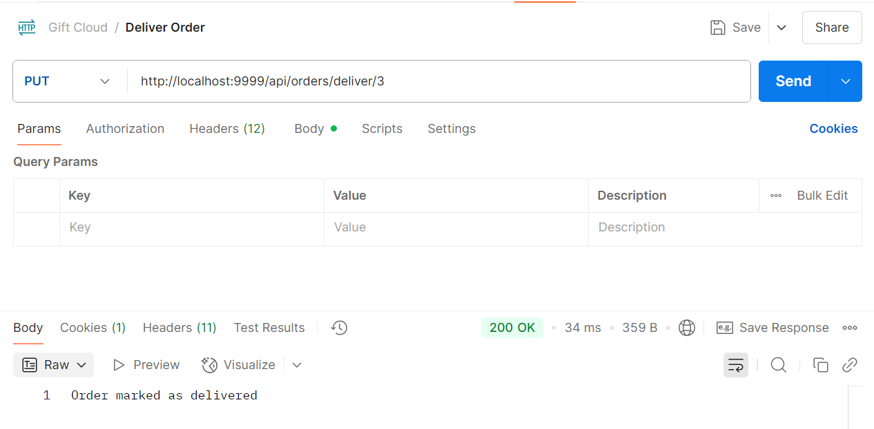

# 10 View All Order(Get)

Get <http://localhost:9999/api/orders>

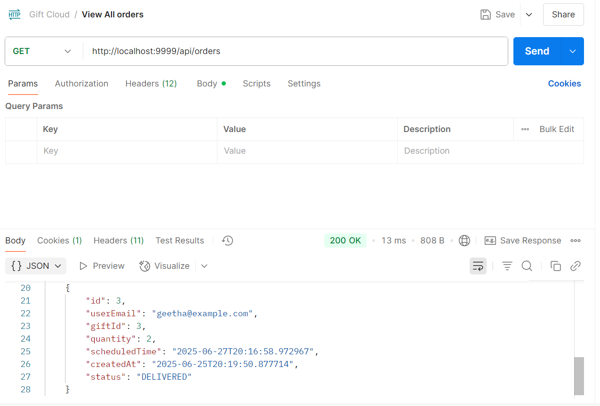

# 10 Check Order status(Get)

Get <http://localhost:9999/api/orders/status/3>

